Name:T Sai Charan

Roll No:2403a51440

Subgroup O  
O.1 — [S20O1] Point-in-polygon (ray casting)  
Context:  
Geofencing checks in urban public transit (metro/bus).  
Your Task:  
Ray-casting point-in-polygon; edges inside.  
Data & Edge Cases:  
Square example; return booleans.  
AI Assistance Expectation:  
Crossing-count logic.  
Constraints & Notes:  
Return list[bool].  
Sample Input  
poly=[(0,0),(4,0),(4,4),(0,4)], pts=[(2,2),(5,5)]  
Sample Output  
[True, False]  
Acceptance Criteria: Edges inside

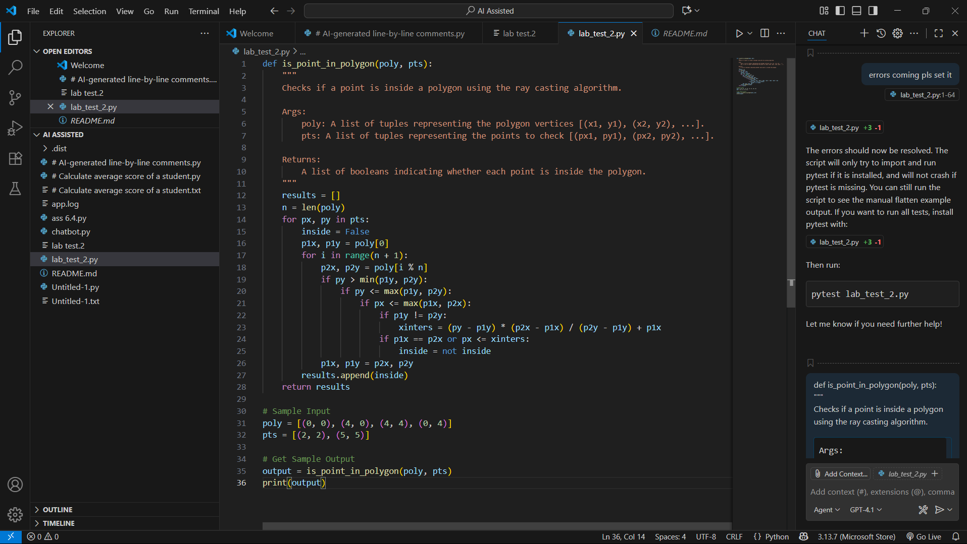

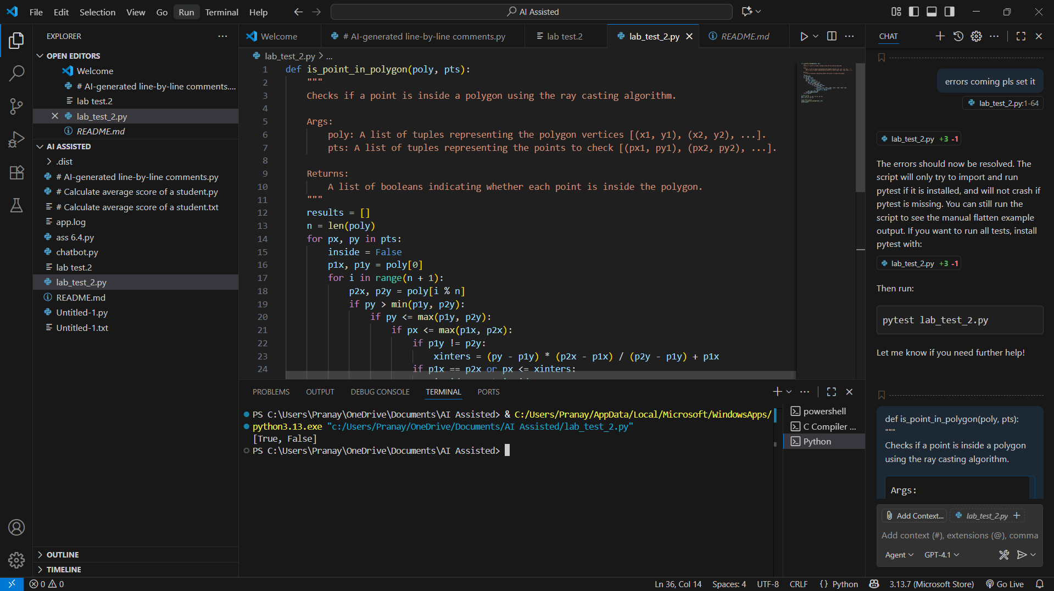

O.2 — [S20O2] Compute rolling median (w=3)  
Context:  
Rolling medians (w=3) for urban public transit (metro/bus) anomaly detection.  
Your Task:  
Return median per sliding window; efficient approach.  
Data & Edge Cases:  
Example list provided; large-n acceptable.  
AI Assistance Expectation:  
AI to propose bisect/heaps and tests.  
Constraints & Notes:  
Include small edge tests.  
Sample Input  
[1, 3, 2, 5, 4]  
Sample Output  
[2, 3, 4]  
Acceptance Criteria: Efficient and correct

