# AI ASSISTED CODING

LAB TEST-1(BATCH -17)

NAME: GOPALA SHASHANK REDDY

BATCH:17

ROLL NO:2403A51447

SET-C

QUESTION 1:Write a Python program to extract all URLs (web links) from a block of text using

regular expressions. Use the Cursor AI tool with zero-shot prompting to generate the solution

PROMPT:

Write a Python program to extract all URLs (web links) from a block of text using regular expressions.

CODE:

import re

def extract_urls(text):

pattern = r'https?://[^\s]+'

return re.findall(pattern, text)

# Example usage

text = "Visit https://www.google.com or follow https://github.com for more info."

print(extract_urls(text))

INPUT:

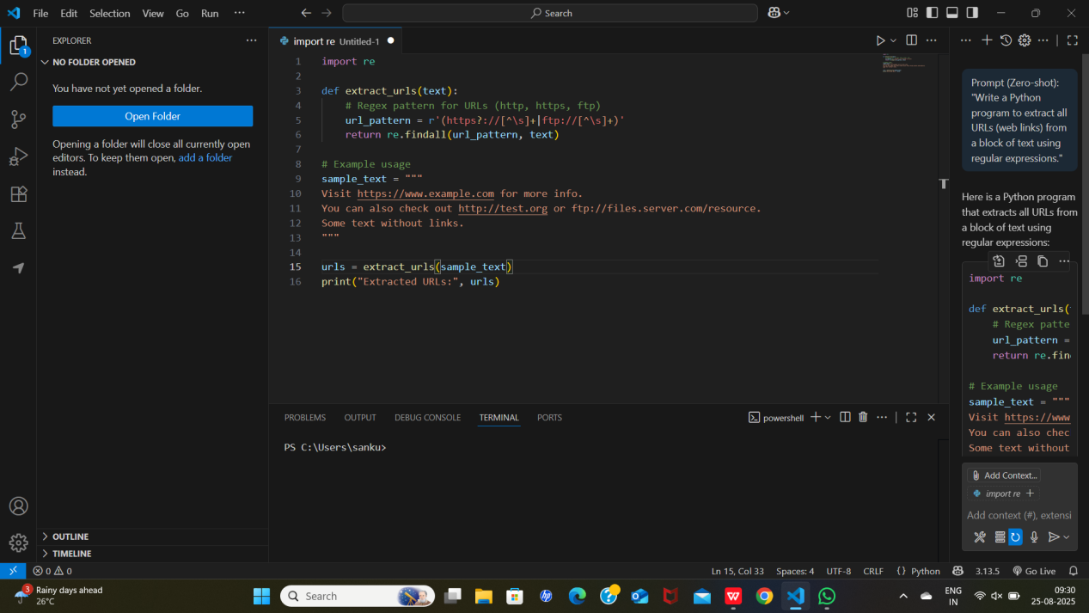

OUTPUT:

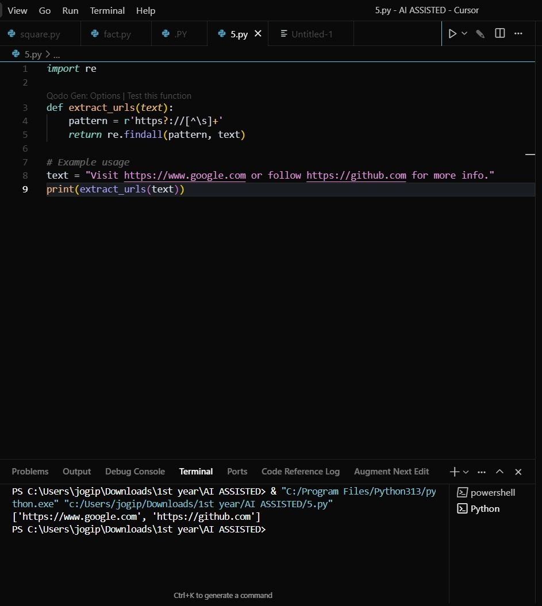

QUESTION 2:Given a list of books with their genres, write a Python function that recommends

books based on a user’s preferred genre. Use the Cursor AI tool. Use few shot prompting.

PROMPT:

Given a list of books with their genres, write a Python function that recommends books based on a user’s preferred genre.

CODE:

def recommend_books(books, genre):

return [title for title, g in books if g.lower() == genre.lower()]

# Example usage

books = [

("Harry Potter", "Fantasy"),

("Lord of the Rings", "Fantasy"),

("Dune", "Science Fiction"),

("Foundation", "Science Fiction"),

("Sherlock Holmes", "Mystery")

]

print(recommend_books(books, "Fantasy"))

print(recommend_books(books, "Science Fiction"))

INPUT:

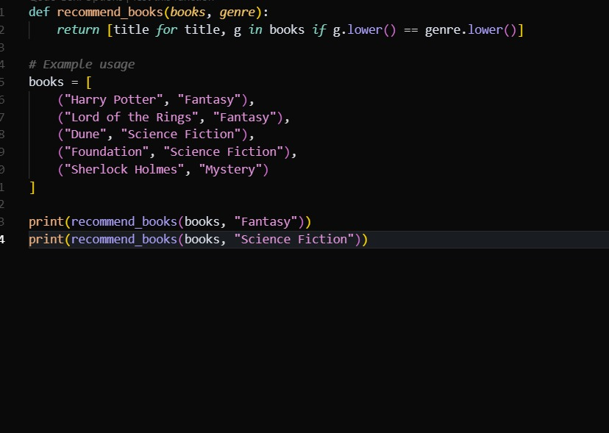

OUTPUT:

