SCHOOL OF COMPUTER SCIENCE AND ARTIFICIAL INTELLIGENCE |  |  |  |  | DEPARTMENT OF COMPUTER SCIENCE ENGINEERING
Program Name: B. Tech |  |  |  | Assignment Type: Lab |  |  | Academic Year:2025-2026
Course Coordinator Name |  |  |  | Venkataramana Veeramsetty
Instructor(s) Name |  |  |  | Dr. V. Venkataramana (Co-ordinator)  Dr. T. Sampath Kumar  Dr. Pramoda Patro  Dr. Brij Kishor Tiwari  Dr.J.Ravichander  Dr. Mohammand Ali Shaik  Dr. Anirodh Kumar  Mr. S.Naresh Kumar  Dr. RAJESH VELPULA  Mr. Kundhan Kumar  Ms. Ch.Rajitha  Mr. M Prakash  Mr. B.Raju  Intern 1 (Dharma teja)  Intern 2 (Sai Prasad)  Intern 3 (Sowmya)  NS_2 ( Mounika)
Course Code |  |  | 24CS002PC215 | Course Title |  | AI Assisted Coding
Year/Sem |  |  | II/I | Regulation |  | R24
Date and Day  of Assignment |  |  | Week6 - Monday | Time(s)
Duration |  |  | 2 Hours | Applicable to  Batches
AssignmentNumber:12.1(Present assignment number)/24(Total number of assignments)
 | Q.No. | Question |  |  |  |  |  | Expected Time  to complete
 | 1 | Lab 12: Algorithms with AI Assistance – Sorting, Searching, and Optimizing Algorithms  Lab Objectives:  - Apply AI-assisted programming to implement and optimize sorting and searching algorithms.  - Compare different algorithms in terms of efficiency and use cases.  - Understand how AI tools can suggest optimized code and complexity improvements.  Task Description #1 (Sorting – Merge Sort Implementation)  - Task: Use AI to generate a Python program that implements the Merge Sort algorithm.  - Instructions:  - Prompt AI to create a function merge_sort(arr) that sorts a list in ascending order.  - Ask AI to include time complexity and space complexity in the function docstring.  - Verify the generated code with test cases.  - Expected Output:  - A functional Python script implementing Merge Sort with proper documentation.  Prompt:  ceate a function merge_sort(arr) that sorts a list in ascending order and include time complexity and space complexity in the function docstring give A functional Python script implementing Merge Sort with proper documentation and test the e generated code with test cases.  Code:  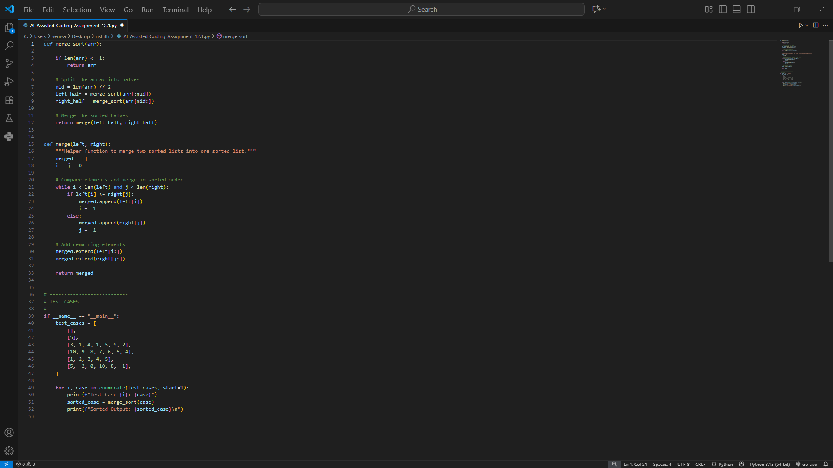  Output:  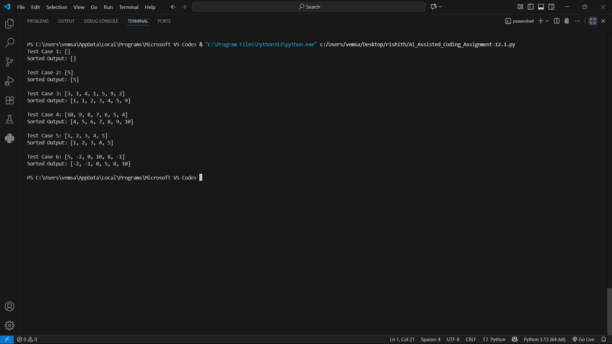  Task Description #2 (Searching – Binary Search with AI Optimization)  - Task: Use AI to create a binary search function that finds a target element in a sorted list.  - Instructions:  - Prompt AI to create a function binary_search(arr, target) returning the index of the target or -1 if not found.  - Include docstrings explaining best, average, and worst-case complexities.  - Test with various inputs.  - Expected Output:  - Python code implementing binary search with AI-generated comments and docstrings.  Prompt:  create a function binary_search(arr, target) returning the index of the target or -1 if not found and Include docstrings explaining best, average, and worst- case complexities and test with various inputs give Python code implementing binary search with AI- generated comments and docstrings.  Code:  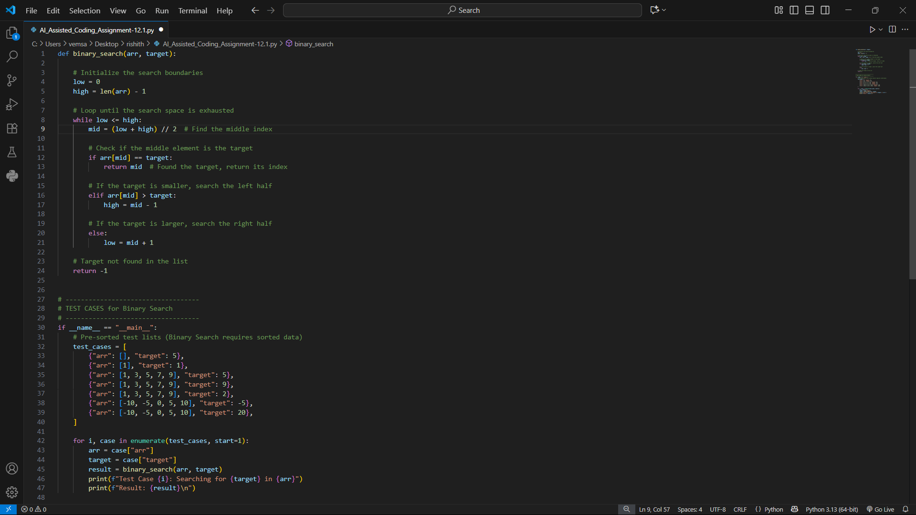  Output:  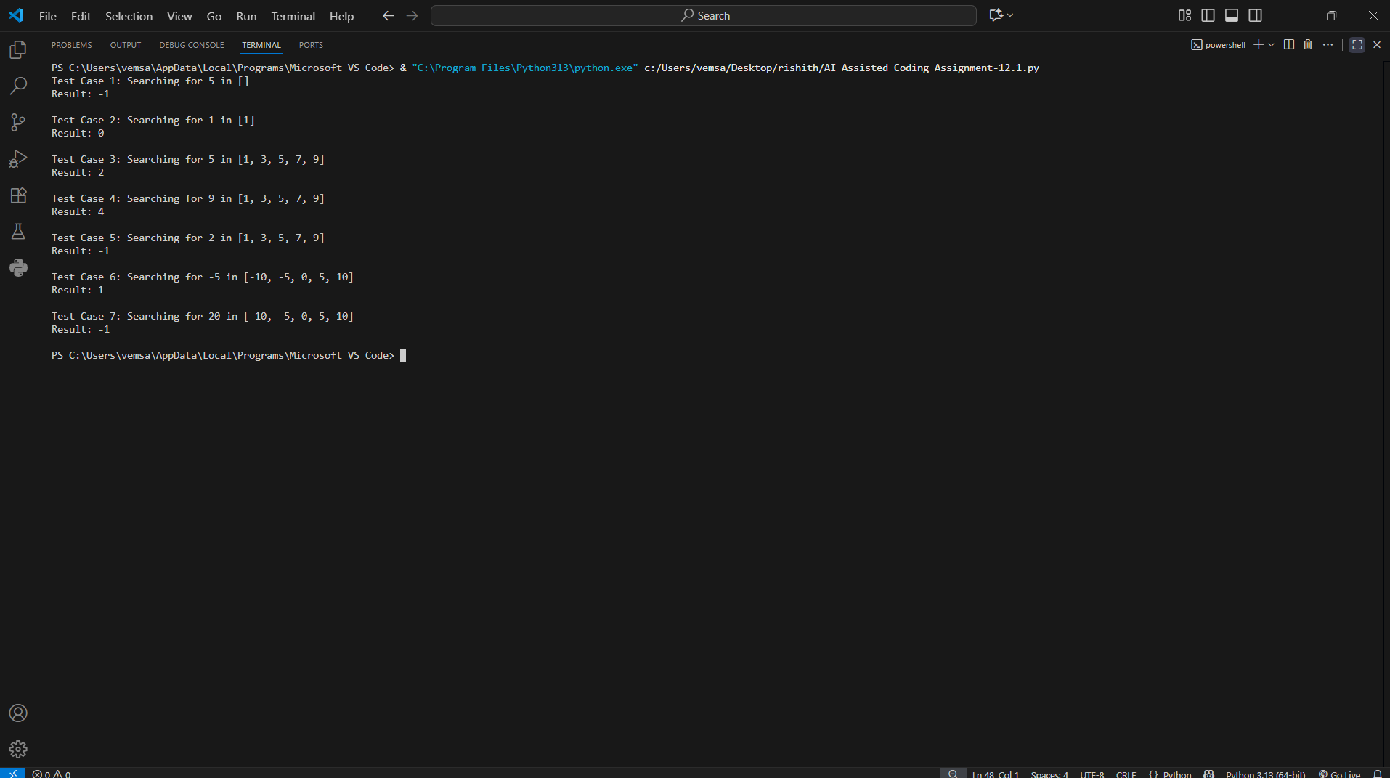  Task Description #3 (Real-Time Application – Inventory Management System)  - Scenario: A retail store’s inventory system contains thousands of products, each with attributes like product ID, name, price, and stock quantity. Store staff need to:  - Quickly search for a product by ID or name.  - Sort products by price or quantity for stock analysis.  - Task:  - Use AI to suggest the most efficient search and sort algorithms for this use case.  - Implement the recommended algorithms in Python.  - Justify the choice based on dataset size, update frequency, and performance requirements.  - Expected Output:  - A table mapping operation → recommended algorithm → justification.  - Working Python functions for searching and sorting the inventory.  Prompt:  Scenario: A retail store’s inventory system contains thousands of products, each with attributes like product ID, name, price, and stock quantity. Store staff need to: 1. Quickly search for a product by ID or name. 2. Sort products by price or quantity for stock analysis. and suggest the most efficient search and sort algorithms for this use case. Implement the recommended algorithms in Python. Justify the choice based on dataset size, update frequency, and performance requirements. and should give o A table mapping operation → recommended algorithm → justification. Working Python functions for searching and sorting the inventory.  Code:  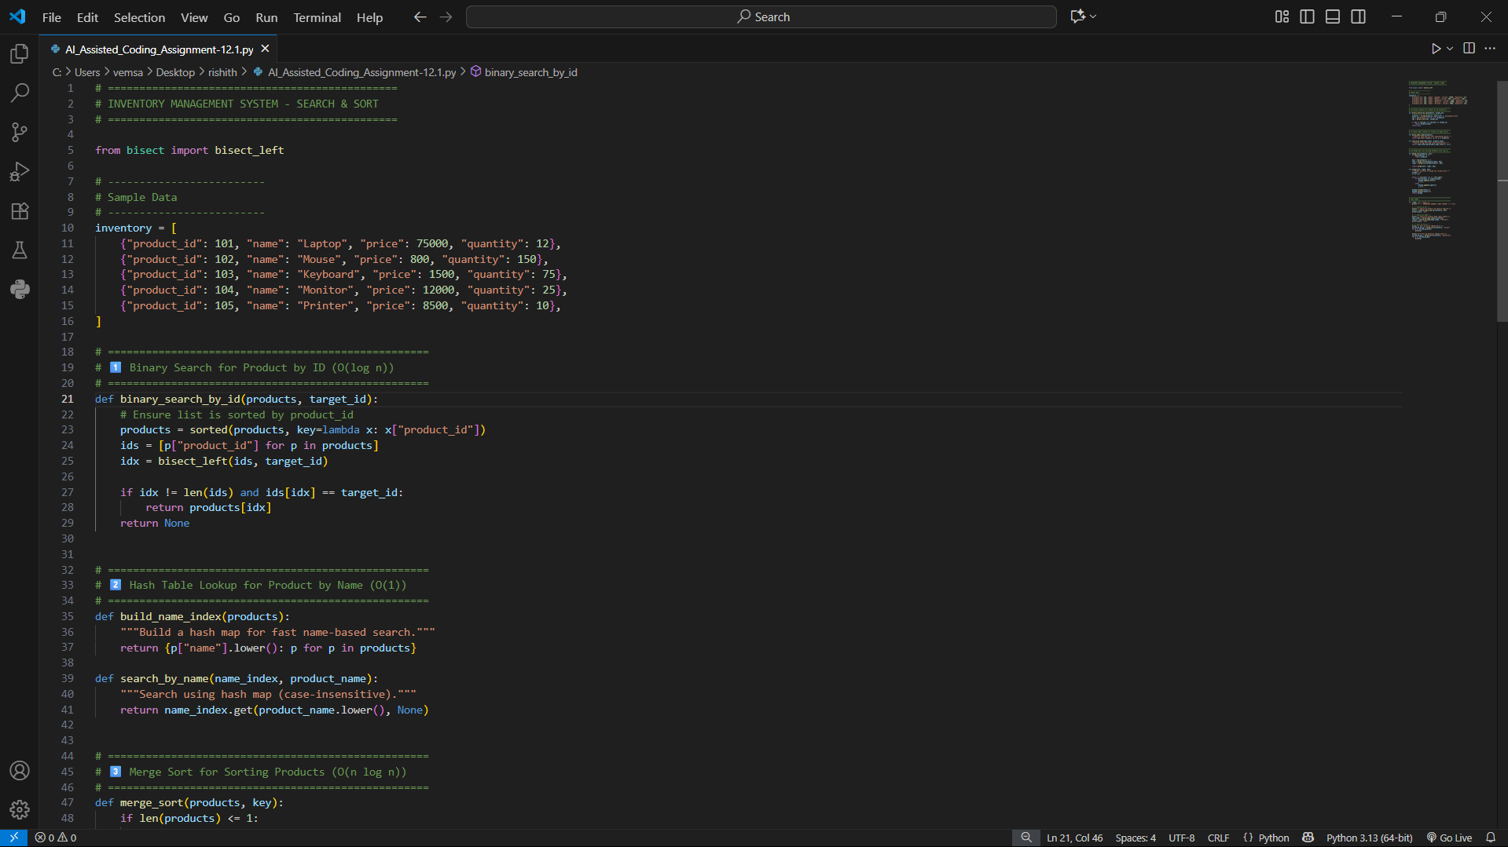  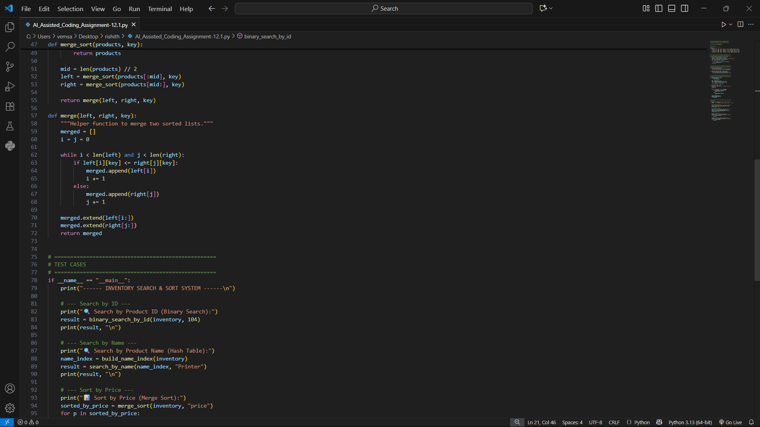  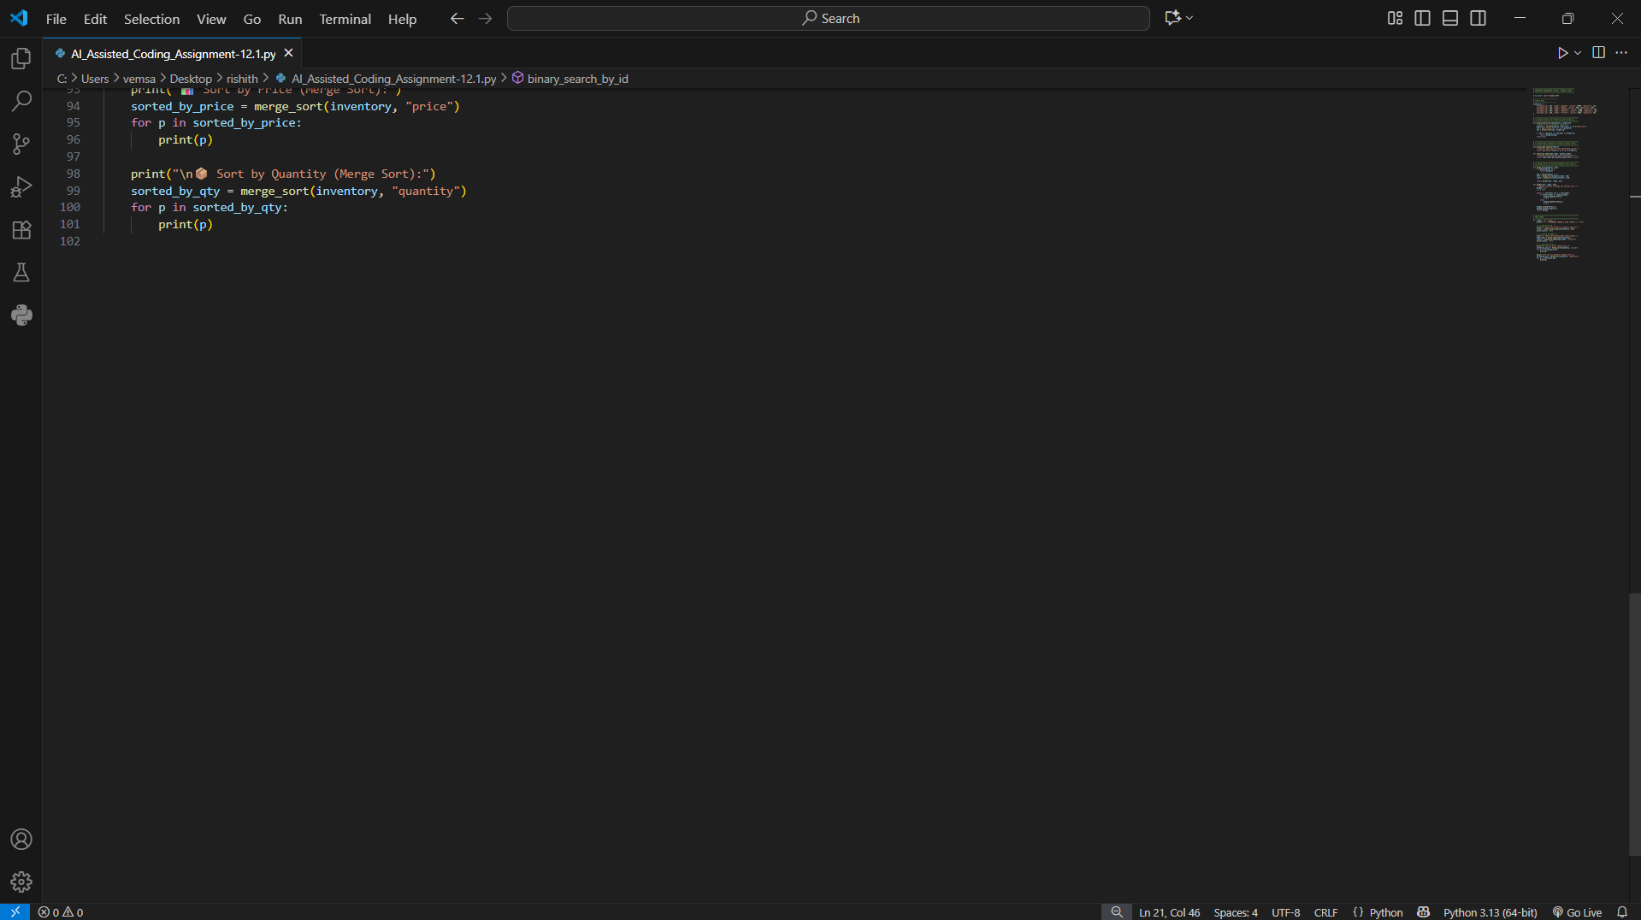  Output:  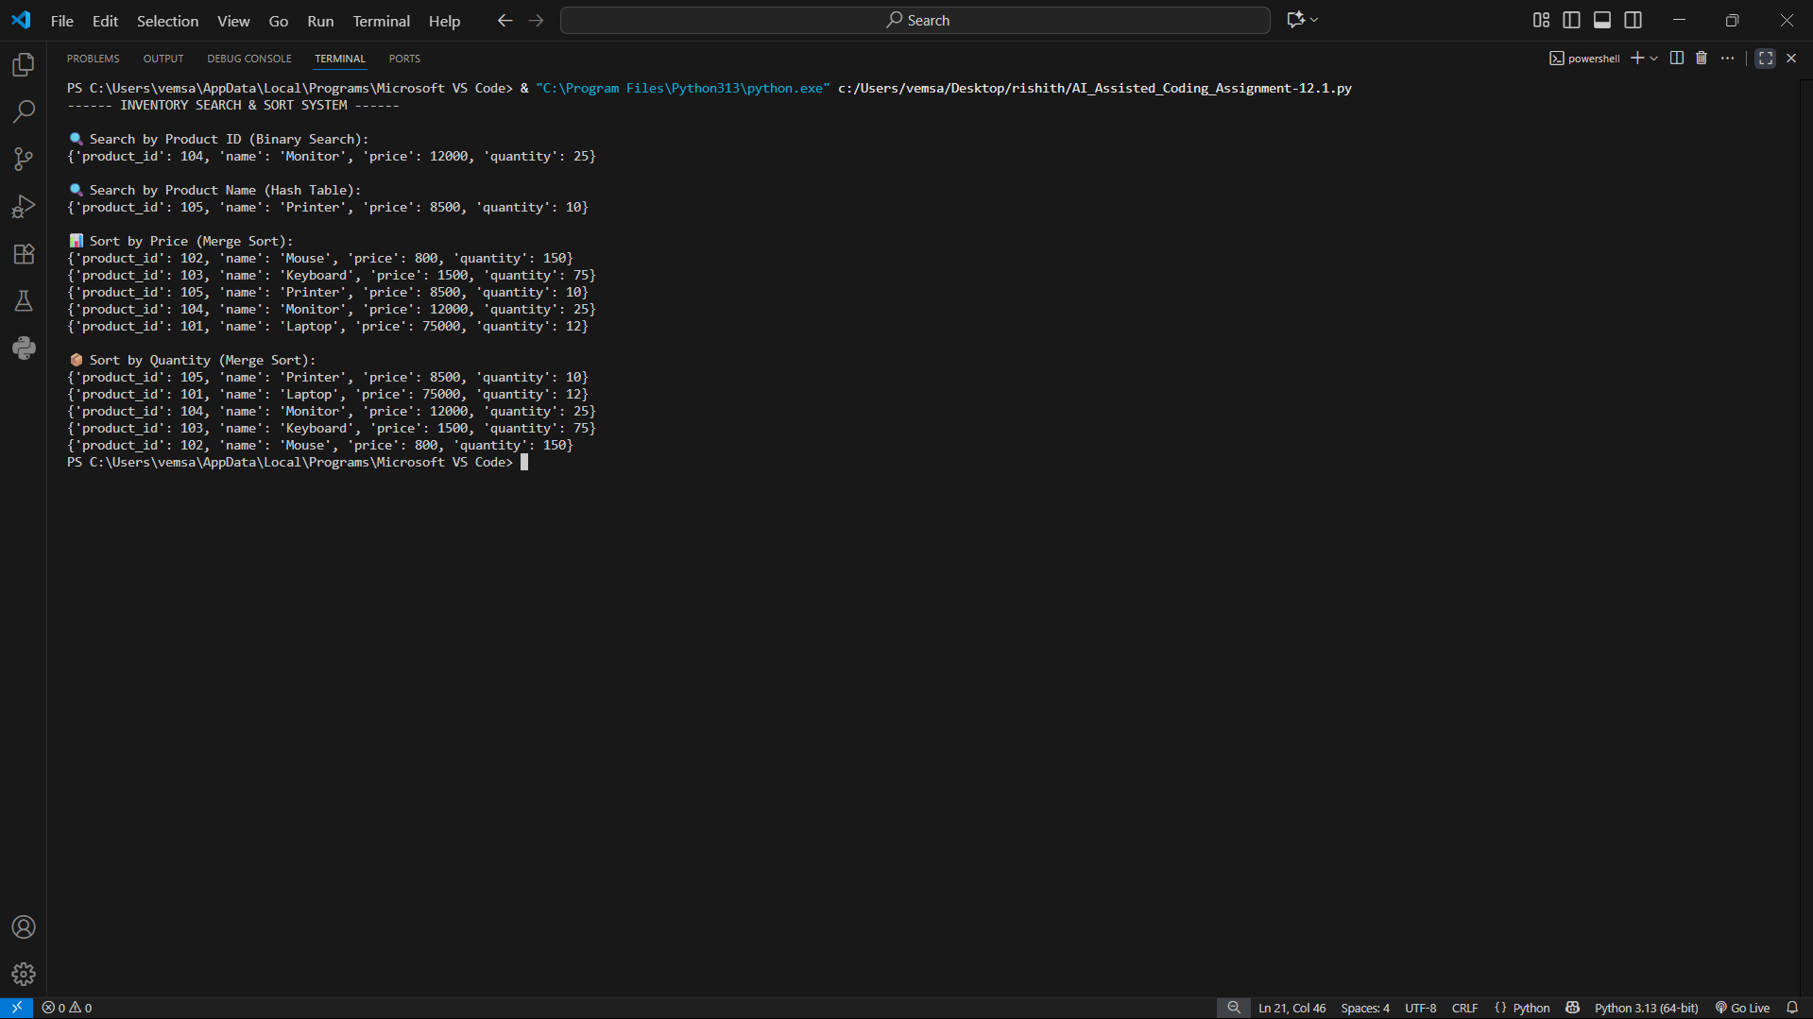  ✅Deliverables (For All Tasks)  - AI-generated prompts for code and test case generation.  - At least 3 assert test cases for each task.  - AI-generated initial code and execution screenshots.  - Analysis of whether code passes all tests.  - Improved final version with inline comments and explanation.  - Compiled report (Word/PDF) with prompts, test cases, assertions, code, and output. |  |  |  |  |  | Week6 - Monday

