Hepsiba Devara
2403A51L25
Batch-51
Experiment 6: AI-Based Code Completion
Topic: Classes, Loops, Conditionals (Python)
Task 1: Voting Eligibility Check (Conditionals)
Prompt used in AI tool:
Generate Python code to check voting eligibility based on age and citizenship.

Python Code:
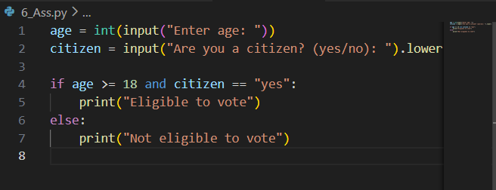
Output:
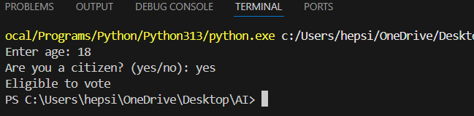
Explanation:
- age >= 18 → minimum voting age
- citizen == "yes" → must be a citizen
- and ensures both conditions are true
Task 2: Count Vowels and Consonants (Loops)
Prompt:
Generate Python code to count vowels and consonants in a string using a loop.
Python Code:
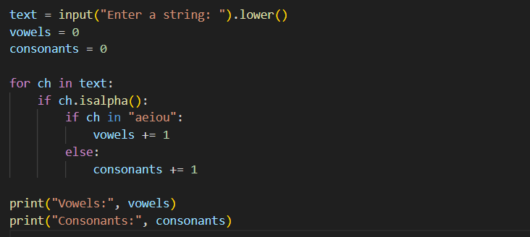
Output:
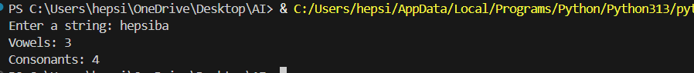
Explanation:
for ch in text → loop through characters
isalpha () → ignores spaces/numbers
Counts vowels and consonants separately

Task 3: Library Management System (Class + Loop + Conditions)
Prompt:
Generate a Python program for a library management system using classes, loops, and conditional statements.

Python code:
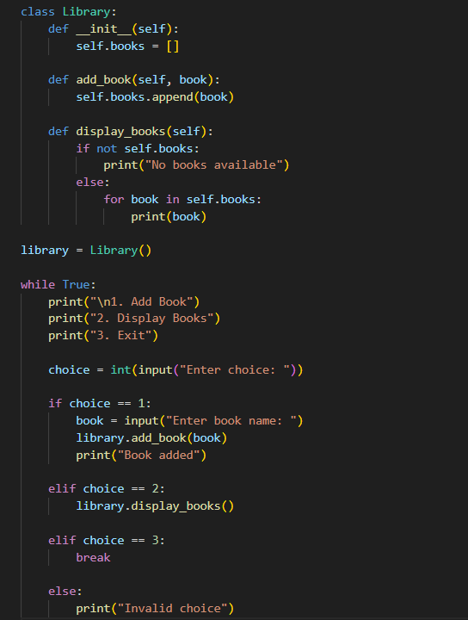
Output:
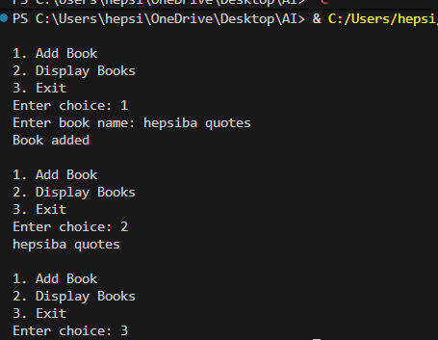
Explanation:
AI-based code completion helped generate a structured program quickly.
The logic was correct, but variable names and menu clarity were improved manually.
AI increases productivity but human review is essential.

Task 4: Attendance Management System (Class + Loop)
Prompt:
Generate a Python class to mark and display student attendance using loops.
Python code:
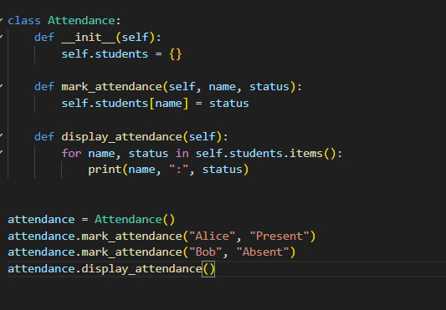

Output:
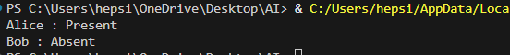

Explanation:
- Dictionary stores student → attendance
- Loop marks multiple students
- Simple and efficient

Task 5: ATM Menu System (Loops + Conditionals)
Prompt:
Generate a Python program using loops and conditionals to simulate an ATM menu.

Python code:
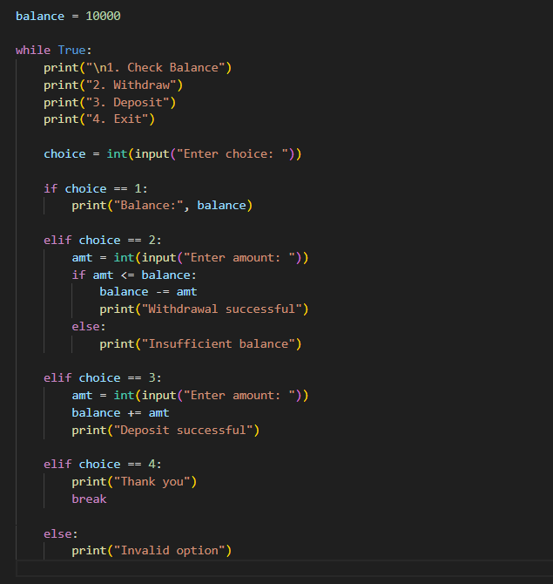
Output:
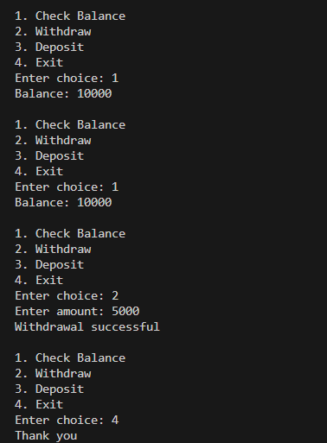
Explanation:
The program effectively simulates real-world ATM operations.
Conditional statements and loops are used correctly.
The system handles invalid inputs and balance conditions properly.

