SchoolofComputerScienceandArtificialIntelligence
LabAssignment#12.5

Program :B.Tech(CSE)
Specialization :
Course Title :AIAssistedCoding
CourseCode :23CS002PC304
Semester II
Academic Session : 2025-2026 Name of Student :J harshithyadav
Enrollment No. : 2403A51L49
Batch No 52
Date :20/02/26

Task-1(Sorting–MergeSortImplementation)
Prompt:Createafunctionmerge_sort(arr)thatsortsalistinascendingorder.includetime complexity and space complexity in the function docstring. Verify the generated code with test cases.

Code:
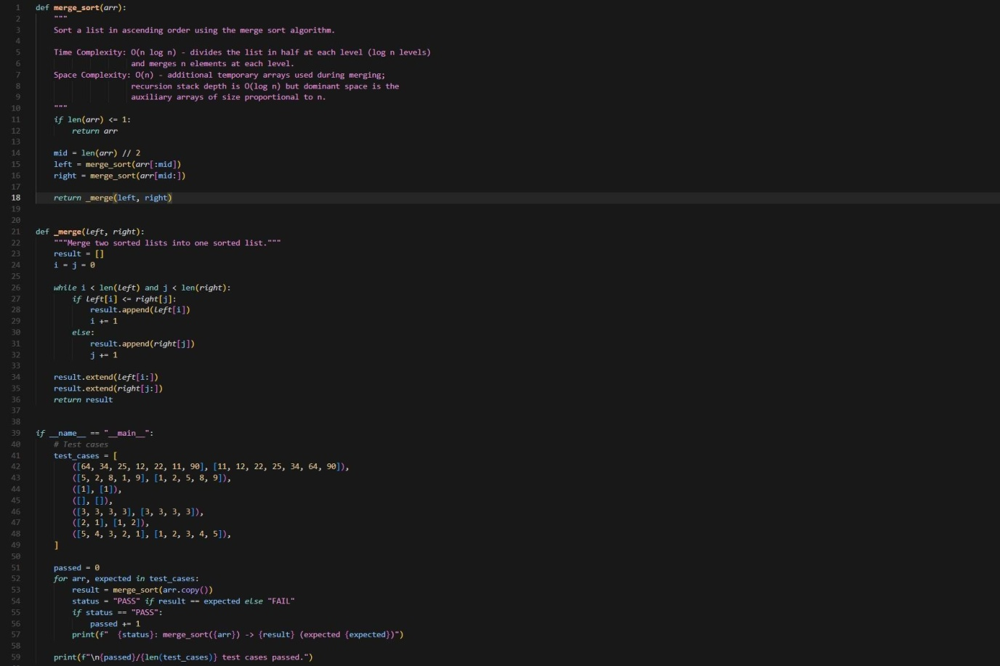

Output:

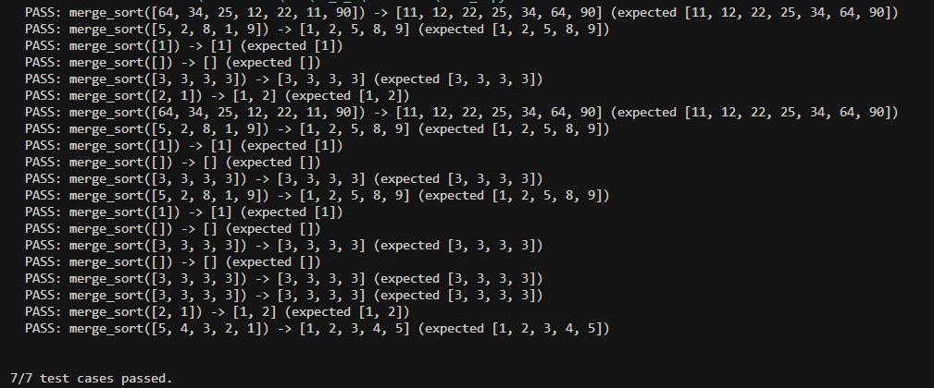

Task-2(Searching–BinarySearchwithAI Optimization):

Prompt:Createafunctionbinary_search(arr,target)returningtheindexofthetargetor-1if notfound.Includedocstringsexplainingbest, average,andworst-casecomplexities.Testwith various inputs.

Code:
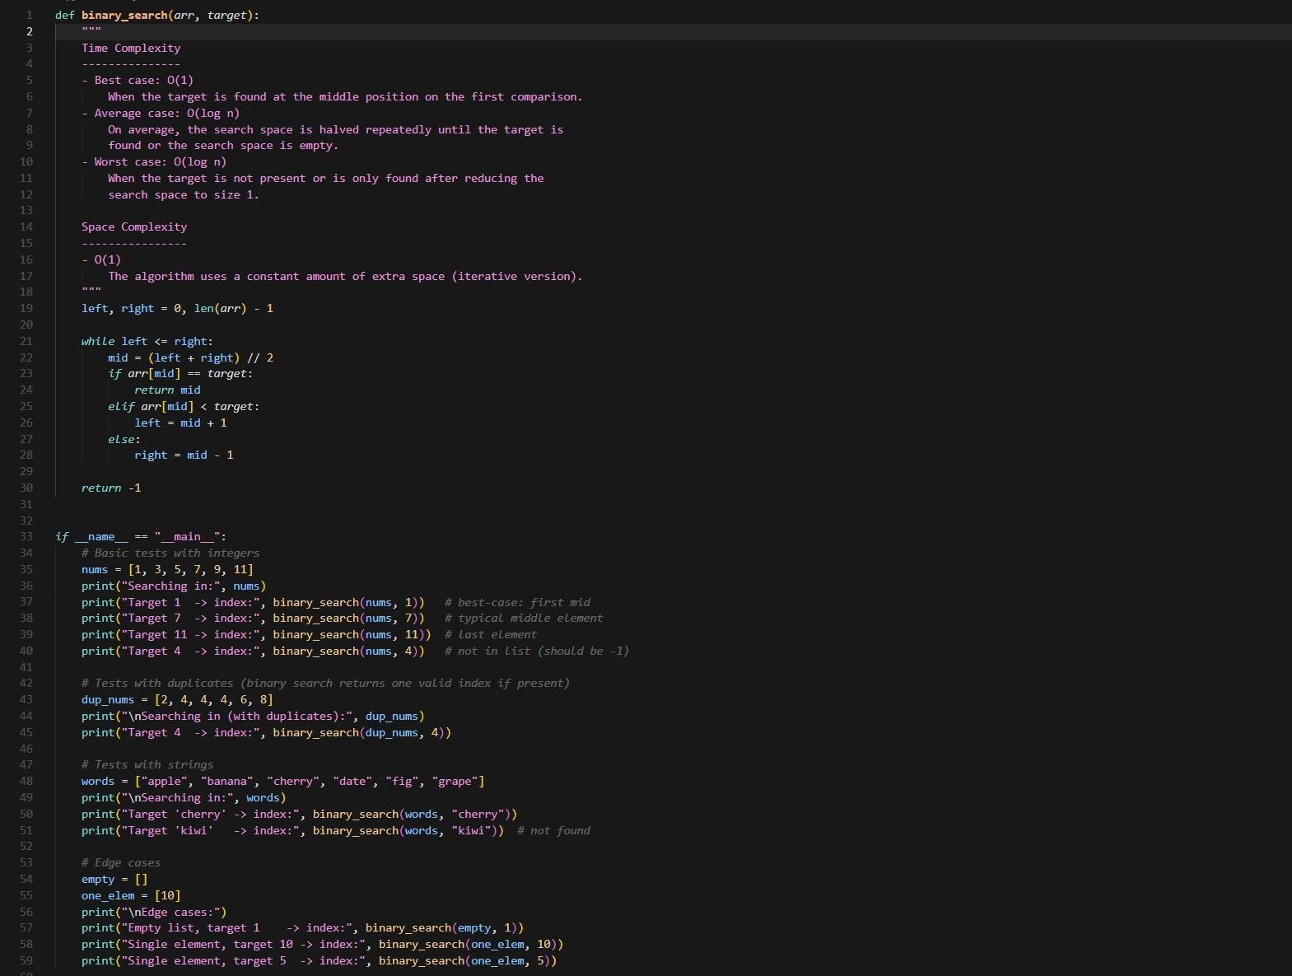

Output:

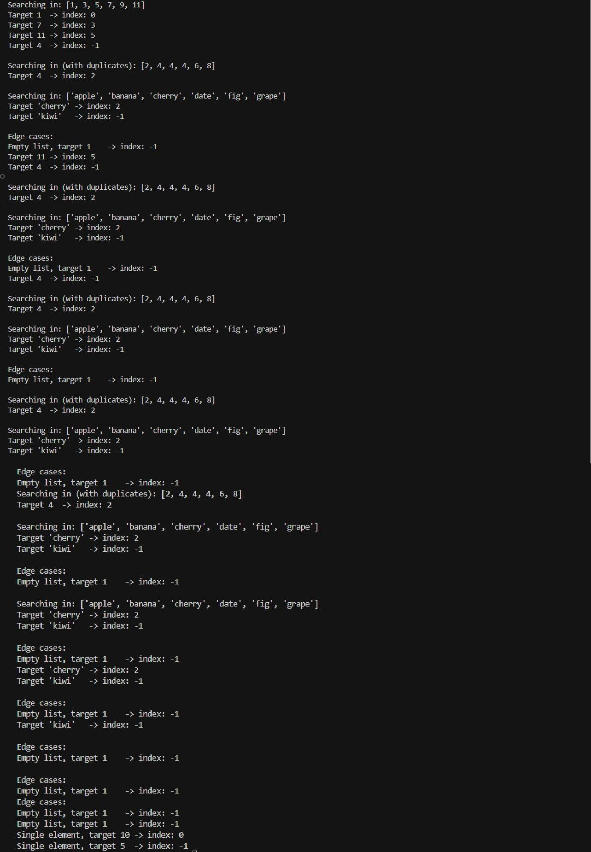

Task-3:SmartHealthcareAppointmentSchedulingSystem

Prompt:
A healthcare platform maintains appointment records containing appointmentID,patientname,doctorname,appointmenttime,and consultation fee. The system needs to:
- SearchappointmentsusingappointmentID.
- Sortappointmentsbasedontimeorconsultationfee.

Tasks
  - recommendsuitablesearchingandsorting algorithms.
  - Justifytheselectedalgorithms.
  - Implementthealgorithmsin Python.

Code:
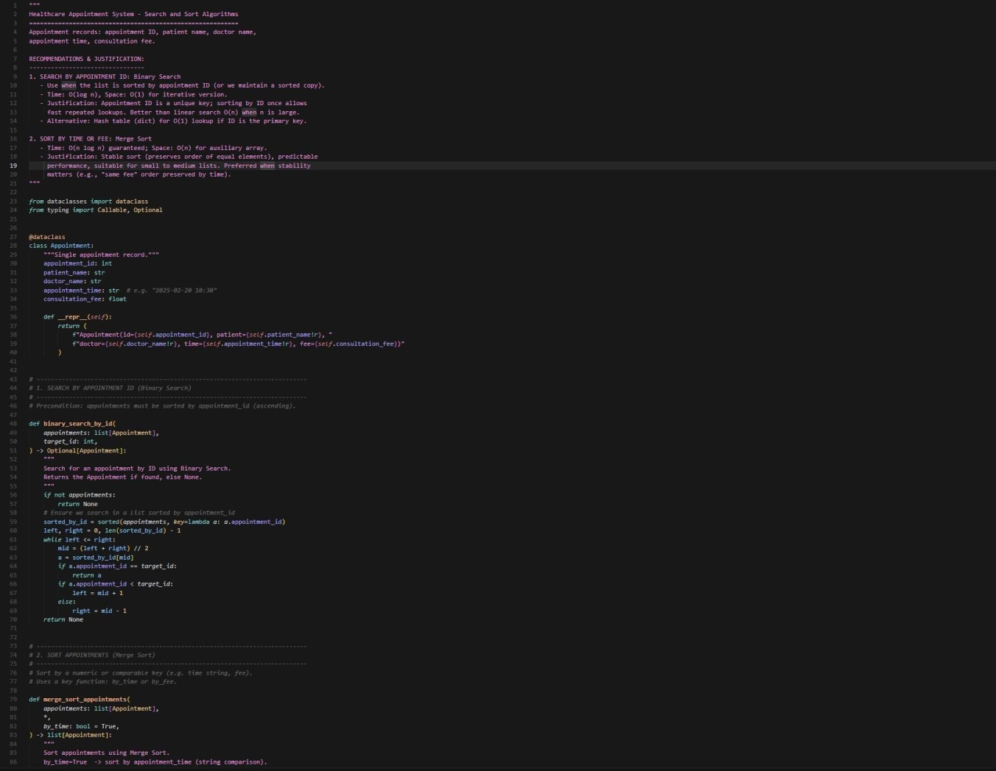

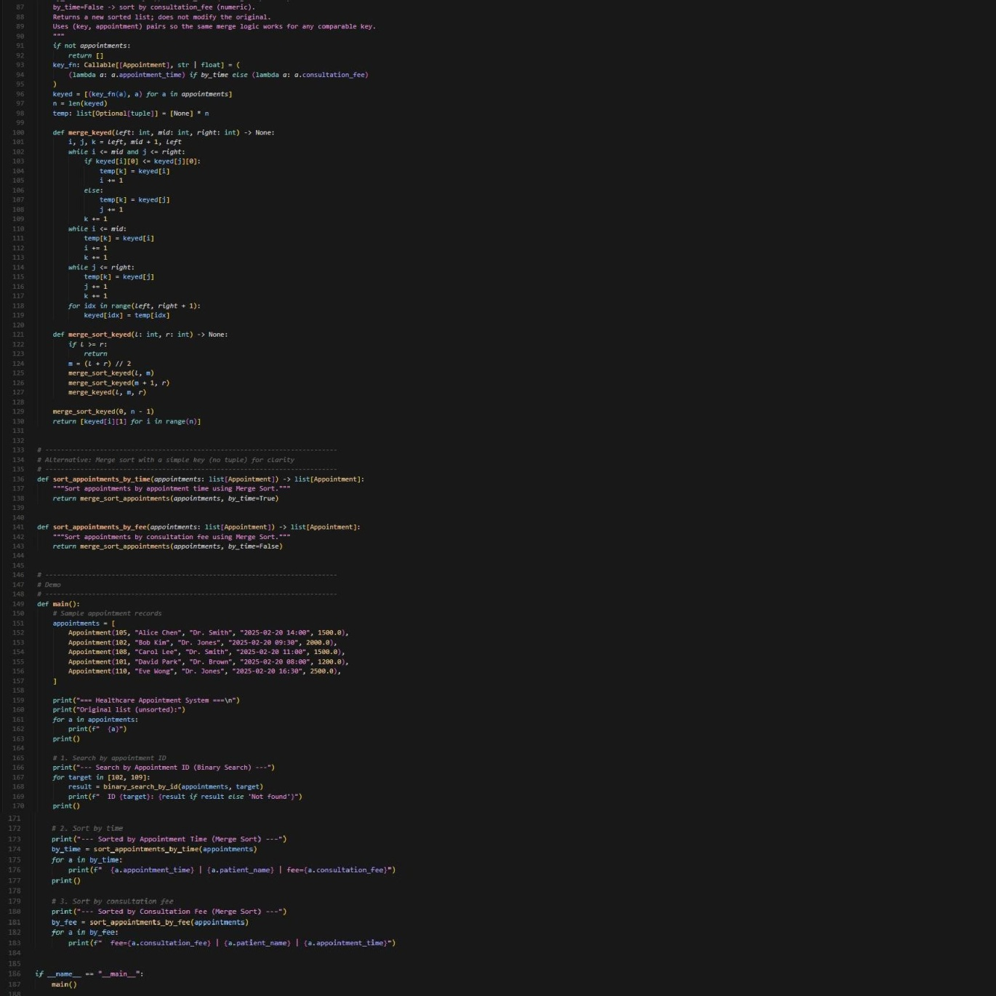

Output:
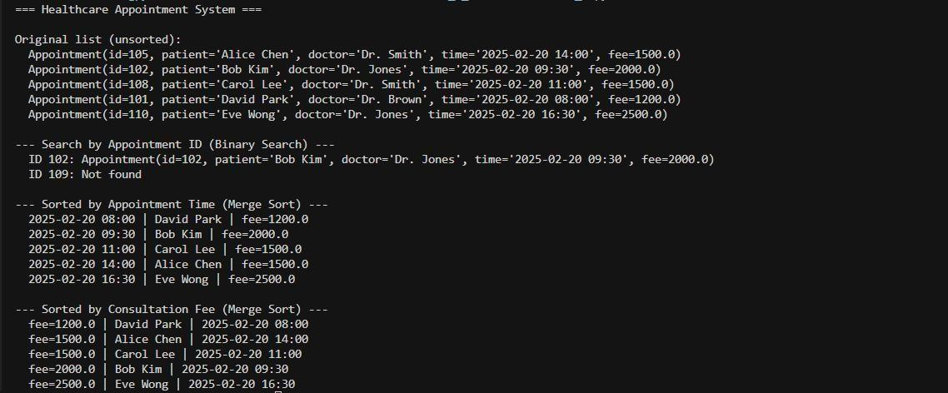

Task-4:RailwayTicketReservationSystemScenario

Prompt:
ArailwayreservationsystemstoresbookingdetailssuchasticketID,passengername,train number, seat number, and travel date. The system must:
- SearchticketsusingticketID.
- Sortbookingsbasedontraveldateorseatnumber.

Tasks
  - Identifyefficientalgorithms.
  - Justifythealgorithmchoices.
  - Implementsearchingandsortingin Python.

Code:
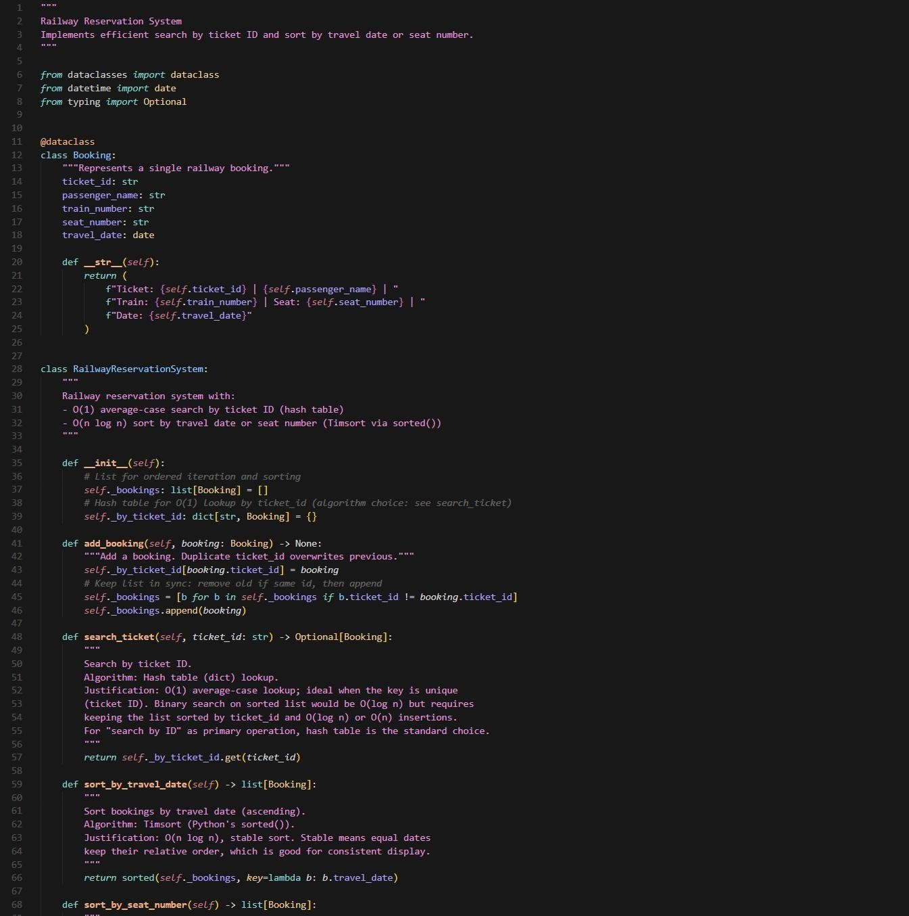

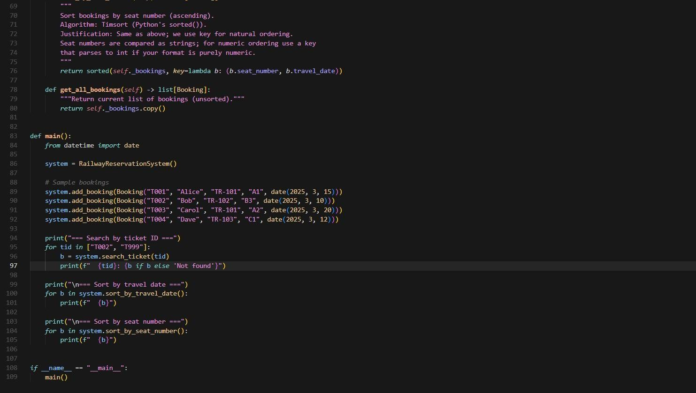

Output:
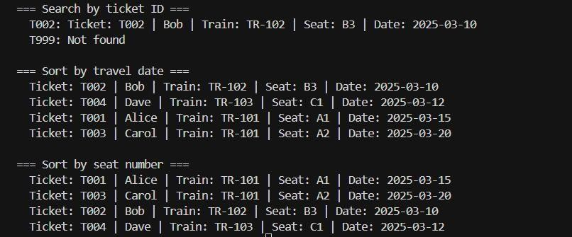

Task-5:SmartHostelRoomAllocationSystem

Prompt:
AhostelmanagementsystemstoresstudentroomallocationdetailsincludingstudentID, room number, floor, and allocation date. The system needs to:
- Searchallocationdetailsusingstudent ID.
- Sortrecordsbasedonroomnumberorallocationdate.

Tasks
  - suggestoptimizedalgorithms.
  - Justifytheselections.
  - Implementthesolutionin Python.

Code:
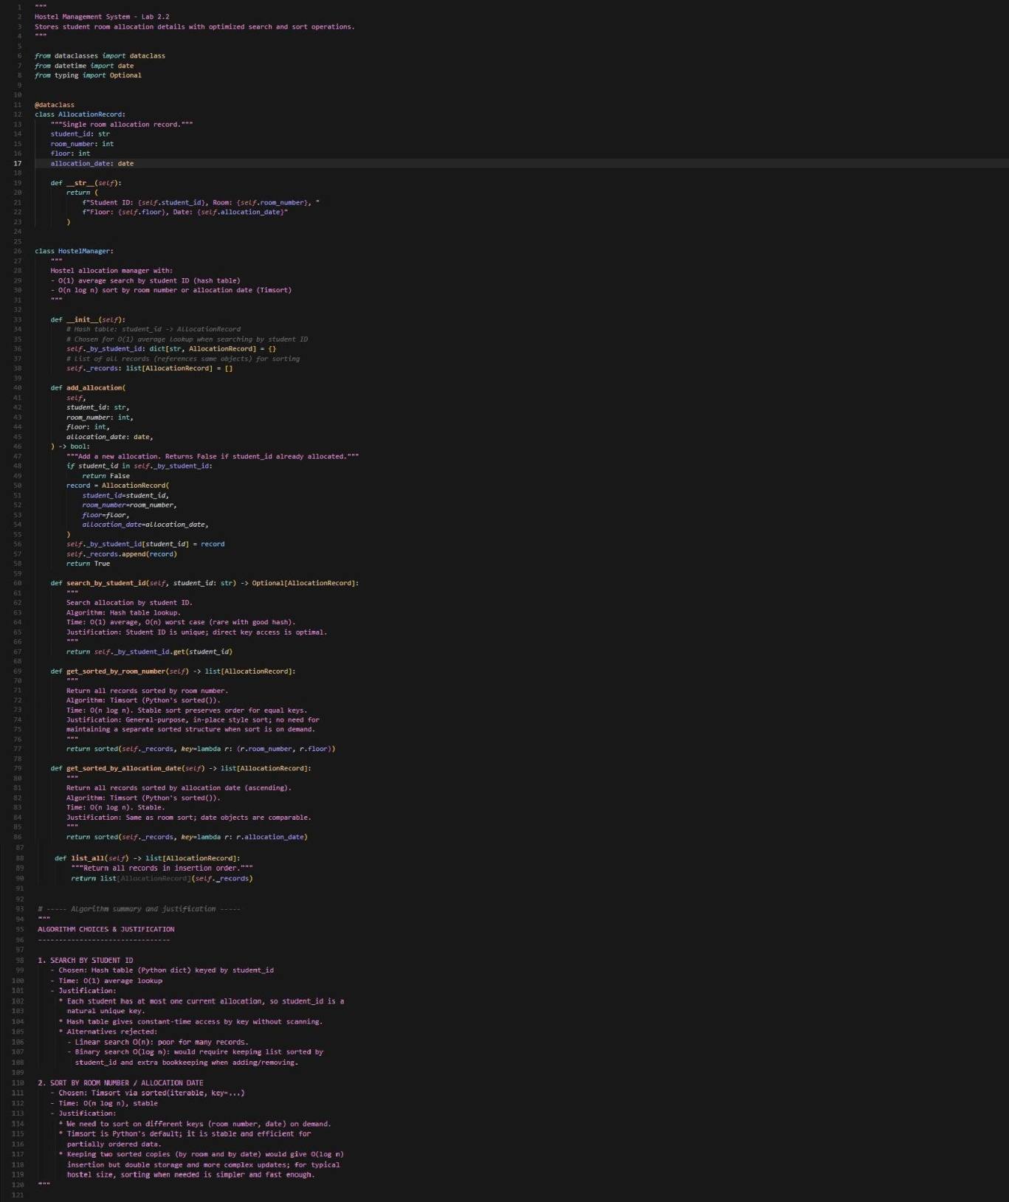

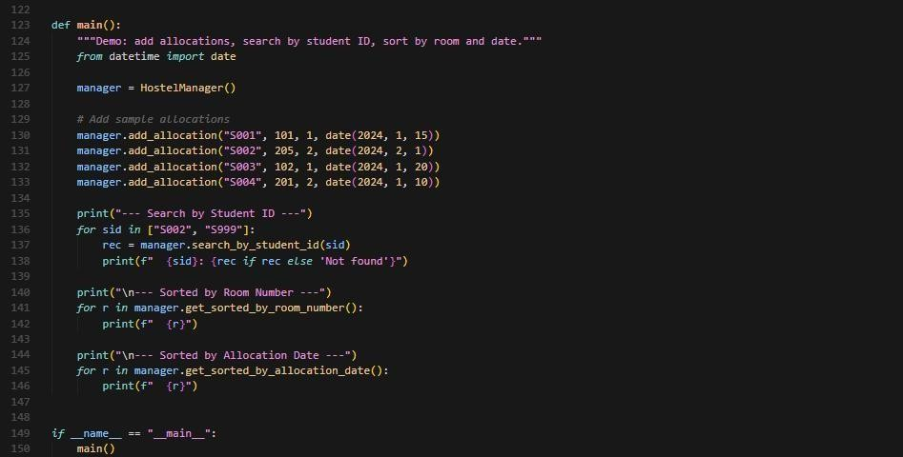

Output:
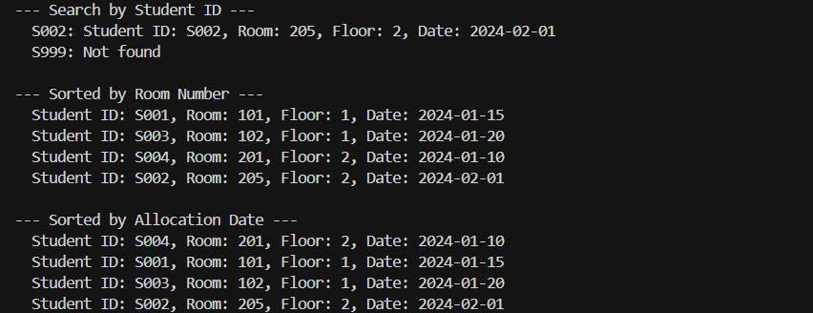

Task-6:OnlineMovieStreamingPlatform

Prompt:
AstreamingservicemaintainsmovierecordswithmovieID,title,genre,rating,andrelease year. The platform needs to:
- Searchmovies by movieID.
- Sortmoviesbasedonratingorreleaseyear.

Tasks
  - Recommendsearchingandsortingalgorithms.
  - Justifythechosen algorithms.
  - ImplementPythonfunctions.

Code:

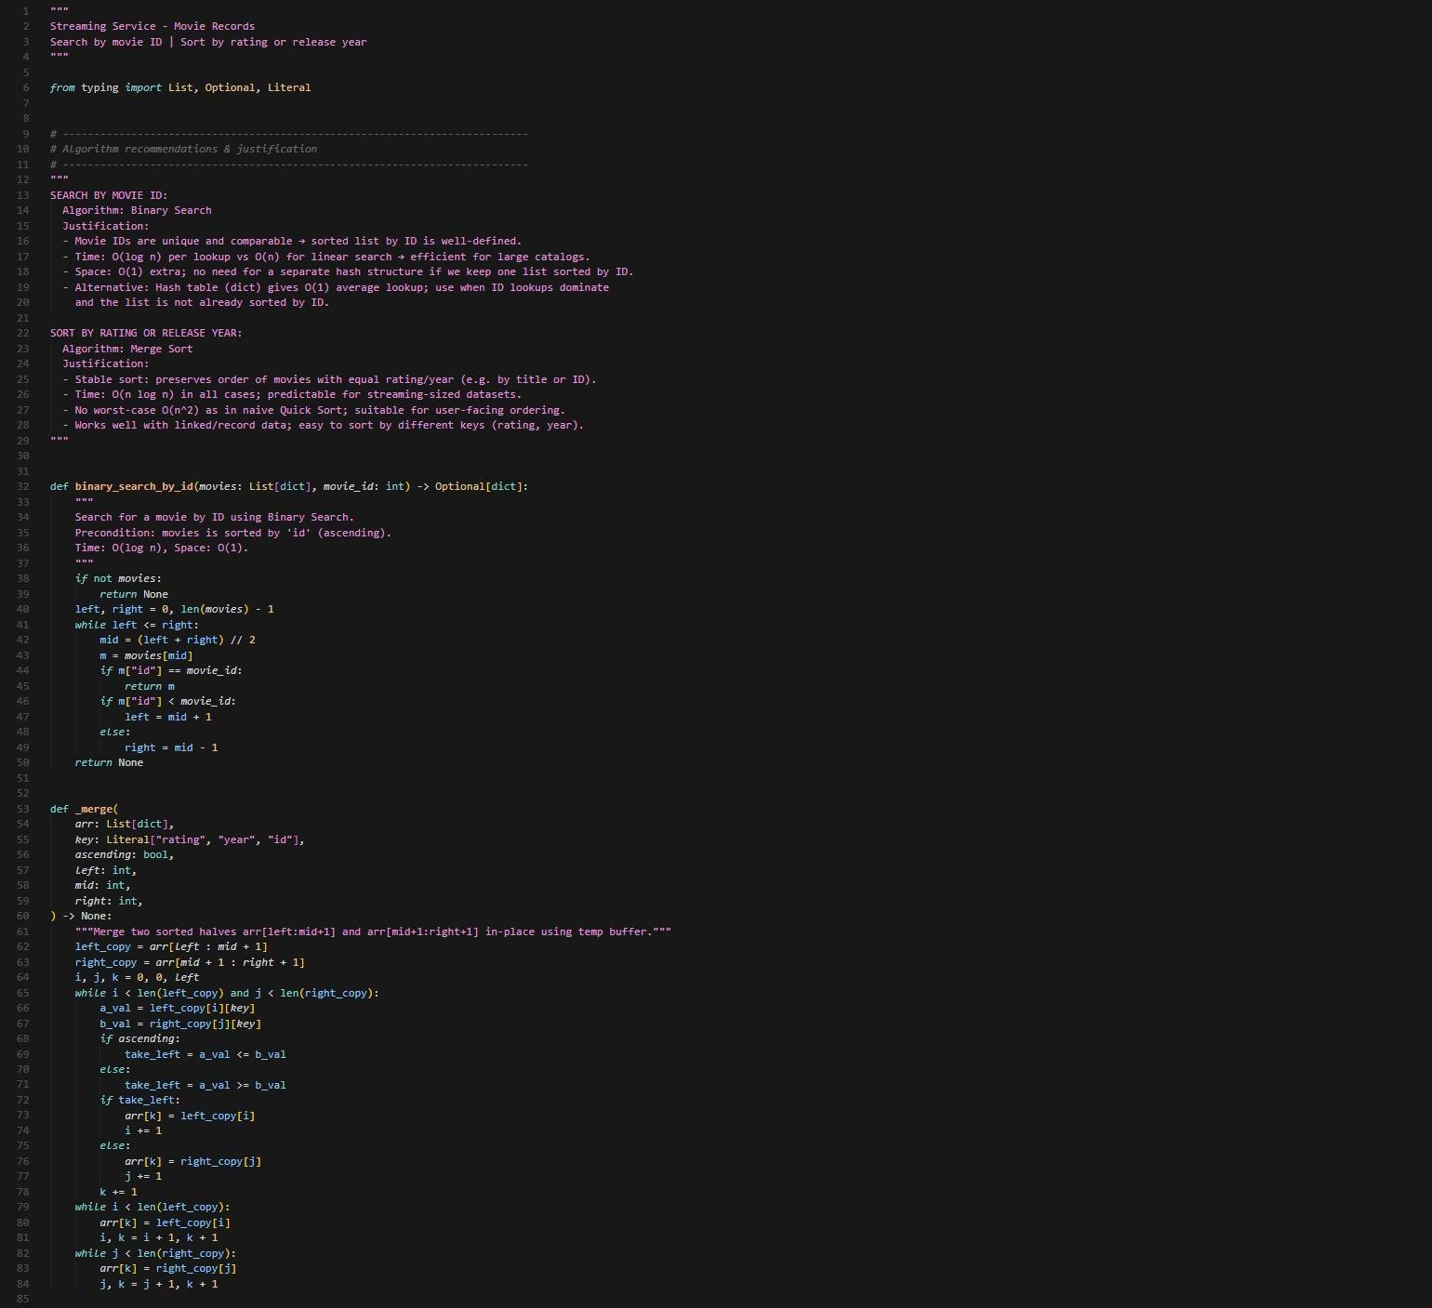

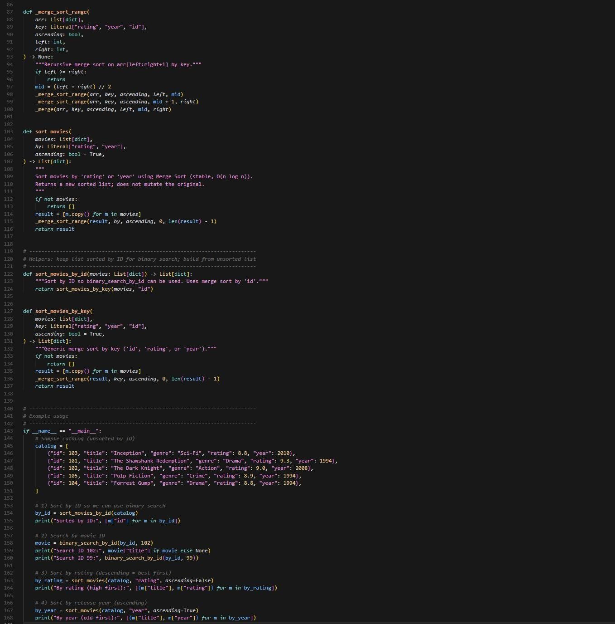

Output:

Task-7:SmartAgricultureCropMonitoringSystem

Prompt:
AnagriculturemonitoringsystemstorescropdatawithcropID,cropname,soilmoisture level, temperature, and yield estimate. Farmers need to:
- Searchcrop detailsusingcrop ID.
- Sortcropsbasedonmoistureleveloryieldestimate.

Tasks
  - usereasoning toselect algorithms.
  - Justifyalgorithmsuitability.
  - Implementsearchingandsortingin Python.

Code:
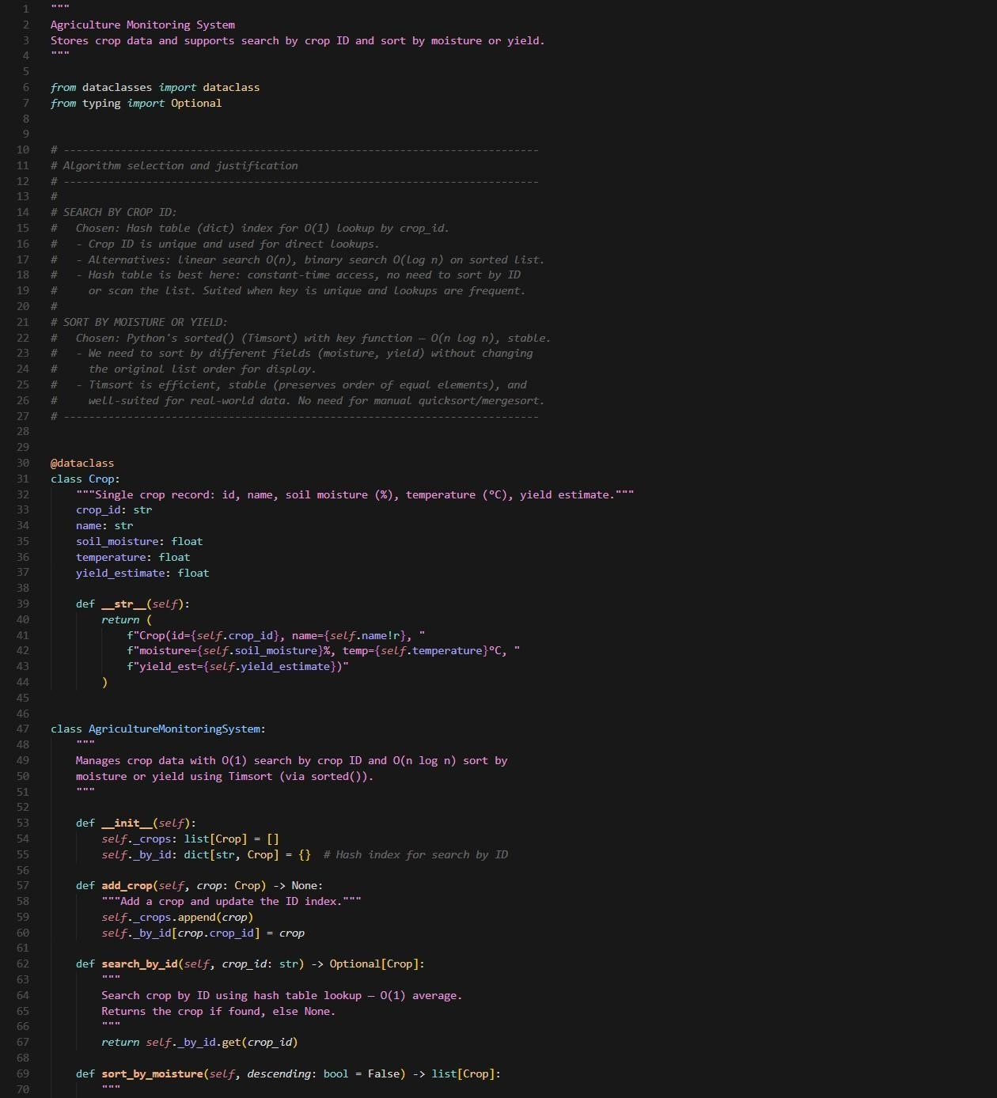

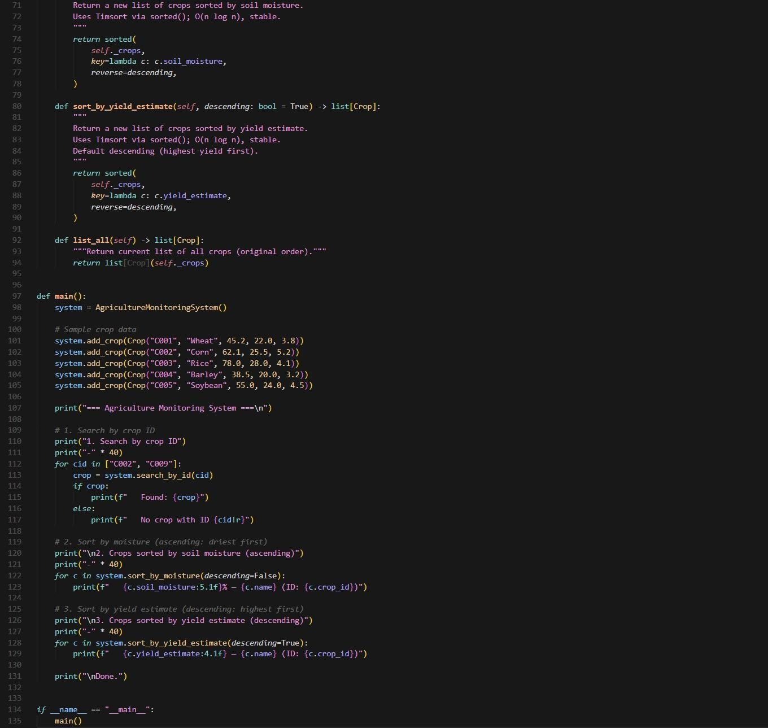

Output:
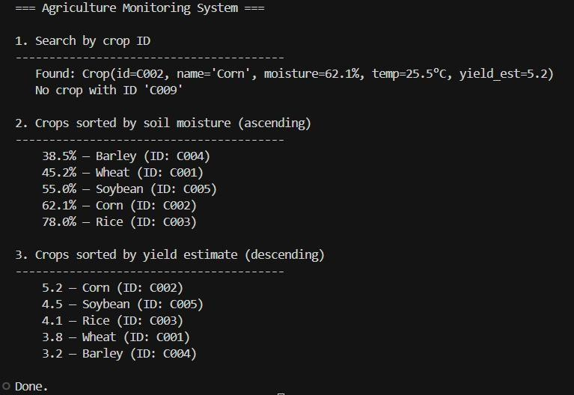

Task-8:AirportFlightManagementSystem

Prompt:
AnairportsystemstoresflightinformationincludingflightID,airlinename,departuretime, arrival time, and status. The system must:
- SearchflightdetailsusingflightID.
- Sortflightsbasedondeparturetimeorarrivaltime.

Tasks
  - recommendalgorithms.
  - Justifythealgorithmselection.
  - Implementsearchingandsorting logicin Python.

Code:

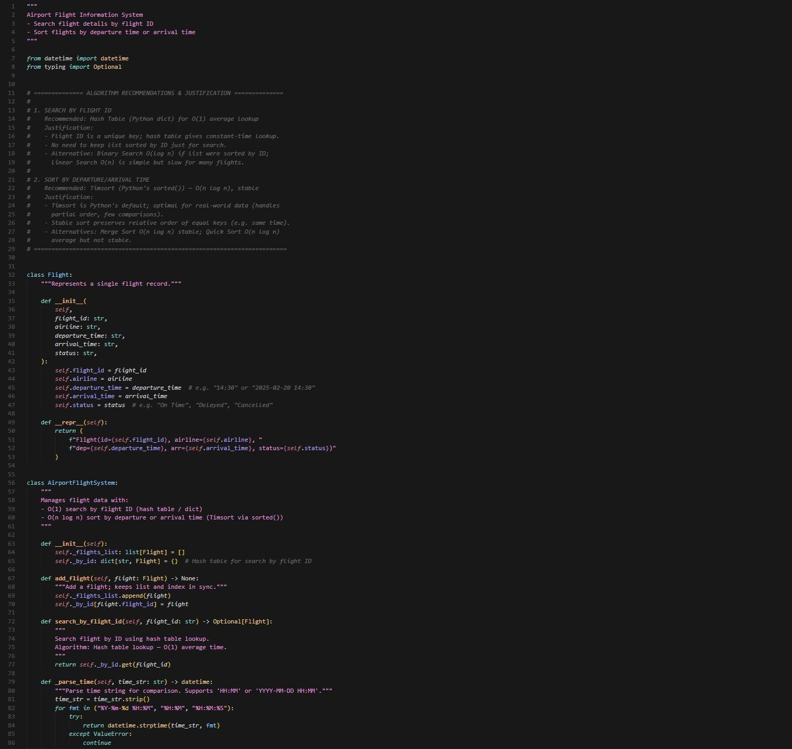

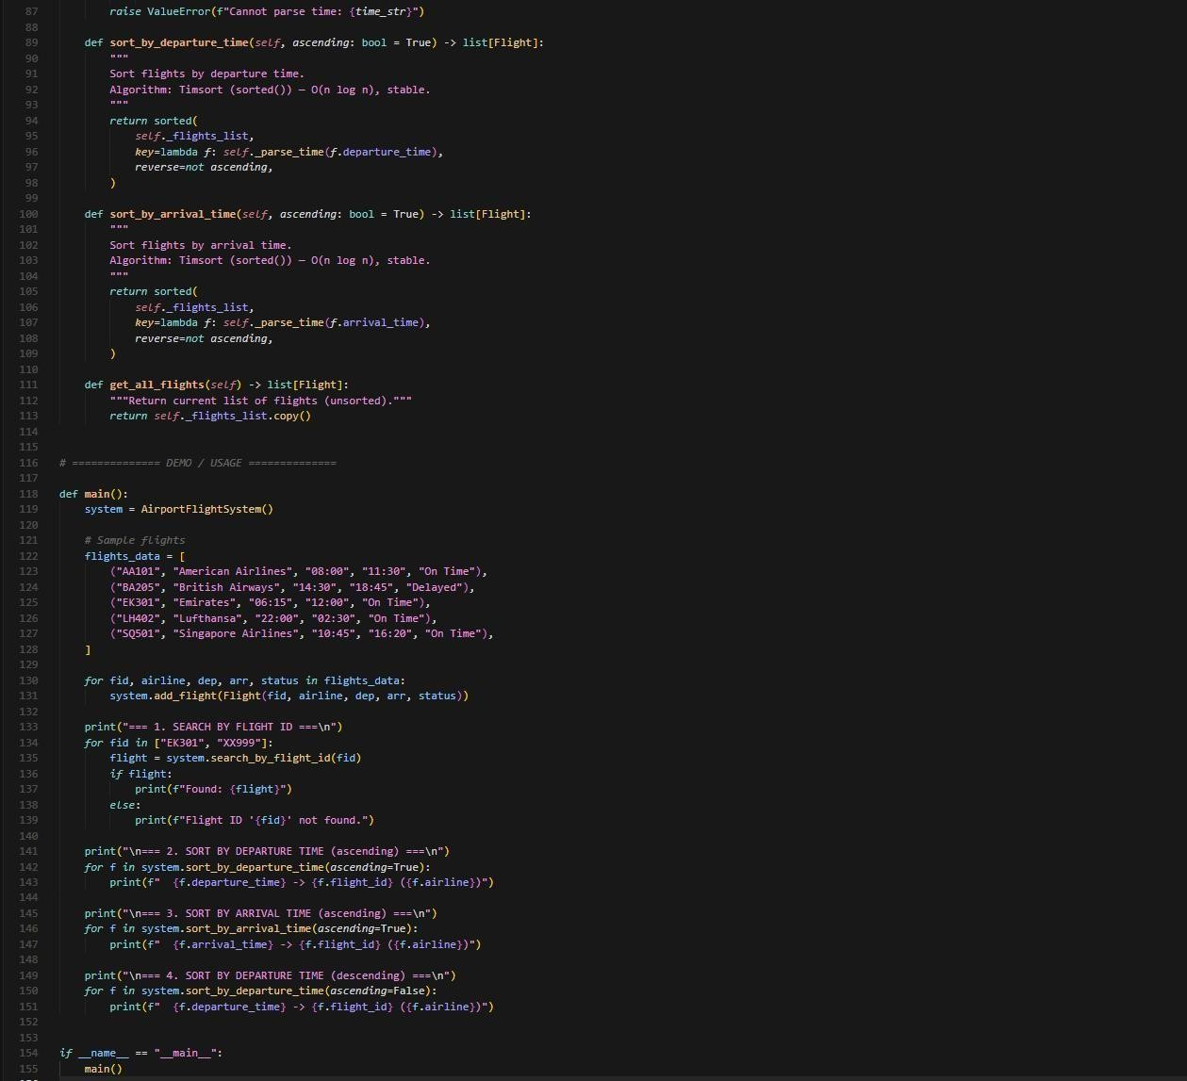

Output:
