**AI ASSITED CODING**

**ENROLLMENT NUMBER :** 2403A52013

**Name of the Student :** ALUWALA SHARANYA

**BATCH : B02**

**ASSIGNMENT : 9.3**

**TASK DESCRIPTION:**

Write python function to return sum of even and odd numbers in the given list.  
• Incorporate manual docstring in code with Google Style  
• Use an AI-assisted tool (e.g., Copilot, Cursor AI) to generate a docstring describing  
the function.  
• Compare the AI-generated docstring with your manually written one.

**Prompt:**

Write a python function to find sum of odd and even numbers separately from a list.Where list elements are user defined without any comments involving comments or Doctstrings.

CODE:

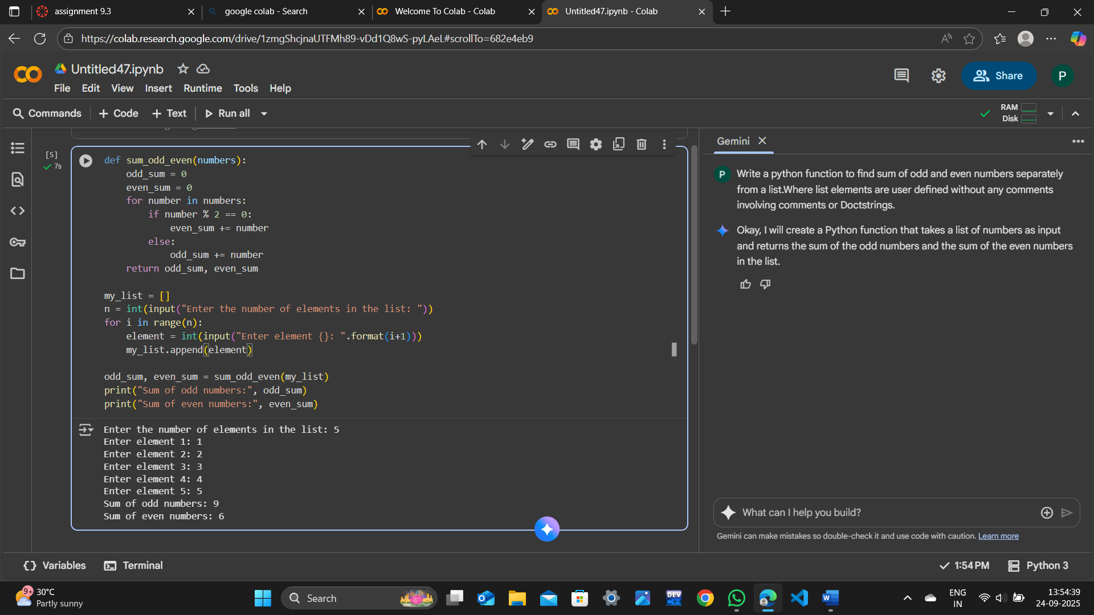

Incorporate manual docstring in code with Google Style

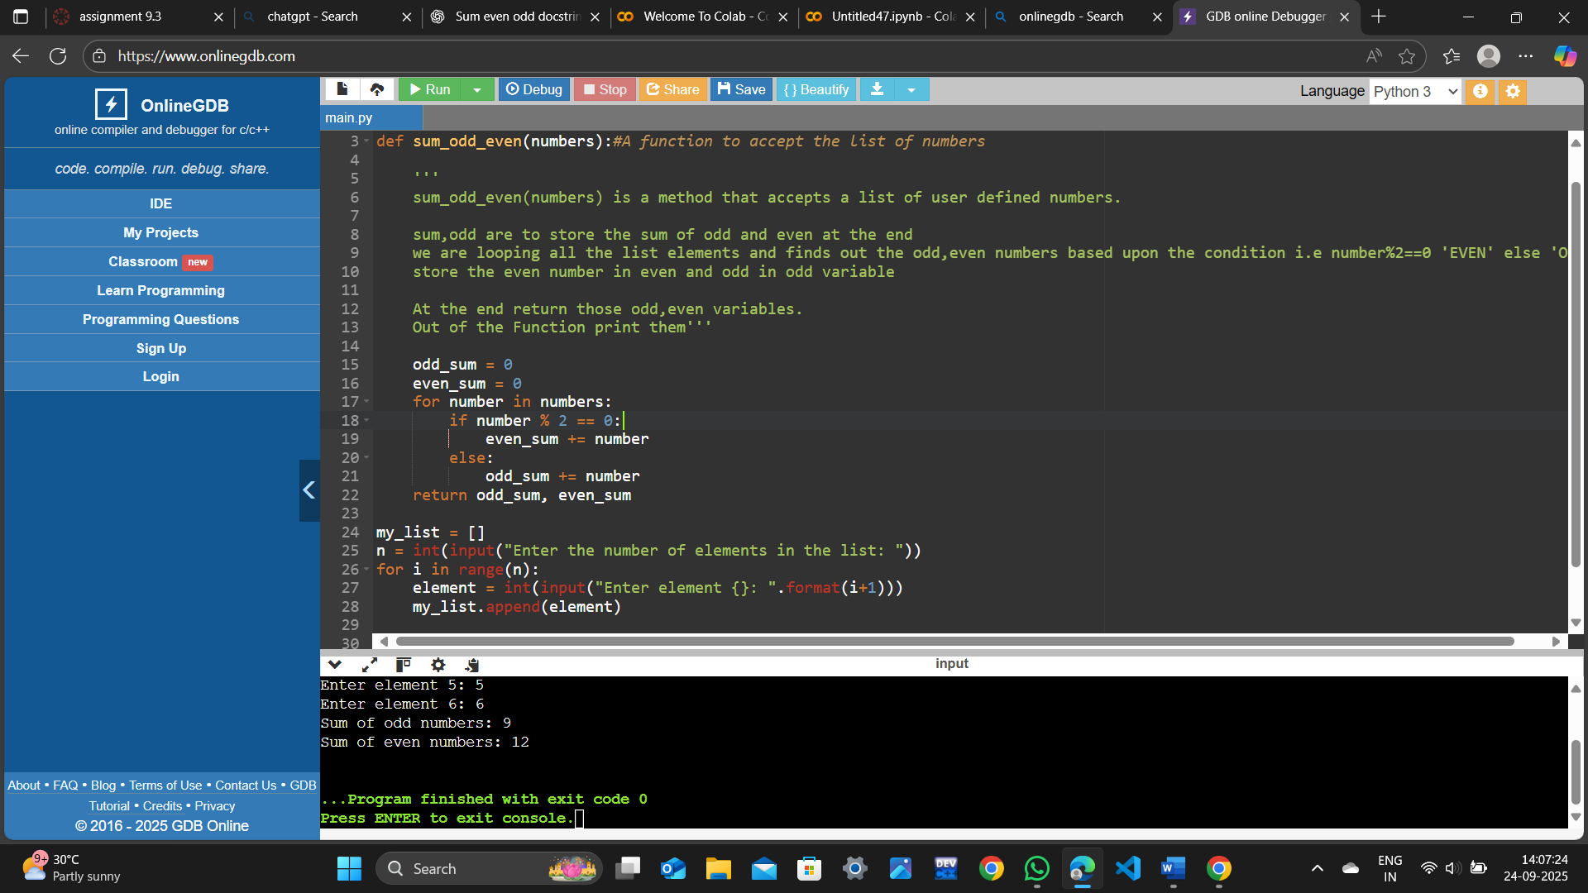

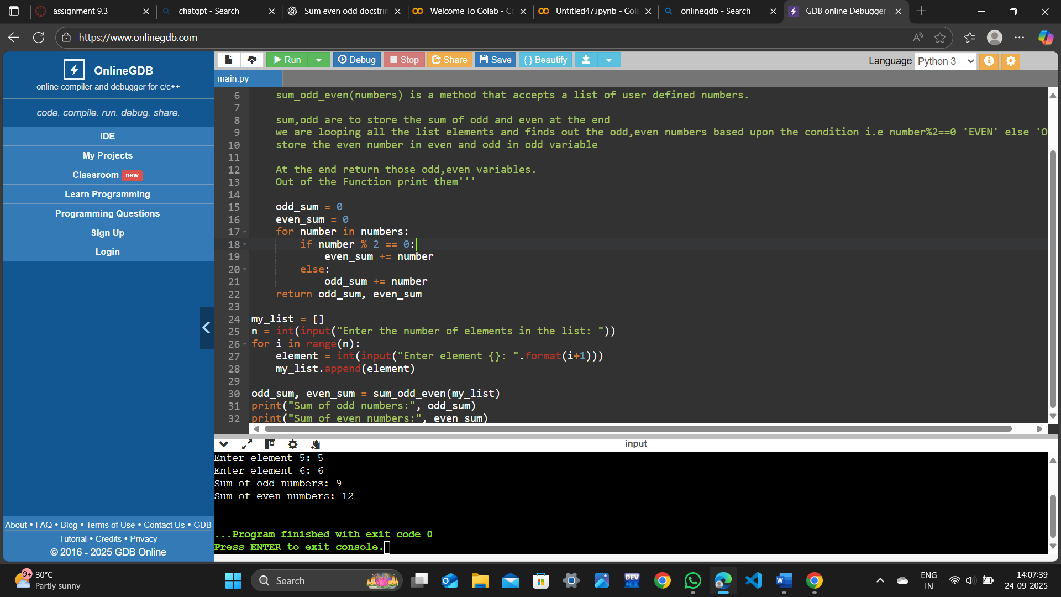

**Use an AI-assisted tool (e.g., Copilot, Cursor AI) to generate a docstring describing  
the function.**

**PROMPT:**

For the code that is been generated by You,Include docstrings in it

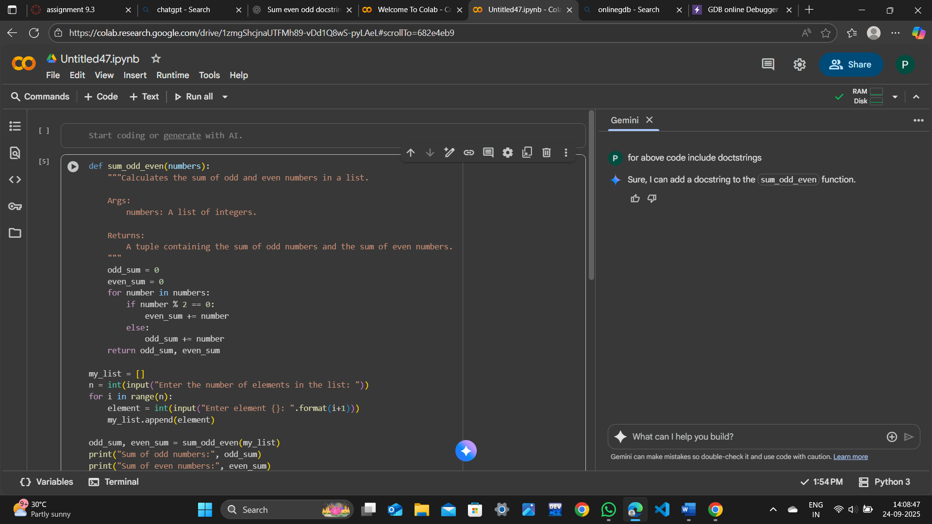

**OBSERVATION:**  
**Compare the AI-generated docstring with your manually written one**.

On Comparision of the Docstrings of mine and AI tool i.e Gemini.Mine is better and understandable by beginers,where as gemini it is a little bit terminology is involved.

**TASK DESCRIPTION-2**

**Write python program for sru_student class with attributes like name, roll no.,  
hostel_status and fee_update method and display_details method.  
•** Write comments manually for each line/code block  
• Ask an AI tool to add inline comments explaining each line/step.  
• Compare the AI-generated comments with your manually written one.  
Expected Output#2: Students critically analyze AI-generated code comments.

**Prompt:**

Write a python class Sru_Students with attributes like name,roll_no,hostel_status,fee_update and a method ‘display’ that displays information without any docstrings**.**

**CODE:**

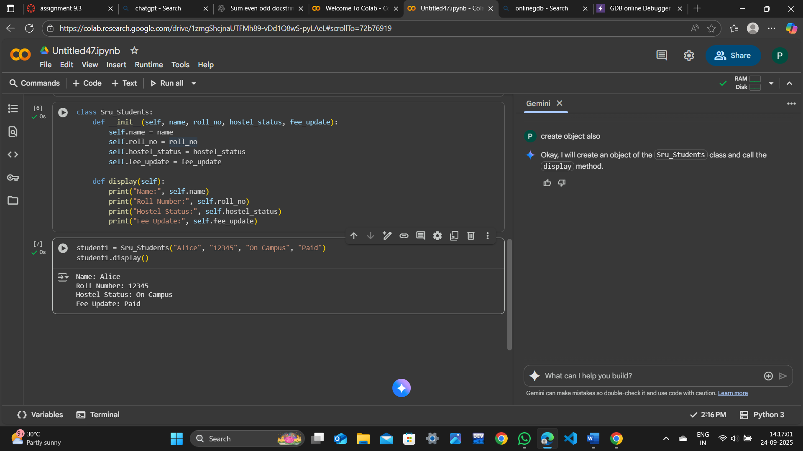

Write comments manually for each line/code block

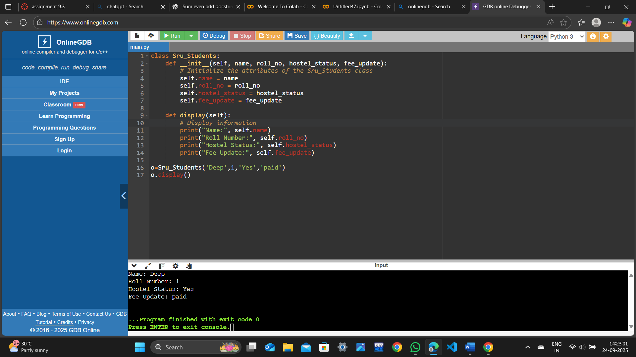

Ask an AI tool to add inline comments explaining each line/step

**PROMPT:**

Add inline comments explaining each step for above code

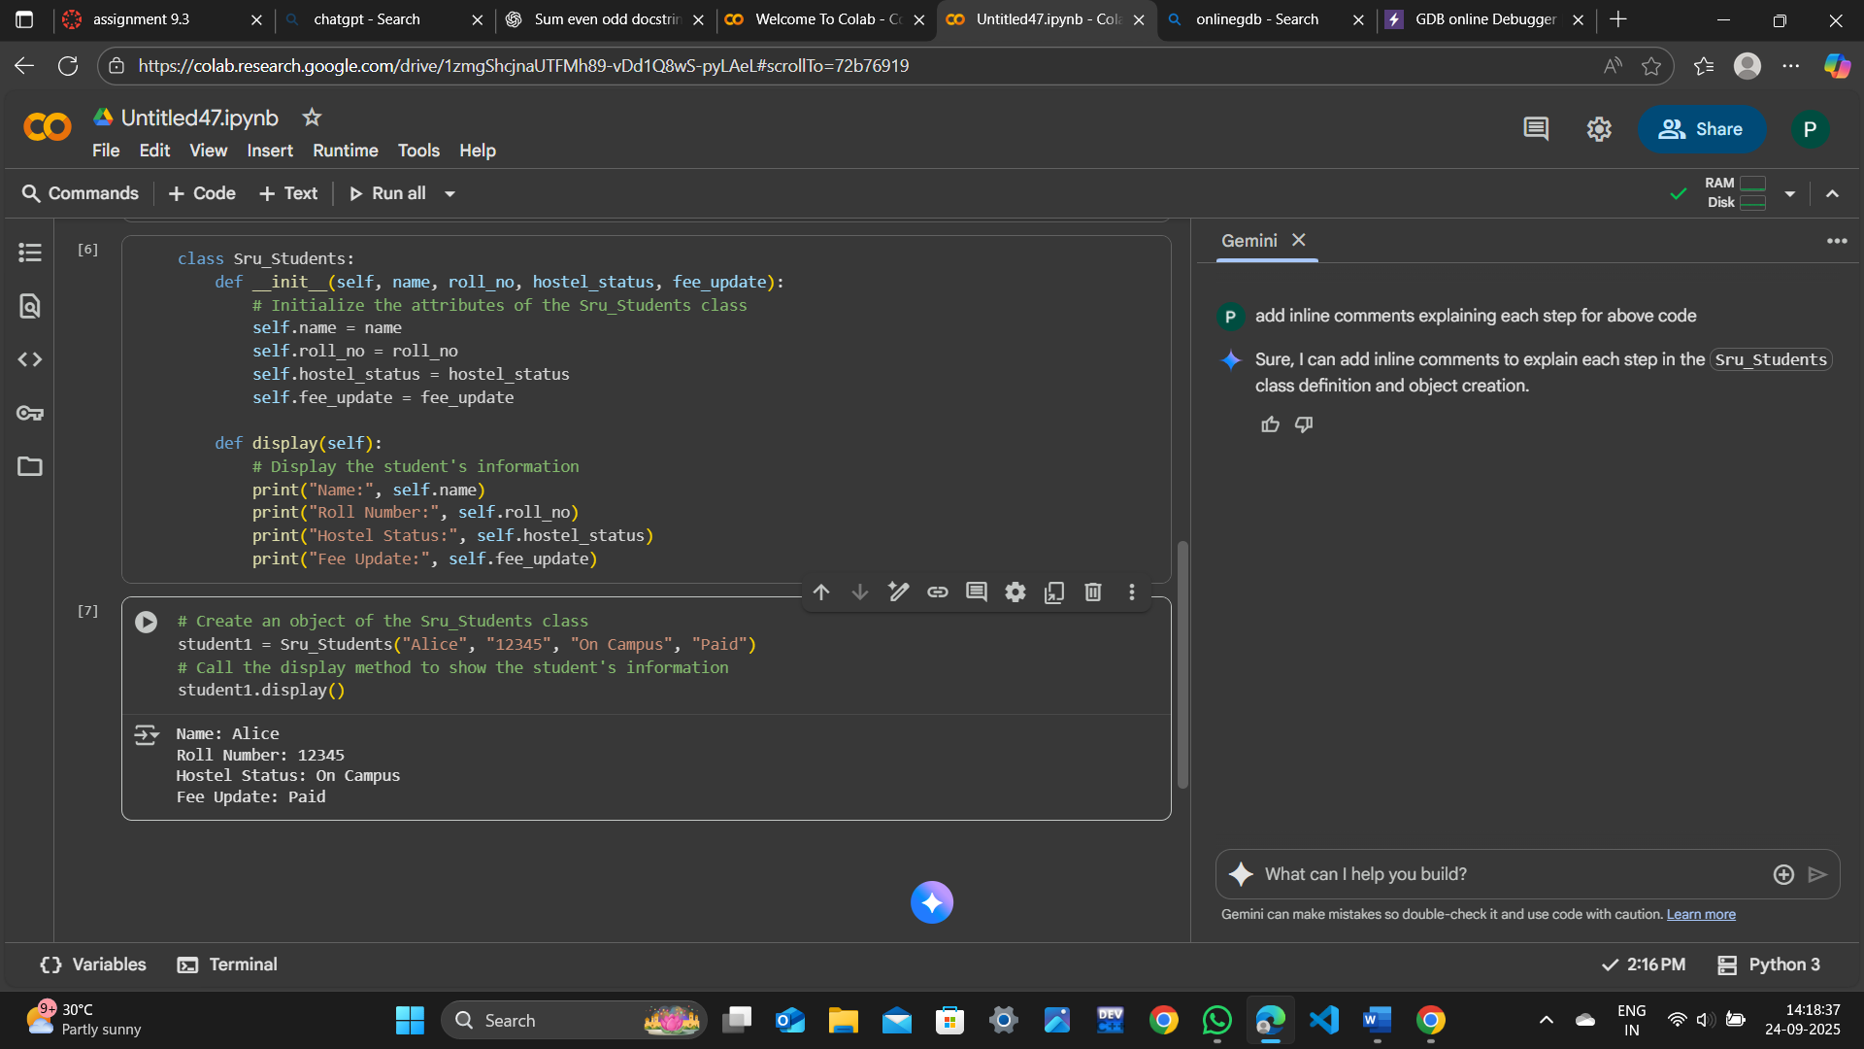

**OBSERVATION:**

Compare the AI-generated comments with your manually written one

I have Analysed the inline comments that are given by me and Gemini.What I observed is Gemini inline comments are far better than my comments.Since it has involved class ,Attributes in the code.So,it has better approach than me

TASK DESCRIPTION -3:

**Write a Python script with 3–4 functions (e.g., calculator: add, subtract, multiply,  
divide).  
•** Incorporate manual docstring in code with NumPy Style  
• Use AI assistance to generate a module-level docstring + individual function  
docstrings.  
• Compare the AI-generated docstring with your manually written one.  
Expected Output#3: Students learn structured documentation for multi-function scripts

**PROMPT:**

Write a Python script with few functions (e.g., calculator: add, subtract, multiply,  
divide).  
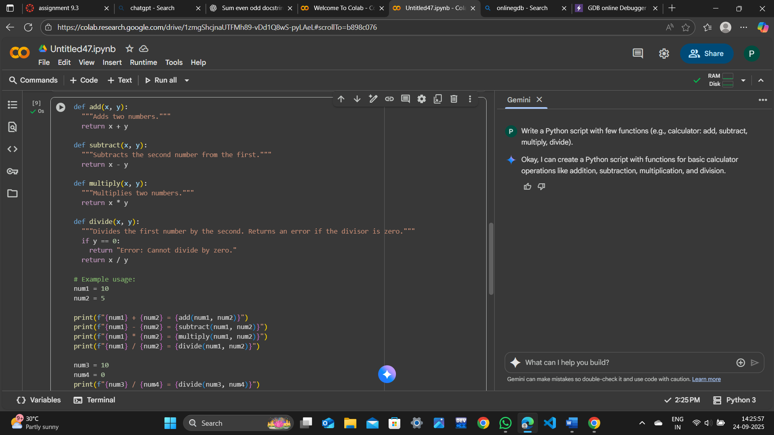

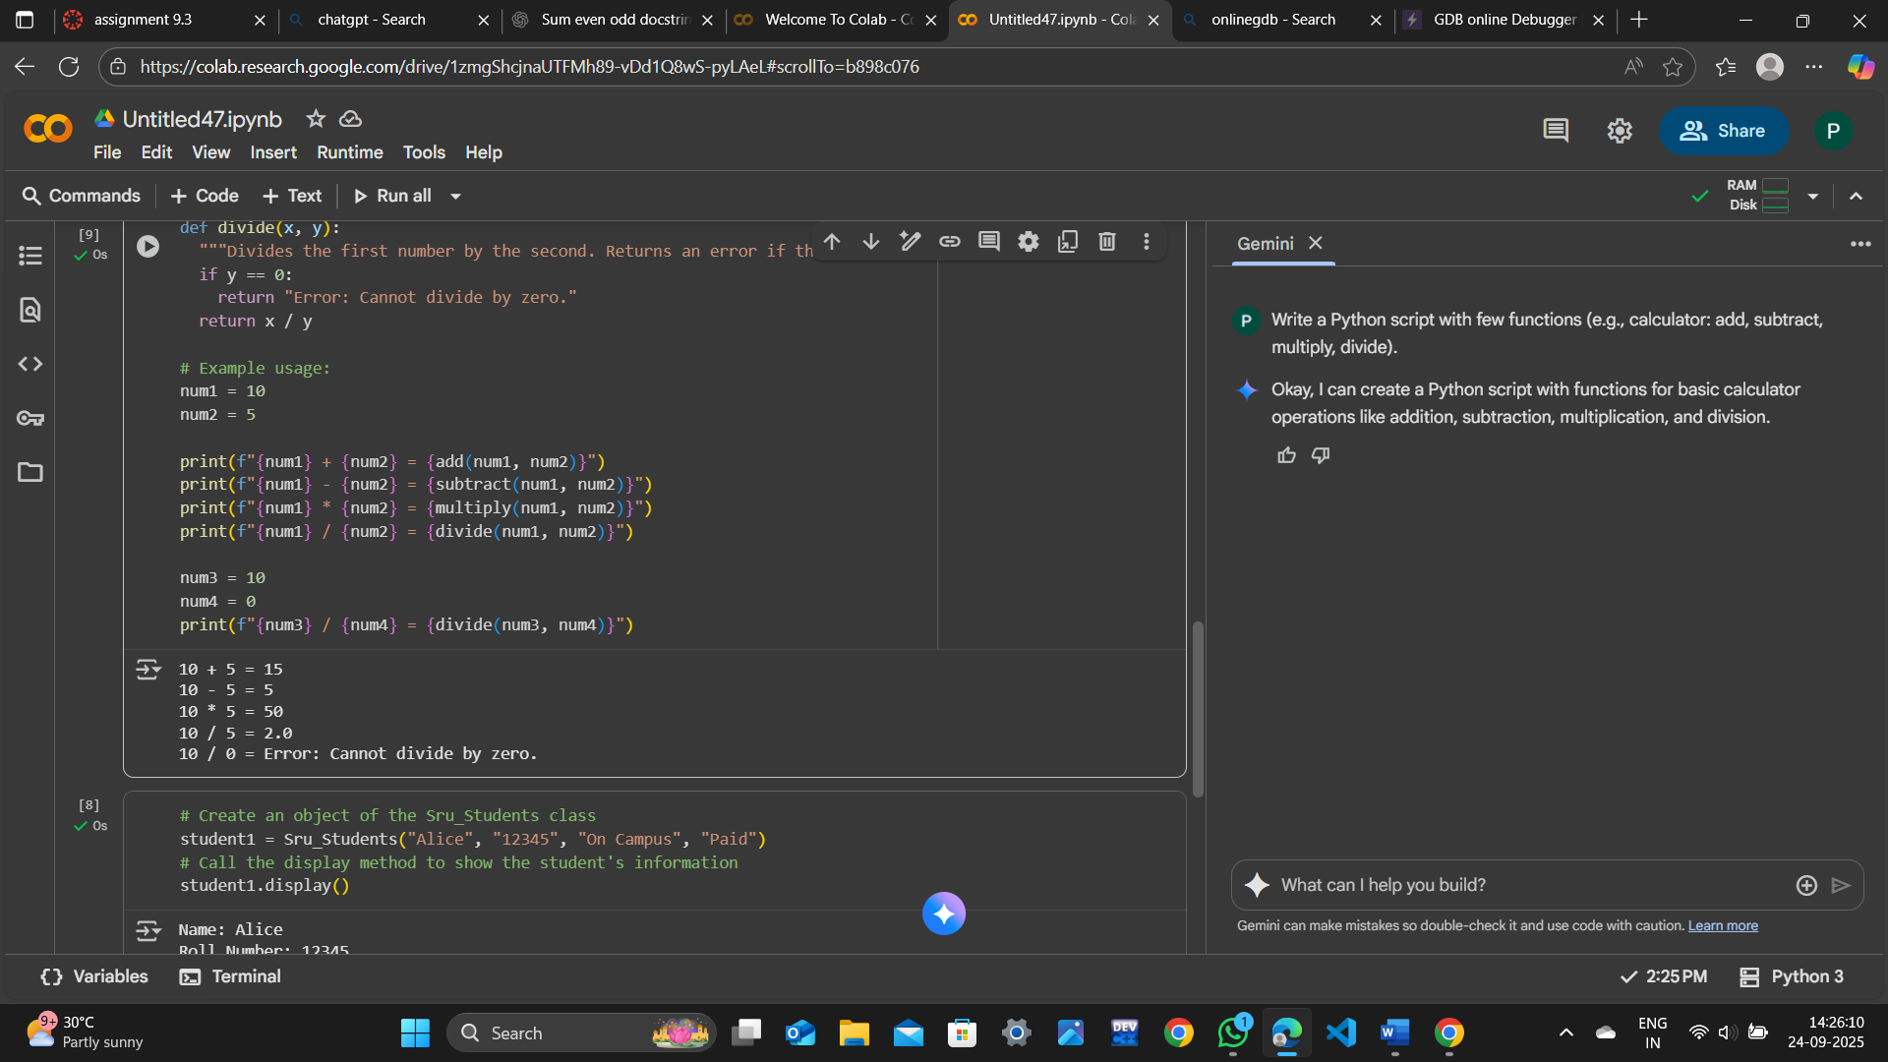

**Incorporate manual docstring in code with NumPy Style**

**PROMPT:**  
For Above code incorporate manual docstring in code with NumPy Style

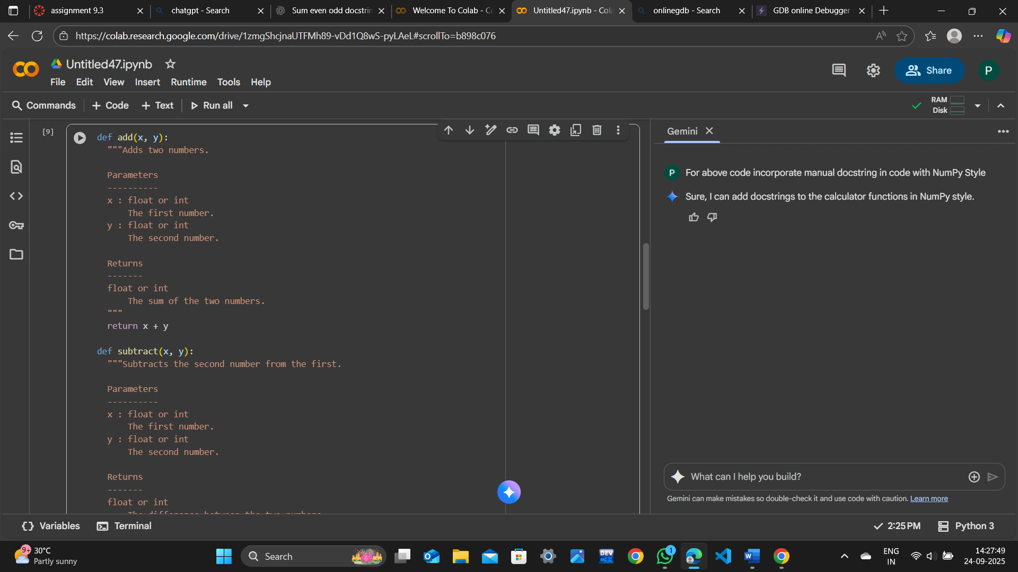

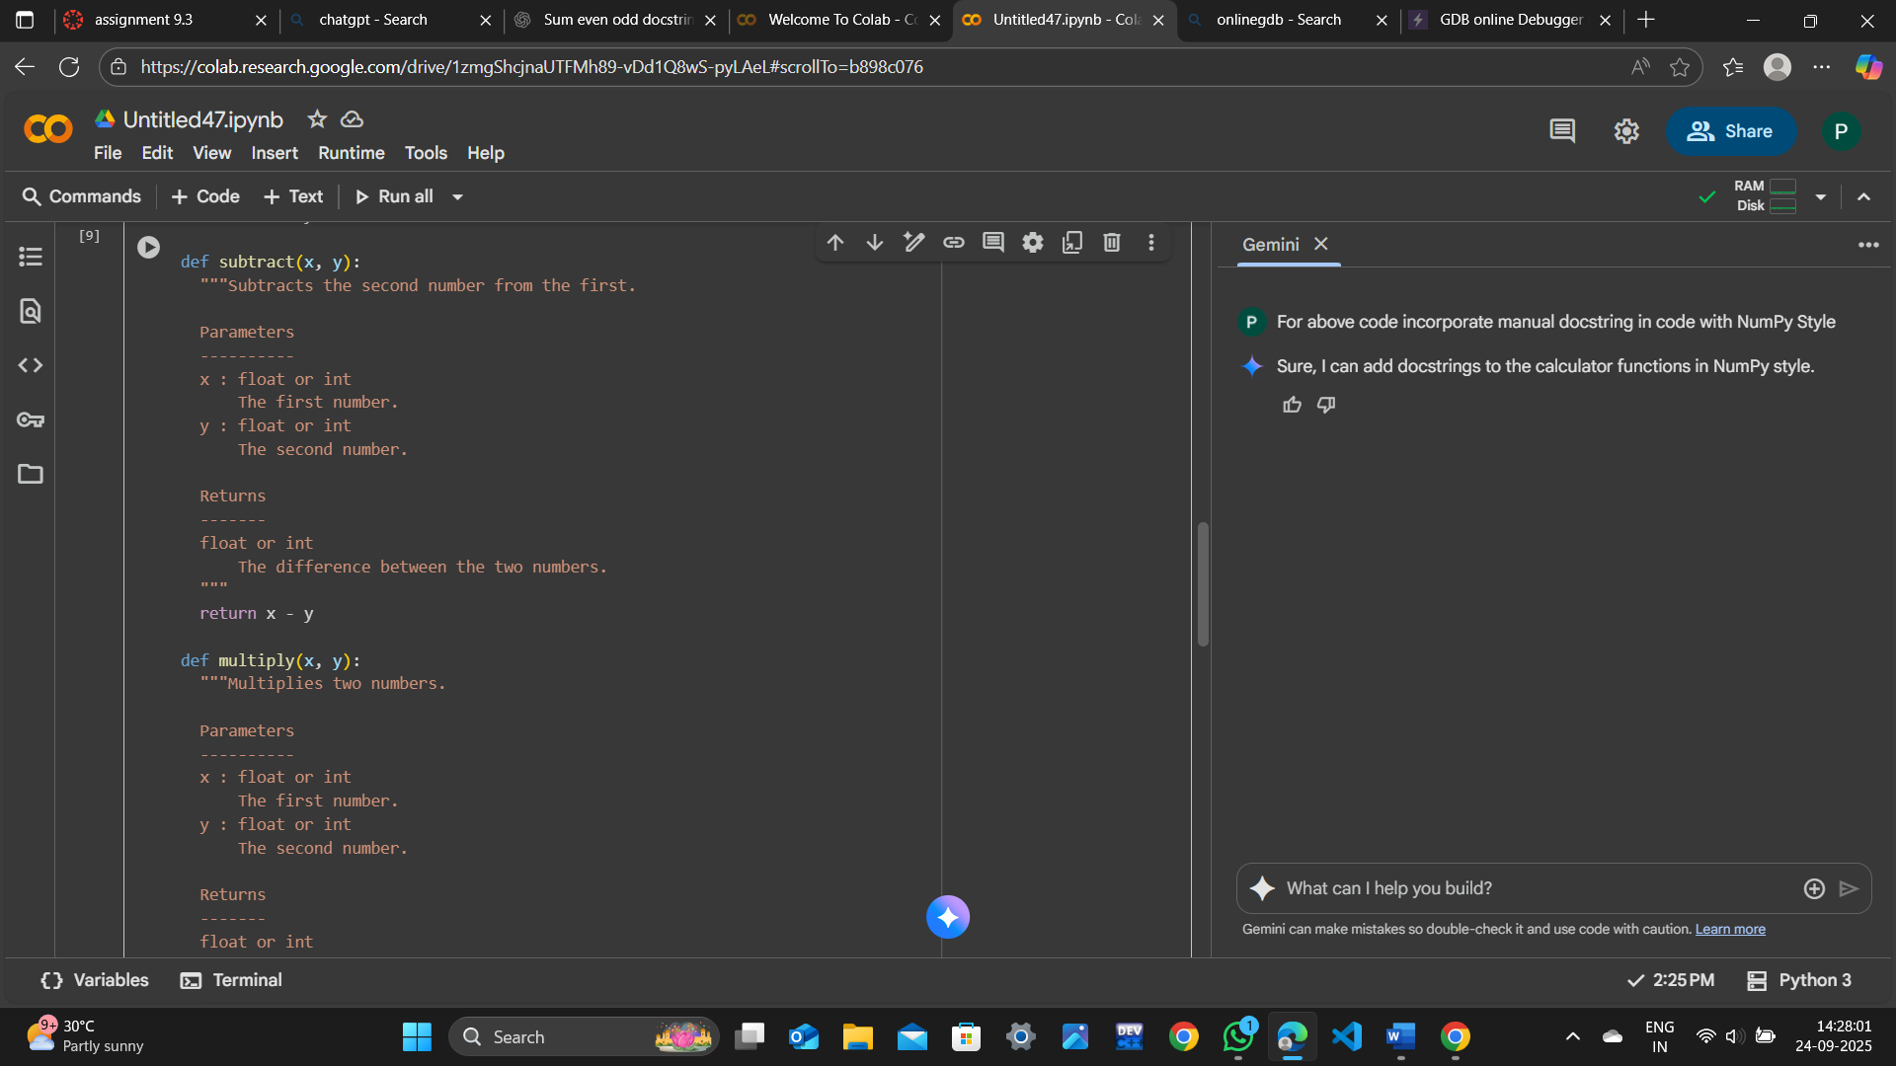

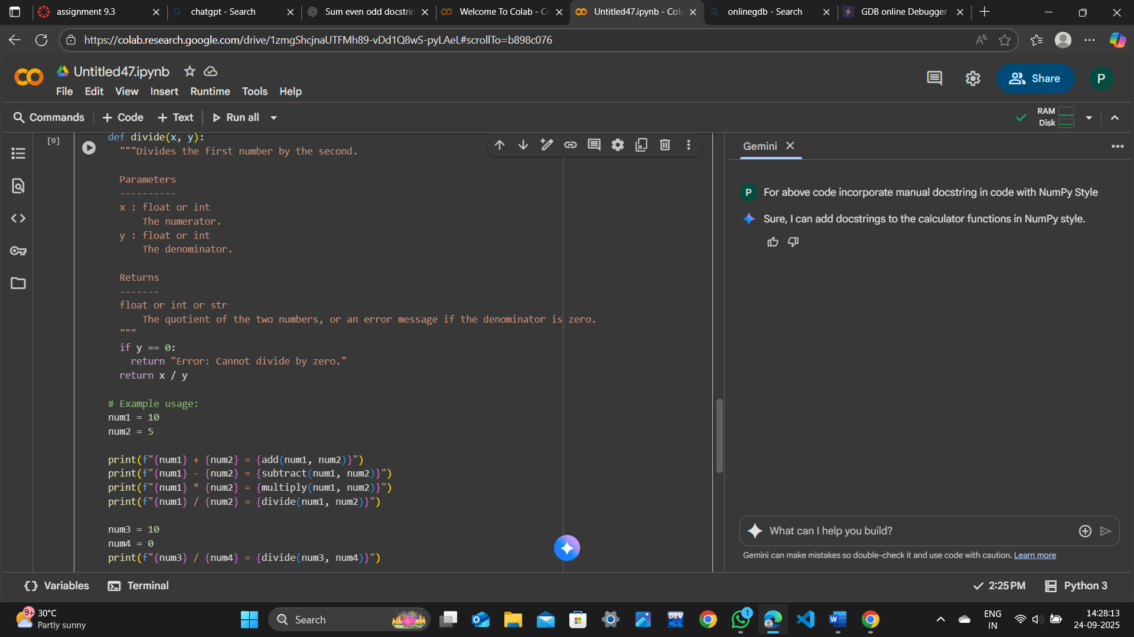

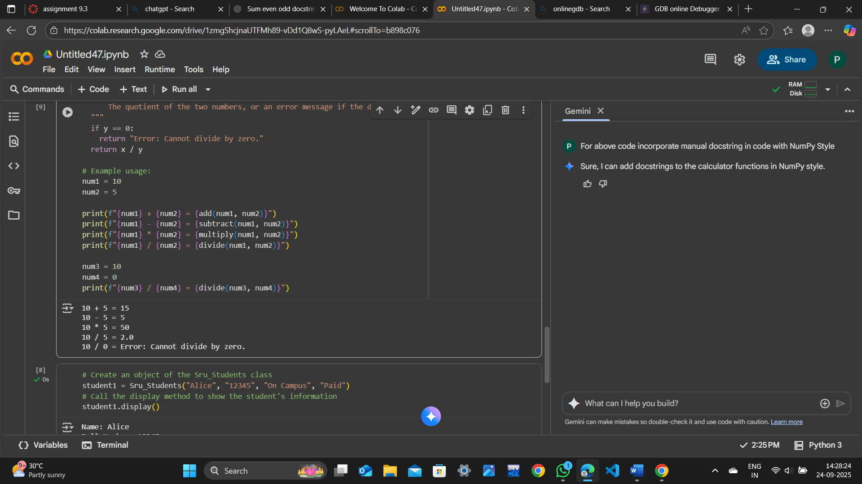

**Use AI assistance to generate a module-level docstring + individual function  
docstrings.**

**PROMPT:**

**Generate a module-level doctring+individual function docstrings for above code**

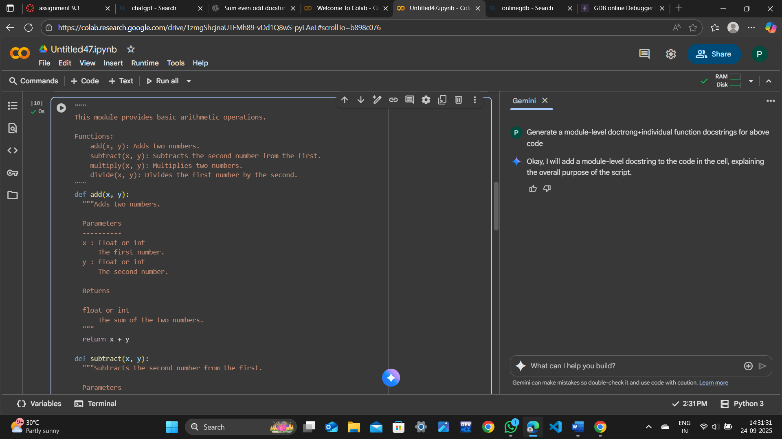

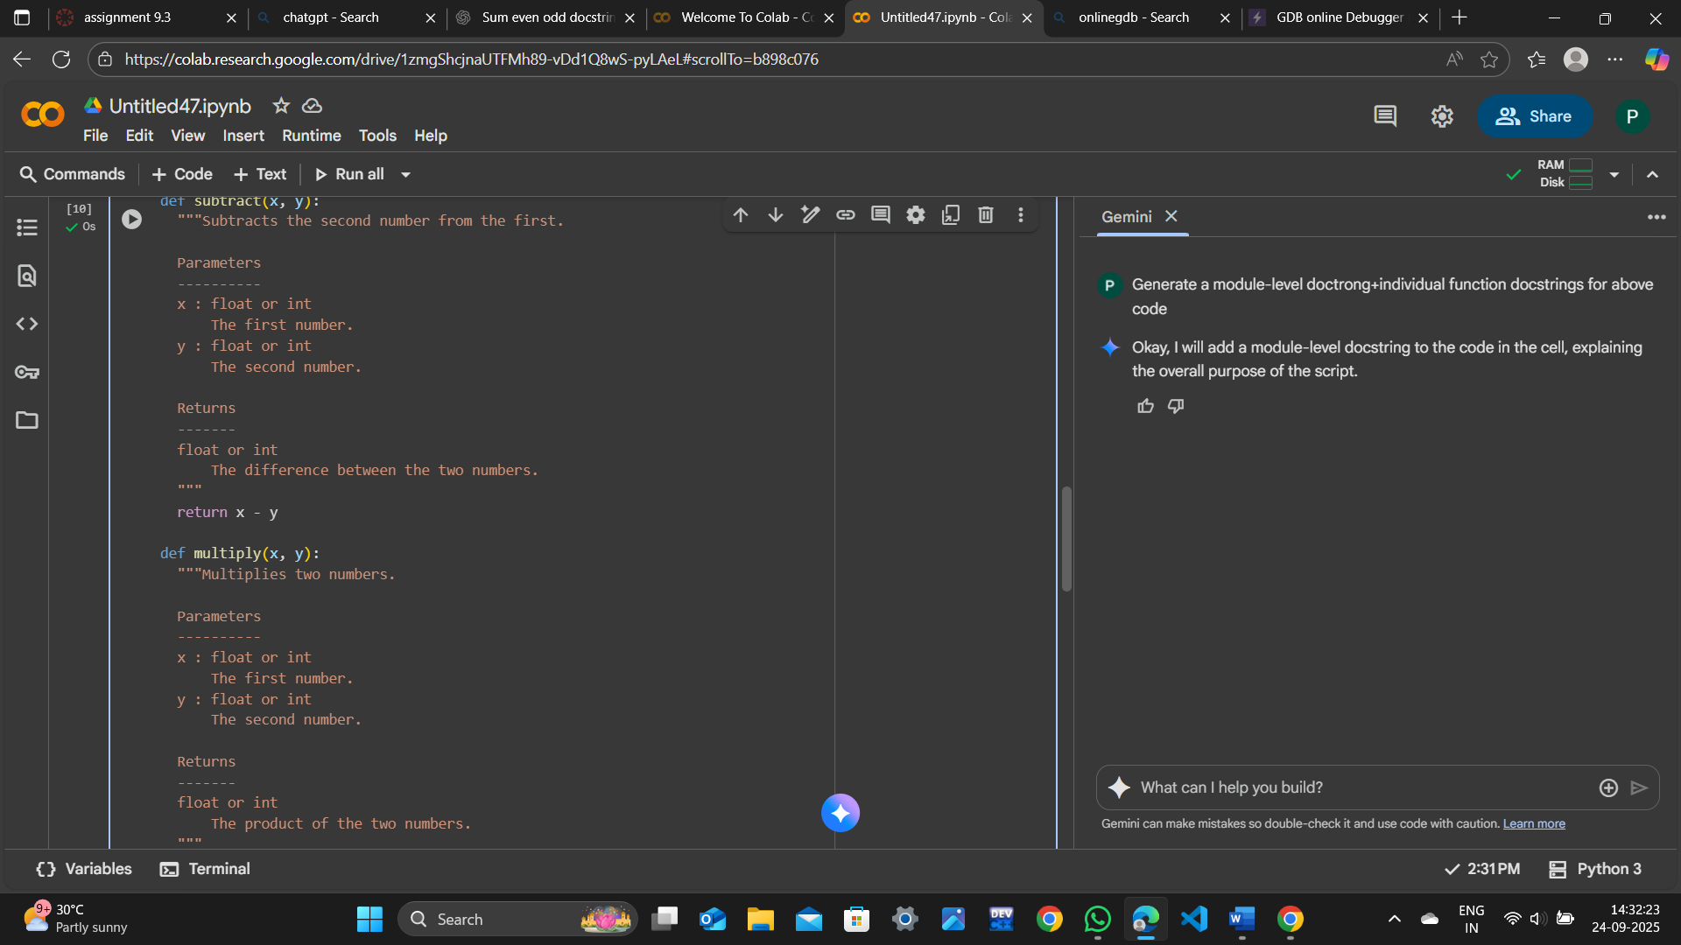

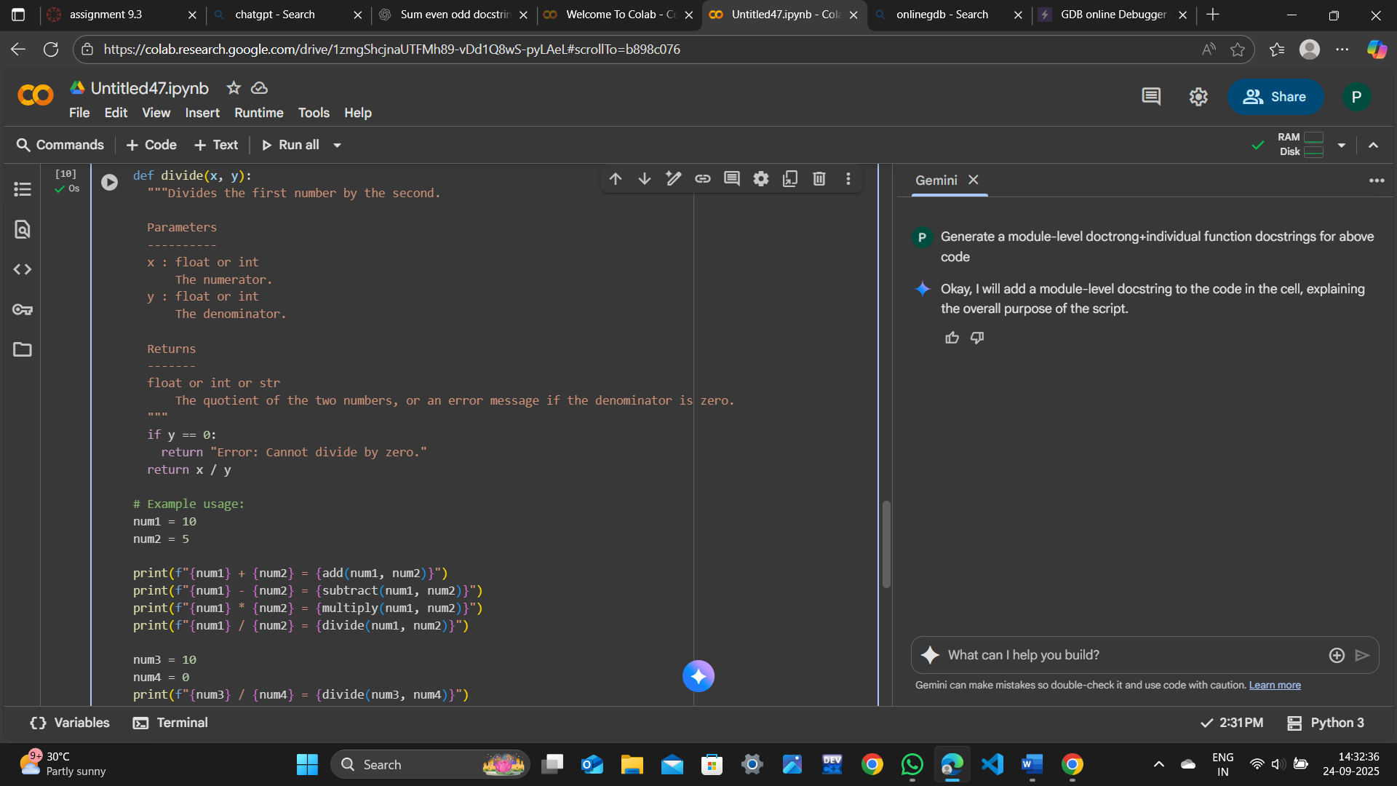

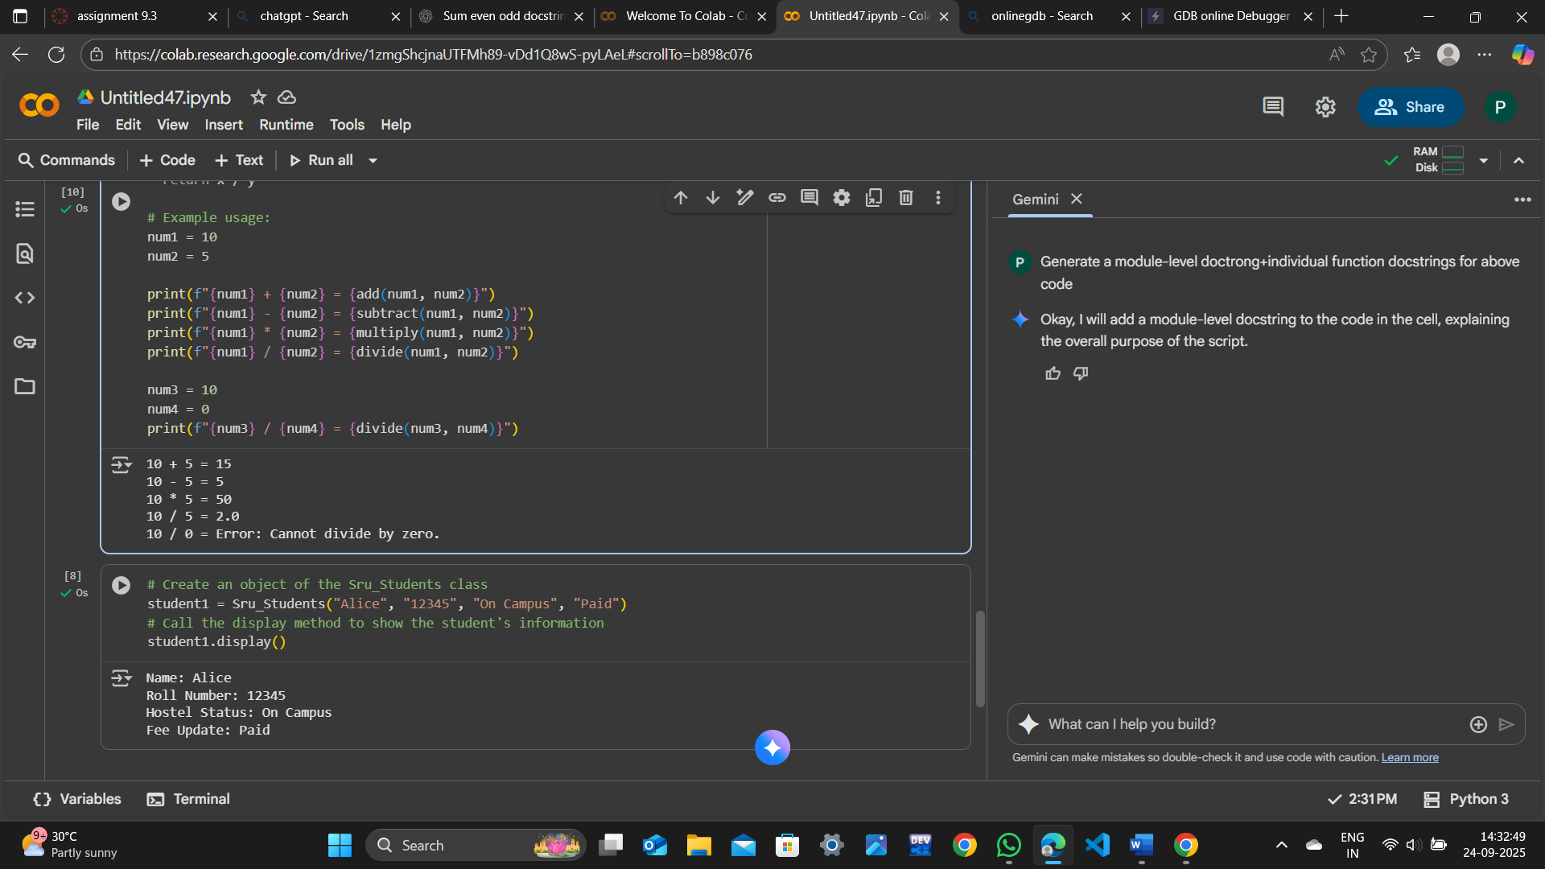

**Compare the AI-generated docstring with your manually written one**

**OBSERVATION:**

As per my Observation.Both docstrings looking good and has meaning as per the code that is been given,In my docstring it has simple English letters and words where as in Gemini code ,it has used some Terminology.

Apart from that Everything is good when we compare the docstrings .Externally We took help to get module level docstring from GEMINI.