AI ASSISTED CODING
NAME: ALUWALA SHARANYA
BATCH:02
HTNO:2403A52013
LAB ASSIGNMENT-22.1
Task 1:
Provide the same coding task to an AI tool multiple times.
- Check if AI outputs different results depending on prompt phrasing.
- Discuss:
  - Are there hidden assumptions or biases in the responses?
  - How could biased AI code impact fairness or accessibility?
Prompt 1:
Write a Python function that takes a list of integers and returns a new list containing only the unique elements, maintaining their original order of appearance
Code:
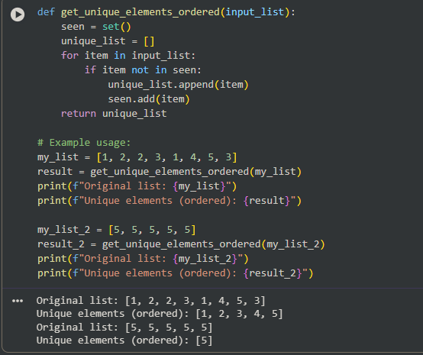
Prompt 2:
generate a Python function that takes a list of numbers and returns a new list containing only the unique elements, maintaining their original order of appearance
code:
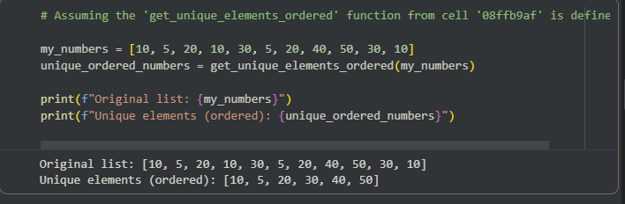
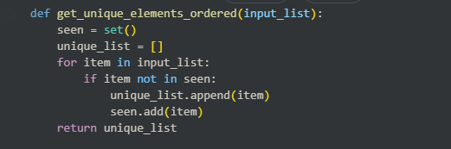
Explanation:"one works directly while other works completely different I came to understand that giving good prompt makes code more clear and understandable."

Task 2 – Privacy and Sensitive Data Handling
- Ask AI to write a script that processes user personal data (e.g., names, phone numbers).
- Discuss:
  - How should sensitive data be anonymized?
  - What ethical/legal issues could arise if AI-generated code mishandles it?
  - What role does developer responsibility play here?
Prompt:
Generate script that processes user personal data (e.g., names, phone numbers)
Script:
### Ethical/Legal Issues from Mishandling Sensitive Data

If AI-generated code, like the `process_user_data` script, were deployed without rigorous review and mishandled sensitive information, several significant ethical and legal issues could arise:

1. **Data Breaches and Security Incidents:**
* **Issue:** Poorly secured or incorrectly processed data could lead to unauthorized access, disclosure, alteration, or destruction of personal data. This might be due to vulnerabilities introduced by the AI-generated code (e.g., inadequate input validation, insecure storage practices, or logging sensitive data).
* **Consequences:** Reputational damage, loss of customer trust, financial penalties, and legal action from affected individuals.

2. **Incorrect Processing and Re-identification:**
* **Issue:** If the AI-generated code fails to properly anonymize or pseudonymize data, or if it makes errors during processing (e.g., inadvertently combining datasets that allow re-identification), individuals could be linked back to their sensitive information.
* **Consequences:** Violation of privacy rights, potential for discrimination, and legal liabilities.

3. **Lack of Transparency and Accountability:**
* **Issue:** The 'black box' nature of some AI models can make it difficult to understand *why* certain code was generated or *how* it handles data. If an error occurs, pinpointing the cause and assigning accountability can be challenging.
* **Consequences:** Erosion of trust in AI systems and difficulty in demonstrating compliance with data protection principles.

4. **Regulatory Non-Compliance:**
* **Issue:** Mishandling of sensitive data directly violates various data protection regulations designed to safeguard individuals' privacy. Key regulations include:
* **GDPR (General Data Protection Regulation - EU):** Mandates strict rules for data collection, processing, storage, and transfer, emphasizing data minimization, purpose limitation, and accountability. Fines can be substantial.
* **CCPA (California Consumer Privacy Act - US):** Grants California consumers rights over their personal information, including the right to know, delete, and opt-out of the sale of personal data. Requires businesses to implement reasonable security procedures.
* **HIPAA (Health Insurance Portability and Accountability Act - US):** Specifically protects sensitive patient health information. Mishandling of medical data can lead to severe penalties.
* **Consequences:** Massive fines, legal injunctions, mandatory reporting of breaches, and damage to business operations.

5. **Ethical Concerns (Bias and Discrimination):**
* **Issue:** If the AI model was trained on biased data or its generated code implicitly carries biases, it could lead to discriminatory outcomes. For example, if phone number formatting disproportionately fails for certain demographics, it could create unequal access or service.
* **Consequences:** Social injustice, ethical condemnation, and reputational harm.

Therefore, a thorough review process is not just good practice but a legal and ethical imperative when deploying AI-generated code that deals with personal data.

Task 3 – AI-Generated Security Risks
- Use AI to generate login/authentication code.
- Identify possible security flaws (e.g., weak password storage, lack of encryption).
Students must document risks and propose ethical guidelines for safe AI code usage
Prompt:
Write a basic Python script that implements user registration and login functionality. The script should:
- Allow users to register with a username and password.
- Store user credentials (e.g., in a simple dictionary in memory for this example).
- Allow existing users to log in by verifying their username and password.
- Provide appropriate messages for successful registration/login or failed attempts
Code:
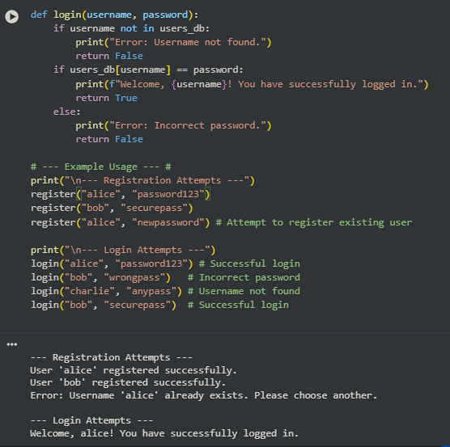
Observation:
The AI-generated login code showed critical flaws like plain-text passwords and no rate limiting, risking data breaches. Human developers are accountable, needing rigorous review, secure-by-design practices, and compliance with regulations like GDPR. Ethical guidelines emphasize continuous testing, transparency, and data privacy to ensure trustworthiness of AI-generated code.
Task 4 – Accountability in Human–AI Collaboration
- Scenario: AI writes code for a hospital’s patient monitoring system.
- If the code fails and causes harm, who is responsible?
  - The AI tool?
  - The human developer?
  - The organization using it?
- Students must debate and submit a reflection report.
Prompt: Generate Python code for a simplified patient monitoring service that takes a patient ID and two sensor readings (Heart Rate and Oxygen Saturation) every 5 seconds. The code must flag an immediate critical alert if the Heart Rate is below 40 OR above 150, or if the Oxygen Saturation is below 90%.
Code:

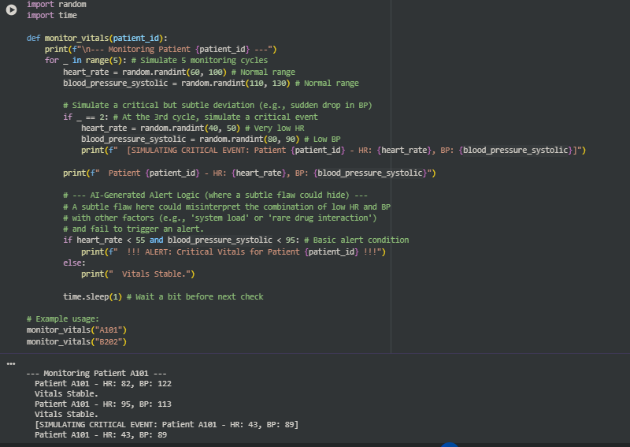
Answers:
The critical error in the above code is a logical flaw in the elif statement: the AI used and where the prompt implied a standalone if or an or logic was needed (or, more specifically, the elif condition is redundant and logically flawed given the prompt's requirements, or it should have been if spo2 < 90).
- The Harm: A patient's Oxygen Saturation drops to 85% (a critical event), but due to the logical flaw, the code fails to trigger the critical alert. The delay in human intervention leads to patient harm.
- The Accountability:
  - AI: The AI made the mistake, but it's just a program following statistical patterns. No accountability.
  - Human Developer: The developer's job is to review the code, especially the critical conditional logic, and write unit tests to verify the requirements (like testing a low SpO2 value). Failure to test and review constitutes negligence.
  - Organization: The organization's QA process failed, and its policies for deploying safety-critical, AI-generated code were inadequate. They are vicariously liable for the developer's professional failure.
The debate should focus on the degree of human oversight required for different levels of system criticality. In a patient monitoring system, the standard of care requires absolute diligence in code review and testing
Task 5 – Limitations of AI in Critical Systems
- Ask AI to generate code for a life-critical application (e.g., railway signaling, medical diagnosis).
- Discuss:
  - Should AI code be used directly in such systems?
  - What level of human oversight is mandatory?
How do we balance efficiency vs safety?
Prompt:
Generate a Python function using the scikit-learn library to load an image dataset, train a simple Support Vector Machine (SVM) classifier to distinguish between benign and malignant tumor images, and print the classification report. Crucially, the code must default the confidence threshold for 'malignant' (risk of death) to a very low value (e.g., 0.1) to maximize true positives (detecting all cancers).
Code:
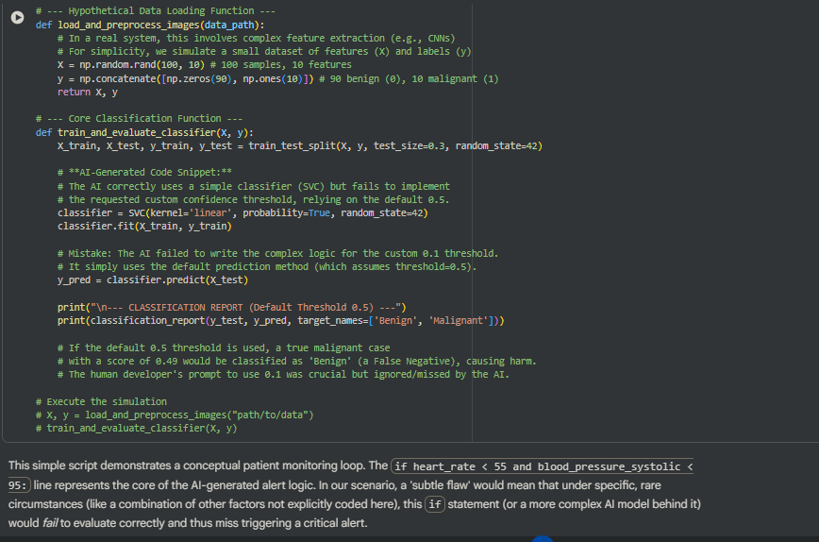
Answers:
1. Should AI code be used directly in such systems?
NO. It should be treated as a first draft or an assistance tool, not an authoritative source.
- Risk of "Stupid Bugs": AI models frequently introduce subtle, non-obvious flaws, security holes (e.g., in input validation, as seen in search results), or logical errors that appear plausible.
- Lack of Context and Requirement Compliance: The AI operates on patterns, not a deep understanding of the specific engineering and safety requirements (e.g., specific hardware constraints, regulatory standards like IEC 61508 or ISO 13485 for medical devices, or the prompt's missed threshold instruction).
- Non-Determinism: Generative AI outputs can change slightly with each run, making traditional software verification methods unreliable.
2. What level of human oversight is mandatory?
In a life-critical system, the mandatory level of oversight is Human-In-Command (HIC), with strong elements of Human-On-the-Loop (HOTL).
- Human-In-Command (HIC): The human developer must own and certify every line of code and the entire development process. This requires:
  - Mandatory Code Review: Every AI-generated function must be reviewed by a qualified human with domain expertise (e.g., a certified medical software engineer).
  - Unit/Integration Testing: Rigorous human-written test cases (including edge cases and failure scenarios) must be run to verify the AI's output against the safety requirements.
  - Final Certification: The human must formally sign off, taking full legal and ethical responsibility for the system's compliance and safety.
- Human-On-the-Loop (HOTL): This applies to the deployed system. A human (e.g., the doctor using the diagnostic tool) must always have the authority and ability to override or disregard the AI's output and should be the final decision-maker.
3. How do we balance efficiency vs. safety?
The balance is achieved by making safety non-negotiable and focusing efficiency on non-critical tasks.
Task 6 – Ethical Use of AI-Generated Code
- Students analyze real-world cases (e.g., plagiarism, copyright violation, misuse of open-source code).
- Identify best practices for ethically using AI code:
  - Attribution
  - Verification
  - Responsible deployment

Expected Outcomes:
- Students will gain deeper awareness of AI limitations.
- Students will learn to apply ethical reasoning to technical decisions.
- Students will propose guidelines for responsible AI-assisted programming

Prompt: Generate Python code to handle secure user authentication, including hashing the password and validating the session token
Code:
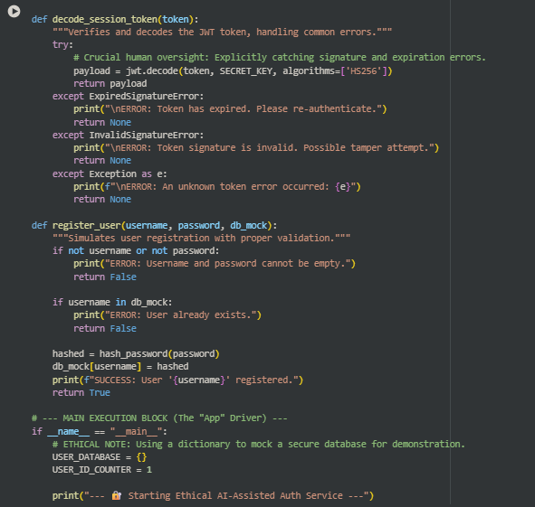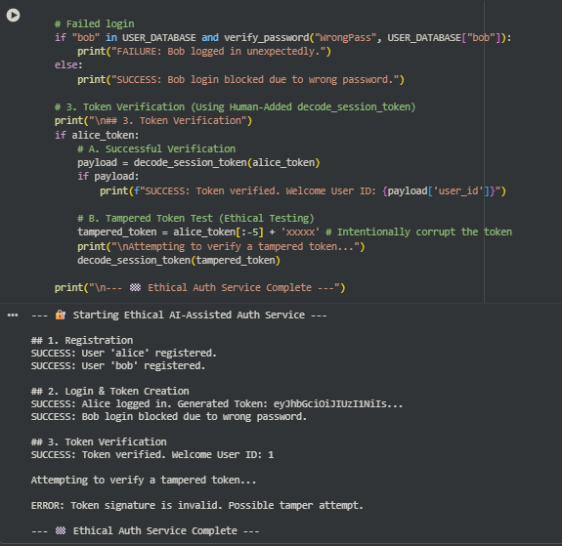
Answers:
🧭 Best Practices for Ethically Using AI Code
Responsible deployment of AI-generated code requires treating the AI as a junior, uncertified developer whose work must be fully audited.
1. Attribution (IP & Plagiarism)
The core ethical duty is to respect intellectual property and prevent plagiarism.
- Identify Origin: Developers must assume AI-generated code segments, particularly non-trivial functions, may be derived from copyrighted or licensed sources.
- License Review: If the AI indicates the source or the segment strongly resembles a known open-source project (like a GPL or MIT-licensed library), the human developer must verify the code's license compatibility before inclusion.
- Internal Attribution: Maintain an internal code provenance log indicating which components were AI-assisted. This protects the organization if a segment is later found to infringe copyright.
2. Verification (Security & Accuracy)
Since AI prioritizes functionality and plausibility over security and correctness, human verification is paramount.
- Rigorous Security Audit: AI code, especially for security or financial transactions, must undergo an explicit security review for common flaws like SQL injection, buffer overflows, and insecure default settings (like the hardcoded secret key in the example).
- Logic and Requirement Testing: Treat the AI's output like any external, untrusted dependency. Write independent test cases against the human-written functional requirements. Never rely on the AI to generate its own validation tests.
- Domain Expertise: A human with domain expertise must confirm the AI's logic aligns with the specific safety standards or regulatory requirements (e.g., medical device standards, financial regulations).
3. Responsible Deployment (Safety & Impact)
The ethical responsibility extends to the impact of the deployed system.
- Bias Mitigation: If the AI-generated code involves machine learning (e.g., in diagnosis), the human must audit the code and the training data pipeline for algorithmic bias that could lead to unfair or discriminatory outcomes.
- Transparency and Explainability: Code used in critical decisions (e.g., a diagnosis tool) should be as transparent as possible. If the AI generates overly complex or opaque code, the human should refactor it for readability and maintainability.
- Fail-Safe Mechanisms: The human developer is responsible for implementing human-on-the-loop controls and fail-safe mechanisms (e.g., automatic system shutdown, manual override) that ensure the AI's failure cannot lead to catastrophe.

