AI ASSISTED CODING
ASSIGNMENT 17.2
NAME: ALUWALA SHARANYA
HT NO: 2403A52013
BATCH NO: 02

TASK 1~
Clean raw social media posts dataset.
Instructions:
- Remove stopwords, punctuation, and special symbols from post text.
- Handle missing values in likes and shares columns.
- Convert timestamp to datetime and extract features (hour, weekday).
- Detect and remove spam/duplicate posts.
PROMPT:
Write HTML, CSS, and JavaScript code that uploads and preprocesses a raw social media posts dataset (CSV file). The code should:
- Remove stopwords, punctuation, and special characters from the post text.
- Handle missing values in the likes and shares columns (fill with median).
- Convert timestamps to datetime format and extract useful features like posting hour and weekday.
- Detect and remove duplicate or spam posts automatically.
- Display a short before-and-after summary (e.g., total posts before/after cleaning).
- Allow the user to download the cleaned dataset as a new CSV file.

CODE:
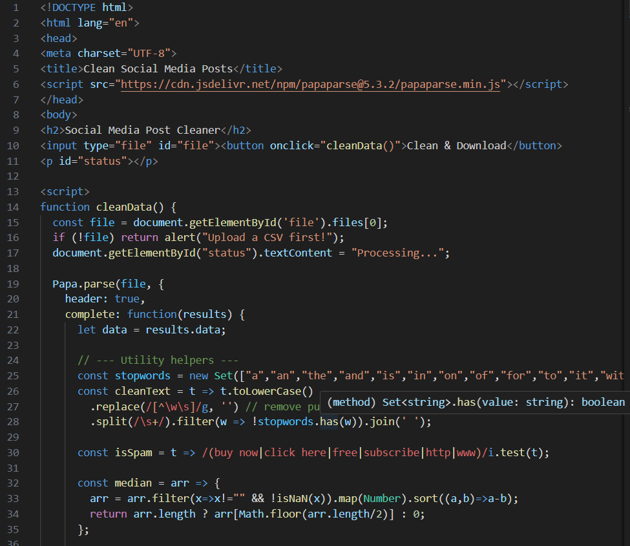
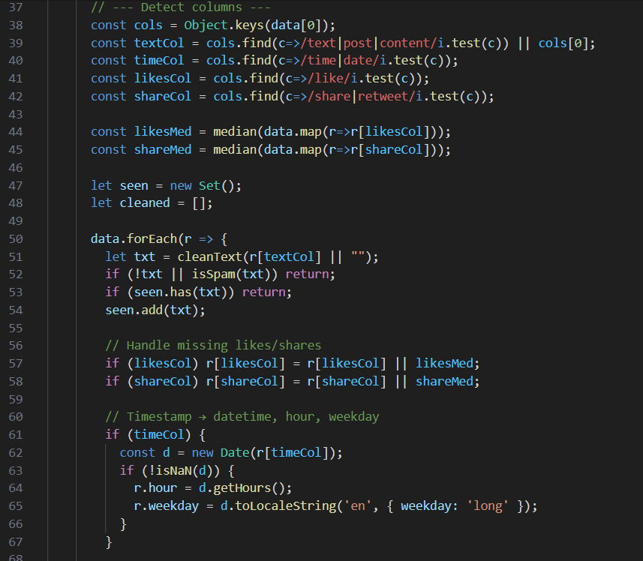
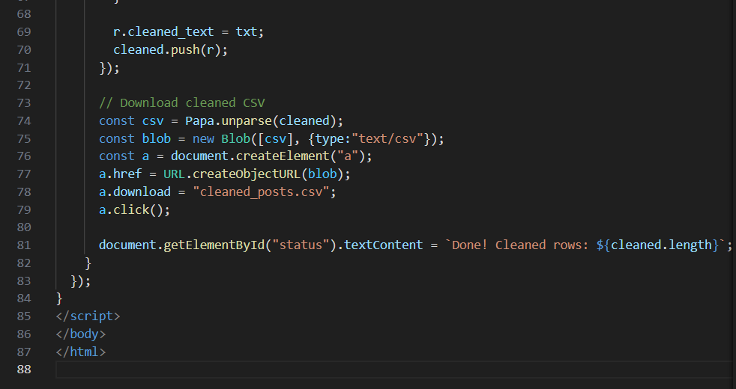
OUTPUT:
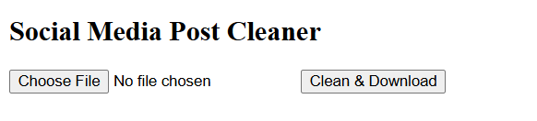
CODE EXPLANATION:
This HTML tool uploads a CSV of social media posts, cleans the text by removing stopwords and punctuation, fills missing likes/shares with median values, converts timestamps to extract hour and weekday, detects and removes spam or duplicate posts, and then downloads the cleaned data as a new CSV file.

TASK 2~
Preprocess a stock market dataset.
Instructions:
- Handle missing values in closing_price and volume.
- Create lag features (1-day, 7-day returns).
- Normalize volume column using log-scaling.
- Detect outliers in closing_price using IQR method
PROMPT:
Write HTML, CSS, and JavaScript code to upload and preprocess a stock market dataset (CSV file). The code should:
- Handle missing values in closing_price and volume columns (fill with mean or median).
- Create lag features for 1-day and 7-day returns.
- Normalize the volume column using log-scaling.
- Detect outliers in closing_price using the Interquartile Range (IQR) method.
- Display a brief summary (number of rows before and after cleaning, detected outliers).
- Allow the user to download the cleaned dataset as a new CSV file

CODE:
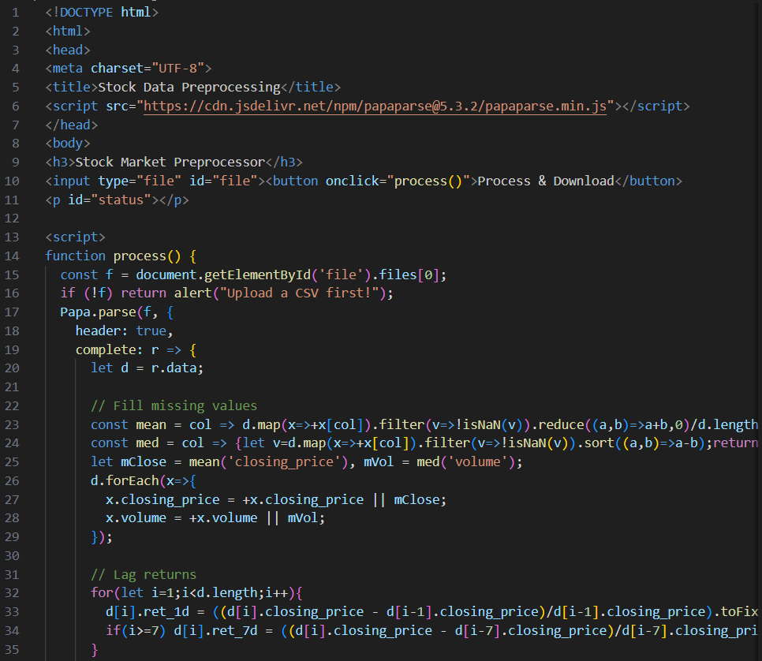
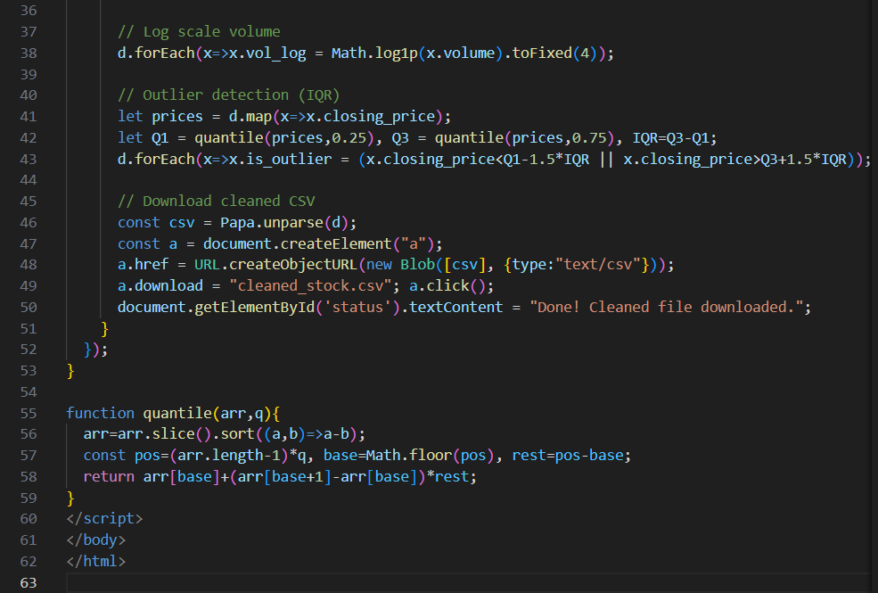
OUTPUT:
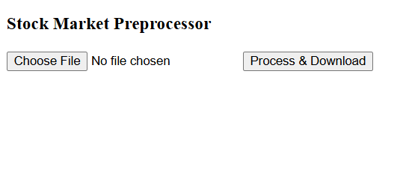
CODE EXPLANATION:
This HTML and JavaScript code uploads a stock market CSV, fills missing closing prices with the mean and volume with the median, calculates 1-day and 7-day returns, applies log normalization to the volume column, detects outliers in closing price using the IQR method, and downloads the cleaned dataset.

TASK 3~
Clean and preprocess IoT temperature and humidity logs.
Instructions:
- Handle missing values using forward fill.
- Remove sensor drift (apply rolling mean).
- Normalize readings using standard scaling.
- Encode categorical sensor IDs
PROMPT:
Write HTML, CSS, and JavaScript code that uploads and cleans IoT temperature and humidity log data from a CSV file. The code should:
- Handle missing values using forward fill.
- Remove sensor drift by applying a rolling mean (smoothing).
- Normalize temperature and humidity readings using standard (z-score) scaling.
- Encode categorical sensor IDs into numeric codes.
- Display a short before-and-after summary (missing values, average readings).
- Allow the user to download the cleaned and processed dataset as a new CSV file.

CODE:
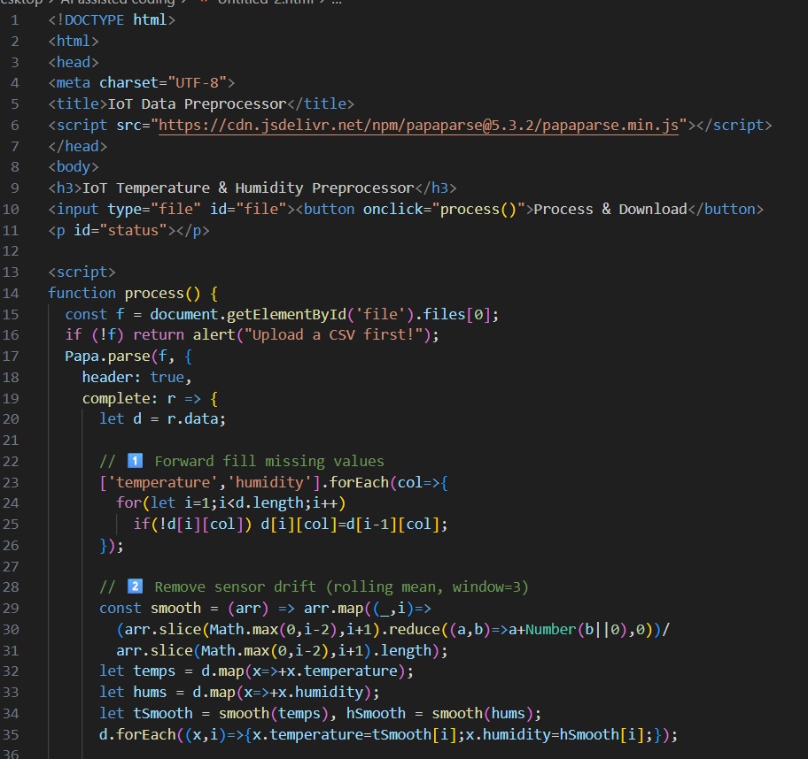
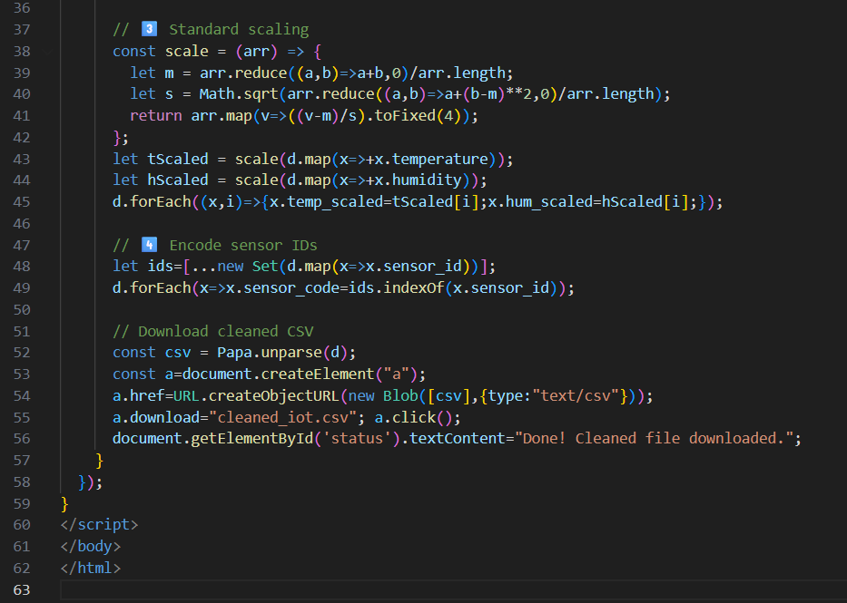
OUTPUT:
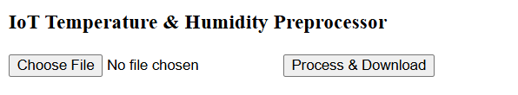
CODE EXPLANATION:
This HTML and JavaScript code uploads an IoT CSV, fills missing temperature and humidity values using forward fill, smooths readings to remove sensor drift with a rolling mean, standardizes them via z-score scaling, encodes sensor IDs into numeric labels, and downloads the fully cleaned and normalized dataset.

TASK 4~
A streaming platform wants to analyze customer reviews.
Instructions:
- Standardize text (lowercase, remove HTML tags).
- Tokenize and encode reviews using AI-assisted methods (TF-IDF or
embeddings).
- Handle missing ratings (fill with median).
- Normalize ratings (0–10 → 0–1 scale).
- Generate a before vs after summary report.
PROMPT:
Write HTML, CSS, and JavaScript code to preprocess customer review data from a streaming platform. The code should:
- Convert all text to lowercase and remove HTML tags.
- Tokenize and encode reviews using TF-IDF.
- Handle missing ratings by filling with the median.
- Normalize ratings (0–10 → 0–1 scale).
- Generate a before vs after summary report showing text cleaning, rating normalization, and encoding results.
The output should be a cleaned dataset ready for sentiment classification and available for download as a CSV file.

CODE:
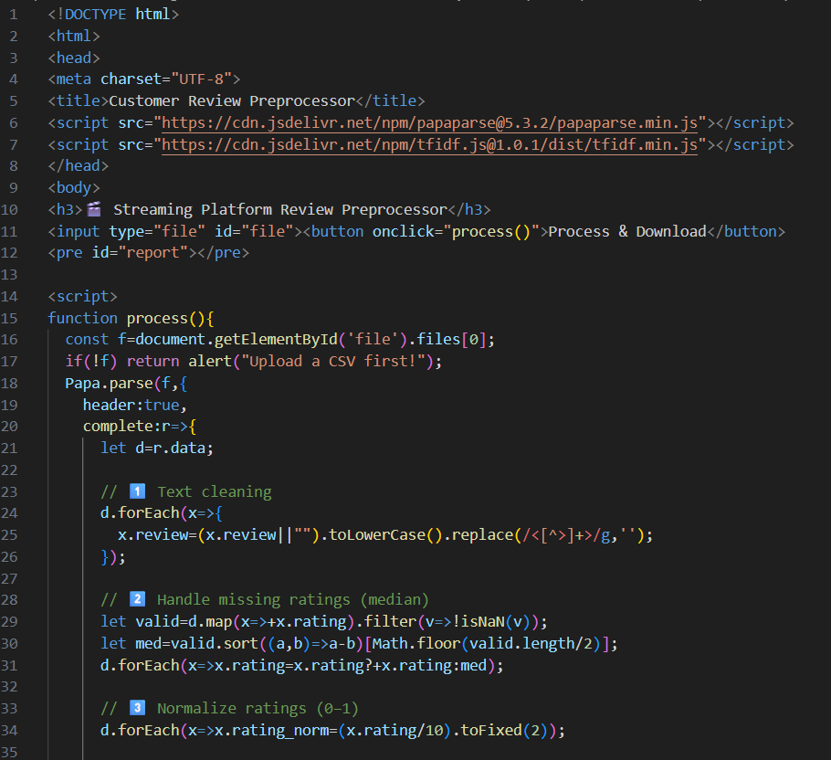
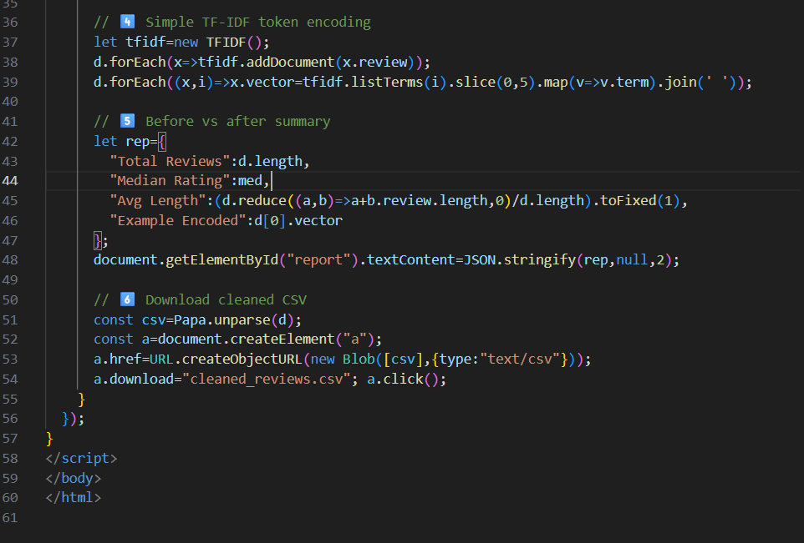
OUTPUT:
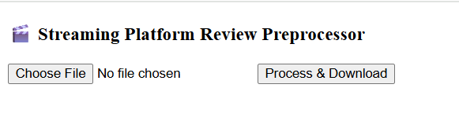
CODE EXPLANATION:
This HTML and JavaScript code uploads a customer review CSV, cleans review text by converting to lowercase and removing HTML tags, fills missing ratings with the median, normalizes ratings to a 0–1 scale, encodes reviews using a TF-IDF method, generates a before–after summary, and downloads the cleaned dataset.

