AI ASSISTED CODING
ASSIGNMENT: 19.2

NAME: ALUWALA SHARANYA
HT.NO:2403A52013
BATCH: 02

TASK 1
TASK DESCRIPTION:
You are part of a multinational development team. The backend is written in
Java, but a new module requires a Python implementation of the same
algorithm for integration with a data science pipeline.
• Task 1: Use AI-assisted coding to translate a given Java bubble sort
program into Python. Verify that the translated code works correctly.
• Task 2: Introduce errors in the Python version to check if the input list
is empty or contains non-numeric values

PROMPT
"Translate a Java bubble sort algorithm into Python, verify its correctness with a test case, and implement error handling for empty or non-numeric input lists."

CODE & OUTPUT
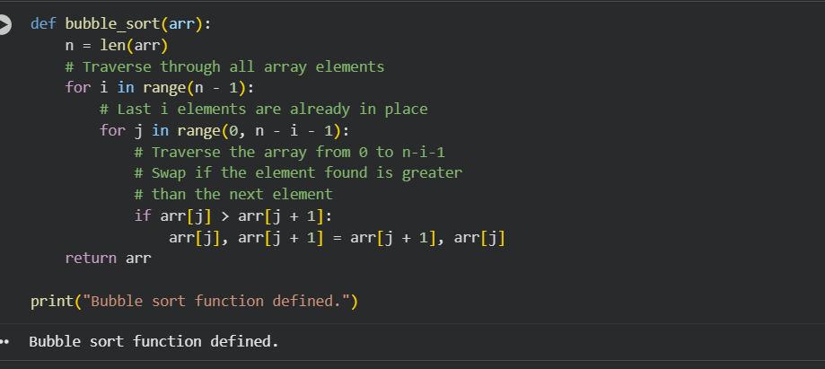
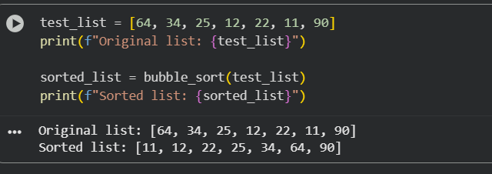

CODE EXPLANATION
The provided code first defines a Python bubble_sort function, which sorts a list by repeatedly stepping through the list, comparing adjacent elements, and swapping them if they are in the wrong order. After defining the function, a test_list is created. The bubble_sort function is then called with this list, and both the original and sorted lists are printed to verify the algorithm's correct functionality.

TASK 2
TASK DESCRIPTION
A company’s legacy codebases stores and processes files in C++, but the
analytics team needs an equivalent program in JavaScript (Node.js) for
integration with a web dashboard.
• Task 1: Translate a given C++ file read-and-write program into
JavaScript using AI assistance. Ensure the script reads a text file and
writes processed output to a new file.
• Task 2: Add error handling in the JavaScript version to gracefully handle
missing files or permission errors
PROMPT
"Translate a C++ file read-and-write program into JavaScript (Node.js) that reads a text file and writes processed output to a new file, including error handling for missing files or permission issues."

CODE & OUTPUT
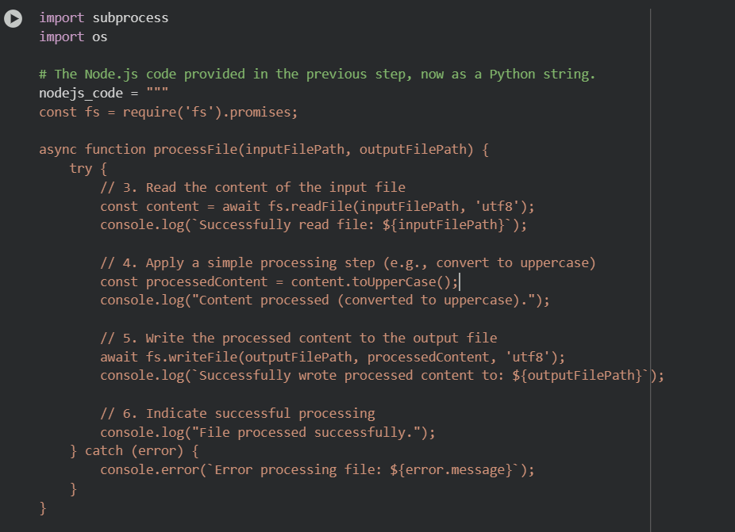
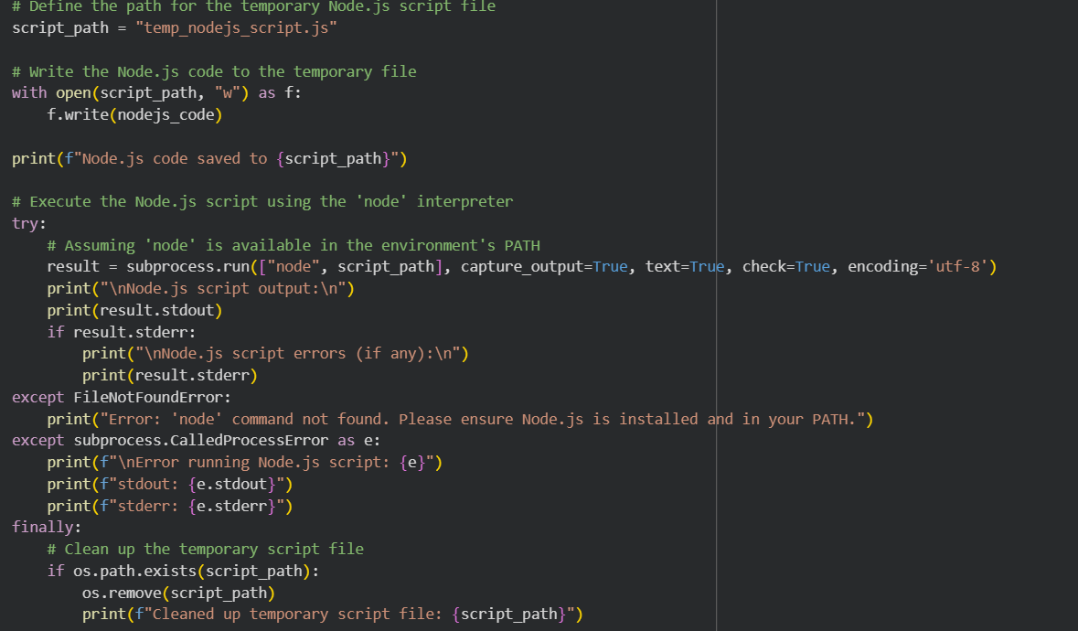
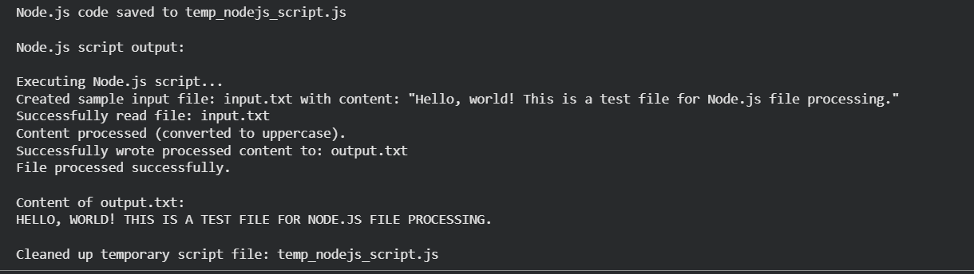
CODE EXPLANATION
The Python script dynamically creates a temporary Node.js file that reads content from input.txt, converts it to uppercase, and writes the processed output to output.txt. This Node.js code, which includes try-catch blocks for error handling, is then executed via Python's subprocess module, ensuring cross-language functionality and proper cleanup of the temporary file
TASK 3
TASK DESCRIPTION
Your team developed a prototype in Python to fetch weather data from an API,
but the production environment only supports Java.
• Task 1: Translate the Python script (that makes an API call and prints
the response) into Java using AI-assisted coding. Ensure equivalent
functionality.
• Task 2: Add proper error handling in the Java version for cases such as
invalid API key, request timeout, or no internet connection.

PROMPT
"Translate a given Python script that makes an API call and prints the response into an equivalent Java program, using AI assistance."

CODE & OUTPUT
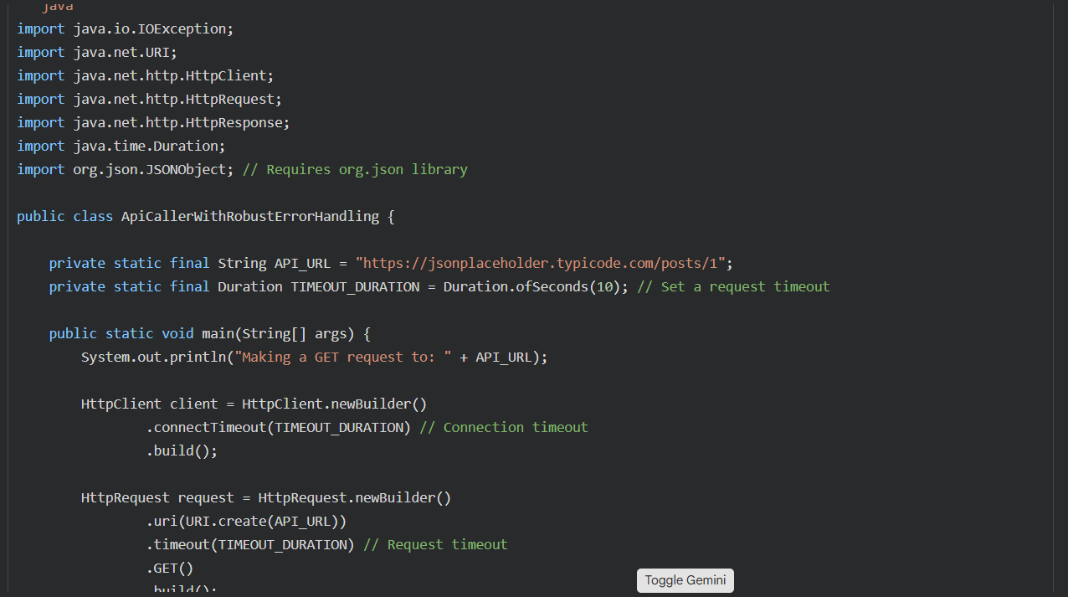
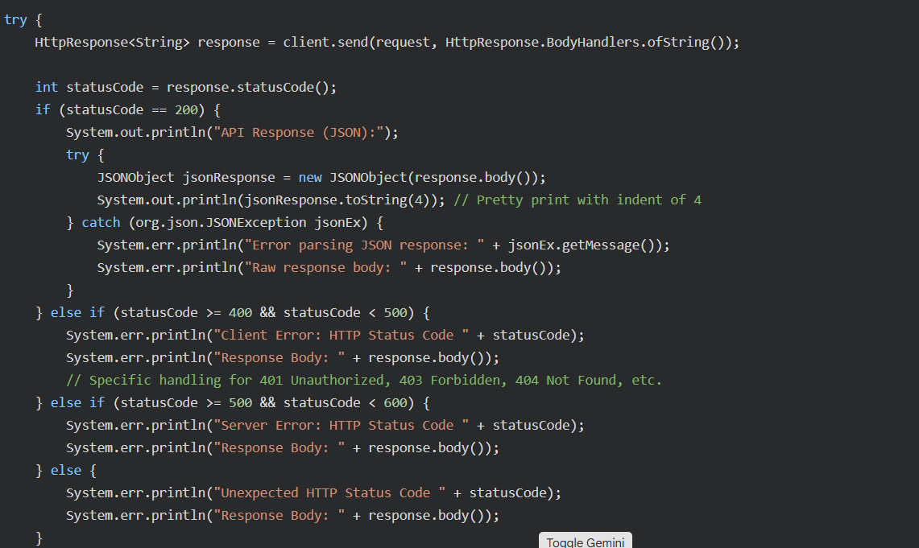
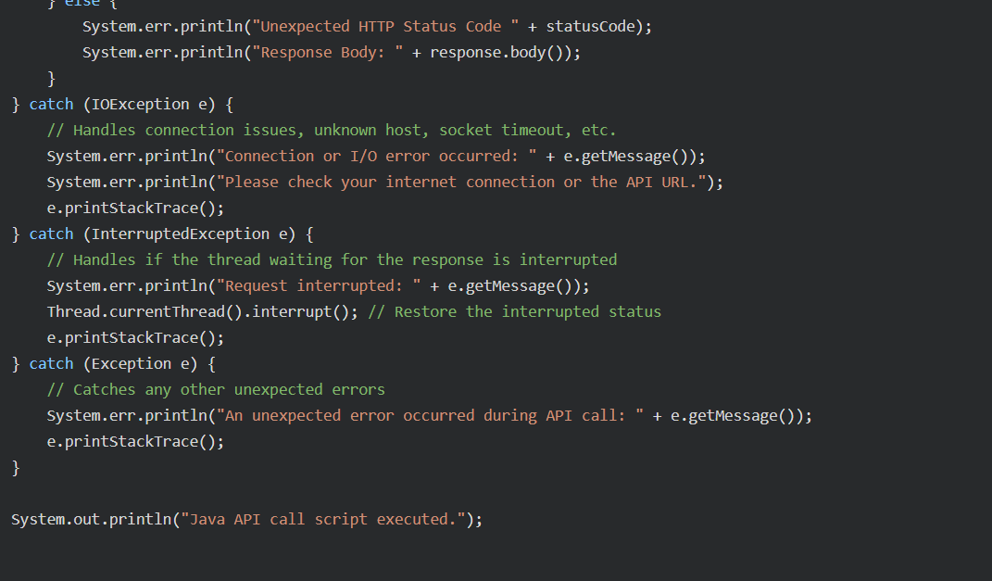
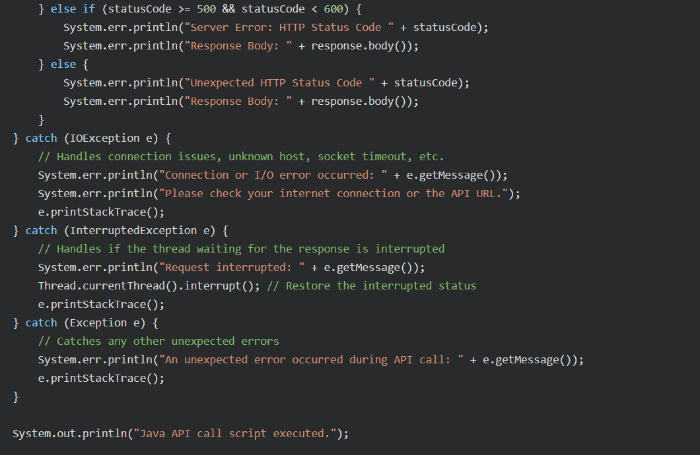
CODE EXPLANATION
The Python script uses requests to make a GET API call, fetching and printing a JSON response, with error handling for network issues. Its Java equivalent, generated by AI, utilizes HttpClient for the GET request and org.json to parse the response. It also incorporates try-catch blocks for IOException, InterruptedException, and checks the HTTP status code, ensuring similar functionality and robustness.

