AI ASSISTED CODING

ASSIGNMENT: 16.3

NAME: ALUWALA SHARANYA

HT NO: 2403A52013

BATCH NO: 02

Task Description #1 – Schema Generation
TASK:
Ask AI to design a schema for a Library Management System
(Tables: Books, Members, Loans).
PROMPT:
Design a database schema for a Library Management System. The schema should include the following tables:

1. Books: Store information about the books in the library.
2. Members: Store information about the library members.
3. Loans: Track the borrowing and returning of books by members.

For each table, define appropriate columns with data types and constraints (e.g., primary keys, foreign keys, not null). Consider the relationships between the tables.

CODE AND OUTPUT:
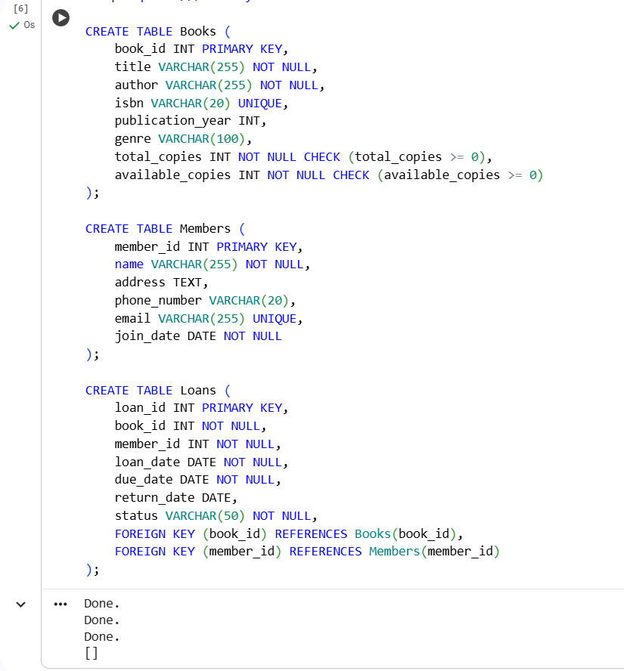
CODE EXPLANATION:
This code uses SQL to create three tables in a SQLite database called library.db. The Books table stores book details with columns for ID, title, author, etc. The Members table holds member information like ID, name, and contact details. The Loans table tracks borrowing with loan ID, book ID, member ID, loan and due dates, and return date. Foreign keys link the Loans table to the Books and Members tables, establishing relationships. Constraints like PRIMARY KEY, NOT NULL, UNIQUE, and CHECK ensure data integrity. This sets up the foundational database structure for a Library Management System.

Task Description #2 – Error Insert Data
TASK:
Ask AI to generate INSERT INTO queries for the schema above
(3 sample records per table).
PROMPT:
Generate SQL INSERT INTO queries to add 3 sample records to each of the following tables, based on the schema provided:
- Books: Include sample data for book_id, title, author, isbn, publication_year, genre, total_copies, and available_copies.
- Members: Include sample data for member_id, name, address, phone_number, email, and join_date.
- Loans: Include sample data for loan_id, book_id, member_id, loan_date, due_date, return_date, and status. Ensure that the book_id and member_id values correspond to the sample data inserted into the Books and Members tables, respectively.

CODE AND OUTPUT:
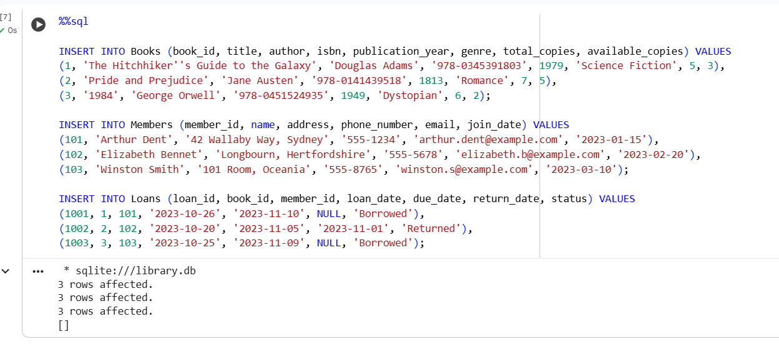
CODE EXPLANATION:
This code uses SQL INSERT INTO statements to add sample data to the Books, Members, and Loans tables. Each INSERT statement provides values for the columns of the respective table. For the Loans table, the book_id and member_id values match existing records in the Books and Members tables, demonstrating the relationships. This populates the database with initial records for testing and exploration.

Task Description #3 – Basic Queries
TASK:
Use AI to generate a query to list all books borrowed by a specific
member
PROMPT:
Generate an SQL query to list the titles of all books currently borrowed by a specific member. The query should take the member's ID as input and retrieve the book titles from the Books table by joining it with the Loans table and filtering by the member's ID and loan status.

CODE AND OUTPUT:
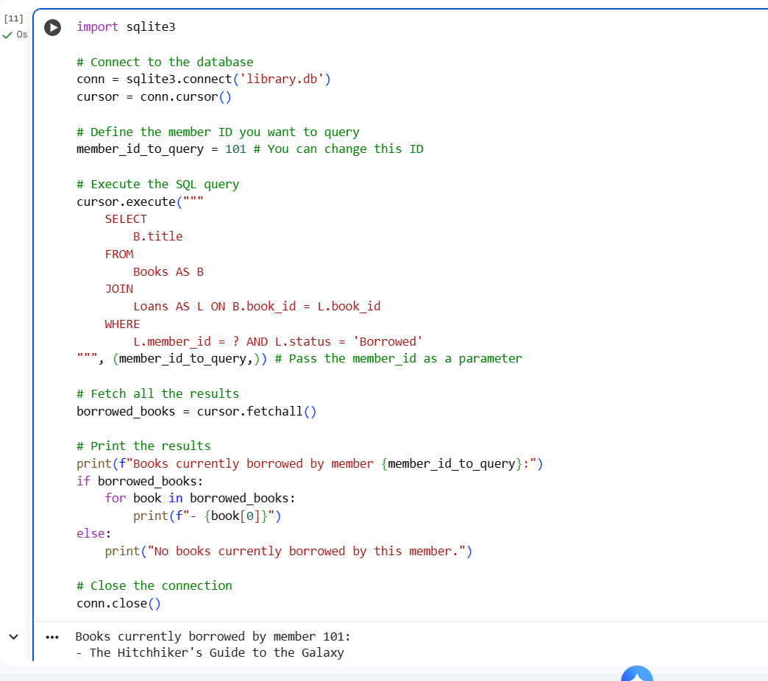
CODE EXPLANATION:

This Python code connects to your library.db database using the sqlite3 library. It then executes an SQL query that joins the Books and Loans tables to find the titles of books currently borrowed by a specific member (ID 101 in this case), using a placeholder for safety. Finally, it fetches the results and prints the list of borrowed book titles. The connection to the database is closed afterwards.

Task Description #4 – Update and Delete Queries
TASK:
Generate queries with AI for:
• Updating a book’s availability to FALSE when borrowed.
• Deleting a member record safely.

PROMPT:
Generate SQL queries for the following tasks based on the library database schema:
- Update Book Availability: Generate an UPDATE query to set the available_copies of a specific book to one less when it is borrowed. Assume the book_id is known.
- Safely Delete Member: Generate a set of SQL statements to safely delete a member record. This should include considering what to do with associated loan records (e.g., deleting them or setting the member_id to NULL, if applicable) to maintain data integrity. Assume the member_id is known.

CODE AND OUTPUT:
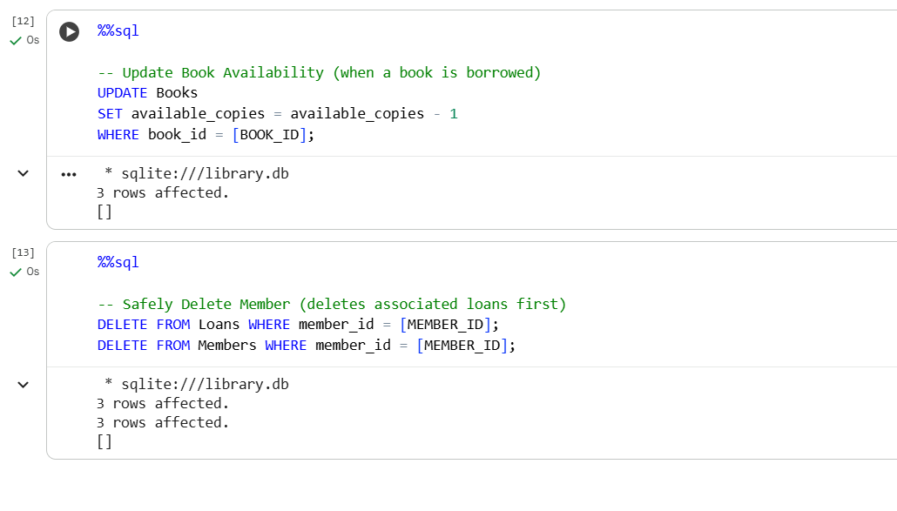
CODE EXPLANATION:
These code cells contain SQL queries. The first updates a book's available copies by subtracting one, useful when a book is borrowed. The second set of queries safely deletes a member by first removing their associated loan records to maintain data integrity, then deleting the member record. Remember to replace placeholders with actual IDs for specific operations.

