

**Program :**B.tech(CSE)

**Specialization :**AIML

**Course Title :**AI Assisted Coding

**Course Code :**24CS002PC215

**Semester :**3rd semester

**Academic Session :**2025-2026

**Name of Student :**Bachanagari Deekshitha

**Enrollment No. :**2403A52032

**Batch No. :**02

**Date :**10/09/2025

#LAB ASSIGNMENT

#Task Description -1:

Use AI to complete a Student class with attributes and a method.  
 Check output  
 Analyze the code generated by AI tool.

#PROMPT:

Write a Python class called Student with attributes like name, age, and grade. Add a method to display the student's information. After generating the code, check the output and analyze the logic for clarity and correctness.

#QUESTION:

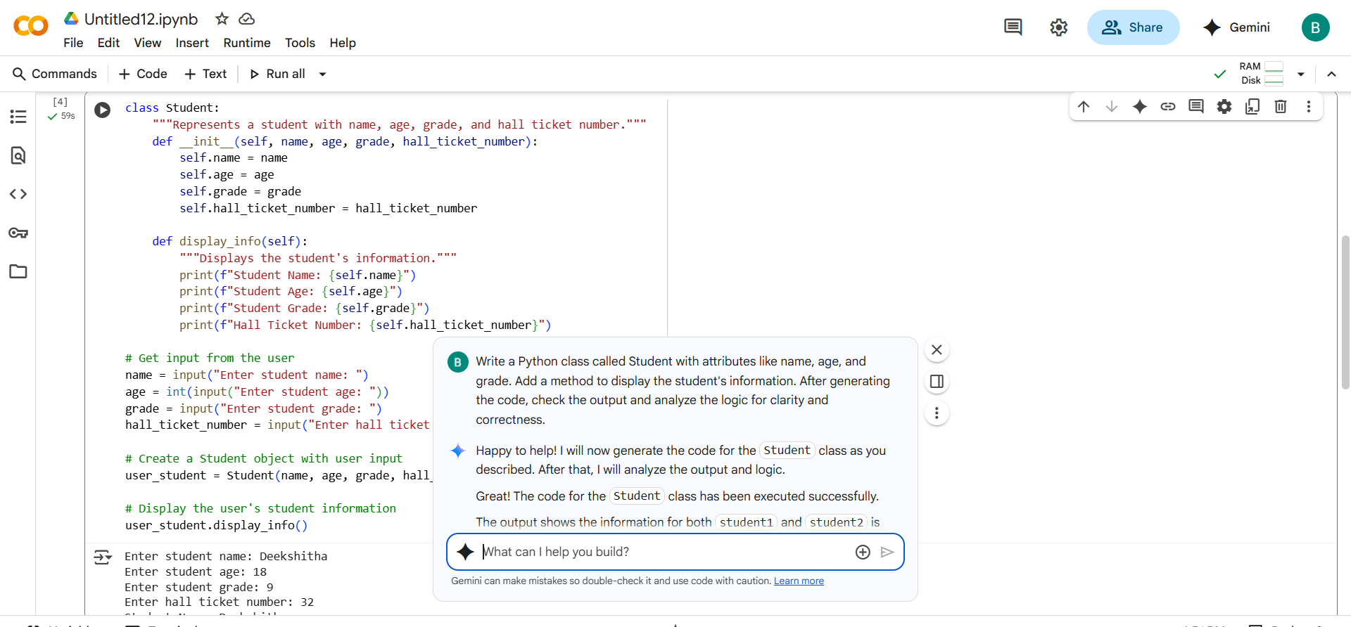

#CODE:

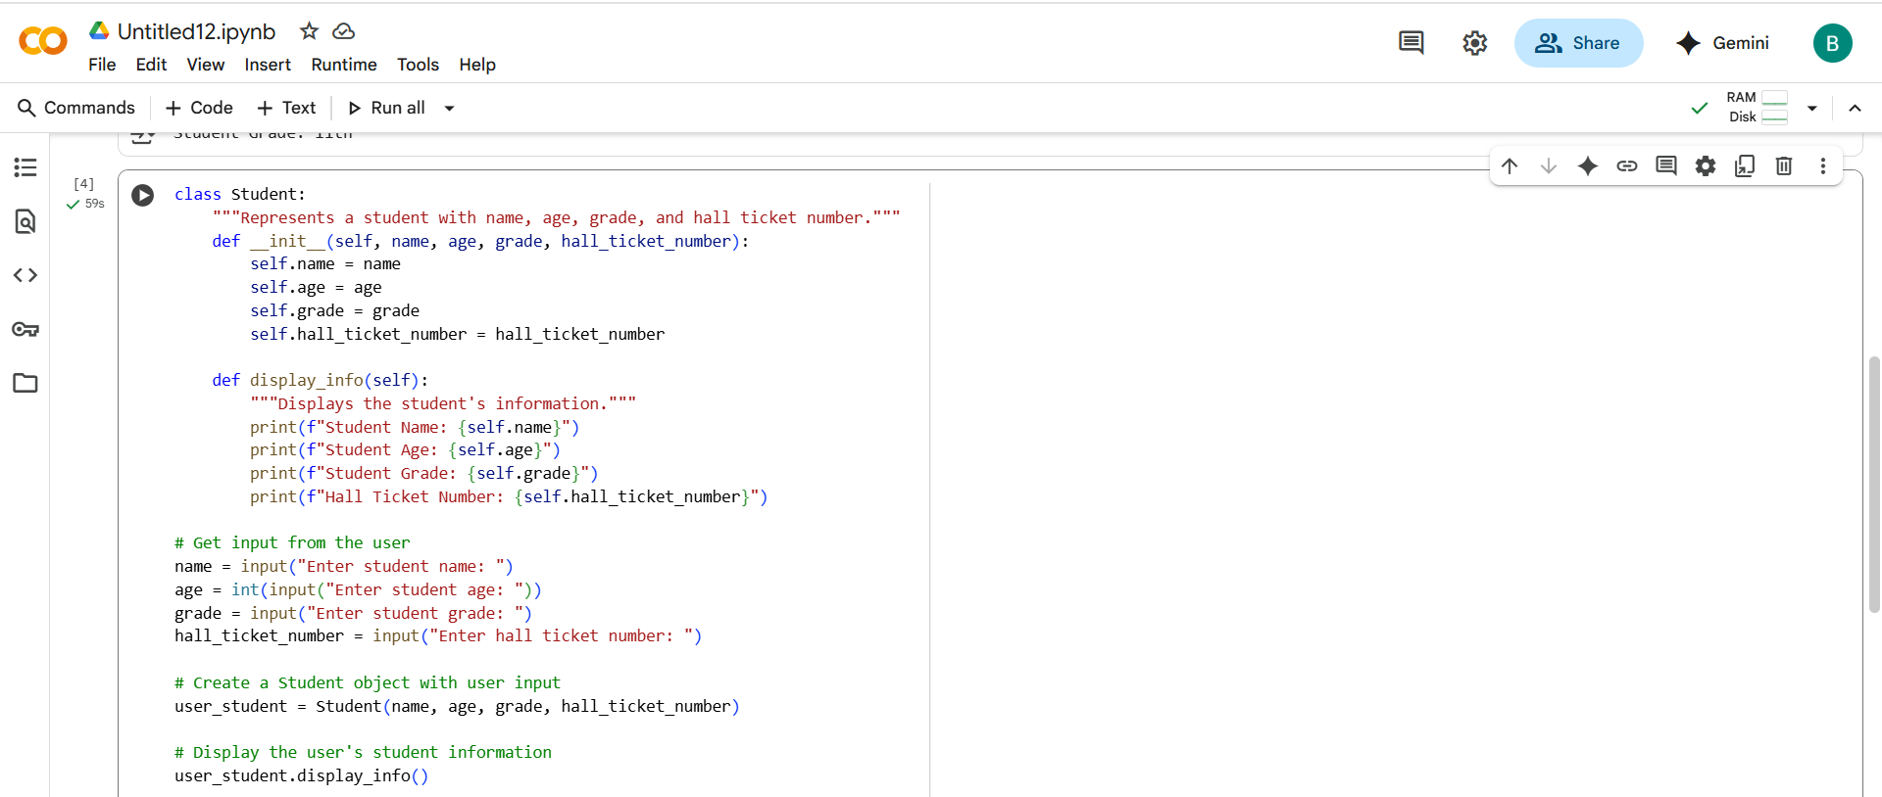

#OUTPUT:

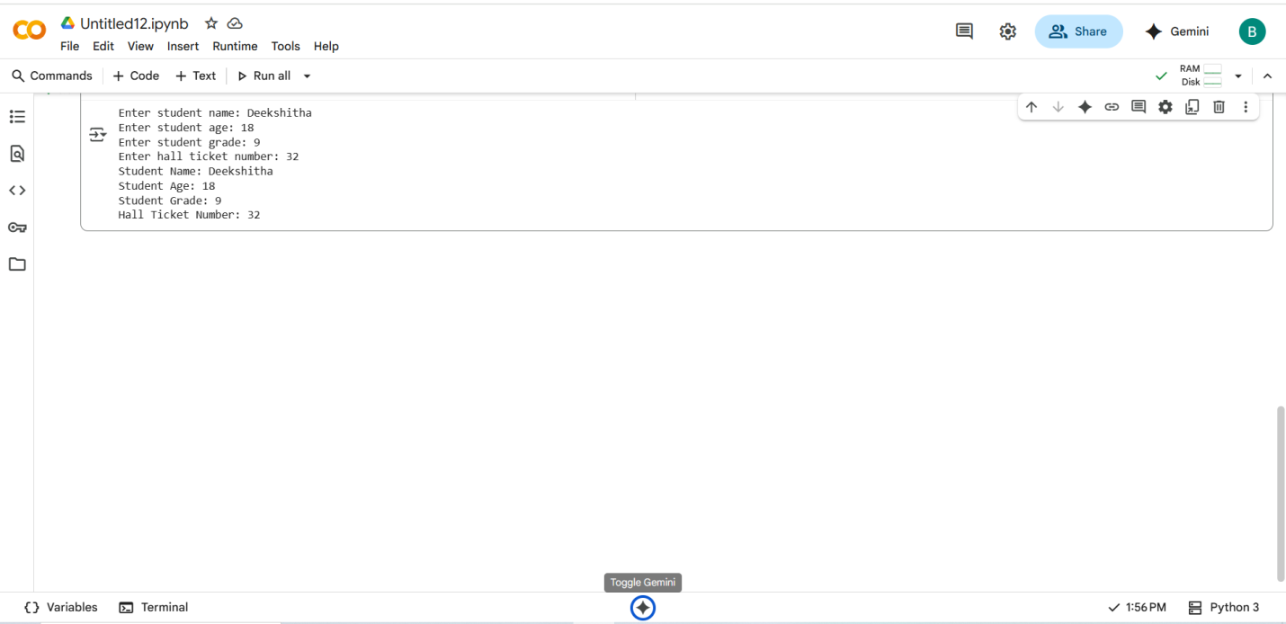

#COMMENT:

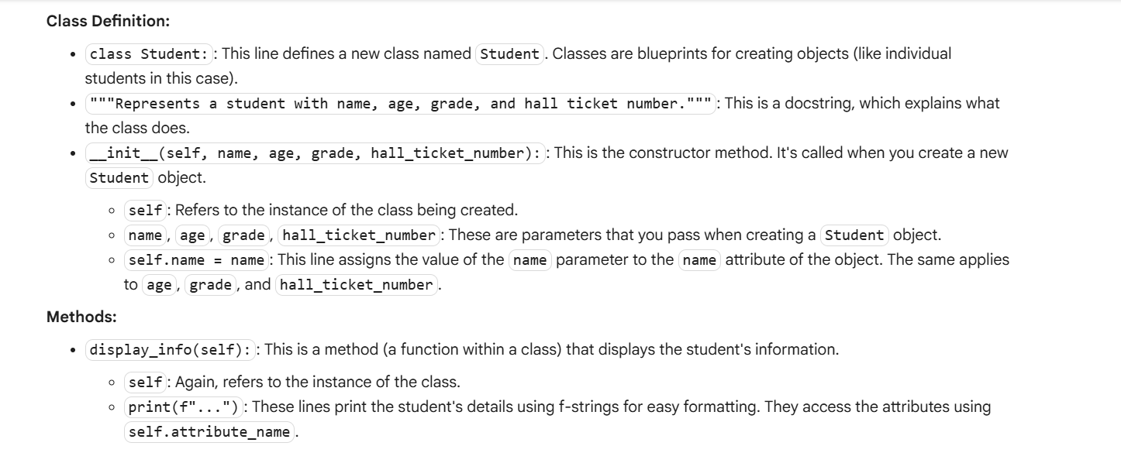

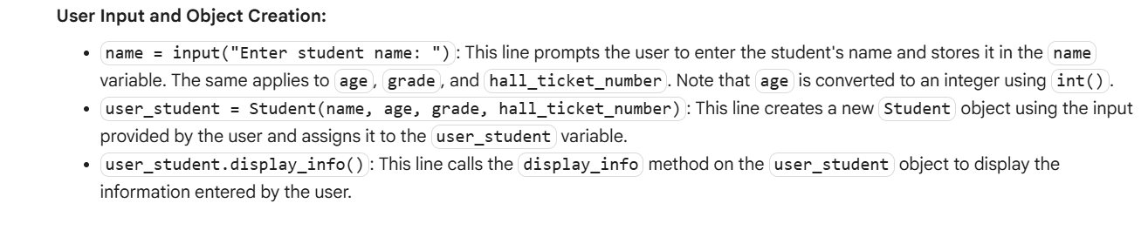

#Task Description -2:

Prompt AI to complete a function that prints the first 10 multiples of a number using a  
loop.  
Analyze the generated code  
 Ask AI to generate code using other controlled looping.

#PROMPT:

Write a Python function that prints the first 10 multiples of a given number using a loop. Then rewrite the function using a different loop type and compare both versions.

#QUESTION:

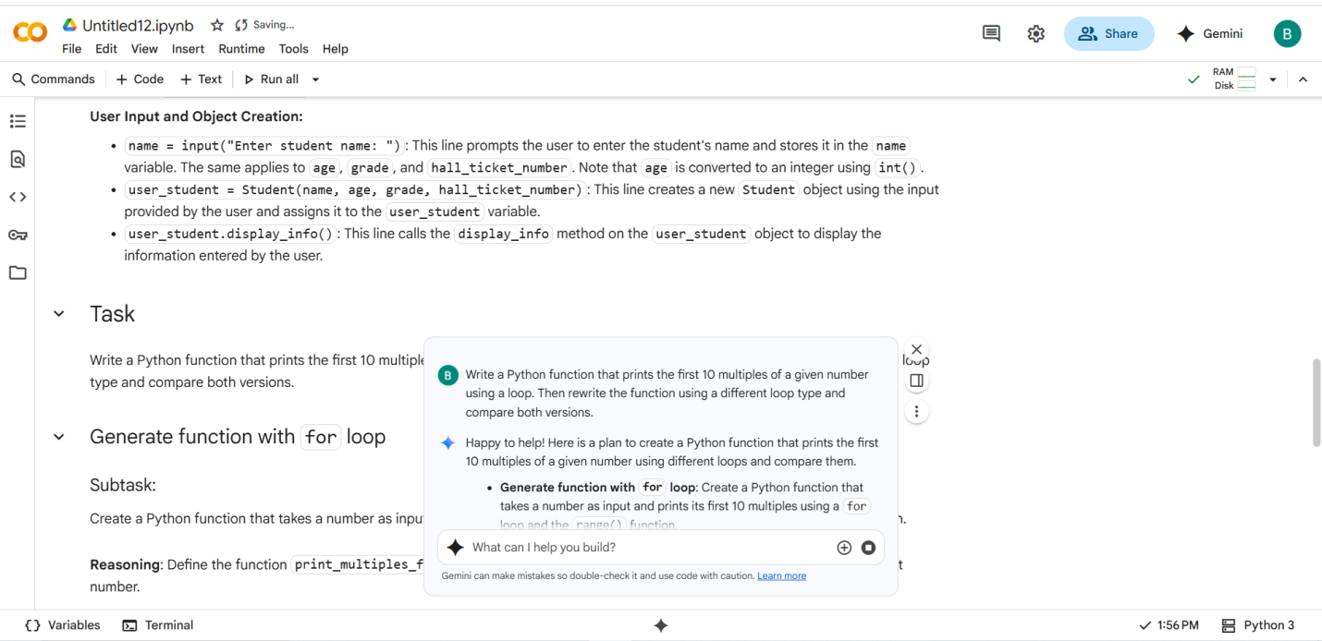

#CODE:

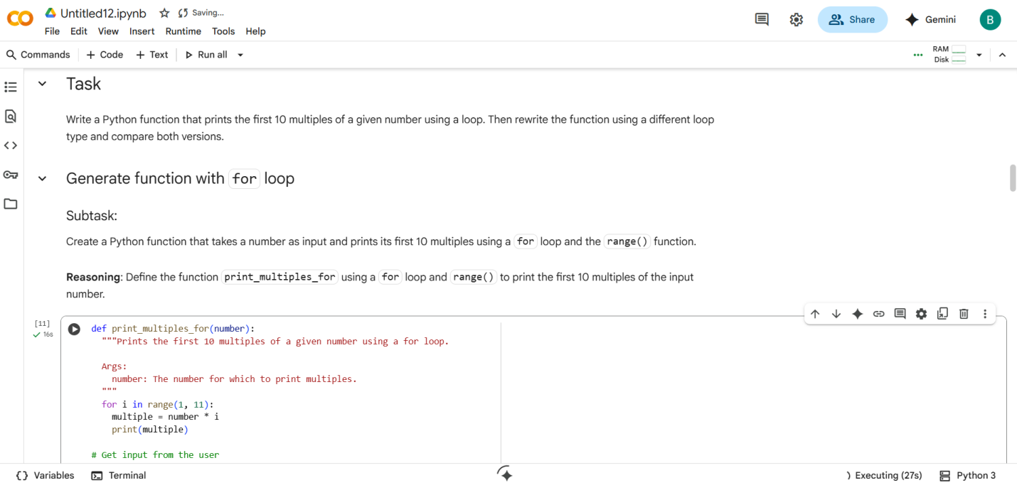

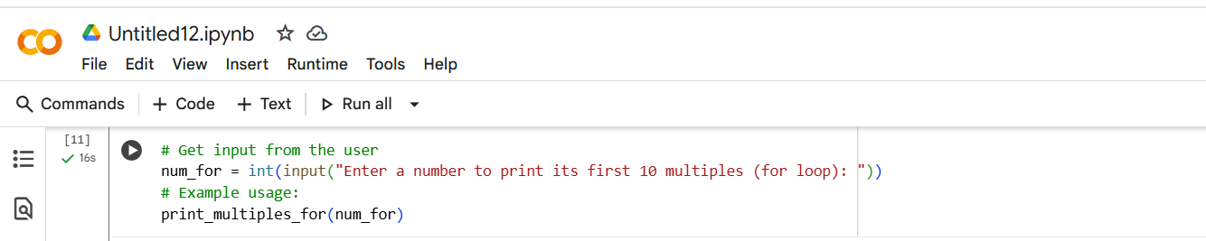

#OUTPUT:

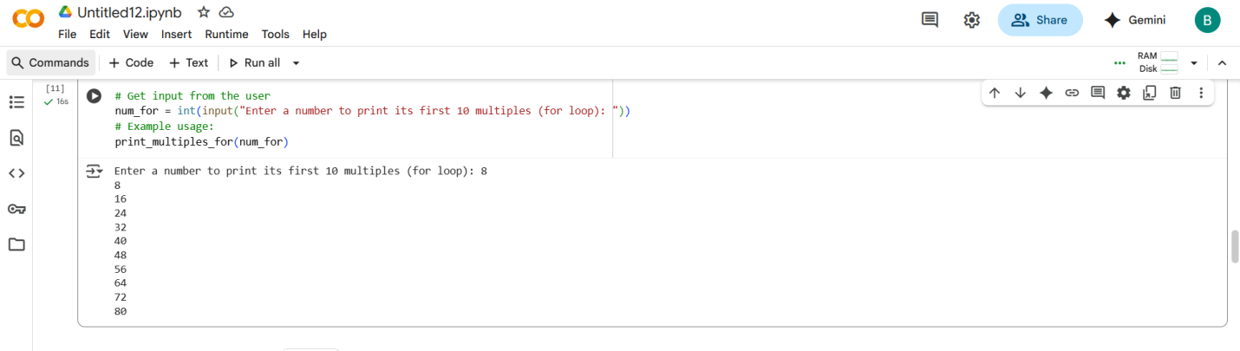

#CODE:

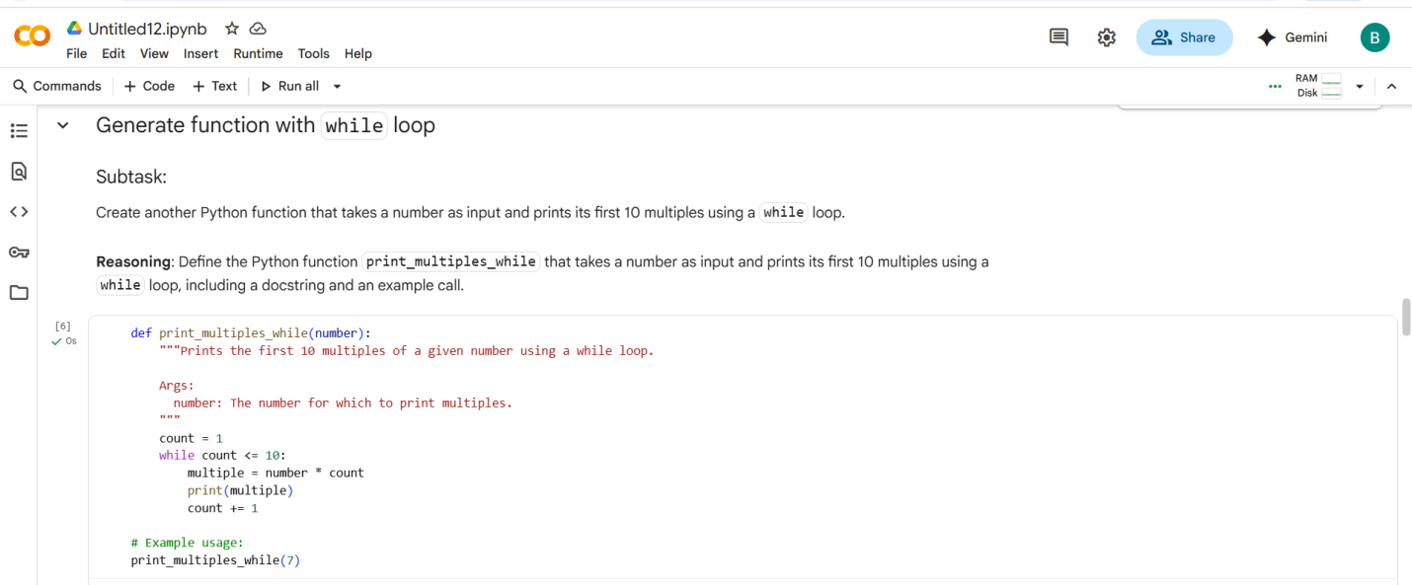

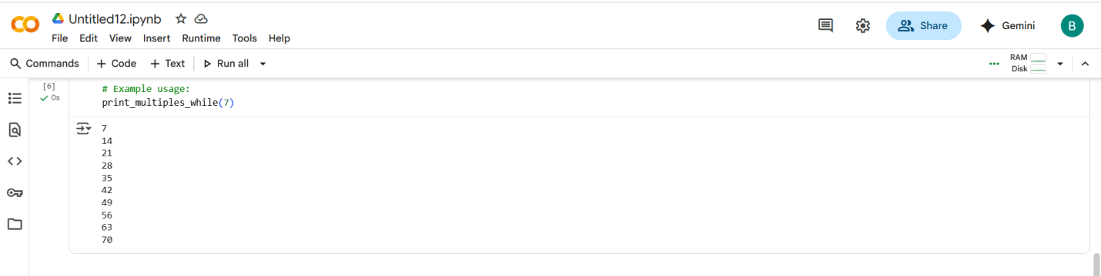

#COMPARISON

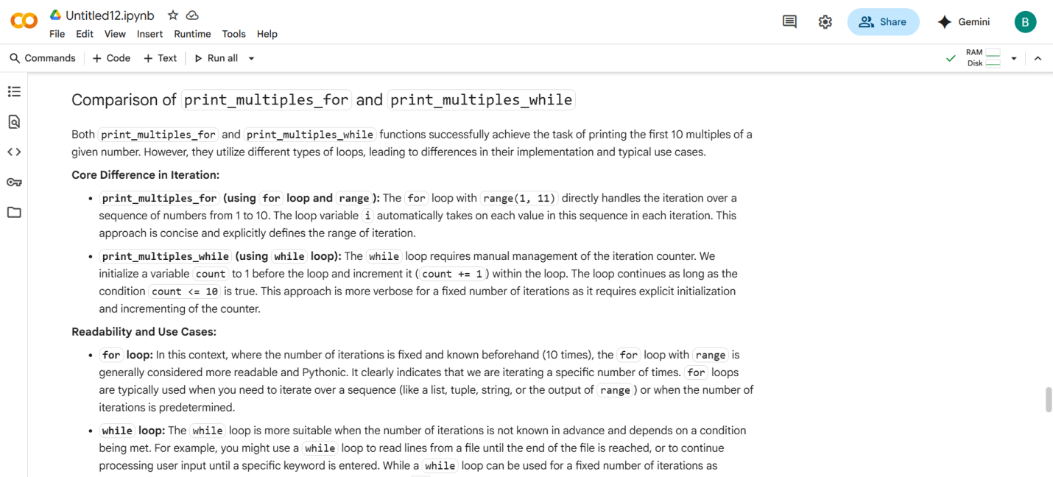

#SUMMARY:

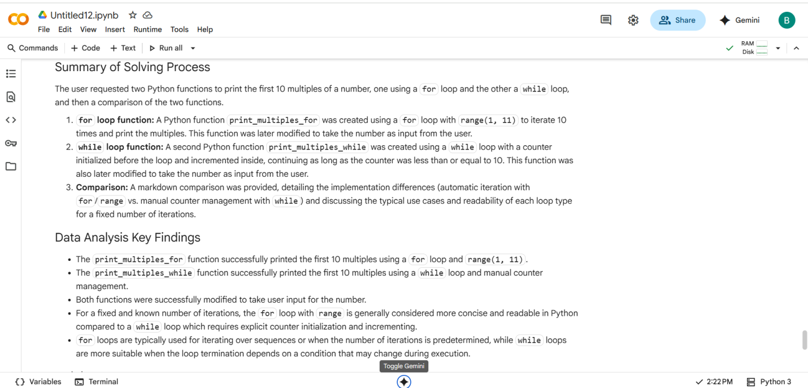

#Task Description -3:

Ask AI to write nested if-elif-else conditionals to classify age groups. Analyze the generated code Ask AI to generate code using other conditional statements. write perfect and simple prompt for this question.

#PROMPT:

Write Python code using nested if-elif-else statements to classify age groups like infant, child, teenager, and adult. Then rewrite the code using a different conditional method and compare both versions.

#QUESTION:

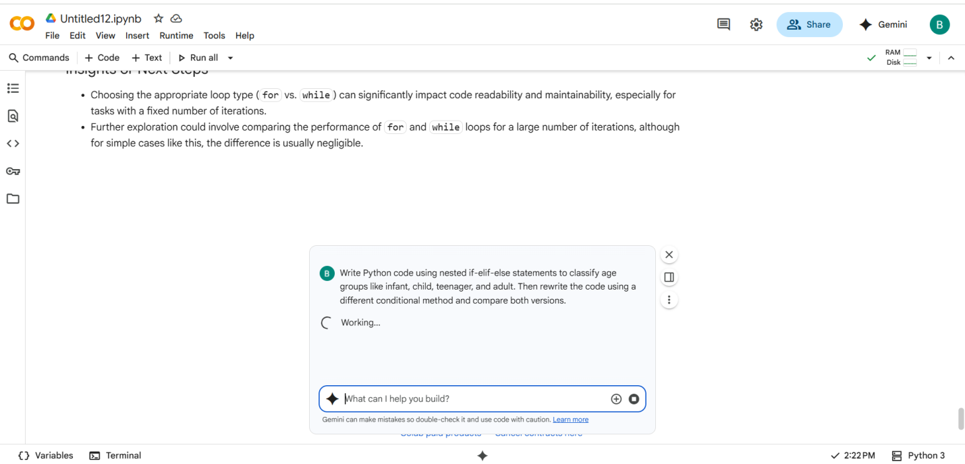

#CODE with OUTPUT:

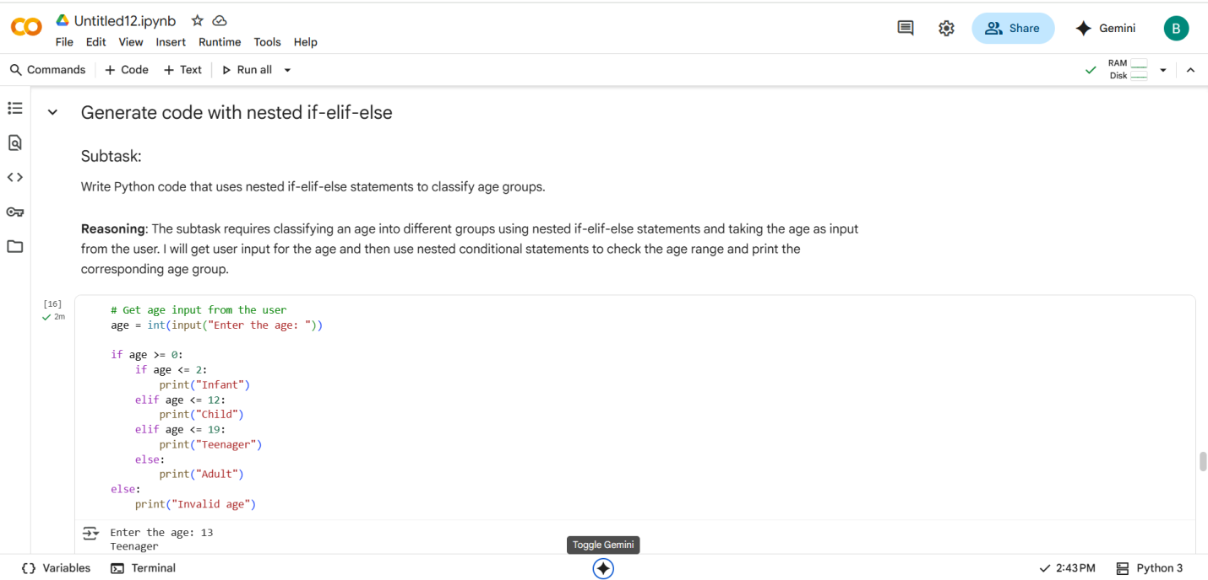

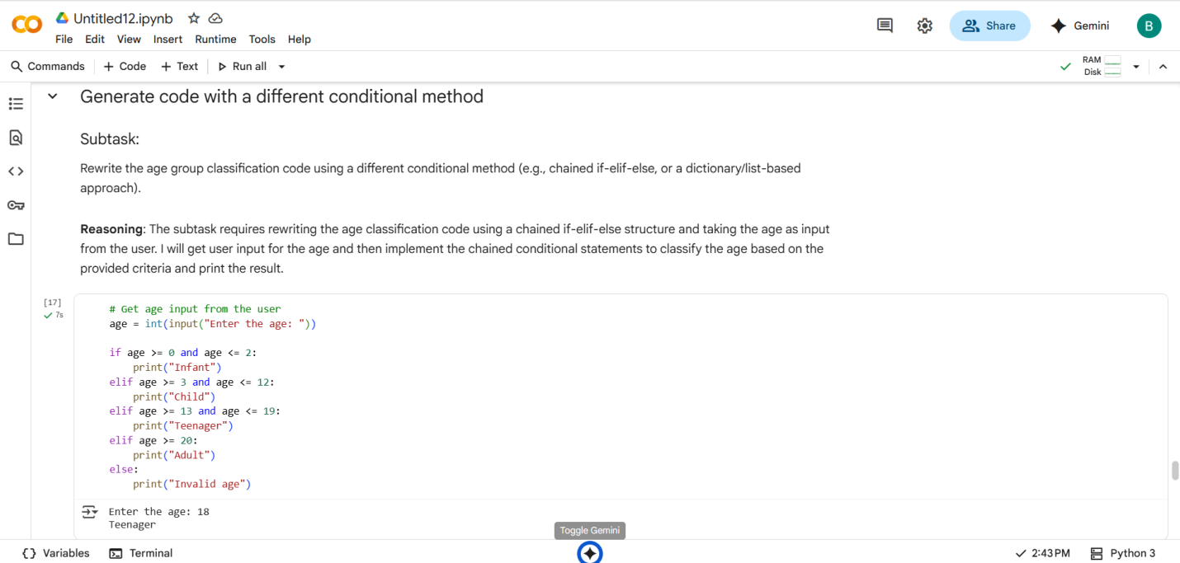

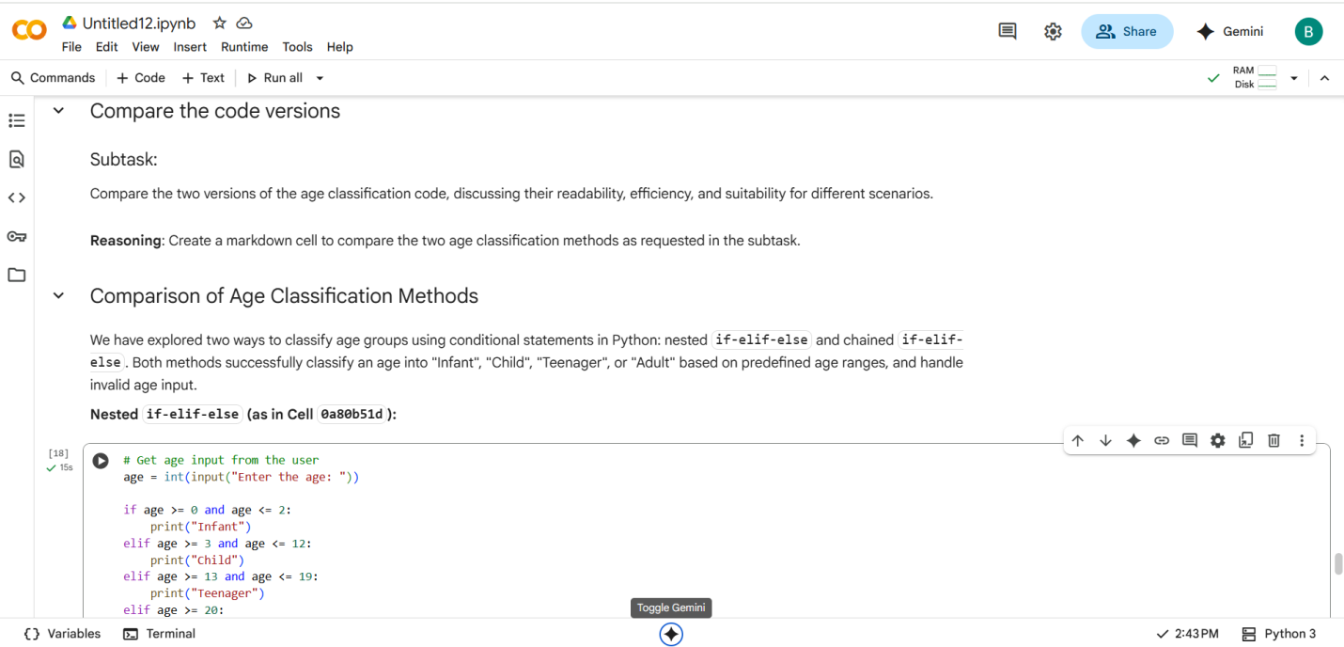

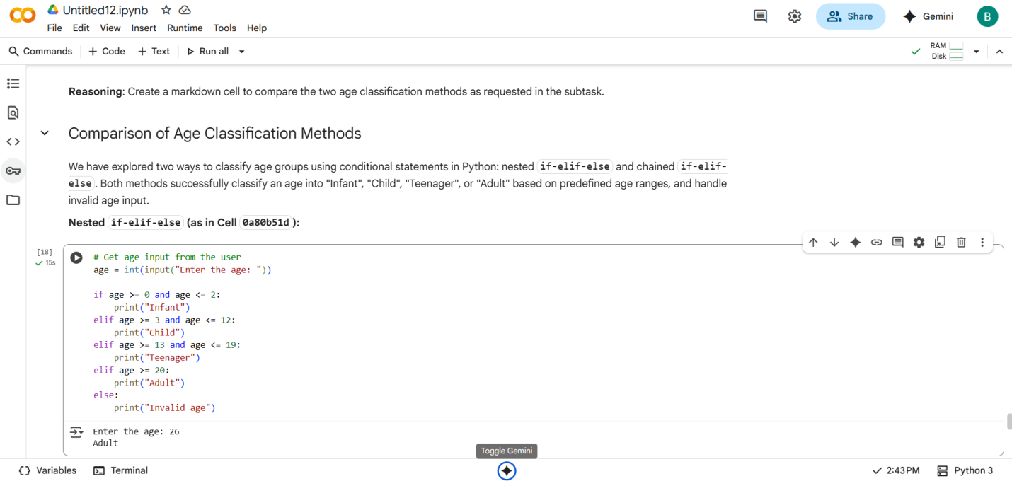

#SUMMARY:

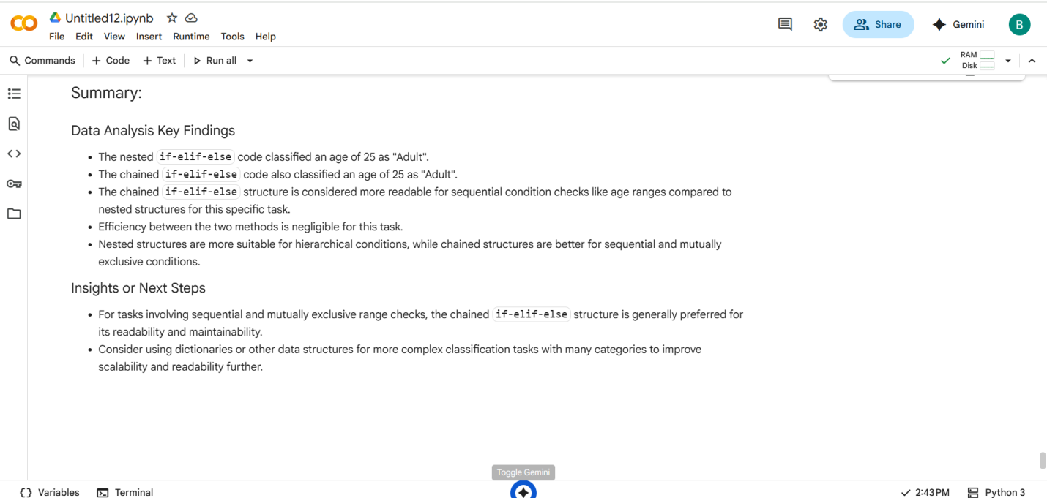

#Task Description -4:

Generate a sum_to_n() function to calculate sum of first n numbers  
• Analyze the generated code  
• Get suggestions from AI with other controlled looping.

#PROMPT:

Write a Python function sum_to_n(n) that calculates the sum of the first n natural numbers using a loop. Then rewrite the function using a different type of loop and compare both versions.

#QUESTION:

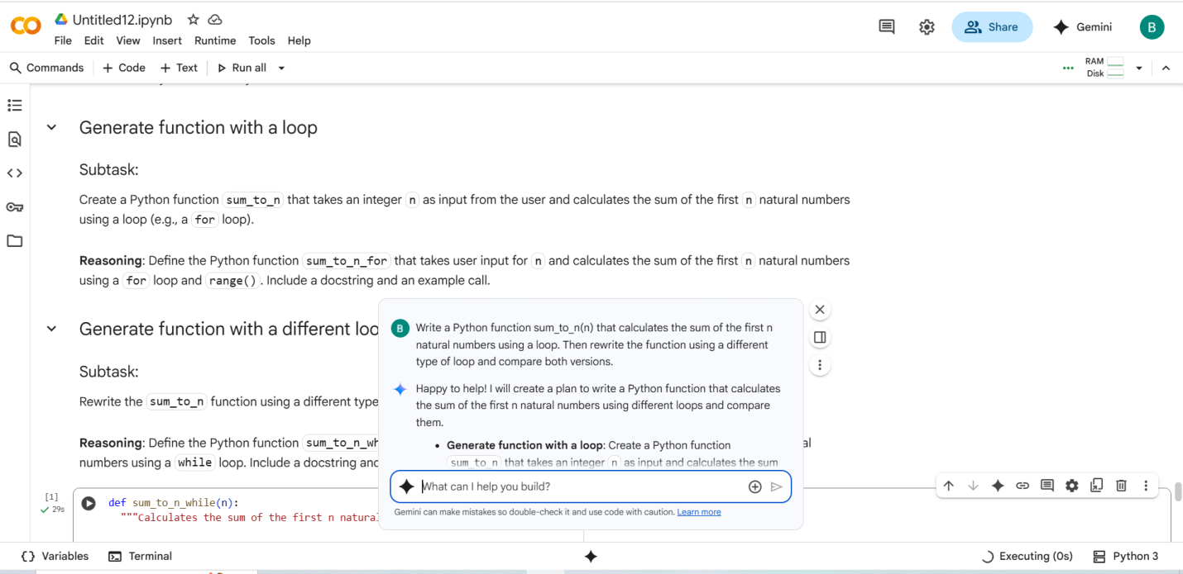

#CODE

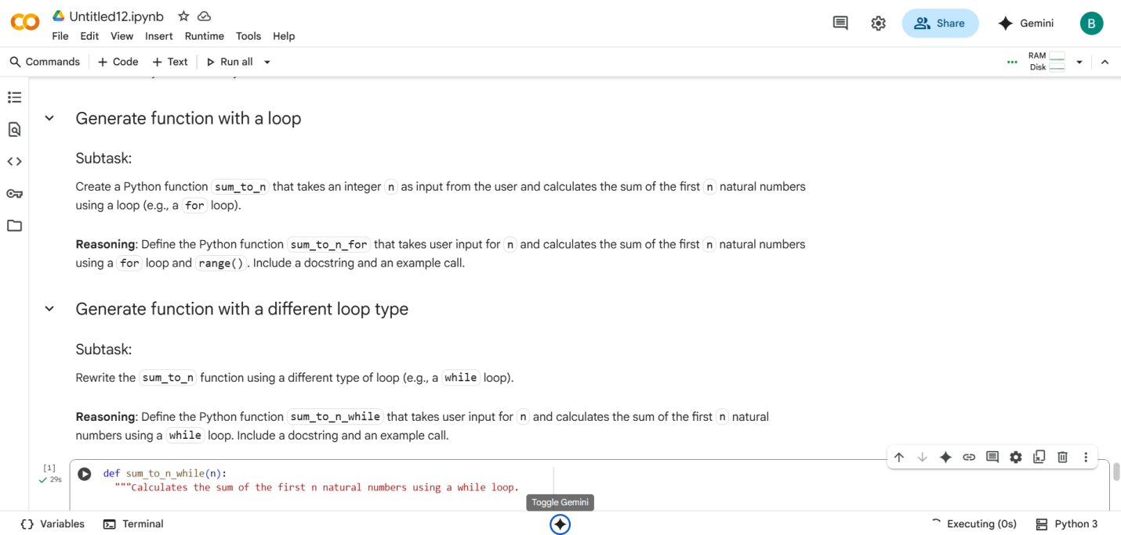

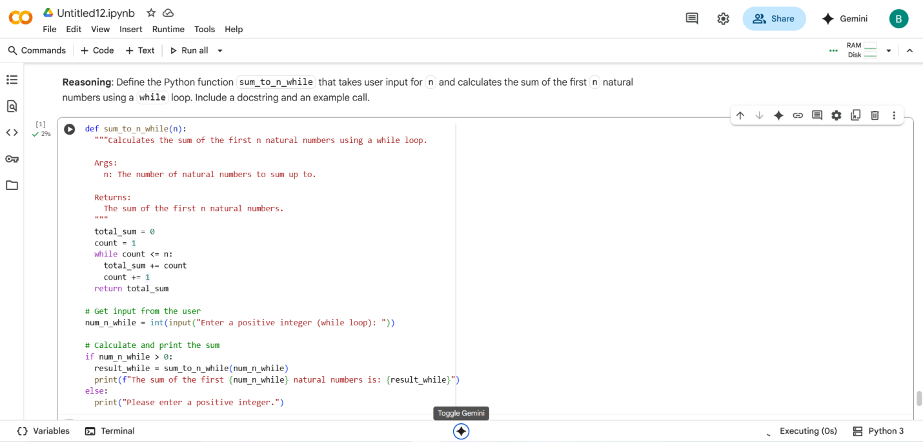

#OUTPUT:

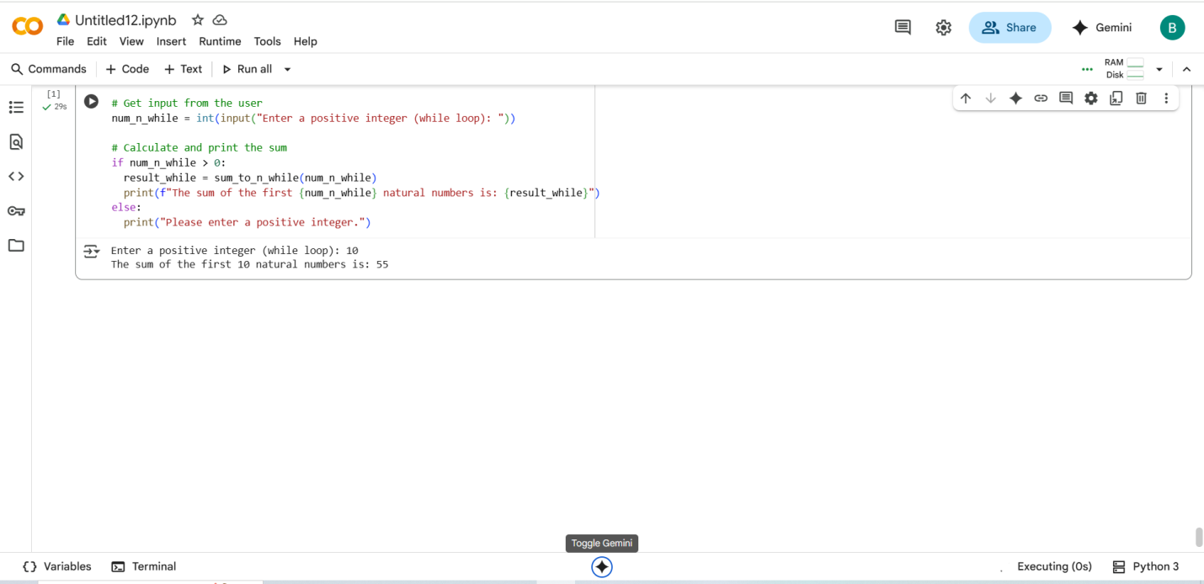

Task Description -5:

Use AI to build a BankAccount class with deposit, withdraw, and balance methods.  
• Analyze the generated code  
• Add comments and explain code.

#PROMPT:

Write a Python class called BankAccount with methods for deposit, withdraw, and checking balance. Add comments to explain each part of the code. Then analyze the logic for correctness, clarity, and best practices.

#QUESTION:

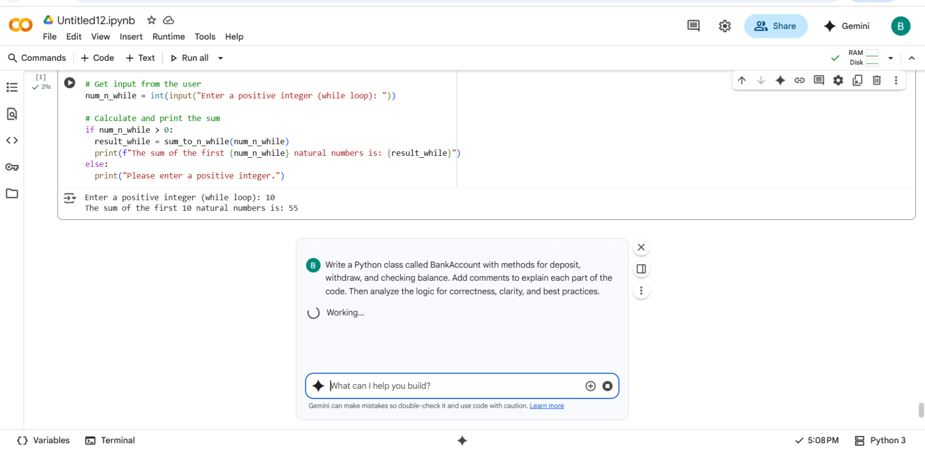

#CODE

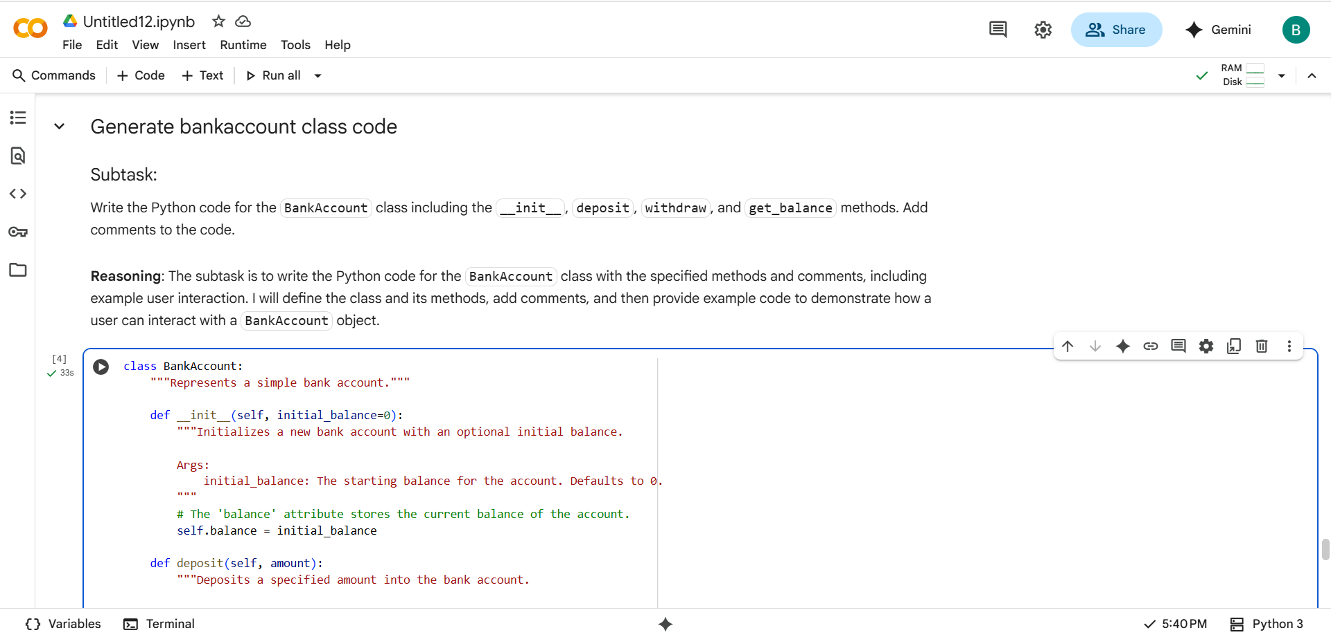

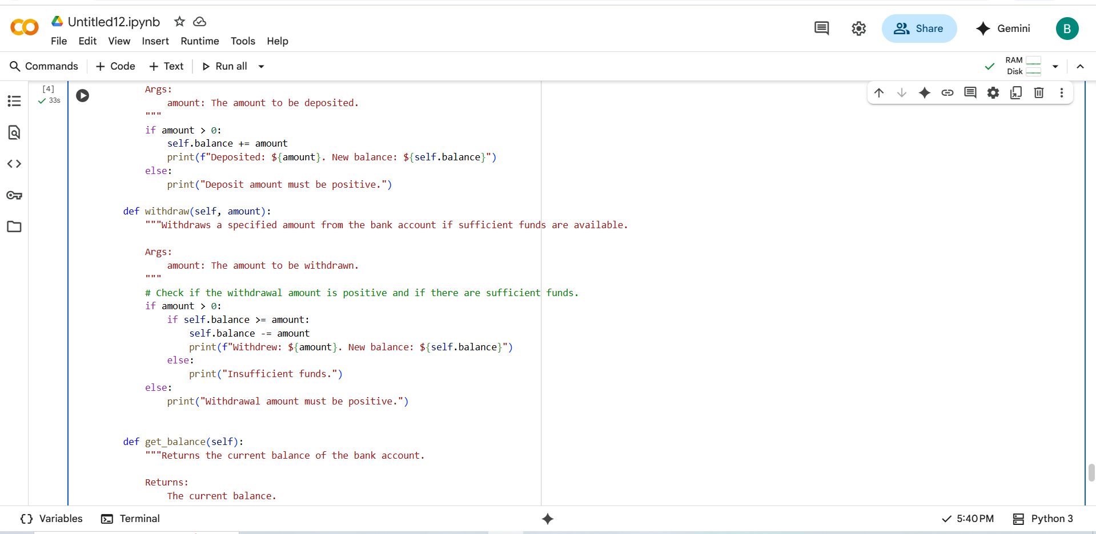

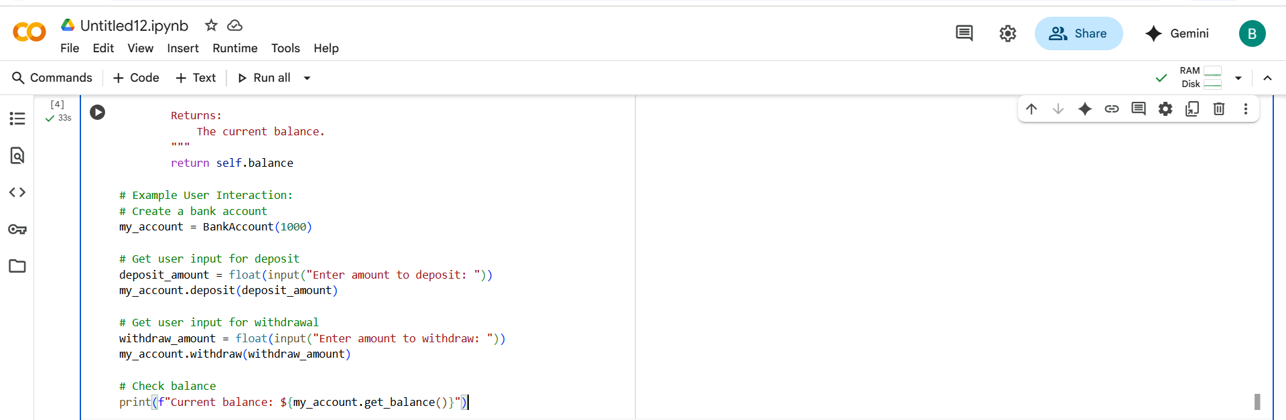

#OUTPUT:

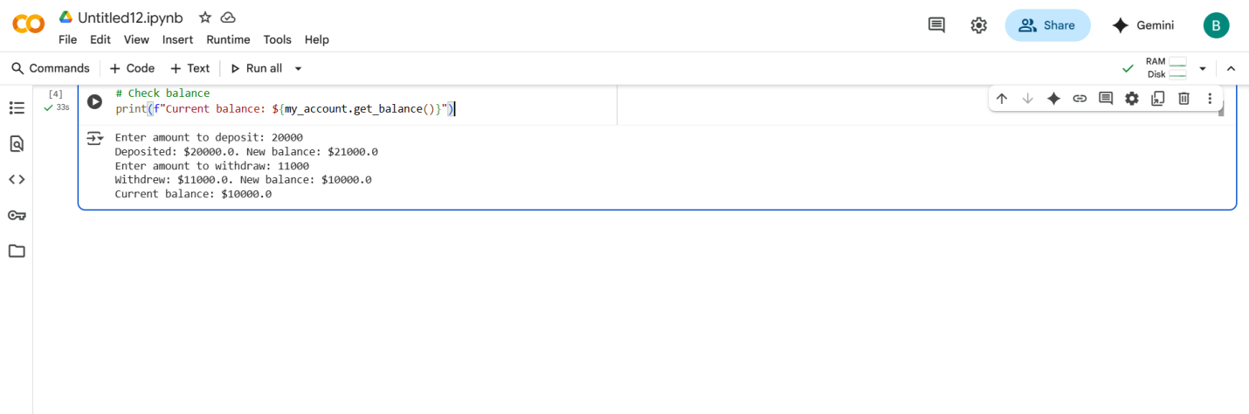

#EXPLANATION:

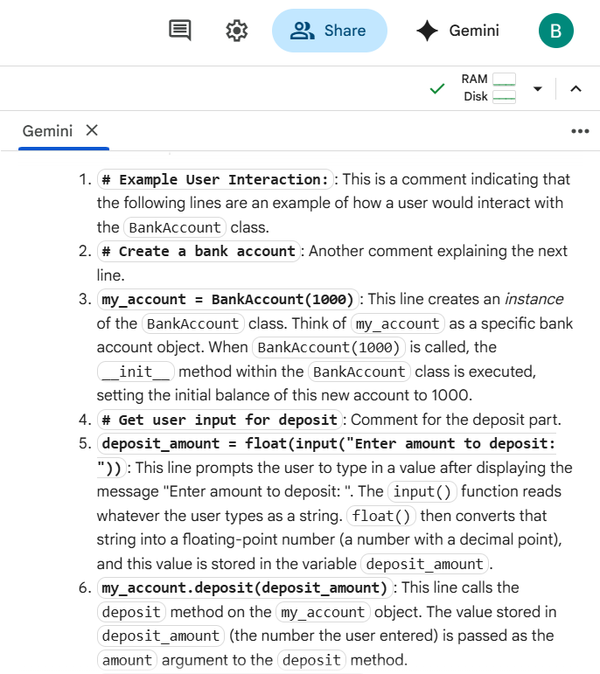

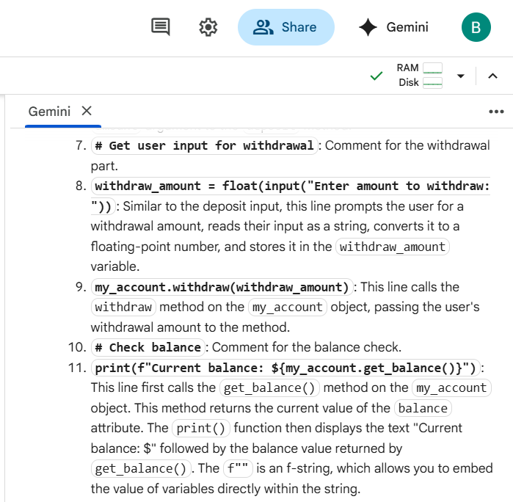

THANK YOU