
Program :B.tech(CSE)
Specialization :AIML
Course Title :AI Assisted Coding
Course Code :24CS002PC215
Semester :3rd semester
Academic Session :2025-2026
Name of Student :Bachanagari Deekshitha
Enrollment No. :2403A52032
Batch No. :02
Date :08/10/2025
#LAB ASSIGNMENT
#TASK DESCRIPTION-1:
- Ask AI to implement a stack class with push(), pop(), peek() and
is_empty() methods
#PROMPT:
Write a Python program that implements a Stack class with push(), pop(), peek(), and is_empty() methods.
The program should take user input to perform stack operations (like push, pop, peek, or check if empty) until the user chooses to exit.
Display clear messages for each action and show the stack after every operation.
#QUESTION:
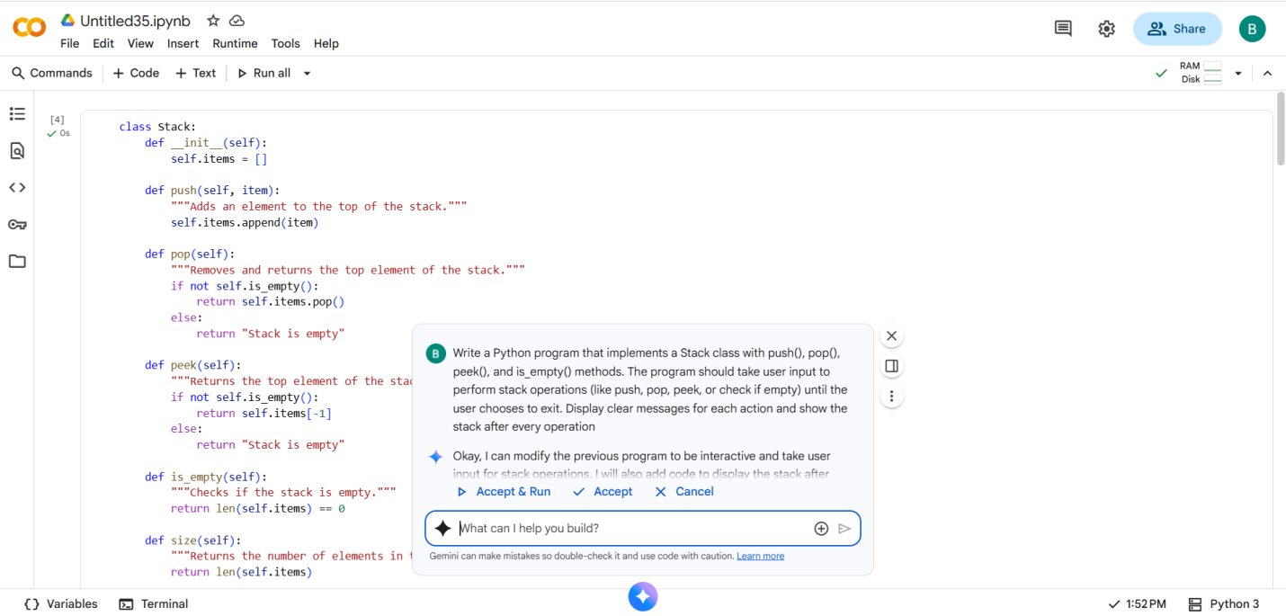
#CODE with OUTPUT:
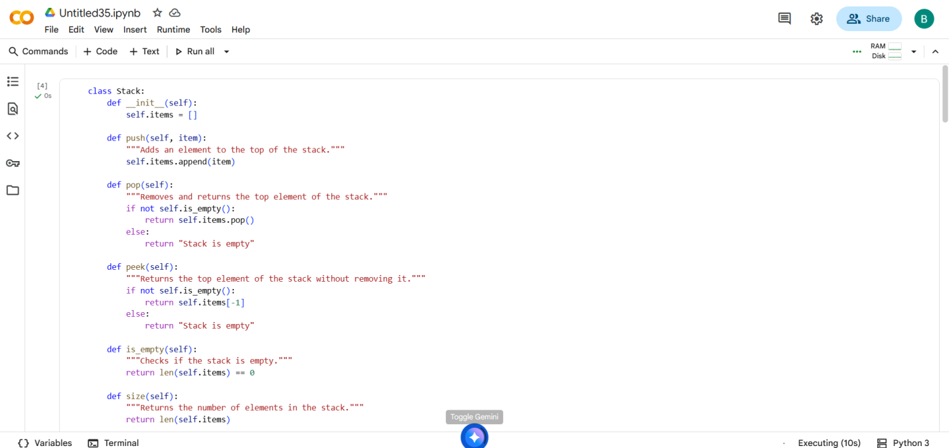
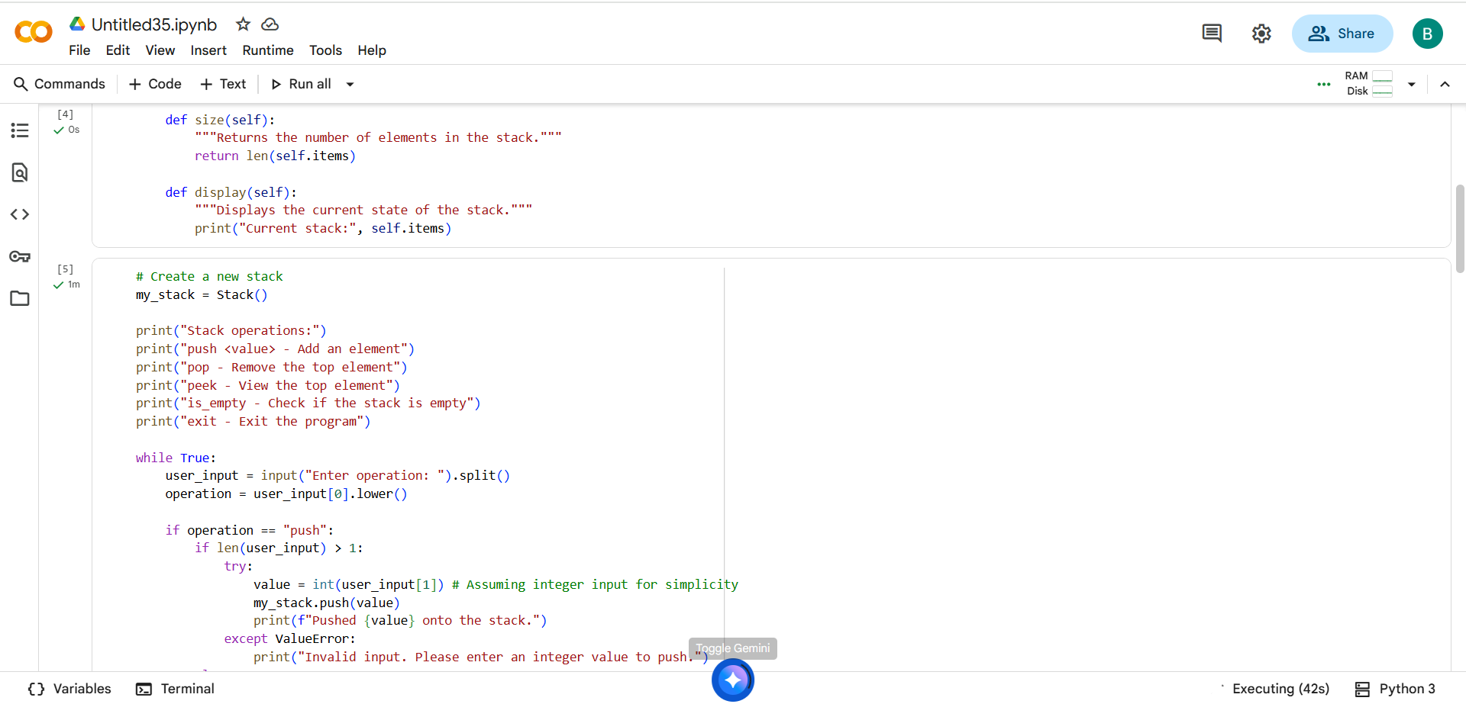
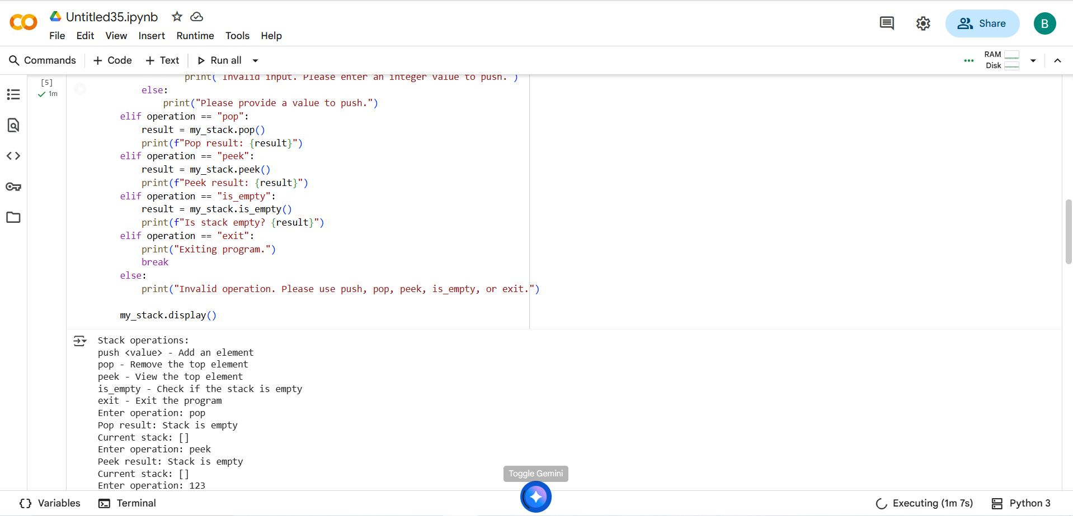
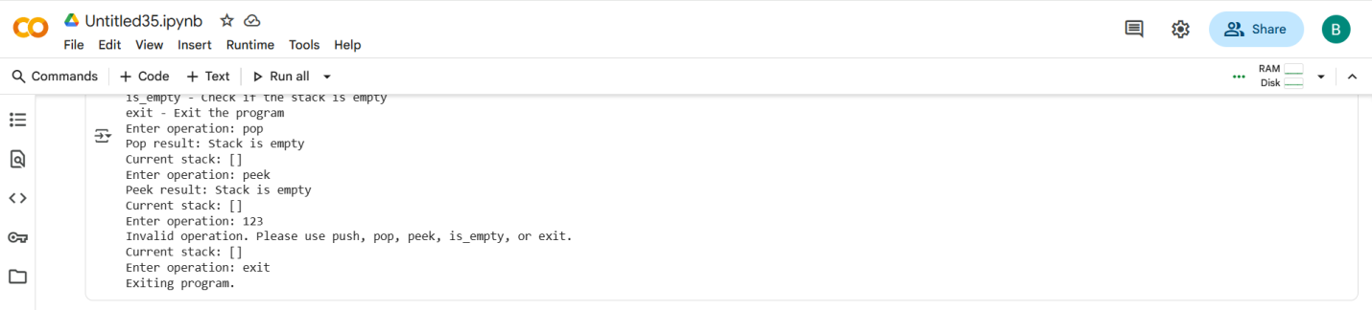

#TASK DESCRIPTION-2:
- Use AI to generate a Queue class with enqueue(), dequeue(), and
is_empty().
#PROMPT:
Write a Python program that implements a Queue class with enqueue(), dequeue(), and is_empty() methods.
The program should allow the user to perform queue operations through input (like adding, removing, or checking if empty) until they choose to exit.
Show clear messages and display the current queue after each operation.
#QUESTION:
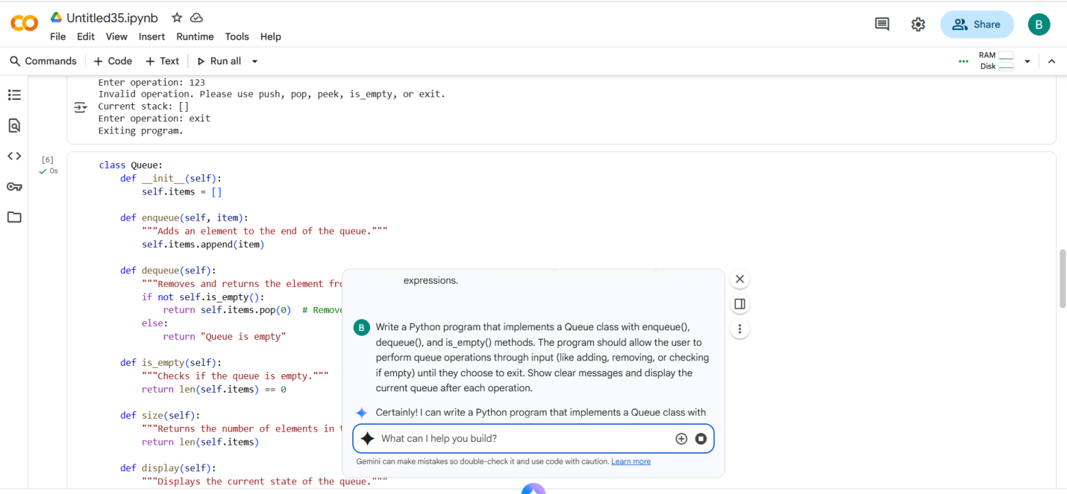
#CODE with OUTPUT:

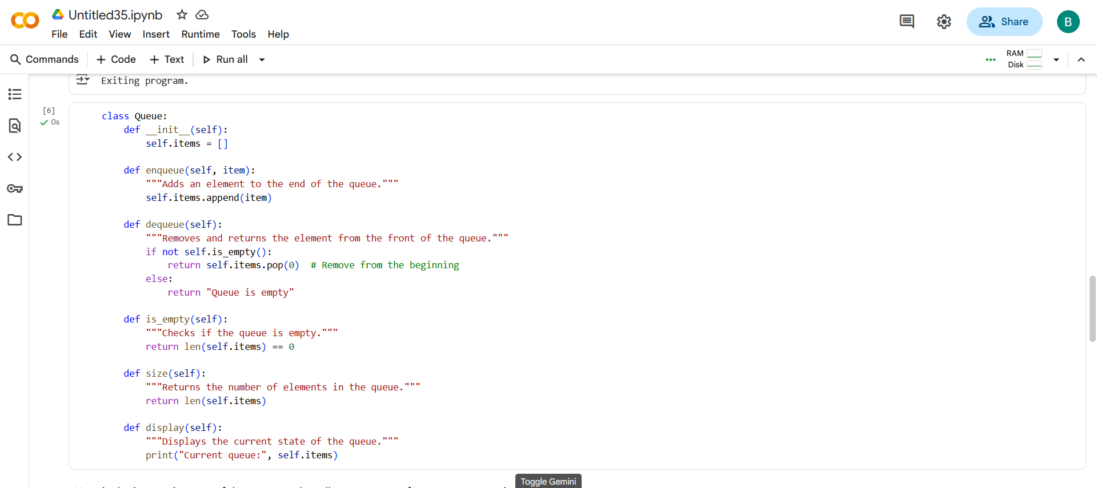
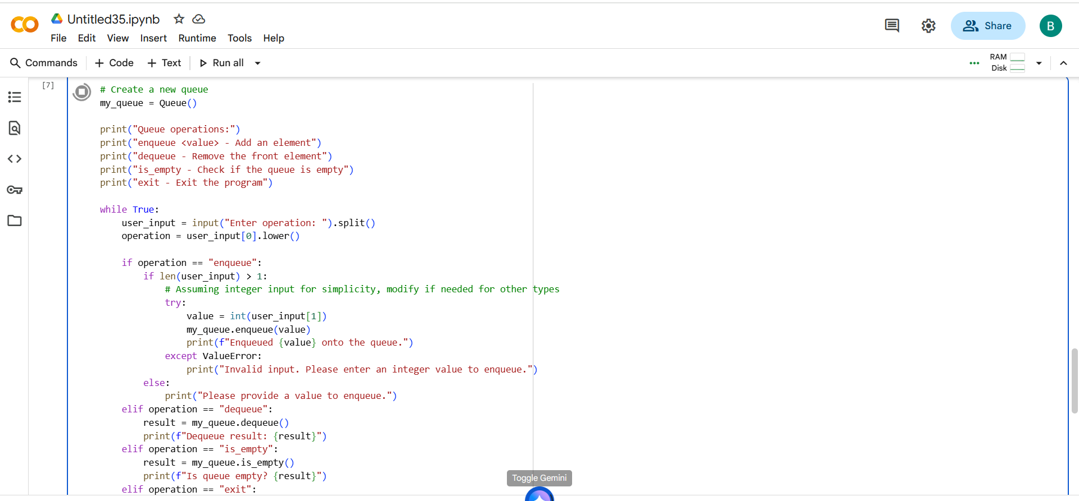
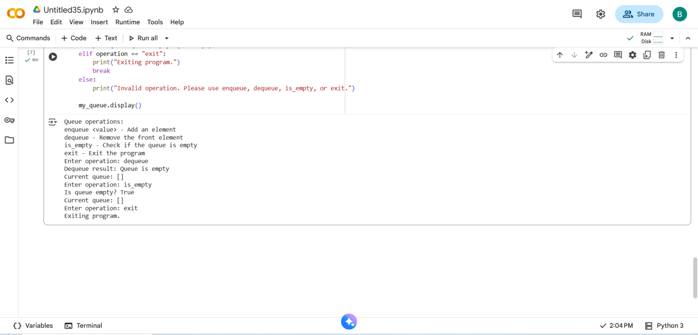
#TASK DESCRIPTION-3:
- Ask AI to create a singly linked list with insert_at_end(),
insert_at_beginning(), and display().
#PROMPT:
Write a Python program that creates a Singly Linked List class with methods insert_at_beginning(), insert_at_end(), and display().
The program should take user input to perform these operations until the user chooses to exit.
Show clear messages and display the linked list after each operation.
#QUESTION:
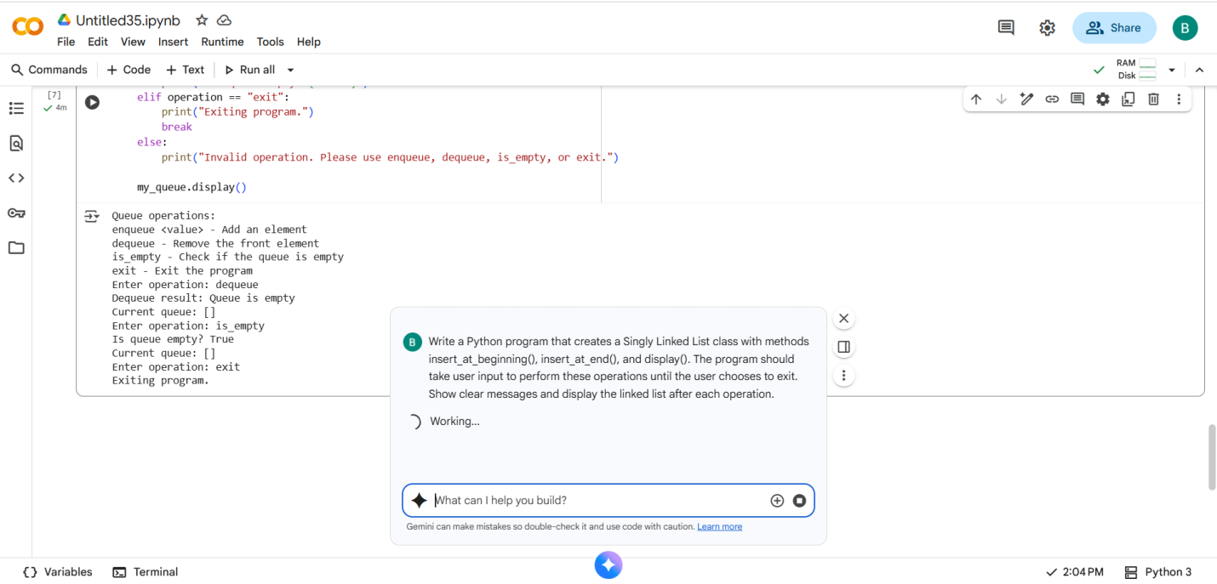
#CODE with OUTPUT:
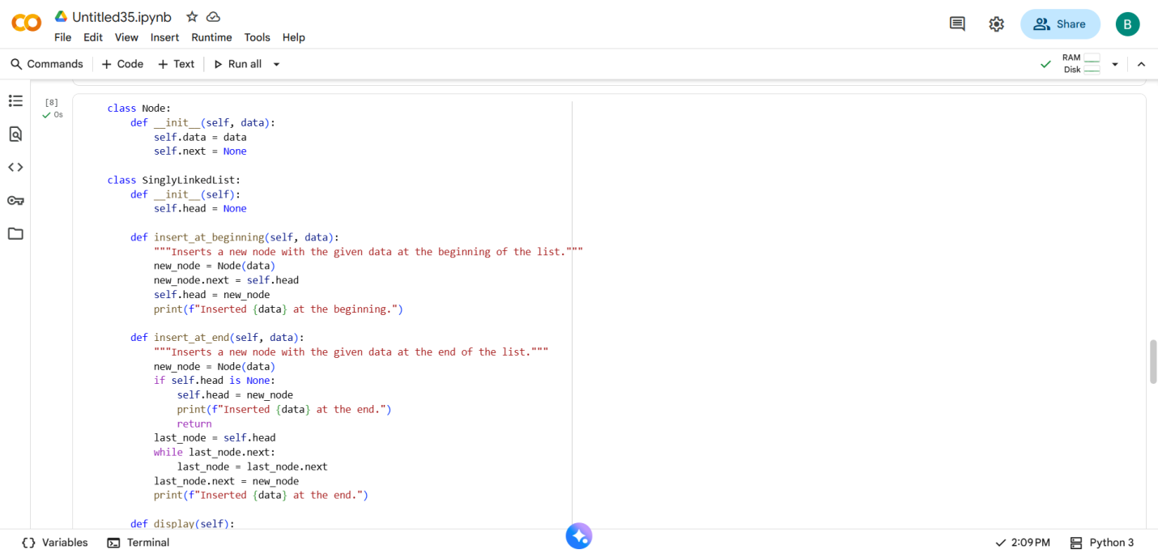
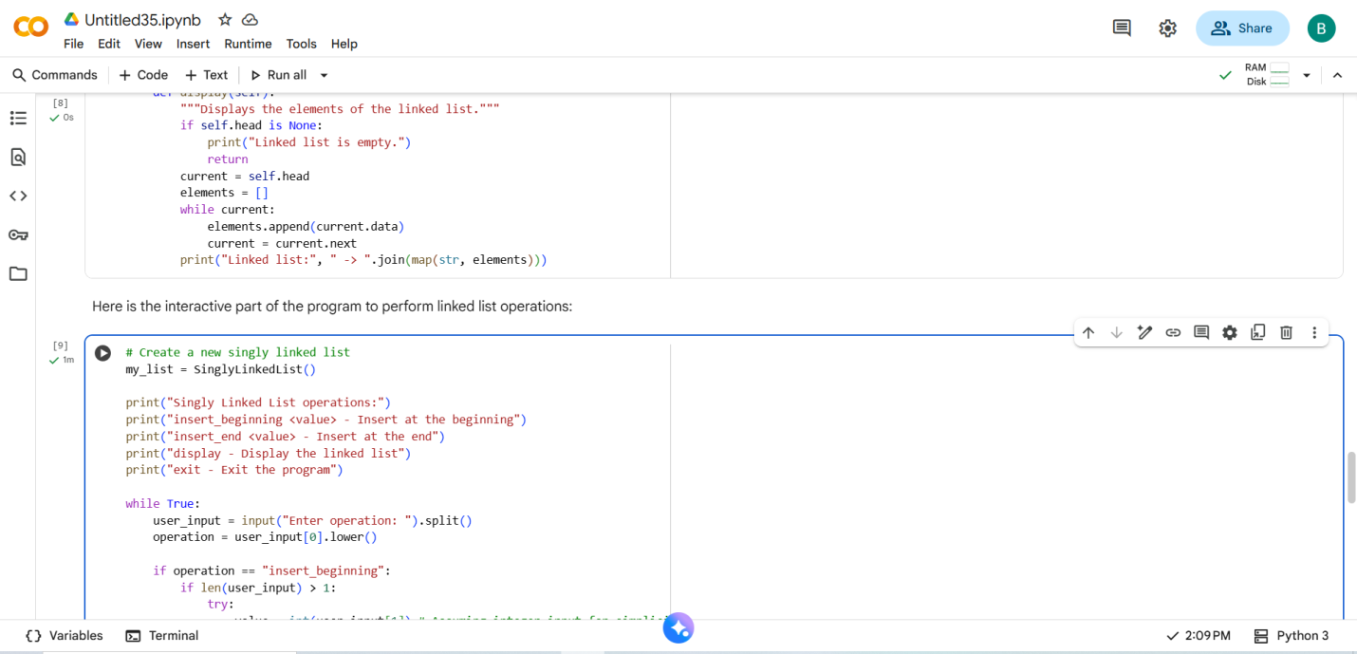
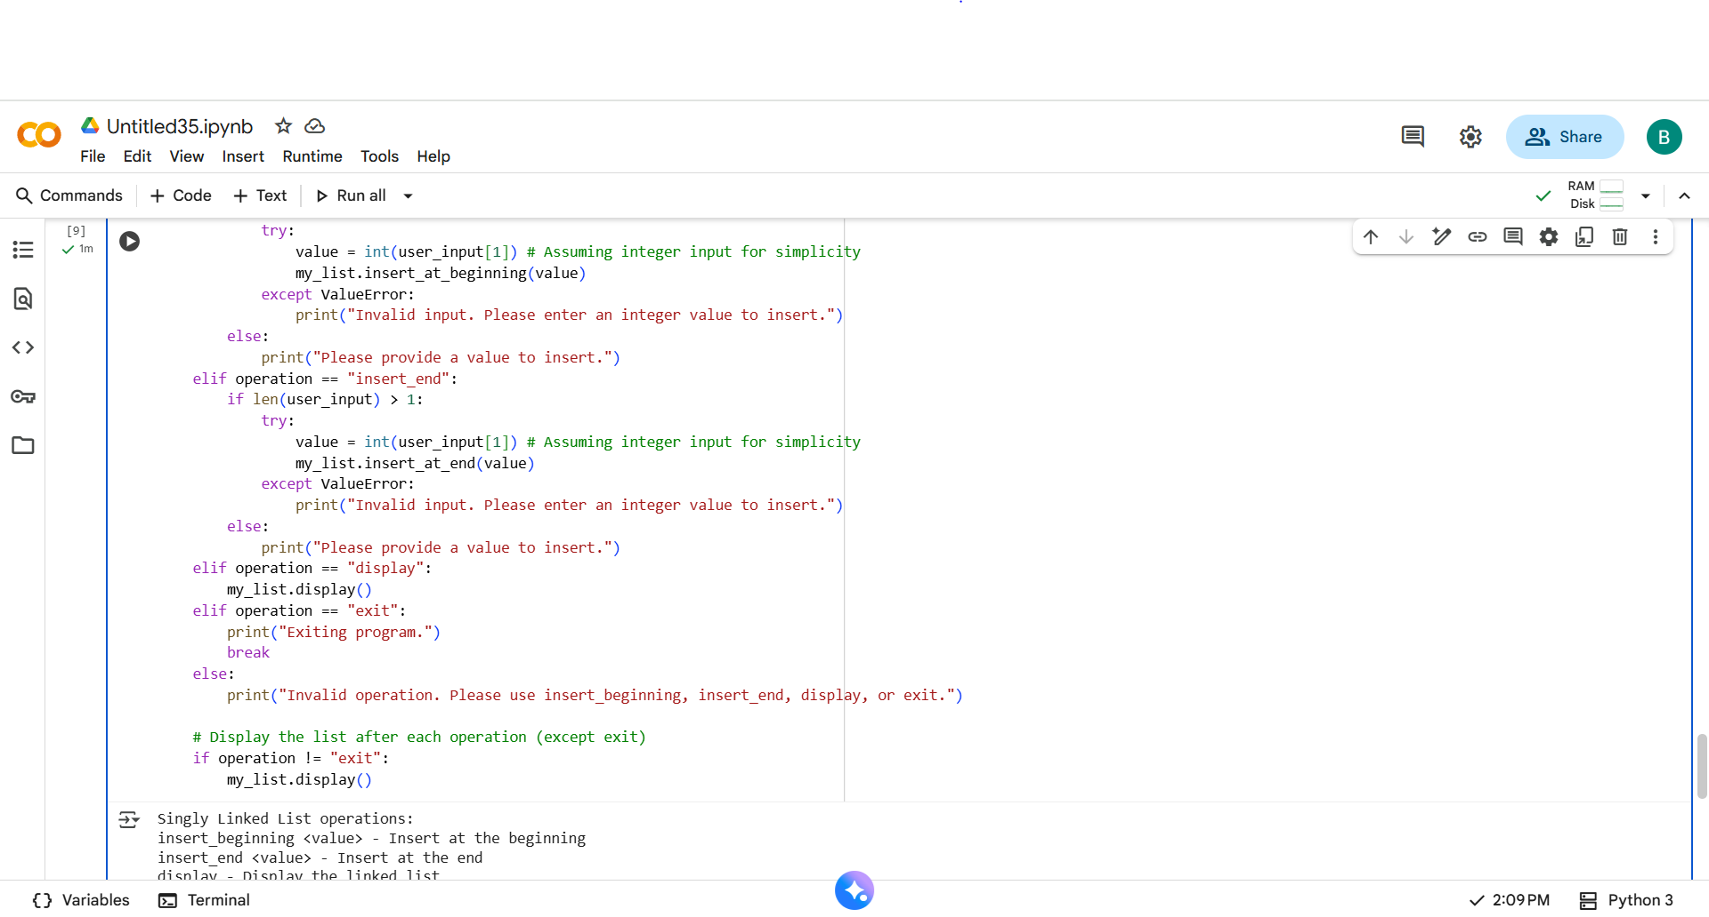
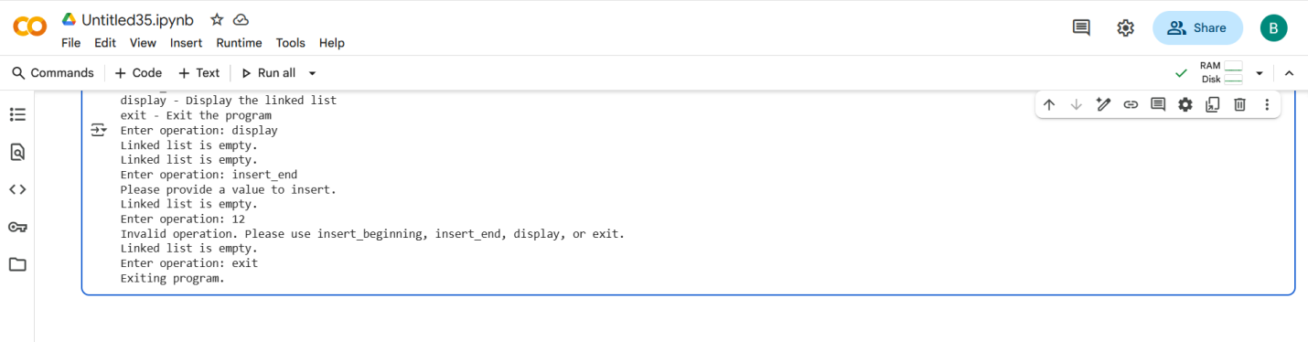
#TASK DESCRIPTION-4:
- Ask AI to generate a simple BST with insert() and
inorder_traversal().
#PROMPT:
Write a Python program that implements a simple Binary Search Tree (BST) with insert() and inorder_traversal() methods.
The program should allow the user to insert elements into the tree using input and then display the inorder traversal of the BST.
Show clear messages for each operation
#QUESTION:
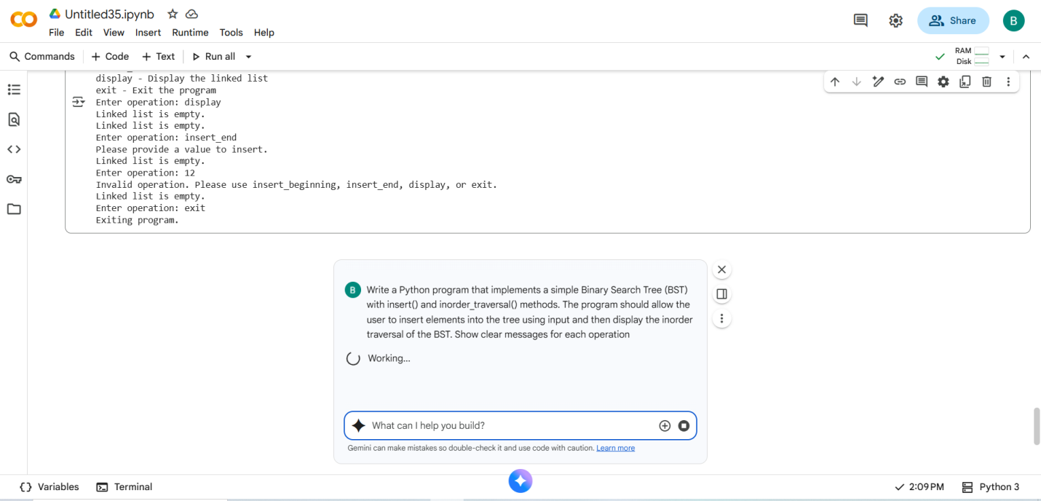
#CODE with OUTPUT:

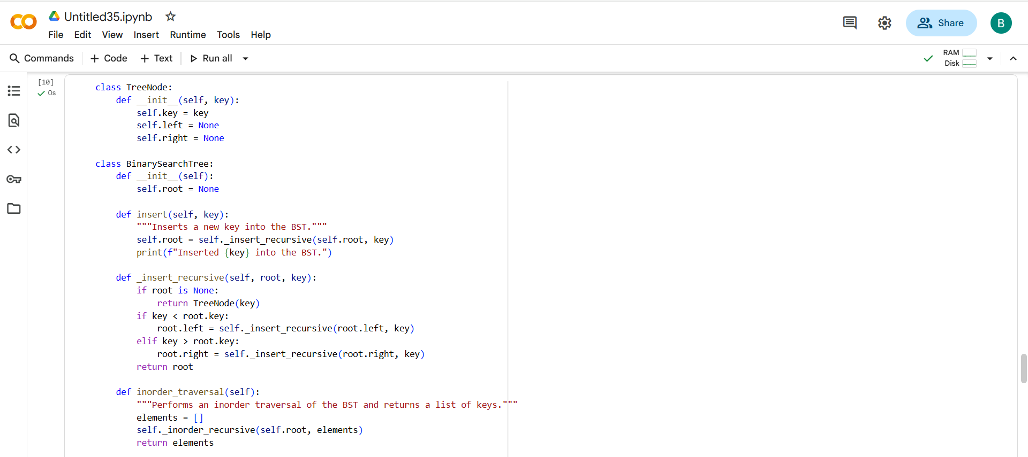
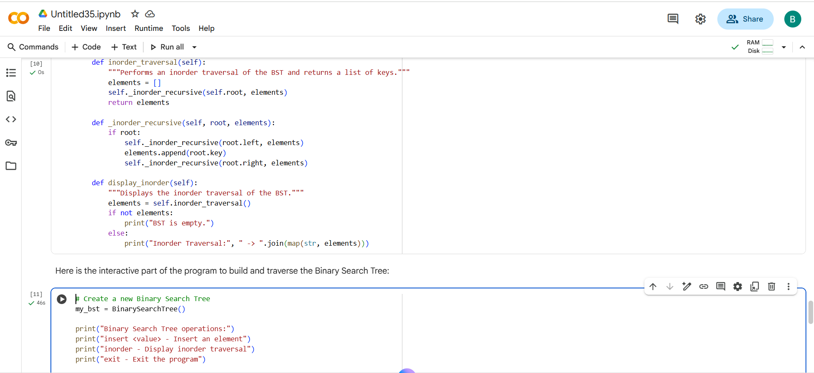
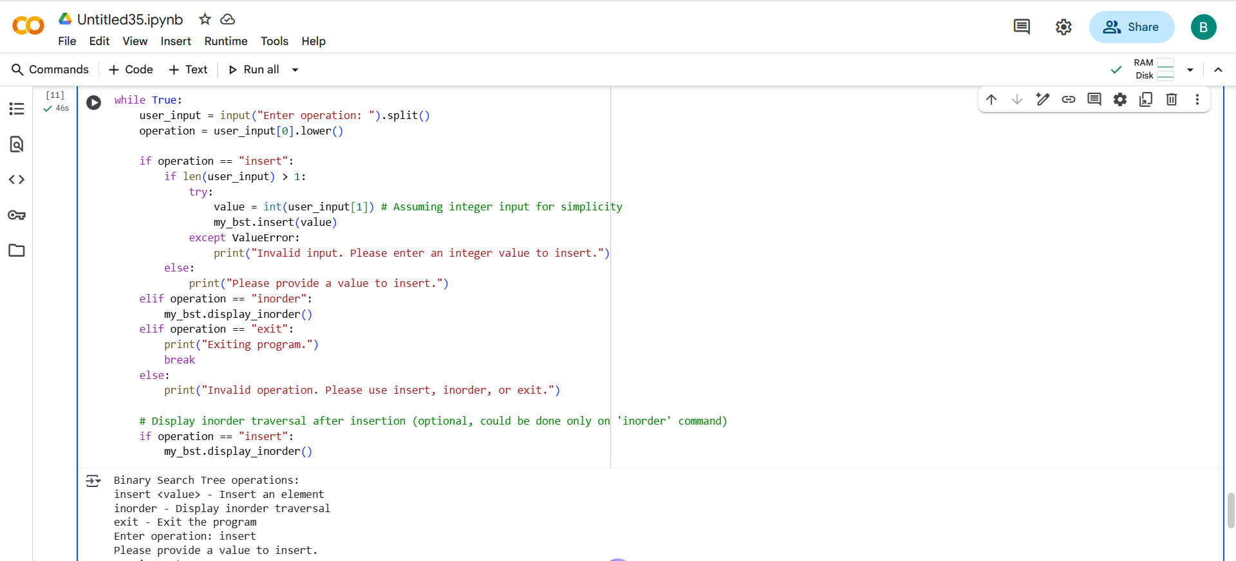
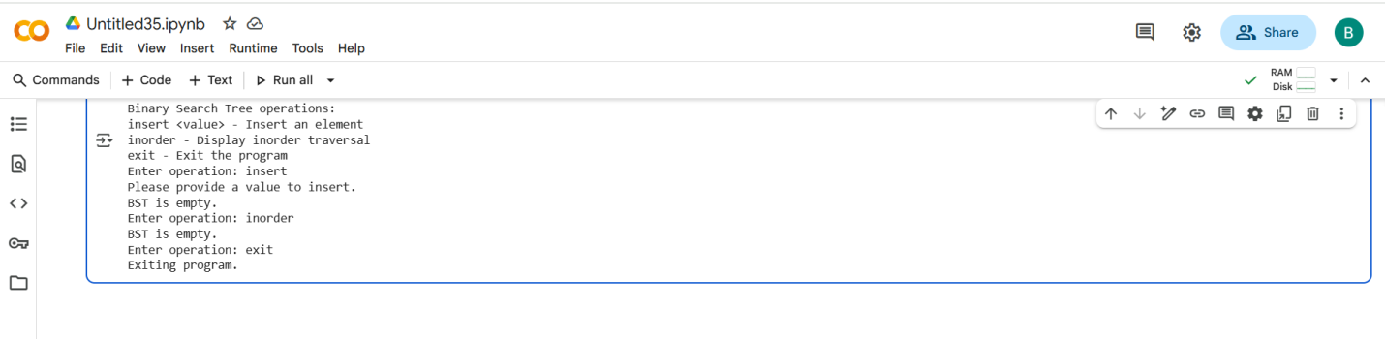

- THANK YOU-

