
SCHOOL OF COMPUTER SCIENCE and ARTIFICIAL INTELLIGENCE
Program :B.tech(CSE)
Specialization :AIML
Course Title :AI Assisted Coding
Course Code :24CS002PC215
Semester :3rd semester
Academic Session :2025-2026
Name of Student : Bachanagari Deekshitha
Enrollment No. :2403A52032
Batch No. :02
Date :08/10/2025
#LAB ASSIGNMENT
- TASK DESCRIPTION-1:
Stack class implementation
Task: Ask AI to implement a stack class with push(), pop(), peek() and is_empty() methods.
- PROMPT:
Create a Python class Stack that implements a stack with methods push(item), pop(), peek(), and is_empty() with dynamic input.
- CODE: 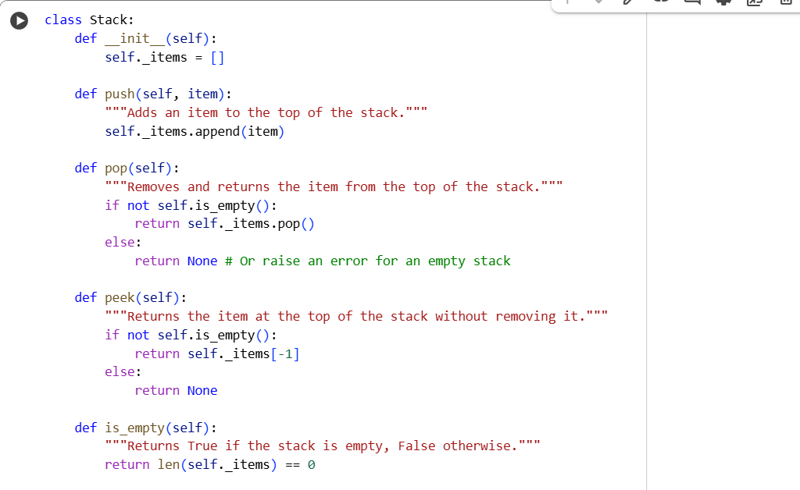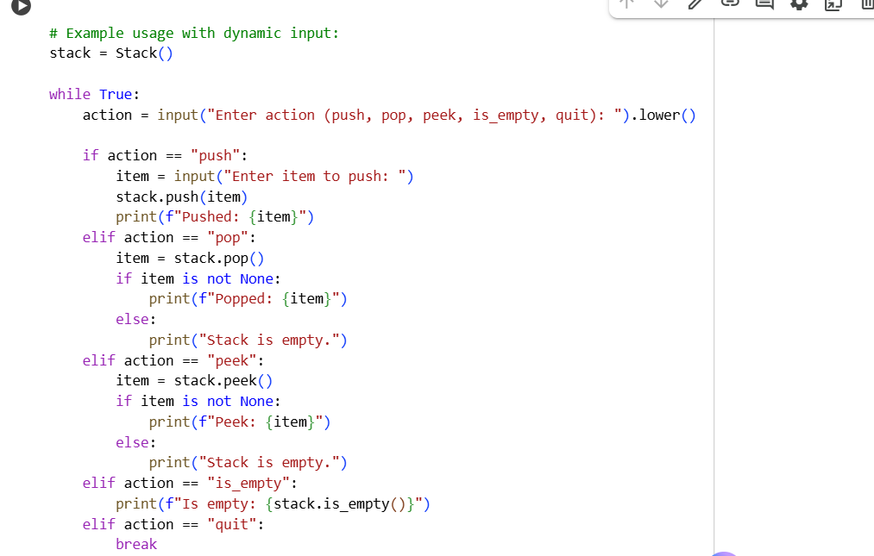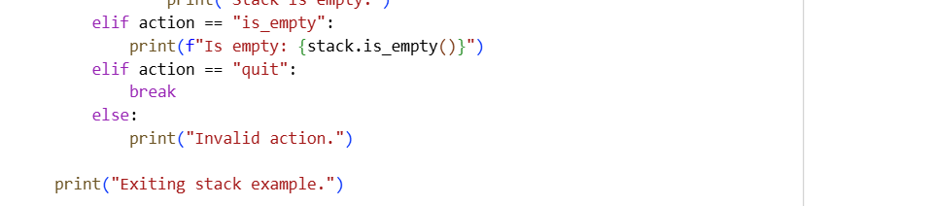

- OUTPUT:
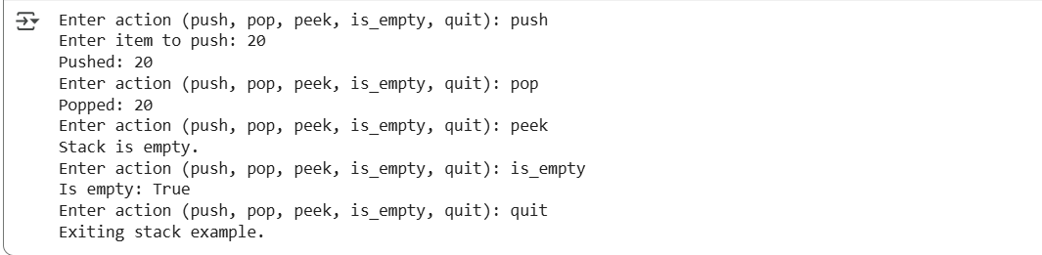

- TASK DESCRIPTION-2:
Queue Implementation
Task: Use AI to generate a Queue class with enqueue(), dequeue(), and is_empty().

- PROMPT:
Create a Python class Queue that implements a queue with methods enqueue(item), dequeue(), and is_empty() with user input.
- CODE:
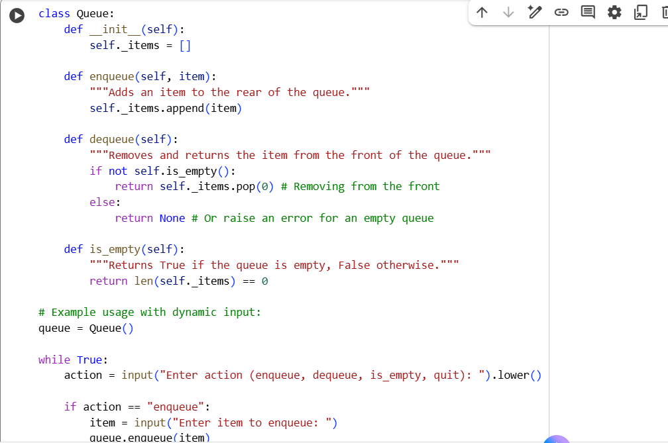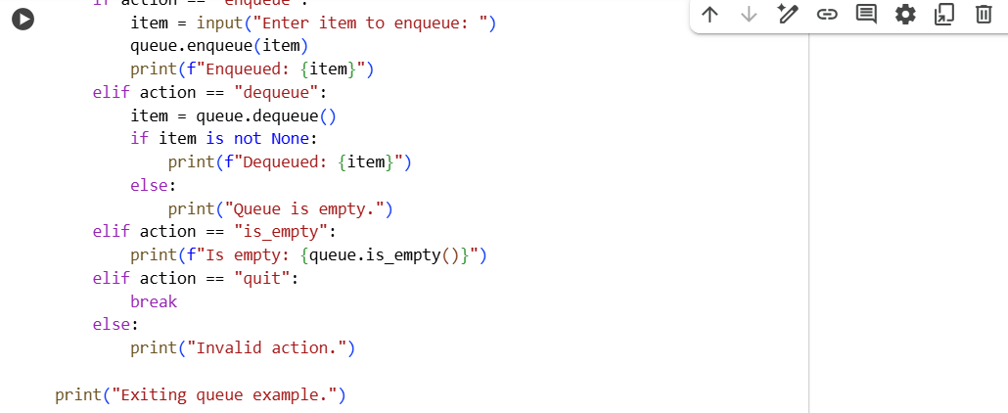
- OUTPUT:
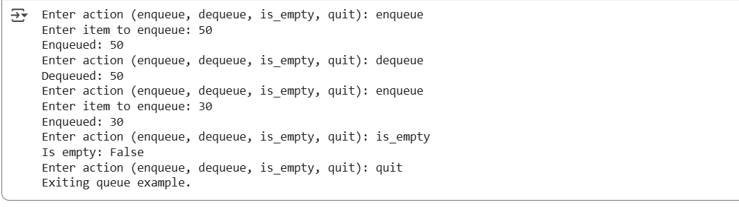
- TASK DESCRIPTION-3:
Linked List Implementation
Task: Ask AI to create a singly linked list with insert_at_end(),
insert_at_beginning(), and display().
- PROMPT:
Create a Python class for a singly linked list with methods insert_at_end(), insert_at_beginning(), and display() with dynamic input.
- CODE: 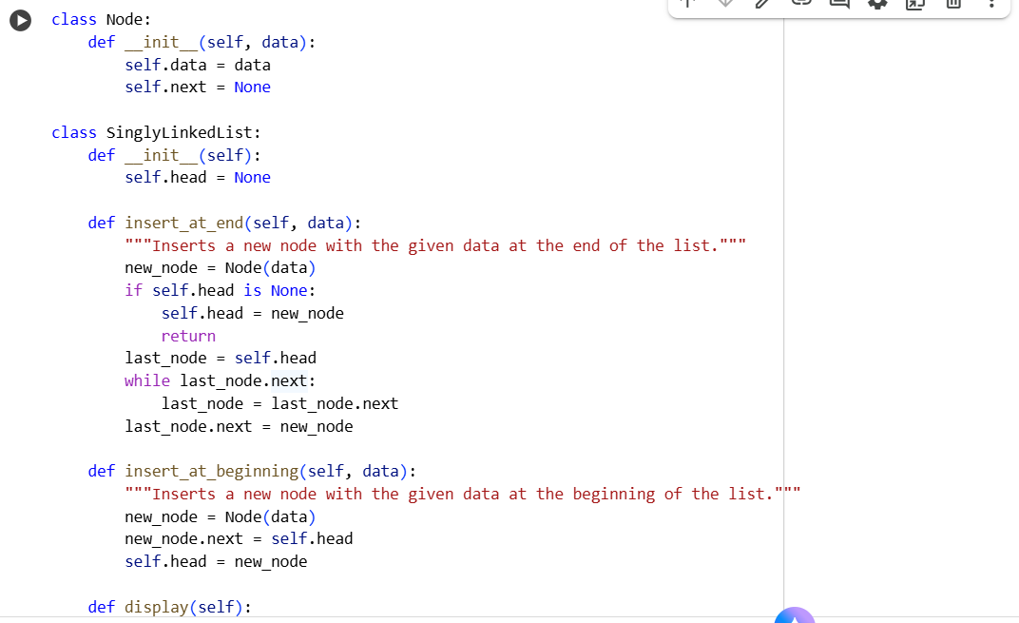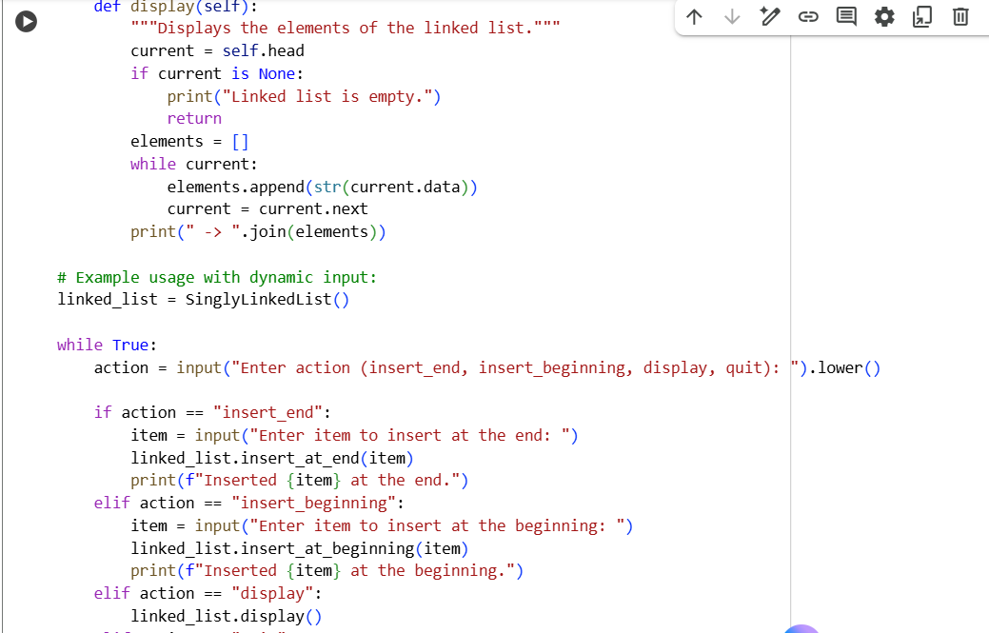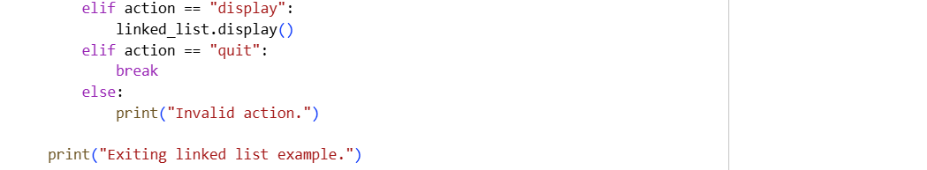

- OUTPUT:
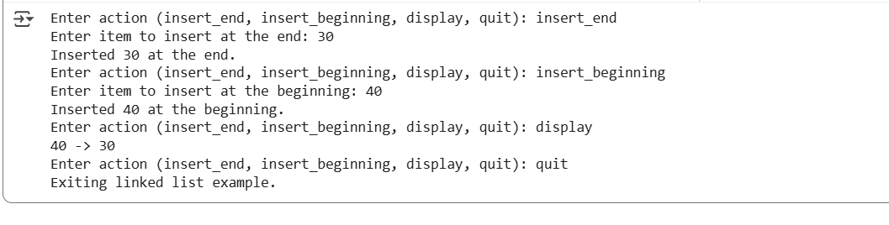
- TASK DISCRIPTION-4:
Binary Search Tree (BST)
Task: Ask AI to generate a simple BST with insert() and
inorder_traversal().
- PROMPT:
Create a Python class for a Binary Search Tree (BST) with methods insert(data) and inorder_traversal() with dynamic input.
- CODE:
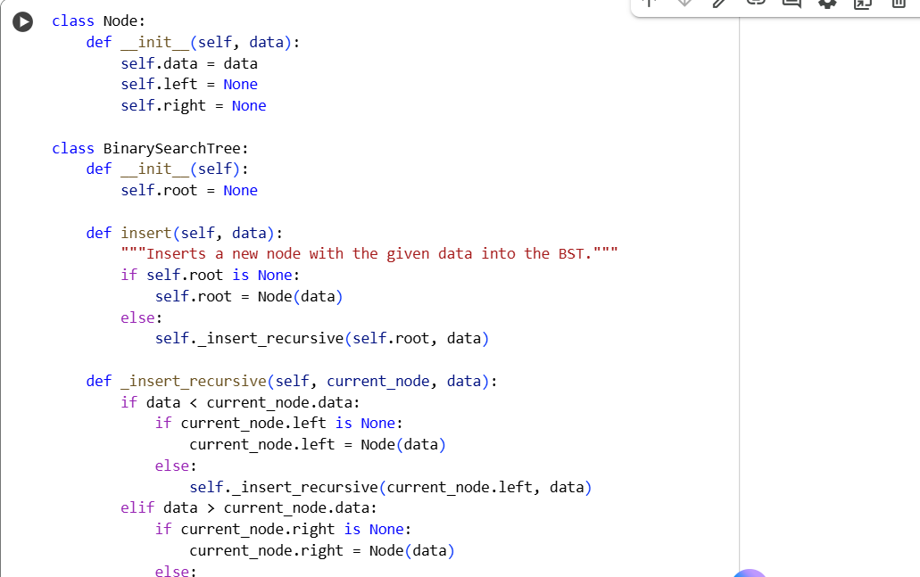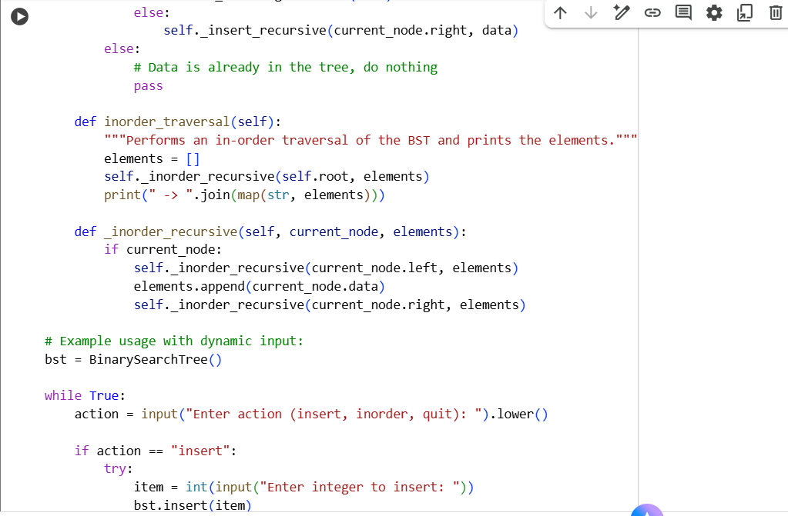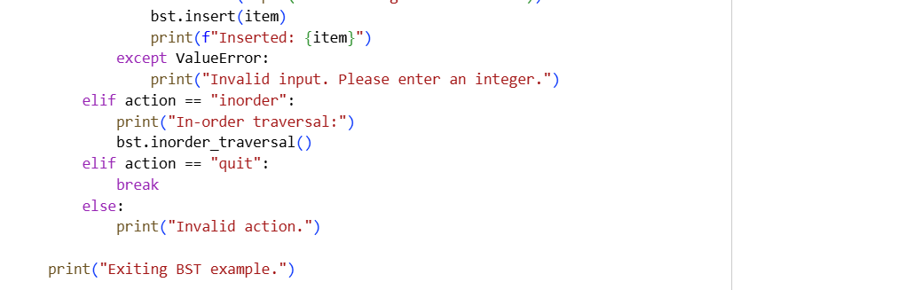
- OUTPUT:
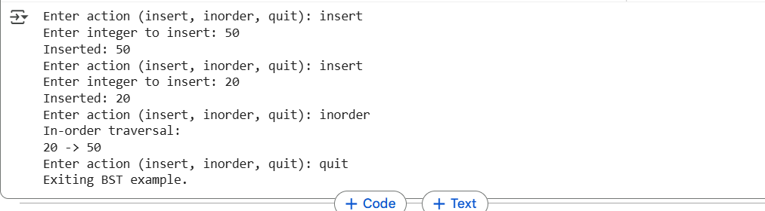

----Thank You----

