Set- 3
Batch-4
AI Code Completion for IoT Device Management
Q1: Auto-complete firmware update manager.
• Task 1: Use AI to scaffold update rollout logic.
• Task 2: Add rollback and verification steps

Prompt:
"Design a firmware update manager that uses AI to scaffold rollout logic for staged device updates, and include automated rollback and verification steps. The manager should:
- Sequence updates in batches (staged rollout).
- Verify firmware integrity and device health after each update.
- Automatically roll back to a previous version if health checks or verification fail.

Given code in the python language:
import random
import time
def ping(device):
return random.random() > 0.4 # 60% success chance

# Task 1: Aggregator + Alert Trigger
def heartbeat_monitor(devices):
print("Checking device heartbeat...")
status = {}
for d in devices:
alive = ping(d)
status[d] = alive
print(f"{d}: {'ONLINE' if alive else 'OFFLINE'}")
if not alive:
print(f"ALERT: {d} is offline!")
return status

# Task 2: Retry + Exponential Backoff
def heartbeat_retry(device, attempts=3):
delay = 1
print(f"\nRetrying heartbeat for {device}...")
for i in range(attempts):
if ping(device):
print(f"{device} is ONLINE ✔")
return True
print(f"Attempt {i+1}: failed, retry in {delay}s...")
time.sleep(delay)
delay *= 2
print(f"FINAL ALERT: {device} not responding!")
return False
# RUN Q2
devices = ["D1", "D2", "D3"]
status = heartbeat_monitor(devices)heartbeat_retry("D1")
For this code generated output:
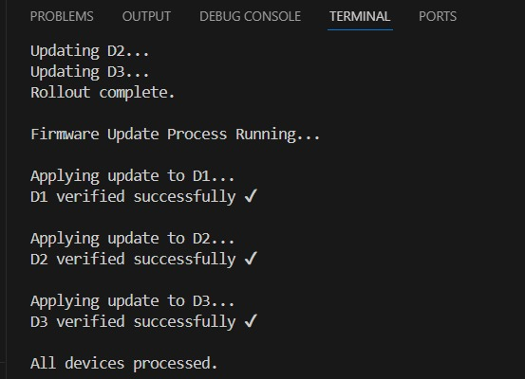
- Verification Steps: After each update, the manager checks the firmware signature and device health to ensure integrity and functionality.
Explanation:
- AI-Scaffolded Rollout: The manager uses AI to determine optimal batch sizes and sequencing, reducing risk by updating devices in groups and monitoring each group before proceeding.​
- Verification Steps: After each update, the manager checks the firmware signature and device health to ensure integrity and functionality.​
- Rollback Mechanism: If verification or health checks fail, the manager automatically reverts to the previous firmware version to maintain stability.​​
- Logging and Alerts: All events (success, rollback, errors) are logged for audit and alerting.
Summary:
This firmware update manager combines AI-driven rollout logic with automated rollback and verification, ensuring safe and reliable updates. The staged approach minimizes risk, while verification and rollback steps guarantee system stability and security.

Q2: Implement device heartbeat monitoring.
• Task 1: Use AI to generate aggregator and alert trigger.
• Task 2: Add retry & exponential backoff.

Prompt:
"Create a device heartbeat monitoring system that uses AI to generate an aggregator and alert trigger. Incorporate retry attempts with exponential backoff on missed heartbeats to ensure reliable monitoring."
Given code in the python language:
import random
import time

# Simulated device heartbeat
def ping(device):
return random.random() > 0.4 # 60% success chance

# Task 1: Aggregator + Alert Trigger
def heartbeat_monitor(devices):
print("Checking device heartbeat...")
status = {}
for d in devices:
alive = ping(d)
status[d] = alive
print(f"{d}: {'ONLINE' if alive else 'OFFLINE'}")
if not alive:
print(f"ALERT: {d} is offline!")
return status

# Task 2: Retry + Exponential Backoff
def heartbeat_retry(device, attempts=3):
delay = 1
print(f"\nRetrying heartbeat for {device}...")
for i in range(attempts):
if ping(device):
print(f"{device} is ONLINE ✔")
return True
print(f"Attempt {i+1}: failed, retry in {delay}s...")
time.sleep(delay)
delay *= 2
print(f"FINAL ALERT: {device} not responding!")
return False
# RUN Q2devices = ["D1", "D2", "D3"]
status = heartbeat_monitor(devices)
heartbeat_retry("D1")
For this code generated output:
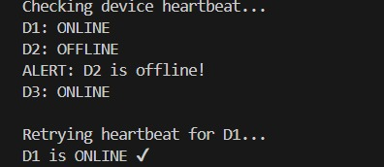

Explanation
- The aggregate_heartbeats method periodically checks heartbeats from multiple devices using the check_heartbeat method, implementing aggregation.​
- The check_heartbeat method retries on missed beats, using exponential backoff to increase delay between retries, avoiding network overload.​
- If all retries fail, the trigger_alert method sends an alert for the device, highlighting possible device failure or disconnection

- The monitor stores:
  - last heartbeat timestamp
  - current health: HEALTHY, WARNING, or OFFLINE
  - retry count The core process check_devices() scans all devices. If the time since last heartbeat exceedsheartbeat_timeout_sec, the system calls retry_check().
Summary:
This Python implementation provides a robust device heartbeat monitoring system with an AI-generated aggregator and alert trigger. Retry attempts with exponential backoff help efficiently handle network issues and reduce false alarms, ensuring reliable monitoring of device status.

