

**Program :**B.tech(CSE)

**Specialization :**AIML

**Course Title :**AI Assisted Coding

**Course Code :**24CS002PC215

**Semester :**3rd sem

**Name of Student :** Kaveti Manohar

**En. No. :**2403A52079

**Batch No. :**02

**Date :**19/08/2025

#LAB ASSIGNMENT

Task Description -1:

Use Gemini and Colab to write a function that filters out all negative numbers from a give list.

#PROMPT:

* Write a python code for a function, out of all negative numbers from the list.

Question:

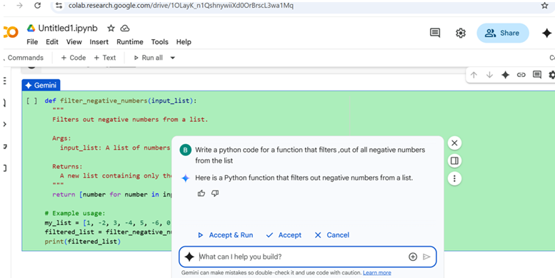

Code:

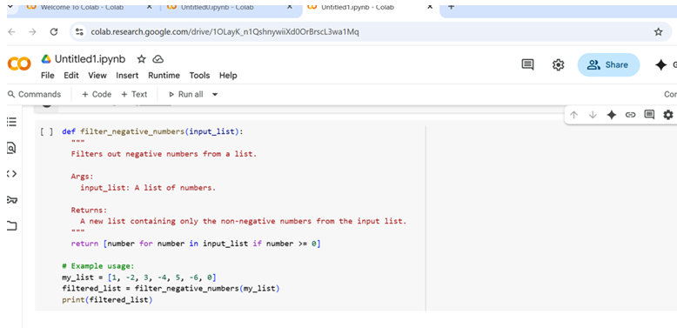

Output:

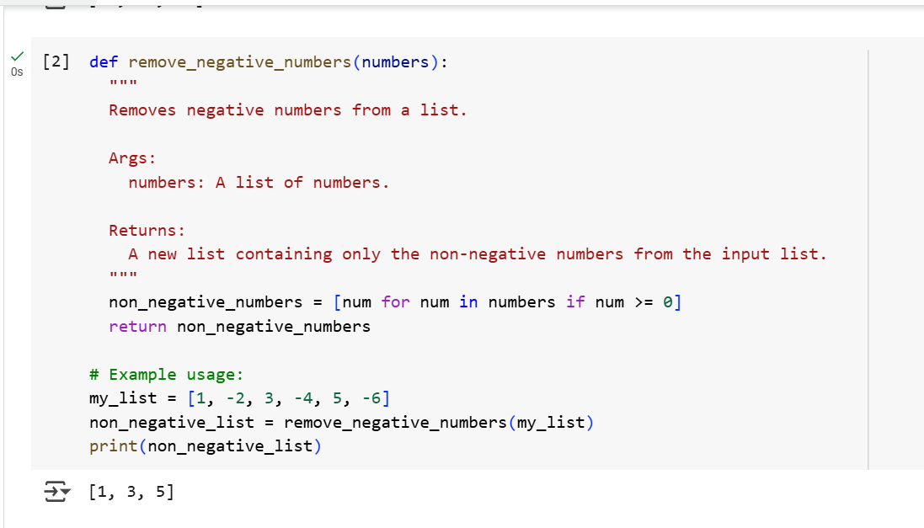

TASK Description-2:

* Ask Gemini to generate code that reads a text file and counts the frequency of each word. Then ask it to explain the code.

Prompt-2

* Write a python code that reads a text file and count the frequency of each word and explain the code.

Question-2

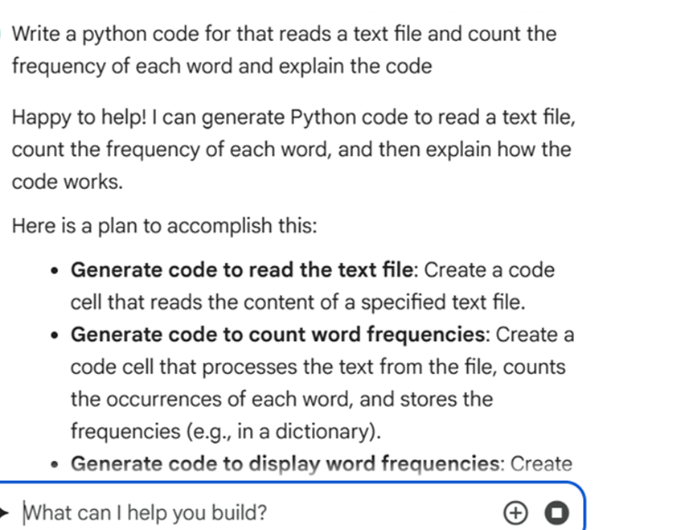

Code:

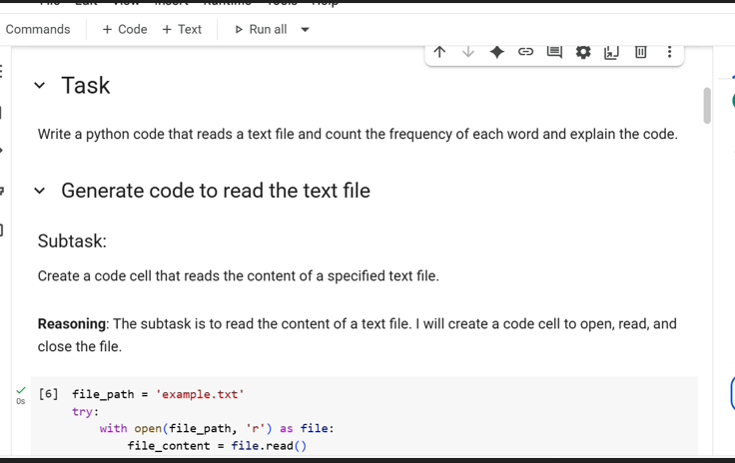

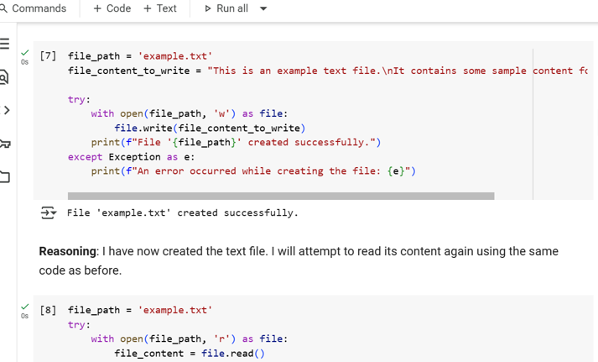

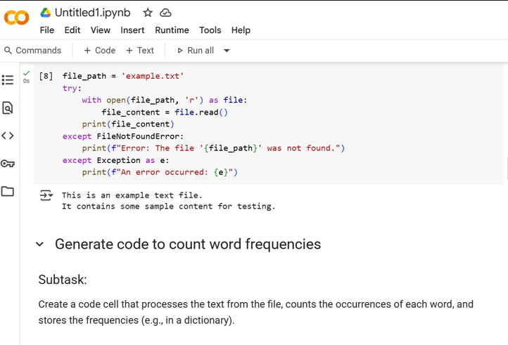

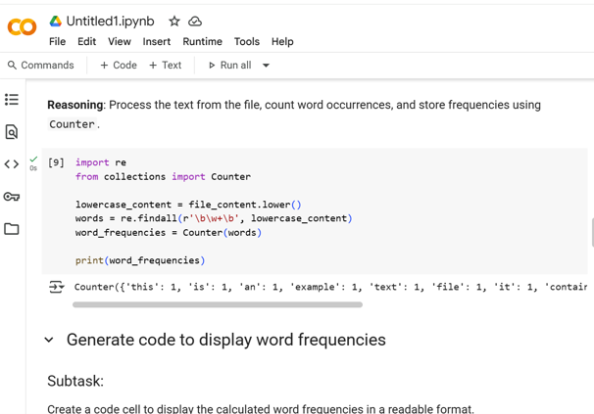 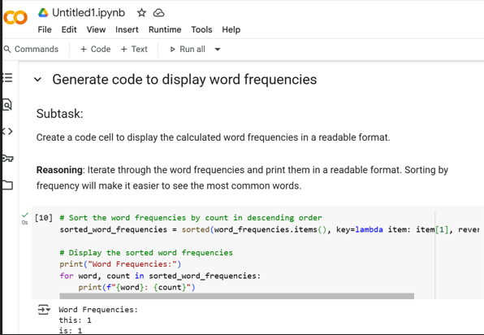

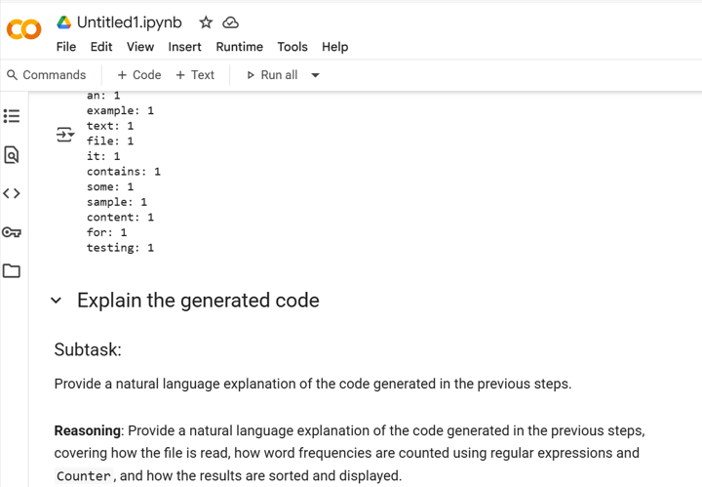 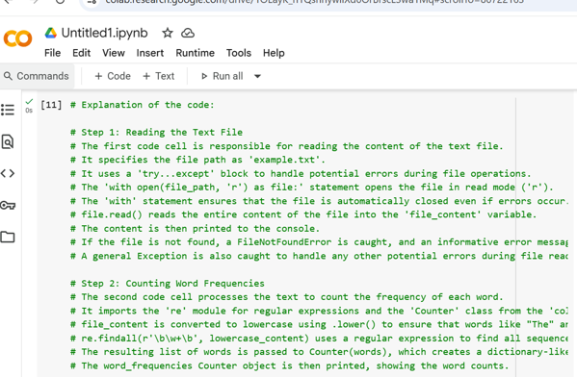 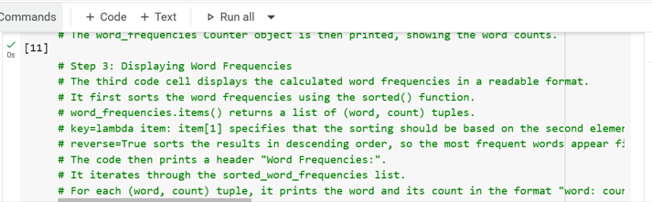

Task Desciption-3:

* Use Cursor AI to generate a python class called book with attributes title, author, and a method Summery() that prints the details.

Prompt-3

* Give me a code for python class Book with attributes title, author and a method summery() that prints the details

QUESTION:

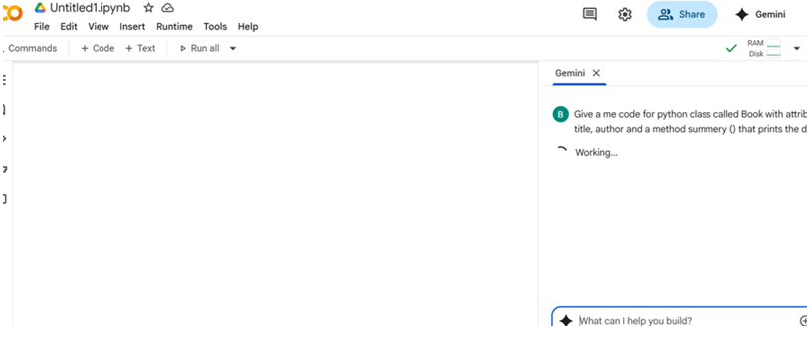

CODE:

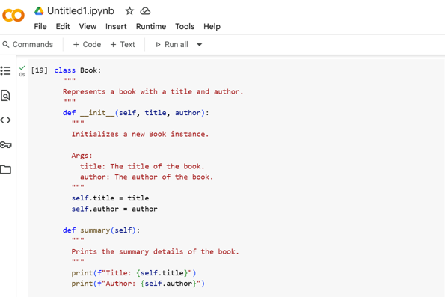

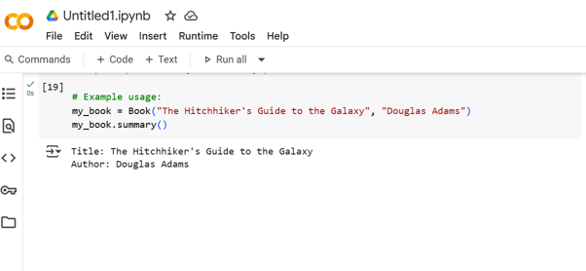

Task Description-4

* Ask Gemini to write a program that checks whether Number is an Armstrong number ,and then modify using cursor Ai to improve performance or structure.

Prompt-4

* Write a python to check whether the given number is Armstrong Number, and improve the Structure.

QUESTION:

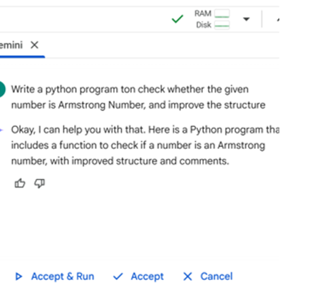

CODE:

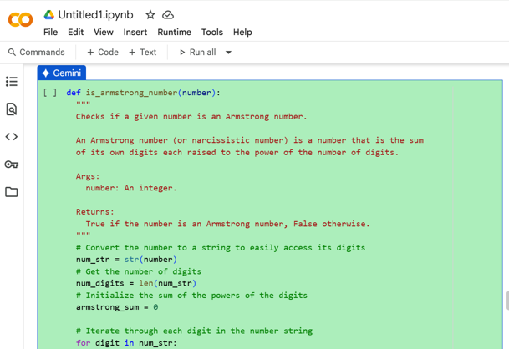

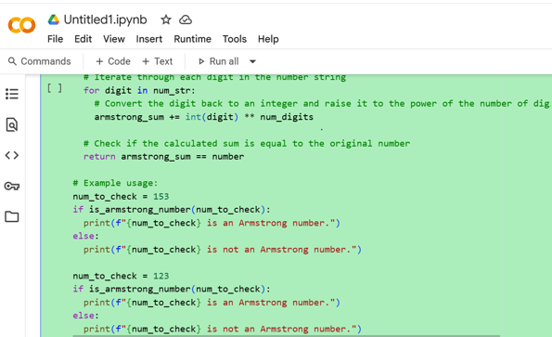

OUTPUT:

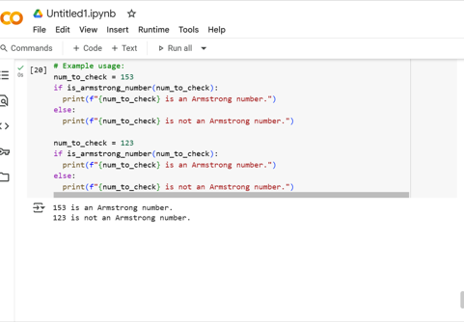

Summery:

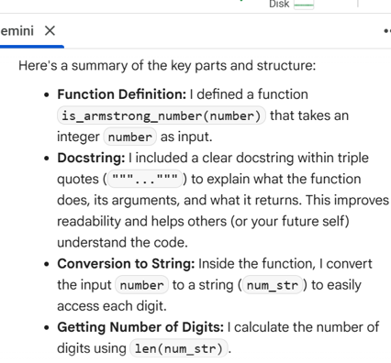

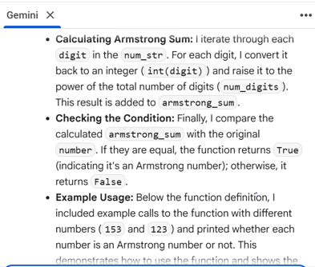

Task Description-6

* Use both Gemini and Cursor AI to generate code for sorting a list of dictionaries by a specific key (e.g., age).

Prompt-6

* Write a Python code for sorting a list of dictionaries by a specific key example:age.

QUESTION:

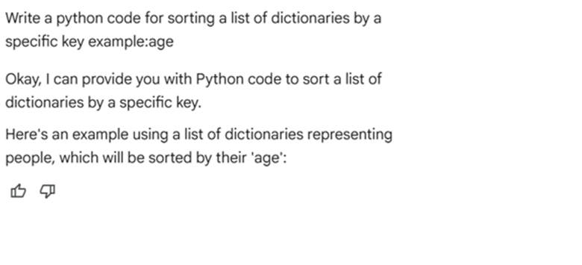

CODE:

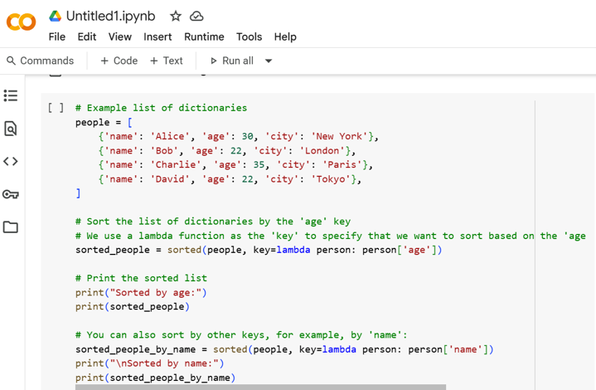

OUTPUT:

