

**Program :**B.tech(CSE)

**Specialization :**AIML

**Course Title :**AI Assisted Coding

**Course Code :**24CS002PC215

**Semester :**3rd semester

**Academic Session :**2025-2026

**Name of Student :**Kaveti Manohar

**Enrollment No. :**2403A52079

**Batch No. :**02

**Date :**16/09/2025

LAB ASSIGNMENT

Task Description -1:

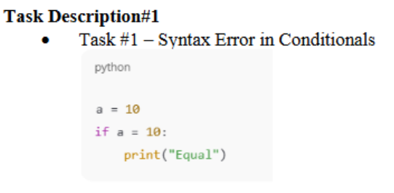

PROMPT:

* Identify and correct the syntax error in this Python conditional statement:a = 10 if a = 10: print('Equal') Explain why the original code fails and how to fix it

QUESTION:

* 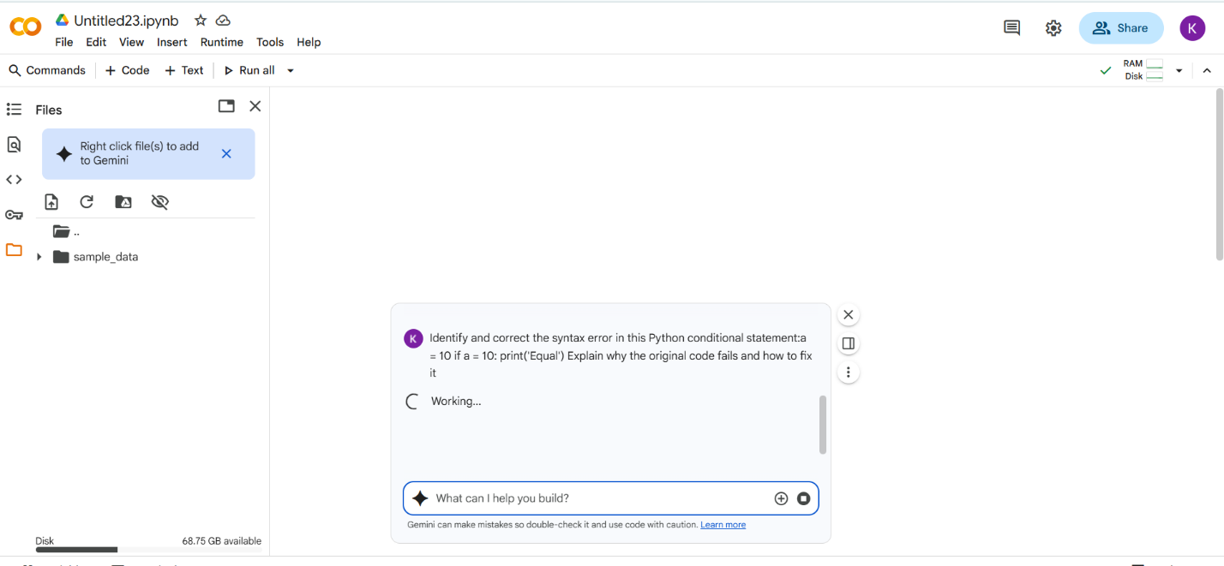
* CODE with OUTPUT:

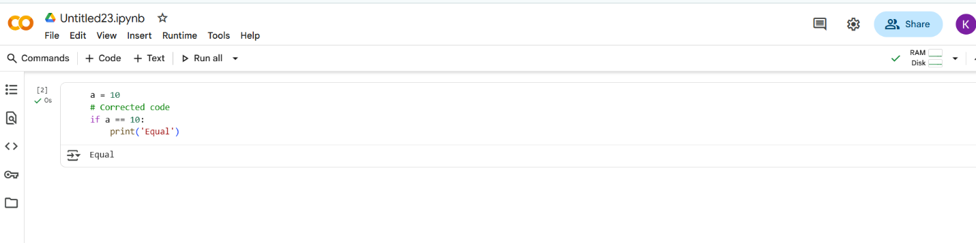

Summary:

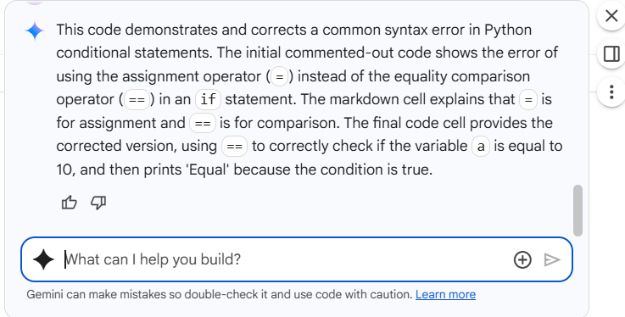

# what I Did:

I Remove the error by using some changes its executed after giving to the AI it will also doing same thing..

Task Description -2:

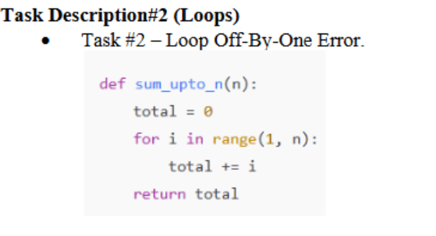

PROMPT:

Fix the loop so that this function correctly returns the sum of numbers from 1 to n:def sum_upto_n(n): total = 0 for i in range(1, n): total += i return total.

QUESTION:

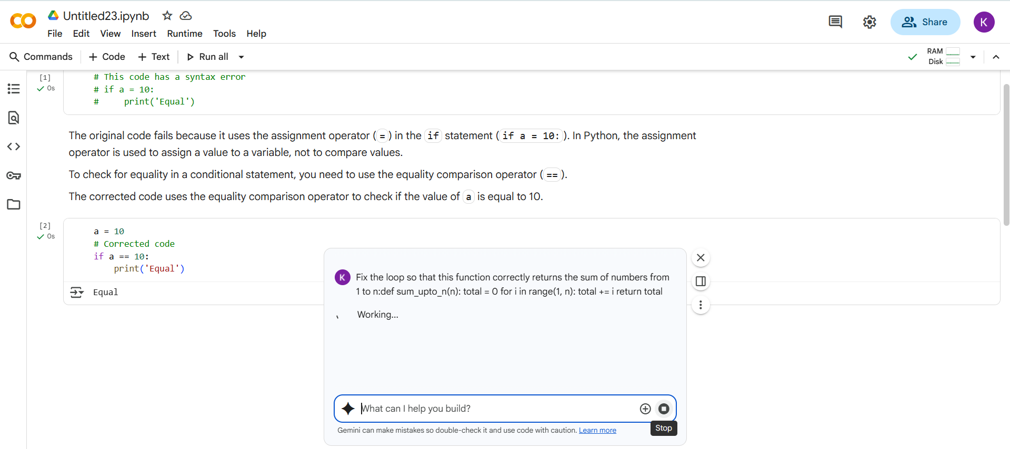

#CODE with OUTPUT:

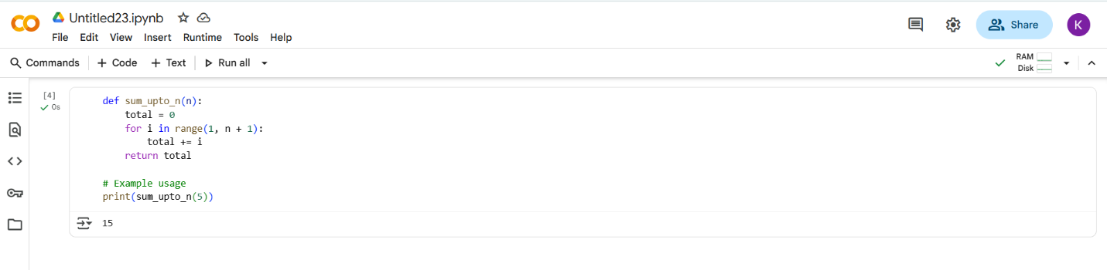

Summary:

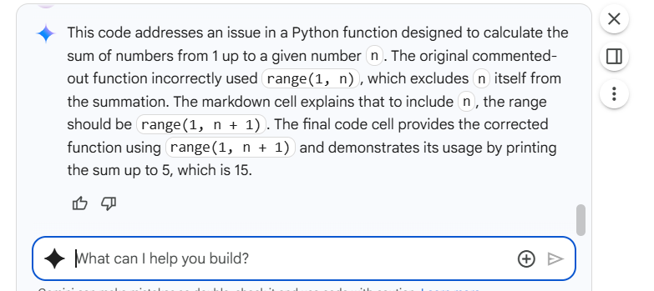

#What I Did:

From the above code , I Remove the error by using some changes after its executed ,giving to the AI it will also doing same thing..

Task Description -3:

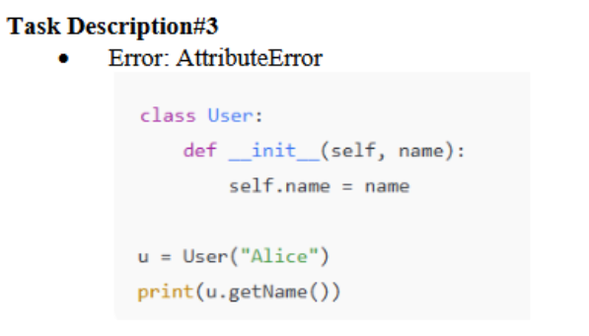

PROMPT:

Fix the AttributeError in the code by adding a getName() method to the User class that returns the user's name. class User: def __init__(self, name): self.name = name u = User("Alice") print(u.getName())

QUESTION: 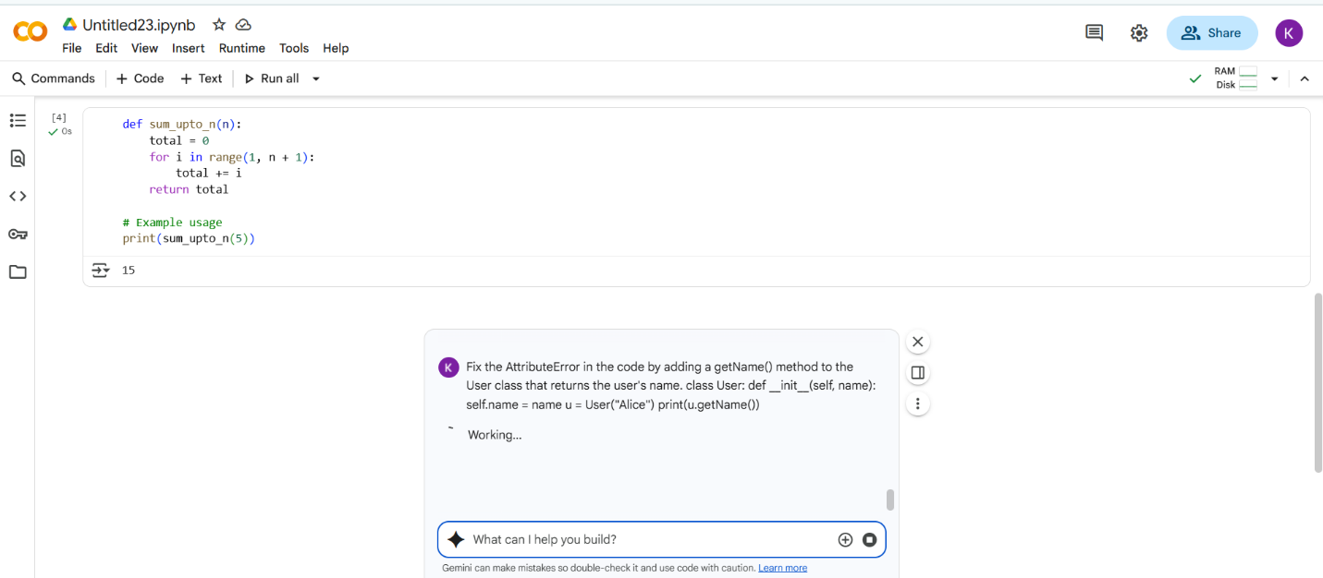

#CODE with Output:

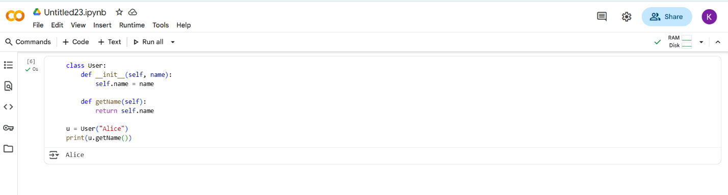

Summary:

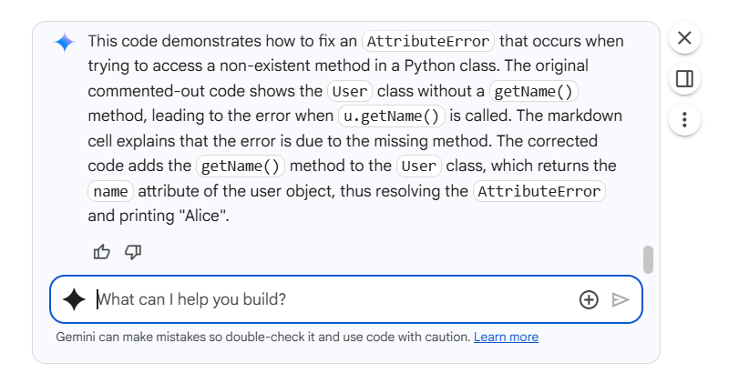

#What I Did:

From the above code , I Remove the error by using some changes after its executed , and also giving to the AI it will also doing same thing.

Task Description -4:

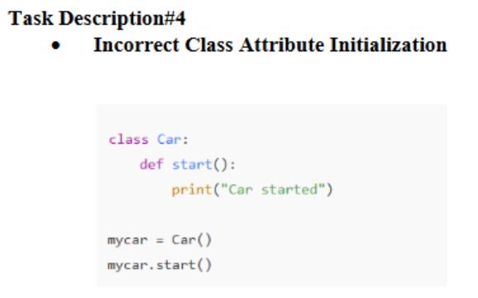

PROMPT:

Fix the method definition in the Car class so that start() works correctly when called on an instance class Car: def start(): print("Car started") mycar = Car() mycar.start().

QUESTION:

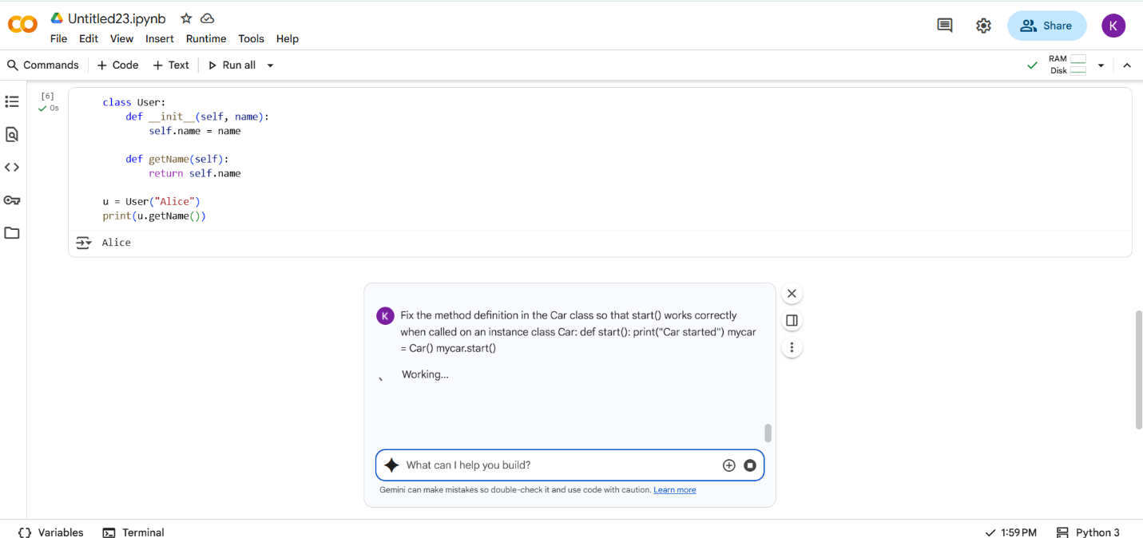

#CODE with OUTPUT:

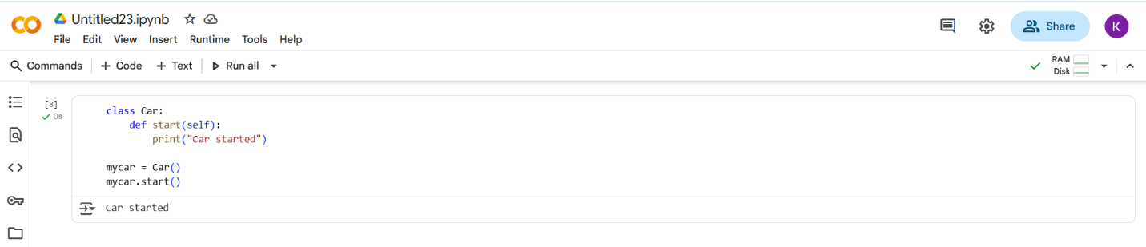

Summary:

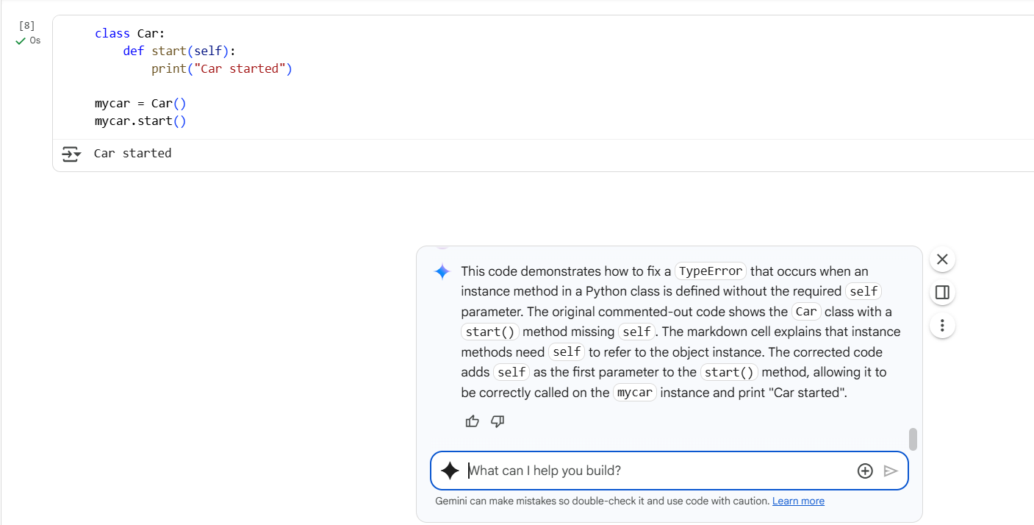

#What I Did:

From the above code , I Remove the error by using some changes after its executed ,giving to the AI it will also doing same pattern.

Task Description -5:

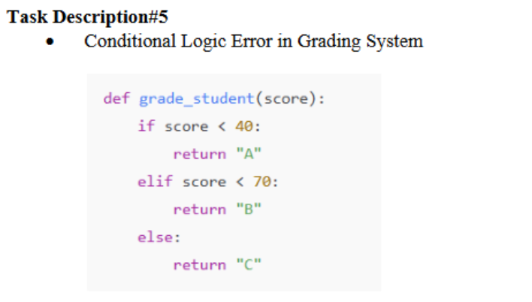

PROMPT:

Fix the grading logic in the grade_student(score) function so that higher scores receive better grades (e.g., 'A' for top scores, 'B' for mid-range, 'C' for low) def grade_student(score): if score <40: return "A" elif score <70: return "B" else: return "C"

QUESTION:

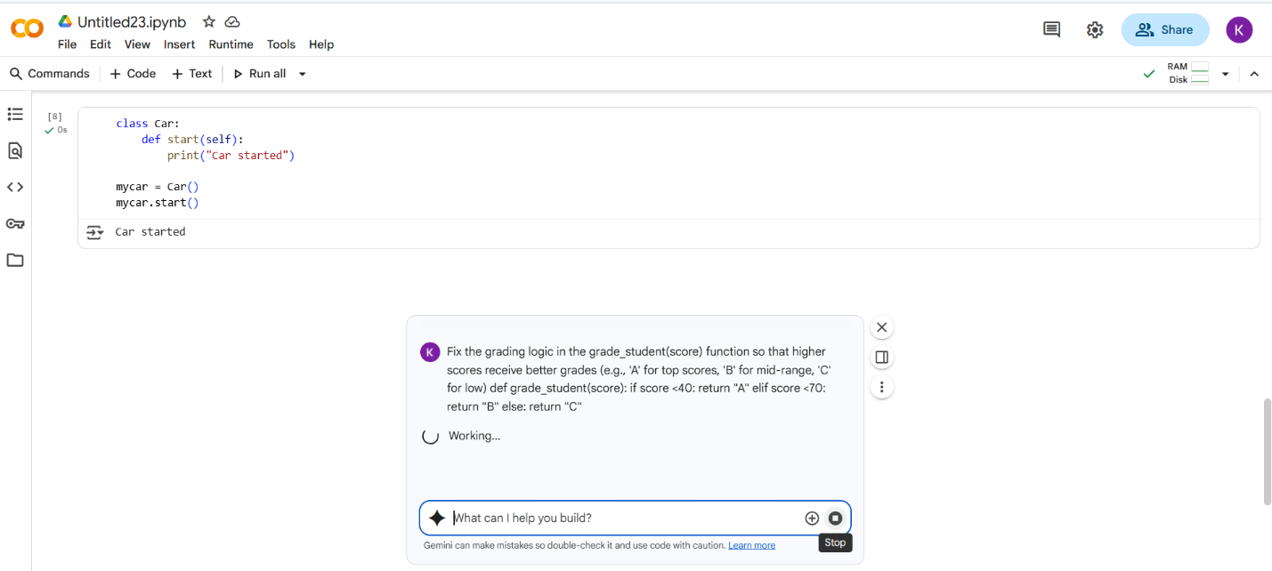

#CODE with OUTPUT

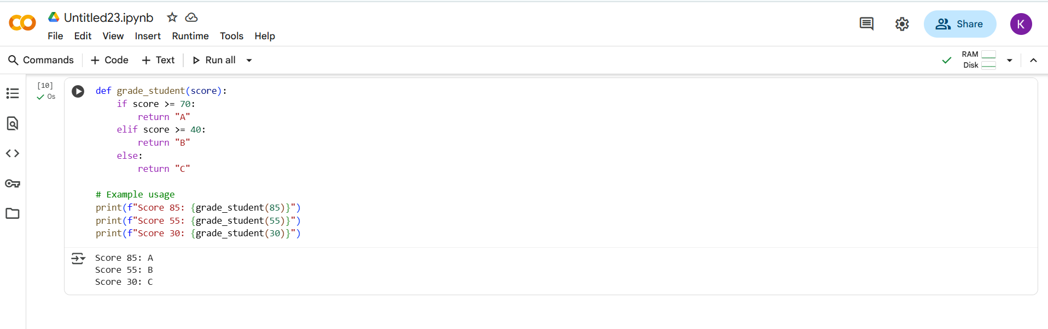

Summary:

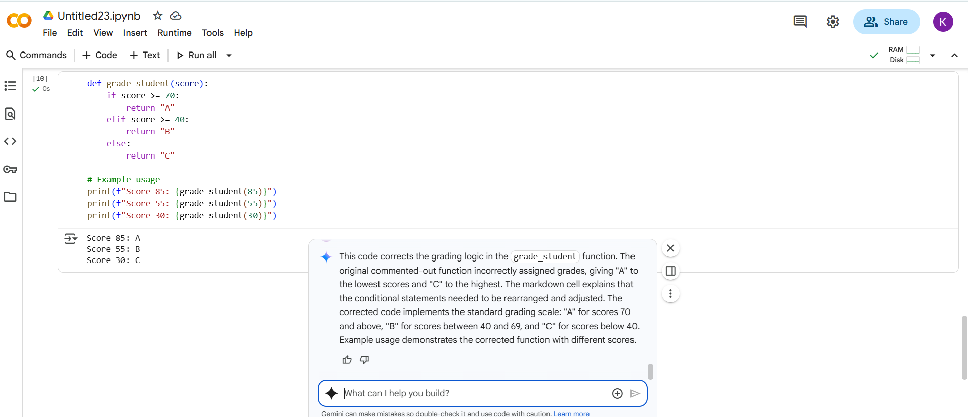

#What I did:

From the above code , I Remove the error by using some changes after its executed ,giving to the AI it will also doing same pattern.

-------------THANK YOU---------------