
SCHOOL OF COMPUTER SCIENCE and ARTIFICIAL INTELLIGENCE
Program :B.tech(CSE)
Specialization :AIML
Course Title :AI Assisted Coding
Course Code :24CS002PC215
Semester :3rd semester
Academic Session :2025-2026
Name of Student : Kaveti Manohar
Enrollment No. :2403A52079
Batch No. :02
Date :28/10/2025
#LAB ASSIGNMENT-14.2:
- TASK DESCRIPTION-1:
AI-generated HTML Page
Task: Ask AI to generate a simple HTML homepage for a "Student Info Portal" with a header, navigation menu, and footer.

- PROMPT:
Create a simple HTML homepage for a "Student Info Portal" that includes a header, a navigation menu, and a footer.

- CODE With OUTPUT:
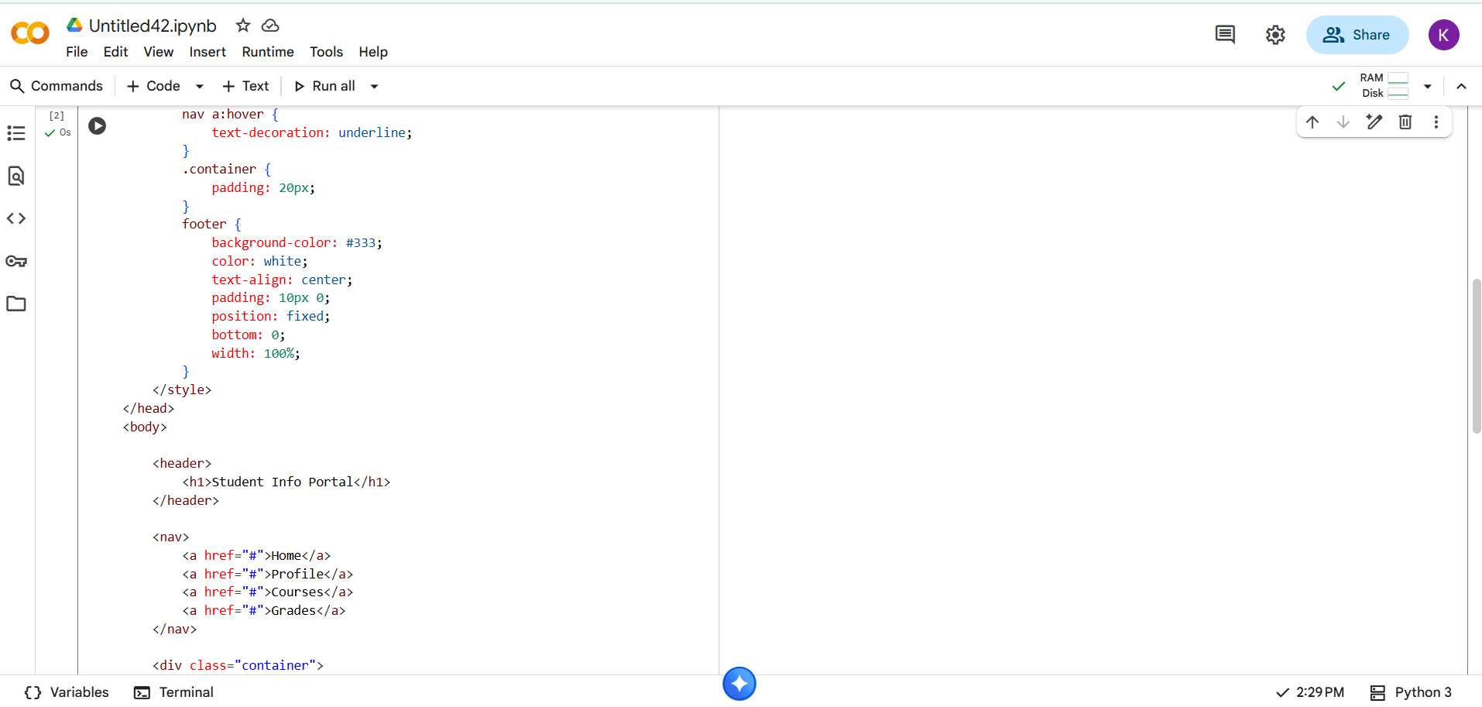
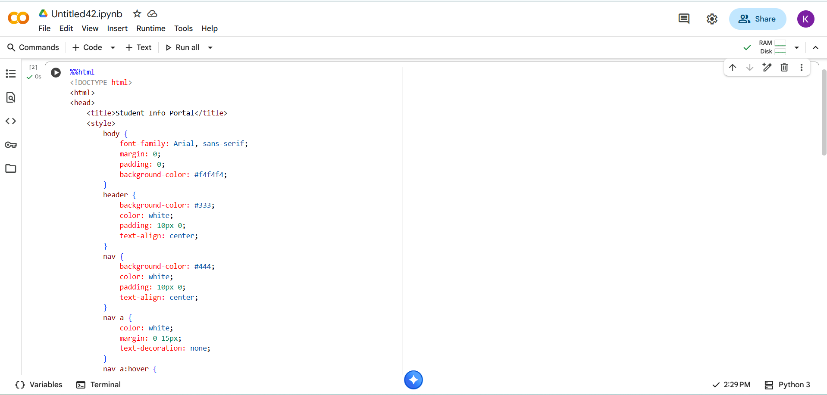
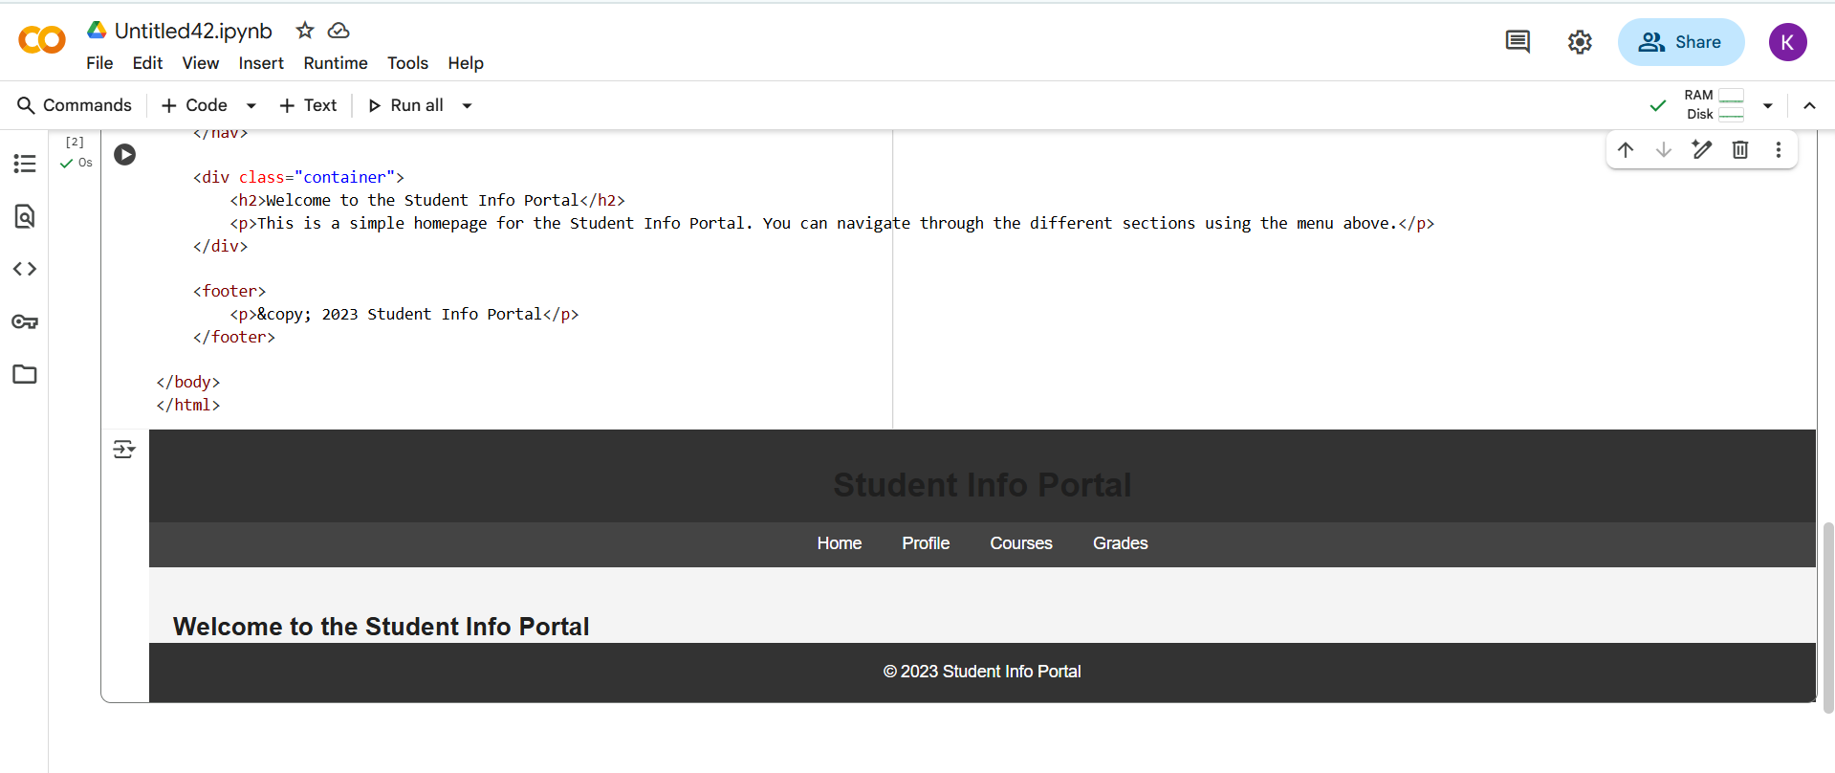

EXPLANATION:
- %%html: This is a Colab magic command that tells the notebook to render the cell's content as HTML.
- <!DOCTYPE html>: Declares the document type to be HTML5.
- <html>: The root element of the HTML page.
- <head>: Contains meta-information about the HTML document, such as the title that appears in the browser tab (<title>). It also includes a <style> block for CSS rules that define the appearance of the page.
- <body>: Contains the visible content of the HTML page.
- <header>: Represents the introductory content or a set of navigational links. In this case, it contains the main heading "Student Info Portal" (<h1>).
- <nav>: Represents a section of navigation links. Here, it contains links for "Home", "Profile", "Courses", and "Grades" (<a> tags).
- <div class="container">: A generic container element used to group content. The class="container" is used by the CSS to apply specific styling (padding in this case).
- <h2>: A second-level heading.
- <p>: A paragraph of text.
- <footer>: Represents the footer for its nearest sectioning content or the root element. It typically contains information like copyright notices.
The <style> section contains CSS rules that define how the HTML elements are displayed:
- body: Sets the default font, removes default margins and padding, and sets a background color.
- header: Styles the header with a background color, text color, padding, and center-aligned text.
- nav: Styles the navigation bar similarly to the header, with a different background color.
- nav a: Styles the navigation links (the <a> tags within the <nav>) with text color, margins, and removes the default underline.
- nav a:hover: Adds an underline when the mouse hovers over a navigation link.
- .container: Adds padding to the container div.
- footer: Styles the footer with a background color, text color, center-aligned text, padding, and positions it at the bottom of the page.

- TASK DESCRIPTION-2:
Use AI to add CSS styling to
Task #1 homepage for:
• Responsive navigation bar.
• Centered content section.
• Footer with light gray background.

- PROMPT:
Add CSS styling to the "Student Info Portal" homepage to include:A responsive navigation bar.A centered content section.A footer with a light gray background.

QUESTION:
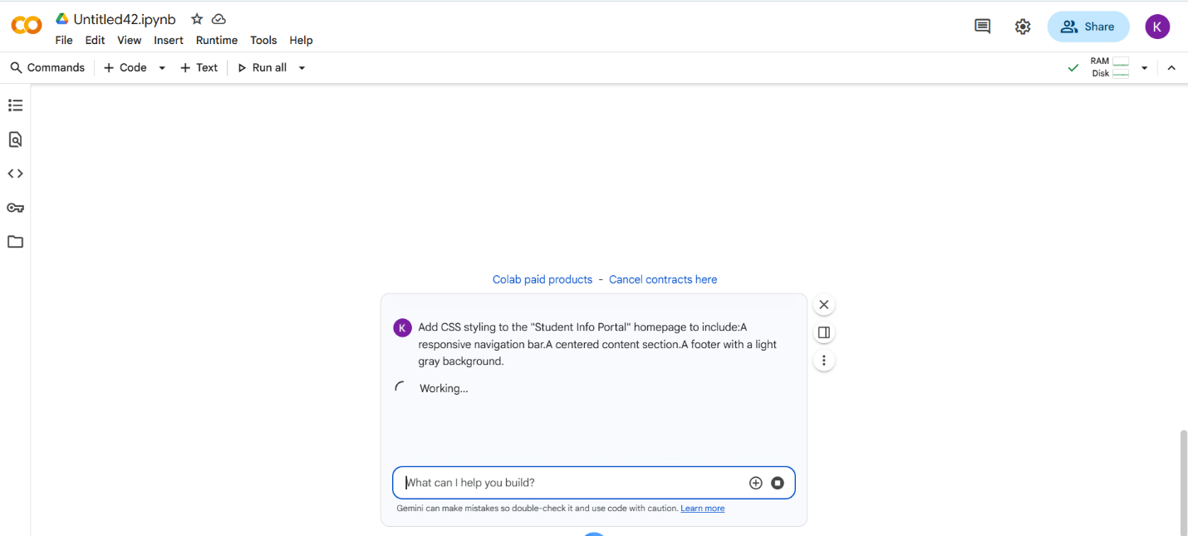

- CODE With OUTPUT:
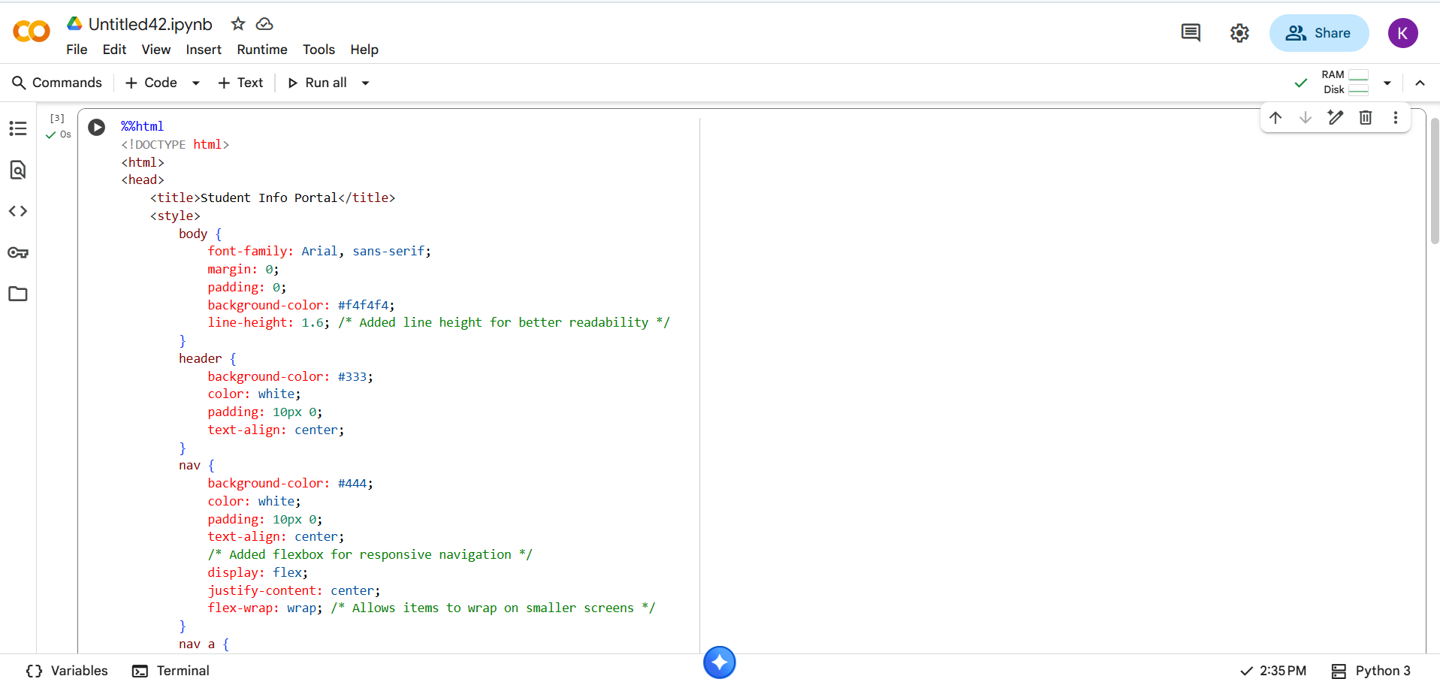
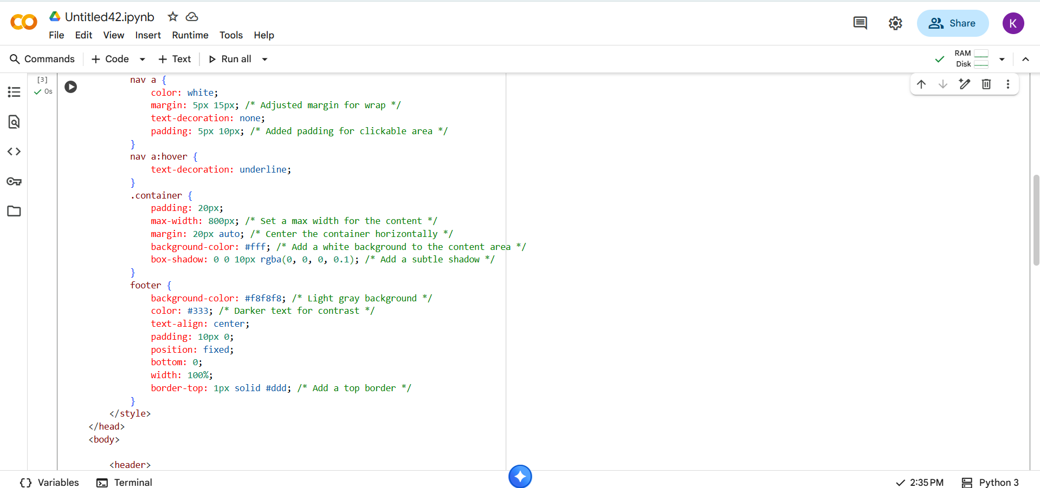
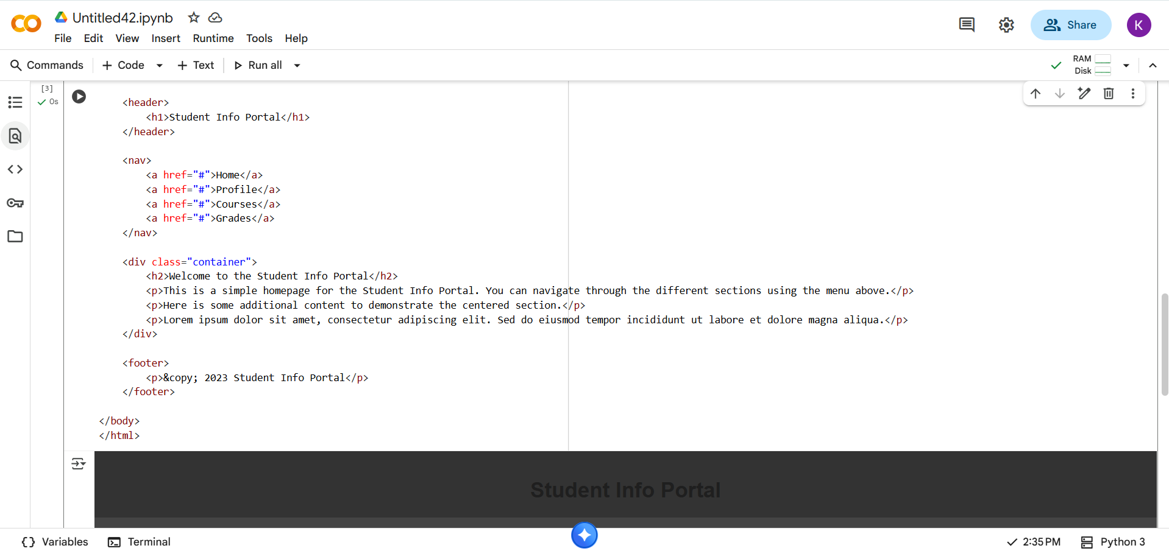
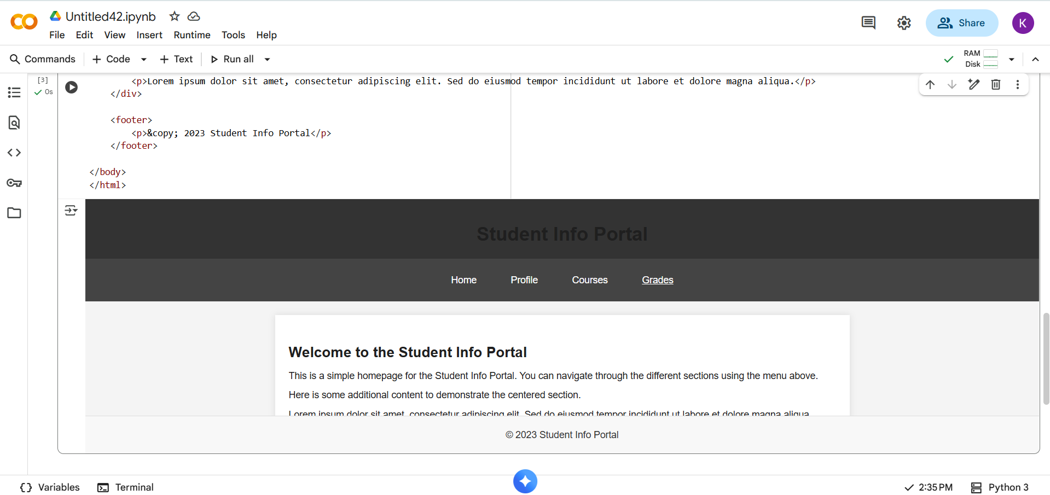

EXPLANATION:
- body: line-height: 1.6; was added for better readability of text.
- nav:
  - display: flex;: This makes the navigation links arrange themselves in a row.
  - justify-content: center;: This centers the navigation links horizontally within the nav bar.
  - flex-wrap: wrap;: This allows the navigation links to wrap onto the next line if the screen is too narrow to fit them all on one line, making the navigation bar responsive.
- nav a:
  - margin: 5px 15px;: The margin was adjusted to provide some space around the links when they wrap.
  - padding: 5px 10px;: Padding was added to increase the clickable area of the links.
- .container:
  - max-width: 800px;: Sets a maximum width for the content area, preventing it from becoming too wide on large screens.
  - margin: 20px auto;: This is a common technique to center a block-level element horizontally. auto for the left and right margins tells the browser to distribute the available space equally on both sides.
  - background-color: #fff;: Sets the background color of the content container to white.
  - box-shadow: 0 0 10px rgba(0, 0, 0, 0.1);: Adds a subtle shadow around the container to make it stand out.
- footer:
  - background-color: #f8f8f8;: Sets the background color of the footer to a light gray.
  - color: #333;: Sets the text color in the footer to a dark gray for better contrast.
  - border-top: 1px solid #ddd;: Adds a light gray border at the top of the footer.
Additional HTML Content:
- More <p> tags with placeholder text (Lorem ipsum...) were added within the .container div to better demonstrate the centered content section with more content.

- TASK DESCRIPTION-3:
JavaScript Interactivity
Task: Prompt AI to generate a JS script that validates a simple login form (non-empty username/password).

- PROMPT:
Write a JavaScript script that validates a simple login form to ensure the username and password fields are not empty before submission.

QUESTION:
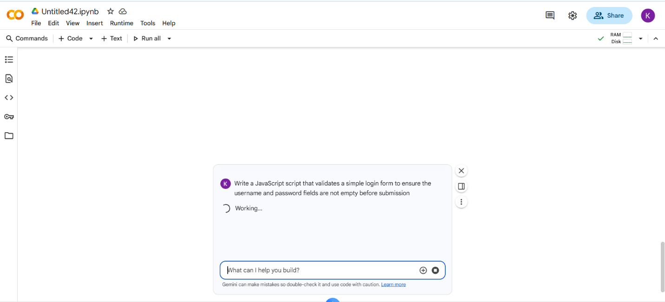

- CODE With OUTPUT:
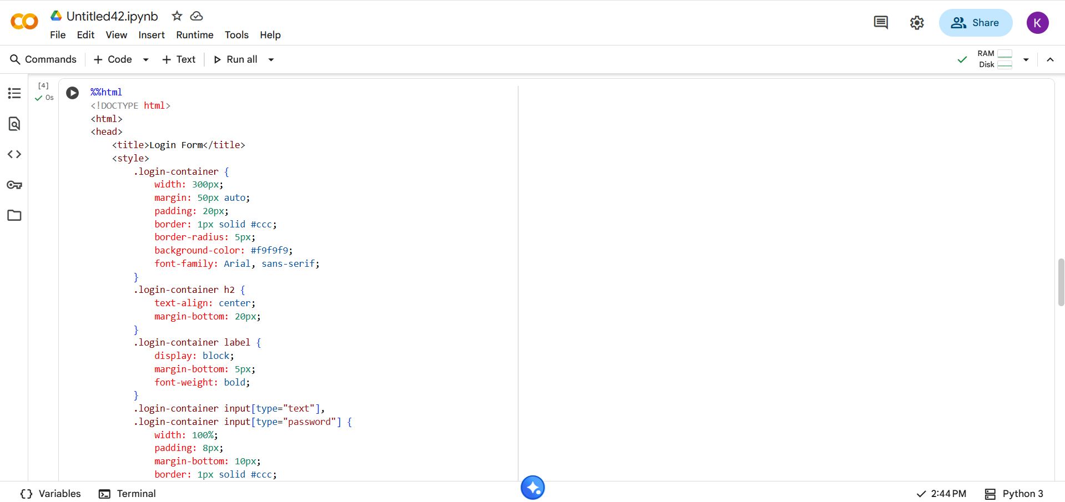
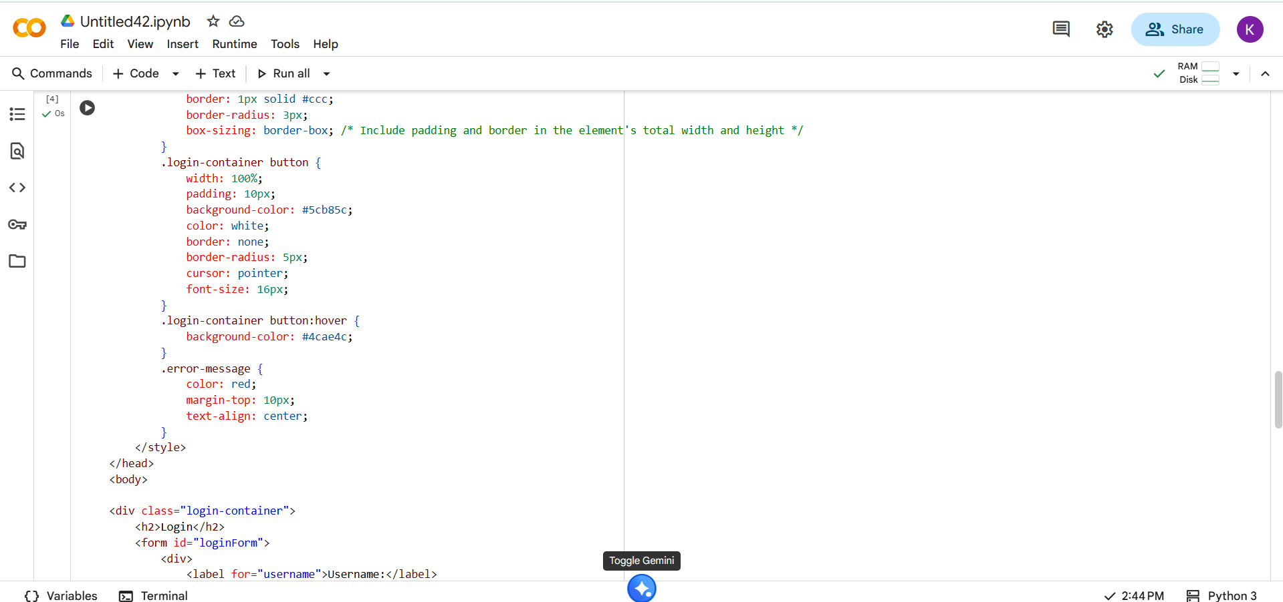
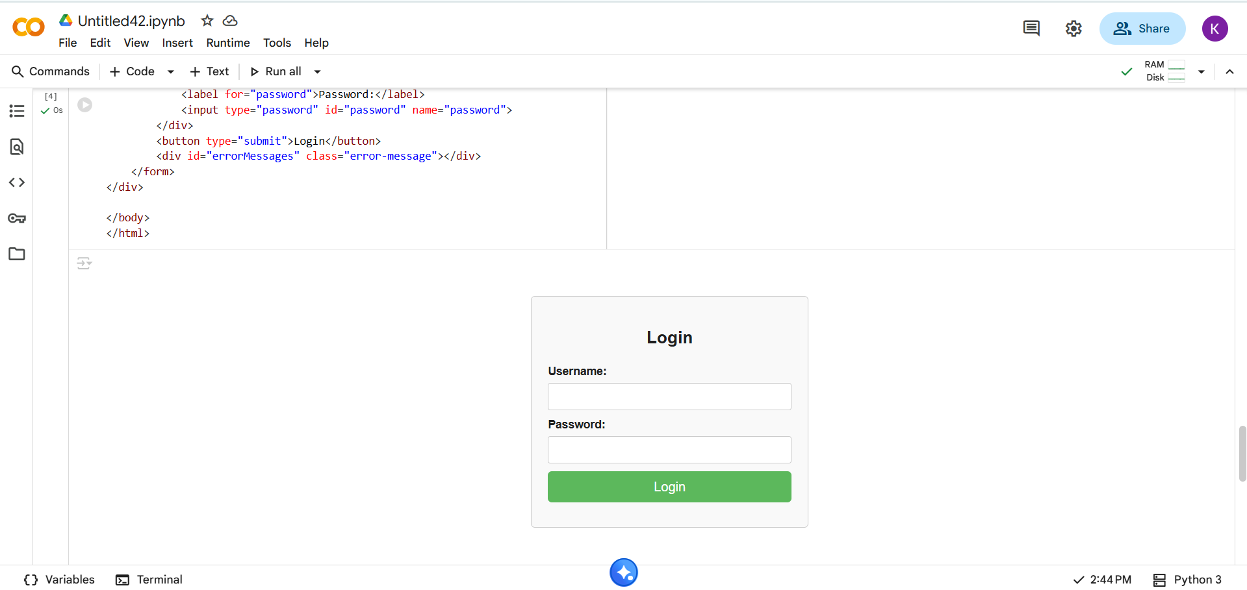

EXPLANANTION:
- %%html: This is a Colab magic command that tells the notebook to render the cell's content as HTML.
- <!DOCTYPE html>, <html>, <head>, <body>: These are standard HTML tags that define the basic structure of the document.
- <title>Login Form</title>: Sets the title of the HTML page, which appears in the browser tab.
- <style> ... </style>: This block contains the CSS rules that style the HTML elements.
  - .login-container: Styles the main container div that holds the login form. It sets the width, margins (to center it), padding, border, border radius, background color, and font family.
  - .login-container h2: Styles the heading inside the container, centering the text and adding a bottom margin.
  - .login-container label: Styles the labels for the input fields, making them block elements (so they appear on their own line), adding a bottom margin, and making the text bold.
  - .login-container input[type="text"], .login-container input[type="password"]: Styles the username and password input fields. It sets the width to 100%, adds padding, bottom margin, border, border radius, and uses box-sizing: border-box; to include padding and border in the element's total width.
  - .login-container button: Styles the submit button. It sets the width, padding, background color, text color, removes the border, adds a border radius, sets the cursor to a pointer on hover, and sets the font size.
  - .login-container button:hover: Changes the background color of the button when the mouse hovers over it.
  - .error-message: Styles the div where error messages will be displayed, setting the text color to red, adding a top margin, and centering the text.
- <div class="login-container"> ... </div>: This div acts as a container for the login form and the heading. The CSS class login-container is applied to this div to style it.
- <h2>Login</h2>: The heading for the login form.
- <form id="loginForm"> ... </form>: This is the HTML form element. The id="loginForm" is used to reference this form in the JavaScript code.
- <div> ... </div>: These divs are used to group each label and input field.
- <label for="username">Username:</label>, <label for="password">Password:</label>: These are labels for the input fields. The for attribute links the label to the input field with the corresponding id.
- <input type="text" id="username" name="username">, <input type="password" id="password" name="password">: These are the input fields where the user will type their username and password. The type attribute specifies the type of input (text or password), and the id and name attributes are used to identify the input fields.
- <button type="submit">Login</button>: This is the button that submits the form.
- <div id="errorMessages" class="error-message"></div>: This div is where the JavaScript will display any error messages. It has an id to be referenced by the JavaScript and a class for styling.

- TASK DISCRIPTION-4:
- Python Backend Integration-
Task: Ask AI to generate a Flask app that serves the HTML form (Task
#3) and prints the username on successful login.

- PROMPT:
Generate a complete and executable Python Flask app that serves a simple HTML login form and, upon successful login, displays the entered username on a new page.
QUESTION:
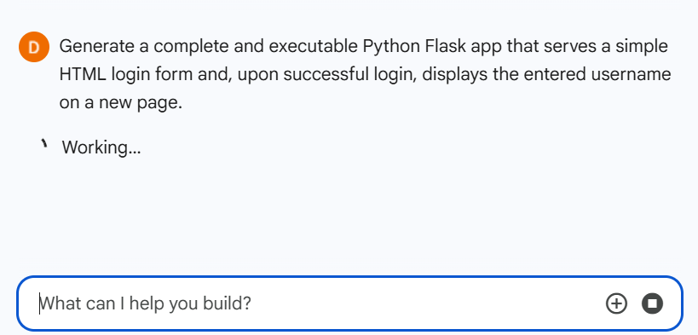

- CODE With OUTPUT:

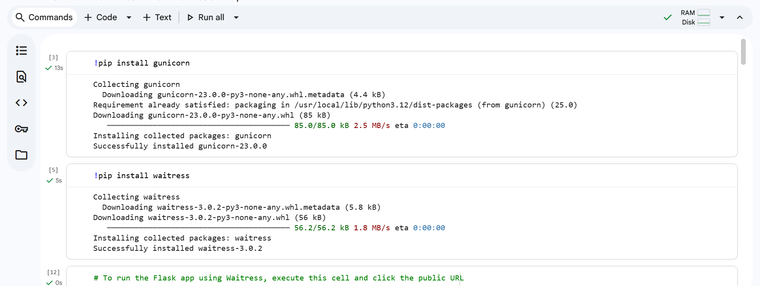
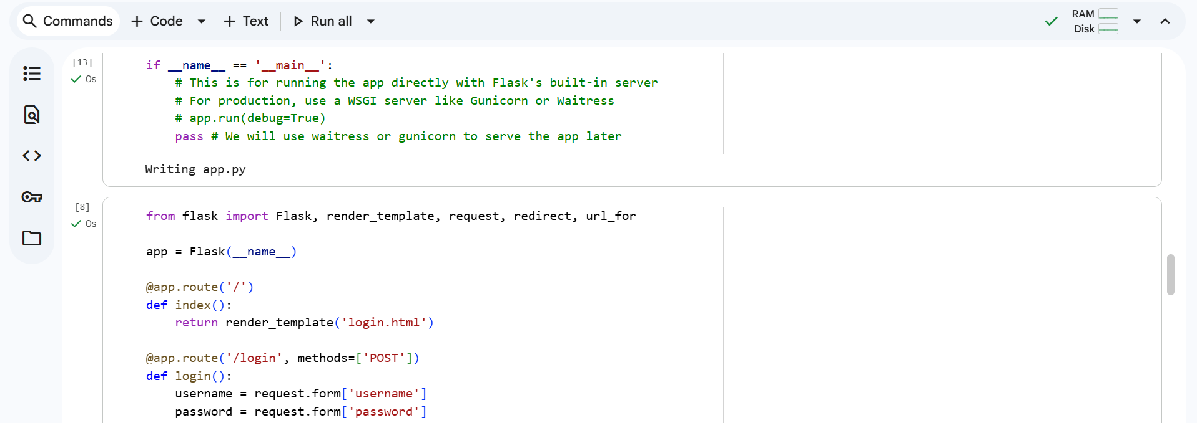
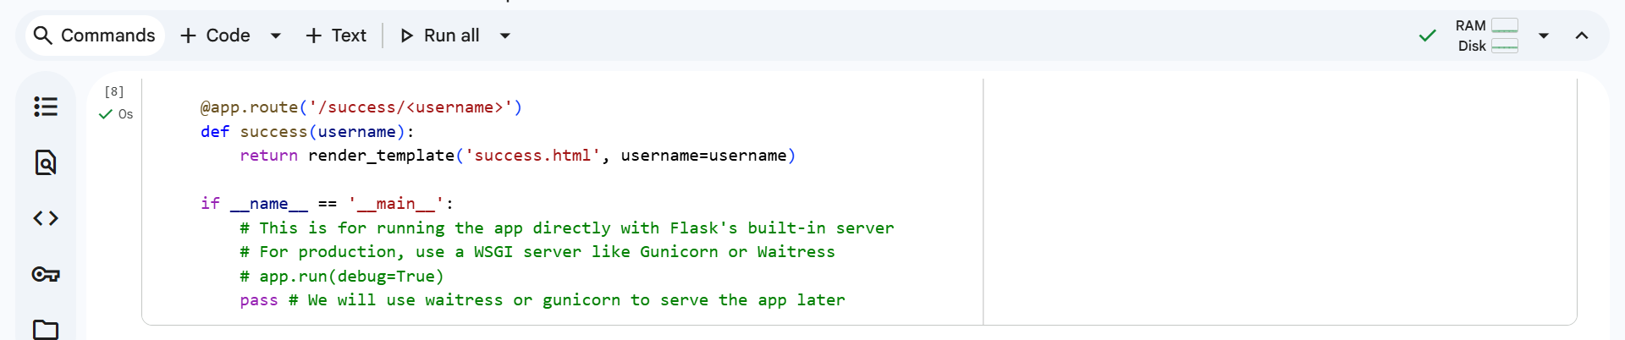
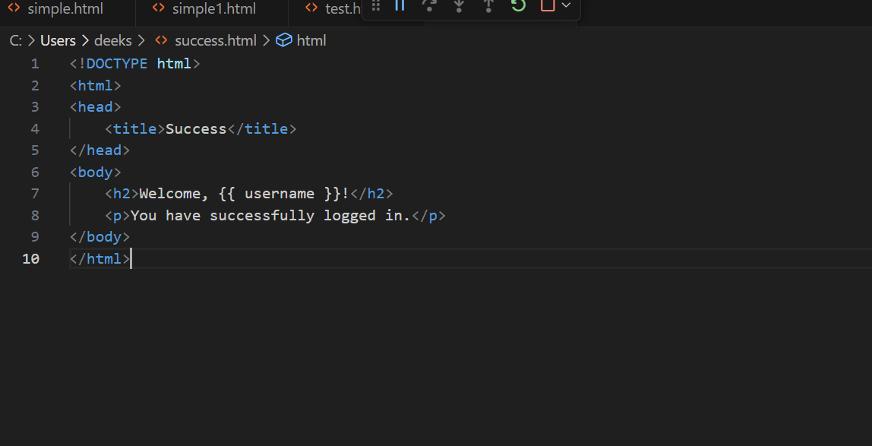
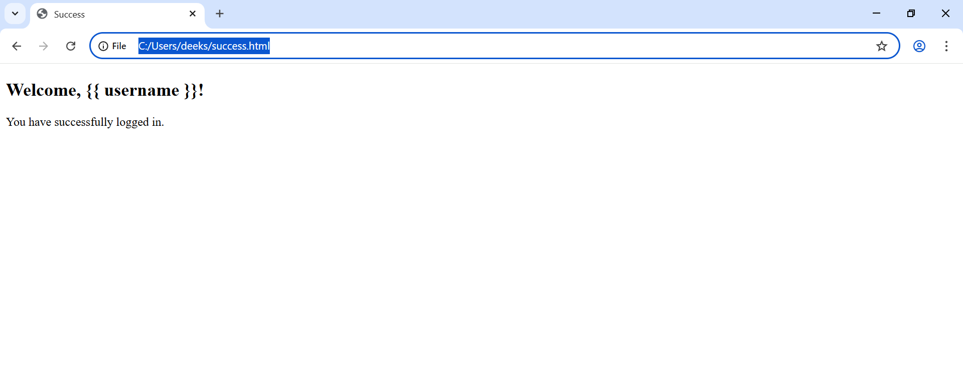

---------------Thank You------------

