Assignment-17
Task-1
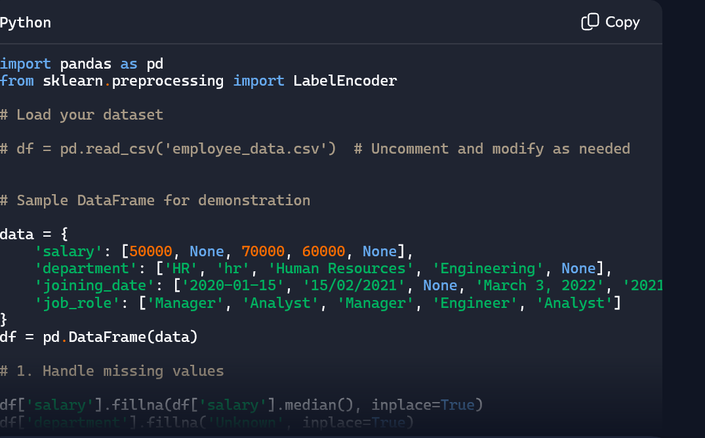
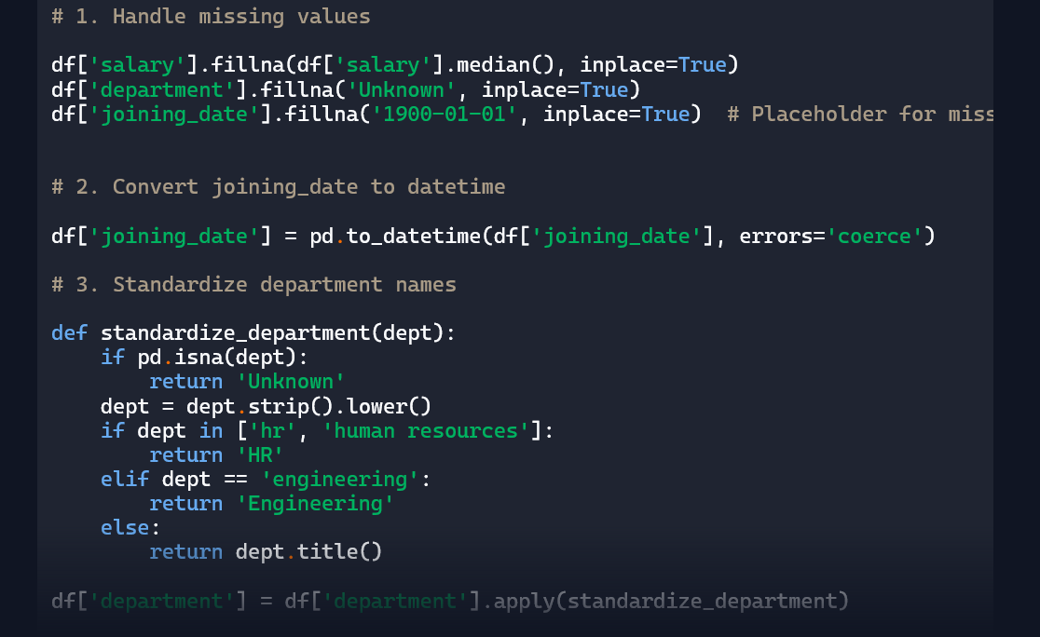
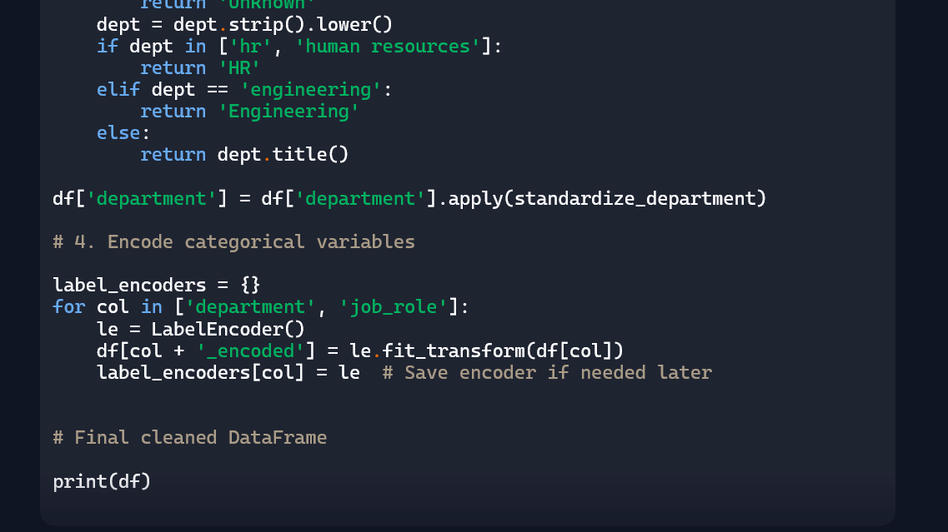
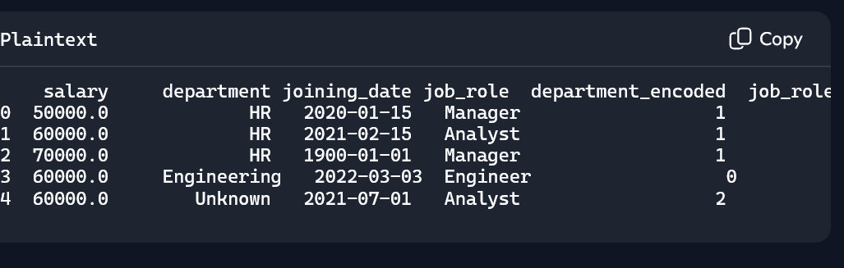
Explanation:
• Missing values handled: Salary filled with median (60000), department with "Unknown", and joining_date with placeholder.
- Dates standardized: All joining dates are in proper datetime64 format.
- Department names normalized: Variants of "HR" unified.
- Categorical encoding: department_encoded and job_role_encoded added for modeling.
Task-2
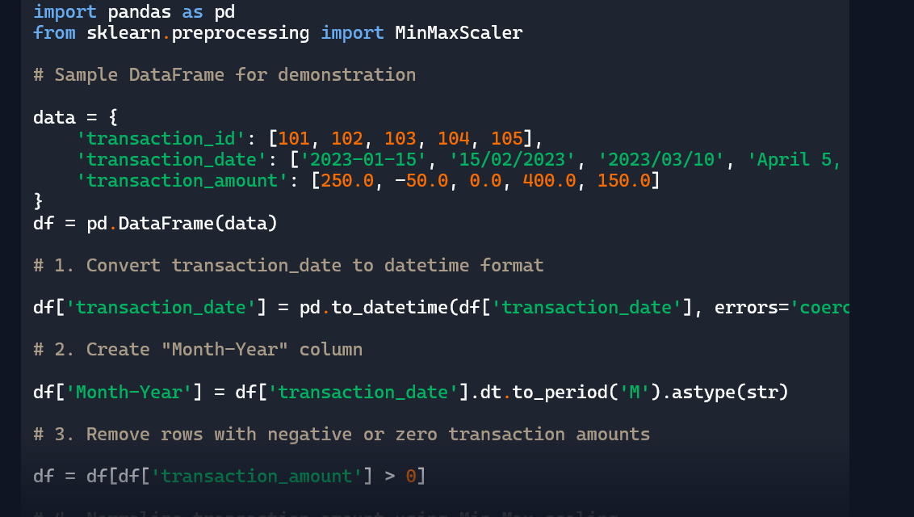
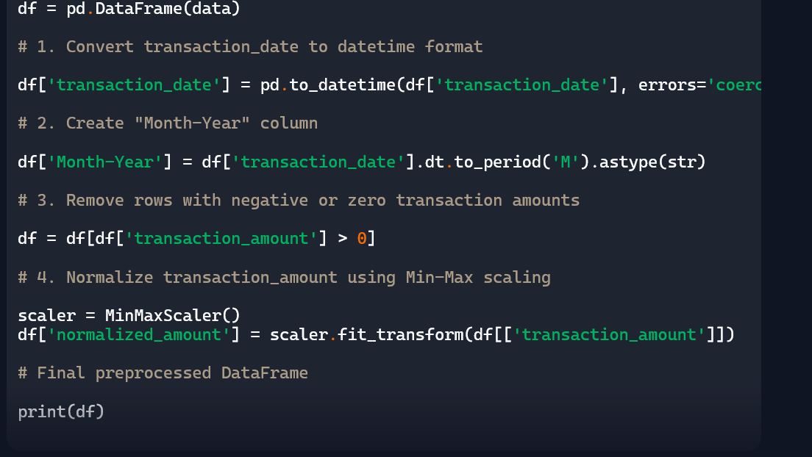
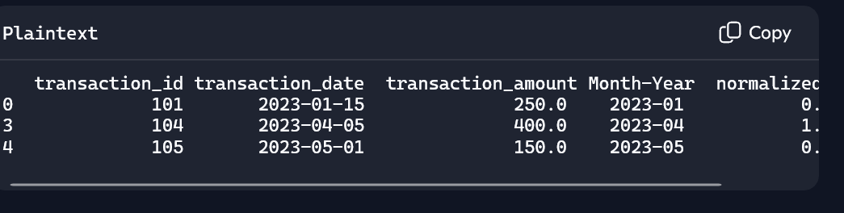
Explanation:
• Dates converted: All transaction_date values are in proper datetime format.
- Month-Year extracted: "Month-Year" column added for time-based analysis.
- Invalid transactions removed: Rows with zero or negative amounts are excluded.
- Amounts normalized: transaction_amount scaled between 0 and 1 using Min-Max scaling.
Task-3
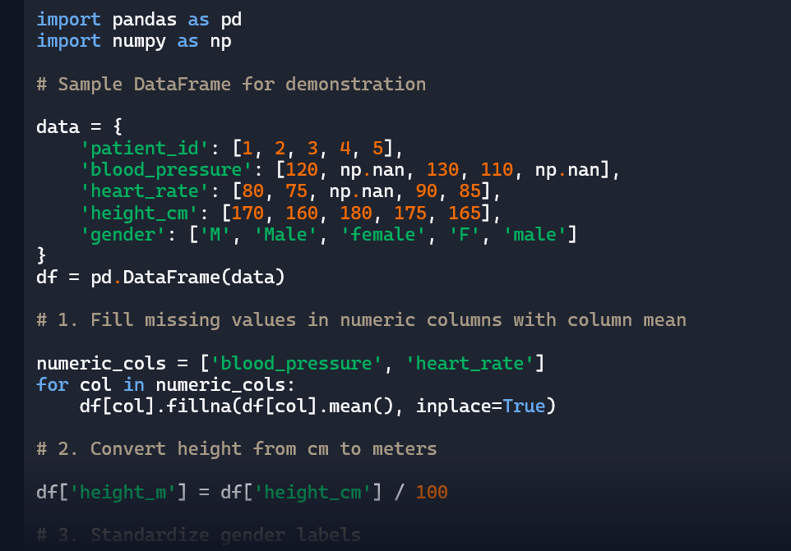
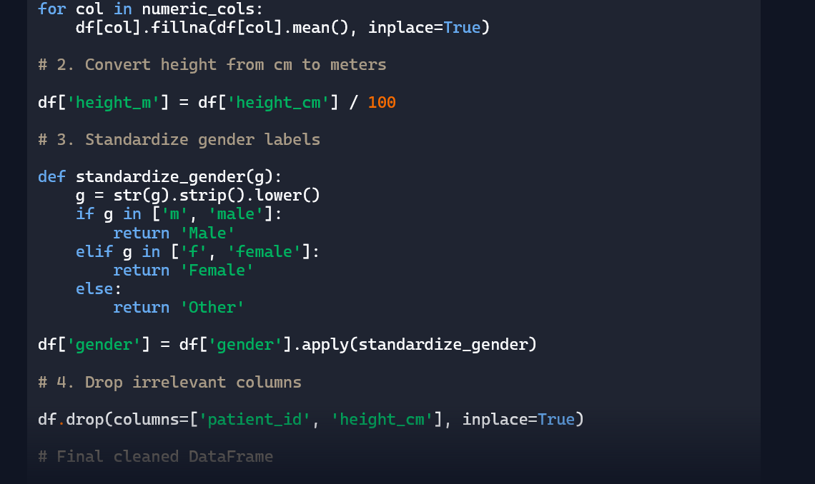
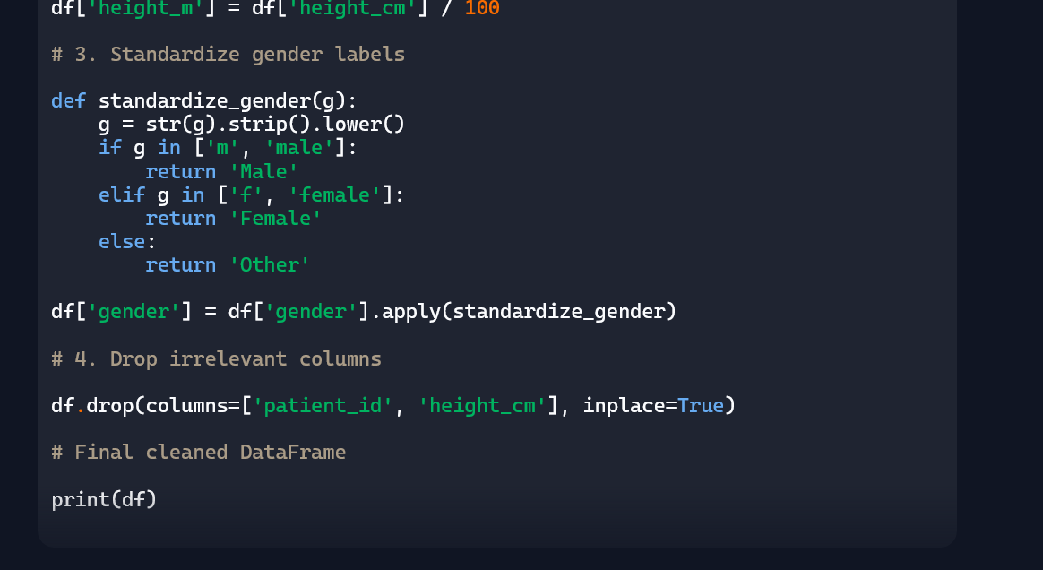
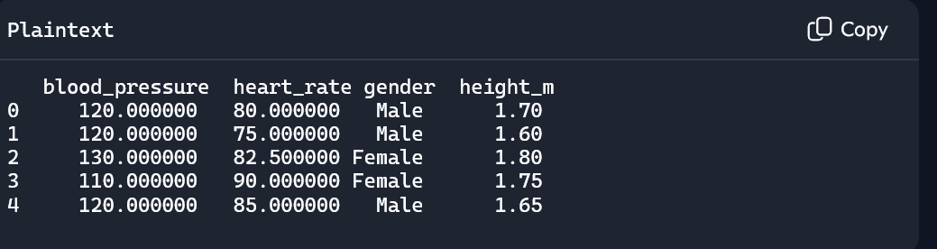
Explanation:
• Missing values filled: blood_pressure and heart_rate use column means.
- Height standardized: Converted from centimeters to meters.
- Gender labels corrected: All variants unified to "Male" or "Female".
- Irrelevant columns dropped: patient_id and height_cm removed.

Task-4
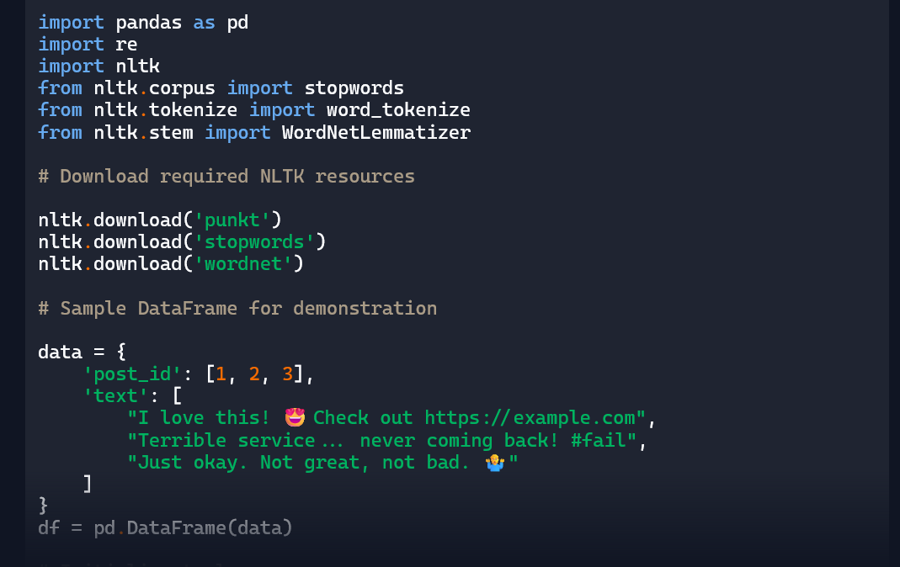
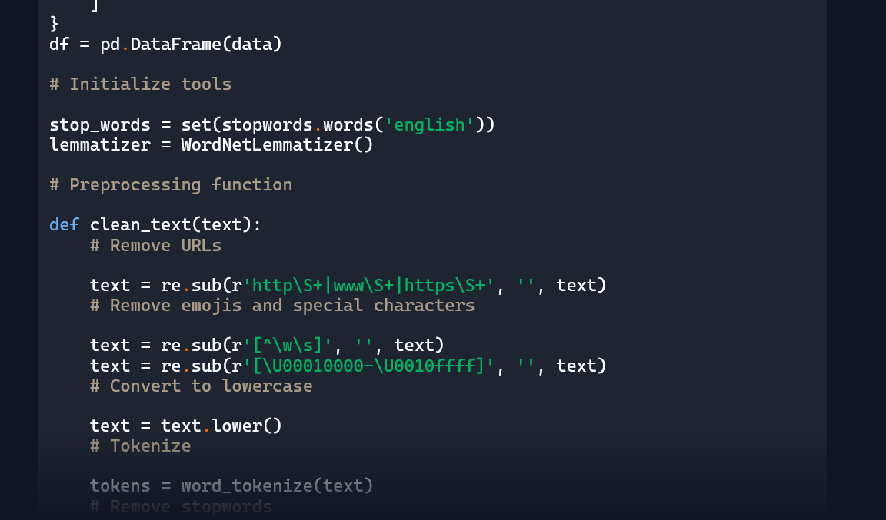
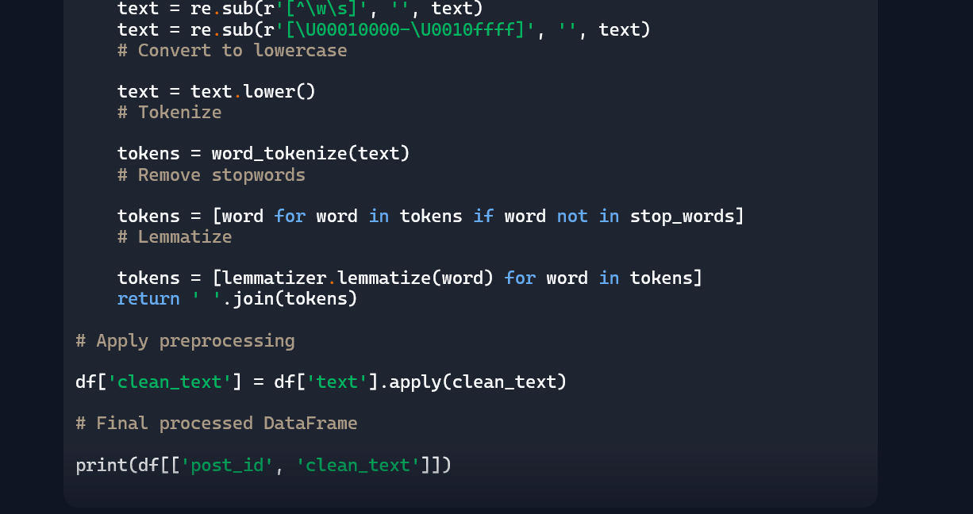
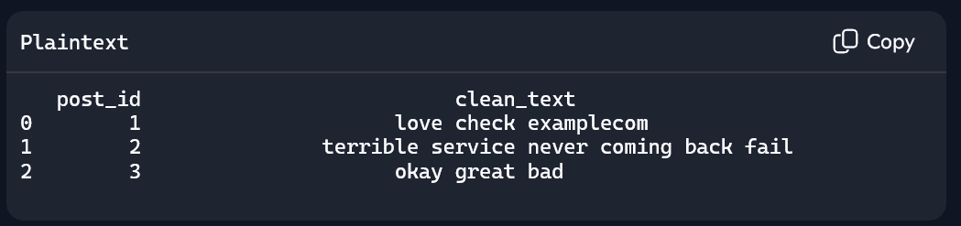
Explanation:
• Special characters, URLs, and emojis removed: Text is stripped of noise.
- Lowercased: All text is normalized to lowercase.
- Tokenized and stopwords removed: Only meaningful words retained.
- Lemmatized: Words like “loved” or “services” would be reduced to “love” and “service”.
This dataset is now ready for NLP tasks like sentiment classification, topic modeling, or vectorization with TF-IDF or embeddings.

Task-5
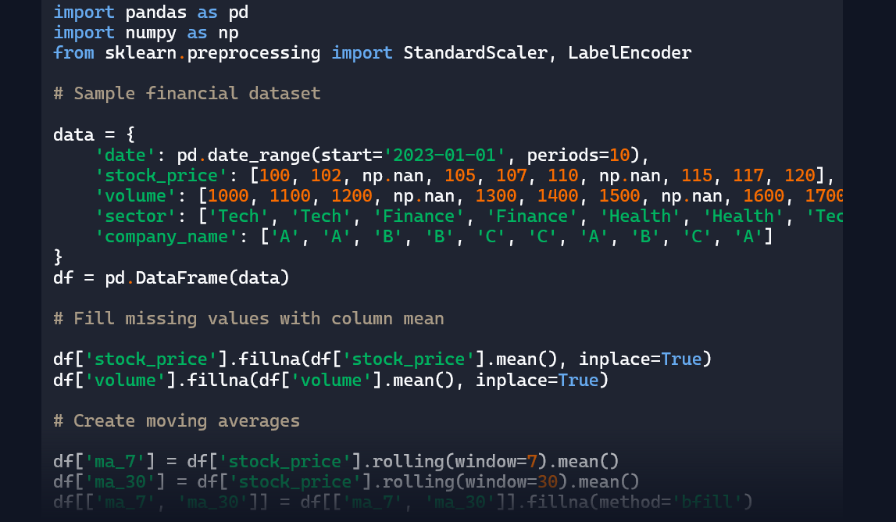
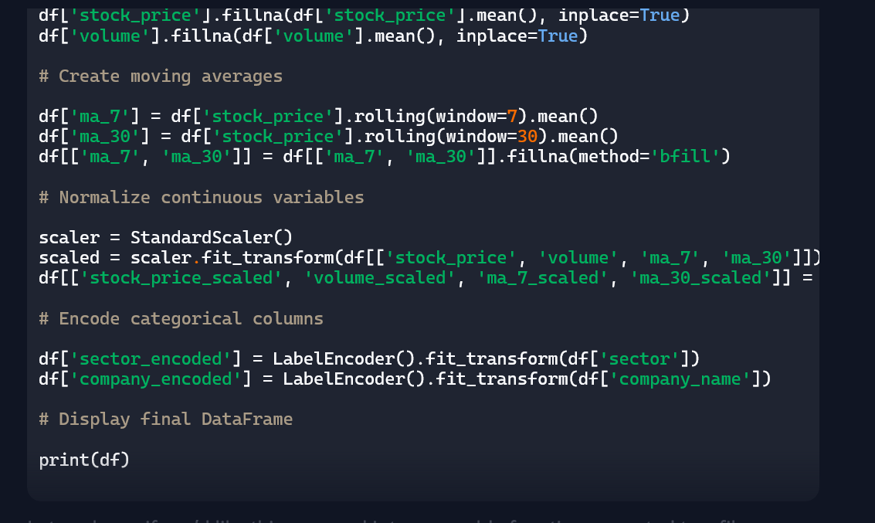
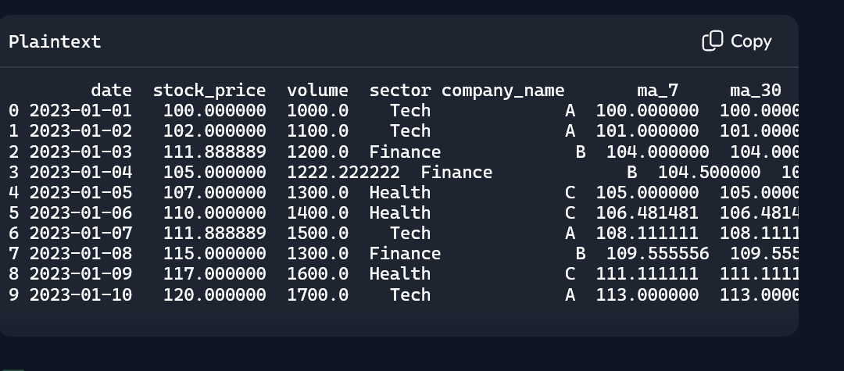
Explanation:
• Missing values handled: stock_price and volume filled with column means.
- Moving averages: ma_7 and ma_30 created and filled.
- Normalized features: Scaled versions of price, volume, and moving averages using StandardScaler.
- Encoded categories: sector_encoded and company_encoded for ML readiness.
This dataset is now fully prepped for regression, classification, or time-series modeling.

