Lab-Assignment-15
Task 1
Student Records API
Task:
Use AI to build a RESTful API for managing student records.
Instructions:
- Endpoints required:
  - GET /students → List all students
  - POST /students → Add a new student
  - PUT /students/{id} → Update student details
  - DELETE /students/{id} → Delete a student record
- Use an in-memory data structure (list or dictionary) to store records.
- Ensure API responses are in JSON format.
Expected Output:
- Working API with CRUD functionality for student records.
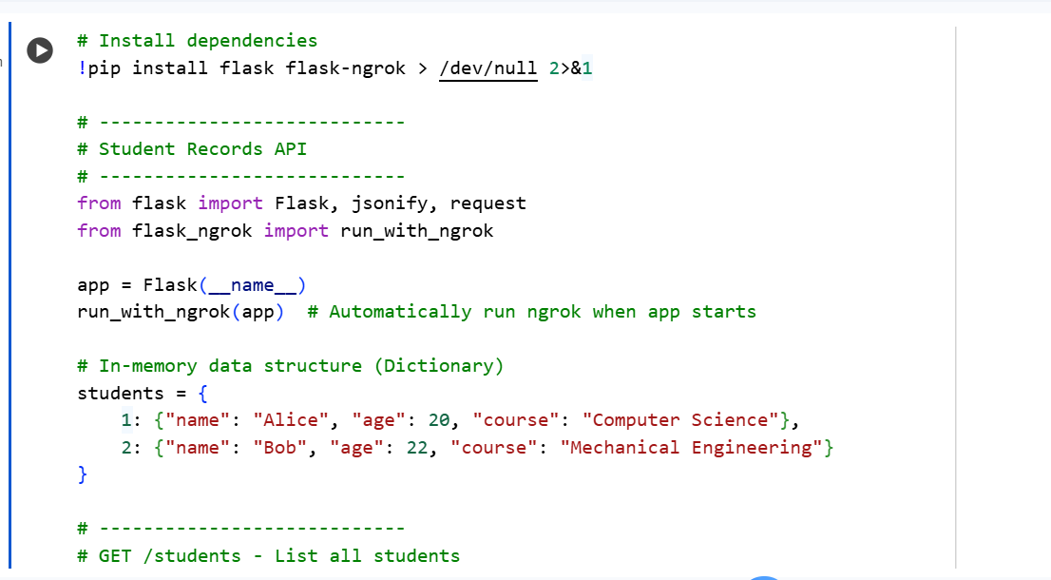
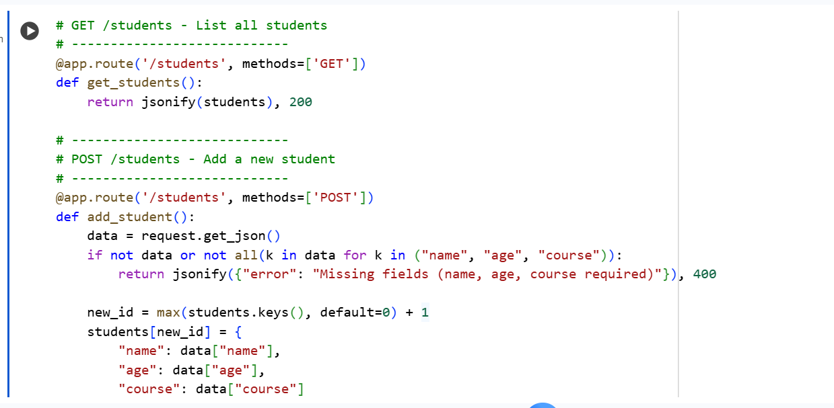
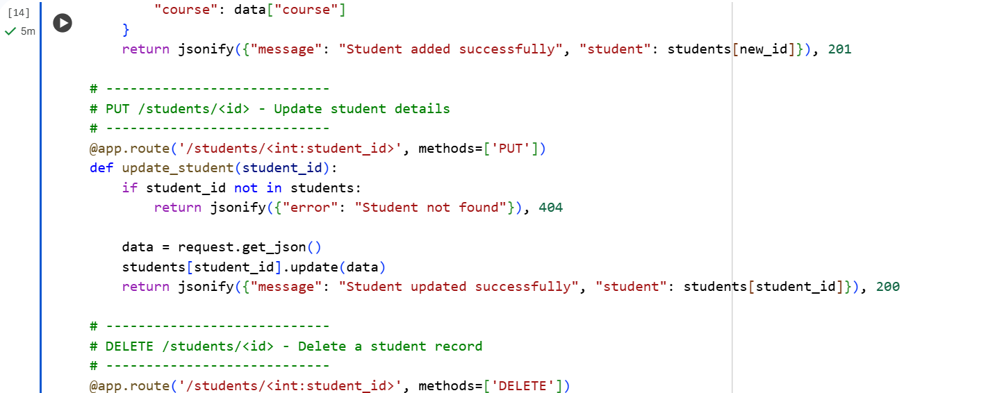
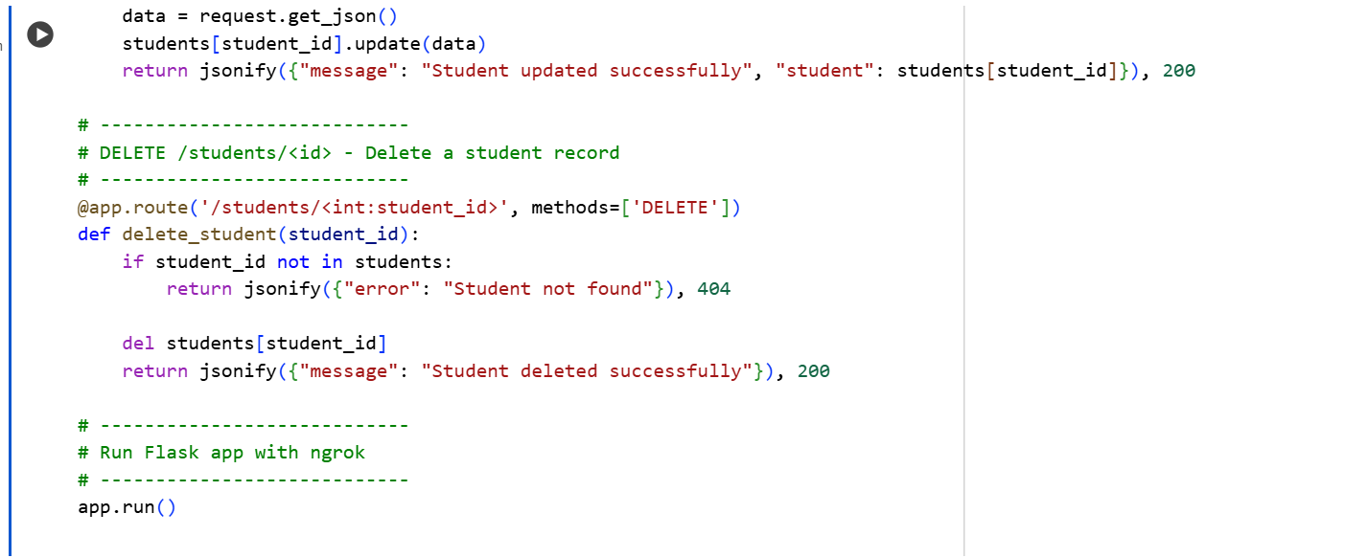
Task 2
Library Book Management API
Task:
Develop a RESTful API to handle library books.
Instructions:
- Endpoints required:
  - GET /books → Retrieve all books
  - POST /books → Add a new book
  - GET /books/{id} → Get details of a specific book
  - PATCH /books/{id} → Update partial book details (e.g., availability)
  - DELETE /books/{id} → Remove a book
- Implement error handling for invalid requests.
Expected Output:
- Functional API with CRUD + partial updates.

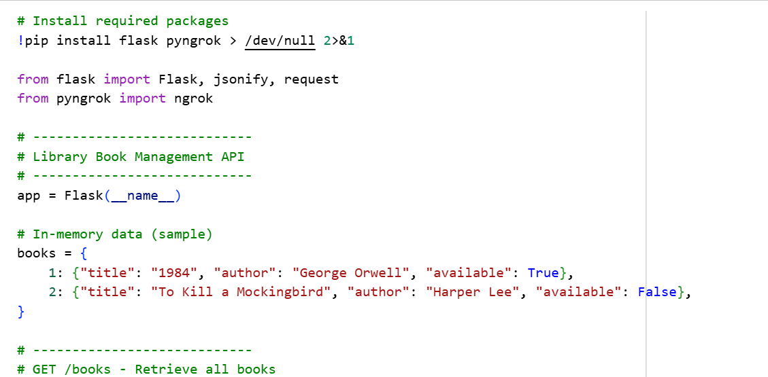
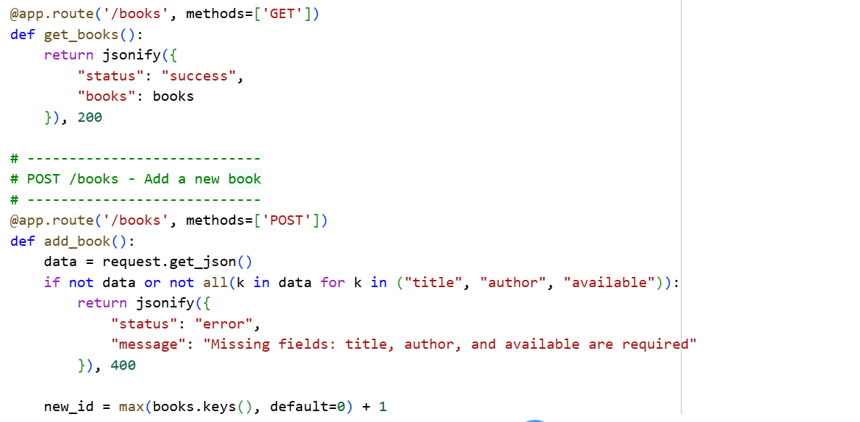
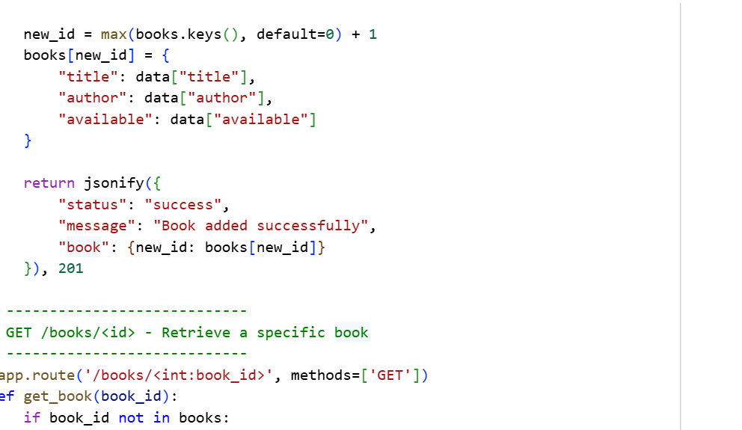
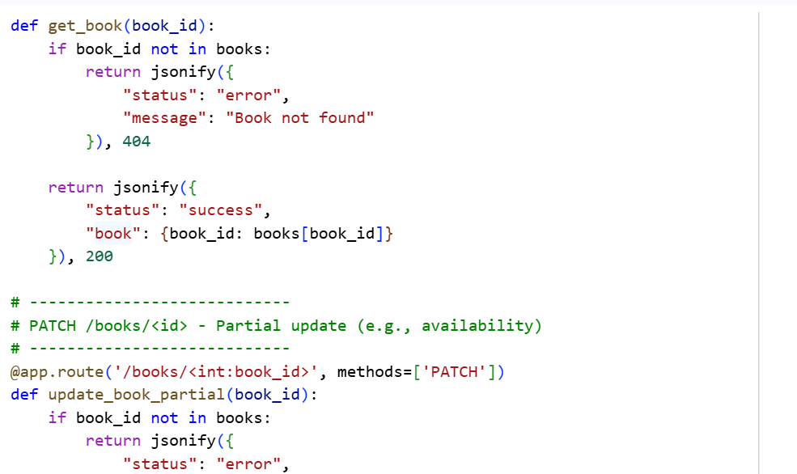
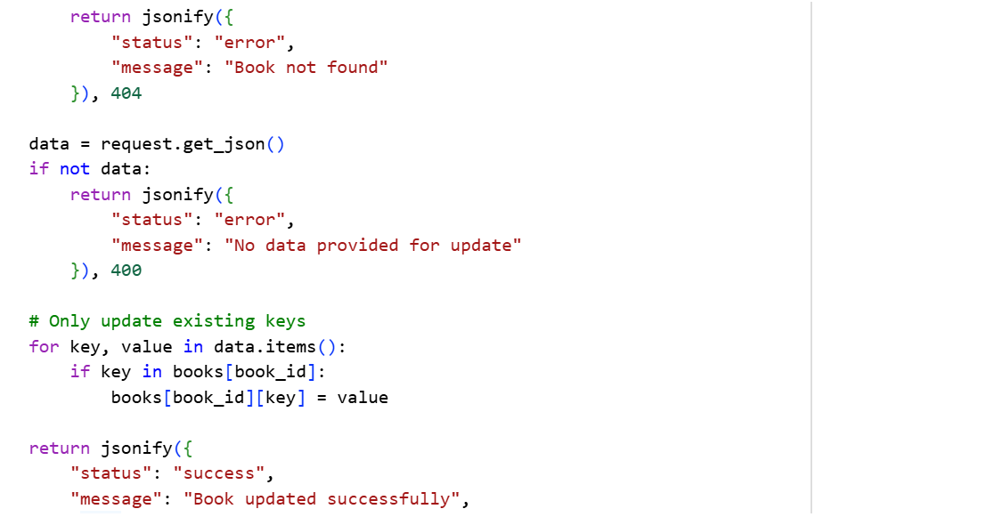
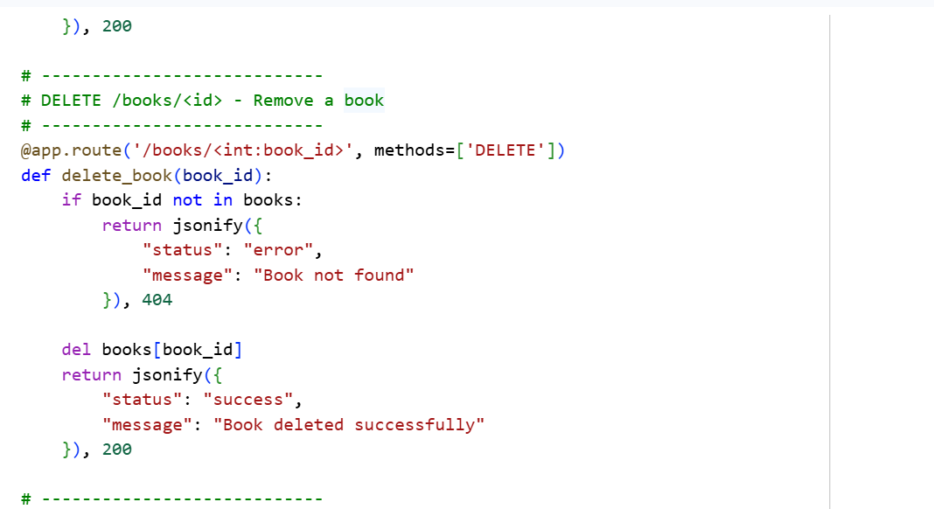
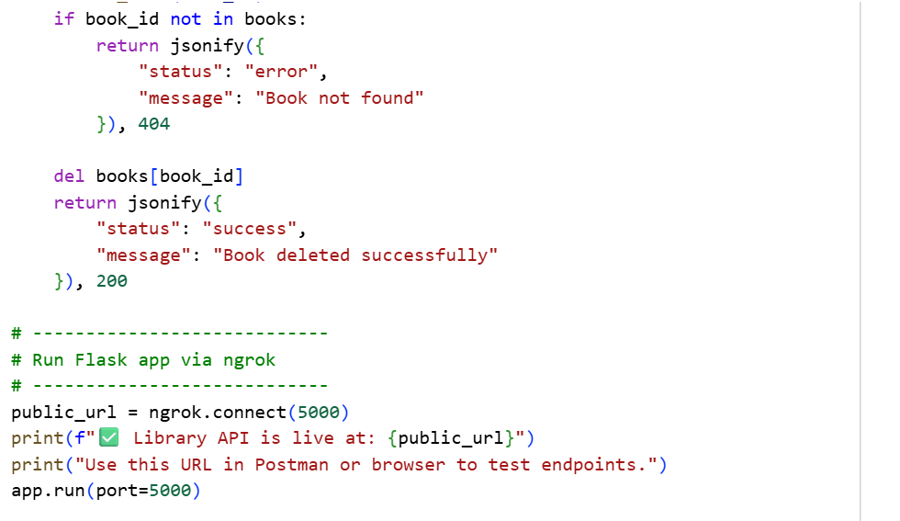
Task 3
Employee Payroll API
Task:
Create an API for managing employees and their salaries.
Instructions:
- Endpoints required:
  - GET /employees → List all employees
  - POST /employees → Add a new employee with salary details
  - PUT /employees/{id}/salary → Update salary of an employee
  - DELETE /employees/{id} → Remove employee from system
- Use AI to:
  - Suggest data model structure.
  - Add comments/docstrings for all endpoints.
Expected Output:
- API supporting salary management with clear documentation.
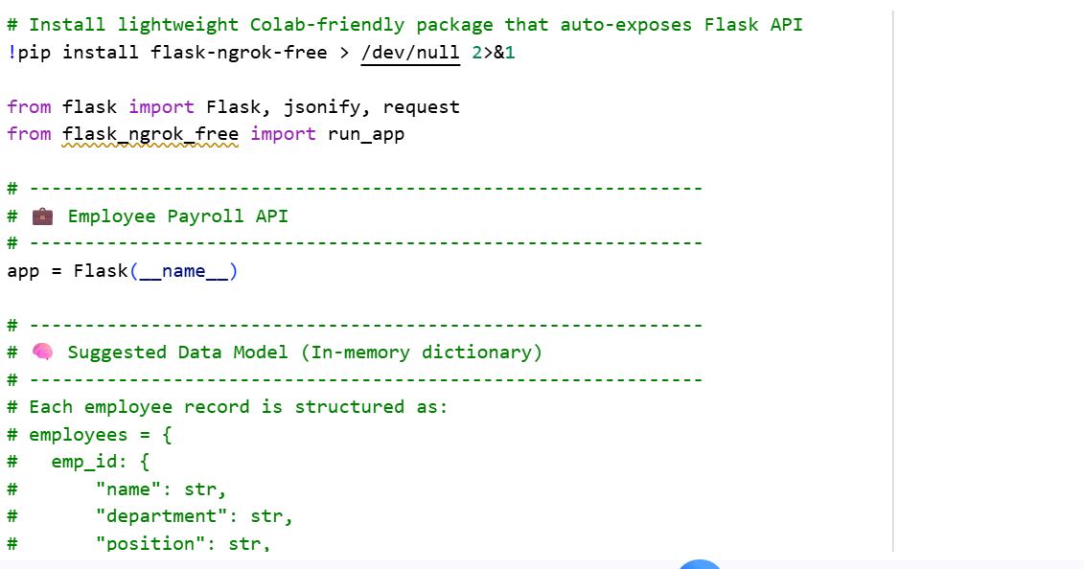
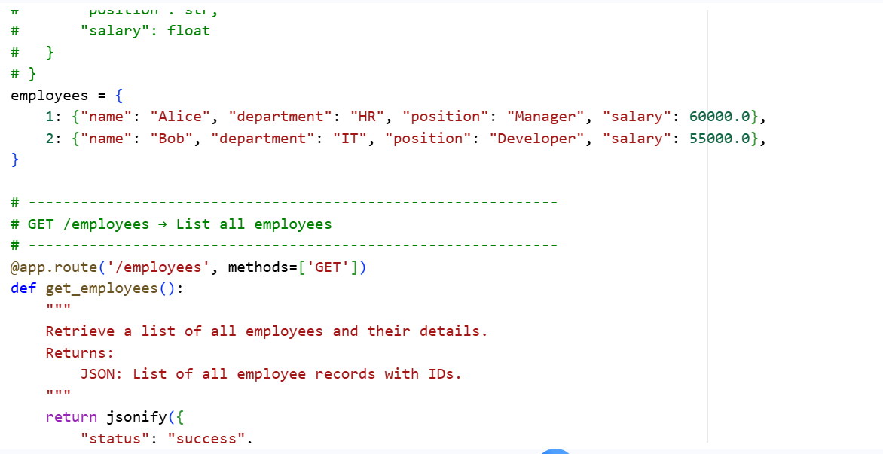
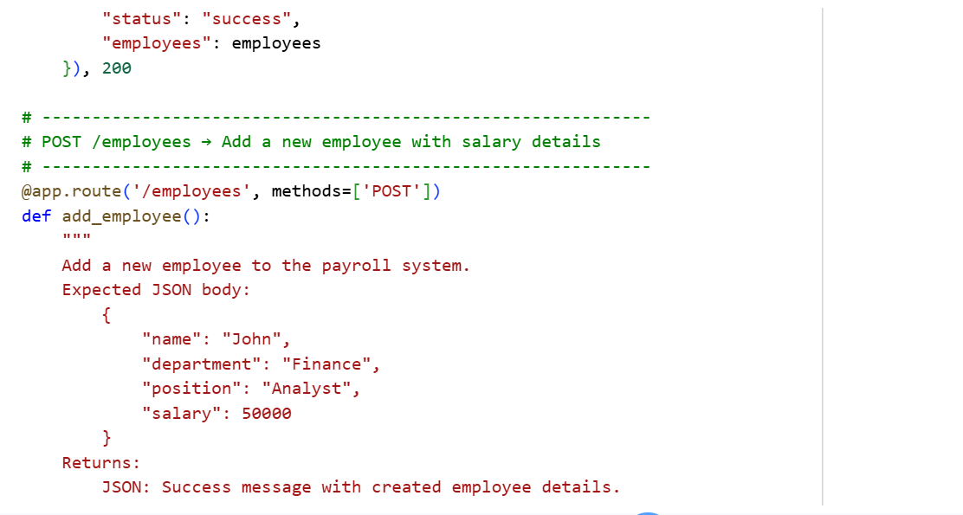
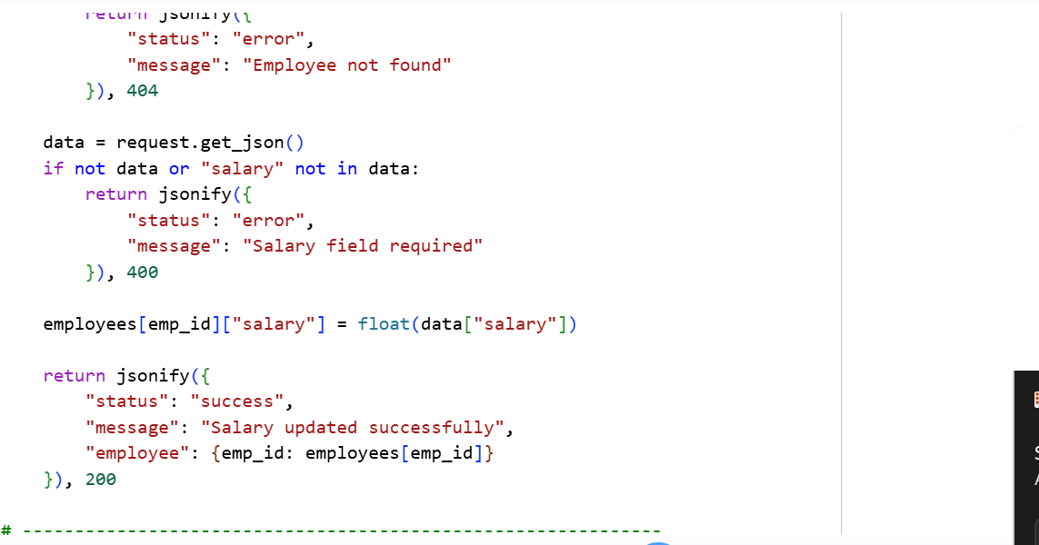
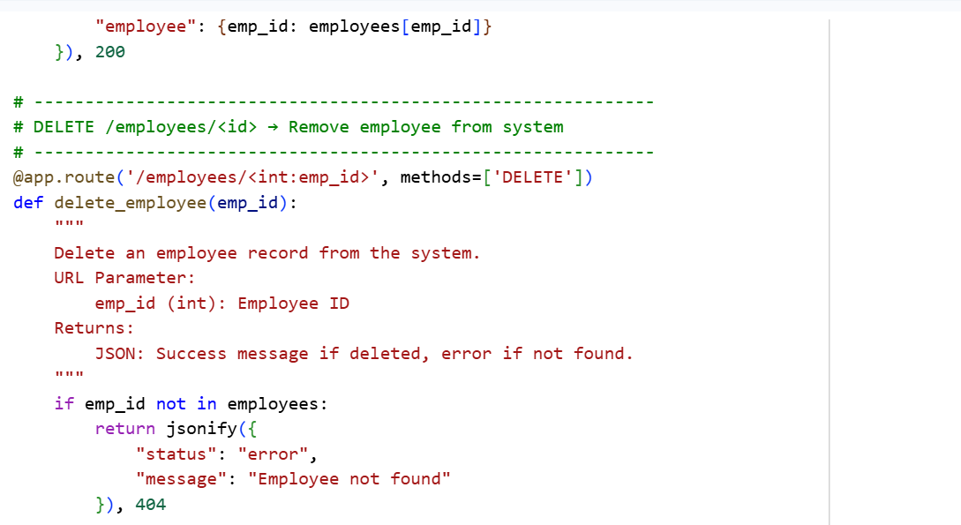

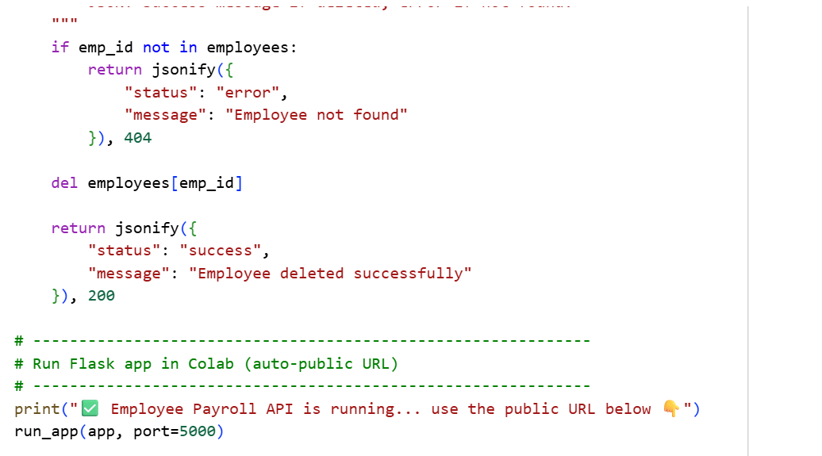

Task 4
Real-Time Application: Online Food Ordering API
Scenario:
Design a simple API for an online food ordering system.
Requirements:
- Endpoints required:
  - GET /menu → List available dishes
  - POST /order → Place a new order
  - GET /order/{id} → Track order status
  - PUT /order/{id} → Update an existing order (e.g., change items)
  - DELETE /order/{id} → Cancel an order
- AI should generate:
  - REST API code
  - Suggested improvements (like authentication, pagination)
Expected Output:
- Fully working API simulating a food ordering backend.

