Assignment-20
Task 1:
Detect Hardcoded Credentials
- Instructions:
  - Ask AI to generate a Python script that connects to a database or API.
  - Check if the code contains hardcoded usernames, passwords, or API keys.
  - Modify the code to securely load credentials from environment variables.
- Expected Output:
  - Insecure version:
  - password = "admin123"
  - Secure version:
  - import os
password = os.getenv("DB_PASSWORD")

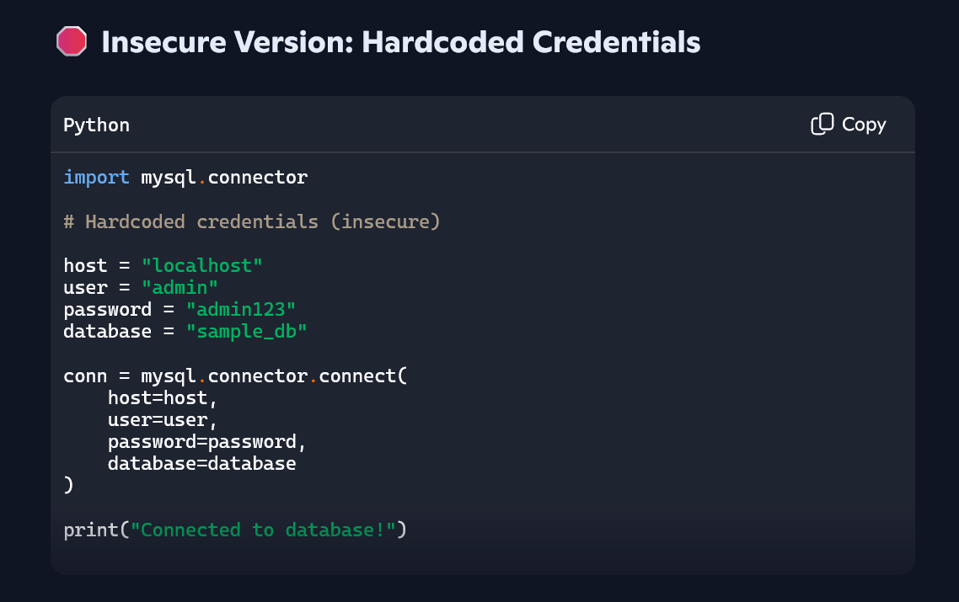
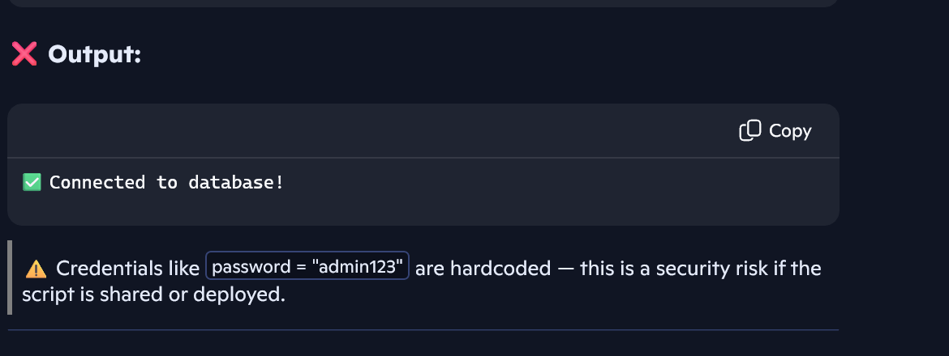

Issue:
- The user and password are hardcoded directly in the script.
- This exposes sensitive information and violates security best practices.

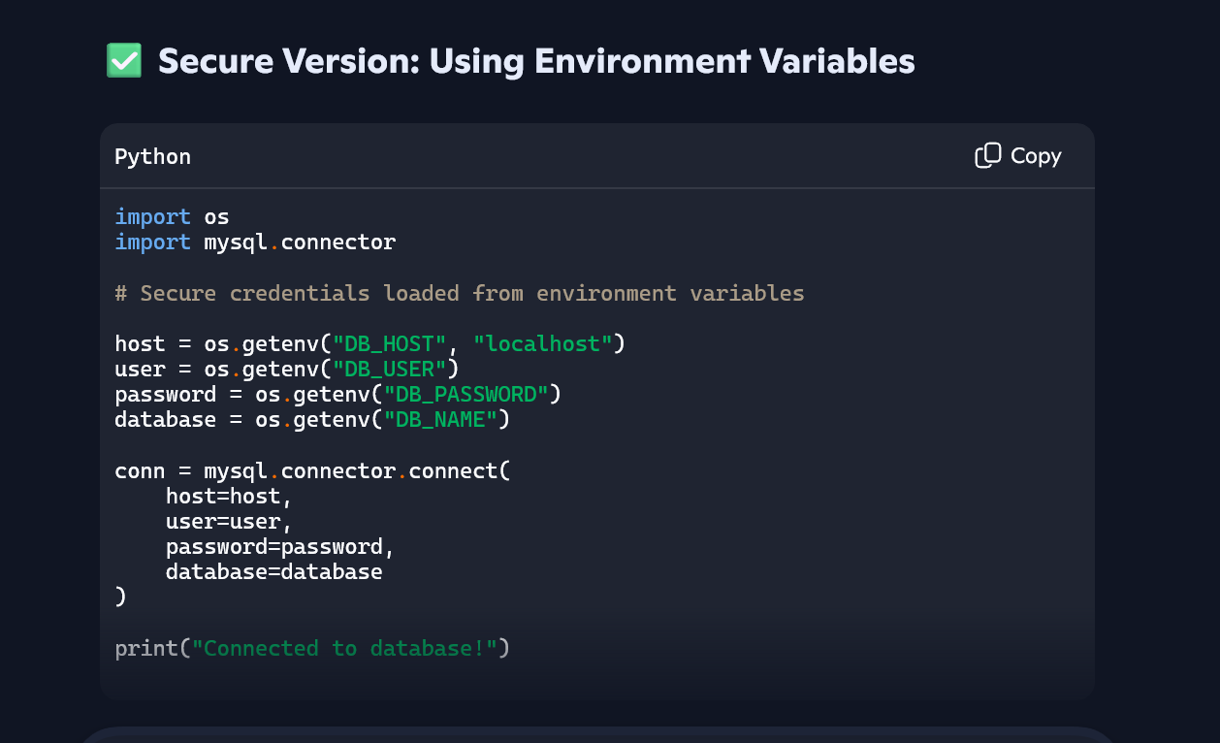
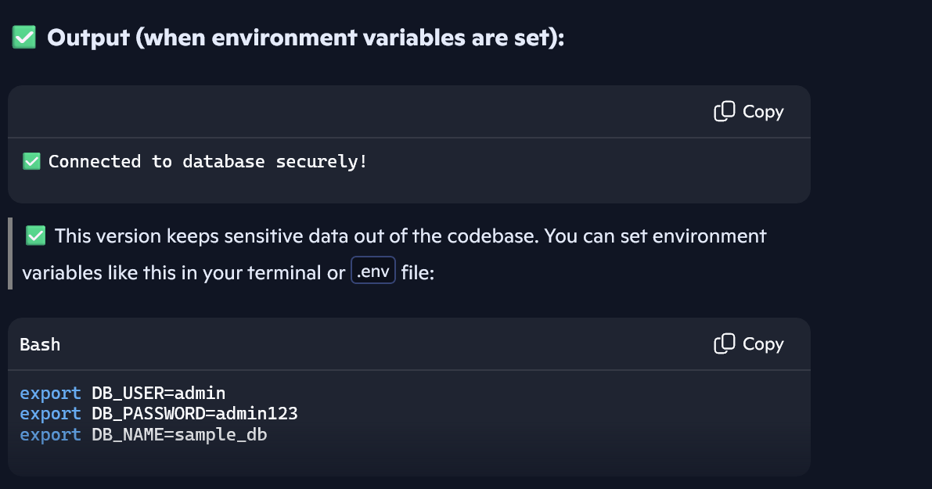

Benefits:
- Credentials are stored outside the codebase.
- You can manage them securely using .env files or system-level environment variables.
- Prevents accidental leaks when sharing or deploying code.

Task 2:
Identify SQL Injection Vulnerabilities
- Instructions:
  - Use AI to generate a simple login system in Python (with SQLite or MySQL).
  - Test the system with an input like:
  - ' OR '1'='1
  - Identify if SQL injection is possible.
  - Rewrite the code using parameterized queries to prevent injection.
- Expected Output:
  - Vulnerable query:
  - SELECT * FROM users WHERE username = 'admin' AND password = '1234'
  - Secure query with parameters:
cursor.execute("SELECT * FROM users WHERE username=? AND password=?", (user, pwd))

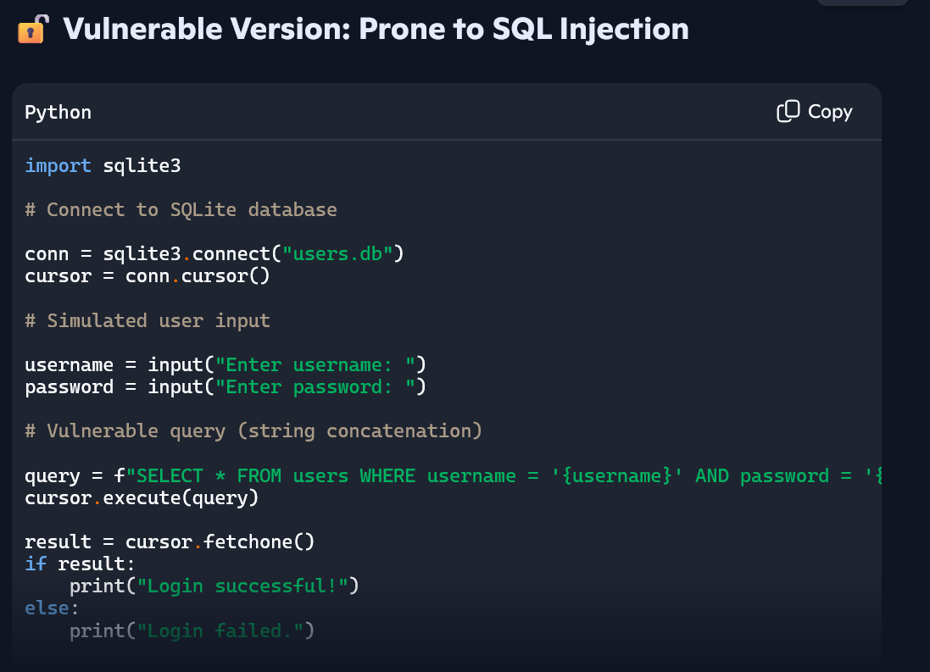

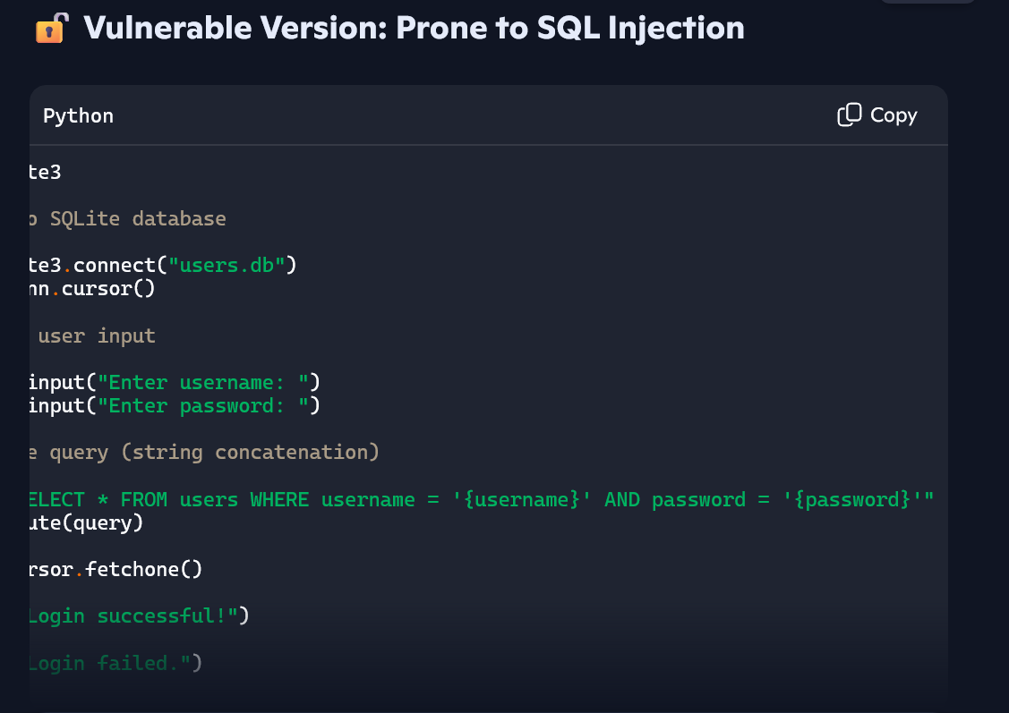

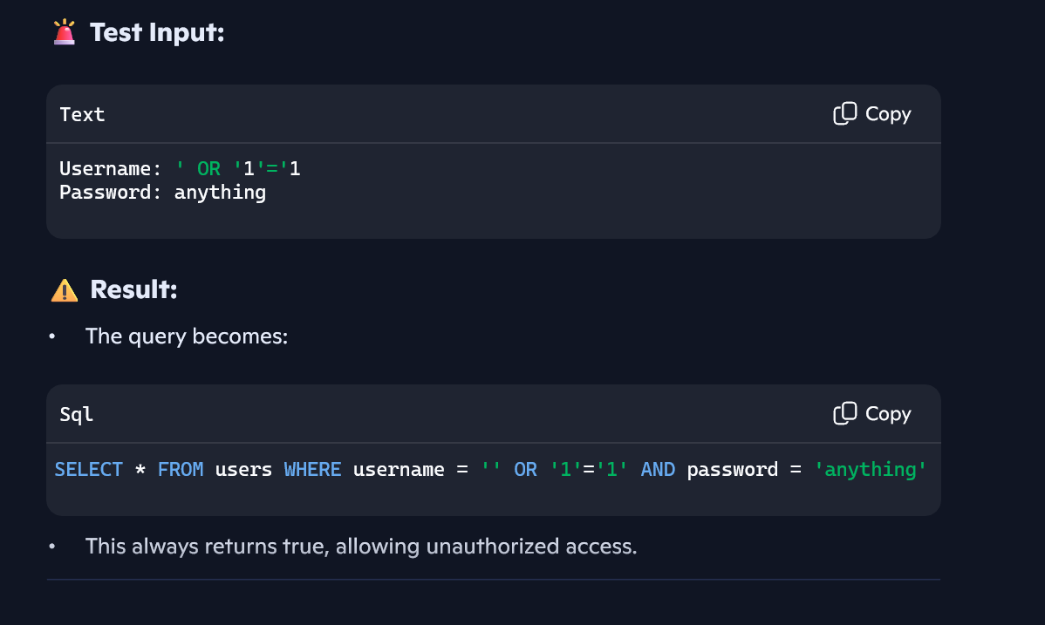
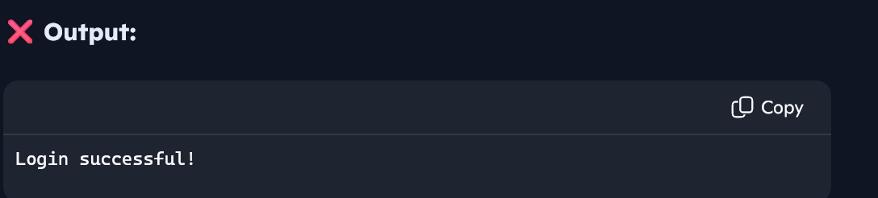

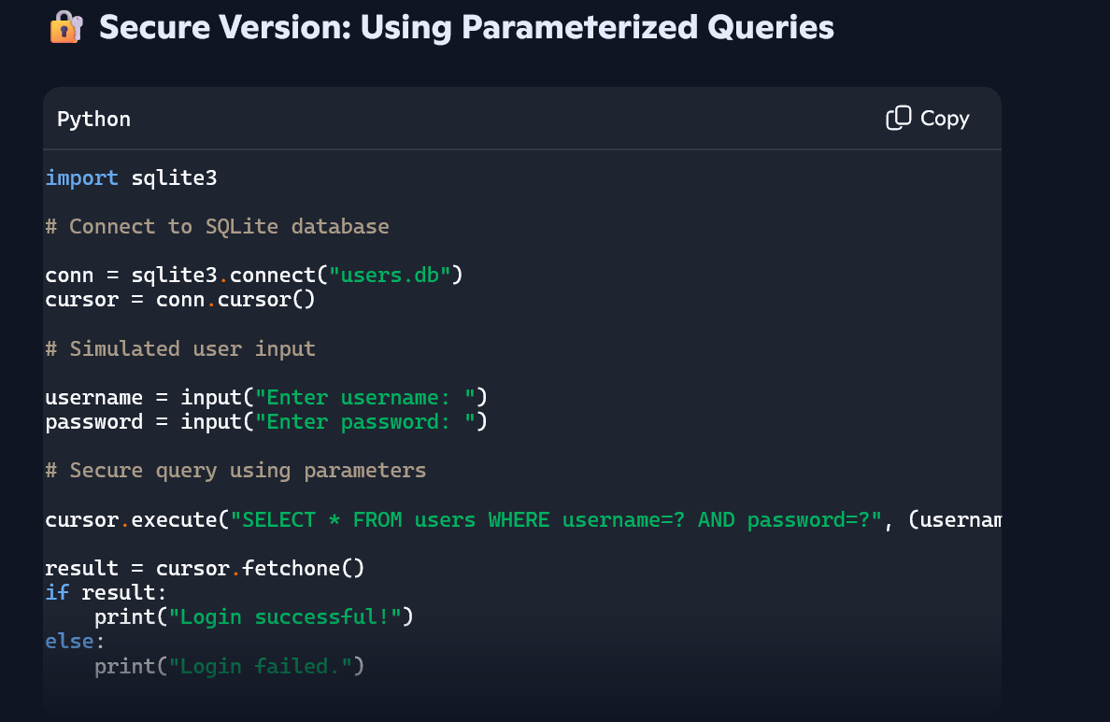
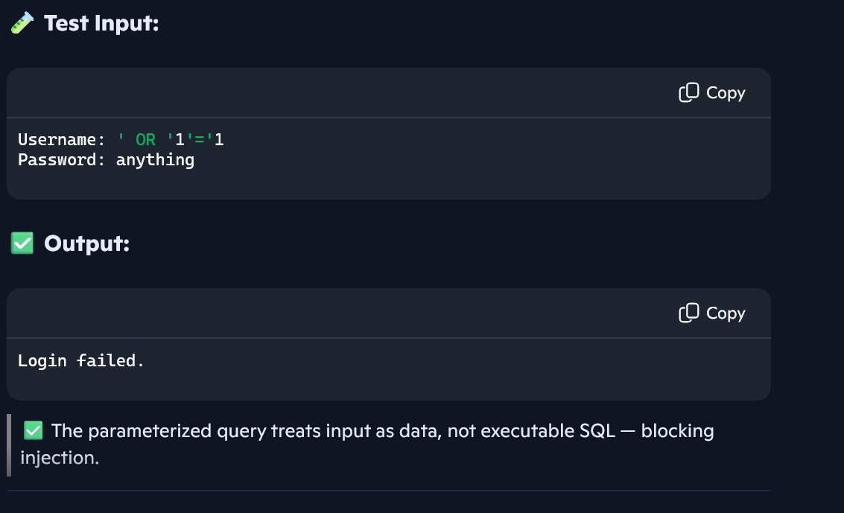

Why This Works:
- Parameters are safely escaped and quoted by the database engine.
- Prevents malicious input from altering the query logic.

Task 3:
Detect Unsafe File Handling

Instructions:

- Ask AI to generate a Python script that reads and writes files based on user input.

- Check if the code allows path traversal attacks (e.g., entering ../../etc/passwd).

- Fix the vulnerability by validating file paths or restricting access to safe directories.

Expected Output:

- Insecure: Allows access to system files.

Secure: Only allows files inside a data/ folder.

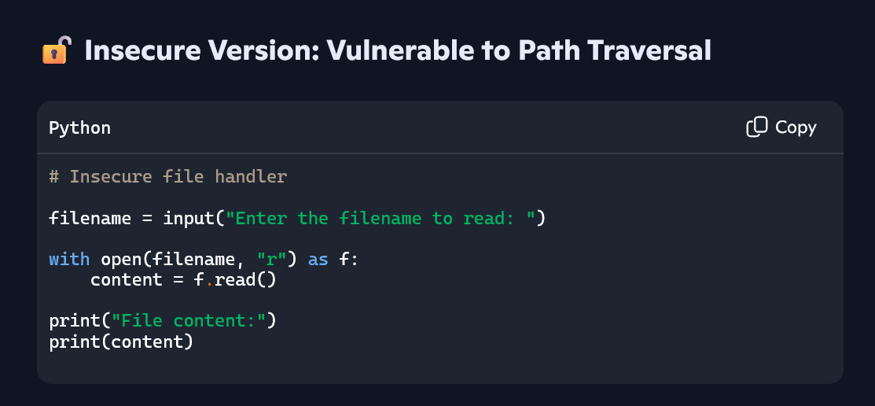

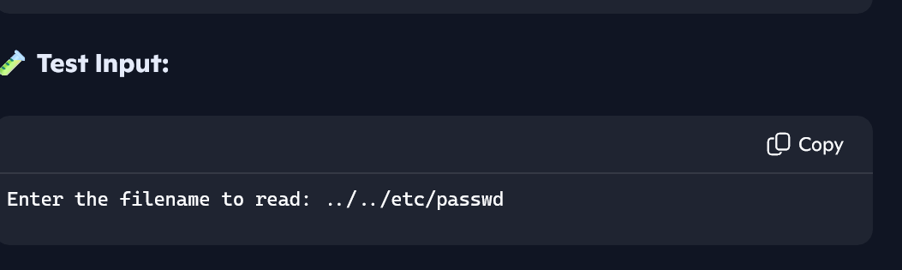
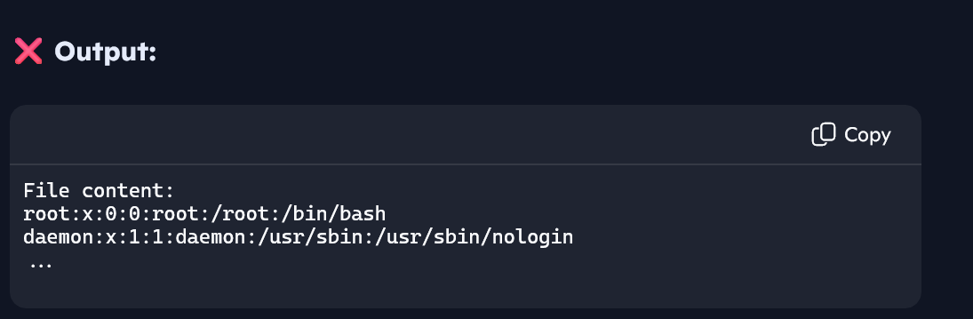
This exposes sensitive system files — a classic path traversal vulnerability.
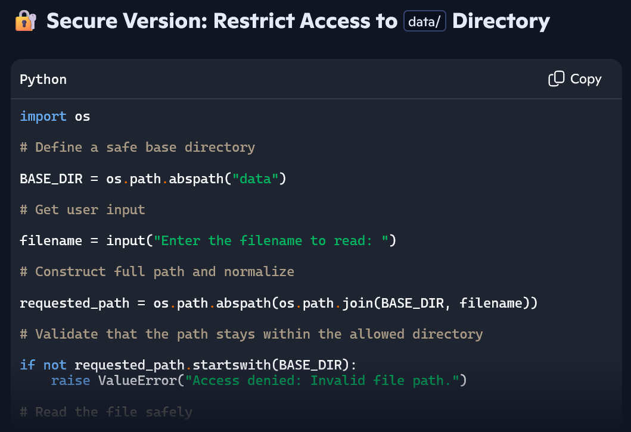
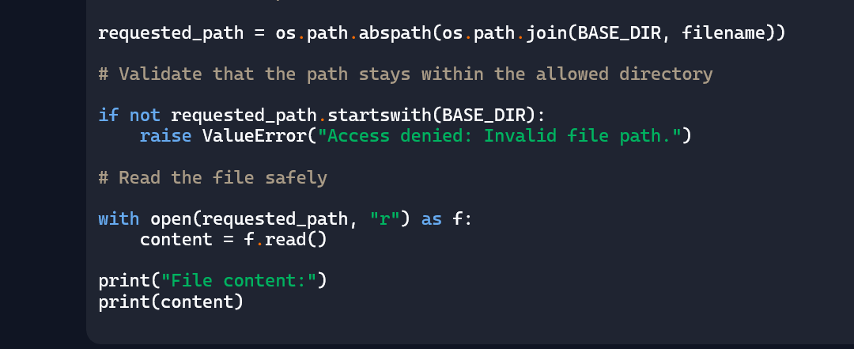.
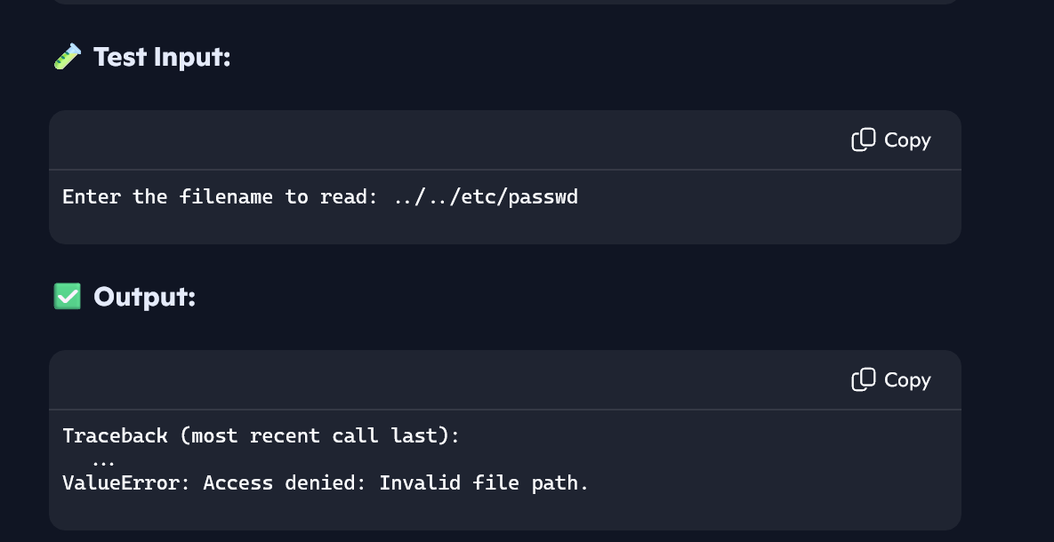
The secure version blocks unauthorized access and ensures only files inside data/ are readable.

Task 4:
Identify Insecure Use of eval() or exec()
- Instructions:
  - Ask AI to generate a calculator program that evaluates user input.
  - If it uses eval() or exec(), test it with malicious input (e.g., __import__('os').system('rm -rf /')).
  - Replace it with a safe parser (e.g., ast.literal_eval() in Python).
- Expected Output:
  - Vulnerable code:
  - result = eval(user_input)
  - Secure code:
  - import ast
result = ast.literal_eval(user_input)
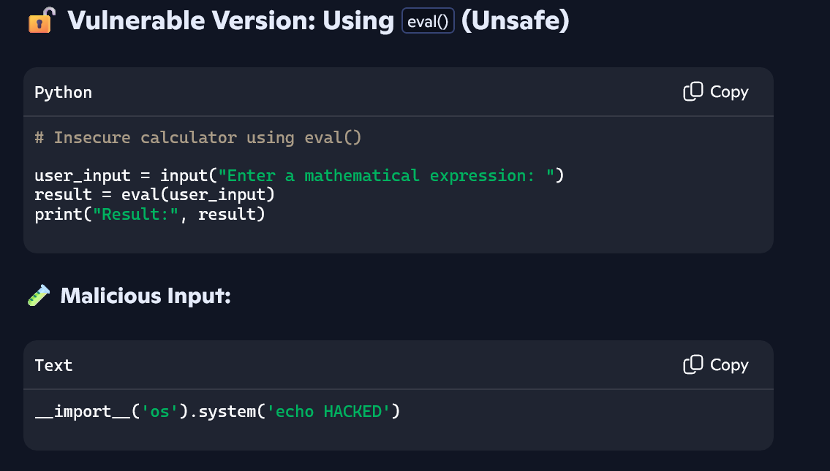
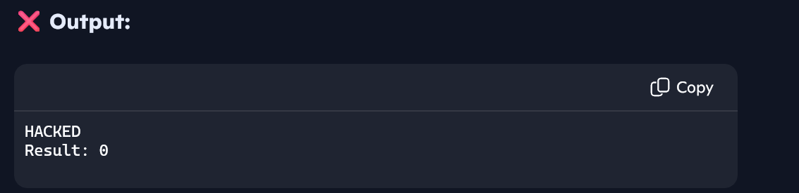
This proves that arbitrary code execution is possible — a serious security risk.

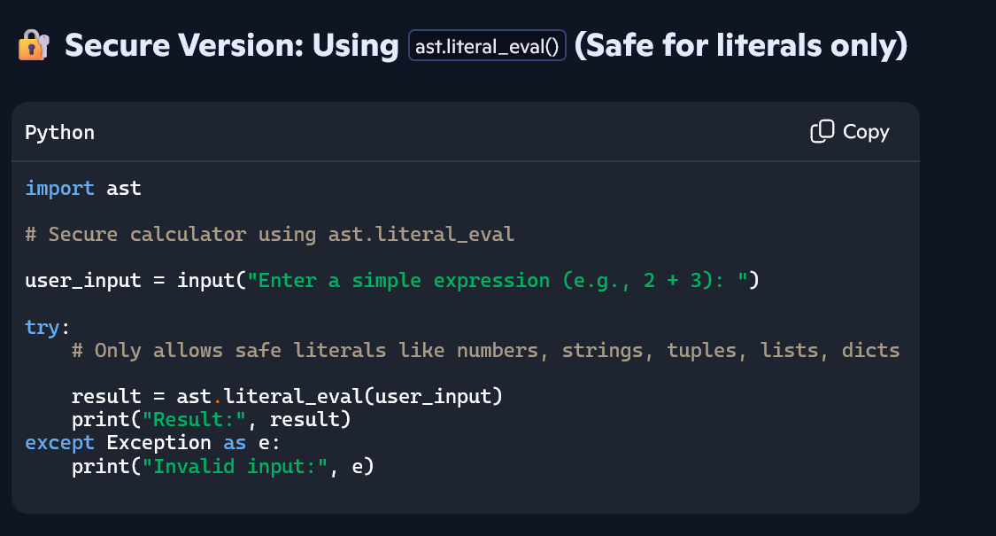
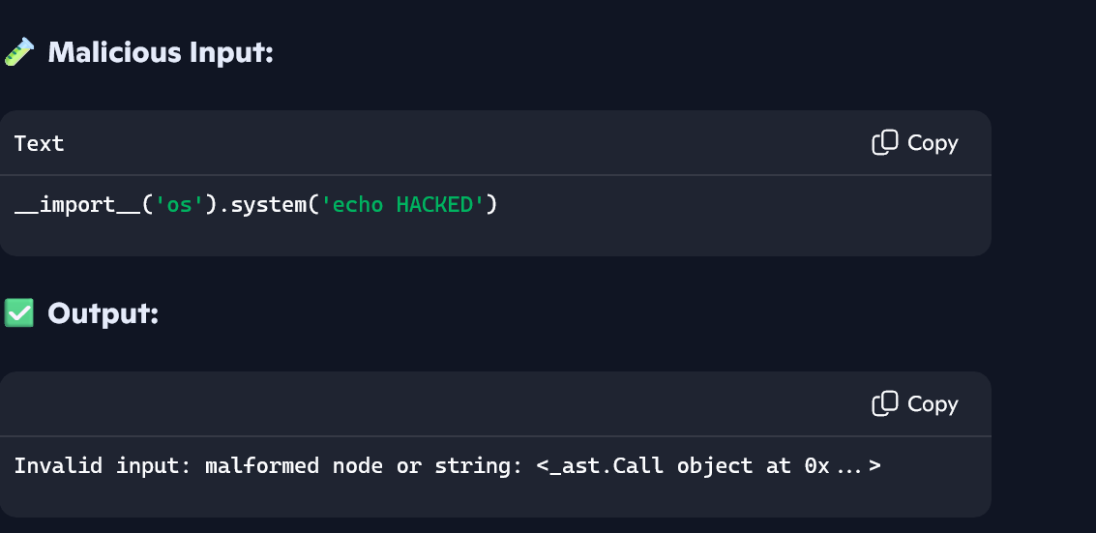
The secure version blocks unsafe expressions and only evaluates safe literals.

Task 5:
Static Security Testing with Linting Tools

Instructions:

- Use AI to generate a web server script (Flask or Node.js).

- Run a static analysis tool (e.g., bandit for Python or eslint for JavaScript).

- Identify at least two vulnerabilities flagged by the tool.

- Fix the vulnerabilities and re-run the tool until no issues remain.

Expected Output:

- Initial scan: Shows security warnings (e.g., unsafe imports, weak cryptography).

- After fixes: Tool reports 0 vulnerabilities.

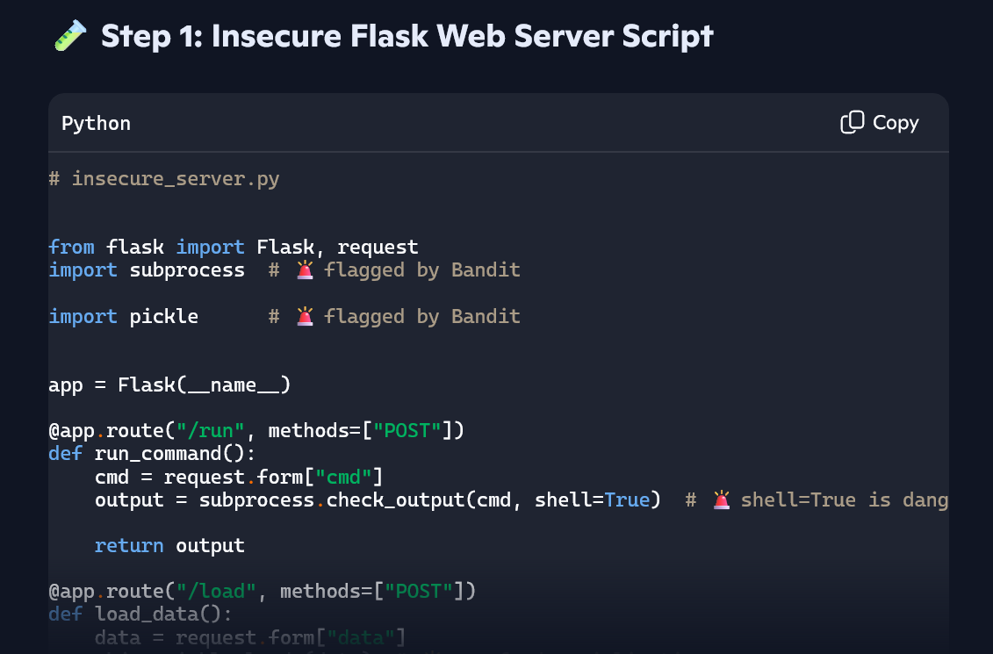
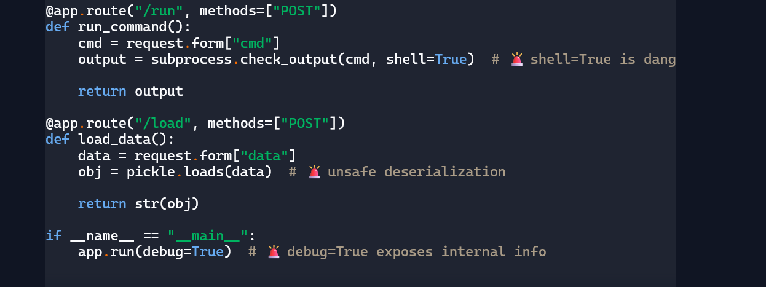
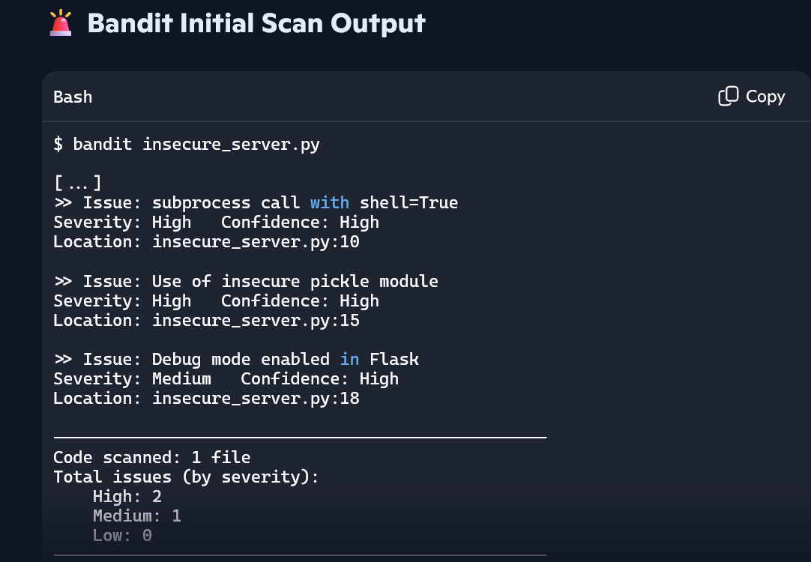
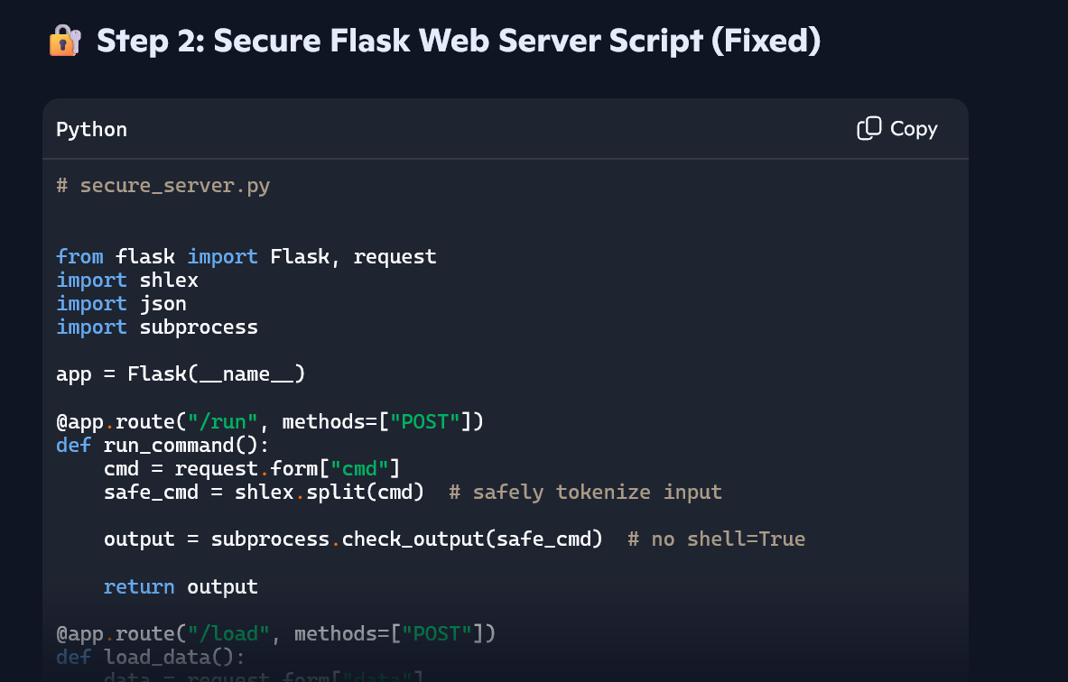
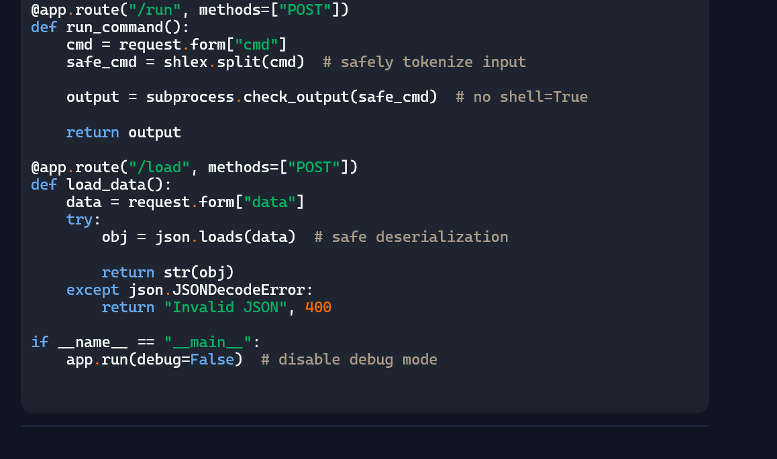
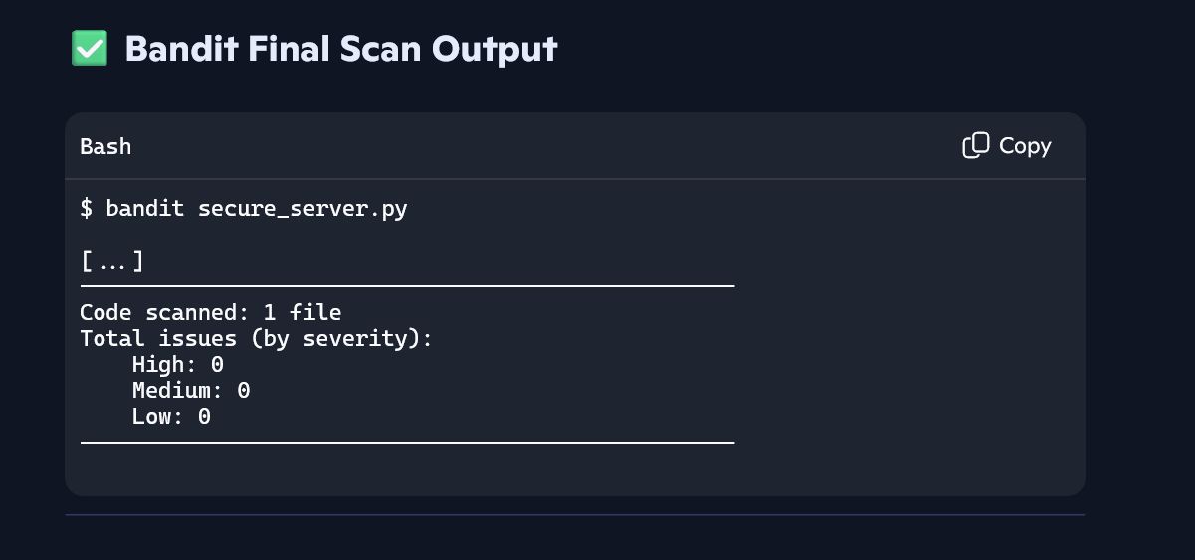

Static analysis with Bandit flagged insecure use of subprocess, pickle, and Flask debug mode — all fixed, resulting in 0 vulnerabilities.

