**ASSIGNMENT-6**

**NAME:**V. VIVEKVARDHAN

**HT NO:**2403A52097

**BATCH:**05

**Task-1:**

Generate a python code to ask input to user using a Class named Student with attributes name, roll_number, and marks to complete methods for displaying details and checking if marks are above average. Use classes like display_details() and is_passed(), demonstrating use of if-else conditions.

**CODE AND OUPUT:**

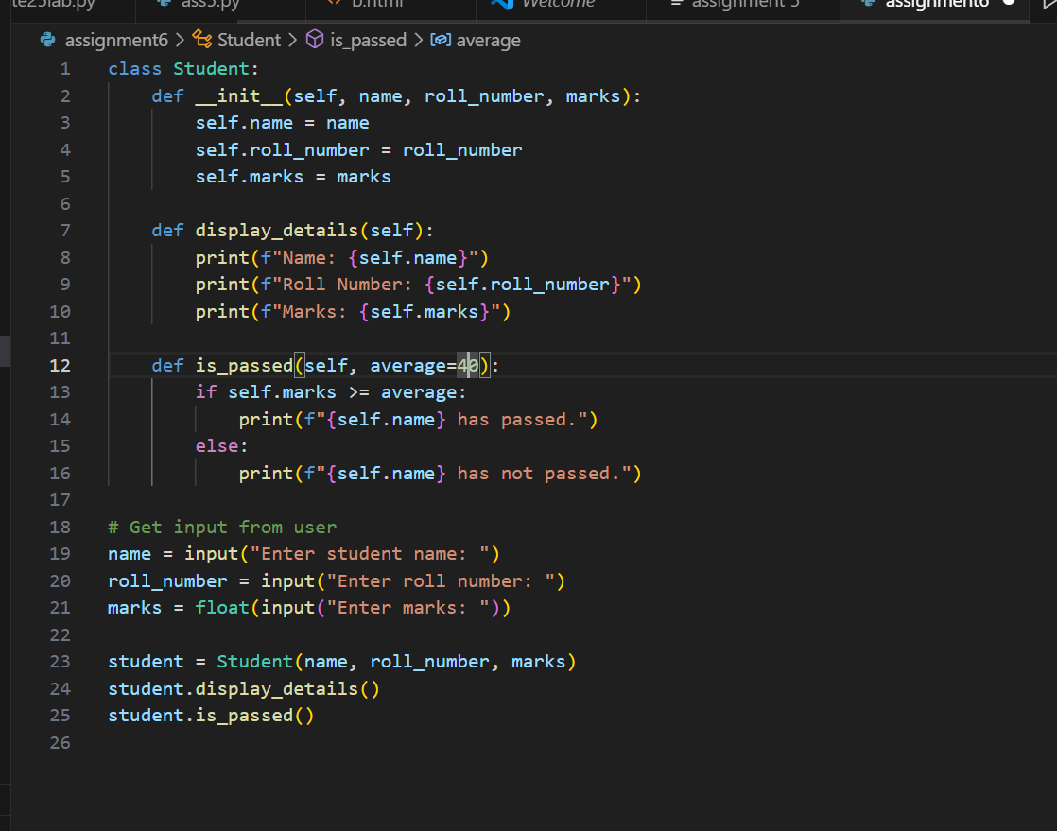

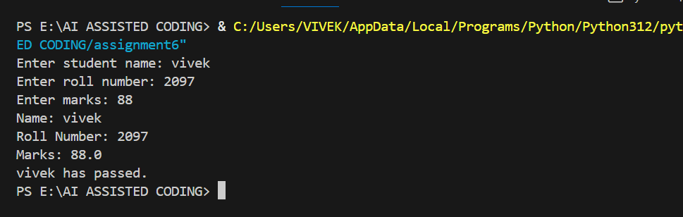

**EXPLANATION:**

1. **Class Definition:**
   * [Student](vscode-file://vscode-app/c:/Users/VIVEK/AppData/Local/Programs/Microsoft%20VS%20Code/resources/app/out/vs/code/electron-browser/workbench/workbench.html) is a class with three attributes: [name](vscode-file://vscode-app/c:/Users/VIVEK/AppData/Local/Programs/Microsoft%20VS%20Code/resources/app/out/vs/code/electron-browser/workbench/workbench.html), [roll_number](vscode-file://vscode-app/c:/Users/VIVEK/AppData/Local/Programs/Microsoft%20VS%20Code/resources/app/out/vs/code/electron-browser/workbench/workbench.html), and [marks](vscode-file://vscode-app/c:/Users/VIVEK/AppData/Local/Programs/Microsoft%20VS%20Code/resources/app/out/vs/code/electron-browser/workbench/workbench.html).
   * The [__init__](vscode-file://vscode-app/c:/Users/VIVEK/AppData/Local/Programs/Microsoft%20VS%20Code/resources/app/out/vs/code/electron-browser/workbench/workbench.html) method initializes these attributes when a new [Student](vscode-file://vscode-app/c:/Users/VIVEK/AppData/Local/Programs/Microsoft%20VS%20Code/resources/app/out/vs/code/electron-browser/workbench/workbench.html) object is created.
2. **Methods:**
   * [display_details(self)](vscode-file://vscode-app/c:/Users/VIVEK/AppData/Local/Programs/Microsoft%20VS%20Code/resources/app/out/vs/code/electron-browser/workbench/workbench.html): Prints the student's name, roll number, and marks.
   * [is_passed(self, average=40)](vscode-file://vscode-app/c:/Users/VIVEK/AppData/Local/Programs/Microsoft%20VS%20Code/resources/app/out/vs/code/electron-browser/workbench/workbench.html): Checks if the student's marks are greater than or equal to the average (default is 40). If so, it prints that the student has passed; otherwise, it prints that the student has not passed. This uses an if-else condition.
3. **User Input and Object Creation:**
   * The program asks the user to input the student's name, roll number, and marks.
   * It creates a [Student](vscode-file://vscode-app/c:/Users/VIVEK/AppData/Local/Programs/Microsoft%20VS%20Code/resources/app/out/vs/code/electron-browser/workbench/workbench.html) object with these values.
4. **Method Calls:**
   * It calls [display_details()](vscode-file://vscode-app/c:/Users/VIVEK/AppData/Local/Programs/Microsoft%20VS%20Code/resources/app/out/vs/code/electron-browser/workbench/workbench.html) to show the student's information.
   * It calls [is_passed()](vscode-file://vscode-app/c:/Users/VIVEK/AppData/Local/Programs/Microsoft%20VS%20Code/resources/app/out/vs/code/electron-browser/workbench/workbench.html) to check and display whether the student passed or not.

**Summary:**  
This code demonstrates how to use classes, methods, user input, and if-else logic in Python to manage and evaluate student information.

**TASK2:**

Prompt:

for number in numbers:

if number % 2 == 0:

#check square of even numbers only

**CODE AND OUPUT:**

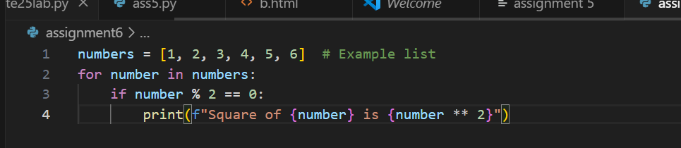

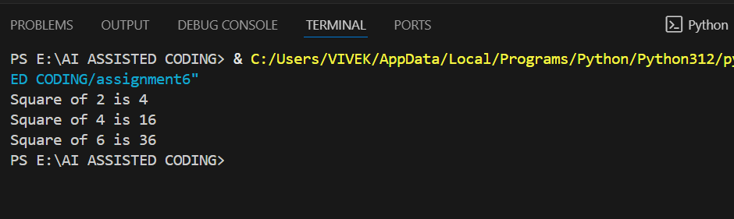

**EXPLANATION:**

* [numbers](vscode-file://vscode-app/c:/Users/VIVEK/AppData/Local/Programs/Microsoft%20VS%20Code/resources/app/out/vs/code/electron-browser/workbench/workbench.html) is a list containing integers.
* The for loop iterates through each number in the list.
* The if statement checks if the number is even ([number % 2 == 0](vscode-file://vscode-app/c:/Users/VIVEK/AppData/Local/Programs/Microsoft%20VS%20Code/resources/app/out/vs/code/electron-browser/workbench/workbench.html)).
* If the number is even, its square ([number ** 2](vscode-file://vscode-app/c:/Users/VIVEK/AppData/Local/Programs/Microsoft%20VS%20Code/resources/app/out/vs/code/electron-browser/workbench/workbench.html)) is calculated and printed.

This code prints the square of each even number in the list. For example, for 2, 4, and 6, it will print their squares.

**TASK3:**

Prompt:

Create a class called BankAccount with attributes account_holder and balance. Give a python code to ask input to user also complete methods for deposit(), withdraw(), and check for insufficient balance**.**

**CODE AND OUTPUT:**

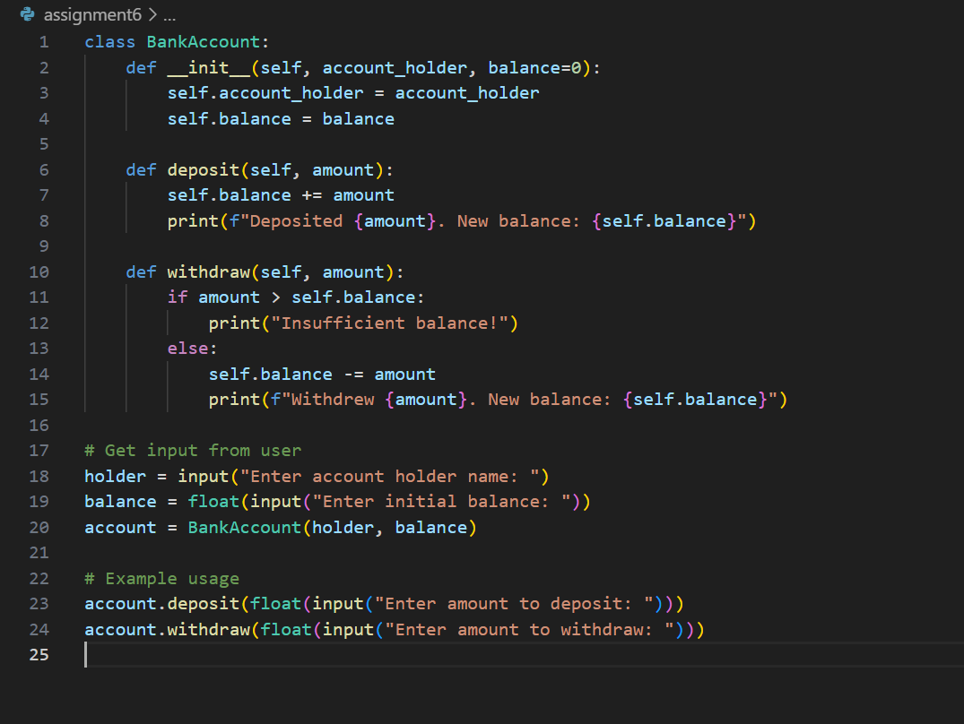

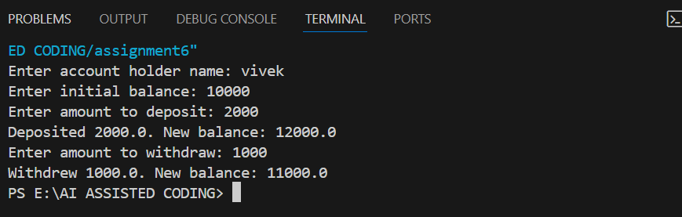

**EXPLANATION:**

1. **Class Definition:**
   * [BankAccount](vscode-file://vscode-app/c:/Users/VIVEK/AppData/Local/Programs/Microsoft%20VS%20Code/resources/app/out/vs/code/electron-browser/workbench/workbench.html) has two attributes: [account_holder](vscode-file://vscode-app/c:/Users/VIVEK/AppData/Local/Programs/Microsoft%20VS%20Code/resources/app/out/vs/code/electron-browser/workbench/workbench.html) (the name of the account owner) and [balance](vscode-file://vscode-app/c:/Users/VIVEK/AppData/Local/Programs/Microsoft%20VS%20Code/resources/app/out/vs/code/electron-browser/workbench/workbench.html) (the account’s current balance, default is 0).
2. **Methods:**
   * [deposit(amount)](vscode-file://vscode-app/c:/Users/VIVEK/AppData/Local/Programs/Microsoft%20VS%20Code/resources/app/out/vs/code/electron-browser/workbench/workbench.html): Adds the specified amount to the balance and prints the new balance.
   * [withdraw(amount)](vscode-file://vscode-app/c:/Users/VIVEK/AppData/Local/Programs/Microsoft%20VS%20Code/resources/app/out/vs/code/electron-browser/workbench/workbench.html): Checks if the withdrawal amount is greater than the current balance. If so, it prints “Insufficient balance!” Otherwise, it subtracts the amount and prints the new balance.
3. **User Input:**
   * The program asks the user for the account holder’s name and initial balance.
   * It creates a [BankAccount](vscode-file://vscode-app/c:/Users/VIVEK/AppData/Local/Programs/Microsoft%20VS%20Code/resources/app/out/vs/code/electron-browser/workbench/workbench.html) object with these values.
4. **Example Usage:**
   * The user is prompted to enter an amount to deposit and an amount to withdraw.
   * The deposit and withdraw methods are called, demonstrating how the class works and how insufficient balance is handled.

**Summary:**  
This code shows how to use classes, methods, user input, and if-else logic to manage a simple bank account in Python.

**TASK4:**

Prompt:

students = [

{"name": "Tony Stark", "score": 97},

{"name": "Steve Rogers", "score": 88},

{"name": "Thor", "score": 82},

{"name": "Bruse Banner", "score": 95},

{"name": "Clint", "score": 74}

]

Here, is a list of student dictionaries. Now, give a python code using while loop to print the names of students who scored more than 75

**CODE AND OUTPUT:**

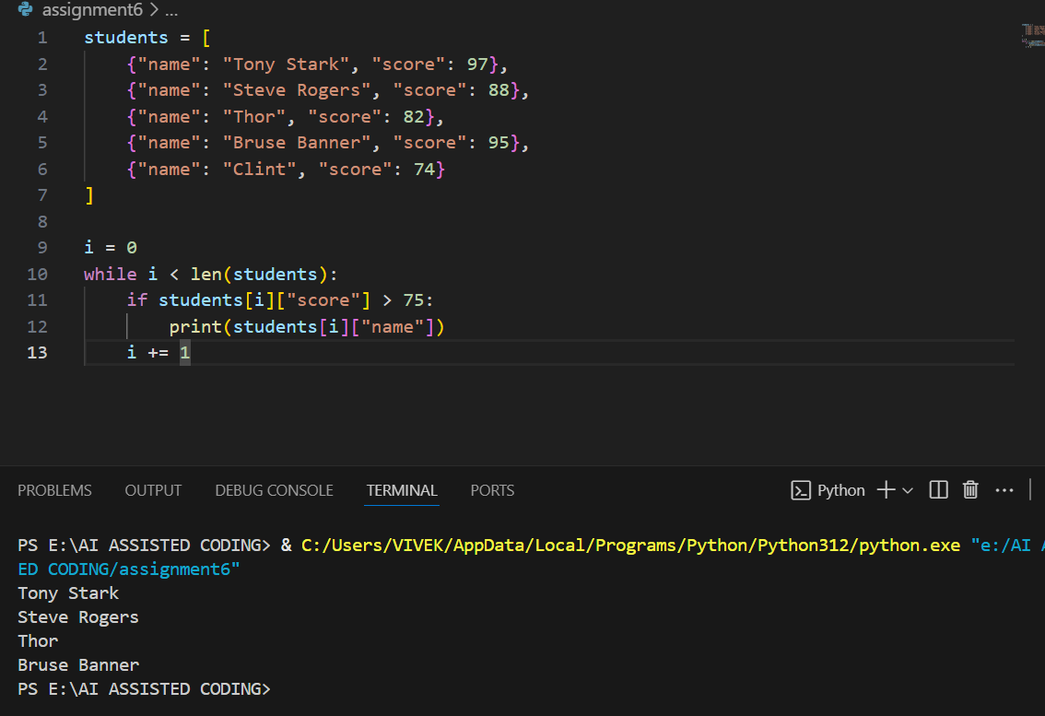

**EXPLANATION:**

* [students](vscode-file://vscode-app/c:/Users/VIVEK/AppData/Local/Programs/Microsoft%20VS%20Code/resources/app/out/vs/code/electron-browser/workbench/workbench.html) is a list of dictionaries, each containing a student's name and score.
* The variable [i](vscode-file://vscode-app/c:/Users/VIVEK/AppData/Local/Programs/Microsoft%20VS%20Code/resources/app/out/vs/code/electron-browser/workbench/workbench.html) is initialized to 0 and used as an index.
* The while loop iterates through the list as long as [i](vscode-file://vscode-app/c:/Users/VIVEK/AppData/Local/Programs/Microsoft%20VS%20Code/resources/app/out/vs/code/electron-browser/workbench/workbench.html) is less than the number of students.
* Inside the loop, the code checks if the current student's score is greater than 75.
* If true, it prints the student's name.
* [i](vscode-file://vscode-app/c:/Users/VIVEK/AppData/Local/Programs/Microsoft%20VS%20Code/resources/app/out/vs/code/electron-browser/workbench/workbench.html) is incremented by 1 in each iteration to move to the next student.

**Summary:**  
This code prints the names of all students who scored more than 75, using a while loop for iteration.

**TASK5:**

Prompt:

Give a python code to ask input to user also generate methods to add_item, remove_item, and use a loop to calculate the total bill using conditional discounts. Begin writing a class ShoppingCart with an empty items list**.**

**CODE AND OUPUT:**

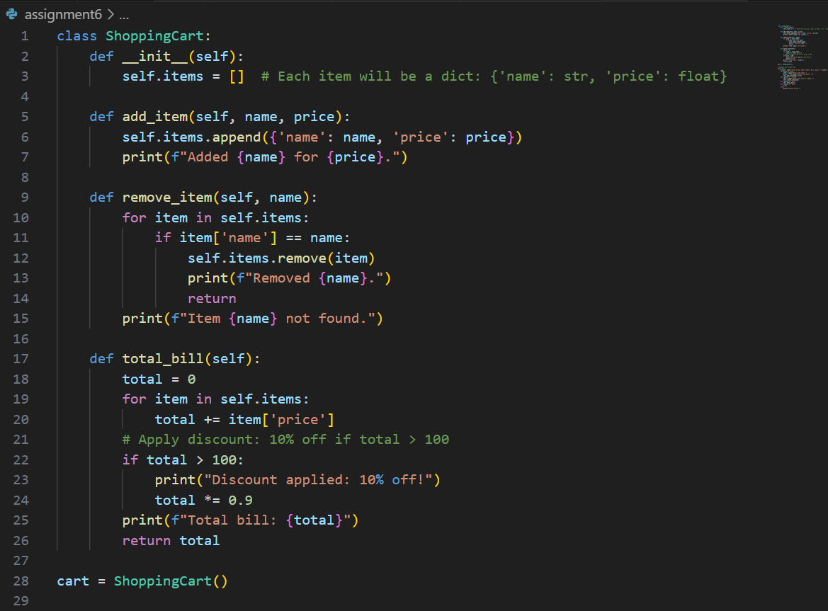

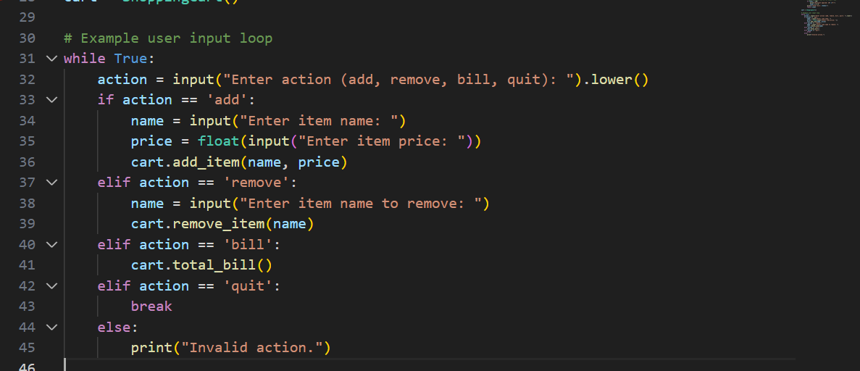

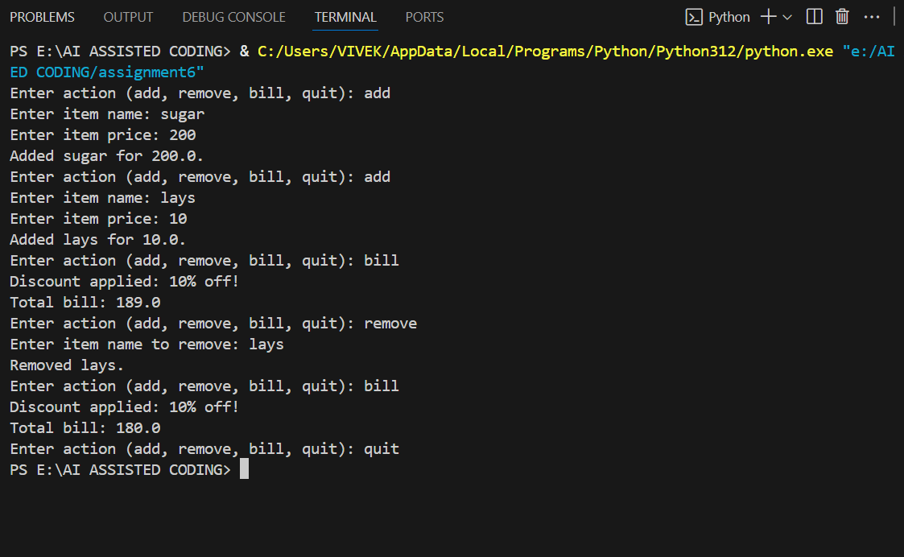

**EXPLANATION:**

1. **Class Definition:**
   * [ShoppingCart](vscode-file://vscode-app/c:/Users/VIVEK/AppData/Local/Programs/Microsoft%20VS%20Code/resources/app/out/vs/code/electron-browser/workbench/workbench.html) has an attribute [items](vscode-file://vscode-app/c:/Users/VIVEK/AppData/Local/Programs/Microsoft%20VS%20Code/resources/app/out/vs/code/electron-browser/workbench/workbench.html), which is a list to store items as dictionaries ({'name': str, 'price': float}).
2. **Methods:**
   * [add_item(name, price)](vscode-file://vscode-app/c:/Users/VIVEK/AppData/Local/Programs/Microsoft%20VS%20Code/resources/app/out/vs/code/electron-browser/workbench/workbench.html): Adds an item with the given name and price to the cart.
   * [remove_item(name)](vscode-file://vscode-app/c:/Users/VIVEK/AppData/Local/Programs/Microsoft%20VS%20Code/resources/app/out/vs/code/electron-browser/workbench/workbench.html): Removes the first item with the given name from the cart. If not found, prints a message.
   * [total_bill()](vscode-file://vscode-app/c:/Users/VIVEK/AppData/Local/Programs/Microsoft%20VS%20Code/resources/app/out/vs/code/electron-browser/workbench/workbench.html): Calculates the total price of all items. If the total is greater than 100, applies a 10% discount and prints the discounted total.
3. **User Input Loop:**
   * The program repeatedly asks the user for an action: add, remove, bill, or quit.
   * For 'add', it asks for item name and price, then adds the item.
   * For 'remove', it asks for item name and removes it.
   * For 'bill', it calculates and prints the total bill (with discount if applicable).
   * For 'quit', it exits the loop.
   * If the action is invalid, it prints an error message.

**Summary:**  
This code demonstrates how to use classes, methods, lists, user input, and conditional logic to manage a shopping cart and apply discounts.