ASSIGNMENT-2.1
TASK-1:
Prompt:
#write a python program to calculate mean, maximum, minimum using functions.
Code and Output:

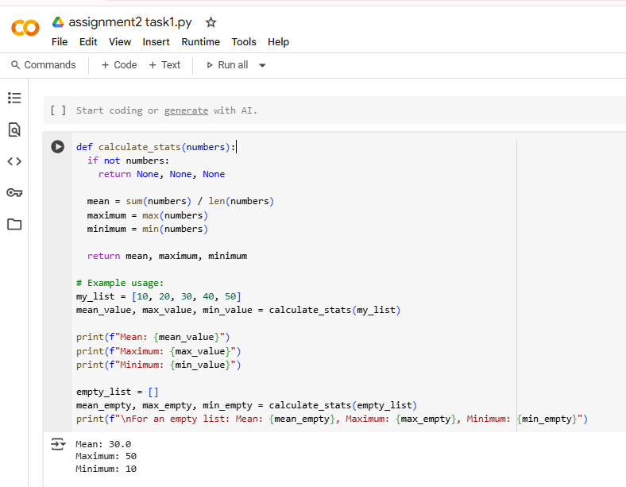

Explanation:
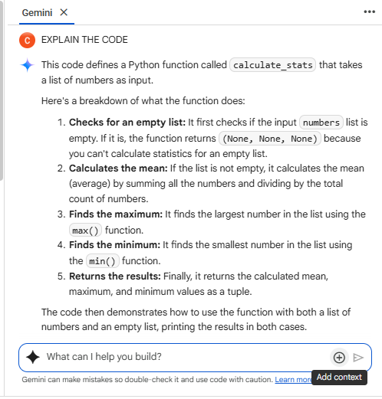

TASK-2:
Prompt:
#write a python code to calculate Armstrong number using functions.
Code and Output:
Armstrong number code and output with Gemini AI:
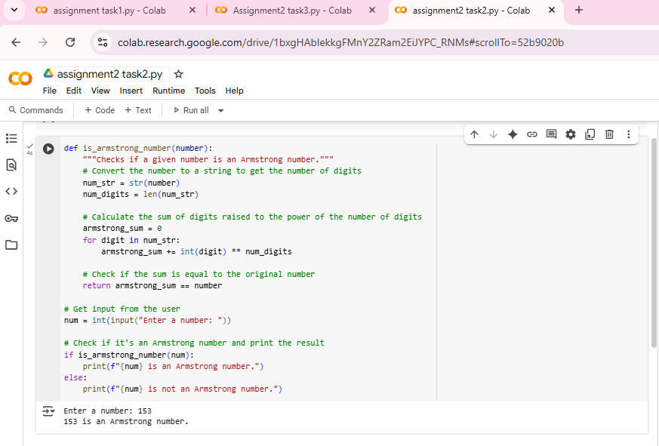

Armstrong Number code and output with GITHUB Copilot:
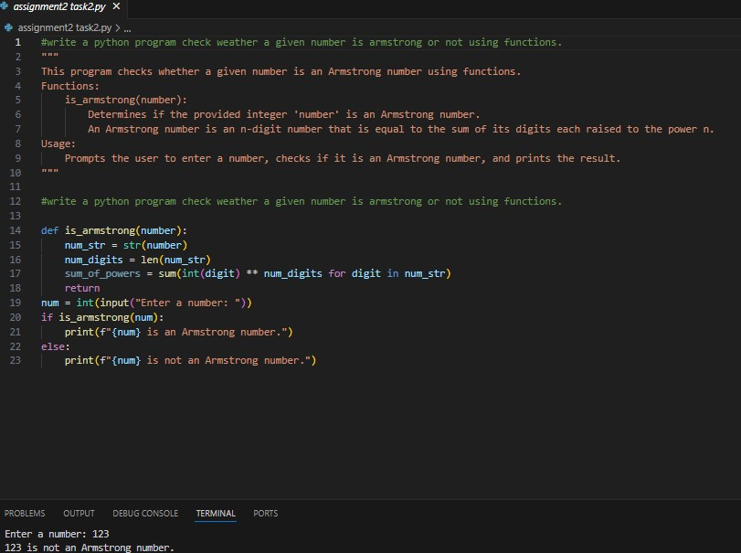
Explanation of both codes Gemini AI and GITHUB copoilt:
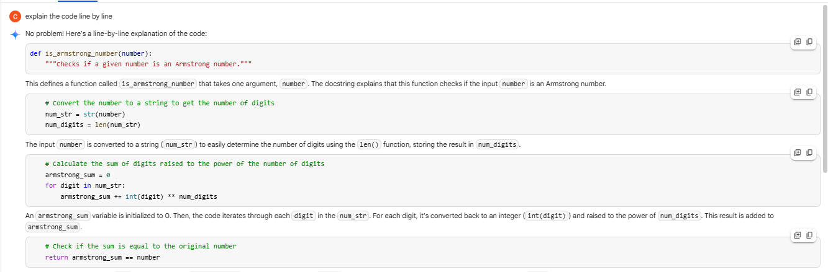
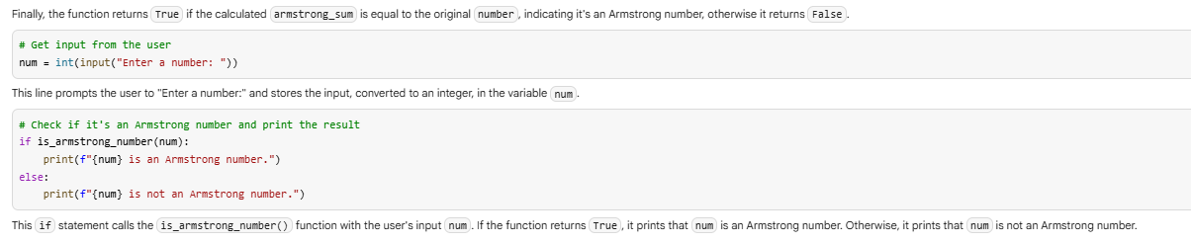
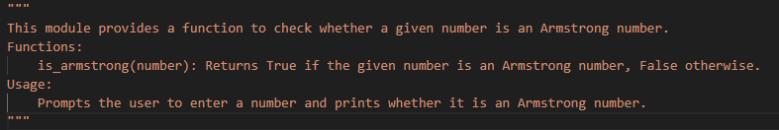
Comparing both the Code and Outputs:
The two codes shown aim to determine whether a given number is an Armstrong number, but only one of them functions correctly. In the first code (VS Code), although the logic to compute the sum of the digits raised to the power of their count is correctly written, the function lacks a proper return statement. It only has return without any value, so it returns None by default. This causes the program to always treat the result as False, printing that the number is not an Armstrong number—even when it is (like 153).
On the other hand, the second code (Colab) implements the logic correctly. It uses a loop to compute the sum and compares it to the original number, returning a Boolean value (True or False). The function in the second code includes clear comments, a docstring, and is structured in a more readable and understandable way.
Because of the logical mistake in the first code, the output is incorrect, while the second code produces the correct result. This highlights the importance of having a complete and functional return statement in Python functions. A small oversight like this can lead to entirely wrong outcomes, even if most of the logic is correct. Always test your function to ensure it returns expected results, especially for edge cases or known values like 153.
TASK-3:
Prompt:
#write a python program to check weather a given number is prime or not.
Code and Output:
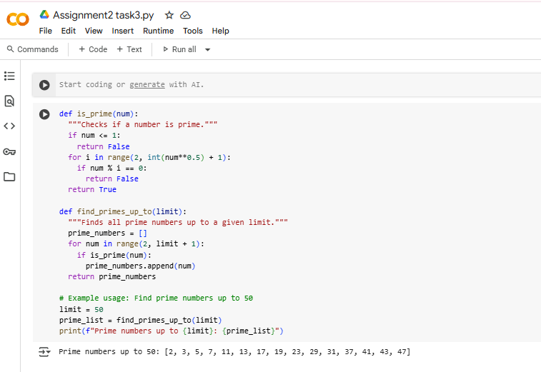

Explanation:
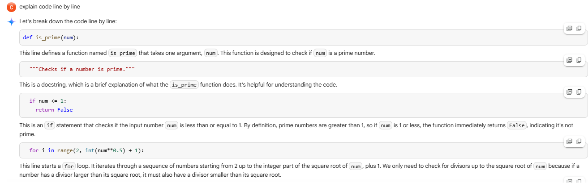

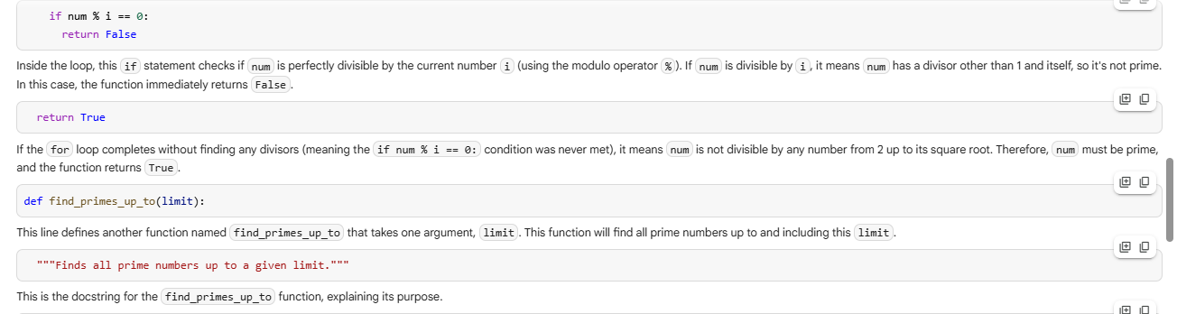
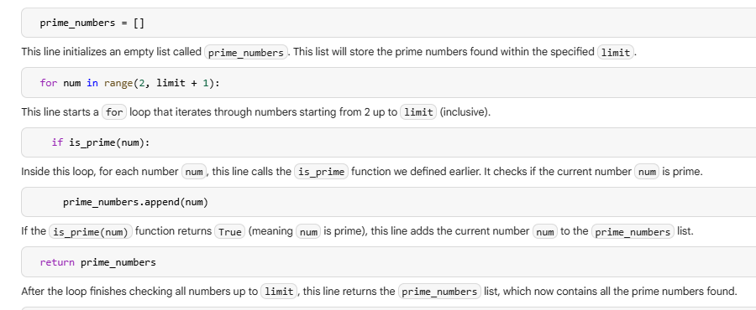

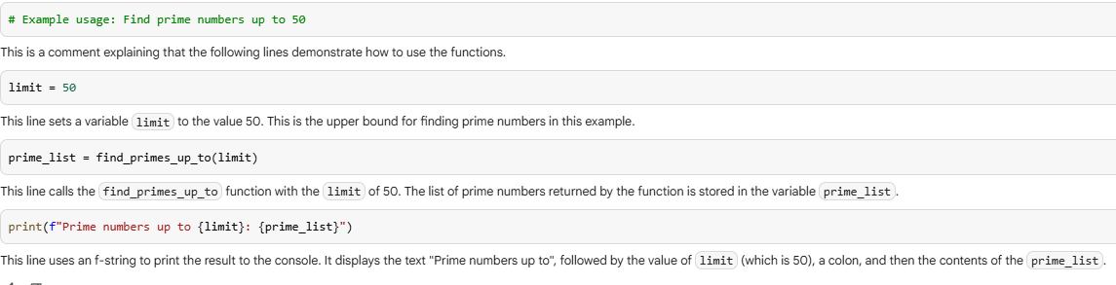
TASK-4:
Prompt:
#write a python program to find sum of N natural numbers using functions.
Code and Output:
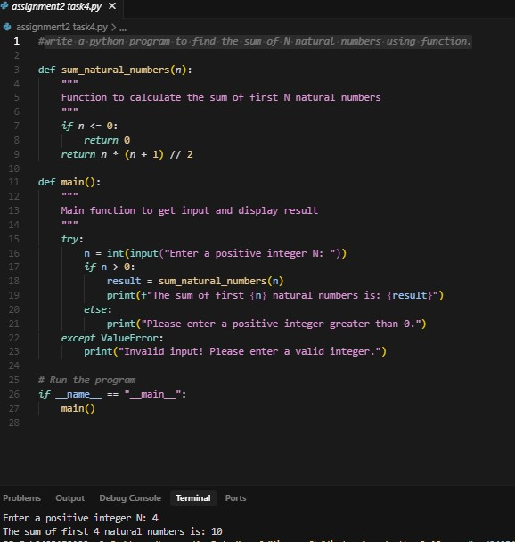
Explanation:

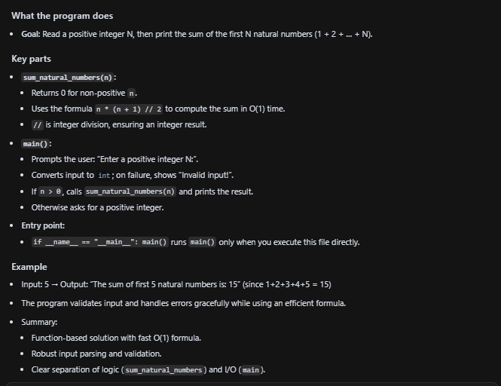

TASK-5
Prompt:
#write a python program to calculate the sum of odd numbers and even numbers in a given tuple.
Code and Output:
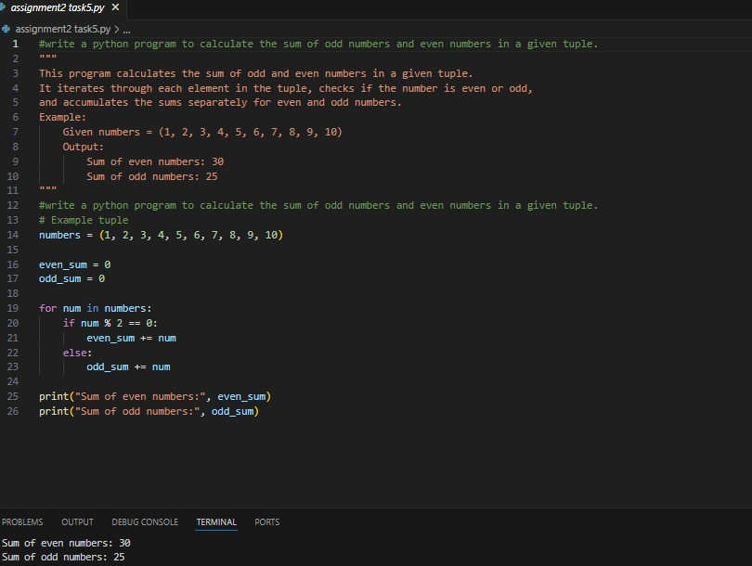
Explanation:
