**Assignment-17**

**Task-1:** Use AI to generate a Python script for cleaning an employee dataset.

* Handle missing values in columns (salary, department, joining_date).Convert the "joining_date" column into proper datetime format.Standardize department names (e.g., "HR", "hr", "Human Resources" → "HR").Encode categorical variables (department, job_role).

**Code and output:**

**Explanation:**

**Task-2:** Use AI to generate a script for preprocessing a sales transaction dataset.

* Convert transaction dates to proper datetime format.Create a new column for “Month-Year” from the transaction date.Remove rows with negative or zero transaction amounts.Normalize the "transaction_amount" column using Min-Max scaling.

**Code and output:**

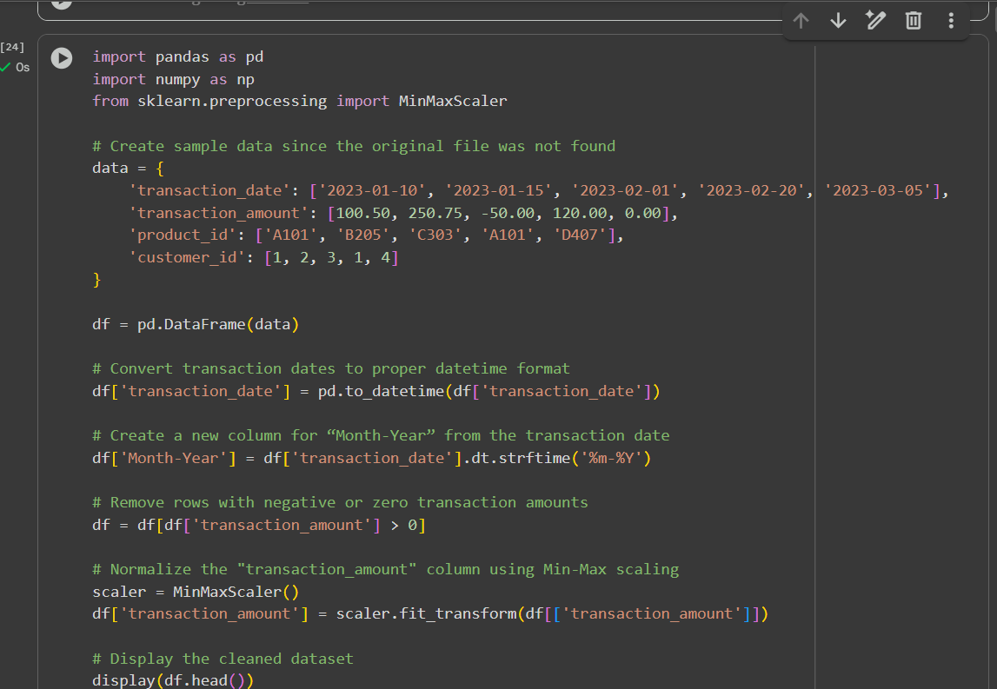

**Explaination:**

**Task-3:** Use AI to generate a script for cleaning healthcare patient records**.**

* Fill missing values in numeric columns (e.g., blood_pressure, heart_rate) with column mean.Standardize units (convert height from cm to meters).Correct inconsistent categorical labels (e.g., "M", "Male", "male" → "Male").Drop irrelevant columns such as patient_id after cleaning.

**Code and output:**

**Task-4:** Use AI to write a script to preprocess a social media text dataset.

* Remove special characters, URLs, and emojis from text.Convert all text to lowercase.Tokenize and remove stopwords.Apply lemmatization for standardizing words.

**Code and output:**

**Explaination:**

**Task-5:** Use AI to create a preprocessing script for a financial dataset.

* Handle missing values in stock price and volume.Create new features such as moving average (7-day, 30-day).Normalize continuous variables using StandardScaler.Encode categorical columns (sector, company_name).

**Code and output:**

**Explaination:**

