Assignment-9
Task-1; Write python function to return sum of even and odd numbers in the given list
Gemini Ai;
With comments:
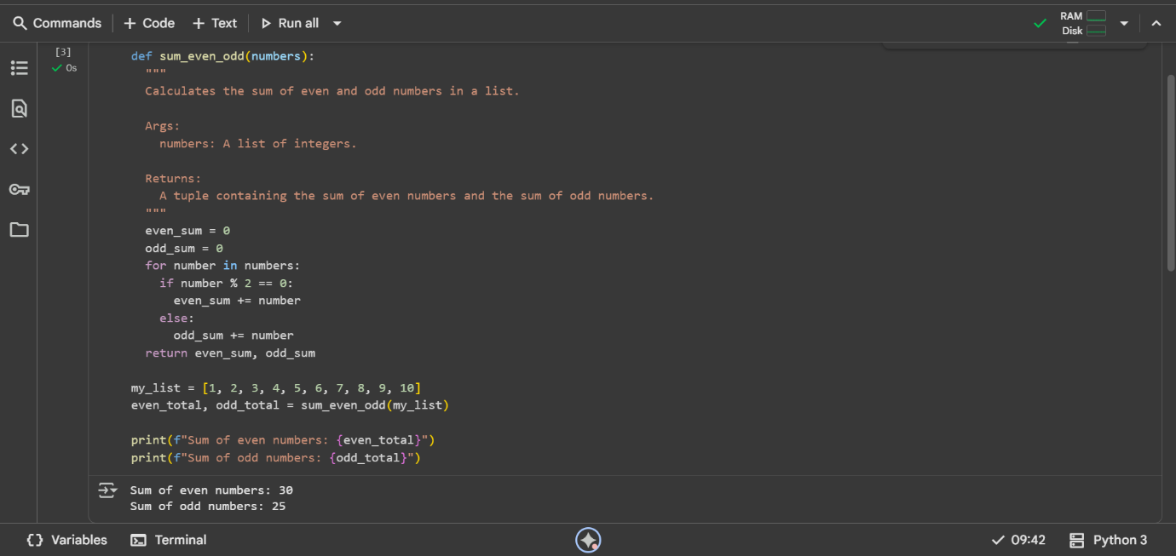
Without comments:
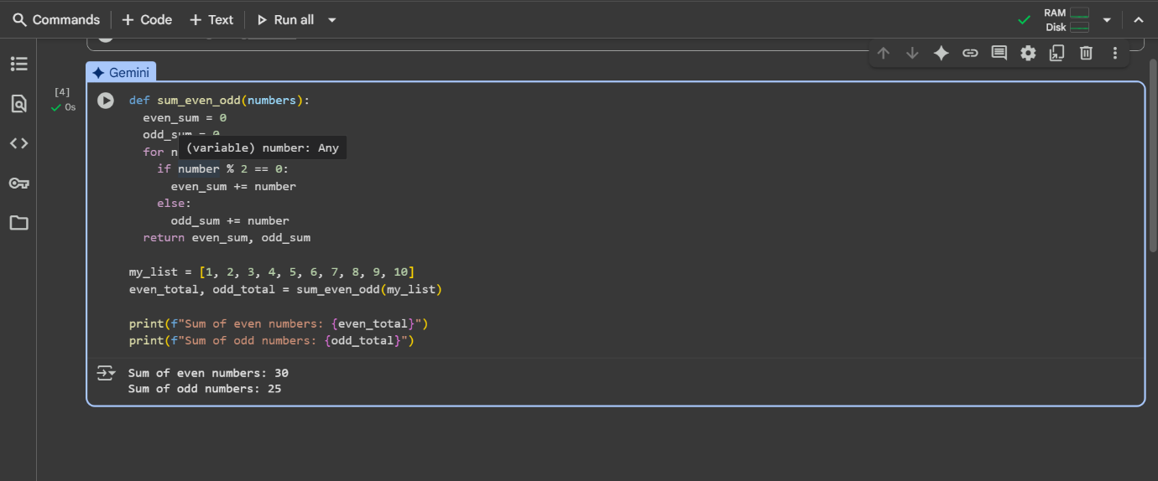

Explanation:
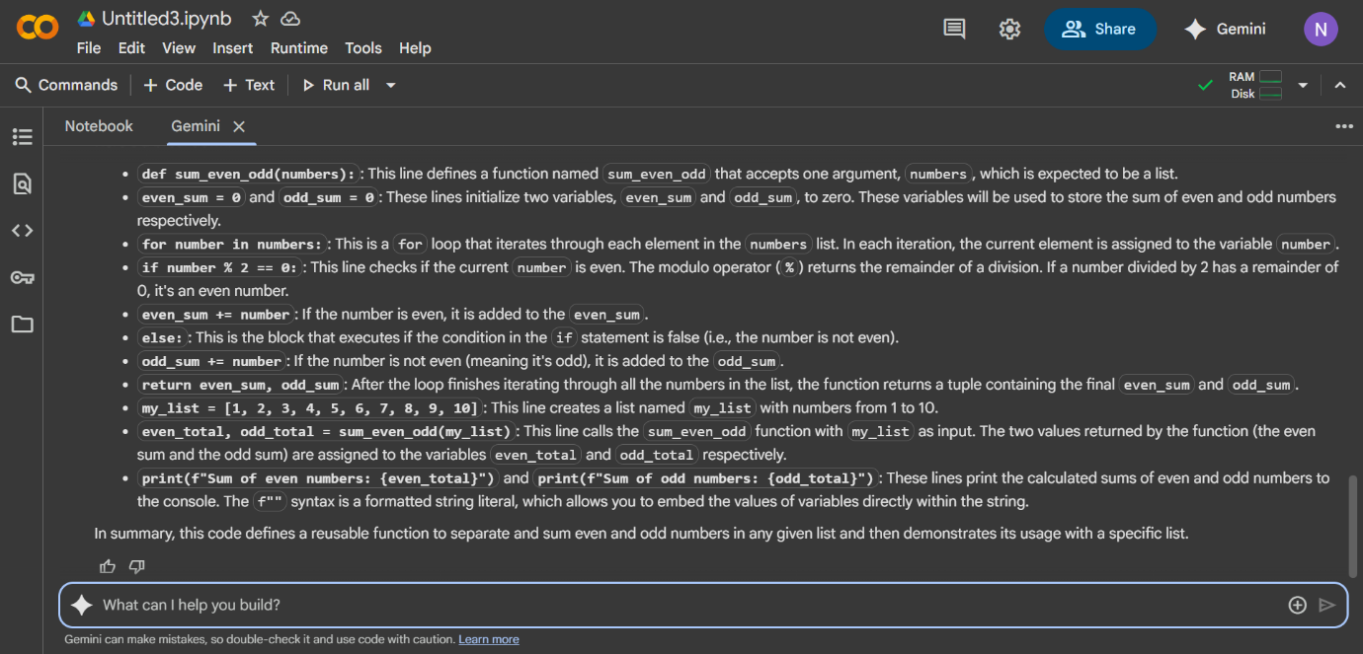

Copilot:
Task-1; Write python function to return sum of even and odd numbers in the given list
Without comments:
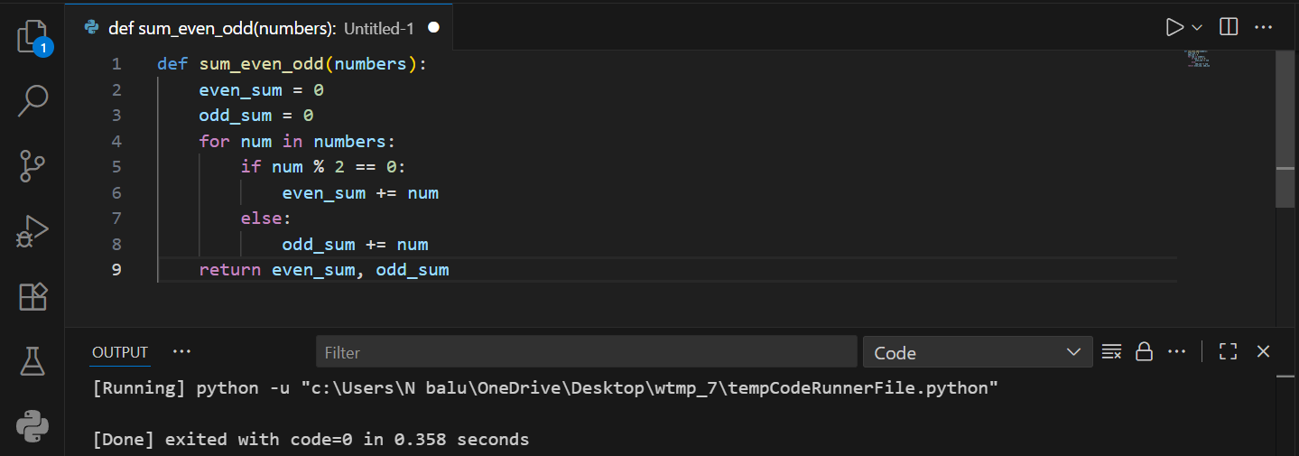

With comments:
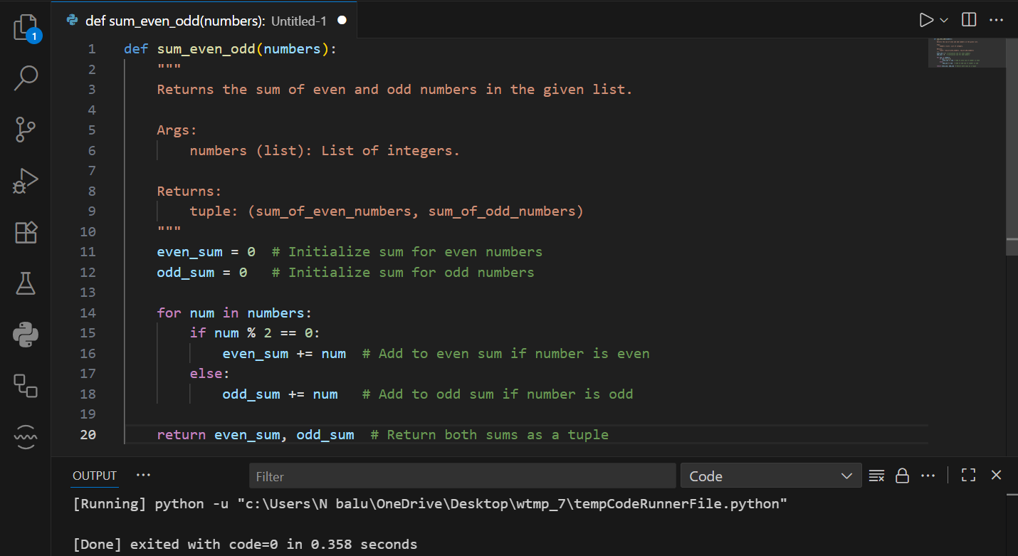

Gemini Ai:
Task-2; Write python program for sru_student class with attributes like name, roll no., hostel_status and fee_update method and display_details method.
Without comments:
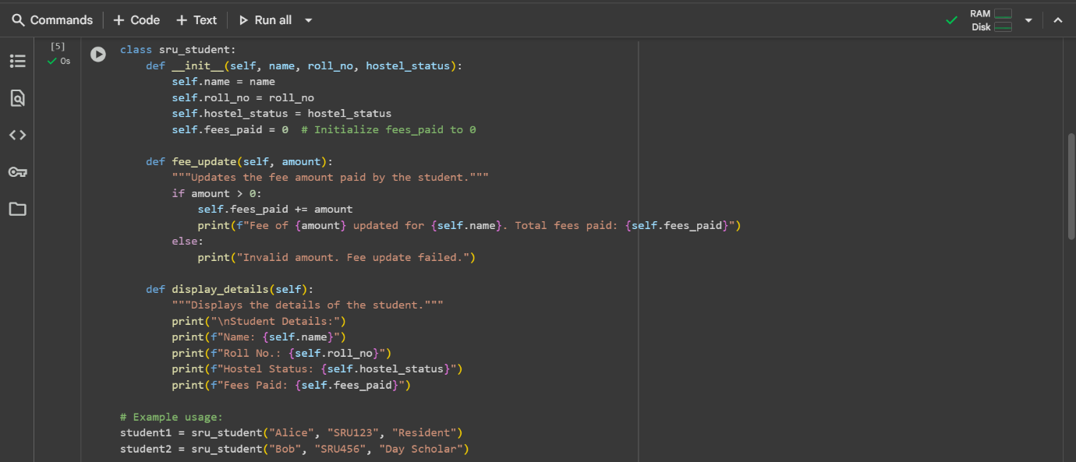
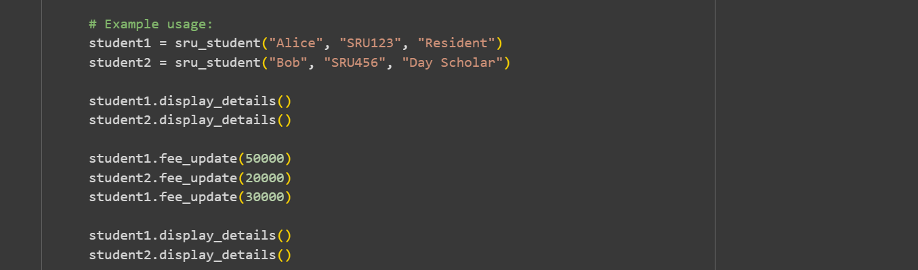
With comments:
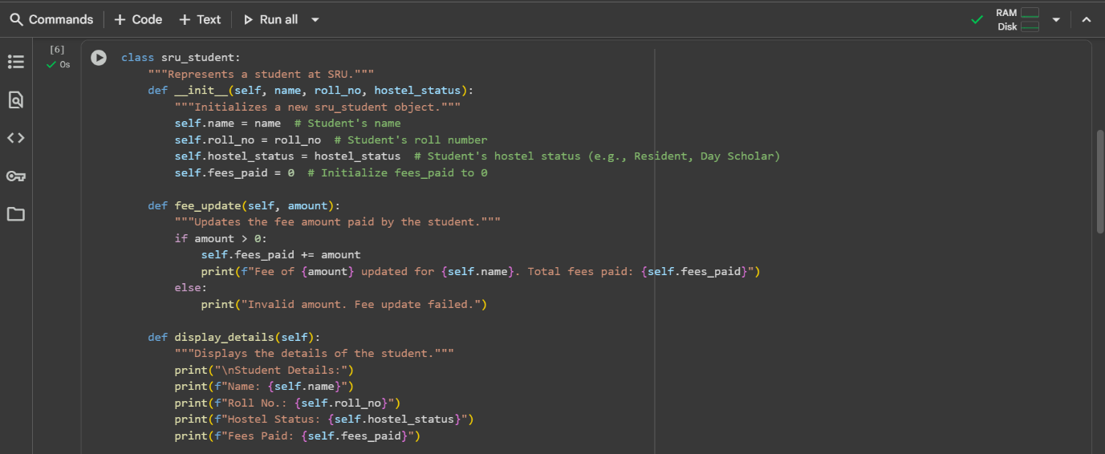
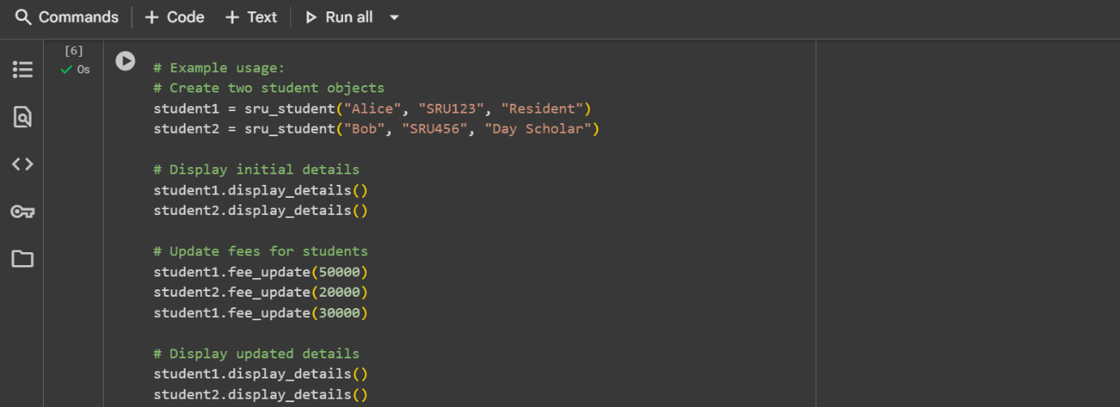
Output: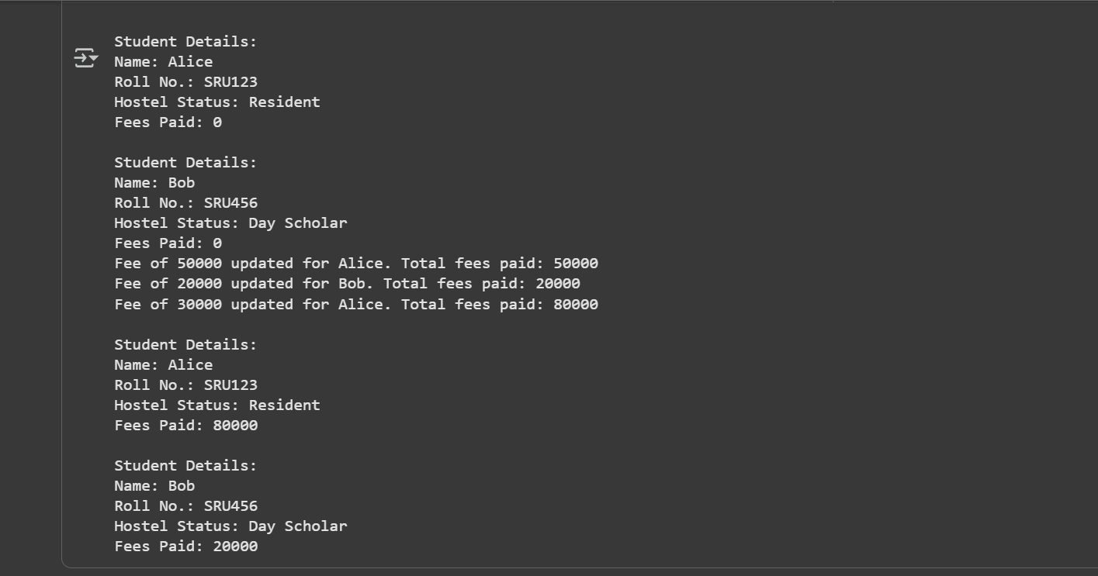

Copilot
With comments:
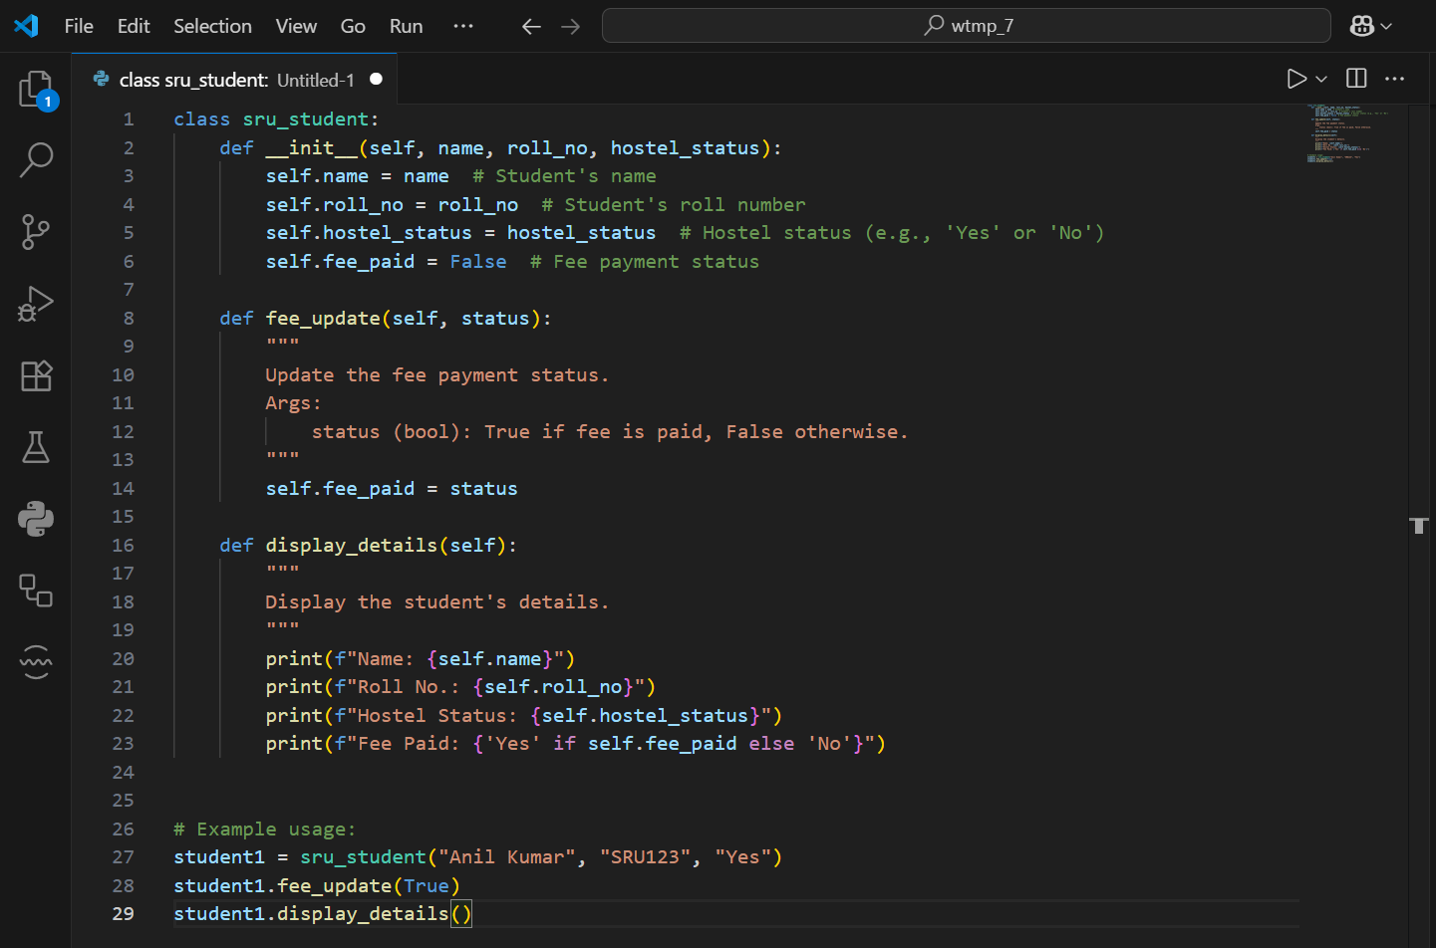
Without comments: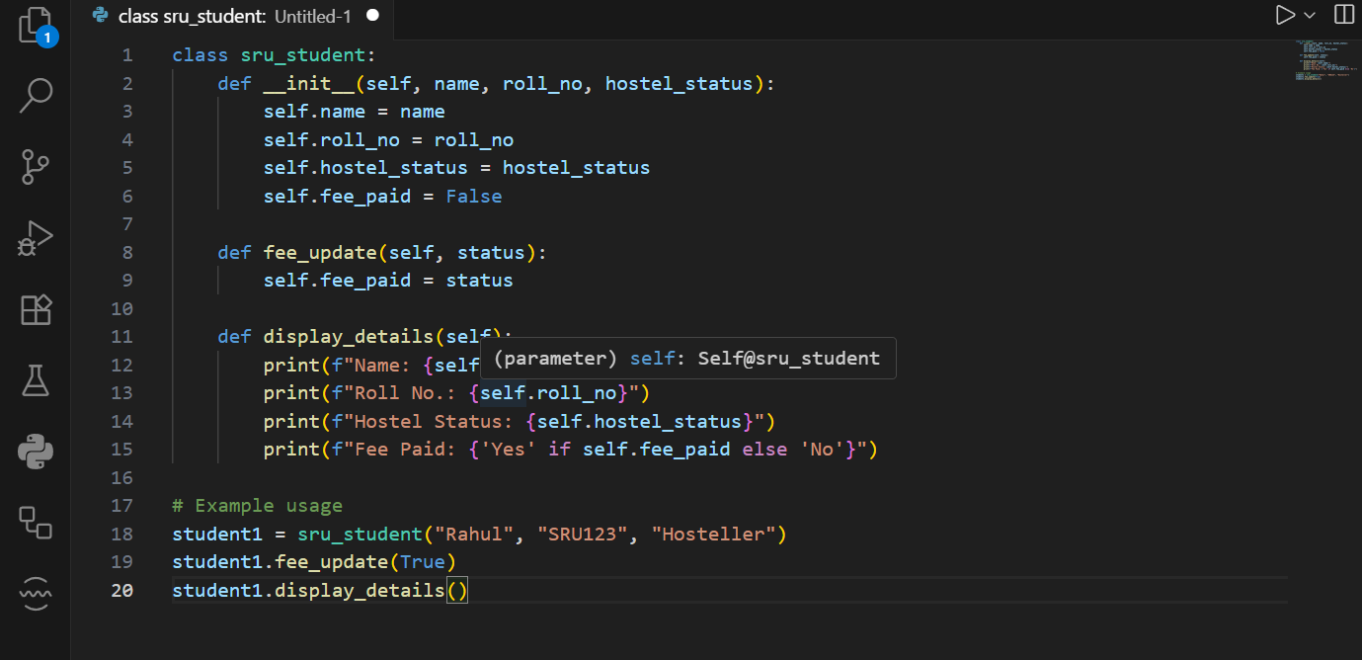
Out put:
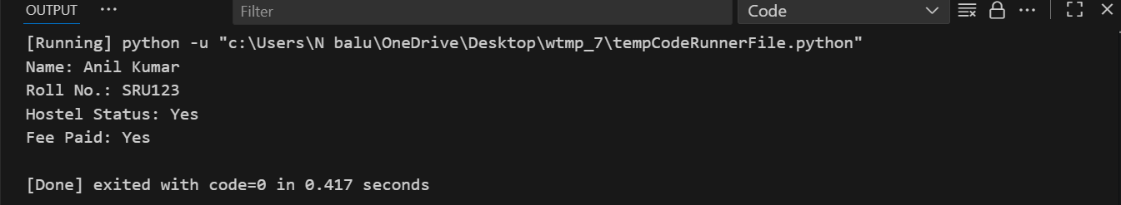
Explanation:
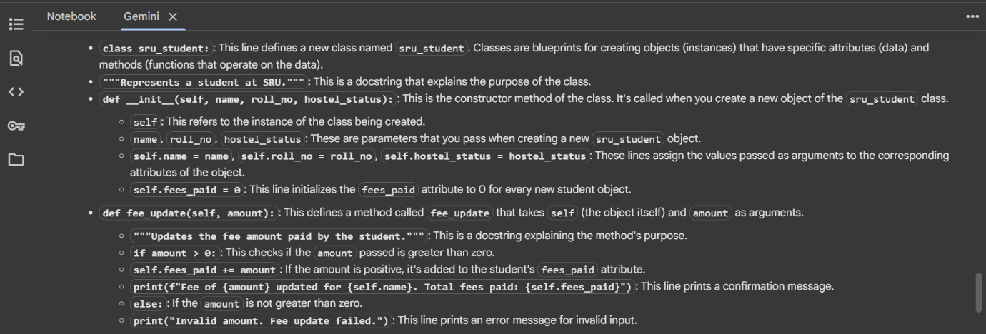
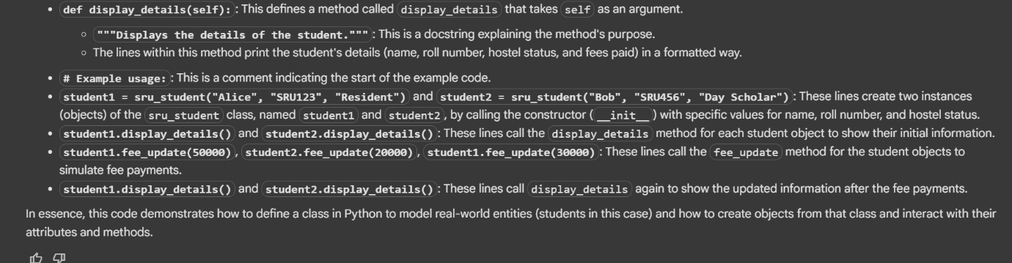
Task-3: Write a Python script with 3–4 functions (e.g., calculator: add, subtract, multiply, divide).
Gemini Ai;
With comments:
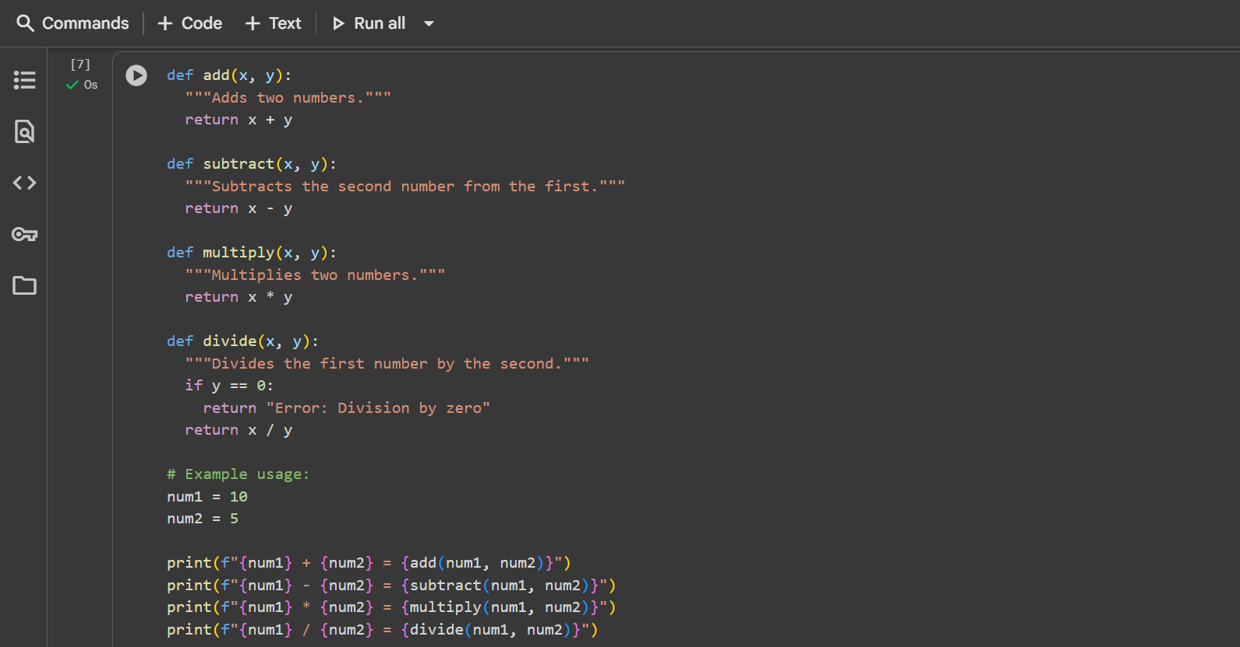
Without comments:
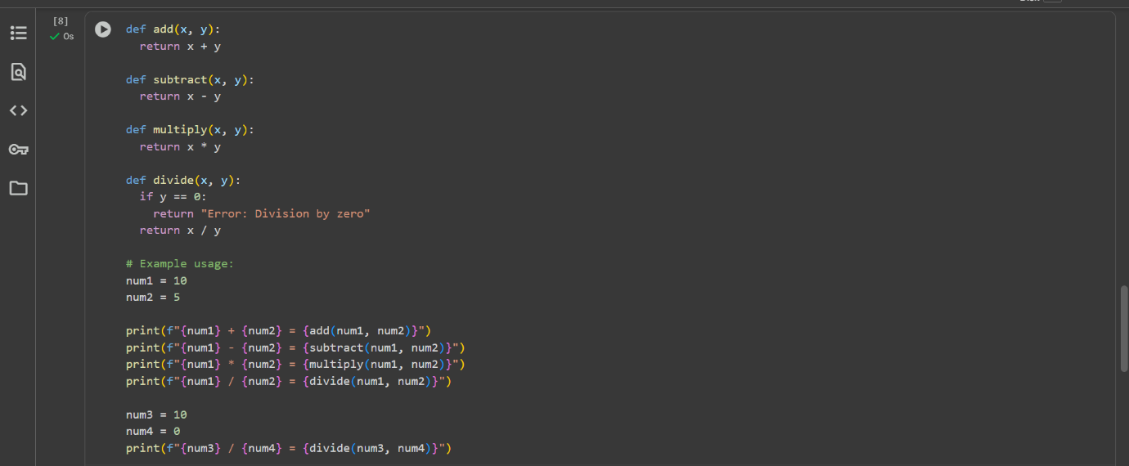
Out put:
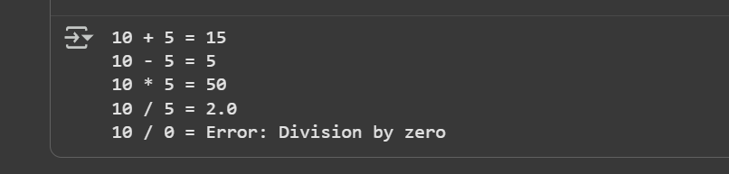
Explaination:
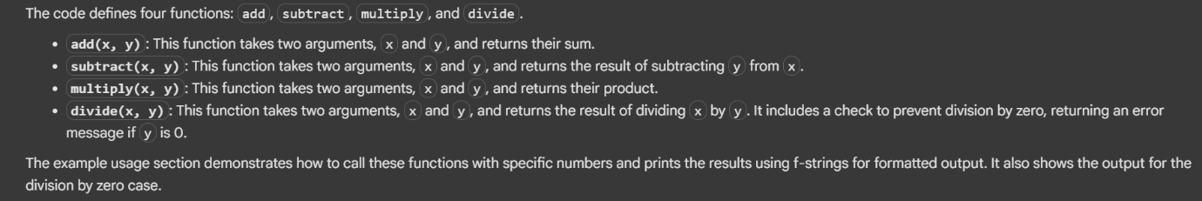

Copilot:
With comments:
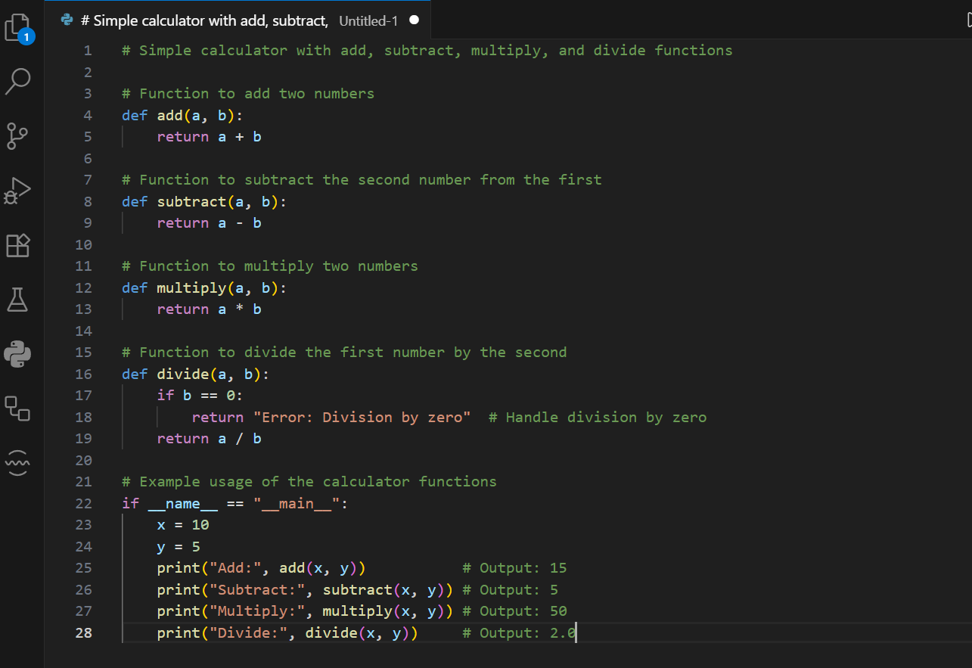
Without comments:
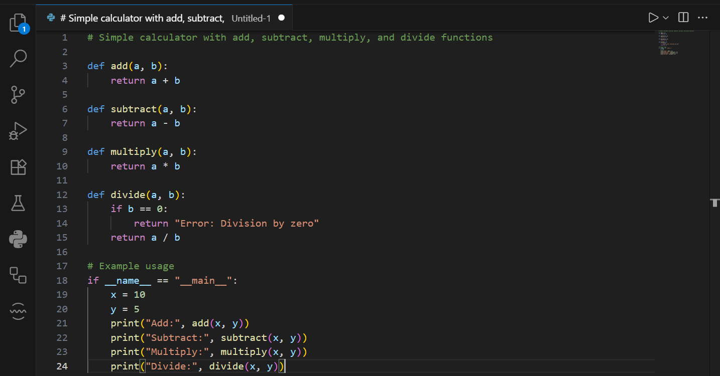
Out put:
