Assignment-9

Task-1

**1 Basic Docstring Generation**

* Write python function to return sum of even and odd numbers in the given list.
* Incorporate manual **docstring** in code with Google Style
* Use an AI-assisted tool (e.g., Copilot, Cursor AI) to generate a docstring describing the function.
* Compare the AI-generated docstring with your manually written one.

**Expected Outcome#1:** Students understand how AI can produce function-level documentation.

With comments

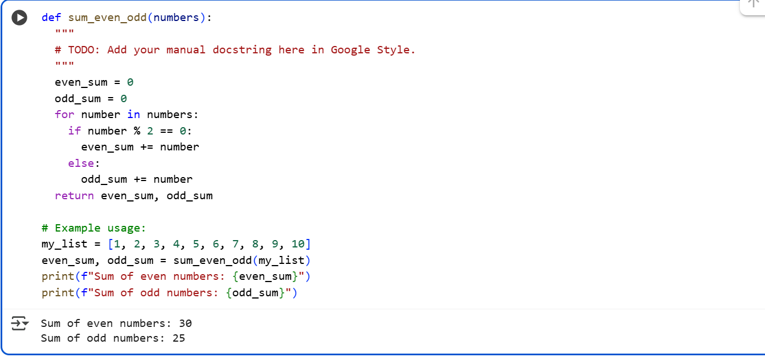

Without comments

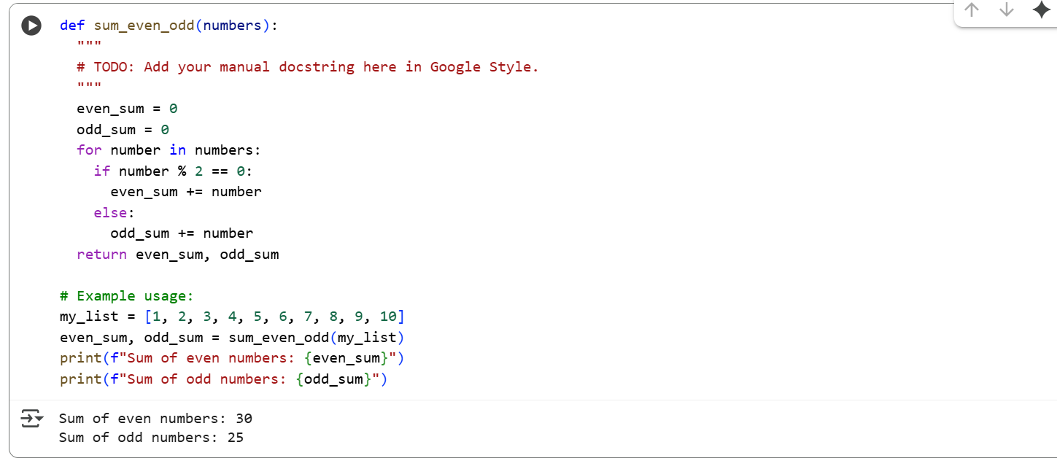

With comments

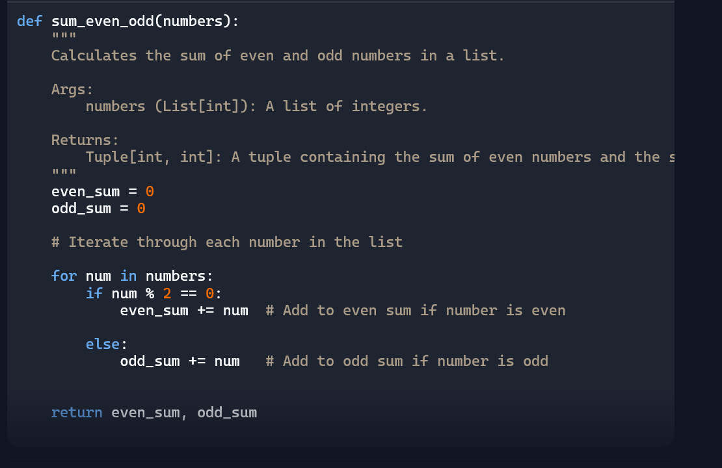

Without comments

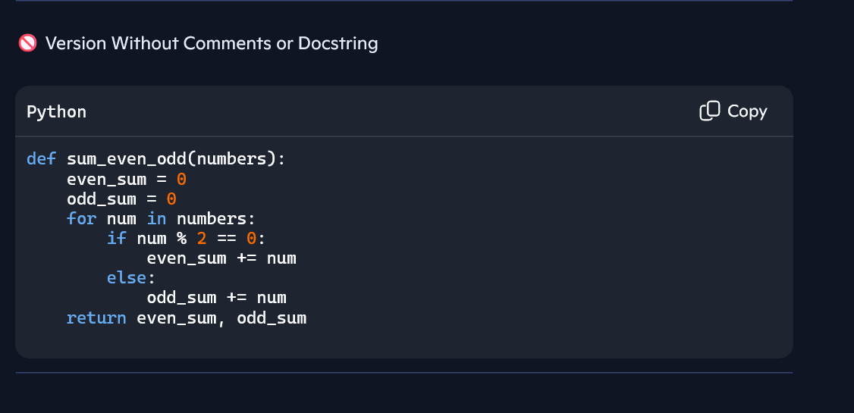

Task-2

**Automatic Inline Comments**

* Write python program for **sru_student** class with attributes like name, roll no., hostel_status and **fee_update** method and **display_details** method.
* Write comments manually for each line/code block
* Ask an AI tool to add inline comments explaining each line/step.
* Compare the AI-generated comments with your manually written one.

**Expected Output#2:** Students critically analyze AI-generated code comments.

With comments

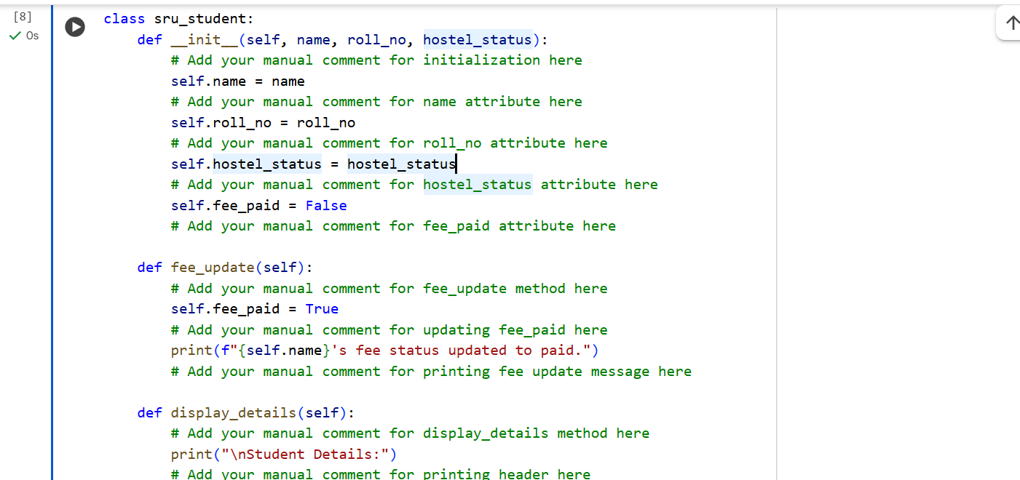

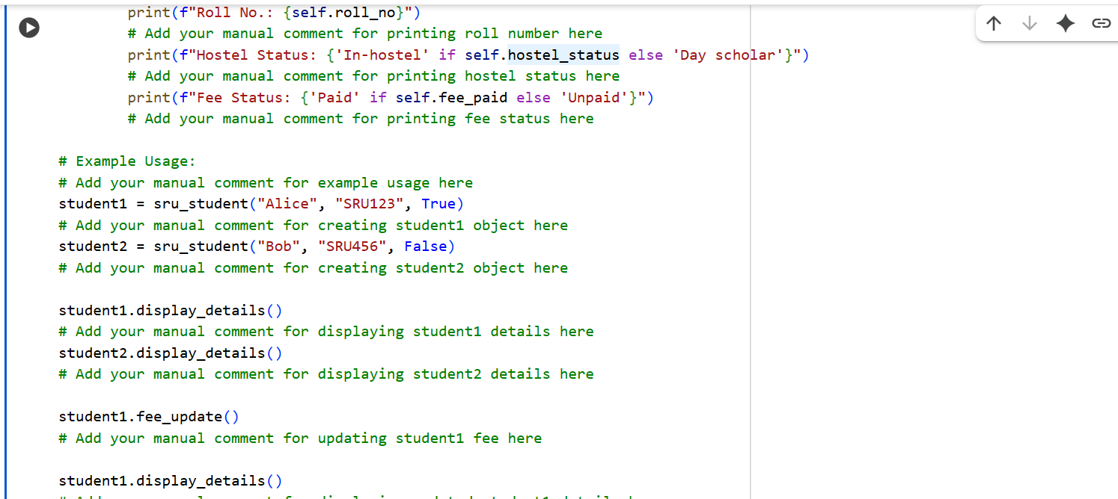

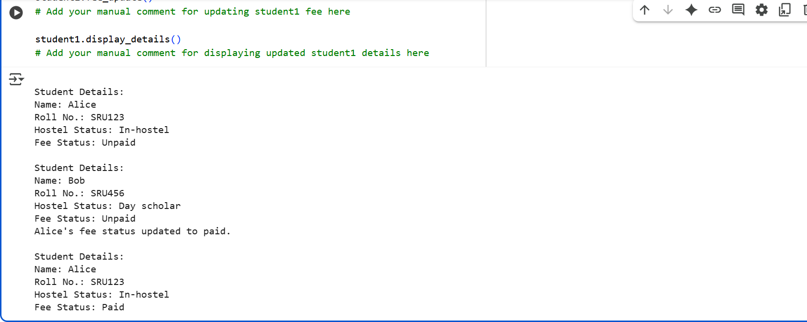

Without comments:

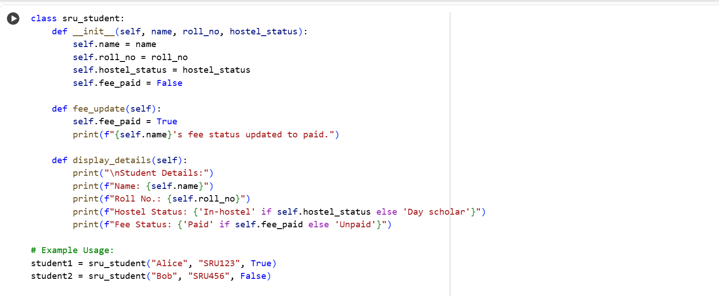

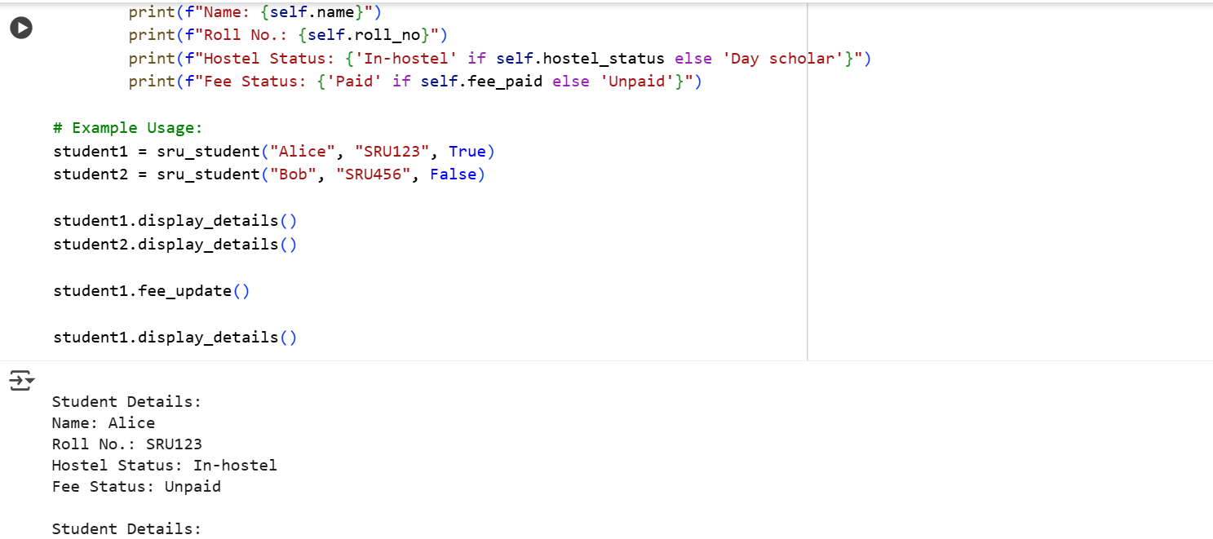

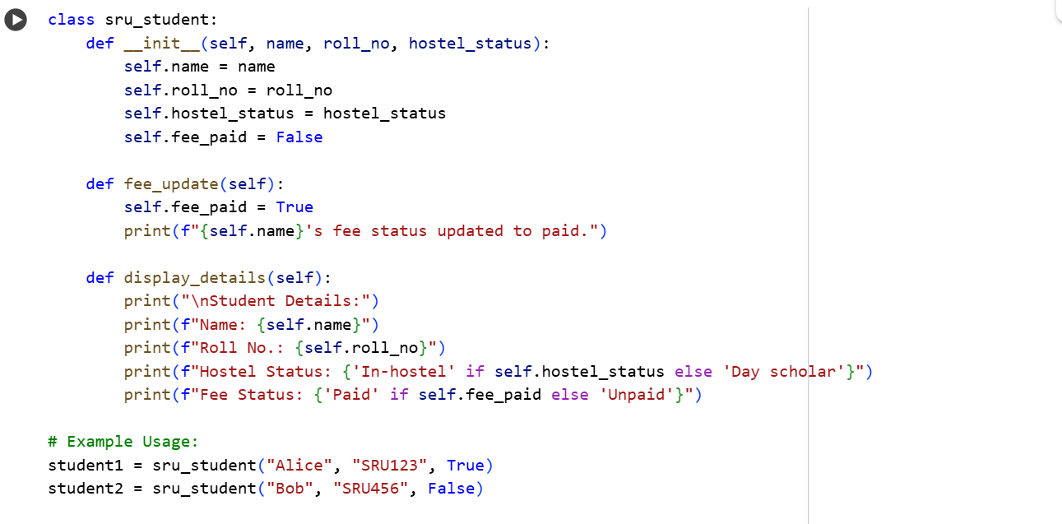

With Comments:

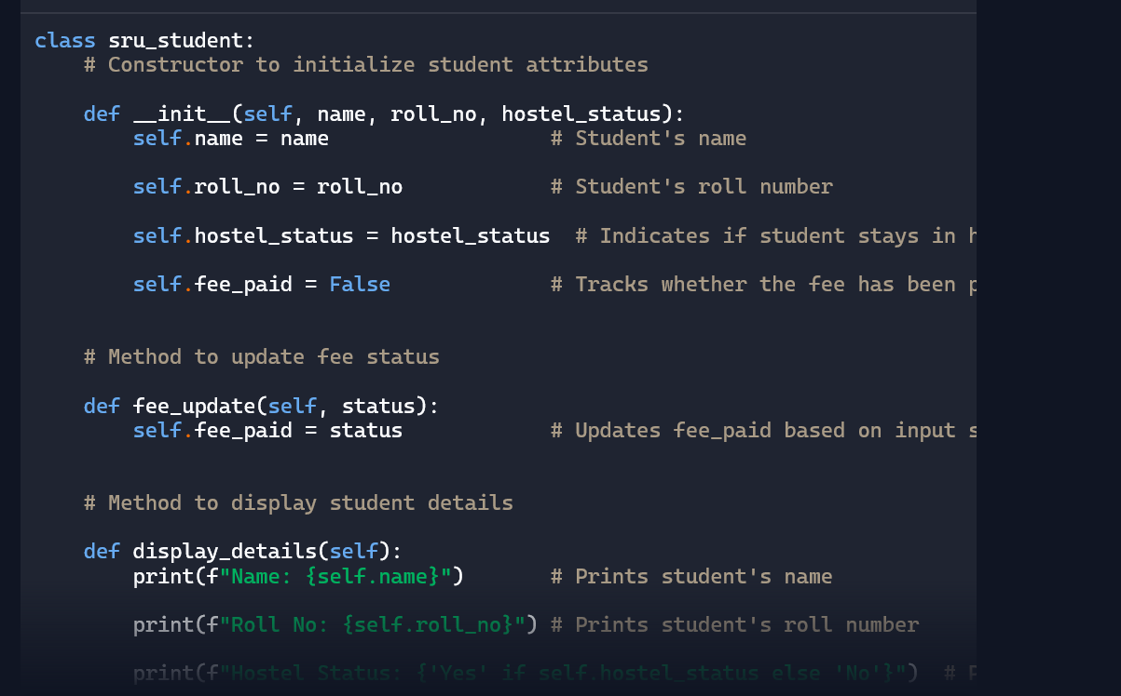

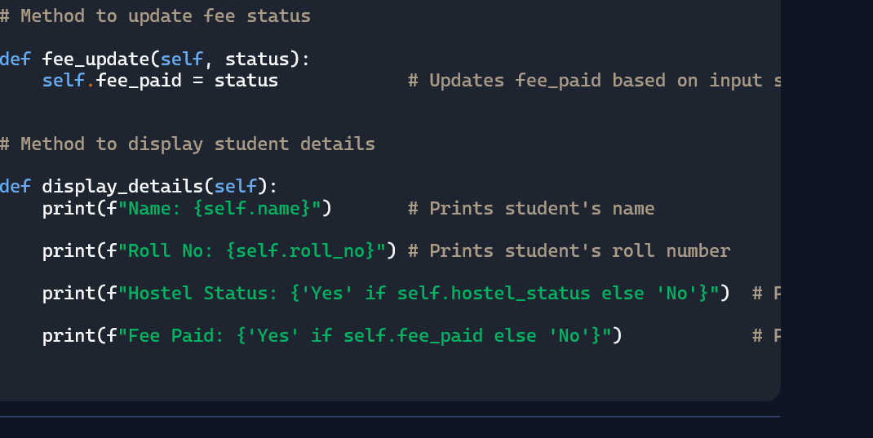

Without comments:

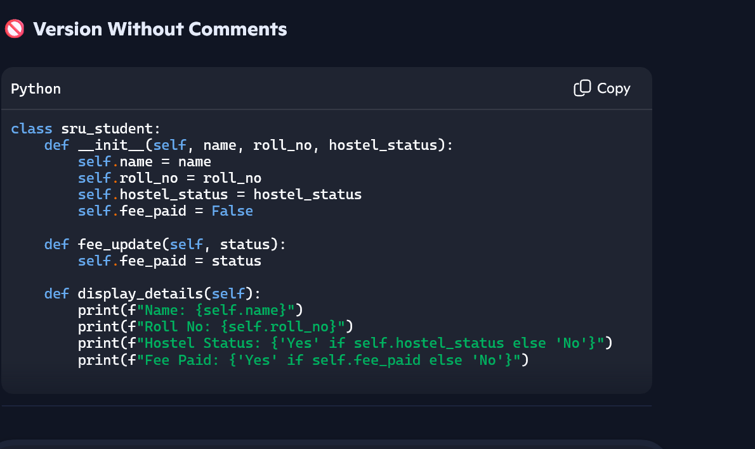

Task-3

* Write a Python script with 3–4 functions (e.g., calculator: add, subtract, multiply, divide).
* Incorporate manual **docstring** in code with NumPy Style
* Use AI assistance to generate a module-level docstring + individual function docstrings.
* Compare the AI-generated docstring with your manually written one.

**Expected Output#3:** Students learn structured documentation for multi-function scripts

With comments

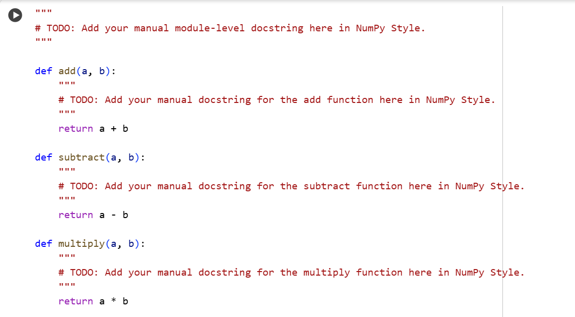

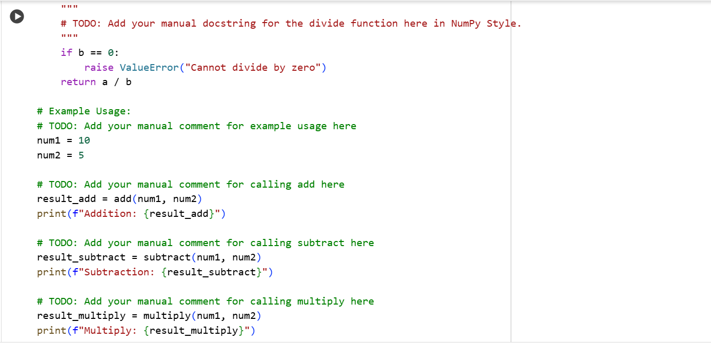

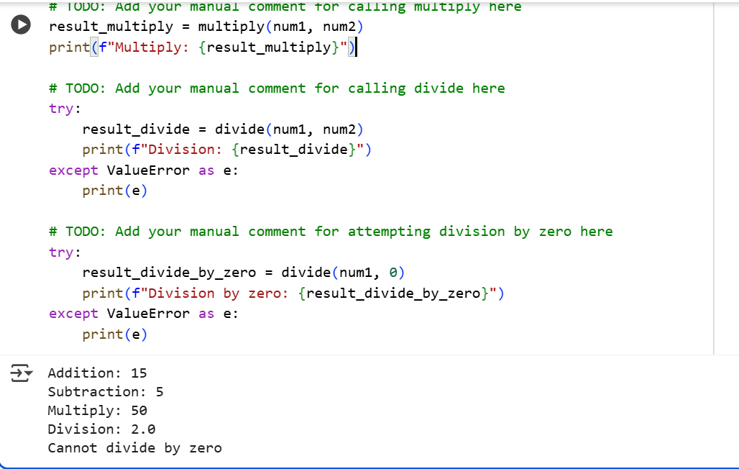

Without comments

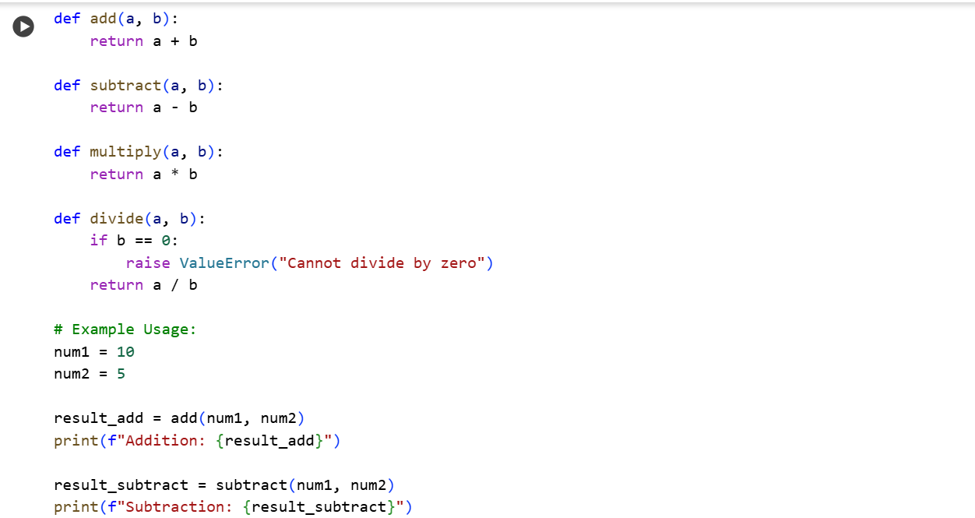

Without comments

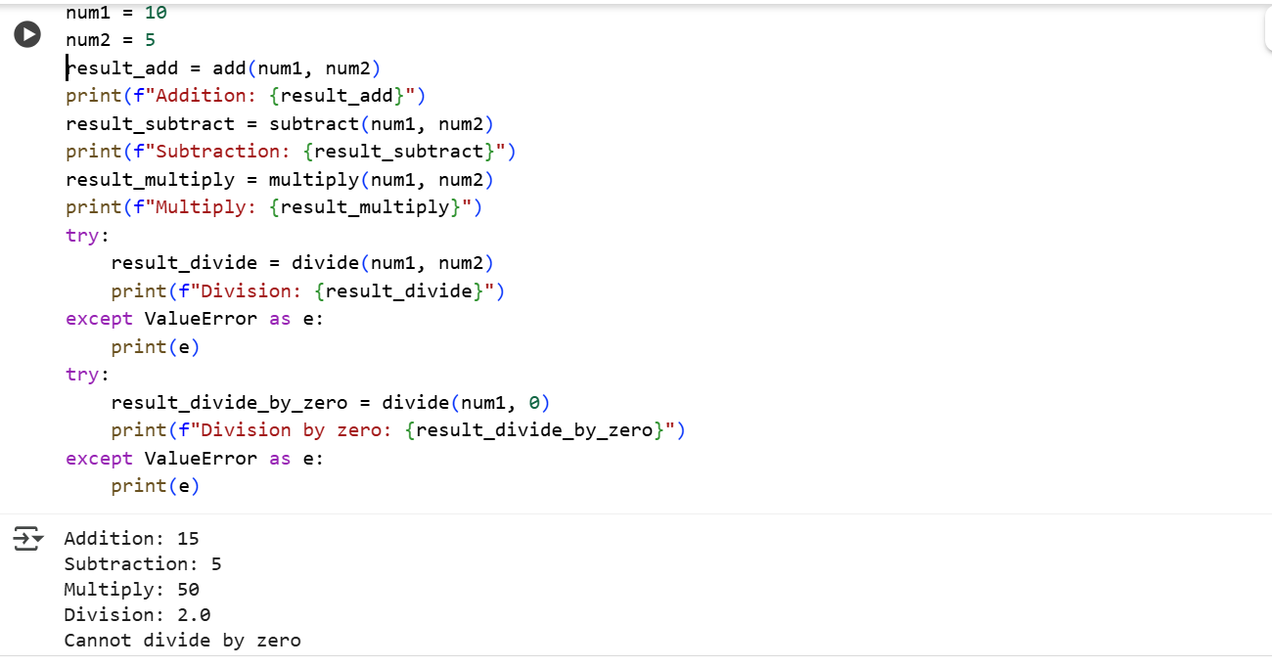

With comments

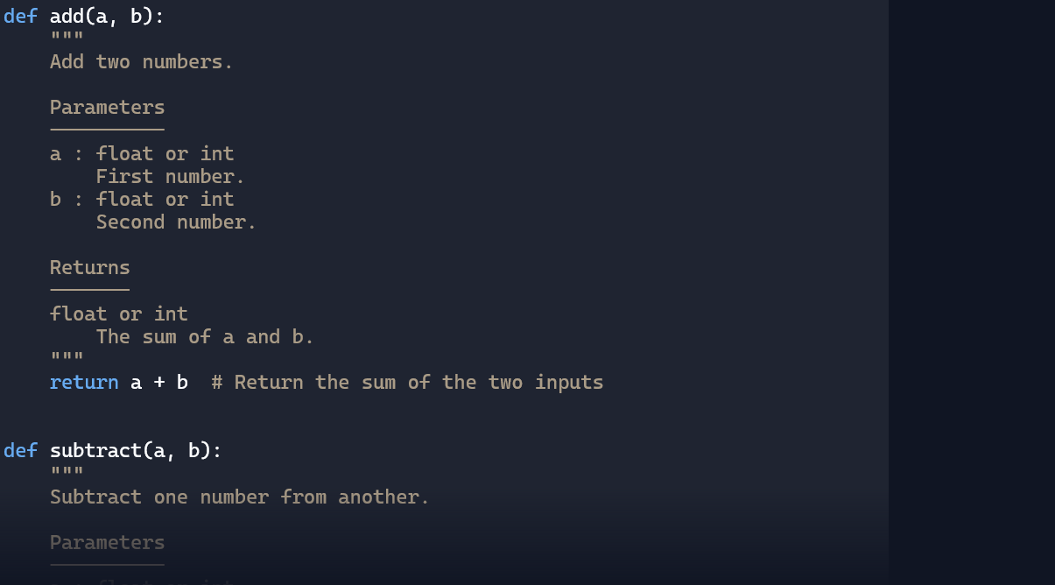

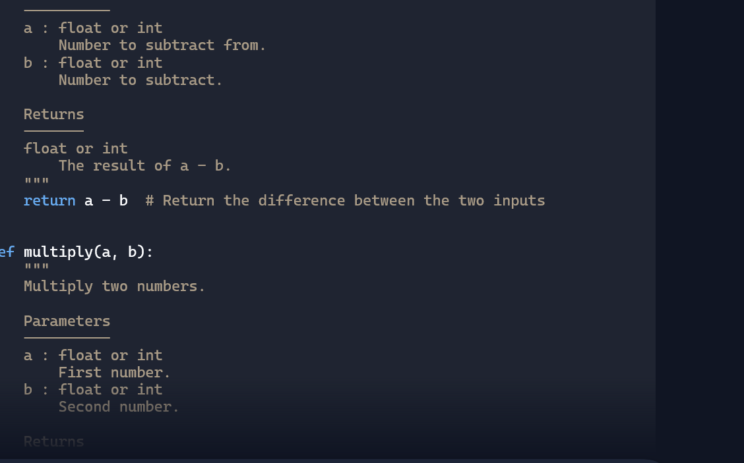

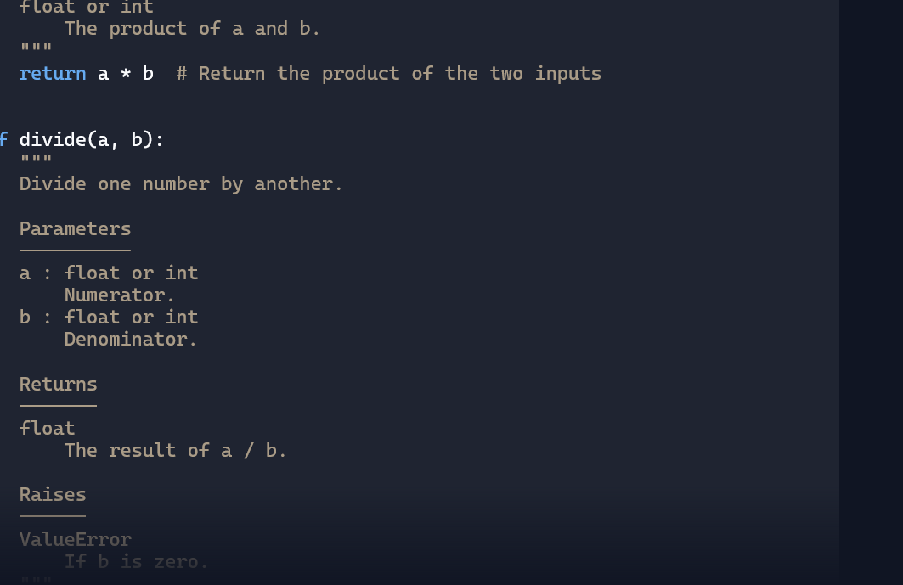

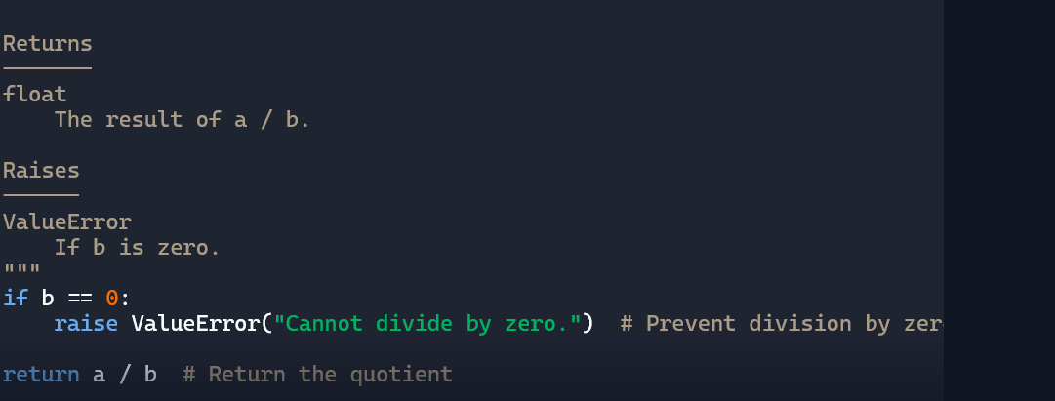

Without comments

