Assignment-19
Task-1
Translate a Simple Program (Python → JavaScript)
- Instructions:
  - Write a Python function print_numbers() that prints the first 10 natural numbers using a loop.
  - Translate the function into JavaScript as a reusable function printNumbers().
  - Call the function in both languages to display results.
- Expected Output:
- 1
- 2
- 3
- ...10

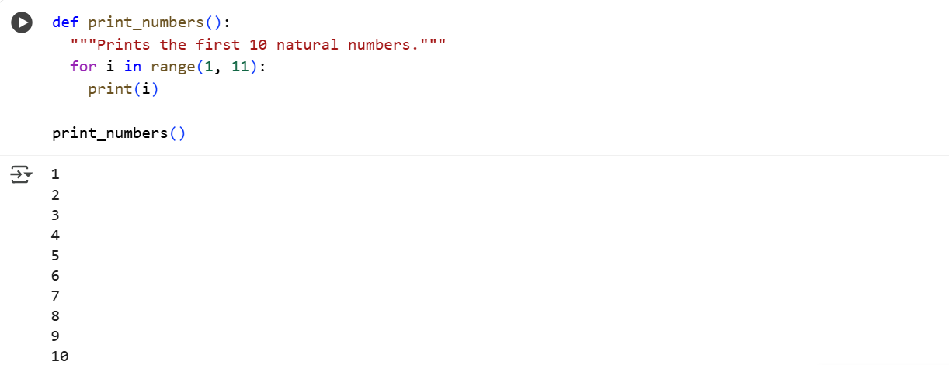
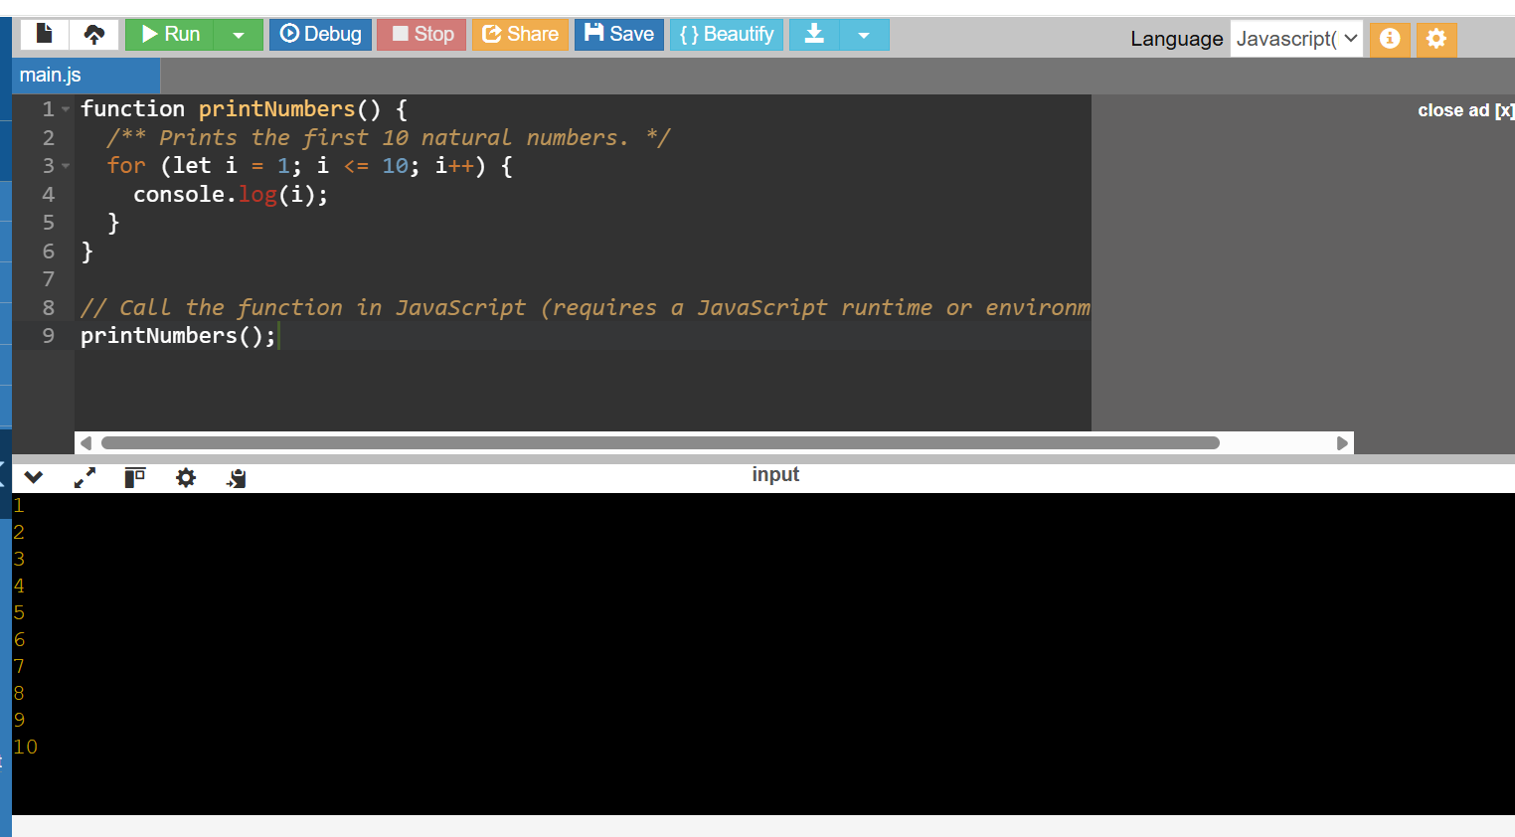
Explanation:
• The program defines a function that prints the first 10 natural numbers (1 to 10).
• In Python, we use a for loop with range(1, 11) — it starts from 1 and stops before 11.
• In JavaScript, we use a for loop with a counter i that goes from 1 to 10.
• print() (Python) and console.log() (JavaScript) are used to display numbers.
• Finally, we call the function to see the numbers printed one after another.

Task-2
Convert Conditional Statements (Java → Python)
- Instructions:
  - Write a Java method checkNumber(int num) that checks if a number is positive, negative, or zero.
  - Translate the method into a Python function check_number(num).
  - Call the function/method with different inputs and compare outputs.
- Expected Output:
  - Input: -5 → Output: The number is negative
  - Input: 0 → Output: The number is zero
Input: 7 → Output: The number is positive
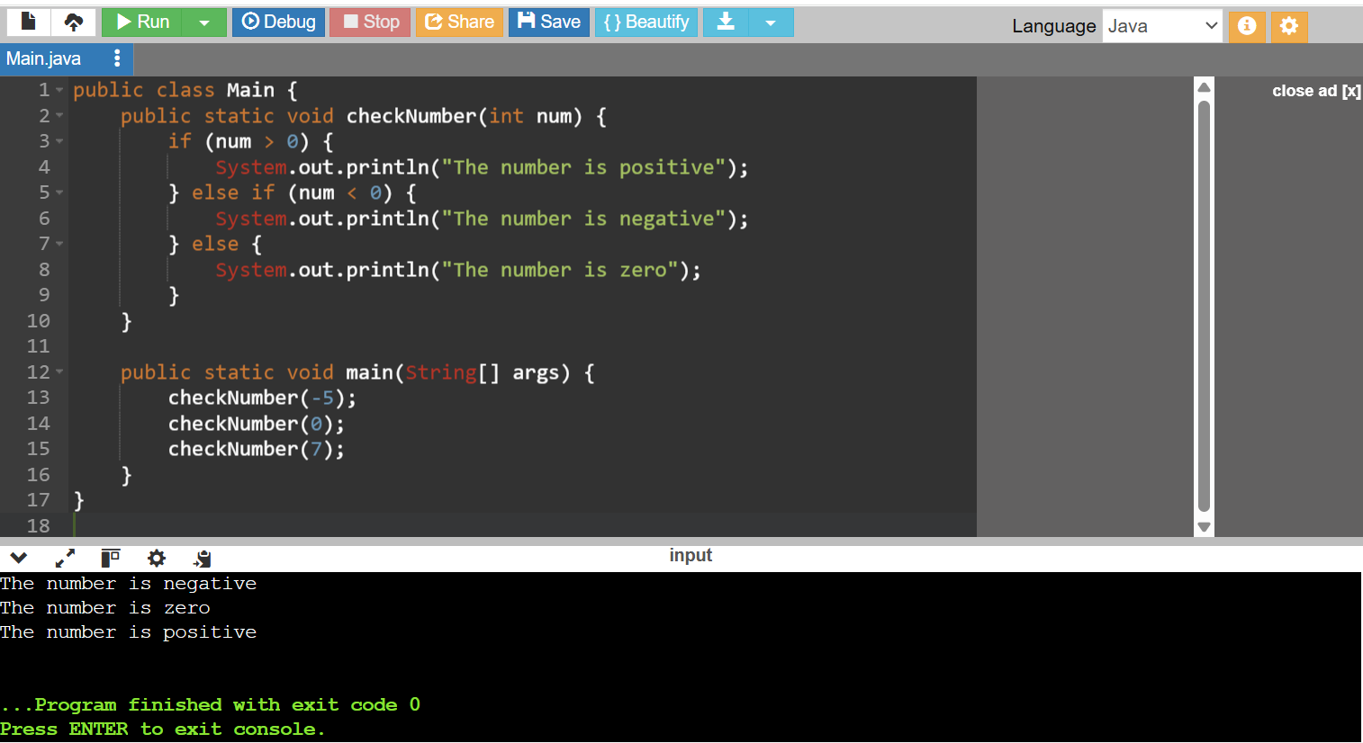
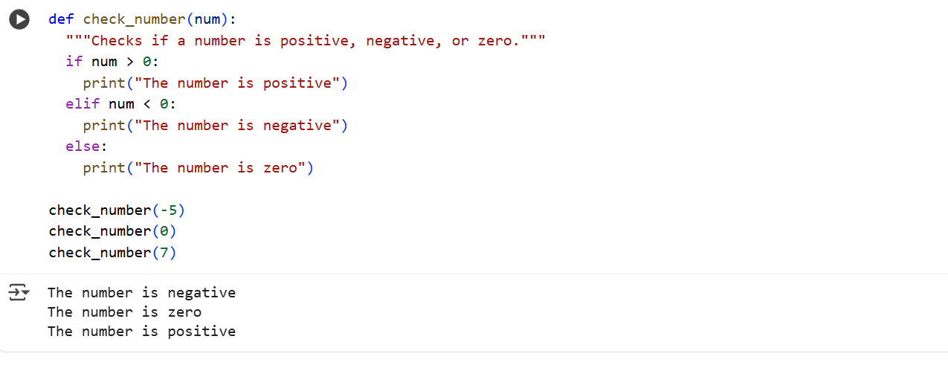
Explanation:
- We created a function checkNumber (Java) or check_number (Python).
- The function checks the value of the input number:
  - If the number is greater than 0, it prints “The number is positive”.
  - If the number is less than 0, it prints “The number is negative”.
  - Otherwise (means equal to 0), it prints “The number is zero”.
- This is done using conditional statements (if, else if, else in Java → if, elif, else in Python).
- The logic stays the same, but the syntax changes slightly between the two languages.

Task-3
Task 3: Translate Recursive Function (Python → C++)
- Instructions:
  - Write a Python function factorial(n) that calculates factorial of a number using recursion.
  - Translate the same into a C++ function int factorial(int n).
  - Call the function in both languages with inputs 5 and 0.
- Expected Output:
  - Input: 5 → Output: Factorial = 120
  - Input: 0 → Output: Factorial = 1
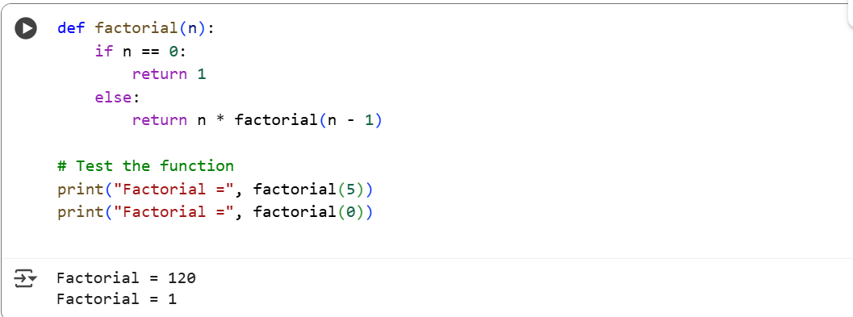

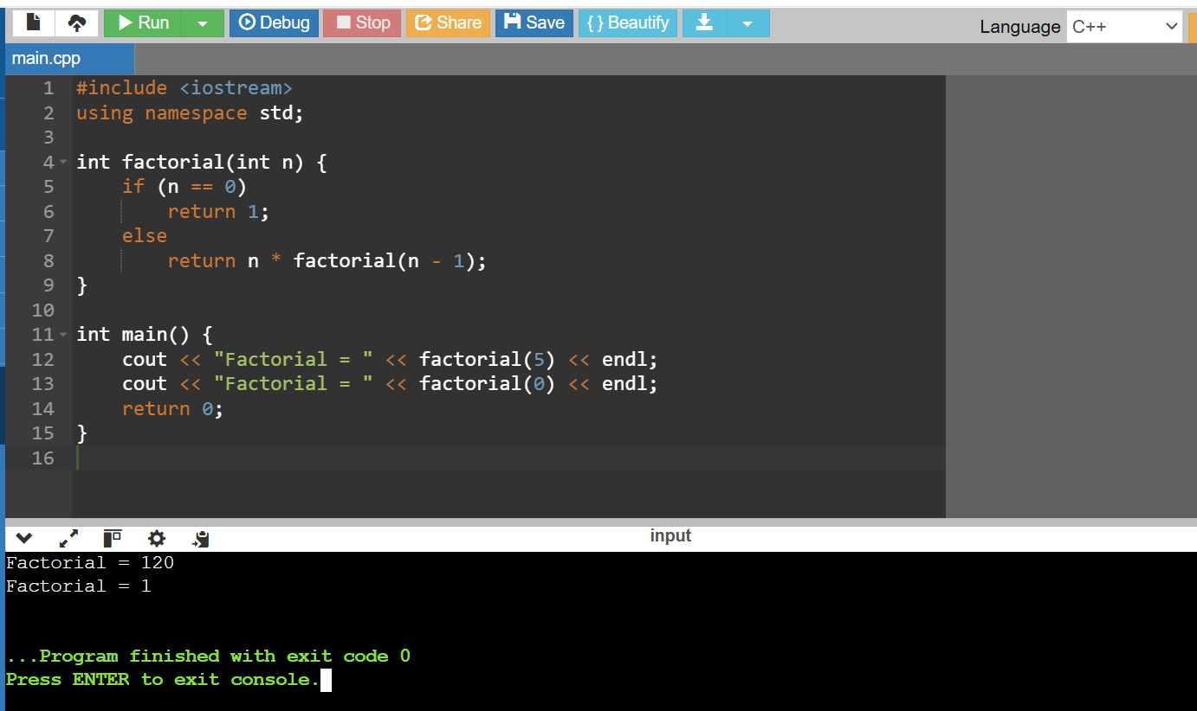

Explanation:
In python:
- If n is 0, it returns 1.
- Otherwise, it multiplies n by factorial(n - 1) — calling itself again with a smaller number.
- This repeats until n becomes 0.
Example:
factorial(5) → 5 × 4 × 3 × 2 × 1 = 120
In C++:
Same idea as Python — the code keeps calling itself until it reaches 0.

Task-4
Task 4: Data Structures with Functions (JavaScript → Python)
- Instructions:
  - Write a JavaScript function printStudents(students) that takes an array of student names and prints each name.
  - Translate it into a Python function print_students(students) using a list.
  - Test both functions with sample student names.
- Expected Output:
- Student List:
- Alice
- Bob
- Charlie

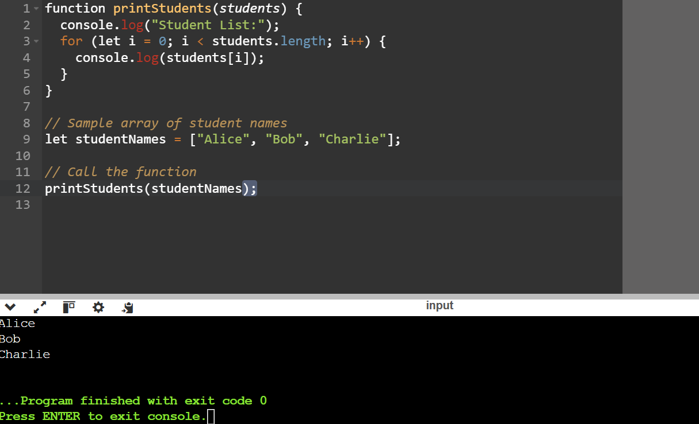
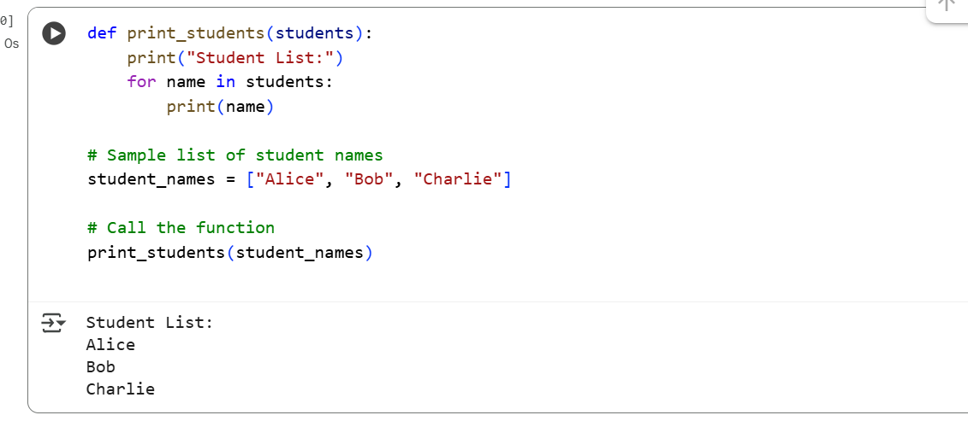
Explanation:
• In this program, we create a function that takes a list of student names and prints them one by one.
• In JavaScript, this list of names is called an array, and in Python, it’s called a list — both store multiple values in one variable.
• The function first prints the heading “Student List:” to show what is being displayed.
• Then a loop is used to go through each name inside the array/list.
• For every name, the program prints it on a new line.
• Finally, we call the function and give it a sample list of students — “Alice”, “Bob”, and “Charlie”.
• The output shows the heading followed by all the names.

Task-5
Class & Object Translation (Python → Java)
- Instructions:
  - Write a Python class Car with attributes: brand, model, year.
  - Add a method display_details() that prints car details.
  - Translate the same into a Java class Car with attributes and a method displayDetails().
  - Create an object in both languages and call the method.
- Expected Output:
- Car Details:
- Brand: Toyota
- Model: Corolla
Year: 2020
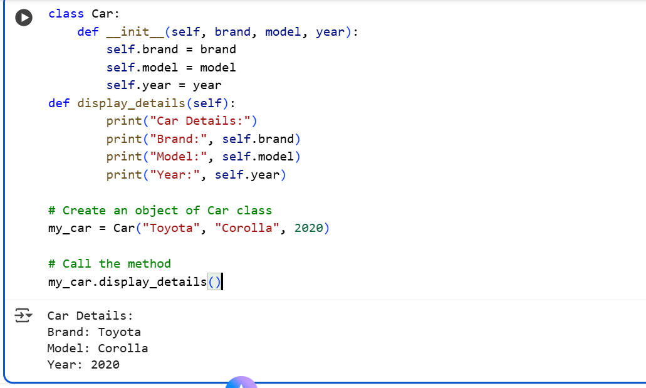
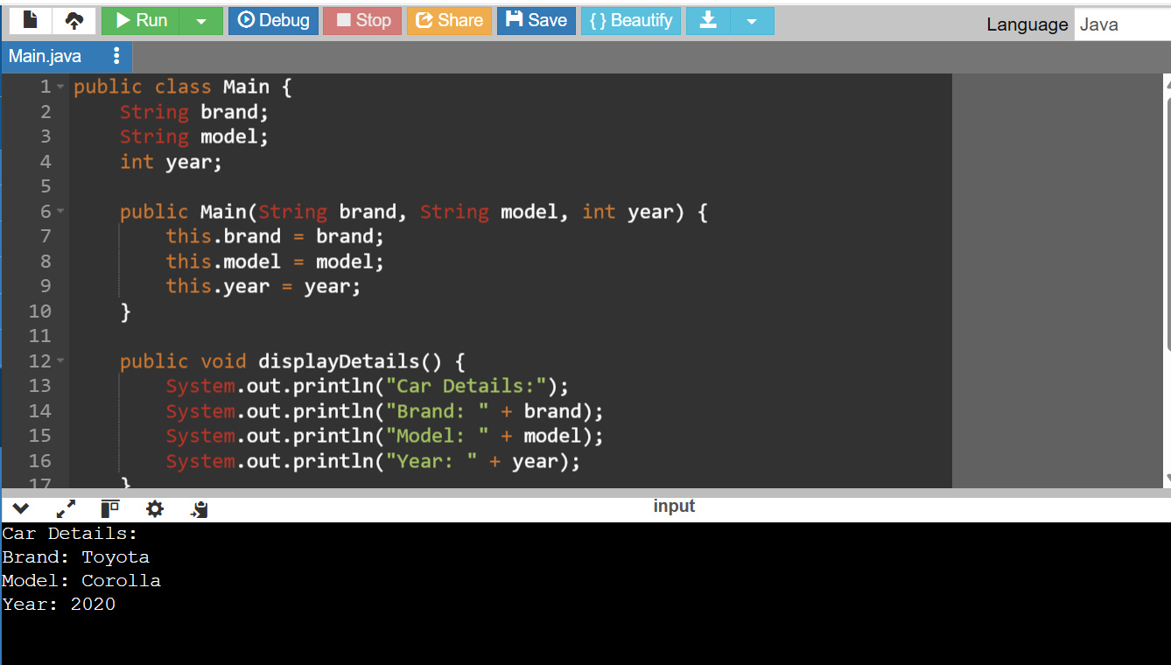
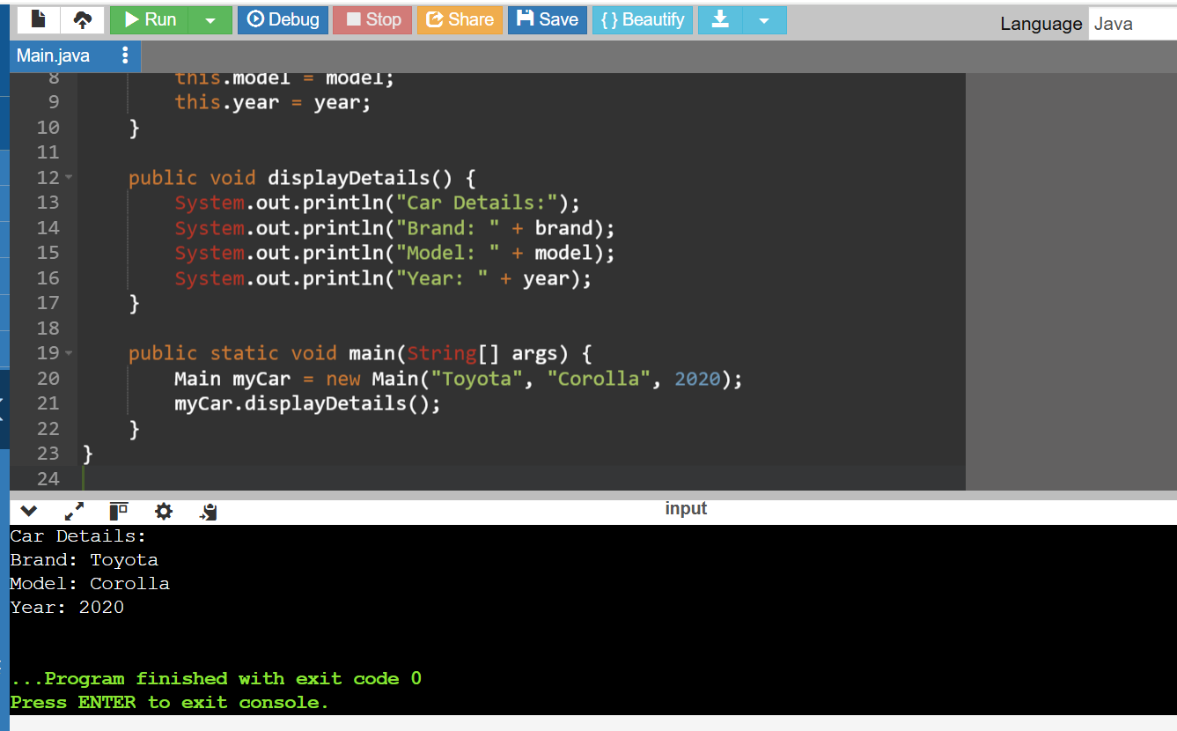
Explanation:
This program is about Object-Oriented Programming (OOP) — where we use classes and objects to represent real-world things.

1. Class
- A class is like a blueprint or template.
- It defines what an object will have (attributes) and what it can do (methods).
- Here, the class is called Car.

2. Attributes
- These are the data or properties of the class.
- In our Car example, the attributes are:
  - brand → e.g., Toyota
  - model → e.g., Corolla
  - year → e.g., 2020

3. Constructor
- A constructor is a special method used to create objects and initialize their attributes.
- In Python, it’s __init__().
- In Java, the constructor has the same name as the class (like Car(String brand, String model, int year)).

4. Method
- A method defines what the object can do.
- The method display_details() (Python) or displayDetails() (Java) prints the car’s information.

5. Object
- An object is a real thing created from the class — like one specific car.
- Example:
my_car = Car("Toyota", "Corolla", 2020) (Python)
or
Car myCar = new Car("Toyota", "Corolla", 2020); (Java)
When you call display_details() or displayDetails(), it prints:

