ASSIGNMENT-2
NAME : K.RAKSHITHA
HT NO: 2403A52150
BATCH: 24BTCAIAIB06

TASK-1: Write a python program that reads a list of numbers and calculates mean,maximum and minimum values.
CODE AND OUTPUT:
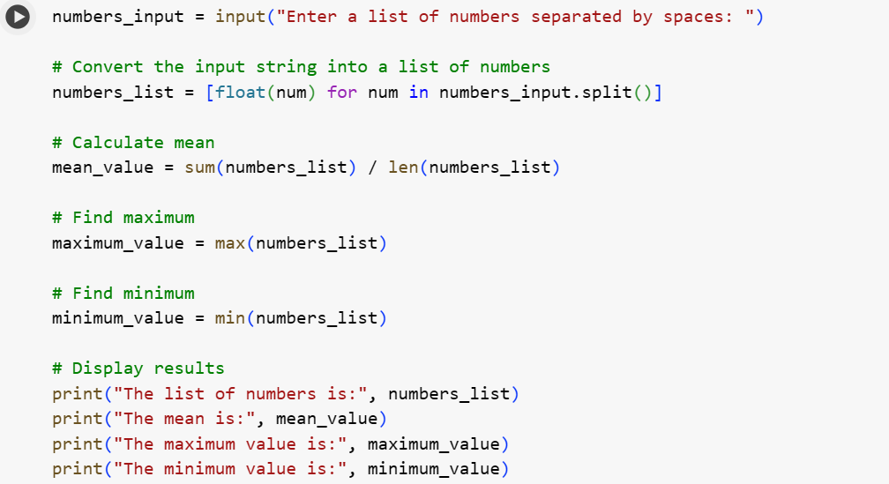
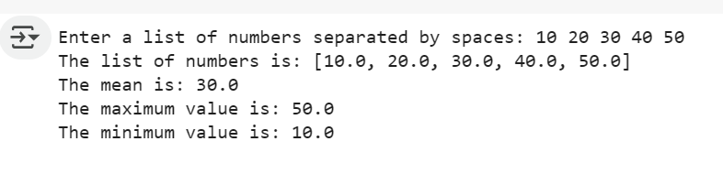

EXPLANATION:
- numbers_input = input("Enter a list of numbers separated by spaces: "): This line prompts the user to enter a list of numbers. The user is instructed to separate the numbers with spaces. The input is read as a single string and stored in the variable numbers_input.
- numbers_list = [float(num) for num in numbers_input.split()]: This is a list comprehension that converts the input string into a list of numbers.
  - numbers_input.split() splits the input string into a list of substrings using spaces as the delimiter.
  - for num in ... iterates through each substring (which should be a number as a string).
  - float(num) converts each substring into a floating-point number.
  - [...] creates a new list called numbers_list containing these floating-point numbers.
- mean_value = sum(numbers_list) / len(numbers_list): This line calculates the mean (average) of the numbers in the numbers_list.
  - sum(numbers_list) calculates the sum of all numbers in the list.
  - len(numbers_list) gets the number of elements in the list.
  - The sum is divided by the count to get the mean.
- maximum_value = max(numbers_list): This line uses the built-in Python function max() to find the largest number in the numbers_list and stores it in maximum_value.
- minimum_value = min(numbers_list): This line uses the built-in Python function min() to find the smallest number in the numbers_list and stores it in minimum_value.
- print("The list of numbers is:", numbers_list): This line prints the list of numbers that was created from the user's input.
- print("The mean is:", mean_value): This line prints the calculated mean value.
- print("The maximum value is:", maximum_value): This line prints the calculated maximum value.
- print("The minimum value is:", minimum_value): This line prints the calculated minimum value.

TASK-2:Write a python function that checks the given number is an Armstrong or not.
Comparision between gemini and copilot-
GEMINI:
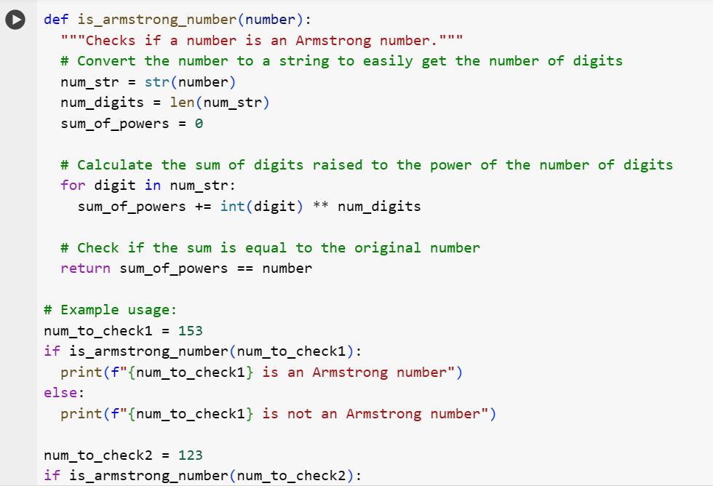
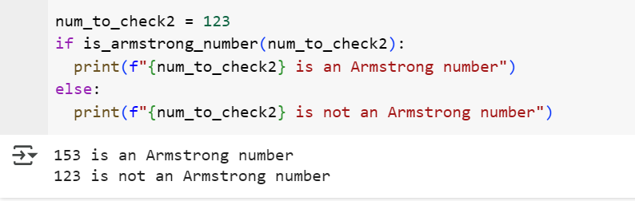

COPILOT:
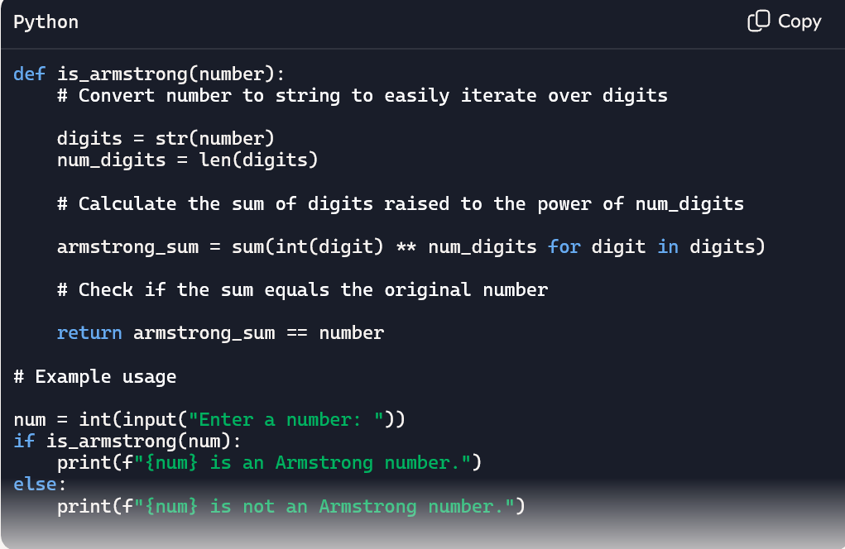
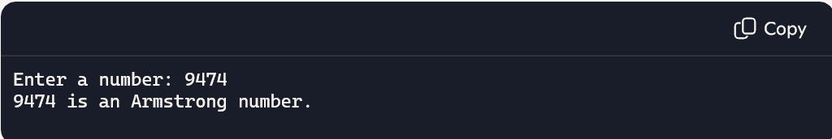
EXPLANATION:
- def is_armstrong_number(number):: This defines the function that takes a number as input.
- num_str = str(number): Converts the input number to a string so we can easily work with its digits.
- num_digits = len(num_str): Gets the total number of digits in the number.
- sum_of_powers = 0: Initializes a variable to store the sum of the powers of the digits.
- for digit in num_str:: This loop goes through each character (digit) in the number string.
- sum_of_powers += int(digit) ** num_digits: Converts the current digit back to an integer, raises it to the power of the total number of digits (num_digits), and adds it to sum_of_powers.
- return sum_of_powers == number: After checking all digits, it compares the calculated sum_of_powers with the original number. If they are equal, the function returns True (it's an Armstrong number); otherwise, it returns False.

TASK-3:
Write a python program to generate prime numbers from 10 to 50 in the form of list.
CODE AND OUPUT:
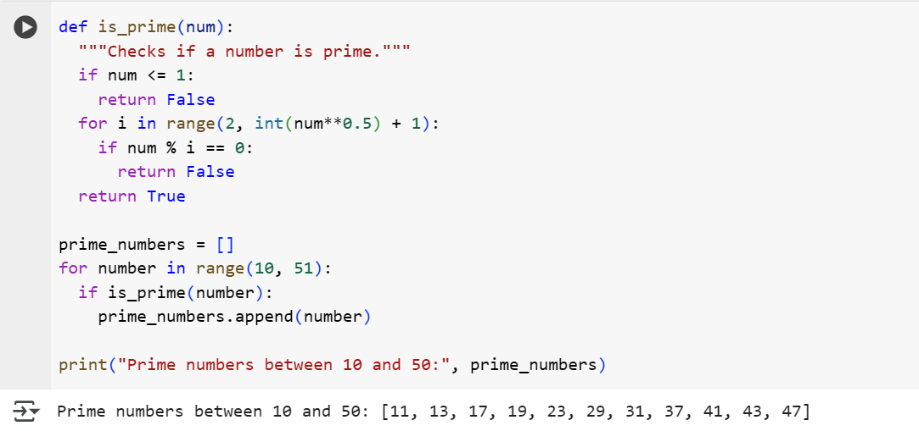
EXPLANATION:
1. The is_prime function:
- def is_prime(num):: This defines a function named is_prime that takes one argument, num.
- """Checks if a number is prime.""": This is a docstring explaining the function's purpose.
- if num <= 1:: This checks if the input number num is less than or equal to 1. Prime numbers are defined as being greater than 1, so if the number is 1 or less, the function immediately returns False.
- `for i in range(2, int(num0.5) + 1):**: This starts afor` loop to check for divisors.
  - range(2, int(num**0.5) + 1) creates a sequence of numbers starting from 2 up to the integer part of the square root of num, plus 1. We only need to check for divisors up to the square root of a number because if a number num has a divisor greater than its square root, it must also have a divisor less than its square root.
- if num % i == 0:: Inside the loop, this checks if num is divisible by the current number i using the modulo operator (%). If the remainder is 0, it means i is a divisor of num.
- return False: If a divisor is found, the number is not prime, so the function immediately returns False.
- return True: If the loop completes without finding any divisors, it means the number is prime, and the function returns True.
2. Generating the list of prime numbers:
- prime_numbers = []: This line initializes an empty list called prime_numbers. This list will store the prime numbers found within the specified range.
- for number in range(10, 51):: This for loop iterates through the numbers from 10 up to (but not including) 51. So it checks numbers 10, 11, 12, ..., 50.
- if is_prime(number):: Inside the loop, for each number in the range, it calls the is_prime function to check if that number is prime.
- prime_numbers.append(number): If the is_prime function returns True (meaning the number is prime), that number is added to the prime_numbers list using the append() method.
- print("Prime numbers between 10 and 50:", prime_numbers): After the loop finishes, this line prints a descriptive message followed by the prime_numbers list containing all the prime numbers found between 10 and 50.
TASK-4:
TASK-5:Write a python program to get sum of even numbers upto 10 and sum of odd numbers upto 10
CODE AND OUTPUT:
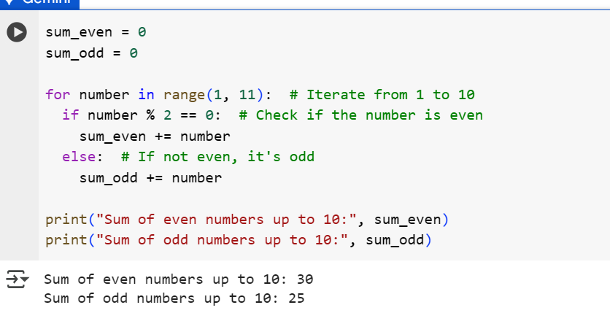
EXPLANATION:
- sum_even = 0: This line initializes a variable called sum_even to 0. This variable will store the running total of even numbers found.
- sum_odd = 0: This line initializes a variable called sum_odd to 0. This variable will store the running total of odd numbers found.
- for number in range(1, 11):: This is a for loop that iterates through a sequence of numbers generated by range(1, 11). The range(1, 11) function produces numbers starting from 1 and going up to (but not including) 11. So, the loop will process the numbers 1, 2, 3, 4, 5, 6, 7, 8, 9, and 10. In each iteration, the current number is assigned to the variable number.
- if number % 2 == 0:: Inside the loop, this if statement checks if the current number is even. The modulo operator (%) gives the remainder of a division. If a number divided by 2 has a remainder of 0, it means the number is even.
- sum_even += number: If the condition in the if statement is true (the number is even), this line adds the current number to the sum_even variable. The += operator is a shorthand for sum_even = sum_even + number.
- else:: This keyword indicates the block of code to execute if the condition in the if statement is false. In this case, it means the number is odd.
- sum_odd += number: If the number is odd, this line adds the current number to the sum_odd variable. This is a shorthand for sum_odd = sum_odd + number.
- print("Sum of even numbers up to 10:", sum_even): After the loop has finished iterating through all the numbers from 1 to 10, this line prints a descriptive message followed by the final calculated sum_even.
- print("Sum of odd numbers up to 10:", sum_odd): This line prints a descriptive message followed by the final calculated sum_odd.

