ASSIGNMENT-4
NAME : K.RAKSHITHA
HT NO: 2403A52150
BATCH: 24BTCAIAIB06

TASK-1: Write a python program that checks the given year is leap year using functions.
CODE AND OUPUT:
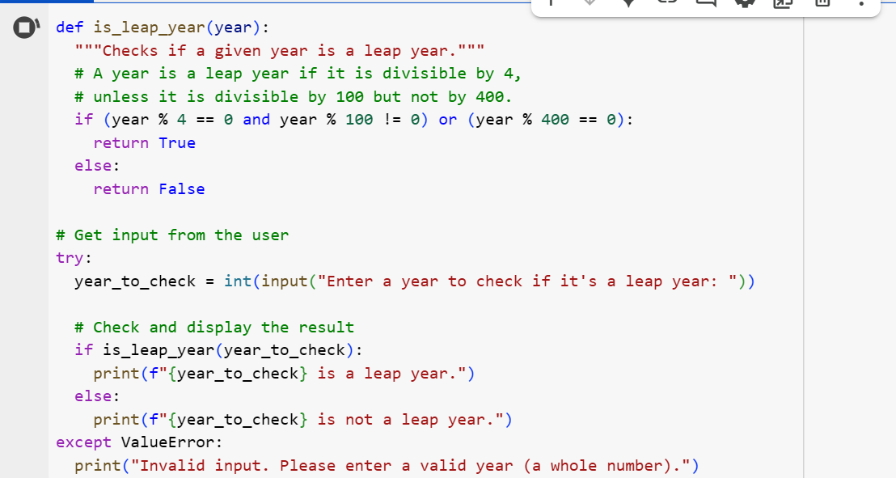
EXPLANATION:
- def is_leap_year(year):: This line defines a function named is_leap_year that takes one argument, year, which is the year you want to check.
- """Checks if a given year is a leap year.""": This is a docstring explaining what the function does.
- if (year % 4 == 0 and year % 100 != 0) or (year % 400 == 0):: This is the core logic for checking a leap year based on the Gregorian calendar rules:
  - year % 4 == 0: Checks if the year is divisible by 4.
  - year % 100 != 0: Checks if the year is not divisible by 100.
  - year % 400 == 0: Checks if the year is divisible by 400.
  - The condition (year % 4 == 0 and year % 100 != 0) covers years divisible by 4 but not by 100 (e.g., 2004, 2008).
  - The condition (year % 400 == 0) covers years divisible by 400 (e.g., 2000, 2400).
  - The or combines these two conditions: a year is a leap year if it satisfies either of these.
- return True: If the condition in the if statement is true, the function returns True, indicating it's a leap year.
- else: return False: If the condition is false, the function returns False, indicating it's not a leap year.
- try...except ValueError:: This block handles user input:
  - year_to_check = int(input("Enter a year to check if it's a leap year: ")): This prompts the user to enter a year and attempts to convert the input string into an integer using int().
  - try:: The code inside the try block is executed. If a ValueError occurs during the int() conversion (e.g., if the user enters text that cannot be converted to an integer), the code in the except block is executed.
  - except ValueError:: If a ValueError occurs, this block catches the error.
  - print("Invalid input. Please enter a valid year (a whole number)."): This prints an error message if the user's input was not a valid integer.
- if is_leap_year(year_to_check): ... else: ...: If the input was successfully converted to an integer (i.e., no ValueError), the is_leap_year function is called with the year_to_check. Based on the boolean value returned by the function (True or False), the code prints whether the year is a leap year or not.
TASK-2:
Write a program in python that converts centimeters into inches using one shot.
CODE AND OUPUT:
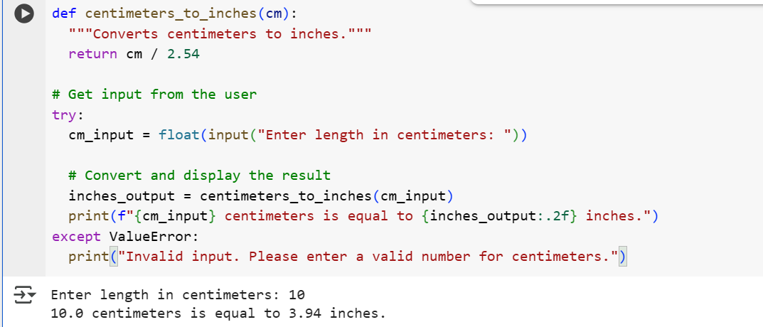
EXPLANATION:
- def centimeters_to_inches(cm):: This line defines a function named centimeters_to_inches that takes one argument, cm, which is the length in centimeters you want to convert.
- """Converts centimeters to inches.""": This is a docstring explaining what the function does.
- return cm / 2.54: This line performs the conversion. Since there are 2.54 centimeters in 1 inch, dividing the number of centimeters by 2.54 gives the equivalent length in inches. The function returns this calculated value.
- try...except ValueError:: This block handles user input:
  - cm_input = float(input("Enter length in centimeters: ")): This prompts the user to enter a length in centimeters and attempts to convert the input string into a floating-point number using float(). Using float() allows for decimal values.
  - try:: The code inside the try block is executed. If a ValueError occurs during the float() conversion (e.g., if the user enters text that cannot be converted to a number), the code in the except block is executed.
  - except ValueError:: If a ValueError occurs, this block catches the error.
  - print("Invalid input. Please enter a valid number for centimeters."): This prints an error message if the user's input was not a valid number.
- inches_output = centimeters_to_inches(cm_input): If the input was successfully converted to a float (i.e., no ValueError), the centimeters_to_inches function is called with the user's input (cm_input) to perform the conversion. The result is stored in the inches_output variable.
- print(f"{cm_input} centimeters is equal to {inches_output:.2f} inches."): This line prints the original centimeter value and the calculated inches value using an f-string for formatted output. The :.2f inside the f-string formats the inches_output to two decimal places.

TASK-3:
Write a python program that formats full names into “first” and “last” using few shot.

CODE AND OUPUT:
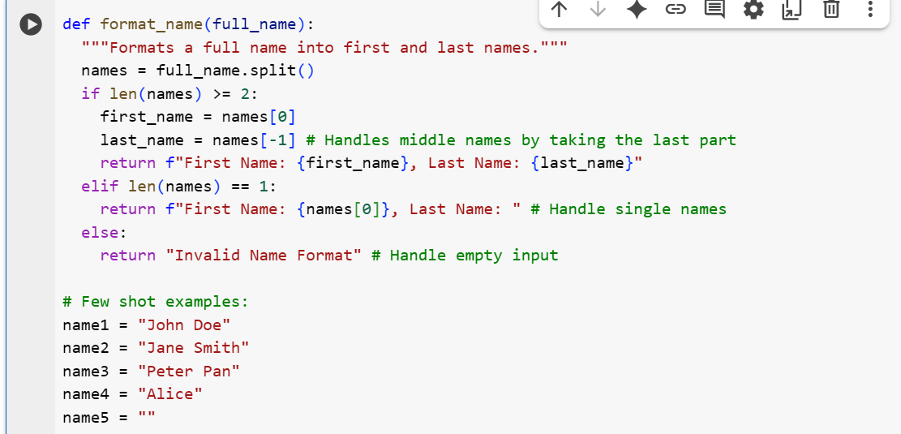

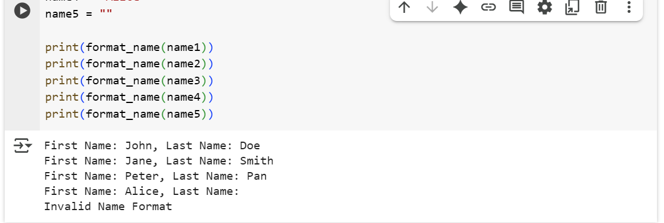

EXPLANATION:
- def format_name(full_name):: This defines a function named format_name that takes one argument, full_name, which is the string containing the full name.
- """Formats a full name into first and last names.""": This is a docstring explaining the function's purpose.
- names = full_name.split(): This line splits the full_name string into a list of words using spaces as the delimiter. For example, "John Doe" becomes ['John', 'Doe'].
- if len(names) >= 2:: This checks if the list of names has two or more elements. This condition is true for names with at least a first and a last name.
  - first_name = names[0]: The first element of the names list (the first name) is assigned to the first_name variable.
  - last_name = names[-1]: The last element of the names list (the last name) is assigned to the last_name variable. Using [-1] is a convenient way to get the last element of a list, which helps handle names with middle names (it will take the last part as the last name).
  - return f"First Name: {first_name}, Last Name: {last_name}": The function returns a formatted string showing "First Name: ..." and "Last Name: ...".
- elif len(names) == 1:: This checks if the list of names has only one element. This condition is true for single names.
  - return f"First Name: {names[0]}, Last Name: ": The function returns a formatted string showing the single name as the "First Name" and an empty "Last Name".
- else: return "Invalid Name Format": If the list of names is empty (meaning the input full_name was an empty string or contained only spaces), this condition is met, and the function returns the string "Invalid Name Format".
- # Few shot examples:: This is a comment indicating the start of the example usage.
- name1 = "John Doe", name2 = "Jane Smith", etc.: These lines define several example strings with different name formats.
- print(format_name(name1)), print(format_name(name2)), etc.: These lines call the format_name function with each of the example names and print the returned formatted string. This demonstrates how the function behaves with different inputs.

TASK-4:
Write a python program that counts the number of vowels in a string.
CODE AND OUPUT:
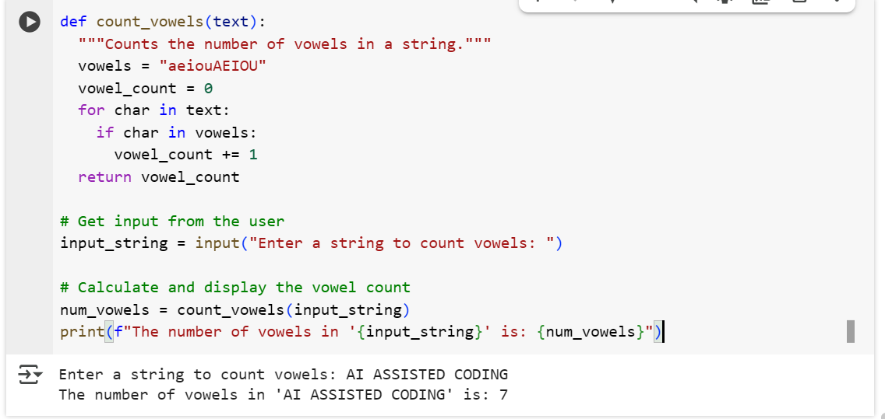

EXPLANATION:
- def count_vowels(text):: This defines a function named count_vowels that takes one argument, text, which is the string you want to analyze.
- """Counts the number of vowels in a string.""": This is a docstring explaining what the function does.
- vowels = "aeiouAEIOU": This line creates a string named vowels containing all lowercase and uppercase vowel characters. This makes it easy to check if a character is a vowel.
- vowel_count = 0: Initializes a variable vowel_count to 0. This variable will store the total number of vowels found in the string.
- for char in text:: This loop iterates through each character (char) in the input text string.
- if char in vowels:: Inside the loop, this checks if the current char is present in the vowels string. If it is, it means the character is a vowel.
- vowel_count += 1: If the character is a vowel, the vowel_count is incremented by 1.
- return vowel_count: After the loop has processed all characters in the string, the function returns the final vowel_count.
- input_string = input("Enter a string to count vowels: "): This line prompts the user to enter a string using the input() function and stores the entered string in the input_string variable.
- num_vowels = count_vowels(input_string): This line calls the count_vowels function with the user-provided input_string and stores the returned vowel count in the num_vowels variable.
- print(f"The number of vowels in '{input_string}' is: {num_vowels}"): This line prints the original input string and the calculated number of vowels using an f-string for formatted output.

TASK-5:
Write a python program that reads a .txt file and returns the number of lines using few short.
CODE AND OUPUT:
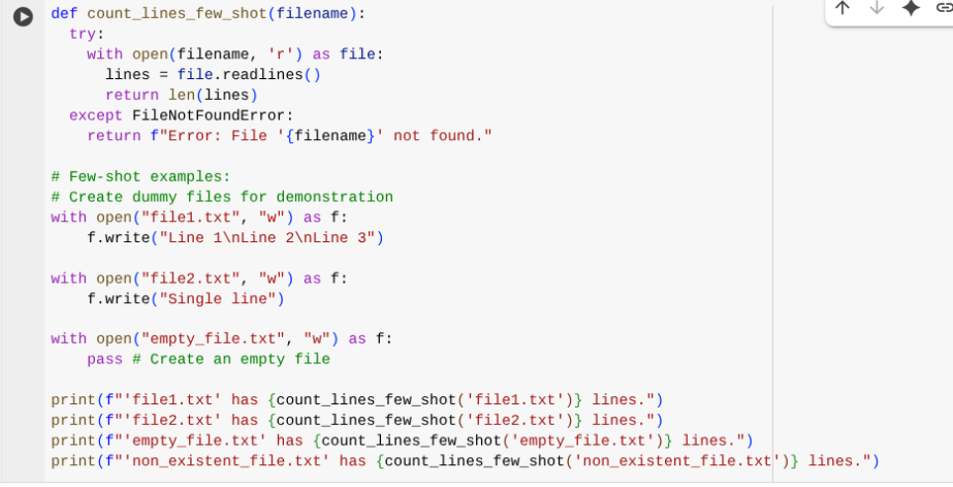
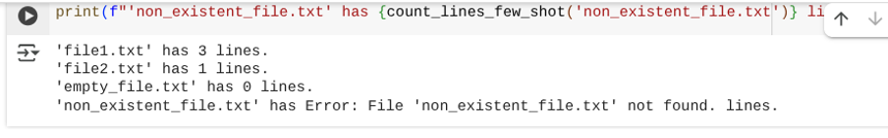
EXPLANATION:
- def count_lines_few_shot(filename):: Defines a function to count lines in a file.
- """...""": A docstring explaining the function's purpose, arguments, and return value.
- try:: Starts a block to handle potential errors, like the file not being found.
- with open(filename, 'r') as file:: Opens the specified file for reading.
- lines = file.readlines(): Reads all lines into a list.
- return len(lines): Returns the number of lines in the list.
- except FileNotFoundError:: Catches the error if the file doesn't exist.
- return f"Error: File '{filename}' not found.": Returns an error message if the file is not found.
- # Few-shot examples:: Comments indicating the following lines are examples.
- # Create dummy files for demonstration: Comment explaining dummy file creation.
- with open("file1.txt", "w") as f: f.write("Line 1\nLine 2\nLine 3"): Creates "file1.txt" with three lines.
- with open("file2.txt", "w") as f: f.write("Single line"): Creates "file2.txt" with one line.
- with open("empty_file.txt", "w") as f: pass: Creates an empty "empty_file.txt".
- print(f"'file1.txt' has {count_lines_few_shot('file1.txt')} lines."): Prints the line count for "file1.txt".
- print(f"'non_existent_file.txt'has {count_lines_few_shot('non_existent_file.txt')} lines."): Prints the result for a non-existent file (showing the error handling).

