ASSIGNMENT-6
NAME : K.RAKSHITHA
HT NO: 2403A52150
BATCH: 24BTCAIAIB06
Task-1:
Generate a python code to ask input to user using a Class named Student with attributes name, roll_number, and marks to complete methods for displaying details and checking if marks are above average. Use classes like display_details() and is_passed(), demonstrating use of if-else conditions.
CODE AND OUPUT:
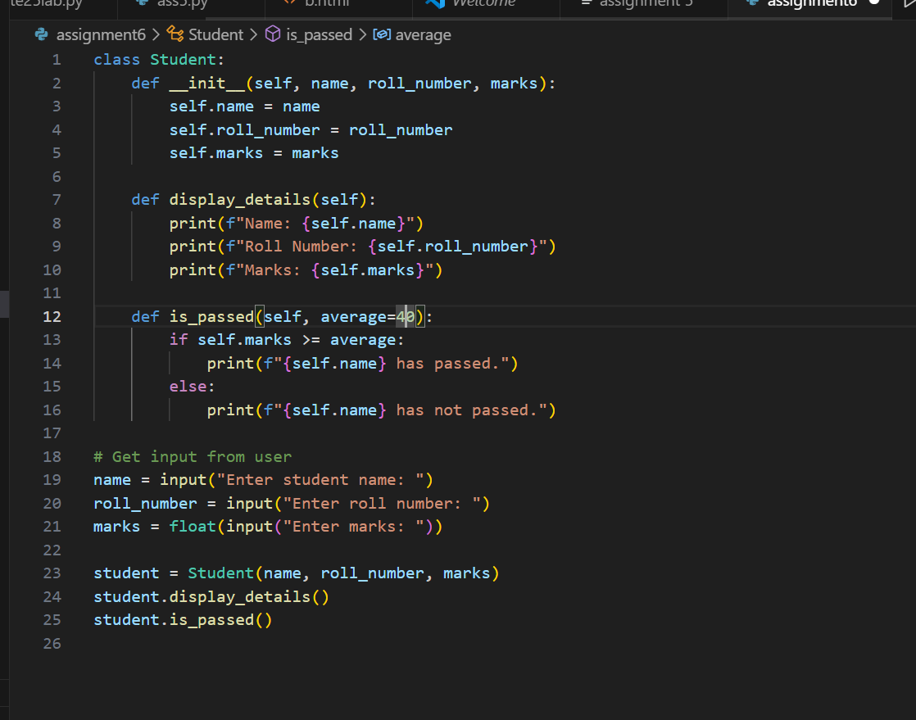
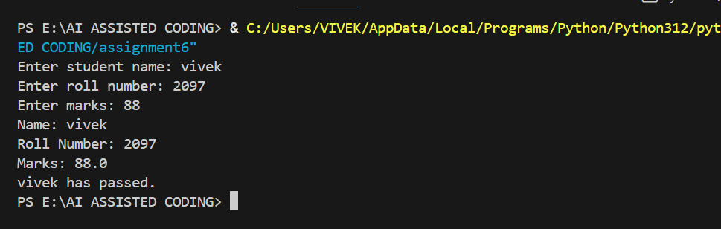
EXPLANATION:
- Class Definition:
  - Student is a class with three attributes: name, roll_number, and marks.
  - The __init__ method initializes these attributes when a new Student object is created.
- Methods:
  - display_details(self): Prints the student's name, roll number, and marks.
  - is_passed(self, average=40): Checks if the student's marks are greater than or equal to the average (default is 40). If so, it prints that the student has passed; otherwise, it prints that the student has not passed. This uses an if-else condition.
- User Input and Object Creation:
  - The program asks the user to input the student's name, roll number, and marks.
  - It creates a Student object with these values.
- Method Calls:
  - It calls display_details() to show the student's information.
  - It calls is_passed() to check and display whether the student passed or not.
Summary:
This code demonstrates how to use classes, methods, user input, and if-else logic in Python to manage and evaluate student information.

TASK2:
Prompt:
for number in numbers:
if number % 2 == 0:
#check square of even numbers only

CODE AND OUPUT:
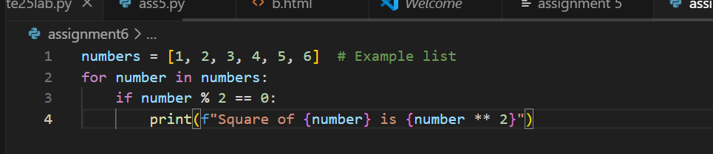
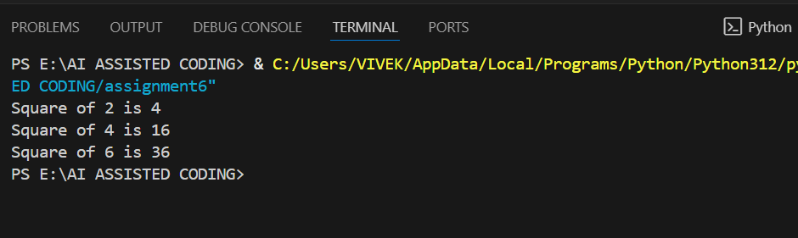
EXPLANATION:
- numbers is a list containing integers.
- The for loop iterates through each number in the list.
- The if statement checks if the number is even (number % 2 == 0).
- If the number is even, its square (number ** 2) is calculated and printed.
This code prints the square of each even number in the list. For example, for 2, 4, and 6, it will print their squares.

TASK3:
Prompt:
Create a class called BankAccount with attributes account_holder and balance. Give a python code to ask input to user also complete methods for deposit(), withdraw(), and check for insufficient balance.
CODE AND OUTPUT:
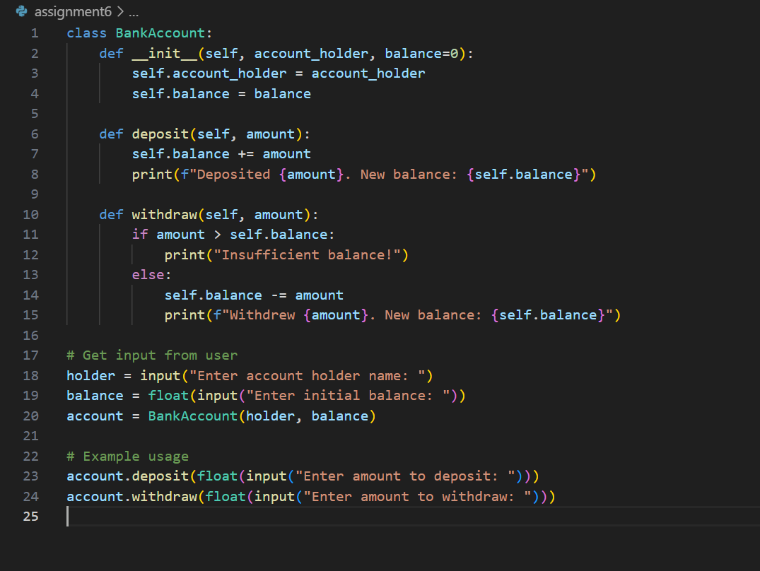
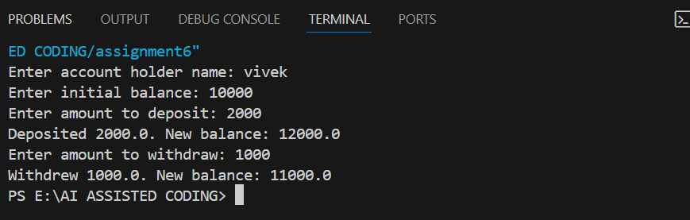
EXPLANATION:
- Class Definition:
  - BankAccount has two attributes: account_holder (the name of the account owner) and balance (the account’s current balance, default is 0).
- Methods:
  - deposit(amount): Adds the specified amount to the balance and prints the new balance.
  - withdraw(amount): Checks if the withdrawal amount is greater than the current balance. If so, it prints “Insufficient balance!” Otherwise, it subtracts the amount and prints the new balance.
- User Input:
  - The program asks the user for the account holder’s name and initial balance.
  - It creates a BankAccount object with these values.
- Example Usage:
  - The user is prompted to enter an amount to deposit and an amount to withdraw.
  - The deposit and withdraw methods are called, demonstrating how the class works and how insufficient balance is handled.
Summary:
This code shows how to use classes, methods, user input, and if-else logic to manage a simple bank account in Python.

TASK4:
Prompt:
students = [
{"name": "Tony Stark", "score": 97},
{"name": "Steve Rogers", "score": 88},
{"name": "Thor", "score": 82},
{"name": "Bruse Banner", "score": 95},
{"name": "Clint", "score": 74}
]
Here, is a list of student dictionaries. Now, give a python code using while loop to print the names of students who scored more than 75

CODE AND OUTPUT:
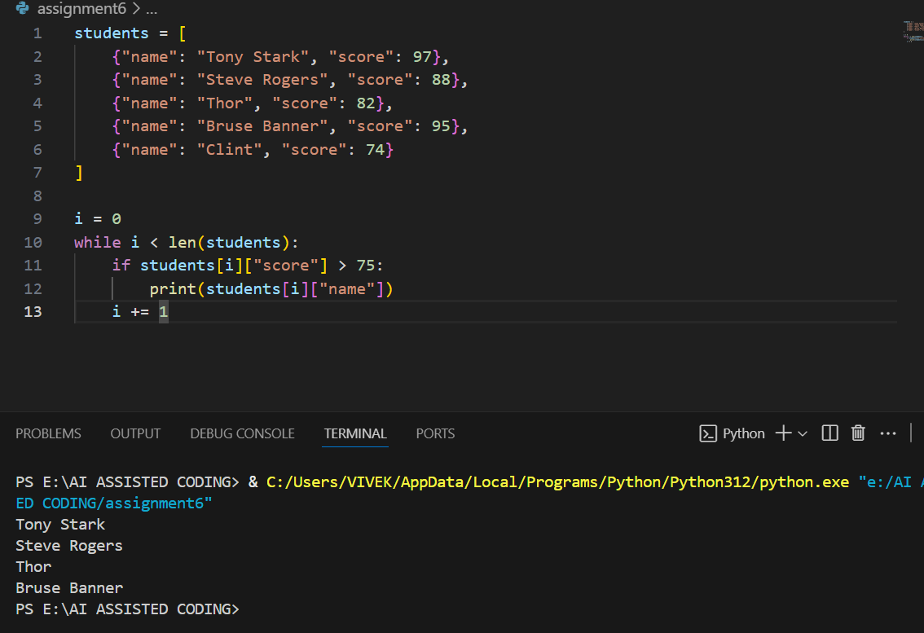
EXPLANATION:
- students is a list of dictionaries, each containing a student's name and score.
- The variable i is initialized to 0 and used as an index.
- The while loop iterates through the list as long as i is less than the number of students.
- Inside the loop, the code checks if the current student's score is greater than 75.
- If true, it prints the student's name.
- i is incremented by 1 in each iteration to move to the next student.
Summary:
This code prints the names of all students who scored more than 75, using a while loop for iteration.

TASK5:
Prompt:
Give a python code to ask input to user also generate methods to add_item, remove_item, and use a loop to calculate the total bill using conditional discounts. Begin writing a class ShoppingCart with an empty items list.

CODE AND OUPUT:
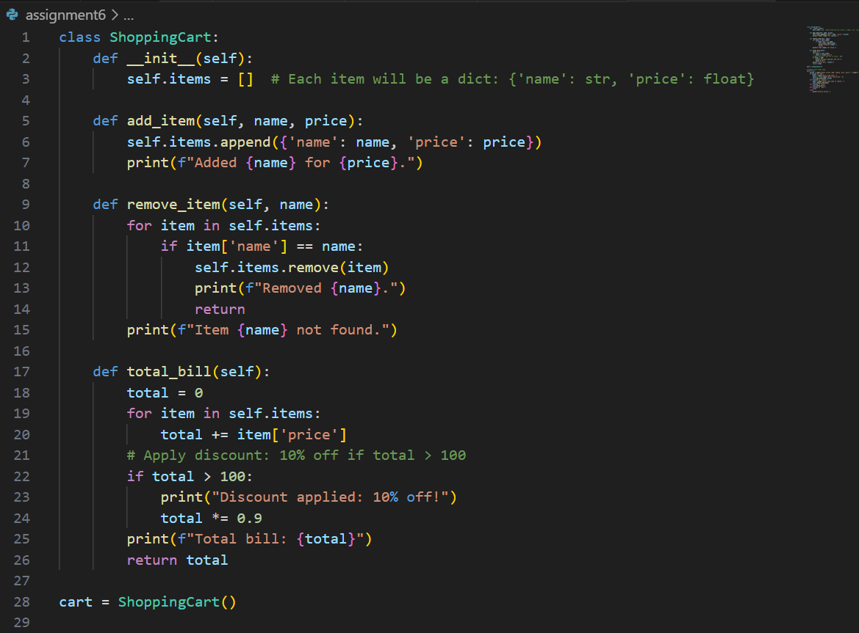
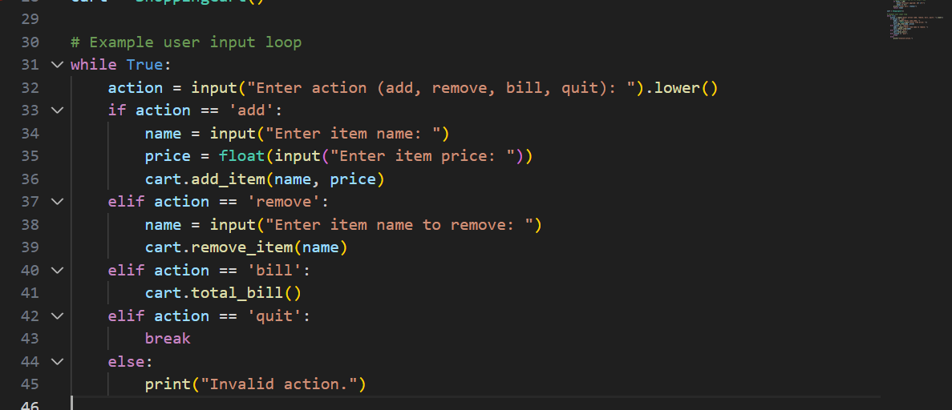
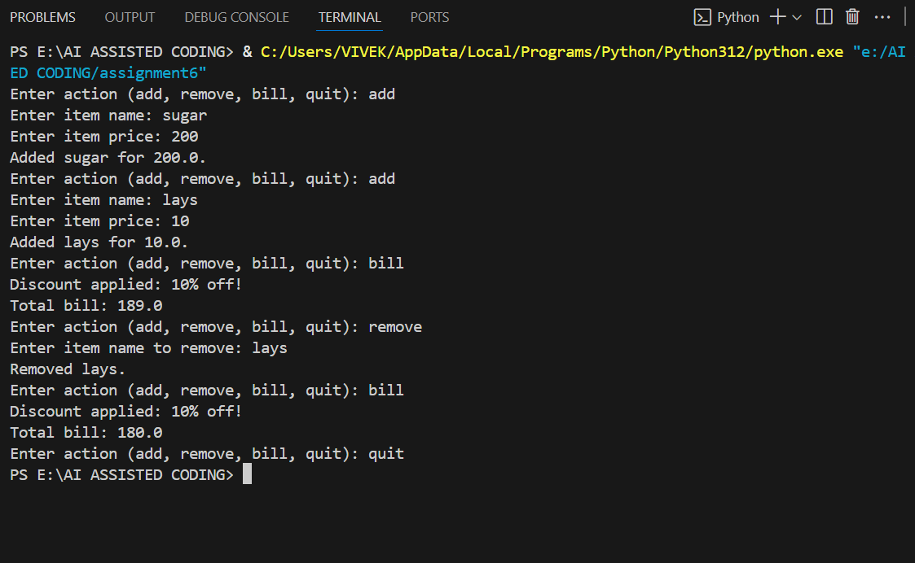
EXPLANATION:
- Class Definition:
  - ShoppingCart has an attribute items, which is a list to store items as dictionaries ({'name': str, 'price': float}).
- Methods:
  - add_item(name, price): Adds an item with the given name and price to the cart.
  - remove_item(name): Removes the first item with the given name from the cart. If not found, prints a message.
  - total_bill(): Calculates the total price of all items. If the total is greater than 100, applies a 10% discount and prints the discounted total.
- User Input Loop:
  - The program repeatedly asks the user for an action: add, remove, bill, or quit.
  - For 'add', it asks for item name and price, then adds the item.
  - For 'remove', it asks for item name and removes it.
  - For 'bill', it calculates and prints the total bill (with discount if applicable).
  - For 'quit', it exits the loop.
  - If the action is invalid, it prints an error message.
Summary:
This code demonstrates how to use classes, methods, lists, user input, and conditional logic to manage a shopping cart and apply discounts.

