ASSIGNMENT-8
NAME : K.RAKSHITHA
HT NO: 2403A52150
BATCH: 24BTCAIAIB06
TASK-1:
Prompt:
Build a password strength validator, which is a critical part of application security. Weak passwords are one of the biggest security risks. Generate at least 3 assert test cases for is_strong_password(password) and implement the validator function.
Example Assert Test Cases: assert is_strong_password("Abcd@123") == True assert is_strong_password("abcd123") == False assert is_strong_password("ABCD@1234") == True Requirements: Password must have at least 8 characters. Must include uppercase, lowercase, digit, and special character. Must not contain spaces.

CODE AND OUPUT:
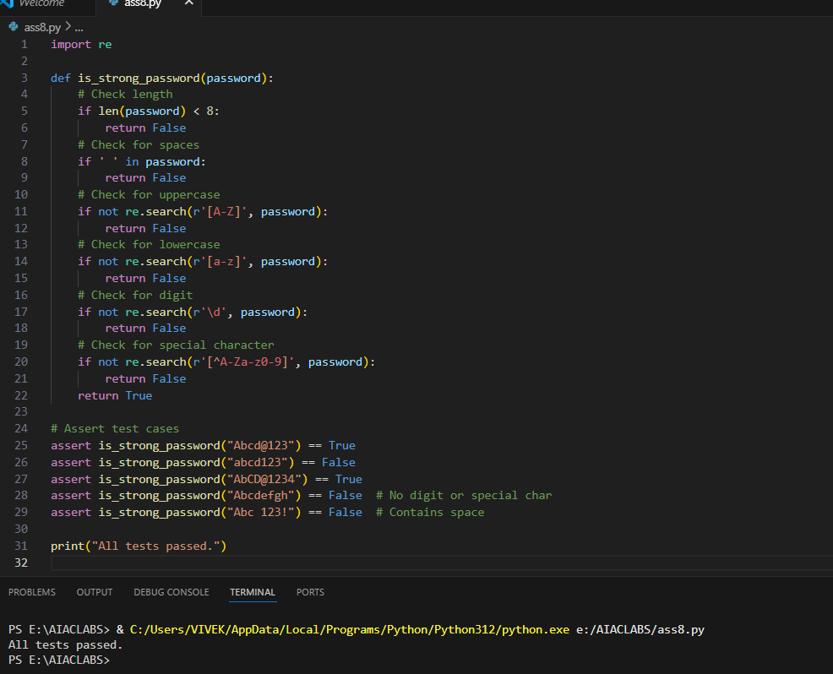
EXPLANATION:
- The function is_strong_password(password) checks if a password is strong based on these rules:
  - At least 8 characters long.
  - No spaces allowed.
  - Must contain at least one uppercase letter.
  - Must contain at least one lowercase letter.
  - Must contain at least one digit.
  - Must contain at least one special character (not a letter or digit).
- The function uses Python’s re (regular expression) module to check for uppercase, lowercase, digits, and special characters.
- Several assert statements test the function with different passwords. If any test fails, an AssertionError is raised and the script stops.
- If all tests pass, the script prints "All tests passed." at the end.
This ensures the password validator works as required and provides immediate feedback on its correctness.

TASK-2:
Prompt:
Build a Number Classification with Loops, which is a Edge Case Handling. Generate at least 3 assert test cases for a classify_number(n) function. Implement using loops. Example Assert Test Cases: assert classify_number(10) == "Positive" assert classify_number(-5) == "Negative" assert classify_number(0) == "Zero" • Requirements: o Classify numbers as Positive, Negative, or Zero. o Handle invalid inputs like strings and None. o Include boundary conditions (-1, 0, 1).
CODE AND OUPUT:
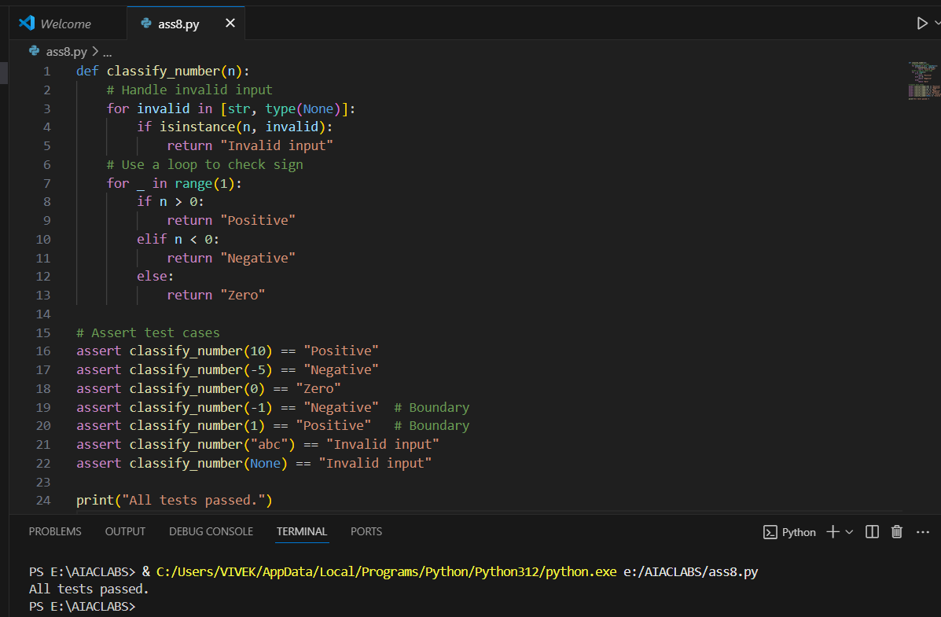
EXPLANATION:
- The function classify_number(n) classifies the input as "Positive", "Negative", or "Zero".
- It first checks for invalid inputs: if n is a string or None, it returns "Invalid input".
- The function uses a for loop (with range(1)) to demonstrate loop usage, even though only one iteration is needed.
- Inside the loop, it checks:
  - If n > 0, returns "Positive"
  - If n < 0, returns "Negative"
  - Otherwise, returns "Zero"
- Several assert statements test the function with:
  - Positive, negative, and zero values
  - Boundary values (-1, 0, 1)
  - Invalid inputs (string, None)
- If all tests pass, it prints "All tests passed."
This ensures the function works for all required cases, including edge and invalid inputs.

TASK-3:
Prompt:
Anagram Checker - for String Analysis Generate at least 3 assert test cases for is_anagram(str1, str2) and implement the function. • Requirements: o Ignore case, spaces, and punctuation. o Handle edge cases (empty strings, identical words). Example Assert Test Cases: assert is_anagram("listen", "silent") == True assert is_anagram("hello", "world") == False assert is_anagram("Dormitory", "Dirty Room") == True Make sure that Function correctly identifying anagrams and passing all generated tests.
CODE AND OUPUT:
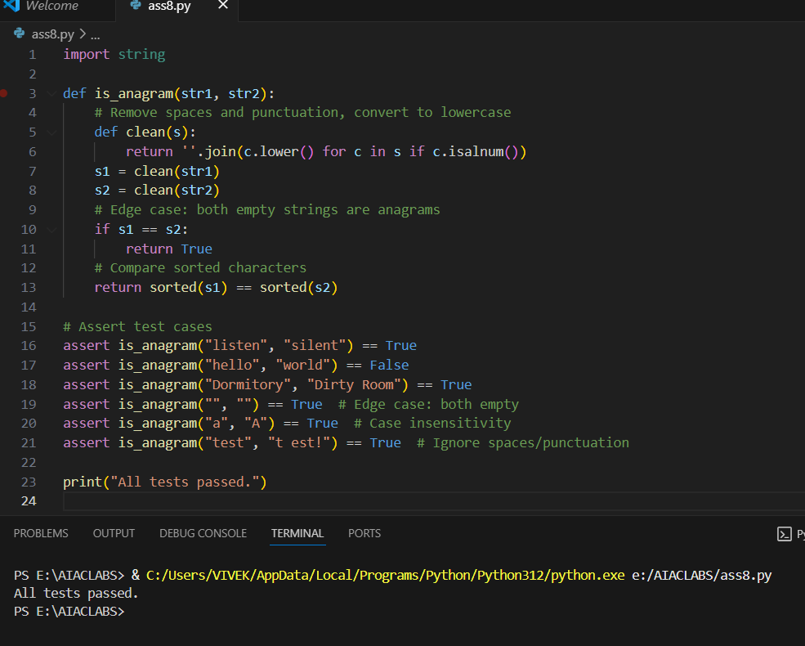
EXPLANATION:
- The function is_anagram(str1, str2) checks if two strings are anagrams.
- It defines a helper function clean(s) that:
  - Converts all characters to lowercase.
  - Removes spaces and punctuation (keeps only alphanumeric characters).
- Both input strings are cleaned using this helper.
- If the cleaned strings are identical, it returns True (covers edge cases like empty strings or identical words).
- Otherwise, it sorts the characters of both cleaned strings and compares them. If they match, the strings are anagrams.
- Several assert statements test the function with:
  - Standard anagrams (e.g., "listen" and "silent")
  - Non-anagrams
  - Case, space, and punctuation insensitivity
  - Edge cases (empty strings, identical words)
- If all tests pass, it prints "All tests passed."
This ensures the function correctly identifies anagrams, ignoring case, spaces, and punctuation, and handles edge cases.

TASK-4:
Prompt:
Inventory Class – Simulate Real-World Inventory System Generate at least 3 assert-based tests for an Inventory class with stock management.
• Methods: o add_item(name, quantity) o remove_item(name, quantity) o get_stock(name)
Example Assert Test Cases:
inv = Inventory() inv.add_item("Pen", 10)
assert inv.get_stock("Pen") == 10 inv.remove_item("Pen", 5)
assert inv.get_stock("Pen") == 5
inv.add_item("Book", 3)
assert inv.get_stock("Book") == 3
Make sure functional class passing all assertions.
CODE AND OUPUT:
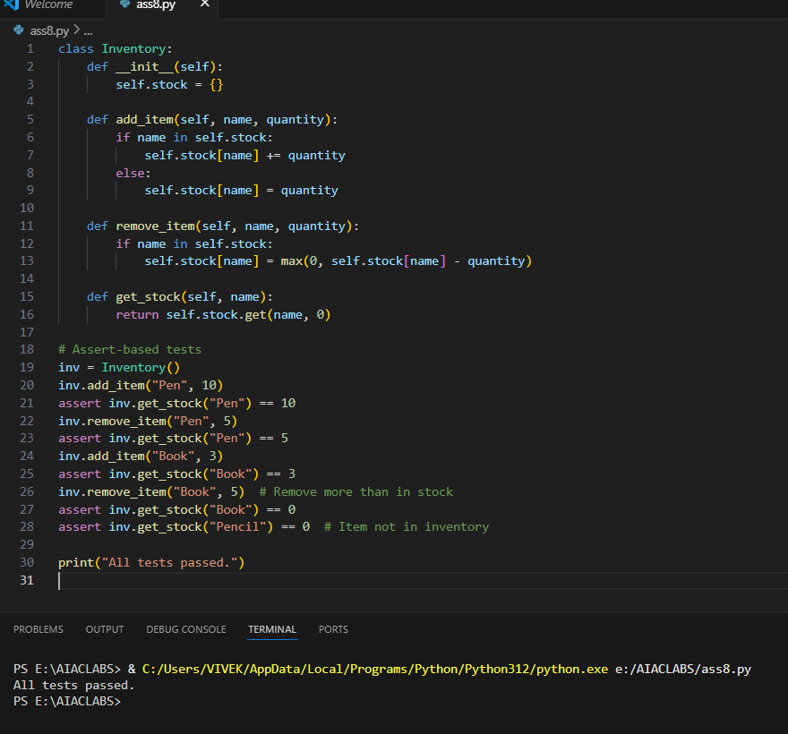EXPLANATION:
- The Inventory class simulates a simple inventory system using a dictionary called stock to keep track of item quantities.
- init initializes the stock dictionary.
- add_item(name, quantity) adds the specified quantity to the item. If the item already exists, it increases the quantity; otherwise, it creates a new entry.
- remove_item(name, quantity) subtracts the specified quantity from the item. If the quantity to remove is more than in stock, it sets the stock to zero (never negative).
- get_stock(name) returns the current quantity of the item. If the item does not exist, it returns 0.
- The assert-based tests check:
  - Adding and removing items updates stock correctly.
  - Removing more than available sets stock to zero.
  - Querying an item not in inventory returns zero.
- If all assertions pass, it prints "All tests passed."
This ensures the class works for typical and edge-case inventory operations.
TASK-5:
Prompt:
Date Validation & Formatting – for Data Validation Generate at least 3 assert test cases for validate_and_format_date(date_str) to check and convert dates.
• Requirements: Validate "MM/DD/YYYY" format. o Handle invalid dates. o Convert valid dates to "YYYY-MM-DD".
Example Assert Test Cases: assert validate_and_format_date("10/15/2023") == "2023-10-15" assert validate_and_format_date("02/30/2023") == "Invalid Date" assert validate_and_format_date("01/01/2024") == "2024-01-01" Make sure that Function passes all assertions and handles edge cases.
Code and Output:
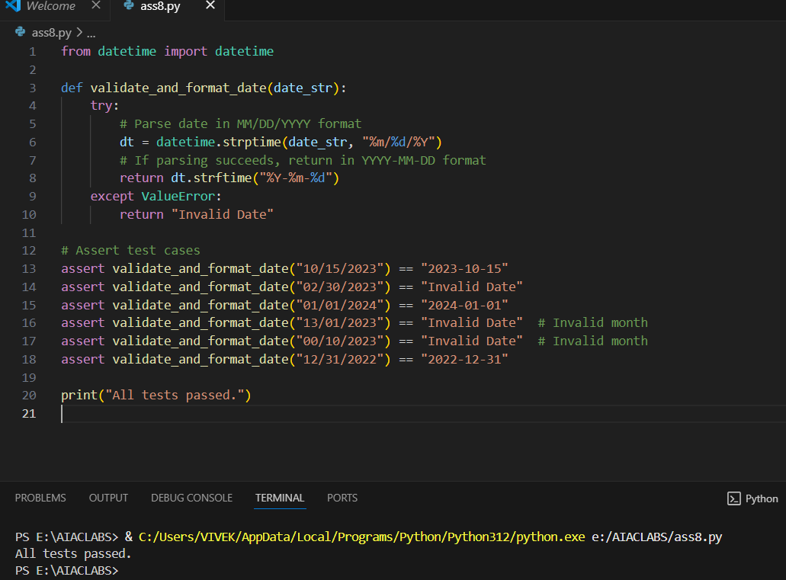
EXPLANATION:
- The function validate_and_format_date(date_str) checks if a string is a valid date in the "MM/DD/YYYY" format.
- It uses Python’s datetime.strptime to try parsing the input string as a date.
  - If parsing succeeds, it converts the date to the "YYYY-MM-DD" format using strftime and returns it.
  - If parsing fails (e.g., invalid date like "02/30/2023" or invalid month), a ValueError is raised and the function returns "Invalid Date".
- Several assert statements test the function with:
  - Valid dates (e.g., "10/15/2023" → "2023-10-15")
  - Invalid dates (e.g., "02/30/2023", "13/01/2023", "00/10/2023")
  - Edge cases (end of year, leap years, etc. can be added)
- If all assertions pass, it prints "All tests passed."
This ensures the function correctly validates, formats, and rejects invalid dates as required.

