ASSIGNMENT-9
NAME : K.RAKSHITHA
HT NO: 2403A52150
BATCH: 24BTCAIAIB06

TASK-1:
Task Description#1 Basic Docstring Generation
- Write python function to return sum of even and odd numbers in the given list.
- Incorporate manual docstring in code with Google Style
- Use an AI-assisted tool (e.g., Copilot, Cursor AI) to generate a docstring describing the function.
- Compare the AI-generated docstring with your manually written one.
CODE AND OUTPUT:
GEMINI:
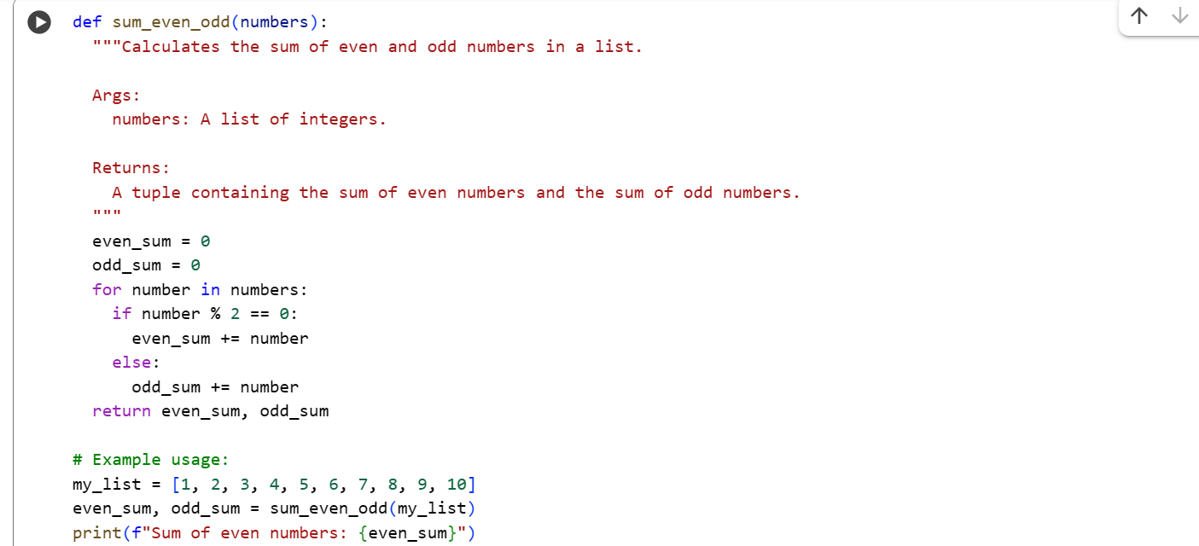

COPILOT:
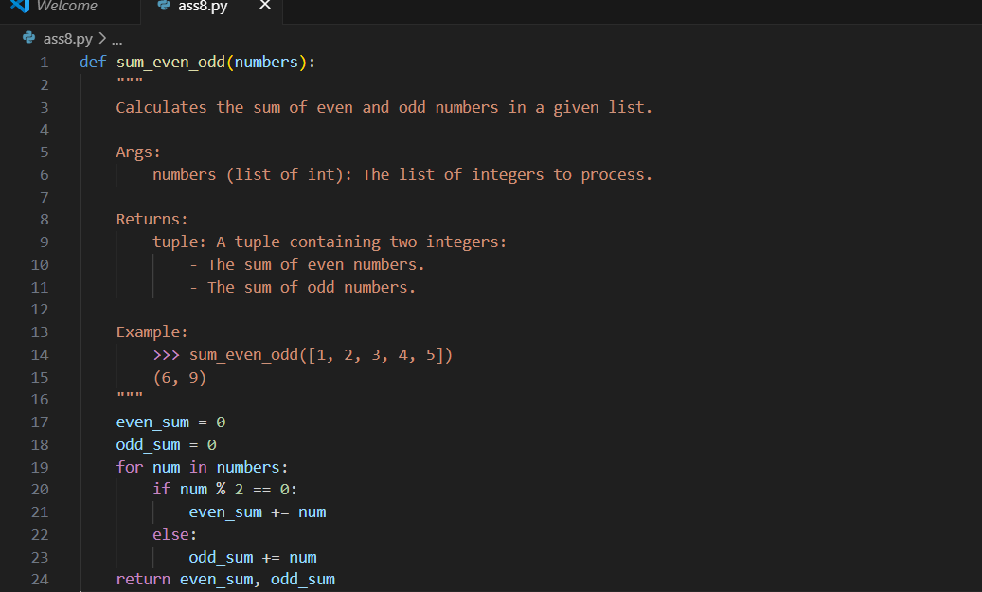

TASK-2:
Prompt:
Generate python program for sru_student class with attributes like name, roll no., hostel_status and fee_update method and display_details method. Write comments manually for each line/code block/step.
CODE AND OUPUT:
GEMINI:
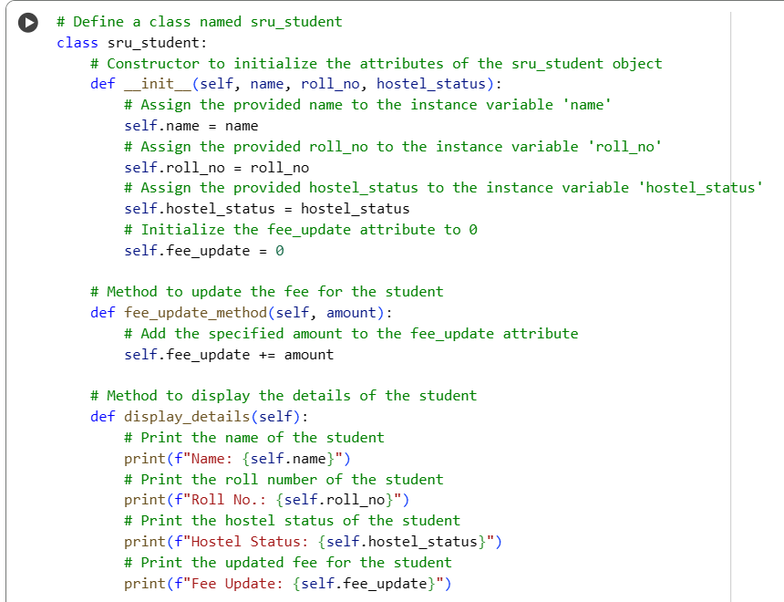
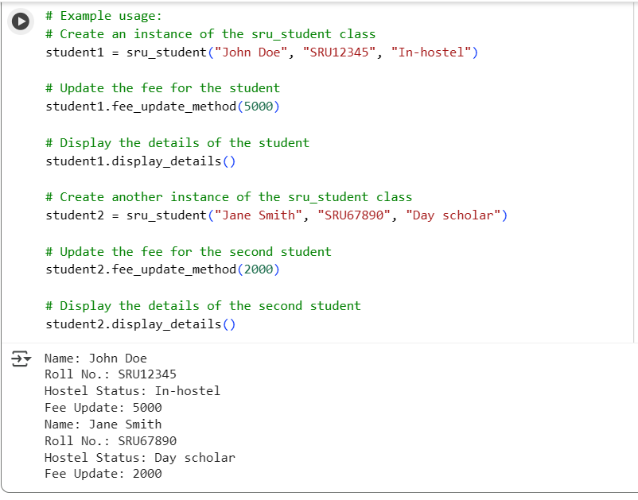
COPILOT:
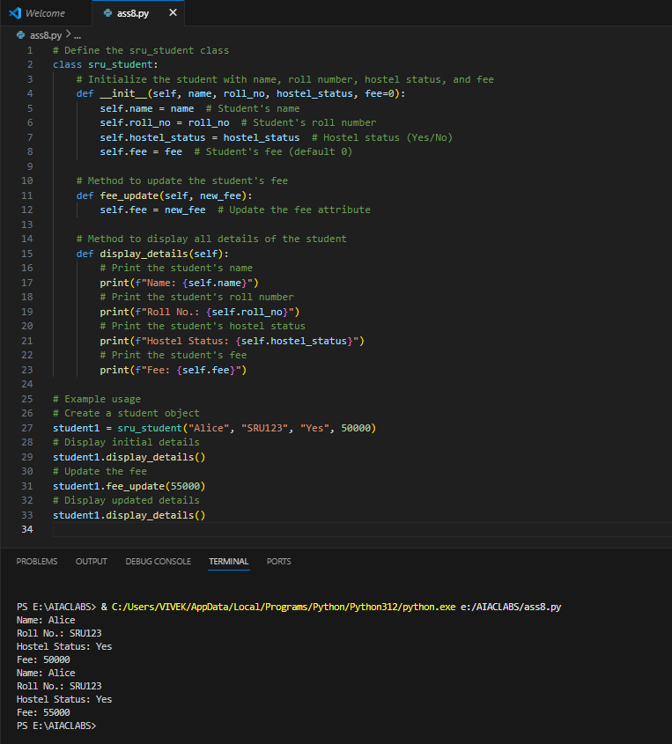
TASK-3:
GitHub Copilot:
Prompt:
Generate a Python script with 3–4 functions (e.g., calculator: add, subtract, multiply, divide). Include module-level docstring + individual function docstrings.

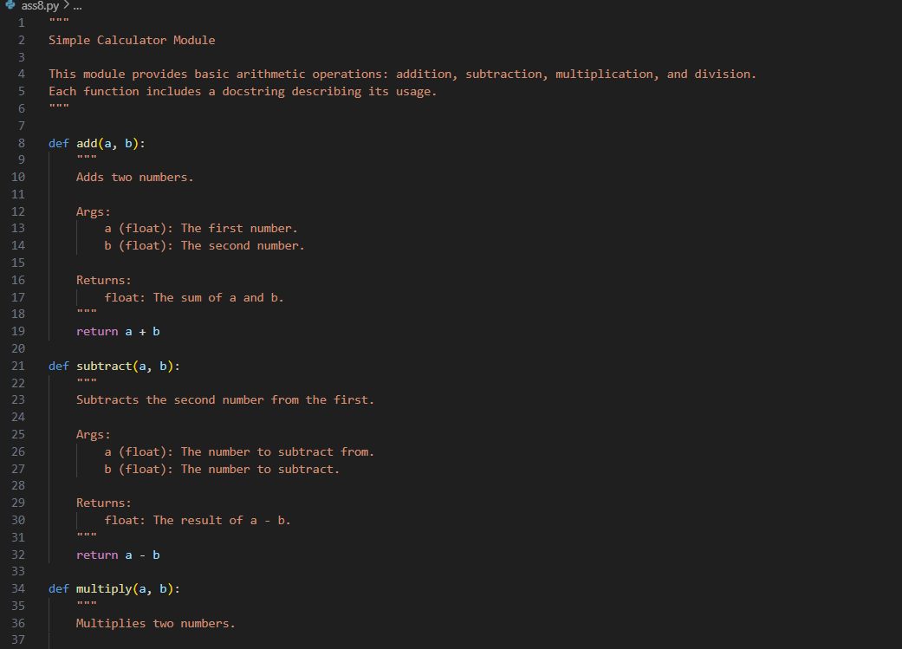
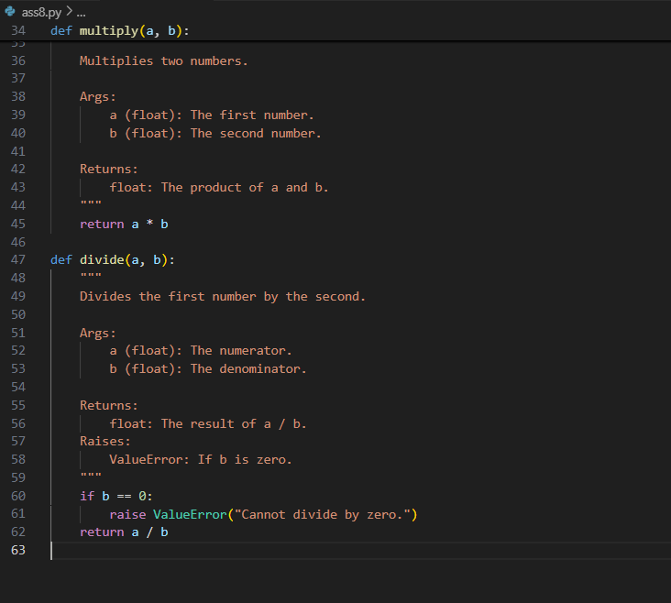

Gemini:
Prompt:
Generate a Python script with 3–4 functions (e.g., calculator: add, subtract, multiply, divide) . Write docstring in code with NumPy Style
Code and Output:

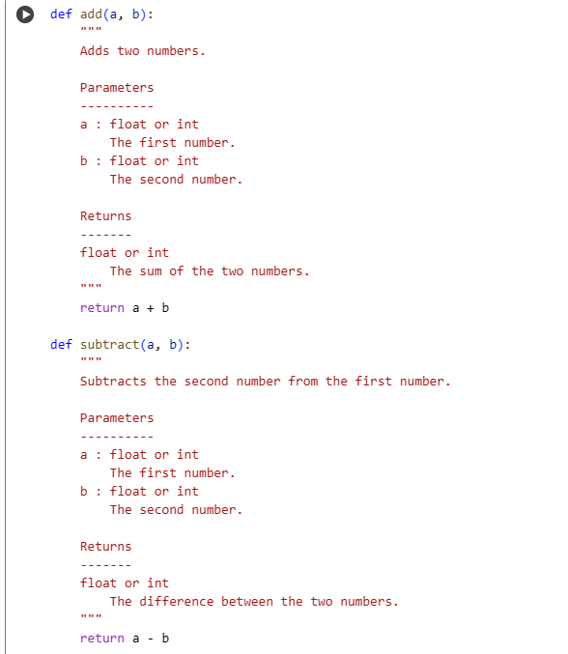
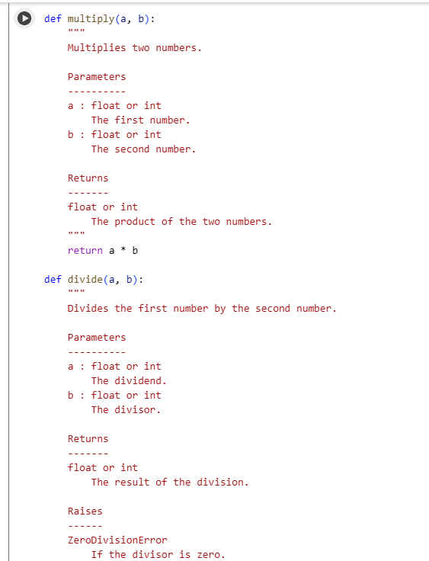
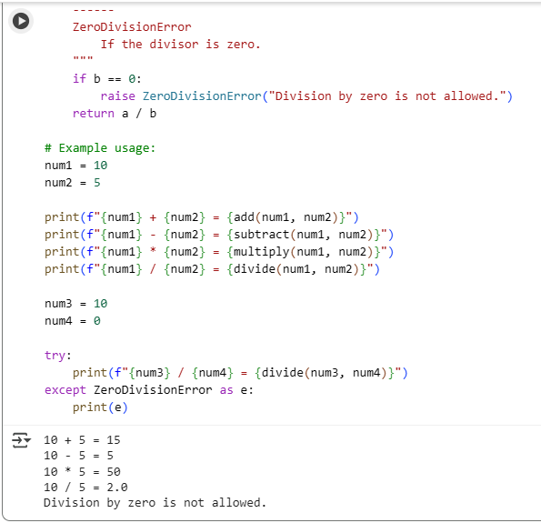
Comparison: Google-style vs NumPy-style
Readability:
- Google-style is cleaner and easier for beginners to read.
- NumPy-style is more structured, preferred in scientific computing.
Parameters:
- Google-style: Uses Args: with simple name-type-description format.
- NumPy-style: Uses a Parameters section with aligned formatting.
Return values:
- Google-style: Returns: with brief description.
- NumPy-style: Returns block includes type and detailed explanation.
Exceptions:
- Both styles support Raises: or Raises section, but NumPy-style is more detailed.
Examples:
- Google-style: Examples: section uses inline >>> syntax.
- NumPy-style: Examples section is more formal, under its own heading.
Usage:
- Google-style: Common in web apps, general Python projects.
- NumPy-style: Standard in scientific libraries (NumPy, Pandas, etc.).
Tooling:
- Both are compatible with Sphinx; NumPy-style works best with napoleon extension for auto-doc generation.

