AI ASSISSTED CODING:19
TASK-1:
: Translate a Simple Program (Python → JavaScript)
- Instructions:
  - Write a Python function print_numbers() that prints the first 10 natural numbers using a loop.
  - Translate the function into JavaScript as a reusable function printNumbers().
  - Call the function in both languages to display results.
PYTHON
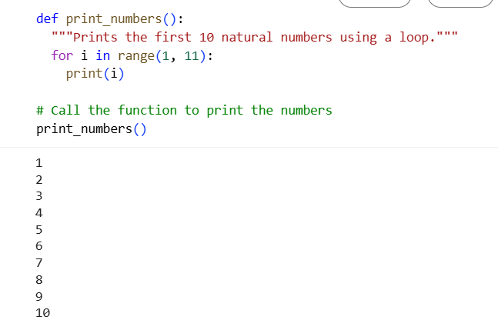

JAVA:
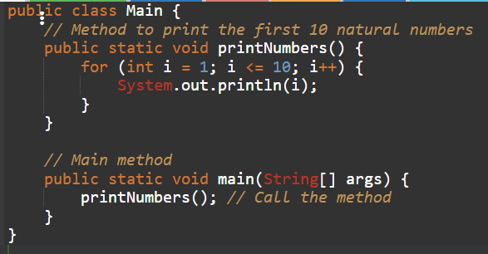
EXPLANATION:
Here's a breakdown:
- public class main { ... }: This defines a class named main. In Java, all code resides within classes. public means the class is accessible from anywhere.
- public static void main(String[] args) { ... }: This is the main method, the entry point of the program.
  - public: Accessible from anywhere.
  - static: Belongs to the main class itself, not an instance of the class.
  - void: This method does not return any value.
  - main: The name of the method, which is special because the Java Virtual Machine (JVM) looks for a method with this name to start the program.
  - String[] args: An array of strings that can be used to pass command-line arguments to the program.
- for (int i = 1; i <= 10; i++) { ... }: This is a for loop that iterates from 1 to 10.
  - int i = 1: Initializes an integer variable i to 1.
  - i <= 10: The loop continues as long as i is less than or equal to 10.
  - i++: Increments i by 1 after each iteration.
- System.out.println(i);: This line is inside the loop and is executed in each iteration.
  - System.out: Refers to the standard output stream.
  - println(i): Prints the value of i to the console, followed by a new line.
So, the loop starts with i as 1, prints 1, then i becomes 2, prints 2, and so on, until i is 10, prints 10, and then the loop terminates

TASK-2:
Convert Conditional Statements (Java → Python)
- Instructions:
  - Write a Java method checkNumber(int num) that checks if a number is positive, negative, or zero.
  - Translate the method into a Python function check_number(num).
Call the function/method with different inputs and compare outputS
PYTHON:
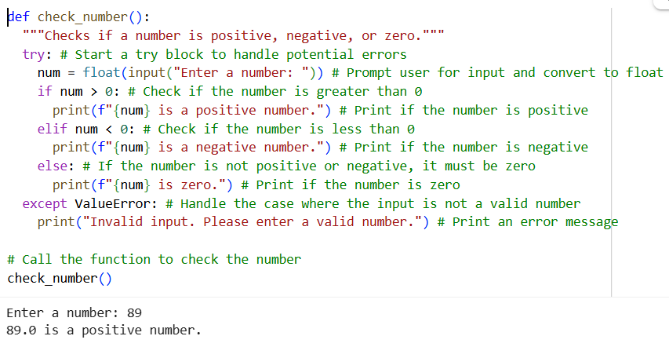
JAVA:
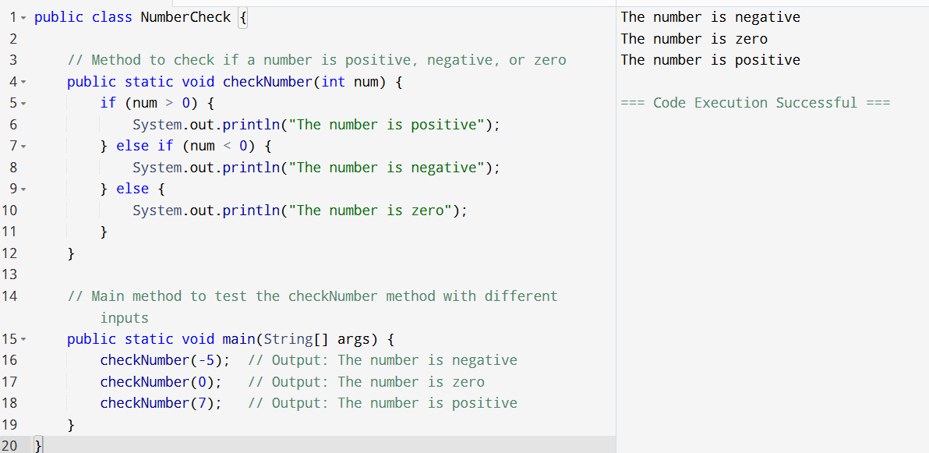
TASK-3:
: Translate Recursive Function (Python → C++)
- Instructions:
  - Write a Python function factorial(n) that calculates factorial of a number using recursion.
  - Translate the same into a C++ function int factorial(int n).
Call the function in both languages with inputs 5 and 0.
PYTHON:
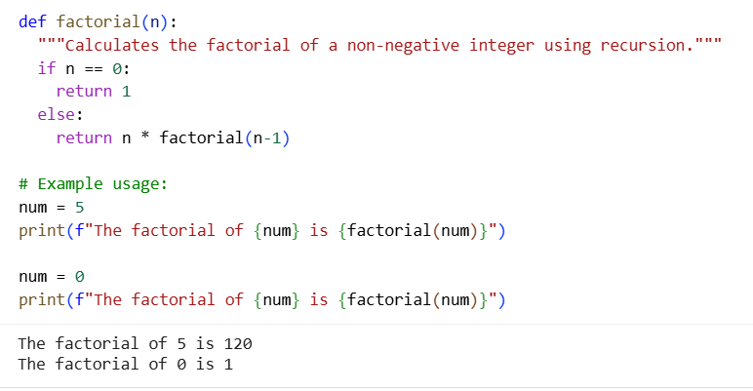

C++:
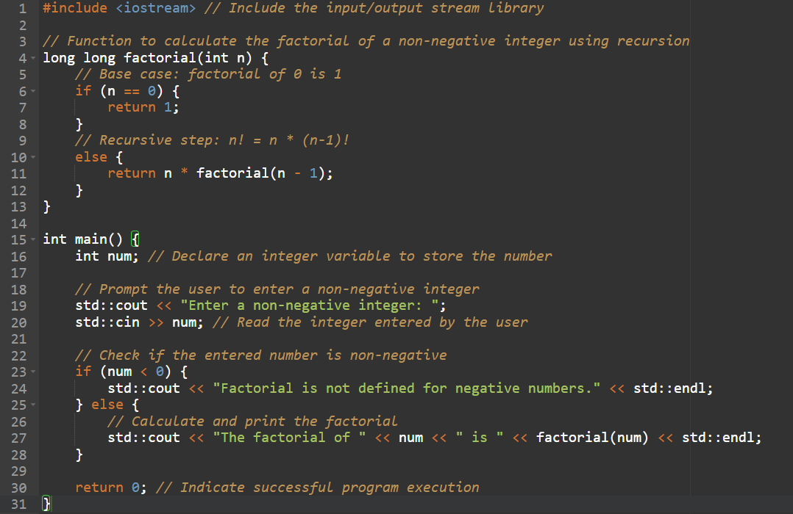
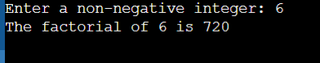

TASK-4:
: Data Structures with Functions (JavaScript → Python)
- Instructions:
  - Write a JavaScript function printStudents(students) that takes an array of student names and prints each name.
  - Translate it into a Python function print_students(students) using a list.
  - Test both functions with sample student names.

JAVASCRIPT:
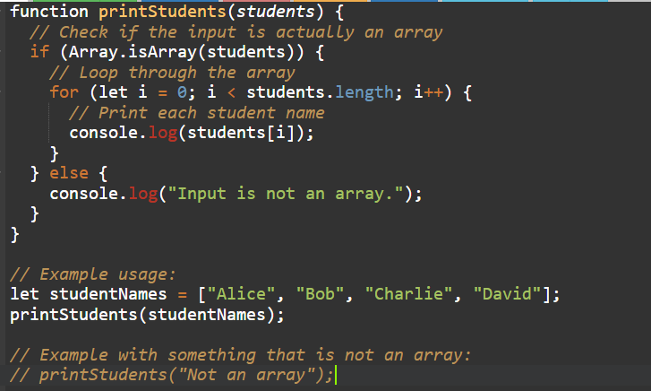
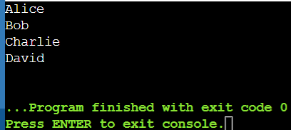
PYTHON:
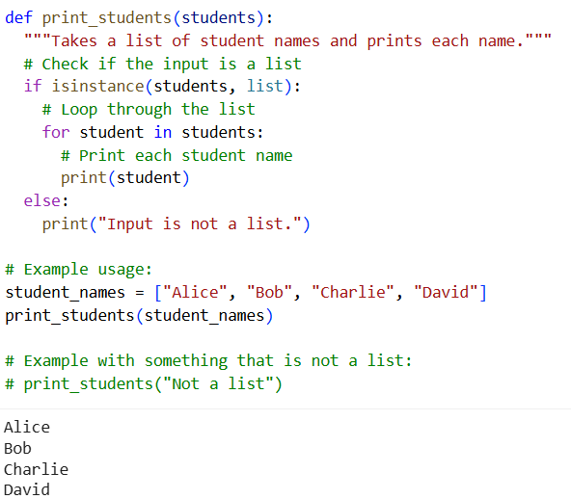
TASK-5:
Class & Object Translation (Python → Java)
- Instructions:
  - Write a Python class Car with attributes: brand, model, year.
  - Add a method display_details() that prints car details.
  - Translate the same into a Java class Car with attributes and a method displayDetails().
  - Create an object in both languages and call the method.

PYTHON:
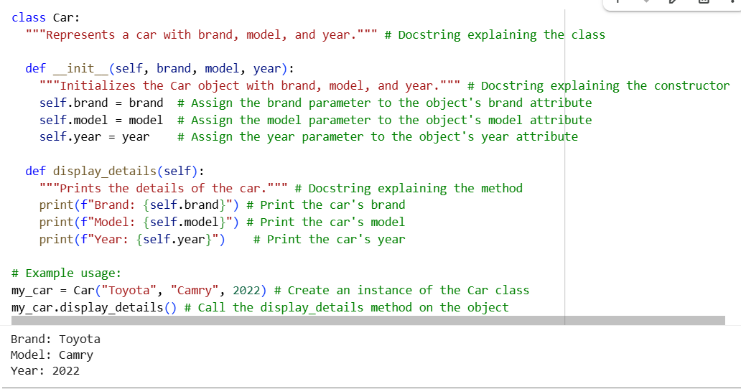

JAVA:
