ASSIGNMENT-7.4

NAME : S.Revanth Reddy

Roll No : 2403a52170

Batch : 07

Task Description #1:

* Introduce a buggy Python function that calculates the factorial of a number using recursion.

Use Copilot or Cursor AI to detect and fix the logical or syntax errors.

Expected Outcome #1:

* Copilot or Cursor AI correctly identifies missing base condition or incorrect recursive call and suggests a functional factorial implementation

PROMPT:

Give me a buggy python code that calculates the factorial of a number using recursions and i need to identify the error.

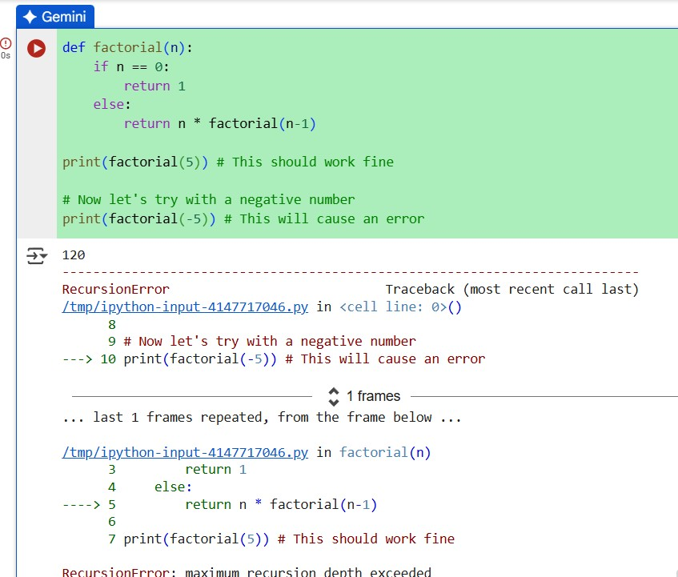

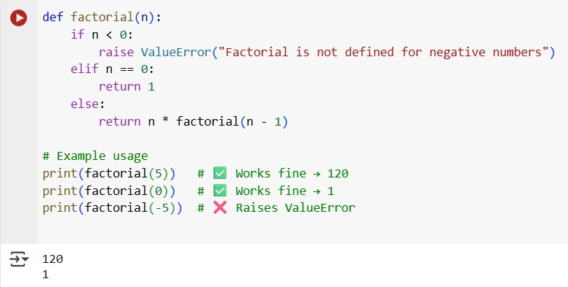

Provide a list sorting function that fails due to a type error

(e.g., sorting list with mixed

integers and strings). Prompt AI to detect the issue and fix the code for consistent sorting.

Expected Outcome #2:

* 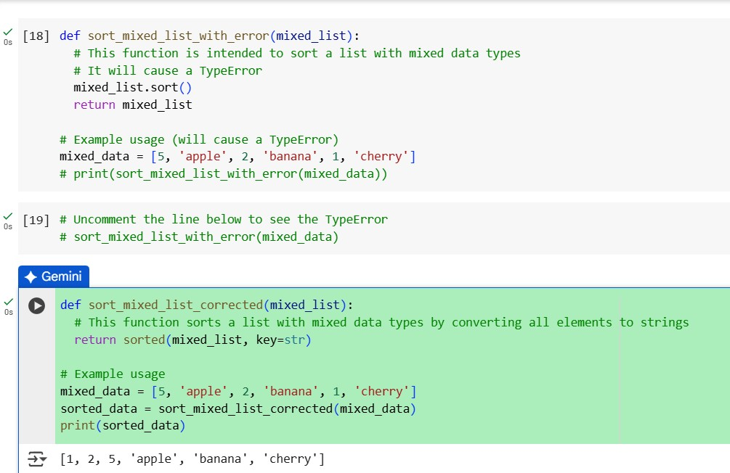AI detects the type inconsistency and either filters or converts list elements, ensuring successful sorting without a crash.

PROMPT:

Wrote a function to sort a list, but it fails with a TypeError because the list has both integers and strings. Can you explain the issue and rewrite the function so it sorts the list consistently.

Write a Python snippet for file handling that opens a file but forgets to close it. Ask Copilot or

Cursor AI to improve it using the best practice (e.g., with open() block).

Expected Outcome #3:

* 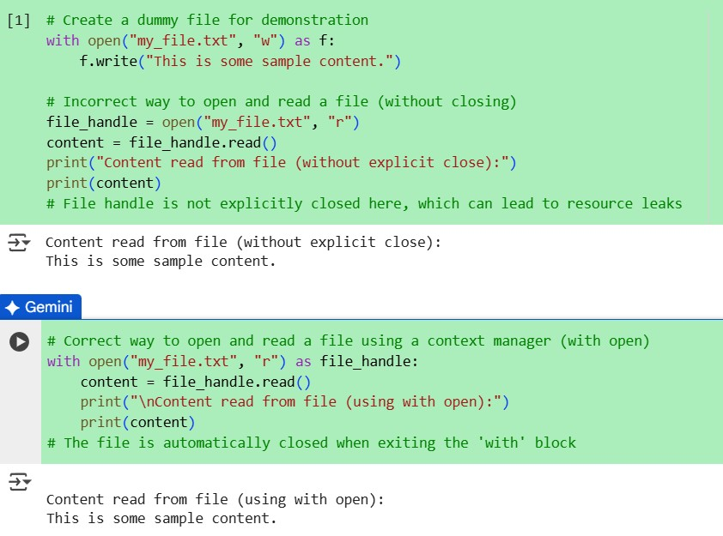AI refactors the code to use a context manager, preventing resource leakage and runtime warnings.

PROMPT:

I wrote a Python snippet that opens a file but I forgot to close it. Can you refactor it using best practices like a context manager (with open) to avoid resource leaks

Provide a piece of code with a ZeroDivisionError inside a loop. Ask AI to add error handling using try-except and continue execution safely.

Expected Outcome #4:

• Copilot adds a try-except block around the risky operation, preventing crashes and printing a meaningful error message.

PROMPT:

I wrote a loop in Python that causes a ZeroDivisionError. Can you add try

-except so it handles the error and keeps running safely

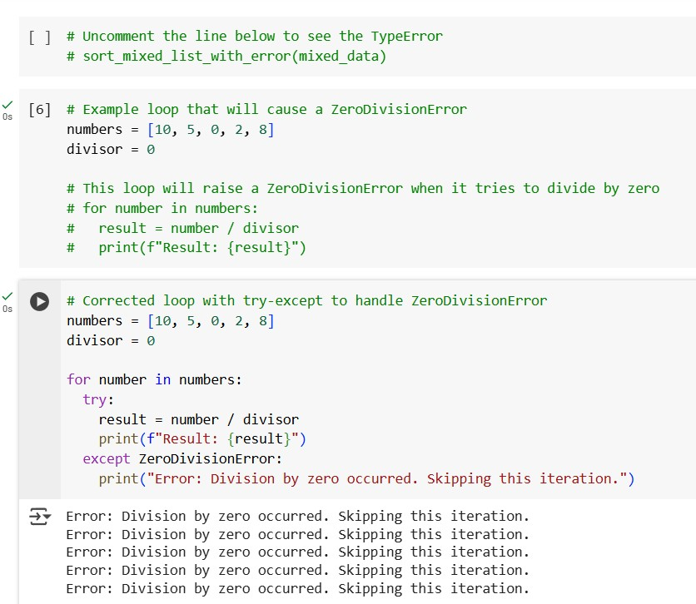

Task Description #5:

* Include a buggy class definition with incorrect __init__ parameters or attribute references. Ask

AI to analyze and correct the constructor and attribute usage.

Expected Outcome #5:

* Copilot identifies mismatched parameters or missing self references and rewrites the class with accurate initialization and usage

PROMPT:

I wrote a Python class with mistakes in the __init__ method and attribute references. Can you fix the constructor and correct the attribute usage

