Assignment-18.3
Application Programming Interfaces
APIs, or Application Programming Interfaces, are like messengers that allow different software applications to talk to each other. Think of it like ordering food at a restaurant: you (the application) tell the waiter (the API) what you want (the request), the waiter takes your order to the kitchen (the other application), and the kitchen prepares your food and gives it back to the waiter (the response), who then brings it to you.
Here are some real-life examples of where APIs are used:
- Social Media: When you use an app like Twitter or Facebook, they use APIs to let other apps share content or log in using your social media account.
- Online Shopping: When you buy something online, the website uses APIs to connect to payment processors (like PayPal or credit card companies) and shipping services (like FedEx or UPS) to handle the transaction and delivery.
- Travel Websites: When you search for flights or hotels on a travel website, it uses APIs to get real-time information from different airlines and hotels.
- Weather Apps: Your weather app uses APIs to get the latest weather data from weather services.
- Google Maps: When you use Google Maps, it uses APIs to get map data, traffic information, and directions.
In essence, APIs allow developers to use features and data from other applications without having to build everything from scratch. This makes it easier and faster to create new applications and services.
In your lab tasks, you will be using APIs to:
- Get movie details from a movie database.
- Fetch real-time public transport arrival times.
- Retrieve stock market data.
- Translate text from one language to another.
These are all examples of how APIs are used to access external data and services to power applications.
Task 1 – Movie Database API
Task: Connect to a Movie Database API (e.g., OMDb or TMDB) to
fetch details of a movie.
Instructions:
Prompt AI to generate Python code to query the API by movie title.
Handle errors like invalid movie name, missing/expired API key, and
timeout.
Display title, release year, genre, IMDb rating, and director.
Expected Output:
A Python script that retrieves and displays movie details in a clean
format.
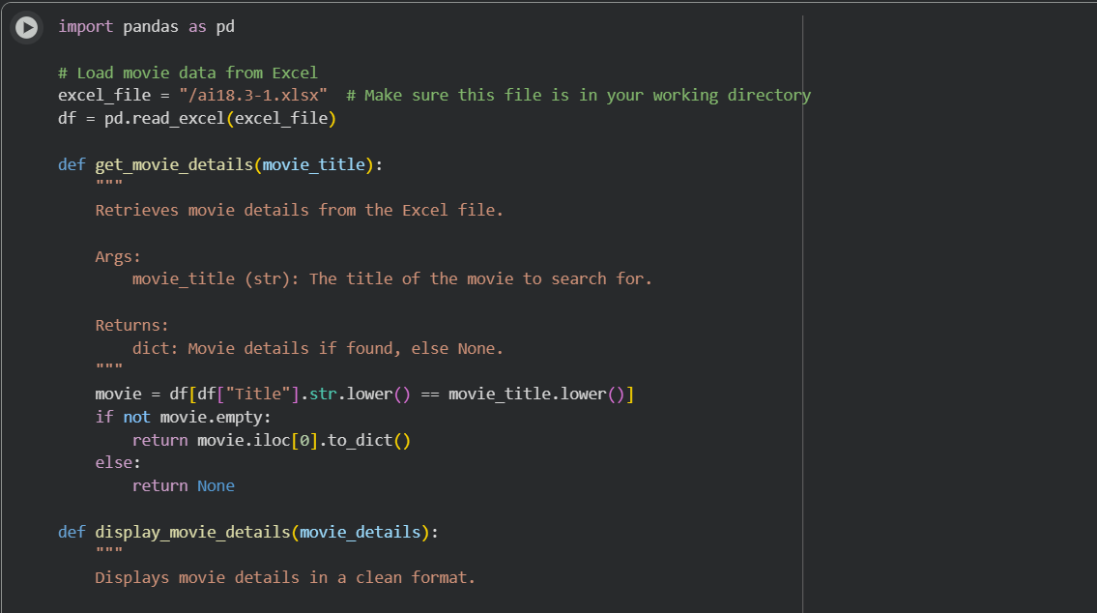
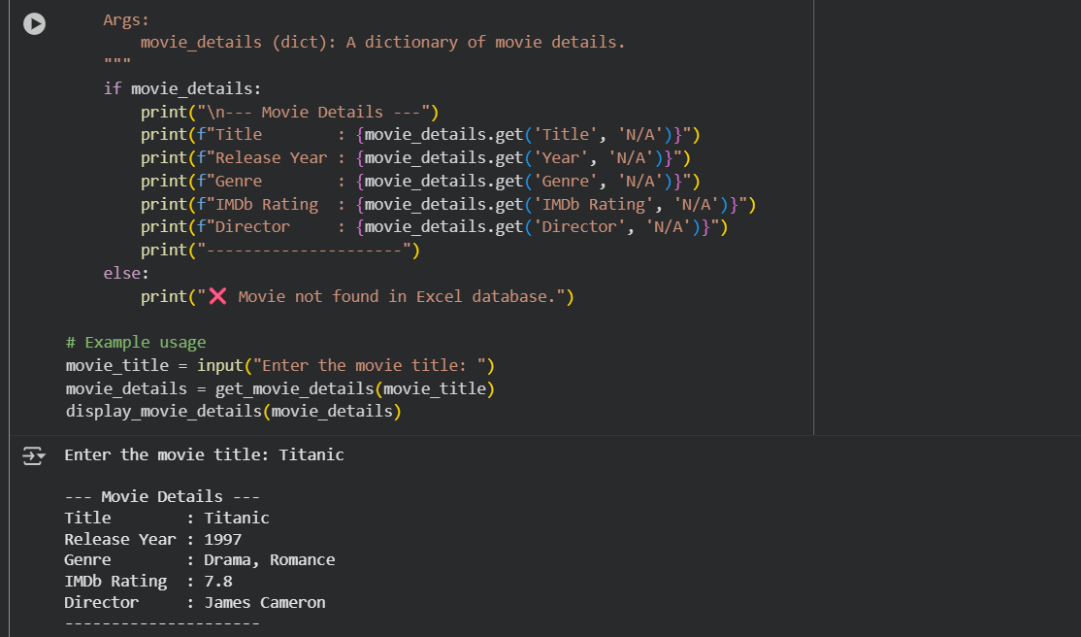

Task 2 – Public Transport API
Task: Use a Public Transport API (e.g., city bus/train API or mock
data) to fetch live arrival times.
Instructions:
• Fetch the next 5 arrivals for a given stop/station ID.
• Handle invalid station codes, unavailable service, and malformed
responses.
• Display results in a readable table with route number, destination,
and arrival time.
Expected Output:
• A script that provides real-time public transport information with
robust error handling.
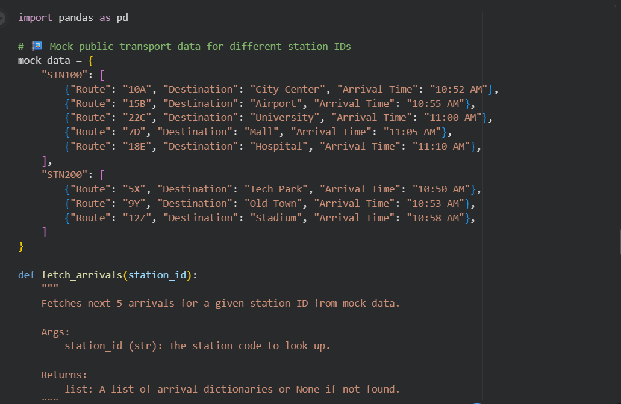
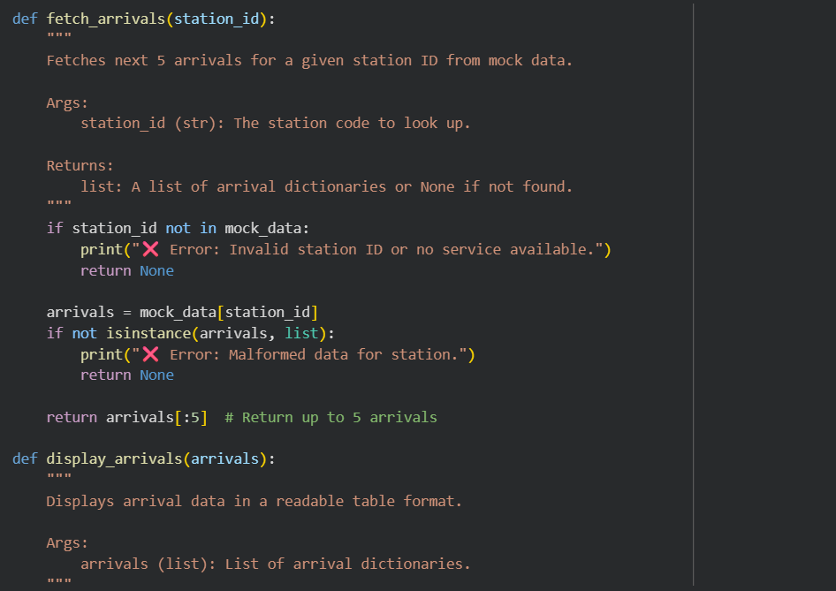
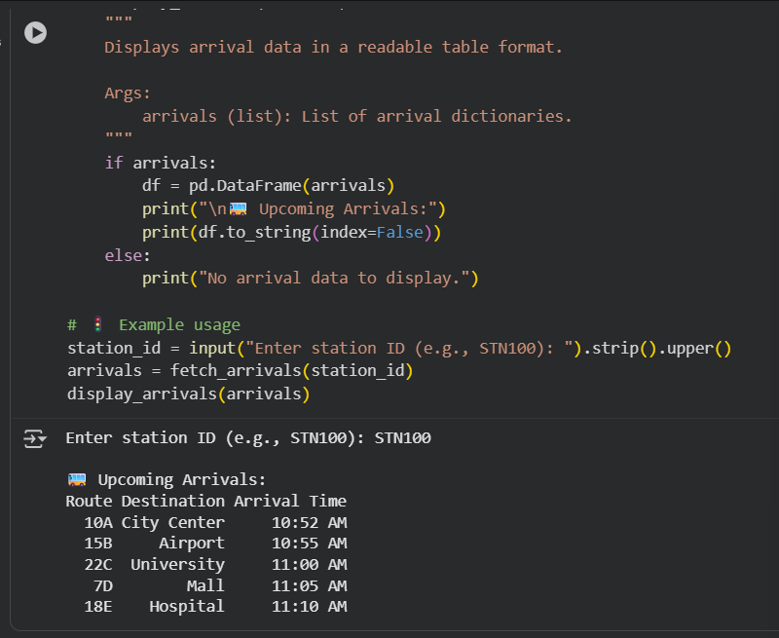
Task 3 – Stock Market/Financial Data API
Task: Connect to a stock data API (e.g., Alpha Vantage, Yahoo
Finance) to fetch daily stock prices.
Instructions:
Prompt AI to generate Python function to query stock data by ticker
symbol.
Handle API call limits, invalid ticker symbols, and null responses.
Display opening price, closing price, high, low, and trading volume.
Expected Output:
A Python script that fetches stock market data and handles failures
gracefully.
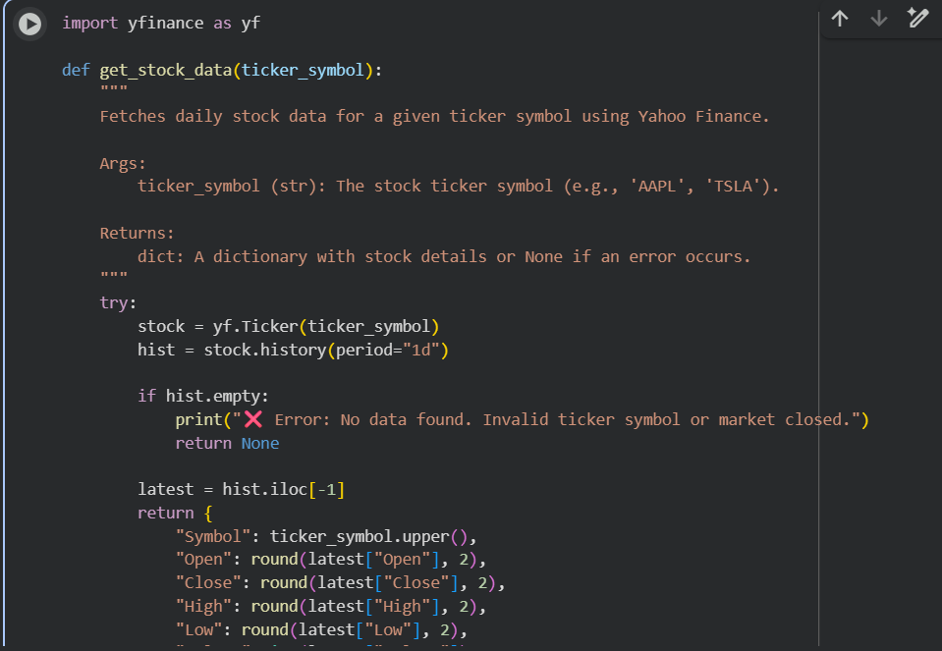
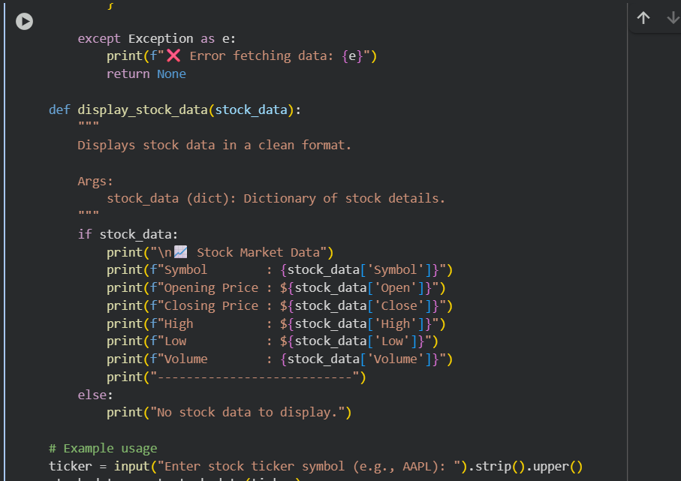
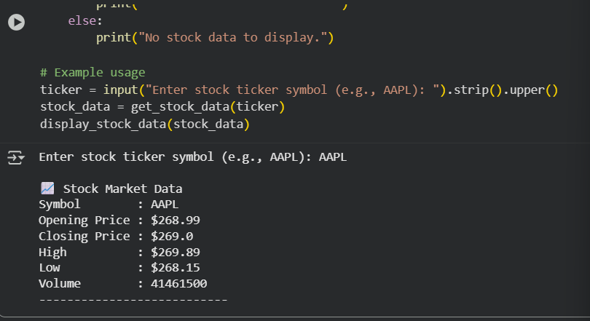

Task 4 – Real-Time Application: Translation API
Scenario: Build a translator using a free Translation API (e.g.,
Libre Translate, Google Translate).
Requirements:
Accept input text and target language from the user.
Handle invalid language codes, API quota exceeded, and empty text
input.
Display original and translated text clearly.
Implement a retry mechanism if the API fails on the first attempt.
Expected Output:
A script that translates text to the specified language with strong error
handling.
Deliverables (For All Tasks)
1. AI-generated prompts for code and test case generation.
2. At least 3 assert test cases for each task.
3. AI-generated initial code and execution screenshots.
4. Analysis of whether code passes all tests.
5. Improved final version with inline comments and explanations.
6. Compiled report (Word/PDF) with prompts, test cases, assertions,
code, and output
