CLOUD COMPUTING

ASSIGNMENT:10.3

NAME: RAMYA

BATCH:08

ROLLNO:2403A52219

TASK1:Identify and fix syntax,indentation,and variable errors in the given script

#buggy_code_task1.py

Def add_numbers(a,b)

Result = a+b

Return reslt

Print(add_numbers(10 20))

Expected Output:

*Corrected code with proper syntax(:after function,fixed variable name,corrected function call)

*Ai should explain what was fixed

Code:

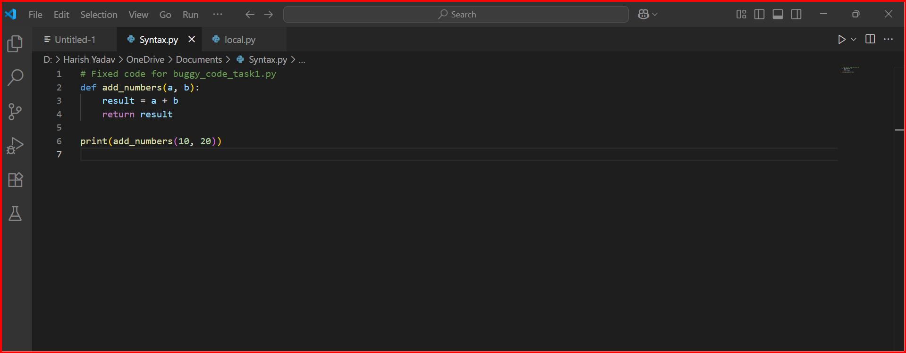  
output:

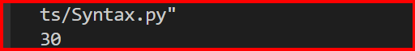

fixed: 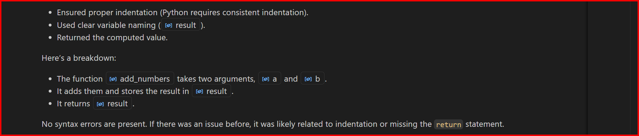

TASK2: Logical and Performance Issue Review

Task: Optimize inefficient logic while keeping the result correct.

# buggy_code_task2.py

def find_duplicates(nums):

duplicates = []

for i in range(len(nums)):

for j in range(len(nums)):

if i != j and nums[i] == nums[j] and nums[i] not in duplicates:

duplicates.append(nums[i])

return duplicates

numbers = [1,2,3,2,4,5,1,6,1,2]

print(find_duplicates(numbers))

Expected Output:

• More efficient duplicate detection (e.g., using sets).

• AI should explain the optimization.

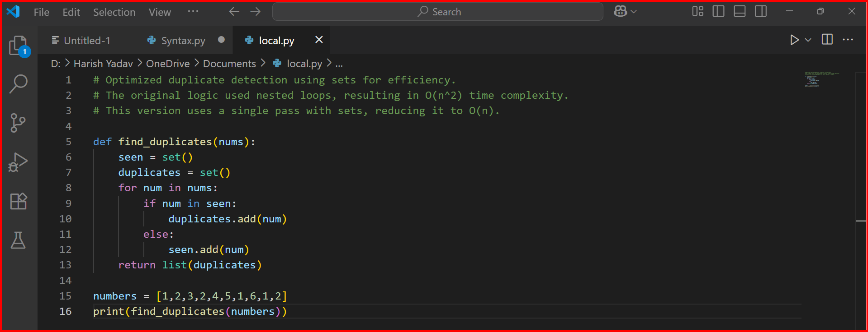

Output:

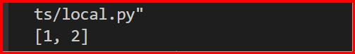

Optimization:

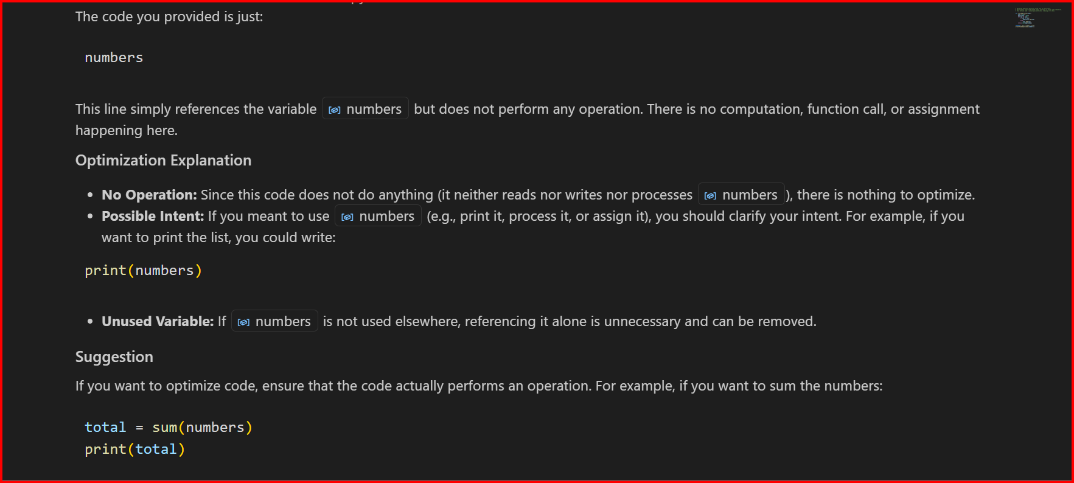

TASK3: Code Refactoring for Readability

Task: Refactor messy code into clean, PEP 8–compliant, well-

structured code.

# buggy_code_task3.py

def c(n):

x=1

for i in range(1,n+1):

x=x*I

def c(n):

x=1

for i in range(1,n+1):

x=x*i

return x

print(c(5))

Expected Output:

Function renamed to calculate_factorial.

Proper indentation, variable naming, docstrings, and formatting.

AI should provide a more readable version

Code:

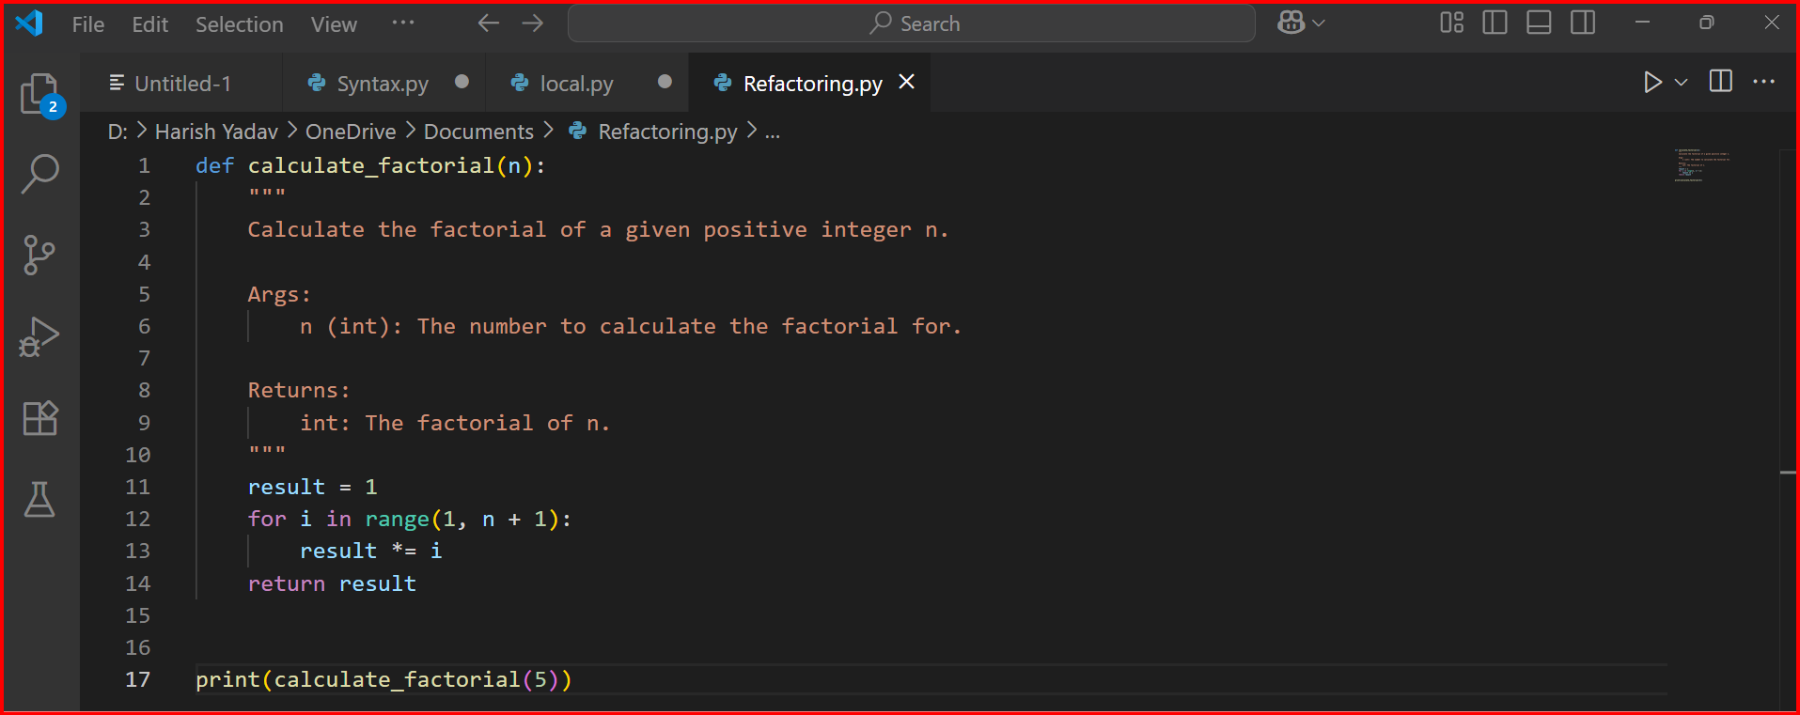

Output:

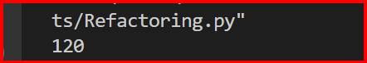

More Readable Version:

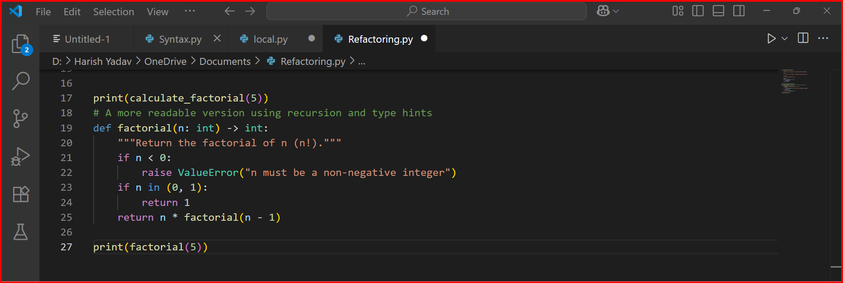

TASK4: Security and Error Handling Enhancement

Task: Add security practices and exception handling to the code.

# buggy_code_task4.py

import sqlite3

def get_user_data(user_id):

conn = sqlite3.connect("users.db")

cursor = conn.cursor()

query = f"SELECT * FROM users WHERE id = {user_id};" #

Potential SQL injection risk

cursor.execute(query)

result = cursor.fetchall()

conn.close()

return result

user_input = input("Enter user ID: ")

print(get_user_data(user_input))

Expected Output:

Safe query using parameterized SQL (? placeholders).

Try-except block for database errors.

Input validation before query execution

Code: 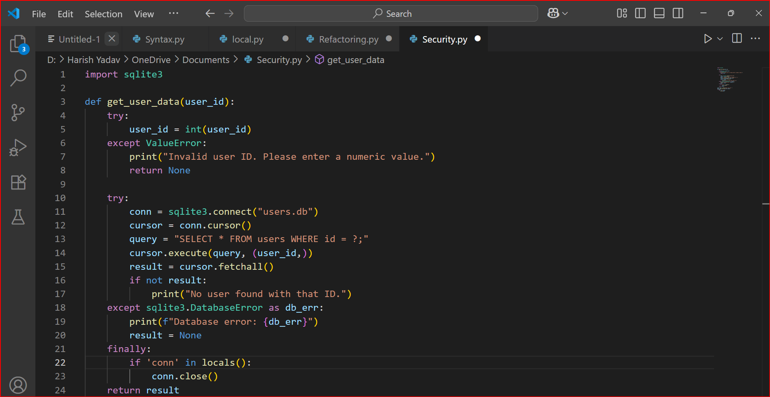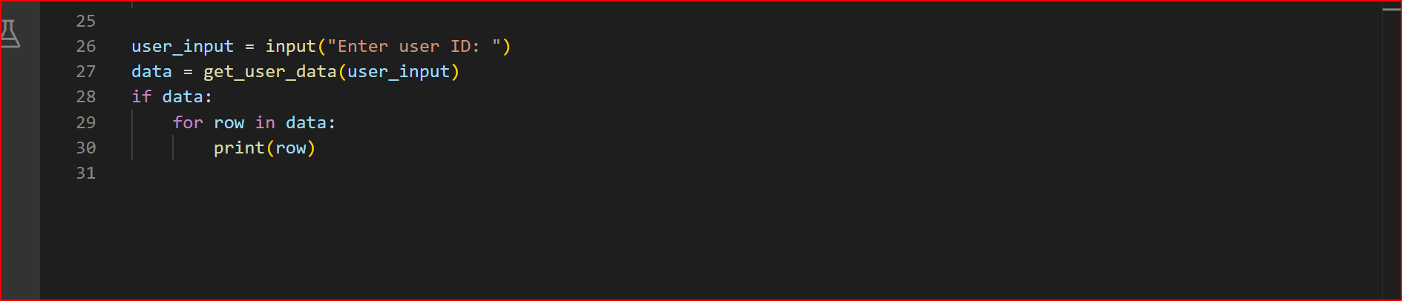

Output: 

Task 5: Automated Code Review Report Generation

Task: Generate a review report for this messy code.

# buggy_code_task5.py

def calc(x,y,z):

if z=="add":

return x+y

elif z=="sub": return x-y

elif z=="mul":

return x*y

elif z=="div":

return x/y

else: print("wrong")

print(calc(10,5,"add"))

print(calc(10,0,"div"))

Expected Output:

AI-generated review report should mention:

o Missing docstrings

o Inconsistent formatting (indentation, inline return)

o Missing error handling for division by zero

o Non-descriptive function/variable names

o Suggestions for readability and PEP 8 compliance

Code:

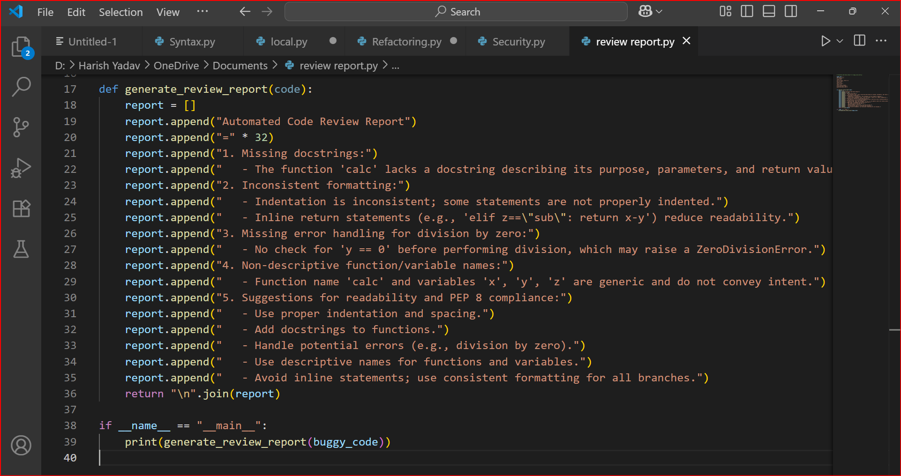

Output:

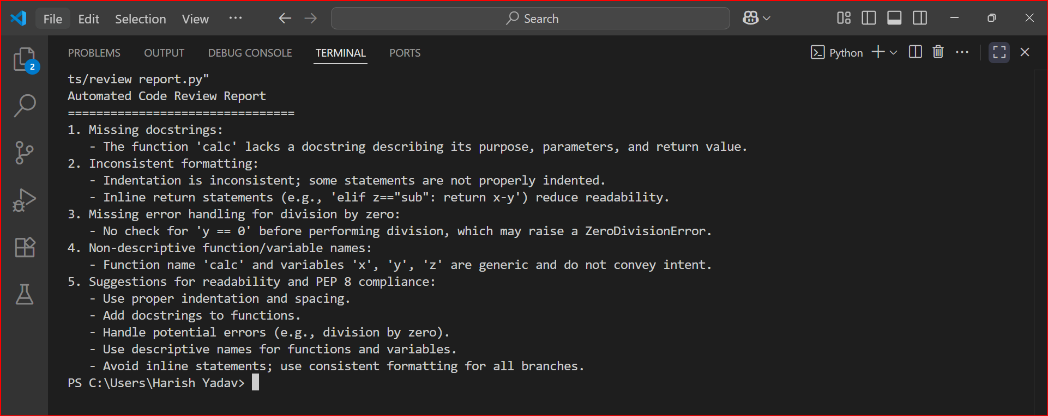

Review Report:

