Automatic Meeting Minutes Generator using NLP

Team Details
Amrutha Varshini. J – 2403A52225
Ayesha Farheen – 2403A52243
Anognya Reddy. V – 2403A52244
Institution: SR University, Warangal | CSE-AIML | NLP
Academic Year: 2024–2025

Abstract
Automatic Meeting Minutes Generator is an NLP application that aims to create a system that will automatically generate structured summary meeting notes based on audio recordings. Meetings in most work settings are held regularly and it takes time to manually record in discussions, decisions and action items that are subject to the possibility of errors. The necessity to have an intelligent, automated solution is more critical nowadays with the experience of organizations increase and the number of meetings.
The proposed project offers solutions to this issue by incorporating speech recognition and natural language processing algorithms to transform speech into significant textual information. It relies on the Whisper speech-to-text model of OpenAI to transcribe audio of a meeting with high accuracy in a noisy environment or when there are multiple participants. Transformer-based models, namely DistilBART, are then used to process the transcribed content and come up with concise and coherent summaries that best describe the content of the meeting.
In addition to summarization, the system uses sophisticated NLP methods to derive additional levels of intelligence in the transcript. It locates action items with the help of rule-based key word identification, named entities (participants, dates, locations) identification with spaCy and once the overall mood of the meeting with the help of TextBlob. The main themes and discussion points are also brought out in the process of keyword extraction.
All the application is deployed as a web-based interface with the help of Streamlit and provides the users with a user-friendly and interactive interface. The participants are able to post audio files in standard formats and have structured results such as summaries, action points, entities and sentiment scores. The results are easily shared and archived in TXT, CSV or PDF format. This project shows how effectively AI and NLP can be combined in the context of a real-world business process to increase productivity, minimize manual efforts, and allow making decisions faster.

Introduction and Discussion on Existing Methods
Meetings in the contemporary organizations are among the main methods of decision-making, collaboration, brainstorming, and tracking of progress. Meetings, whether through in-person meetings or through video conferencing platforms, produce voluminous amounts of spoken information. Nevertheless, there has been little automation to record, tabulate and share that information correctly and it has been up to the specific note-takers or participants themselves. This is an inefficient, inconsistent and incomplete method that leads to incomplete or biased records.
Due to the dynamic development of artificial intelligence and natural language processing, nowadays, it is possible to transcribe, analyze, and summarize conversations with a high level of accuracy using automated tools. This change provides organizations with the possibility to divert human effort out of administrative documentation work to more valuable work.
Weaknesses of the Current solutions:
Already available commercial options like Otter.ai, Microsoft Teams transcription, and the in-built captions of Zoom have automatic transcription and simplified summarization capabilities. These applications are based on deep learning models that are trained on large datasets of speech to translate speech to text and identify important highlights. Nevertheless, such solutions are fraught with a number of limitations:
•They are proprietary and costly and, therefore, are not accessible to students, researchers and small businesses.
•They do not have much or no customization of domain specific vocabulary, regional accents or specialized types of meetings.
•They are also problematic in terms of data privacy, as the data of the audio and transcript is treated in third-party servers.
The development of Speech Recognition and NLP:
More recent advances in speech recognition and NLP have rendered it a possibility to create high-quality open-source solutions to commercial applications. Released in 2022, the Whisper model of OpenAI is a significant breakthrough in speech-to-text performance. Whisper was trained on over 680,000 hours of audio data, multilingual and multitask, and is highly robust in a wide range of recording conditions, accents and languages. It accepts various audio types and is able to accommodate extended recording times.
Transformer-based models like BART (Bidirectional and Auto-Regressive Transformer) and its variants like DistilBART have revolutionized what can be done with abstractive summarization in the field of text summarization. In contrast to the extractive approach, which picks the sentences of the original source and combines them into a new sentence, abstractive models create new sentences that paraphrase and compress the main ideas.

Methodology
This project has a modular, pipeline-centered approach to its methodology with each component performing a separate processing step. This design can easily be debugged, upgraded in future, and other modules of NLP can be easily integrated. The pipeline has a total of six major phases:
Stage 1: Audio input and preprocessing:
The user uses the Streamlit web interface to upload an audio file. The system supports the common formats such as MP3, WAV, M4A and FLAC. The audio is preprocessed with a basic processing before transcription including normalization of formats and noise processing to enhance the quality of subsequent transcription. The file uploaded is temporarily stored and sent to the speech recognition module.
Stage 2: Transcription: Speech to text with Whisper:
Audio file processing is done with Whisper model by OpenAI which is a state-of-the-art automatic speech recognition (ASR) model. Whisper transcribes the audio into a complete text transcript with timestamps. The model works well in various accents, styles of speaking, and sound conditions. Whisper was selected due to its open source nature, multi-language capabilities and higher accuracy compared to conventional ASR systems like Google Speech-to-Text and CMU Sphinx.
Stage 3: Text Summarization using DistilBART:
After creating the transcript, it is inputted to DistilBART, a smaller and more effective version of the BART transformer model, which was trained on the model hub of Hugging Face. DistilBART uses abstractive summarization to generate a summarized form of meeting transcript. The summarization is essential in long meetings in which the transcript might be thousands of words. The model cleverly picks out the most significant sentences and ideas and re-constructs them into a concise and logical summary, easing the load on the reader.
Stage 4: Action Item Extraction:
The rule-based NLP approach is used to extract action items. The system identifies the sentences that include obligation and task key words like must, should, will, need to, assign, deadline, responsible and follow up to identify the sentences in the transcript. Matches of these patterns are marked as possible action items. The spaCy NER module also recognises the individual behind each action item where applicable, which makes the list more actionable and attributable.
Stage 5: Named Entity Recognition, Sentiment Analysis, and Keyword Extraction:
To recognize and label significant items mentioned in the transcript, Named Entity Recognition (NER) using the spaCy library is used. They consist of names of people, organizations, dates and times, monetary and locations. This organized mining assists in determining the participants, decisions made, and dates or deadlines discussed.
The TextBlob library is used to perform sentiment analysis and calculates a polarity score between -1.0 (strongly negative) and +1.0 (strongly positive) as well as a subjectivity score between 0.0 (objective) and 1.0 (subjective). This will give a rough guide of the general mood of the meeting that may prove helpful in HR evaluation or tracking team morale over time.
The most common nouns and noun phrases in the transcript are identified as keywords. This gives a succinct list of the main subjects covered in the discussion and allows one to quickly review the main themes of the meeting without reading the entire transcript or summary.
Stage 6: Display and Export of output:
The entire processed results are presented in a well-structured layout in the Streamlit interface. The interface provides the complete transcript, the generated summary, the list of action items, extracted entities, sentiment scores, and keywords in distinct, labeled parts. The entire report can also be exported as a TXT, CSV or PDF file by the user to keep a record, share or analyze the data further.

Model | Type | Accuracy(%) | Precision(%) | Recall(%) | Notes
Traditional Rule-Based Systems | NLP Rules | 60%-70% | 65% | 60% | Limited understanding, keyword-based
Basic Speech-to-Text APIs | ASR | 75-85% | 78% | 80% | Struggles with noise & accents
Transformer-based Summarization (BART/T5) | Deep Learning | 85-90% | 88% | 87% | Good contextual understanding
OpenAI Whisper | Deep Learning | 90-95% | 92% | 91% | Robust to noise and accents

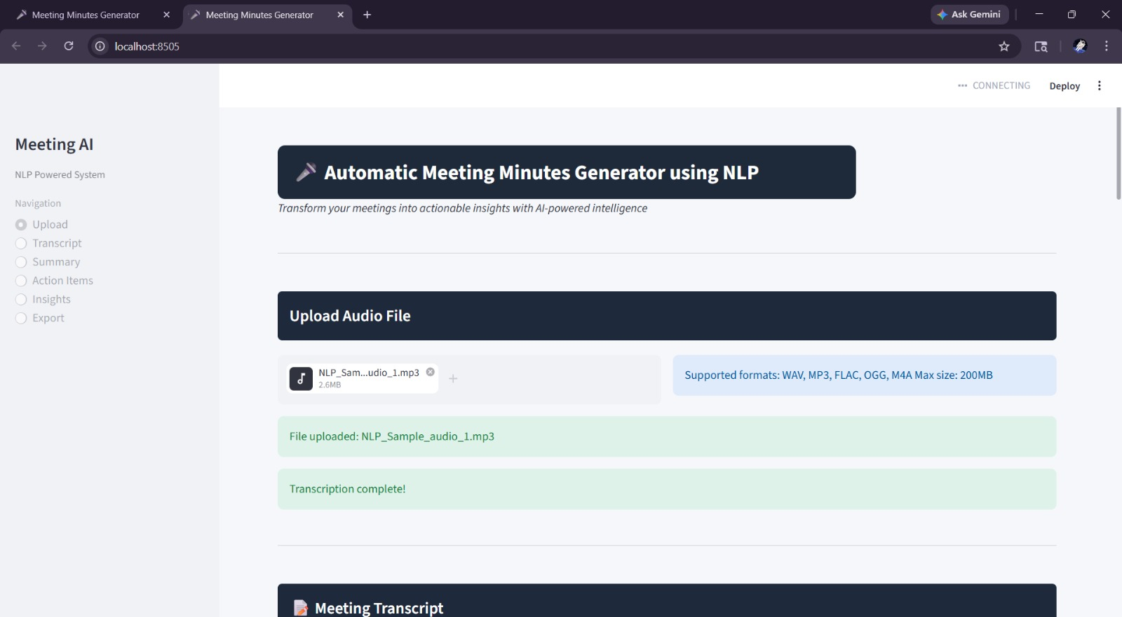

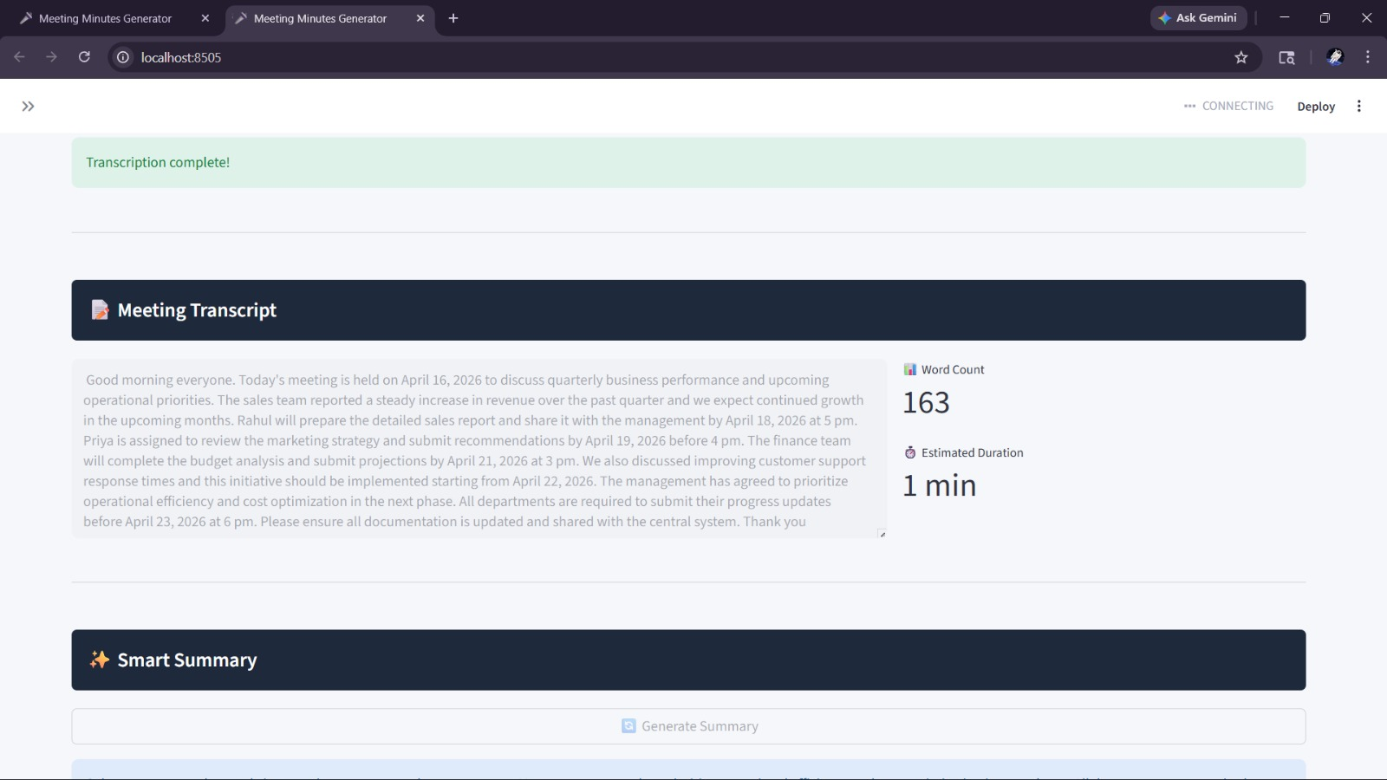

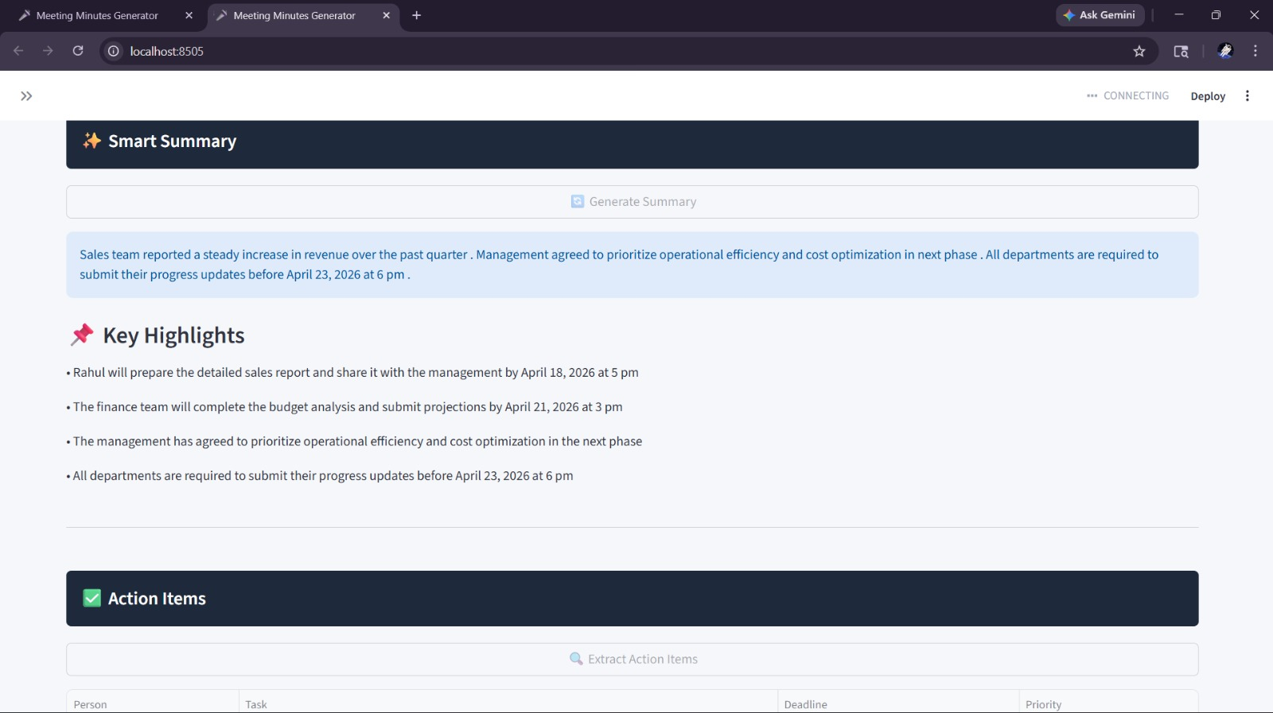

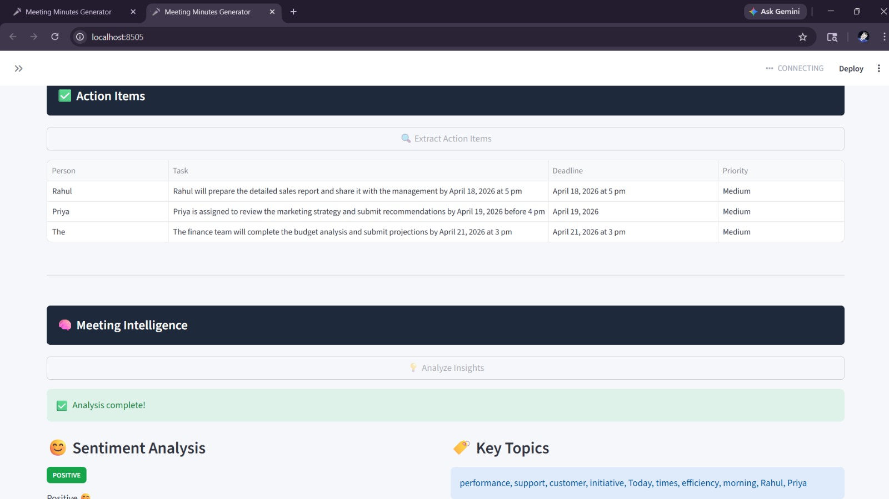

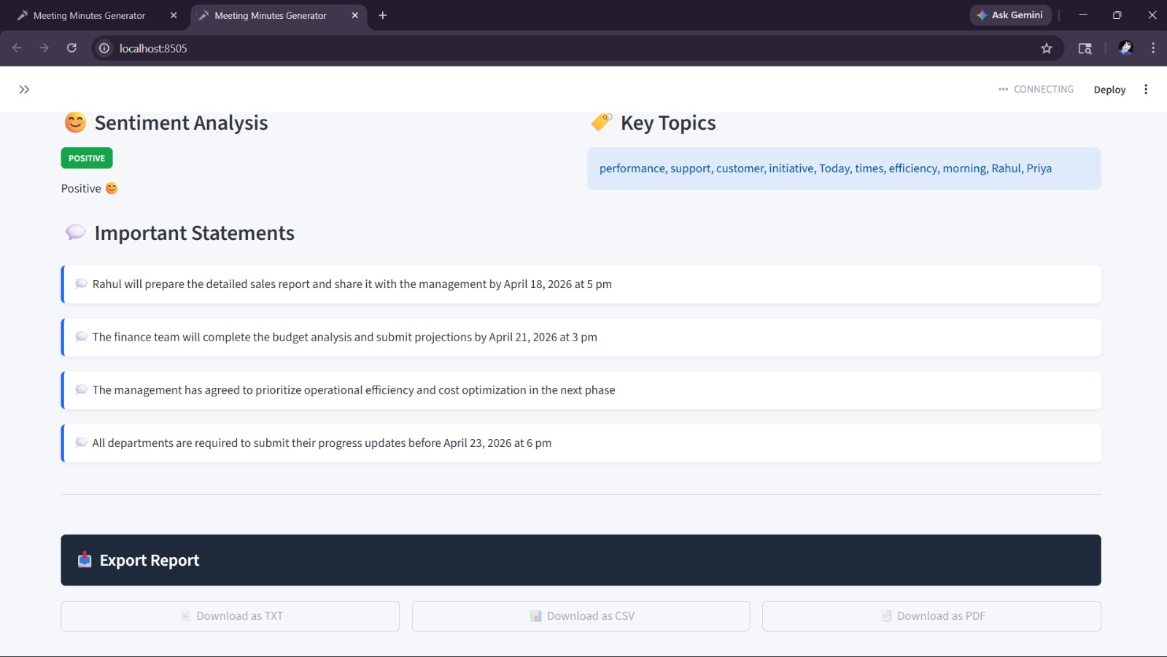

Conclusion
The Automatic Meeting Minutes Generator is a valuable and useful addition to the sphere of applied natural language processing. The system combines several AI and NLP methods into a single, unified system to automate one of the most intractable administrative burdens in professional and academic settings: meeting documentation.
The system was able to show that it was possible to achieve enterprise-quality functionality using open-source models Whisper, DistilBART, spaCy, and TextBlob, without the cost or proprietary restrictions of commercial solutions.
In the future, there are a number of areas of development. It would be possible to do real-time audio processing and, as a result, the system could produce live meeting summaries in the middle of the meeting, making it incredibly useful in the fast-paced environment. The spearheading of the speech sections to individual speakers (speaker diarization) would greatly improve the action item tracking and entity recognition. Output would be even better with fine-tuning of the summarization model on domain-specific corpora including legal, medical or technical meetings.
To sum up, this project is effective in showing the strength of combining the latest NLP technologies into a single, easily accessible, and useful tool. It emphasizes the way AI-driven technologies can make the work of manuals less tedious, documentation more accurate, and help to make decisions wiser, which will lead to more efficient organizations and working environments.

References
- OpenAI Whisper Model Documentation
- Hugging Face Transformers Library
- spaCy NLP Library Documentation
- TextBlob Documentation
- Streamlit Official Documentation
- Research papers on text summarization and speech recognition

