Project Title: Lost & Found Portal
Team Members:
- [Akhil] – 2403A52241
- [Hemanth] – 2403A52242
- [Ganesh] –2403A52239
Batch: 09

Objective
To build a user-friendly web application that streamlines the process of reporting and recovering lost items within college. The portal will:
- Provide a centralized platform for logging lost and found items.
- Enable users to search and filter items based on category, location, and date.
- Notify users when a potential match is found.
- Reduce dependency on manual tracking and physical notice boards.

Stakeholders:
- Students – Primary users who report and search for lost items.
- Faculty & Staff – Can report found items and assist in verification.
- Campus Security – Helps validate claims and manage sensitive items.
- Administration – Oversees platform usage and ensures data integrity.

Programming Languages, Tools, and Software:
Frontend: HTML, CSS, JavaScript
Backend: Flask (Python) or Node.js with Express
Database: MongoDB
Authentication: JWT (JSON Web Tokens)

Features:
- Report lost/found items with image and location
- Search and filter items by category, date, location
- Claim items with contact form
- Admin approval for sensitive items
- Email notifications for matched items

Real-Time Problem at college:
- Frequent loss of items like ID cards, books, chargers, etc.
- No centralized system to report or find them
- Manual methods are slow and unreliable
- This portal solves that with automation and accessibility

Frontend View of Your Web Application
screenshots or wireframes of the following key pages:

- Home Page
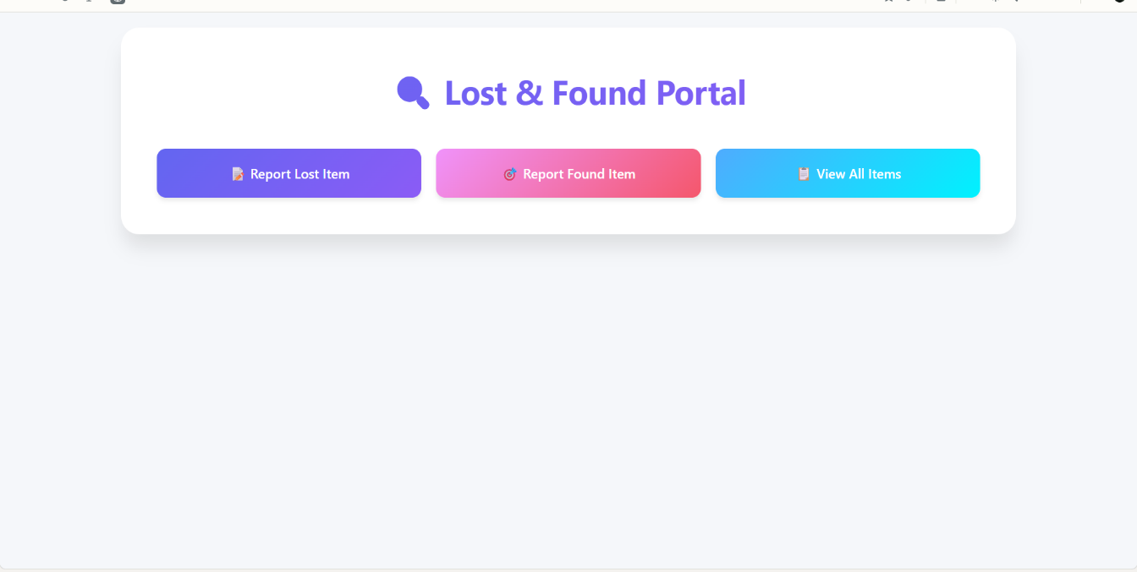

- Report Lost Item Page
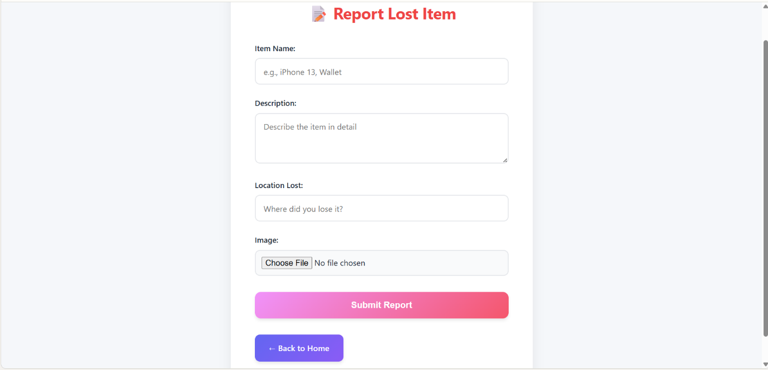

- View Found Items Page
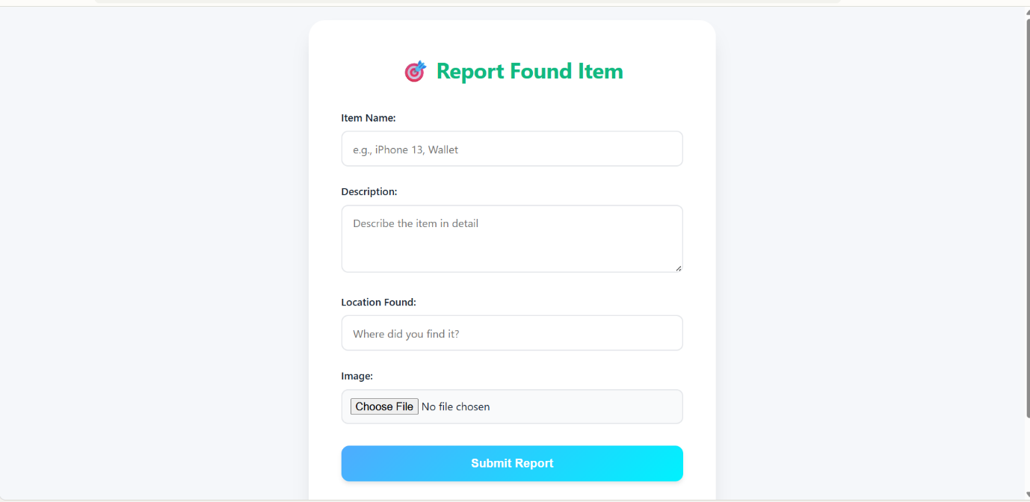

- View reported items

