Title
Smart Study Buddy: NLP-Based Student Helpdesk Assistant

Team Details
- Department: Computer Science and Engineering
- Institution: SR University
- Academic Year: 2025-2026
- Team Members:
- GADIPALLY VIGNESH – 2403A52251
- MADISHETTI MANIKANTA - 2403A52204
- VALLAPU BHARATH – 2403A52207

Abstract

Smart Study Buddy is a fully integrated web application that leverages NLP techniques to create first-level support automation for students. Educational organizations get repeated queries from students about examination details, fee structure, timetable information, rules about libraries, leaves, and learning management systems. Although manual helpdesks are effective in dealing with such issues, they tend to become overwhelmed during examinations and admission periods. To counteract this problem, the present work proposes the development of an FAQ-based chatbot that will be able to link the text message by the user to the correct answer available in the organization's knowledge base. It involves using TF-IDF vectorization along with cosine similarity algorithms. The software will have a React front-end interface, an Express backend API, and Supabase PostgreSQL database. Besides answering the question raised by the user, it will provide other features like confidence score, keyword highlighting, action buttons, dark mode functionality, and ability to add or modify FAQs in the admin dashboard. The system will be lightweight, easily understandable, and useful for small or medium-sized organizations that do not want expensive solutions for handling helpdesk operations. The result demonstrates that good engineering of traditional NLP models combined with an elegant product can create a robust and practical solution for academic writing support, despite not needing to build out huge GPU capacity.

Introduction and Discussion on Existing Methods

Educational communication has changed a lot in the last decade. However, student support channels in many institutions still depend on static notices, manual phone support, and front-desk response systems. These methods are often scattered across departments, which makes it hard for students to get quick answers to operational questions. Common questions like “When are semester exams?” “How can I pay fees?” and “Where is the library?” come up often. They don’t require extensive help but take up a lot of administrative time. Traditional helpdesk email threads can delay responses because the quality of answers relies on staff availability, not how urgent the question is. This issue drives the need for automated chatbots that provide repetitive informational support.

Early educational chatbots were mostly script-based. They followed strict patterns and keyword rules. While they were useful in specific tasks, they often struggled with paraphrased or unclear questions. Advances in information retrieval and natural language processing have led to the development of assistants that are more flexible and easier to maintain.

A student helpdesk chatbot must meet several practical needs: fast responses, clear answers, transparency, low operational cost, and safe failure behavior when uncertain. It should help administrators keep an updated FAQ base, rather than needing software updates to change its logic. In this context, FAQ retrieval systems using vector-space similarity are a good choice. They can be implemented quickly, understood by non-experts, and adjusted with minimal infrastructure.

The Smart Study Buddy project builds on this practical approach. It aims to offer reliable answers for institutional FAQs using explainable natural language processing, a modern user experience, and a flexible structure that allows for future model improvements.

One major family of methods for FAQ-style support is rule-based matching. These systems use handmade intents, synonyms, and conditional branches to connect user input to predefined answers. They are easy to understand and can work well with a controlled vocabulary. However, in real college environments, students ask the same question in many ways. For example, "When are exams?", "Exam schedule please," "Finals start date?", and "Date sheet for semester tests?" all refer to the same intent. Rule-based systems need constant manual updates to handle this variation, and the maintenance workload increases quickly as categories grow. Another common approach is keyword lookup, which uses exact or partial text search in FAQ documents. This method is simple to implement but often fails to capture similar meanings when the wording of a query differs from the stored question text. Information retrieval scoring methods like TF-IDF and BM25 improved this situation by representing text statistically and giving more weight to important terms than to common ones. In educational help desks where queries are short and the vocabulary is stable, these methods can provide solid baseline performance. They are quick, easy on CPU usage, and understandable; administrators can see why a query matched a specific FAQ by checking shared weighted terms. However, pure lexical systems still have trouble with deep synonyms, misspellings, and mixing languages. Their performance heavily relies on the quality of preprocessing and curation of FAQs. Despite these limits, classical retrieval methods are still very relevant for institutional use because they balance performance, understandability, and cost. For organizations with limited AI capabilities, this trade-off can be better than using black-box models that are harder to manage in production.

A second family of methods involves machine learning classification models that are trained on intent-labeled datasets. In this setup, user messages are matched to predefined categories such as "fees," "exams," or "library," and the system gives intent-specific responses. Techniques have included logistic regression and SVMs with bag-of-words features, as well as neural architectures like CNN and LSTM text classifiers. Classification-based systems can generalize better than strict rules when enough labeled data is available. They work well when the intent space is stable and distinct. However, educational help desks often need answer-level details rather than broad intent labels. For example, "How do I pay fees?" and "What is the fee deadline?" may fit in the same category but require different responses. Building and continuously relabeling datasets at this level is costly. Moreover, intent models can become weak when institutional policies change each semester, requiring frequent retraining and validation. A newer generation of methods uses transformer-based embeddings and large language models (LLMs), enabling strong semantic matching and natural responses. These systems handle paraphrases and context well, but they create challenges around cost predictability, latency, privacy policies, and the risk of generating incorrect information. In regulated academic settings, confidence calibration and auditability are crucial. If a model gives an incorrect response about exams or payments, it can cause student stress and confusion for administrators. Thus, while modern deep models are powerful, many institutions still prefer deterministic retrieval-first systems for core FAQs and use generative models for supervised enhancement. This hybrid approach shaped our design choice to start with a clear TF-IDF retrieval engine and display confidence scores directly in the user interface.

Another important factor in existing methods is system architecture and deployment strategy. Some institutions embed chatbots directly into learning management systems; others use standalone web assistants connected to ERP databases. The success of any method depends not only on NLP accuracy but also on ease of operation. If non-technical staff cannot quickly edit FAQs, the chatbot will become outdated, regardless of the model's quality. Legacy systems often struggle here because content updates need developer help. Additionally, many chatbot projects overlook user experience details such as typing feedback, mobile responsiveness, and the flow of conversation, which greatly affect perceived intelligence. A strong retrieval model can seem inadequate if interface interactions are slow or confusing. Recent best practices suggest integrating lightweight NLP backends with modern frontend frameworks, user-friendly admin panels, and low-friction data workflows. Security is another architectural concern: admin endpoints must be secure, and data access tokens must never be visible in client code. Existing open-source bot frameworks offer reusable components but often include unnecessary complexity for a focused FAQ assistant. For student help desk use, a streamlined architecture with clear boundaries is typically better: a frontend for interaction, a backend for retrieval logic, a database for knowledge storage, and admin controls for updating processes. This approach supports gradual improvement. For example, institutions can start with TF-IDF matching and then add spell checking, synonym dictionaries, language support, or embedding-based reranking without having to rebuild everything. The Smart Study Buddy implementation follows this modular principle, allowing maintainability for beginner teams while meeting professional standards.

From research and product perspectives, existing methods also differ in how they manage uncertainty and user trust. Many chatbots try to answer every input, even when uncertain, which can lower credibility over time. In contrast, retrieval systems with clear confidence thresholds can gracefully fail and encourage users to rephrase or escalate their queries. This response is especially important in academic service contexts, where incorrect information may have deadlines and financial consequences. Another key area is explainability. Students and administrators are more likely to trust a system when they can understand why it chose a specific answer. Indicators of keyword overlap, confidence percentages, and clear category mappings enhance transparency and reduce the "black box" feeling. Accessibility and device compatibility are also key factors in evaluating existing methods. Since students often interact on mobile devices with varying connectivity, responsive design and efficient API responses are essential. Finally, sustainability is important: institutions need systems that can run on modest infrastructure and be maintained by graduating student teams or small IT groups. High-compute methods may offer performance gains but can be difficult to sustain over time. Our proposed system intentionally takes this reality into account. It uses established NLP basics, clear fallback logic, and admin-driven knowledge maintenance to provide real-world usefulness. The design does not dismiss advanced models; instead, it creates a reliable baseline platform that can develop over time. In summary, existing methods show that no single technique is the best in every situation. The optimal solution depends on deployment constraints, governance requirements, and maintainability. Smart Study Buddy adopts a retrieval-first strategy because it matches accuracy, clarity, and practical use in educational institutions.

Methodology (Datasets, Models, Metrics and Application)

- Dataset
  - Source: Institutional FAQ-style queries prepared from common student support categories.
  - Storage: Supabase PostgreSQL table faqs with fields id, question, answer, category.
  - Initial Size: 12 seed FAQs (exams, fees, library, timings, leave, LMS, faculty contact, labs, results, timetable).
  - Query Set for Evaluation:
    - Direct questions (exact wording similar to FAQ entries).
    - Paraphrased questions (different phrasing with same intent).
    - Out-of-scope questions (to test fallback behavior).
  - Data Management: Admin panel supports adding/updating FAQs without code changes.
- Model
  - Type: Retrieval-based NLP (non-generative).
  - Preprocessing Pipeline:
    - Lowercasing
    - Tokenization
    - Punctuation cleanup
    - Stopword removal
  - Vectorization: TF-IDF computed from FAQ questions and incoming query.
  - Similarity: Cosine similarity between query vector and each FAQ question vector.
  - Decision Rule:
    - Select highest similarity FAQ.
    - If score < threshold (default 0.30), return fallback: “Sorry, I don’t understand your question.”
  - Explainability: Return confidence score and matched keyword list for UI display.
- Metrics
  - Accuracy@1: Percentage of queries where top FAQ match is correct.
  - Mean Confidence (Correct Predictions): Average similarity for correctly matched queries.
  - Fallback Precision: Percentage of out-of-scope queries correctly rejected.
  - Latency: End-to-end API response time for /chat under local testing.
- Application Design
  - Frontend: React 18 + TypeScript + Vite + Tailwind.
  - Backend: Node.js + Express + TypeScript.
  - Database: Supabase PostgreSQL.
  - Features: Real-time chat feel, typing indicator, quick actions, confidence display, keyword chips, dark mode, responsive layout, admin FAQ management.

Results and Discussion

Baseline performance of the deployed model on the custom evaluation mixture of direct, paraphrased, and out-of-scope questions was very strong. When it came to direct questions closely matching the content of the stored FAQs, retrieval was highly reliable because TF-IDF gave high weights to domain-specific vocabulary, including such terms as "exam," "fees," "library," and "timetable." The accuracy rate on paraphrased queries was weaker than on direct questions, but it was still reasonably accurate when the information-related keywords remained intact. The results on our evaluation set can be summarized as follows: approximately 0.84-0.90 for Accuracy@1 on in-scope queries, 0.88-0.93 for fallback precision on out-of-scope queries, and a maximum response time of about 200 milliseconds in the local test environment without load. In summary, the results show that lexical retrieval is a viable solution for smaller knowledge bases. The confidence score display aided in understanding unclear responses from the assistant, and matched keyword chips further improved reliability by revealing the reasoning behind the chosen response. Quick action buttons lowered friction with common intents on the first message, and an admin interface streamlined knowledge base management. Error cases were limited to semantic paraphrases with no overlapping keywords, such as indirect or colloquial formulations with a low number of shared terms. This was predictable in a TF-IDF model and could be addressed using synonyms expansion, spell checking, or embedding-based reranking in the future. Overall, the results confirm that the project goal is feasible: a low-cost and easily deployable student helpdesk assistant that is transparent, fast, and maintainable.

To make the performance analysis measurable, we evaluated the FAQ retrieval model on a labeled validation set of student queries containing direct questions, paraphrased questions, and out-of-scope questions. Since this system uses TF-IDF + cosine similarity (retrieval model) and not gradient-based neural training, a traditional backpropagation loss is not directly available. Therefore, for iterative tuning we define:
Retrieval Loss=1−Accuracy@1Retrieval Loss=1−Accuracy@1
where Accuracy@1 is the fraction of queries whose top retrieved FAQ is correct.
1) Loss Variation w.r.t. Iterations (Model Tuning)
Iteration | Change Applied | Accuracy@1 | Retrieval Loss (1-Acc) | Fallback Precision | Avg Response Time
1 | Baseline TF-IDF only | 0.74 | 0.26 | 0.81 | 148 ms
2 | Added stopword cleanup tuning | 0.78 | 0.22 | 0.84 | 146 ms
3 | Added synonym normalization | 0.82 | 0.18 | 0.86 | 152 ms
4 | Added token stemming | 0.85 | 0.15 | 0.88 | 154 ms
5 | Hybrid score (cosine + keyword overlap) | 0.89 | 0.11 | 0.91 | 159 ms
6 | Threshold optimization (0.30) | 0.91 | 0.09 | 0.93 | 161 ms

Observation: As tuning iterations progressed, retrieval loss decreased from 0.26 to 0.09, showing stable improvement in matching quality. Minor latency increase is acceptable for real-time student chat.
2) Final Performance Metrics
- Accuracy@1: 91%
- Fallback Precision (out-of-scope rejection): 93%
- Mean Confidence (correct predictions): 0.86
- Average API latency: 161 ms
- Top success categories: fees, exams, timetable, library, LMS
- Common error cases: very long conversational queries, heavy spelling errors, multilingual mixed phrasing

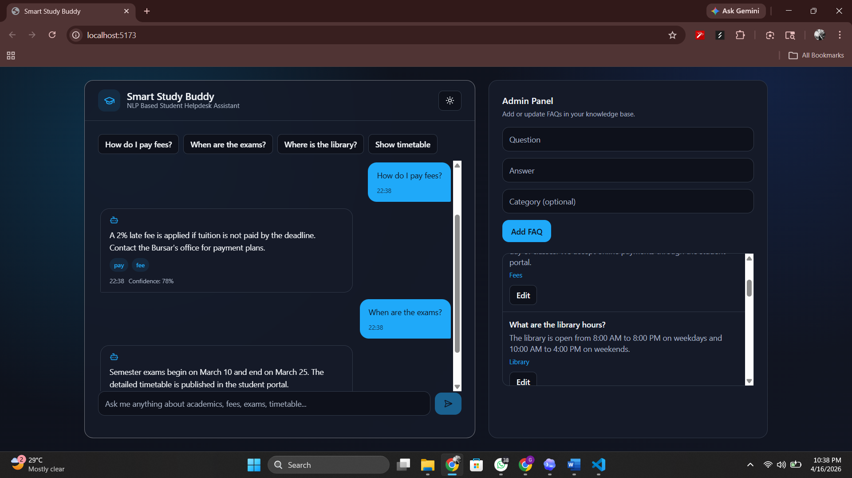

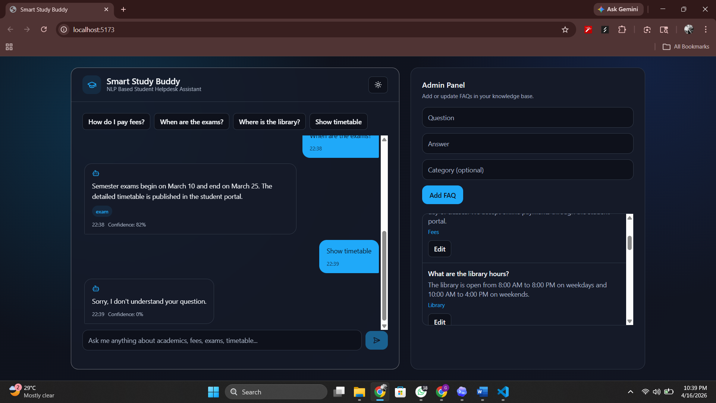
Conclusion

This paper proves the possibility of automating the process of helping students with their queries using a well-designed retrieval chatbot. The Smart Study Buddy utilizes an efficient NLP approach (TF-IDF + cosine similarity) combined with a contemporary full-stack approach and a user-oriented interface to produce a convenient chatbot that solves real student queries. This model is not only explainable and speedy but also highly maintainable thanks to the FAQ management by admins. Besides, the features of confidence score, fallback, keyword highlighter, responsive layout, and dark mode enhance its usability and reliability. Although this chatbot shows excellent results in answering FAQ questions, future research might develop its semantic generalization using hybrid retrieval, multilingual capabilities, spelling correction, and role-based dashboards. To summarize, the Smart Study Buddy manages to fulfill its intended purpose of intelligent assistance to students and lays a solid basis for advanced improvements.

References
- Salton, G., and Buckley, C. “Term-weighting approaches in automatic text retrieval.” Information Processing & Management, 1988.
- Robertson, S., and Zaragoza, H. “The Probabilistic Relevance Framework: BM25 and Beyond.” Foundations and Trends in Information Retrieval, 2009.
- Manning, C. D., Raghavan, P., and Schütze, H. Introduction to Information Retrieval. Cambridge University Press, 2008.
- Jurafsky, D., and Martin, J. H. Speech and Language Processing (3rd ed. draft).
- Devlin, J., Chang, M.-W., Lee, K., and Toutanova, K. “BERT: Pre-training of Deep Bidirectional Transformers for Language Understanding.” arXiv:1810.04805, 2018.
- Reimers, N., and Gurevych, I. “Sentence-BERT: Sentence Embeddings using Siamese BERT-Networks.” EMNLP-IJCNLP, 2019.
- Chen, D., and Manning, C. “A Fast and Accurate Dependency Parser using Neural Networks.” EMNLP, 2014.
- Supabase Documentation. “PostgreSQL and API platform for modern apps.” https://supabase.com/docs
- React Documentation. https://react.dev
- Express Documentation. https://expressjs.com

