SET 1
Q1: Design a database schema for a Library Management System using AI assistance.
- Use AI tools to generate SQL commands for creating tables: Books, Members, and Loans and execute in VS code
- Insert at least 3 records in each table
- Write a query to display all books currently issued to members.
- CODE:
- 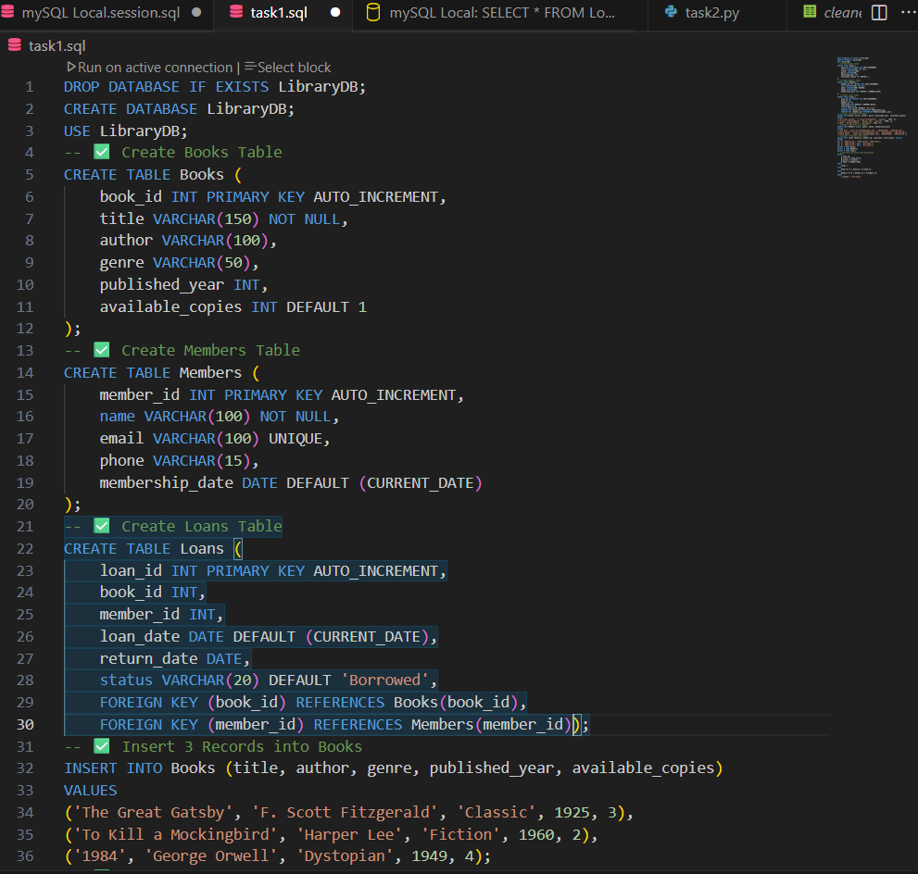
- 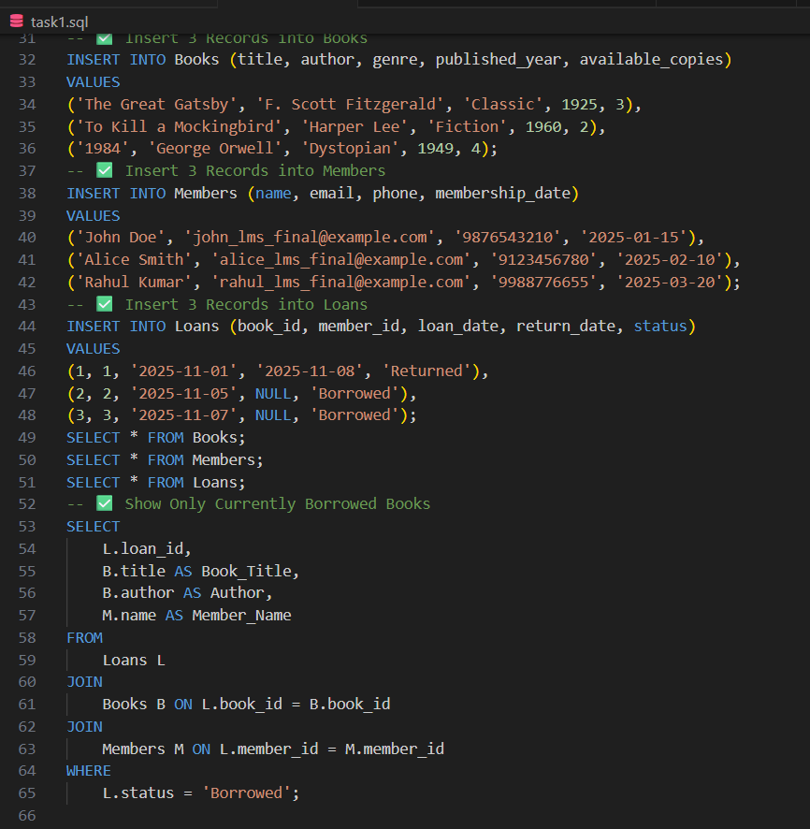
- OUTPUT:
- 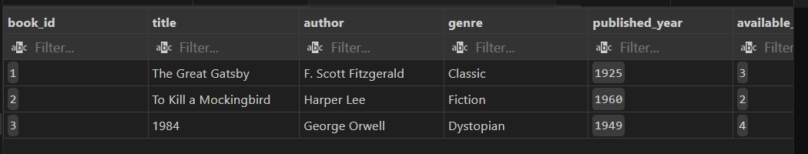
- 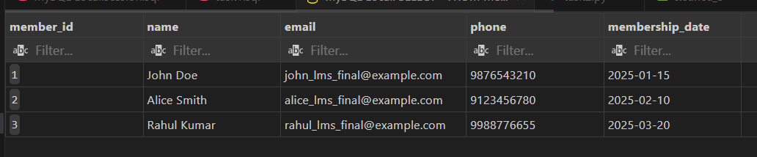
- 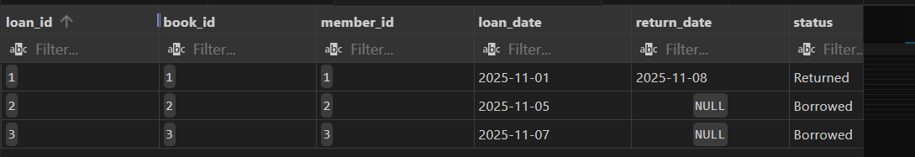
- 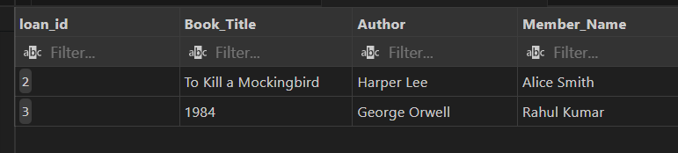
Q2. Using AI, generate a Python script to clean a sales dataset by handling missing values and normalizing the “transaction_amount” column using Min-Max scaling and standard scalar method. Use VS Code with Github copilot or cursor AI
- Generate dataset using ChatGPT that helps to complete the below two taks
- Handle missing values
- Normalize “transaction_amount”
- CODE:
- 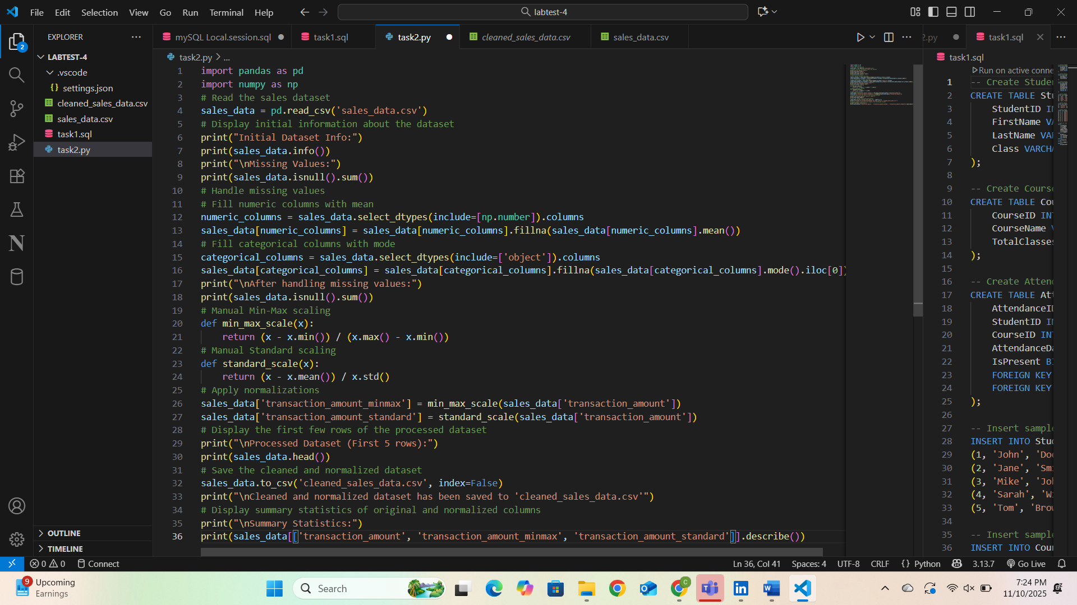 Raw dataset:
- 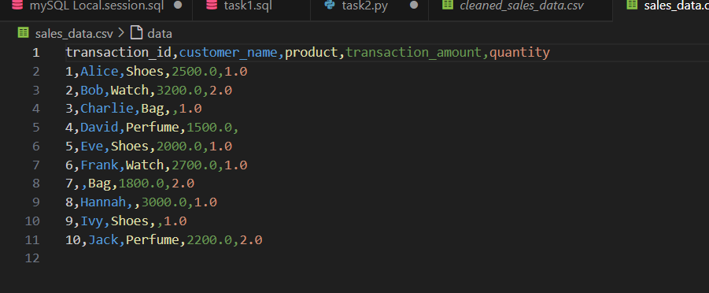
- CLEANED DATASET:
- 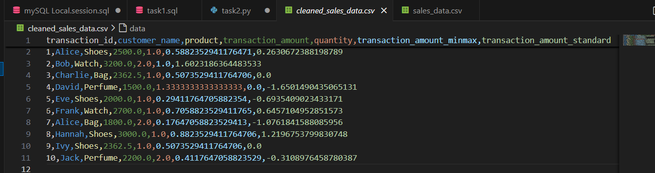
========OUTPUT:
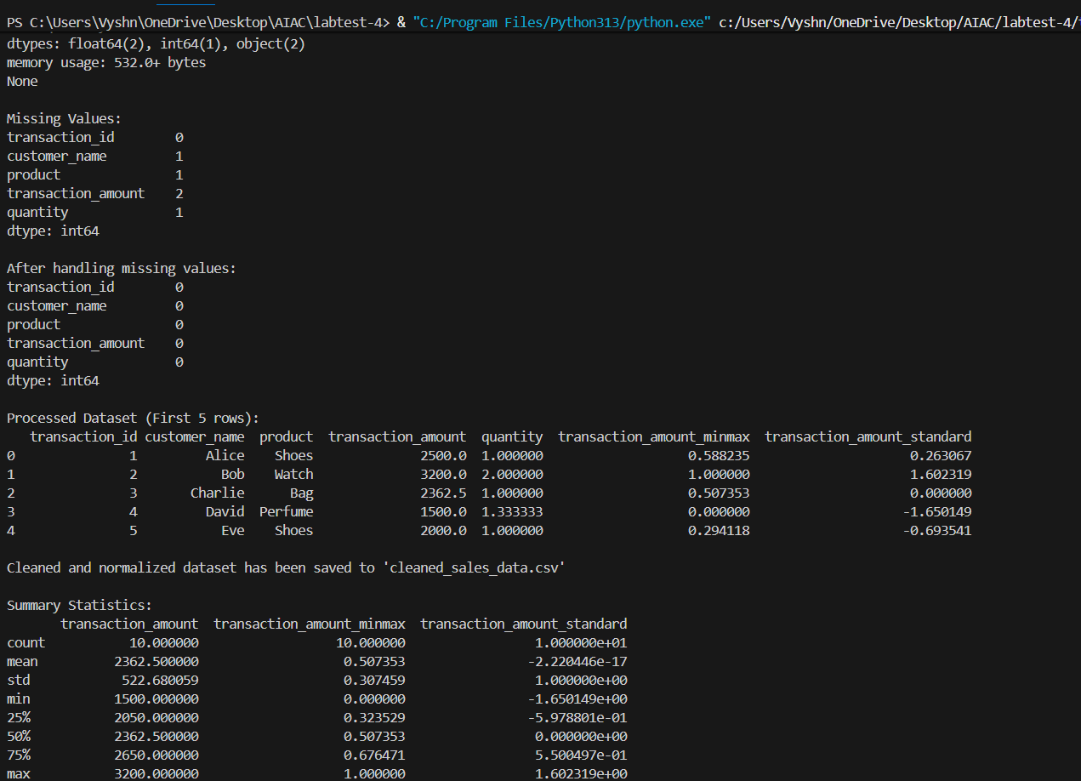=============================================================================

SET 2
Q1. Using AI, create a database schema for a Student Attendance Management System.
- Generate CREATE TABLE queries for Students, Courses, and Attendance with random data that can full fill below task
- Write a query to find students with attendance below 75%.
Q2. Generate a Python data preprocessing script using AI to:
- Generate dataset using ChatGPT that helps to complete the below two tasks
- Fill missing values with column mean.
- Encode categorical data using one-hot encoding.
- Save the cleaned dataset as processed_students.csv.

============================================================

SET 3
Q1. Generate an AI-assisted database schema for an Online Food Delivery Application. Use VS code with Github copilot
- Include tables: Restaurants, Customers, Orders, Menu_Items with some random data.
- Write SQL queries to list all customers who ordered items costing above ₹500.
Q2. Use AI to convert a Python dictionary manipulation program into equivalent JavaScript code.
- Verify correctness by comparing outputs of both scripts.

============================================================

SET 4
Q1. Design an E-commerce Product Inventory schema using AI-assisted SQL generation.
- Include tables: Products, Suppliers, and Stock.
- Write SQL query to insert random data in each table
- Write an SQL query to find products with stock quantity less than 10.
Q2. Generate an AI-assisted data cleaning script to:
- Generate dataset using ChatGPT that helps to complete the below two tasks
- Remove duplicates, handle NaN values, and standardize column names.
- Demonstrate the result using a sample CSV file
=====================================================================

SET 5
Q1. With the help of AI, create and populate a database schema for a Flight Booking System.
- Include tables: Flights, Passengers, Bookings. Insert random data that helps to complete below task
- Write a query to list all passengers booked for flights on a specific date.
Q2. Use AI to convert a SQL query that retrieves employees with salary > 60,000 into equivalent Python Pandas code.
- Write SQL program to build table and insert data
- Ask chatGpt to generate data required data in .csv
- Write SQL query that retrieves employees with salary > 60,000 from SQL Table
- Write Python code that retrieves employees with salary > 60,000 from .csv file
- Execute both and compare results.

