SCHOOL OF COMPUTER SCIENCE AND ARTIFICIAL INTELLIGENCE |  |  |  |  | DEPARTMENT OF COMPUTER SCIENCE ENGINEERING
ProgramName:B. Tech |  |  |  | Assignment Type: Lab |  |  | AcademicYear:2025-2026
CourseCoordinatorName |  |  |  | Venkataramana Veeramsetty
Instructor(s)Name |  |  |  | 1. Dr. Mohammed Ali Shaik  2. Dr. T Sampath Kumar  3. Mr. S Naresh Kumar  4. Dr. V. Rajesh  5. Dr. Brij Kishore  6. Dr Pramoda Patro  7. Dr. Venkataramana  8. Dr. Ravi Chander  9. Dr. Jagjeeth Singh
CourseCode |  |  | 24CS002PC215 | CourseTitle |  | AI Assisted Coding
Year/Sem |  |  | II/I | Regulation |  | R24
Date and Day  of Assignment |  |  |  | Time(s)
Duration |  |  | 2 Hours | Applicableto  Batches
AssignmentNumber:3.3(Present assignment number)/24(Total number of assignments)
 | Q.No. | Question |  |  |  |  |  | ExpectedTime  to complete
 | 1 | Lab 3: Prompt Engineering – Improving Prompts and Context Management  Lab Objectives:  - To understand how prompt structure and wording influence AI-generated code.  - To explore how context (like comments and function names) helps AI generate relevant output.  - To evaluate the quality and accuracy of code based on prompt clarity.  - To develop effective prompting strategies for AI-assisted programming.  Lab Outcomes (LOs):  After completing this lab, students will be able to:  - Generate Python code using Google Gemini in Google Colab.  - Analyze the effectiveness of code explanations and suggestions by Gemini.  - Set up and use Cursor AI for AI-powered coding assistance.  - Evaluate and refactor code using Cursor AI features.  - Compare AI tool behavior and code quality across different platforms.  Task Description#1  - Try 3 different prompts to generate a factorial function.  Expected Output#1  - Comparison of AI-generated code styles  - prompt-1: Write a function to calculate the factorial of a number in Python  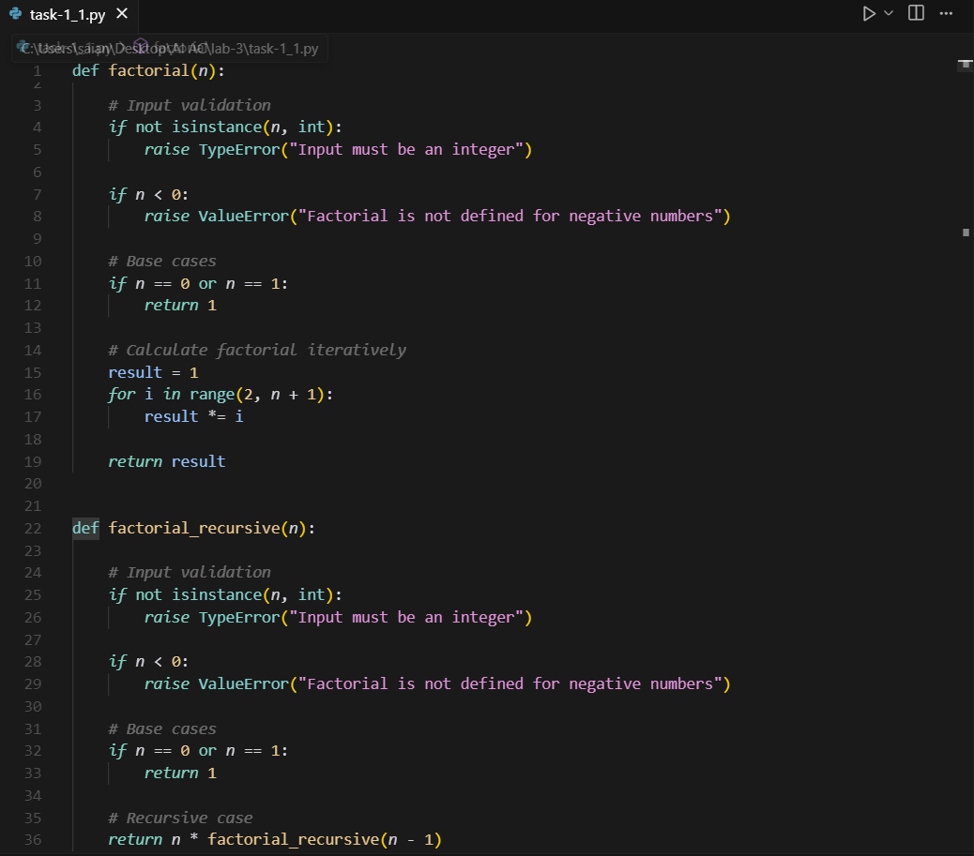  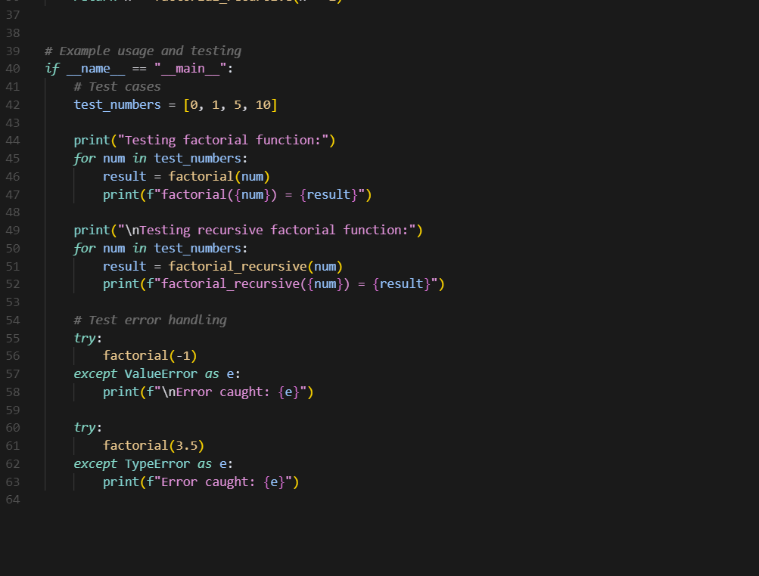  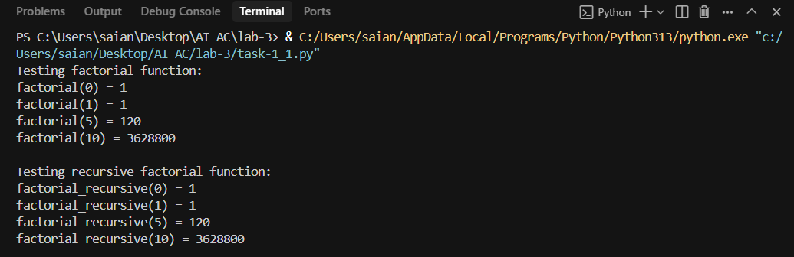  Conclusion:  - Negative Input Check: It raises a ValueError if the input is negative, since factorials are not defined for negative numbers.  - Base Cases: Returns 1 for inputs 0 and 1, which are standard factorial definitions.  - Iterative Logic: Uses a for loop from 2 to n to multiply and compute the factorial.  - Recursive Logic: Calls itself with n - 1 until it reaches the base case, building the result step by step.  - Test Cases: Demonstrates both functions with sample inputs like 0, 1, 5, and 10.  - Error Handling: Includes try-except blocks to catch and display errors for invalid inputs.  - Clear Output: Prints results for both methods in a readable format for easy comparison.  - Well-Structured Code: Organized with comments, function definitions, and a __main__ block for testing and clarity.  Prompt-2: Simulate a factorial calculation in Python as part of a biology experiment where factorials represent cell division stages. Include comments explaining each step.  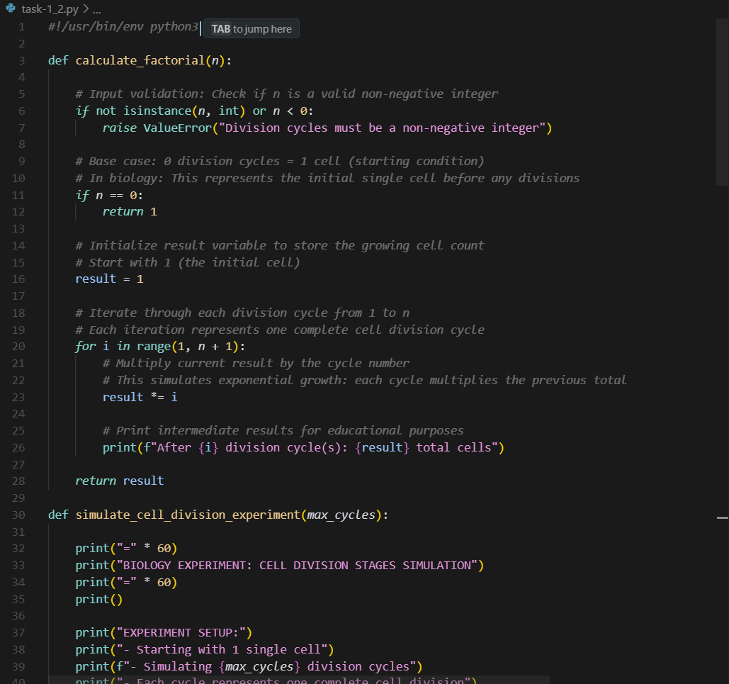  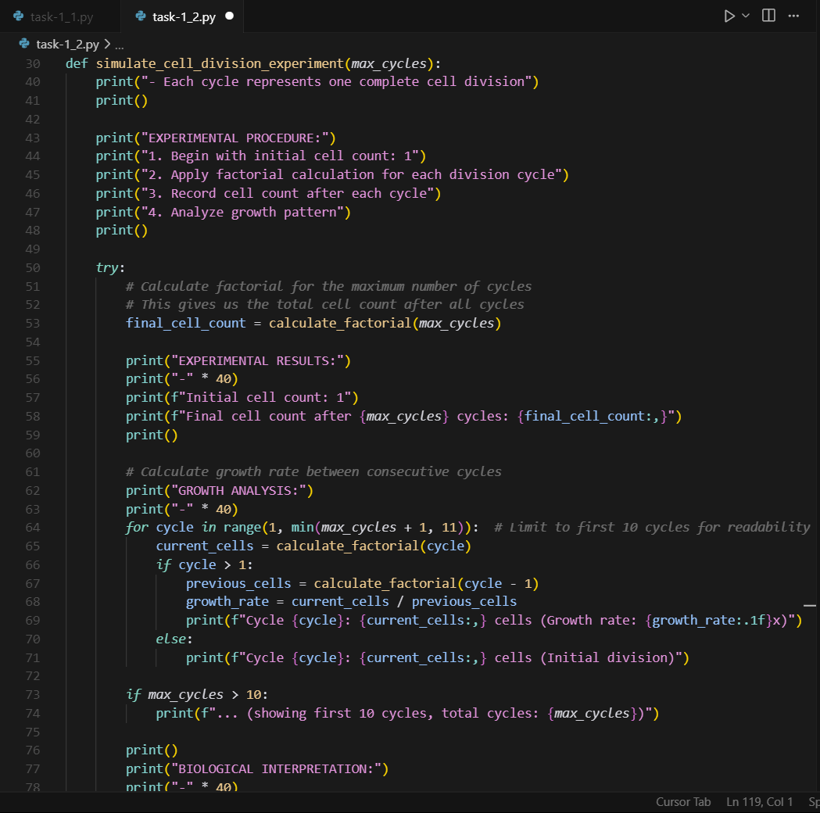  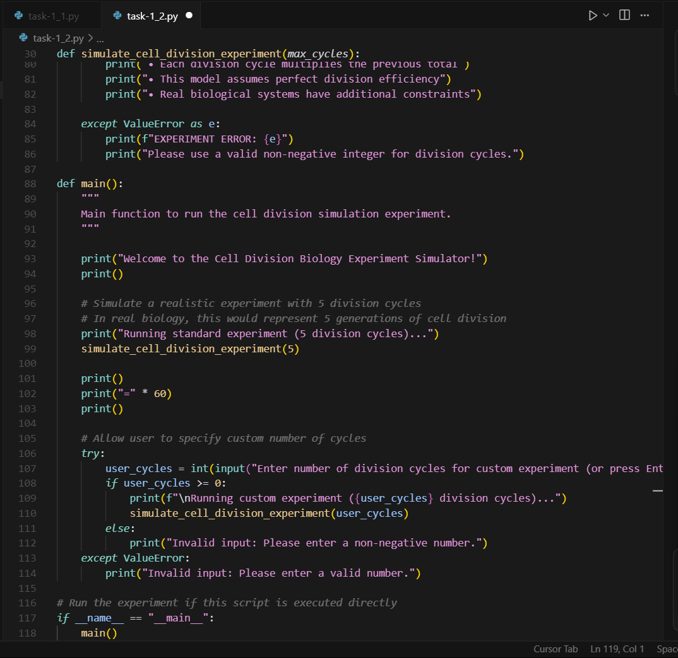  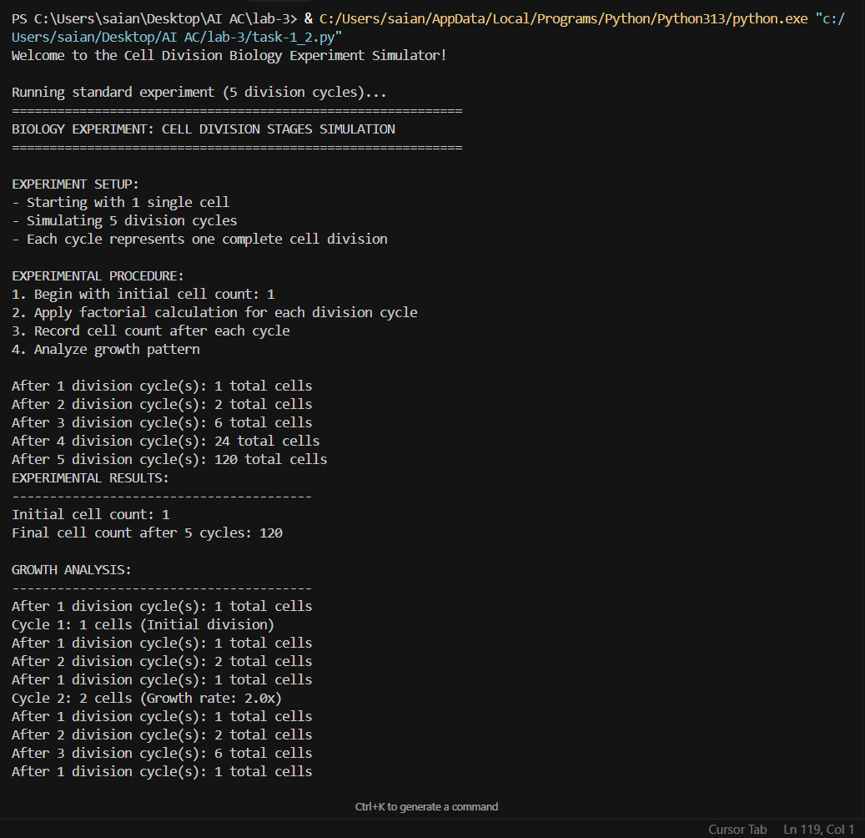  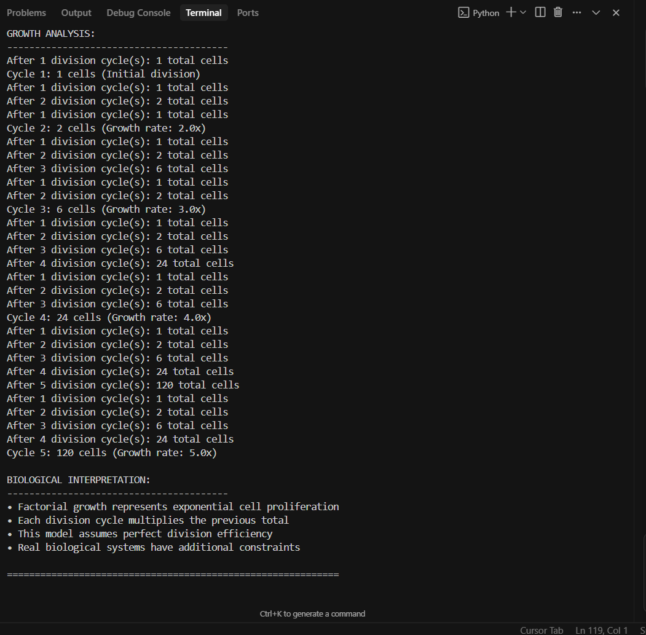  Conclusion:  - It models exponential cell growth using powers of 2 for each generation.  - Factorials represent the number of possible arrangements of division events.  - Recursive logic is used to compute factorials with biological context.  - The simulation displays generation-wise cell counts and factorial values.  - It compares factorial growth with exponential growth to show divergence.  - A ratio analysis highlights how factorials grow much faster than exponentials.  - The interactive calculator allows users to explore factorials hands-on.  - Biological interpretations are provided for small values to aid understanding.  - Overall, the program blends math and biology to make learning engaging and visual.  Prompt-3- Write a Python function called factorial that calculates the factorial of a non-negative integer using a while loop.  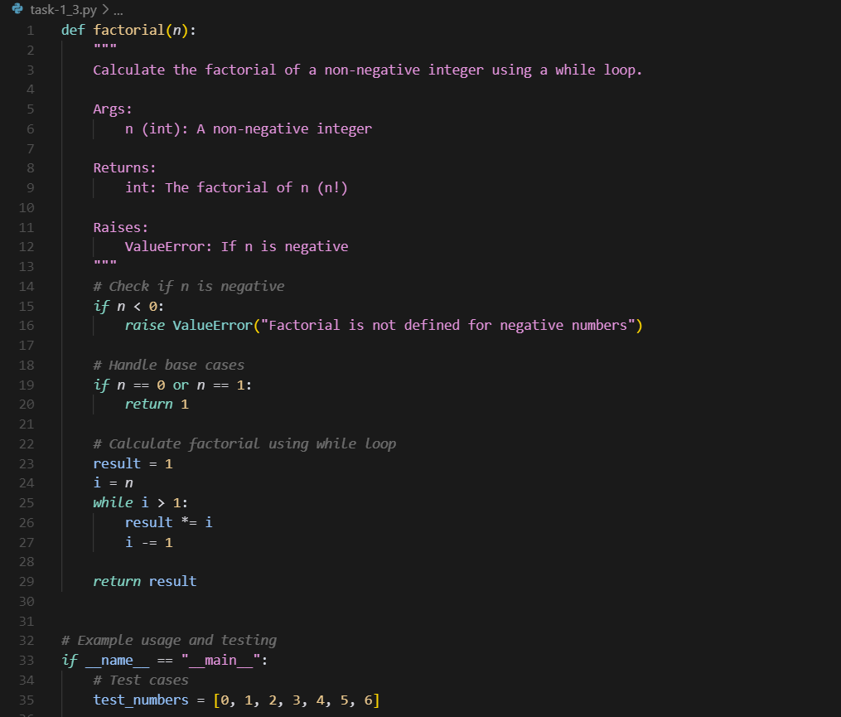  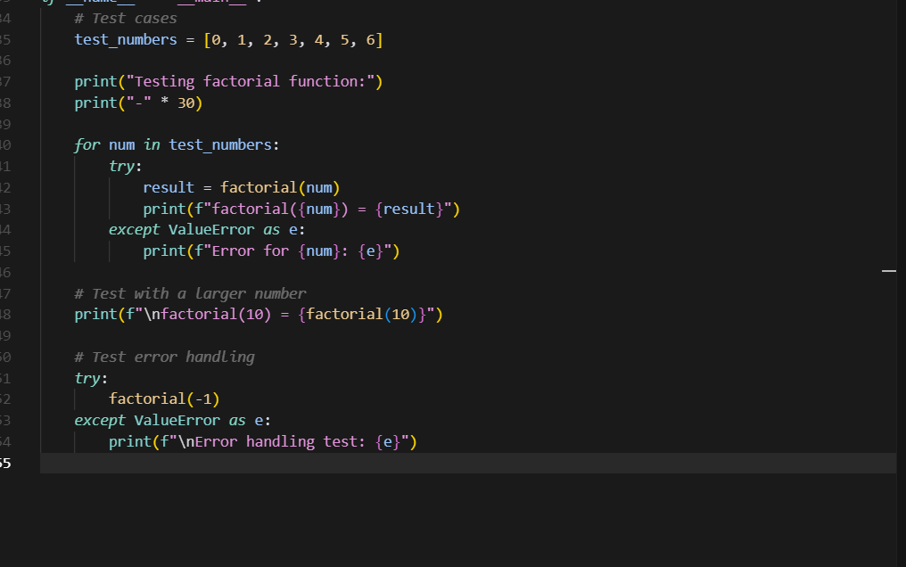  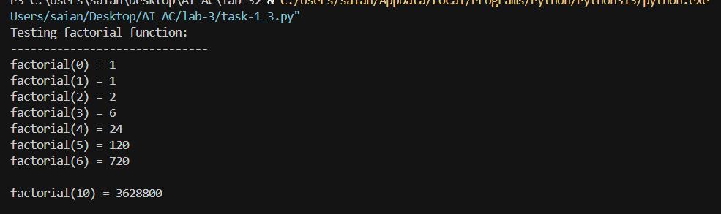  Conclusion:  - The script calculates the factorial of a non-negative integer using a while loop.  - It includes input validation to ensure the number is not negative.  - A ValueError is raised if the input is less than zero, preventing invalid calculations.  - The base case 0! = 1 is handled explicitly, following mathematical convention.  - The loop starts from i = 1 and multiplies up to n, building the factorial iteratively.  - The use of a while loop offers an alternative to for loops or recursion.  - The logic is simple and beginner-friendly, ideal for learning loop-based computation.  - The result is printed in the format n! = result, making output clear and readable.  - The script is wrapped in a __main__ block to allow safe execution when run directly.  - Overall, it’s a clean and efficient implementation of factorial logic using basic control flow.  Task Description#2  - Provide a clear example input-output prompt to generate a sorting function.  Expected Output#2  Functional sorting code from AI  Prompt: Write a Python function that takes a list of integers as input and returns the list sorted in descending order  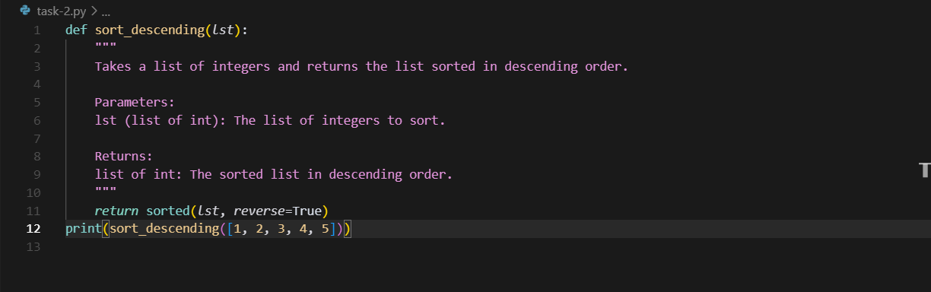  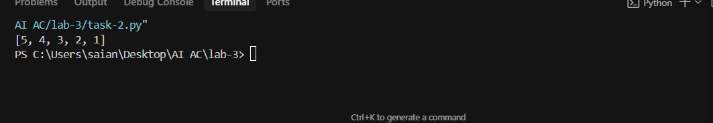  Conclusion:  - The function sort_descending sorts a list of integers in descending order.  - It uses Python’s built-in sorted() function for efficient sorting.  - The reverse=True argument ensures the list is sorted from highest to lowest.  - The function is concise and performs the task in a single line.  - It accepts a list of integers as input and returns a new sorted list.  - The original list remains unchanged, preserving data integrity.  - The function includes a clear docstring explaining its purpose, parameters, and return value.  - It demonstrates good practice by separating logic from output.  - The sample call print(sort_descending([1, 2, 3, 4, 5])) outputs [5, 4, 3, 2, 1].  - Overall, it’s a clean and readable implementation for descending order sorting.  Task Description#3  - Start with the vague prompt “Generate python code to calculate power bill” and improve it step-by-step  Expected Output#3  - Enhanced AI output with clearer prompts  Prompt-1 - : Write a Python program that takes the number of electricity units consumed as input and calculates the total bill based on the following customer  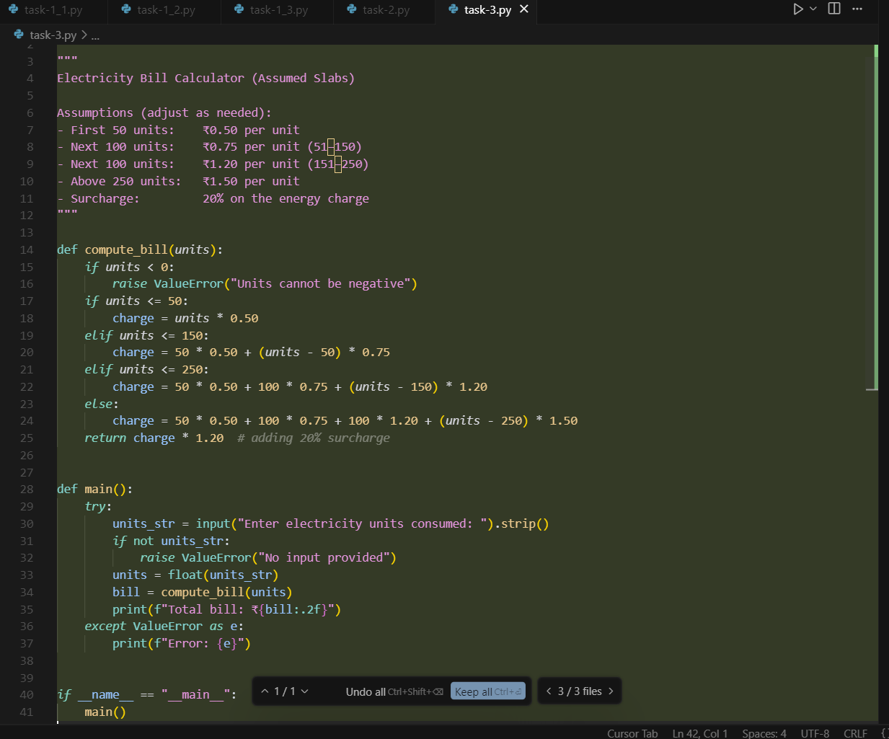  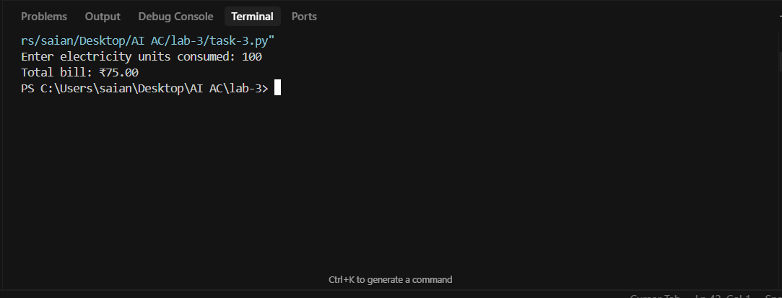  Conclusion:  - The script calculates electricity bills based on predefined slab rates.  - It uses conditional logic to apply different rates for different unit ranges.  - The slab structure includes four tiers, with increasing rates for higher consumption.  - A 20% surcharge is added to the total energy charge to reflect additional fees.  - Input validation ensures that negative or empty inputs are handled gracefully.  - The function compute_bill() encapsulates the billing logic for clarity and reuse.  - The main() function manages user interaction and error handling.  - The bill amount is displayed with two decimal places for precision.  - The code is modular, readable, and easy to modify for different rate structures.  - Overall, the script provides a practical and user-friendly way to estimate electricity costs.  Prompt-2- Generate Python code to calculate an electricity bill based on the number of units consumed, using a fixed rate per unit.  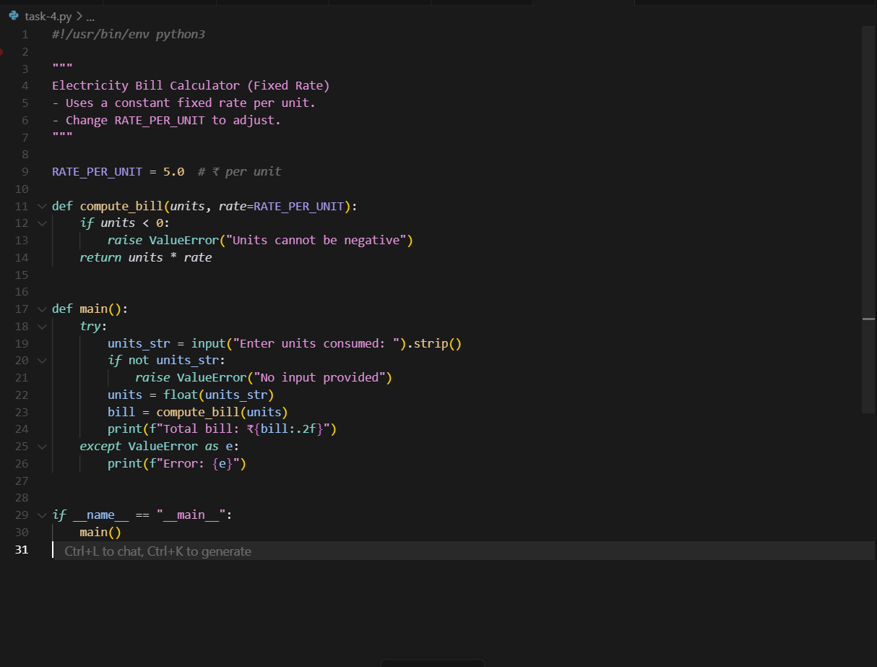  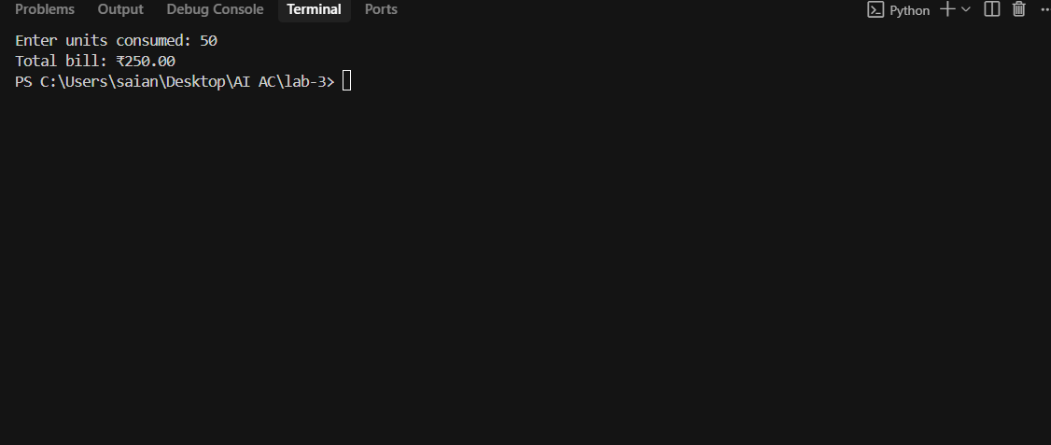  Conclusion:  - The script calculates electricity bills using a constant rate per unit.  - The rate is defined by the variable RATE_PER_UNIT, making it easy to adjust.  - The function compute_bill() multiplies units consumed by the fixed rate.  - Negative unit inputs are handled with a ValueError to prevent invalid billing.  - The main() function manages user input and displays the final bill.  - Input is stripped and converted to float for flexible numeric entry.  - The bill is formatted to two decimal places for clarity and precision.  - The code is simple and beginner-friendly, ideal for learning basic I/O and functions.  - It avoids complex slab logic, focusing on straightforward rate application.  - Overall, the script is clean, efficient, and easily adaptable for different rate models.  Task Description#4  - Write structured comments to help AI generate two linked functions (e.g., login_user() and register_user()).  Expected Output#4  - Consistent functions with shared logic  Prompt: : generate a two linked functions in python (Celsius,fahrenheit)  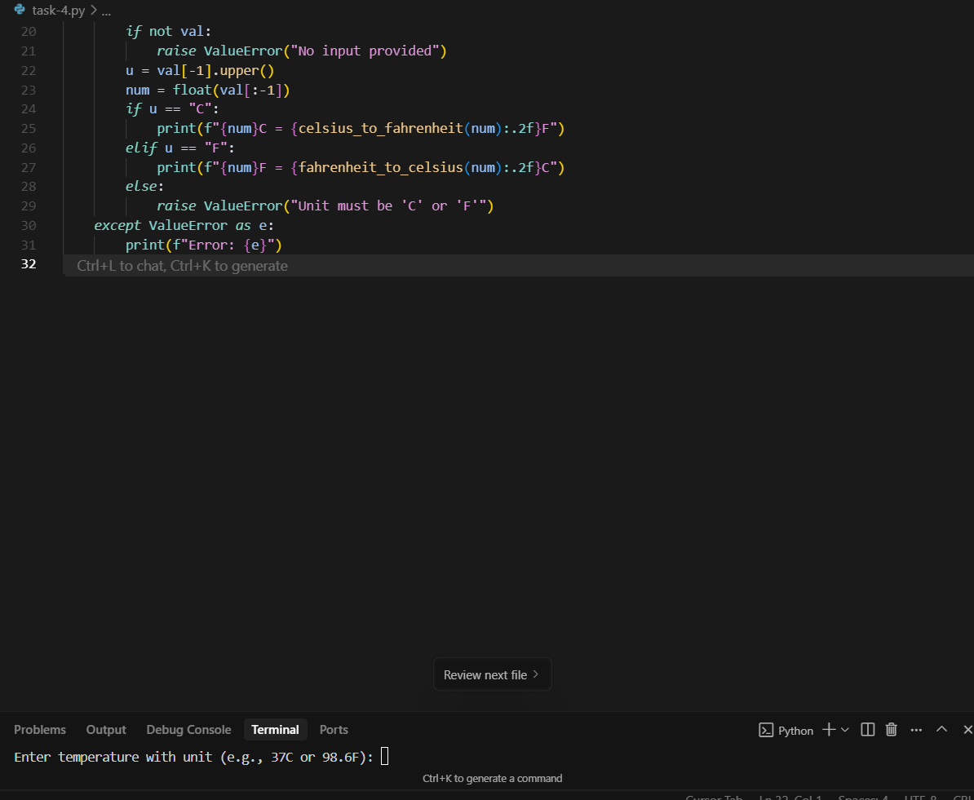  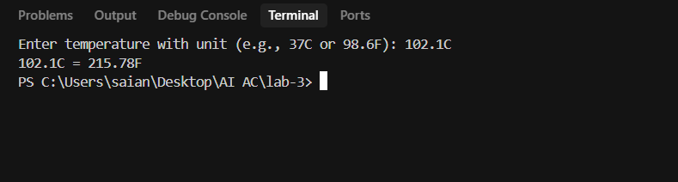  Conclusion:  - The script provides two functions to convert temperatures between Celsius and Fahrenheit.  - celsius_to_fahrenheit(c) converts Celsius to Fahrenheit using the formula F = C × 9/5 + 32.  - fahrenheit_to_celsius(f) converts Fahrenheit to Celsius using the formula C = (F − 32) × 5/9.  - The user inputs a temperature value followed by its unit (e.g., 37C or 98.6F).  - The script extracts the numeric part and the unit from the input string.  - It supports both uppercase and lowercase unit indicators by normalizing to uppercase.  - Input validation ensures that empty or incorrectly formatted inputs raise meaningful errors.  - The converted temperature is displayed with two decimal places for clarity.  - The code is modular and easy to extend for additional temperature scales like Kelvin.  - Overall, the script is a simple, interactive tool for accurate temperature conversion.  Task Description#5  - Analyzing Prompt Specificity: Improving Temperature Conversion Function with Clear Instructions  Expected Output#5  - Code quality difference analysis for various prompts  Prompt-1: Write a Python function to convert Celsius to Fahrenheit  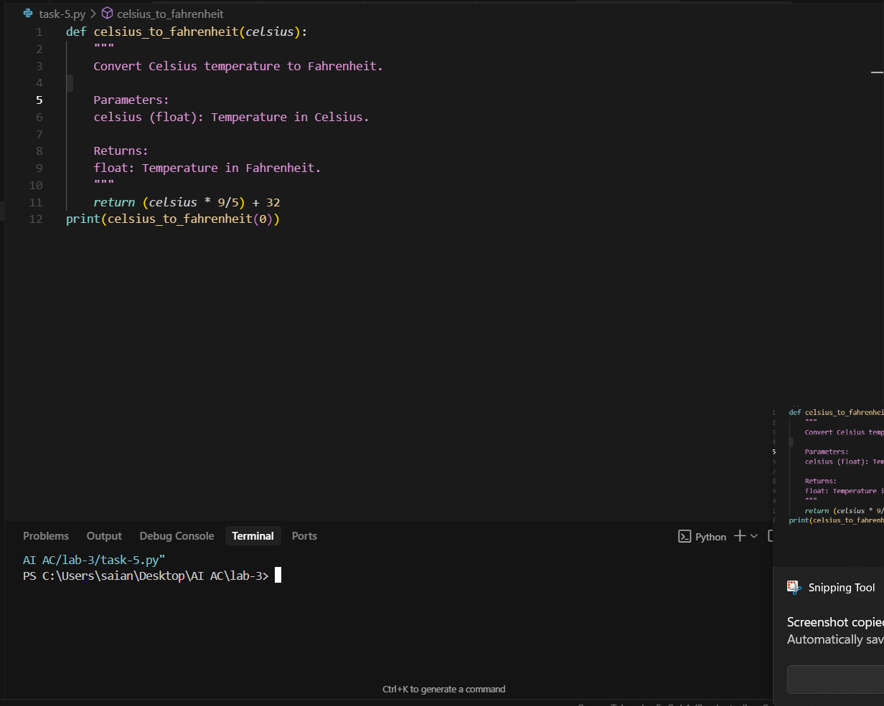  Conclusion:  - The function converts temperature from Celsius to Fahrenheit.  - It applies the standard formula: (Celsius × 9/5) + 32.  - The input is a float representing the Celsius temperature.  - The output is a float representing the Fahrenheit equivalent.  - The function is simple and performs the calculation in one line.  - A clear docstring explains the function’s purpose, input, and output.  - It demonstrates basic mathematical operations in Python.  - The function is reusable in larger temperature conversion programs.  - The sample call celsius_to_fahrenheit(0) correctly returns 32.0.  - Overall, it’s a clean, efficient, and beginner-friendly utility function.  Let me know if you'd like to build a full temperature converter with user input or GUI.  Prompt-2: Write a Python function that converts temperature between Celsius and Fahrenheit, based on user input.  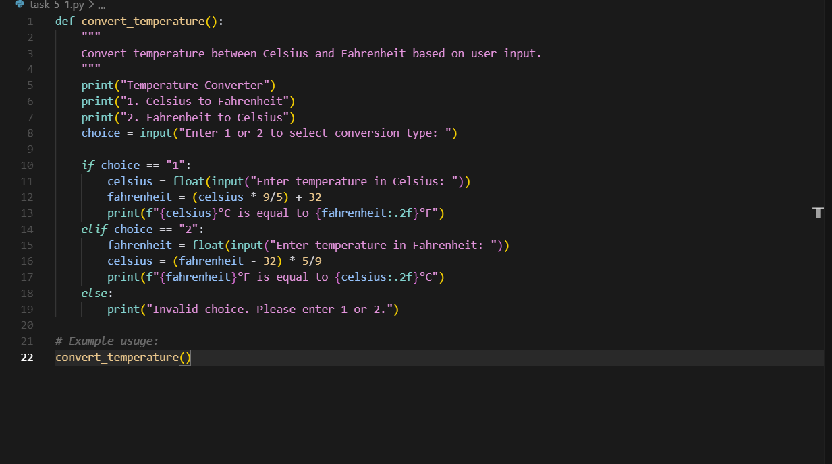  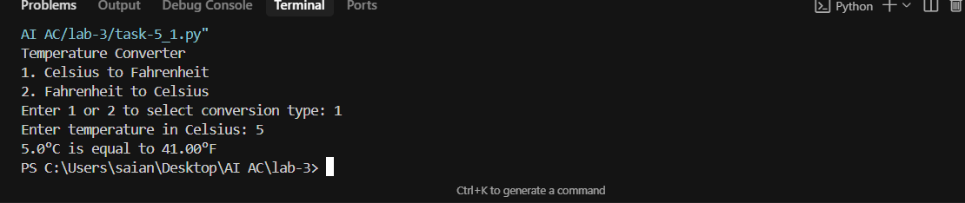  Conclusion:  - The script allows users to convert temperatures between Celsius and Fahrenheit.  - It presents a simple menu with two options for conversion direction.  - User input determines whether to convert from Celsius to Fahrenheit or vice versa.  - The conversion formulas used are mathematically accurate and standard.  - Input values are converted to float for precise temperature handling.  - Results are displayed with two decimal places for clarity and readability.  - The script includes basic input validation for the conversion choice.  - It provides immediate feedback based on user selection and input.  - The function is interactive and beginner-friendly, ideal for learning conditionals and I/O.  - Overall, it’s a practical and well-structured utility for temperature conversion tasks.  Note: Report should be submitted a word document for all tasks in a single document with prompts, comments & code explanation, and output and if required, screenshots  Evaluation Criteria: |  |  |  |  |  | 03.08.2025 EOD
  Criteria | Max Marks
  Factorial Function (Task#1) | 0.5
  Sorting Function (Task#2) | 0.5
  Vogue Vs. Specific Prompting (Task #3) | 0.5
  Linked Functions (Task #4) | 0.5
  Temperature Conversion Function (Task #5) | 0.5
  Total | 2.5 Marks

