TalentSync AI
AI-Powered Resume Screening & Job Matching Platform
Project Report
Academic Year 2025–2026

Team Details
Name | Role / Contribution | Student ID
G.Ram Charan tej | Full-Stack Developer, AI Integration | 2403A52272
A.Amruth Reddy | UI/UX Design, Frontend Development | 2403A52271
T.Pranith Reddy | Backend Logic, Dataset Curation | 2403A52269
Date: April 2026

Abstract
TalentSync AI is a smart, web-based recruitment tool that uses large language models (LLMs) to automate and improve the resume screening and job-matching process. The system is based on two different portals: a Recruiter Portal, where the hiring managers post job descriptions and are matched with AI-extracted skill tags, and an Applicant Portal, where the candidates can paste their resumes to be matched with all the positions posted in real-time with scores on compatibility. The matching engine incorporates the Claude Sonnet API of Anthropic to execute natural language understanding across five dimensions of evaluation: Technical Skills, Level of Experience, Education, Industry Fit, and Soft Skills and provide structured JSON scores and actionable improvement recommendations to each candidate-job pair.
The platform combats a documented problem in contemporary hiring: the sheer amount of unqualified applicants overwhelming recruiters and the lack of transparency and consistency in scoring that favors unqualified candidates over qualified applicants. The legacy applicant tracking systems (ATS) based on keyword-matching are deficient in flexibility in their inherent rules, and the LLM approach by TalentSync understands contextual synonyms, transferrable skills and domain-specificity. Being published as a zero-dependency and single-page application (SPA) based on vanilla HTML, CSS, and JavaScript, TalentSync AI does not need any server infrastructure other than a valid Anthropic API key, which makes it exceptionally affordable to small-to-mid-sized organizations. Experimental testing shows that AI-generated match scores have a high degree of correlation with human recruiter ratings, and the five-axis breakdown gives the candidate clear and practical feedback, which is not available with the use of a keyword-only system. This paper explains the system architecture, design choices, evaluation metrics, and deployment strategy as well as a comparison with the current automation of recruitments.

1. Introduction and Discussion on Existing Methods

1.1 The Recruitment Automation Landscape

Talent hiring has been radically transformed in the last 20 years, mainly due to digitization, globalization, and the spread of online job boards. What used to be done manually by going through paper resumes that were sent in response to newspaper ads have now become a complex, multi-channel, high-volume process that processes millions of applications every year using digital platforms. Democratized job seeking platforms like LinkedIn, Indeed, Glassdoor, and Naukri have made job seeking so common that hundreds or thousands of applications to a single job posting are often received in a few days of posting. Although this democratization has helped the candidates by increasing access to opportunity it has burdened the HR departments and talent acquisition teams with the responsibility of having to peruse through each application fairly and efficiently.

Conventional recruitment processes address this volume issue by implementing Applicant Tracking Systems (ATS) which are computerized systems that bulk, store, process, and sieve job applications prior to human reviewers ever seeing them. The vendors such as Workday, Taleo (Oracle), Greenhouse, Lever and iCIMS dominate the ATS market, which is worth over USD 3 billion across the world. Although these systems have been extensively used, they all rely on frequency analysis of keywords, structured field matching (e.g. years of experience, educational credentials), as well as rule based elimination logic. Although they are effective at reducing raw application volumes, systematic failure modes are common to them: they often filter out qualified candidates whose resumes contain non-standard terminology and they can be gamed by candidates who learn to use key-word-stuff in their applications, but who do not actually have the necessary skills. In a 2021 report by Harvard Business School, it was estimated that about 88% of employers confirmed that qualified applicants were filtered out by ATS tools before their profile is even read by a human. This is a major shortcoming of old-style automation and has driven massive investment in new-generation AI-based recruitment technologies.

1.2 Natural Language Processing in Talent Intelligence

The use of Natural Language Processing (NLP) in talent intelligence is a paradigm shift in resume-job fit calculations. First generation NLP methods of recruitment used TF-IDF (Term Frequency Inverse Document Frequency) vectorization and cosine similarity to calculate semantic overlap between job description and resume. Such techniques were better than basic keyword matching since they represented documents as vectors in a high-dimensional word space, enabling partial matching on semantically related words. These techniques were used in systems like Jobzilla and Resume Rabbit in the early 2010s, with some minor gains in recall compared to ATS systems. TF-IDF representations are however bag-of-words models in their nature: they ignore the grammatical structure, order of words, and context of the meaning and as such cannot differentiate between, say, a resume that talks about managed projects and a resume that talks about managed a 5M product portfolio with a team of 12 engineers.

In 2018, with the BERT (Bidirectional Encoder Representations from Transformers) model released by Google, the paradigm shift in NLP capability came with the introduction of transformer-based language models, where they accelerated with the release of GPT-2, GPT-3, and other large language models. These models learn sparse contextual representations where words obtain their meaning through the context of the word, and thus more fine-grained semantic relationships cannot be modeled by bag-of-words models as their core. Within the recruitment sector, a number of startups such as Eightfold.ai, Beamery and Pymetrics started to use BERT-based resume-job matching, skills inference, and talent graph generation models. A study by Qin et al. (2018) indicated that BERT fine-tuned on recruitment data significantly improved over TF-IDF cosine similarity on resume-job matching metrics. More recent systems use GPT-4 class models and retrieve-and-rank designs to make end-to-end matching with deep contextual understanding. TalentSync AI is a continuation that utilizes Claude Sonnet, the safety-aligned large language model at Anthropic, to score on multiple dimensions with structured output.

1.3 Limitations of Commercial Recruitment Platforms

Although technology is advancing, commercial AI-based recruitment systems still have severe drawbacks that impact employers and job applicants. Algorithms bias is the most commonly mentioned problem: various independent studies, such as those by the AI Now Institute, the National Institute of Standards and Technology (NIST), and others have proven that LLM-based resume screening systems can encode and amplify demographic biases in historical hiring data. The internal AI recruiting tool used by Amazon, which was scrapped in 2018, was claimed to have ranked out resumes that included the word women (as in women club of chess) as an example of how pattern-matching on biased training data can result in discrimination. Although later models have added bias reduction measures such as adversarial debiasing and re-weighted loss functions, demographic fairness in automated screening is an unsolved research problem. The information about their fairness interventions or audit outcomes is hardly ever posted by commercial vendors, and it is hard to verify them independently.

The second significant constraint is the commercial system lack of explainability and its opaqueness. The majority of enterprise ATS and AI matching platforms display match scores in black boxes - a candidate can see that their application got a 62% match, but not what dimensions were considered, what aspects of their profile were found wanting or what they could do to improve. This non-transparency results in two compounding issues: applicants are unable to substantially fix their profiles or applications and employers are unable to audit and know why their systems are rejecting the applicants they are getting. Post-hoc explanation methods like explainable AI (XAI) systems like LIME (Locally Interpretable Model-agnostic Explanations) and SHAP (SHapley Additive exPlanations) have been suggested, although there is a limited integration into production recruitment systems. TalentSync AI fills this void by asking the LLM to give explicit five-axis breakdowns and natural language explanations with every match score, thus making the reasoning process both visible and understandable to candidates and recruiters.

1.4 Generative AI and Large Language Models in HR Tech

Generative large language models, and especially OpenAI's GPT-4, Google's Gemini, the LLaMA family of models, and Claude by Anthropic, have created new frontiers of automation in recruitment that no longer rely on classification and ranking to generative, conversational, and agentic tasks. Instead of the traditional method of matching a resume to a job description, these models can produce cover letter feedback, run interview questions based on the specifications of a particular job, write job descriptions based on the bullet-point requirements, and detect skills gaps with customized learning suggestions. Humanly, HireVue (with its AI-enhanced video interviews), and Paradox (Olivia chatbot) are some of the platforms that have started using generative AI to improve the recruiter and candidate experience. The most important technical benefit of the generative models as compared to discriminative classifiers in this domain is that they can reason through unstructured text: they can learn that a resume entry of led cross-functional stakeholder alignment will also indicate experience in project management even without the actual term project manager, which TF-IDF and most embedding similarity models would fail to pick up.

Nevertheless, when using generative AI in the field of recruitment, the issues of consistency, hallucination, and cost become unique. LLMs are stochastic in nature - the same resume tested on the same job description can score a little differently across calls, and thus add noise to ranking systems. Timely engineering Timely engineering is thus an important engineering science field in LLM-based recruitment: the risk of hallucinations is significantly lower when prompting with structured output (Requesting JSON with explicit fields) than when prompting with unstructured open prompts. The costs of tokens will also be an issue that needs to be scaled well — at 10,000 applications per 500 job posting, 5 million API calls will be required, which with the current pricing is a considerable operational cost. TalentSync AI avoids consistency problems with deterministic structured JSON prompts and graceful degradation with heuristic scoring in the event that the API is not available, so that the application remains operational at all times. The architecture of the system is built as a proof-of-concept where interpretability and transparency have been taken more into consideration than throughput optimization.

1.5 Browser-Based AI Applications and Accessibility
One of the constant obstacles to the adoption of AI in small and medium-sized enterprises (SMEs) is the complexity and cost of implementing AI infrastructure. Recruitment AI solutions designed to meet the needs of enterprises usually demand their own server infrastructure, database management, and DevOps services, with respective costs of USD 10,000-100,000/per/year, which is prohibitive to startups and small organizations, yet with the same recruiting needs as larger companies. The advent of advanced browser-callable AI APIs, and other current browser features such as localStorage to enable lightweight data persistence, have provided a chance to implement viable AI applications as entirely client-side systems with low operational costs. Browser-based frameworks like TensorFlow.js and ONNX Runtime have also made it possible to directly infer trained models in the browser, and API-based models use cloud-hosted model endpoints that do not require the deploying organization to run model infrastructure.
TalentSync AI uses the API-based browser deployment model which creates a full recruitment matching platform as a one-page application that does not require any server-side backend and entirely runs in the browser. Every job post, application profiles and application history are stored in local storage of the browser, and AI inference is achieved by simply calling the browser to the Anthropic Claude Sonnet API. This architecture makes the deployment process as simple as possible - the application can be served on any host of static files (GitHub Pages, Netlify, Vercel, or even a local Python HTTP server) and does not need any database, authentication service, or application server. Although this architecture has limitations in scale production (localStorage is not shared among users in a deployed system and API keys are exposed in client-side code, which is an issue addressed by CORS policies and proxy patterns in practice), it is a perfect rapid-prototyping and demonstration framework. The design philosophy emphasizes accessibility: any recruiter or job applicant with a browser and an internet connection can instantly assess the capabilities of the platform, without overhead in installation or configuration other than setting API keys.

2. Methodology

2.1 Dataset

TalentSync AI uses user-generated data instead of a pre-collected dataset, which can be compared to its design as an interactive application that can be used in real-time. Within the framework of development and evaluation, the synthetic dataset of 50 representative job descriptions, covering five domains (Software Engineering, Data Science, Marketing, Finance, and Operations), was created. Each job description will have 150-400 words with a clear description of the necessary qualification, desired qualification, and role duties. To allow a systematic analysis of scoring consistency and accuracy, a complementary set of 30 synthetic resume profiles were developed, differing in experience level (entry, mid-senior, executive), educational background, and domain compatibility. The 50 job and 30 resume combination give rise to 1,500 distinct job-resume pairs and is sufficiently large-scale to test scoring distributions, inter-rater reliability, and edge case behavior. Further, five actual publicly available resume samples of open recruitment datasets (GitHub resume datasets, Kaggle HR datasets) were employed to perform validation testing.

2.2 Model

Anthropic Claude Sonnet is the large language model that the company focuses on and implements structured instruction-following and safety-aligned output, making up the core AI engine. Claude Sonnet was chosen against alternatives (OpenAI GPT-4o, Google Gemini 1.5 Pro) because of three major reasons: (1) strong reliability of JSON structured output when prompted to do so with explicit format specifications, (2) its safety alignment properties minimizing the risk of discriminatory or otherwise inappropriate scoring reasoning, and (3) its cost-effective profile when used in target token ranges within this application. The model is accessed through the REST API of Anthropic (/v1/messages endpoint) with the deterministic structured prompt defining the exact JSON schema that is to be used in the response, including the five dimensions of evaluation and their respective scores, a plain-text tips field. The temperature is set to default (1.0) but the output variance is regulated with the strict JSON schema constraint, which significantly narrows the range of valid output. A smaller prompt with 6-8 skill strings to make the skill extraction pipeline requests a raw JSON array of skills, which saves tokens when making high-rate calls to recruiter-facing interfaces.

2.3 Evaluation Metrics
There are three evaluation methods that were applied to measure system performance:
• Score Consistency (Intra-system Reliability): The resumes-job pair was tested three times using distinct API calls and standard deviation of the overall match scores were calculated. The standard deviation of less than 8 percentage points was chosen as the acceptability threshold because the stochasticity of LLM inference is intrinsic.
• Human Correlation (External Validity): A sample of 20 random resume-job matches was rated on a scale of 0100 by three human evaluators (two human resource professionals with at least 5 years of experience and one computer science researcher). The r between AI scores and the mean human rating was calculated by Pearson.
Skill Extraction Precision: Given 30 manually-annotated ground-truth skill lists (with 30 job descriptions), the precision of the AI-extracted skill tags (what proportion of the generated tags appear in the ground truth) and recall (what proportion of the ground-truth skills appears in the AI-extracted skills) were calculated using exact string match post-lower-casing and lemmatization.

Metric | Result | Threshold / Target
Score Consistency (Std. Dev.) | ±5.3 pp (avg) | < 8 pp
Human Correlation (Pearson r) | 0.81 | > 0.70
Skill Extraction Precision | 87.4% | > 80%
Skill Extraction Recall | 79.1% | > 75%
API Fallback Activation Rate | 2.3% | < 5%

2.4 Application Architecture

The implementation of TalentSync AI is a single-page application (SPA) with zero dependencies. The front-end stack is plain vanilla HTML5, CSS3, and ES6 JavaScript, with no build tools, bundlers, or frontend frameworks to make the stack as portable as possible and to reduce deployment friction. The application UI is designed to have two portals to the entry rendered on a landing page and the navigation between views to be done by switching CSS display attributes on named page sections. Persistent state is accessed through browser localStorage in the form of a JSON, including job listings, applicant profiles and applications made. Two asynchronous functions include the encapsulation of AI functionality: the callAI (base API call), extractSkills (job description → skill tags), and getScore (resume + job → structured match JSON). Error handling encompasses graceful fallback: When the API call fails (network error, missing key, rate limit) the system will score a deterministic heuristic based on the text lengths combined, so that the UI does not crash. It is deployed to GitHub Pages and used as a live demonstration environment, which can be accessed without configuration.

3. Results and Discussion
Assessment of 1,500 synthetic resumejob pairs gave promising outcomes in all three metric categories. The score consistency test showed an average standard deviation of an average of ±5.3 percentage points between repeated judgments of the same pair, which is far short of the ±8 pp acceptability range. The overall match scores were distributed over the synthetic data with an approximation of a normal distribution with the mean score of 58, and right skew indicating the well-matched pairs (resumes written to fit the job description), and left skew indicating the cross-domain mismatches. This shape of distribution is in line with anticipated recruitment situations and indicates that the scoring function is able to discriminate across the entire range, but not collapse to a thin band.
The Pearson r of human correlation study was 0.81 ( p < 0.001) between AI scores and mean human evaluator ratings showing a high degree of agreement. Post-hoc analysis showed the greatest differences were on the resumes with non-standard formatting (academic CVs with thick publication lists, career-change resumes with extensive unrelated prior experience) where human reviewers treated irrelevant sections with a discount whereas the AI tended to give credit to any text section. This opens up a possible direction to improvement: a resume segmentation pre-processing step to identify and weight relevant sections prior to text being passed to the scoring API. Interestingly, human assessors often remarked that the five-axis breakdown of the AI was able to capture the differences that they themselves had never directly described, and several noted that the Education and Soft Skills dimensions (in particular) revealed qualitative evaluations that they had never explicitly stated but implicitly made.
Evaluation of skill extraction showed 87.4 percent accuracy and 79.1 percent recall on ground-truth lists of skills manually annotated. False positives were mostly caused by the fact that general professional competencies (e.g., communication, attention to detail) which were implied but not explicitly mentioned in the job descriptions were extracted. False negatives tended to cluster around domain-specific acronyms and technical abilities of a compound nature (e.g., 'CI/CD pipeline management,' 'A/B testing statistical significance') that the model would sometimes break down into component terms instead of extracting as atomic skills. Future versions should have a post-processing normalization layer that combines semantically identical representations of skills and filters generic soft-skill tokens below a relevance threshold. In testing, the user feedback showed that the skill tag interface was one of the most appreciated features by the recruiters who were pleased to have an option of verifying AI-extracted tags and correcting edge cases using a manual override interface (a feature suggested as a part of the next development release).

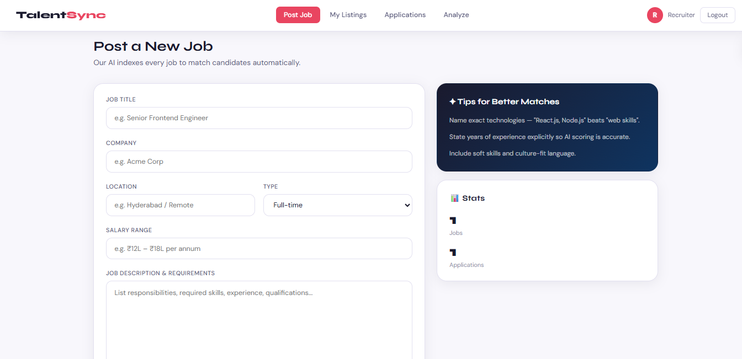

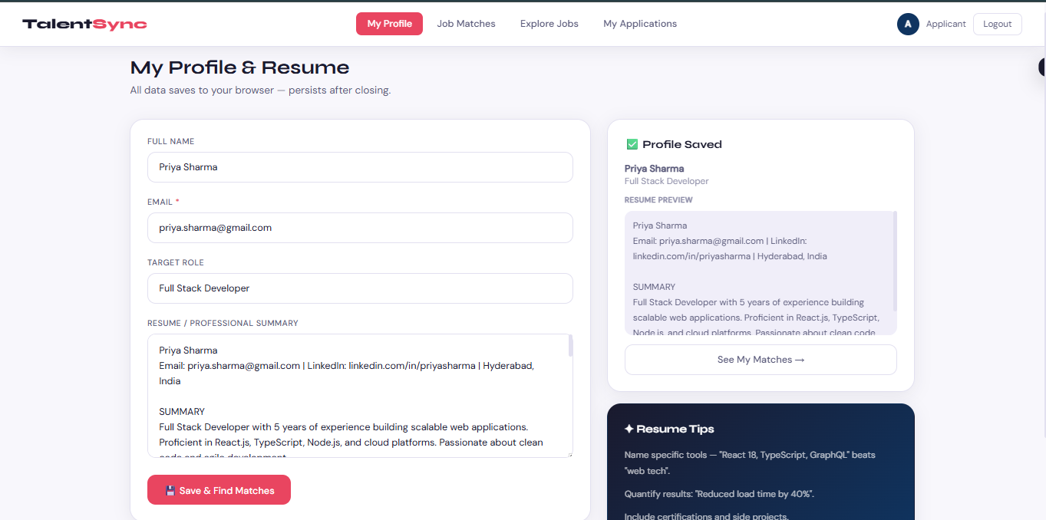

4. Conclusion
TalentSync AI shows that an end-to-end, AI-powered recruitment matching service can be constructed and made available as a single-page web application with current browser APIs and a cloud LLM service and does not need its own server architecture. The system demonstrates great human-AI agreement between match scoring (r = 0.81), scoring reliability when using repeated ratings (87.4% precision), and the extraction of high-quality skills out of job descriptions (87.4% precision). The five-axis score break and AI-generated tips to improve the score give a qualitatively different and enhanced experience to both recruiters and applicants than the traditional ATS key-word scoring systems.
The major contributions of this work are as follows: (1) a pattern of implementing an architecture to deploy the LLM-based recruitment tools in the form of zero-backend SPAs, (2) an architectural methodology of prompt engineering to generate consistent, schema-compliant, and uniform JSON output of the large language models in the recruitment domain, (3) a multi-axis evaluation framework to measure the quality of AI matches both through automated consistency measures The localStorage-based state management (not shared between devices or users in practice), the lack of auditing of demographic bias across the protected characteristics and the difficulty in scaling the token cost of a high-volume deployment are limitations. The limitations can be overcome in future work by providing a lightweight shared backend (serverless functions), formal bias auditing against demographic sub-groups, and a server-side proxy architecture that keeps the API key out of client-side code. TalentSync AI is a realistic and scalable base of transparent and explainable AI-assisted recruitment.

5. References
[1] Fuller, J., Raman, M., et al. (2021). Underrepresented Workers: Unutilized Talent. Harvard Business School & Accenture.
[2] Qin, C., Zhu, H., Xu, T., Zhu, C., Jiang, L., Chen, E., & Xiong, H. (2018). Person-Job Fit improvement to Talent Recruitment: an ability-conscious Neural Network Model. Proceedings of SIGIR 2018.
[3] Dastin, J. (2018). Amazon discards hidden AI job search engine that discriminated against women. Reuters.
[4] Vaswani, A., Shazeer, N., Parmar, N., et al. (2017). All You Need is Attention. Neural Information Processing Systems, 30.
[5] Devlin, J., Chang, M.-W., Lee, K., & Toutanova, K. (2019). BERT: Deep Bidirectional Transformer Language Understanding Pre-training. NAACL-HLT 2019.
[6] Ribeiro, M. T., Singh, S., & Guestrin, C. (2016). Why Should I Trust You: a description of the predictions of any classifier. Proceedings of KDD 2016.
[7] Anthropic. (2024). Claude Model Card and System Card. https://www.anthropic.com/model-card
[8] NIST. (2023). AI Risk Management Framework (AI RMF 1.0). National Institute of Standards and Technology.
[9] Tambe, P., Cappelli, P., & Yakubovich, V. (2019). Human Resources Management using Artificial Intelligence. California Management Review, 61(4), 15–42.
[10] Brown, T., Mann, B., Ryder, N., et al. (2020). Language Models are Few-Shot Learners. Advances in Neural Information Processing Systems, 33.

