SCHOOL OF COMPUTER SCIENCE AND ARTIFICIAL INTELLIGENCE |  |  |  | DEPARTMENT OF COMPUTER SCIENCE ENGINEERING
ProgramName:B. Tech |  |  | Assignment Type: Lab |  |  | AcademicYear:2025-2026
CourseCoordinatorName |  |  | Venkataramana Veeramsetty
Instructor(s)Name |  |  | Dr. V. Venkataramana (Co-ordinator)  Dr. T. Sampath Kumar  Dr. Pramoda Patro  Dr. Brij Kishor Tiwari  Dr.J.Ravichander  Dr. Mohammand Ali Shaik  Dr. Anirodh Kumar  Mr. S.Naresh Kumar  Dr. RAJESH VELPULA  Mr. Kundhan Kumar  Ms. Ch.Rajitha  Mr. M Prakash  Mr. B.Raju  Intern 1 (Dharma teja)  Intern 2 (Sai Prasad)  Intern 3 (Sowmya)  NS_2 ( Mounika)
CourseCode |  | 24CS002PC215 | CourseTitle |  | AI Assisted Coding
Year/Sem |  | II/I | Regulation |  | R24
Date and Day  of Assignment |  | Week4 - Wednesday | Time(s)
Duration |  | 2 Hours | Applicableto  Batches
AssignmentNumber:9.3(Present assignment number)/24(Total number of assignments)
 | Q.No. | Question |  |  |  |  | ExpectedTime  to complete
 | Lab 8: Documentation Generation: Automatic documentation and code comments  Lab Objectives:  - To understand the importance of documentation and code comments in software development.  - To explore how AI-assisted coding tools can generate meaningful documentation and inline comments.  - To practice generating function-level and module-level docstrings automatically.  - To evaluate the quality, accuracy, and limitations of AI-generated documentation.  - To develop a small automated tool for documentation generation in Python..  Lab Outcomes (LOs):  After completing this lab, students will be able to:  - Apply AI-assisted coding tools to generate docstrings and inline comments for Python code.  - Critically analyze AI-generated documentation for correctness, completeness, and readability.  - Create structured documentation (function-level, module-level) following standard formats.  - Design and implement a mini documentation generator tool to automate code commenting and docstring creation.  Task Description#1 Basic Docstring Generation  - Write python function to return sum of even and odd numbers in the given list.  - Incorporate manual docstring in code with Google Style  - Use an AI-assisted tool (e.g., Copilot, Cursor AI) to generate a docstring describing the function.  - Compare the AI-generated docstring with your manually written one.  Expected Outcome#1: Students understand how AI can produce function-level documentation.  CODE:  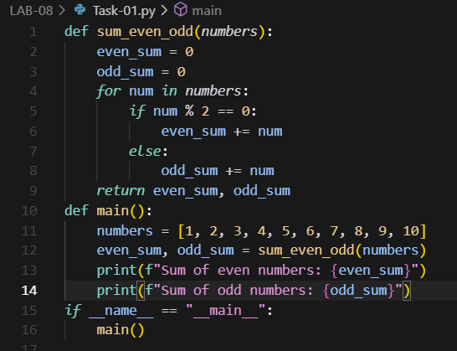  OUTPUT:  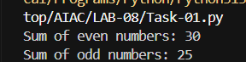  DOCSTRING:  def sum_even_odd(numbers):  """  Takes a list of numbers and figures out the total of all even ones and all odd ones.  Returns both sums as a tuple: (even_sum, odd_sum).  Handy when you want to separate the two for analysis or display.  """  even_sum = 0  odd_sum = 0  for num in numbers:  if num % 2 == 0:  even_sum += num  else:  odd_sum += num  return even_sum, odd_sum  def main():  """  Just a quick demo: creates a list of numbers from 1 to 10,  runs them through sum_even_odd(), and prints out the results.  Nothing fancy—just showing how it works.  """  numbers = [1, 2, 3, 4, 5, 6, 7, 8, 9, 10]  even_sum, odd_sum = sum_even_odd(numbers)  print(f"Sum of even numbers: {even_sum}")  print(f"Sum of odd numbers: {odd_sum}")  if __name__ == "__main__":  main()  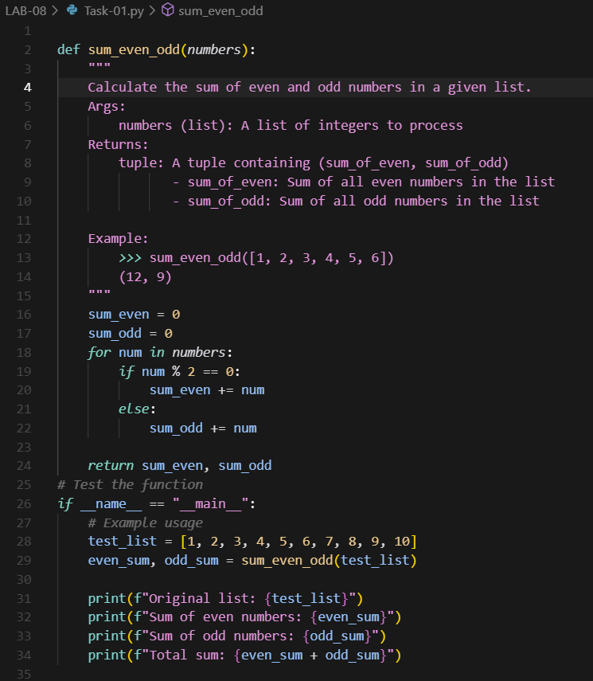  COMPARISION:  The first code uses a casual, conversational docstring—great for quick understanding and informal projects. It’s easy to read but lacks structure for documentation tools. The second code adopts a formal, well-structured docstring with clear Args, Returns, and an example, making it ideal for professional or shared codebases. Functionally, both codes do the same thing, but the second version adds a total sum printout for completeness. Overall, the second is more documentation-friendly, while the first is more beginner-friendly.  Task Description#2 Automatic Inline Comments  - Write python program for sru_student class with attributes like name, roll no., hostel_status and fee_update method and display_details method.  - Write comments manually for each line/code block  - Ask an AI tool to add inline comments explaining each line/step.  - Compare the AI-generated comments with your manually written one.  Expected Output#2: Students critically analyze AI-generated code comments.  CODE:  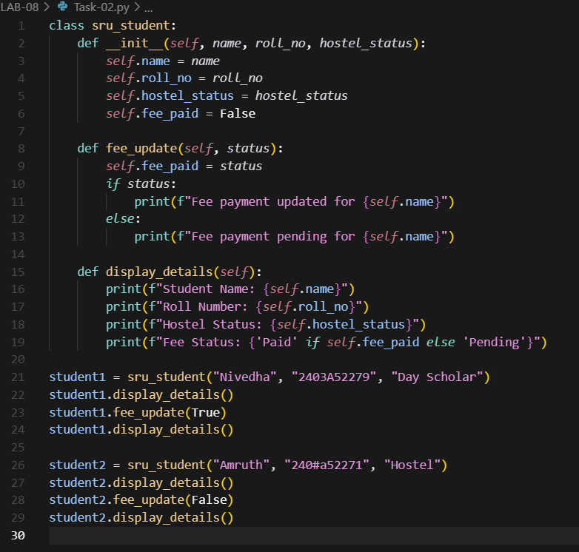  OUTPUT:  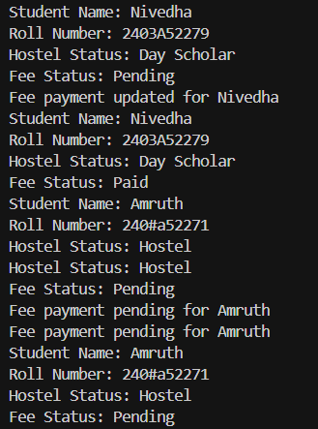  DOCSTRING:  class sru_student:  """  Represents a student at SRU with basic details like name, roll number,  hostel status, and fee payment status. Useful for tracking individual  student records and updating fee info.  """  def __init__(self, name, roll_no, hostel_status):  """  Initializes the student with name, roll number, and hostel status.  Fee status is set to unpaid by default.  """  self.name = name  self.roll_no = roll_no  self.hostel_status = hostel_status  self.fee_paid = False  def fee_update(self, status):  """  Updates the fee payment status for the student.  Prints a message based on whether the fee is paid or pending.  """  self.fee_paid = status  if status:  print(f"Fee payment updated for {self.name}")  else:  print(f"Fee payment pending for {self.name}")  def display_details(self):  """  Displays all the student details including name, roll number,  hostel status, and current fee payment status.  """  print(f"Student Name: {self.name}")  print(f"Roll Number: {self.roll_no}")  print(f"Hostel Status: {self.hostel_status}")  print(f"Fee Status: {'Paid' if self.fee_paid else 'Pending'}")  student1 = sru_student("Nivedha", "2403A52279", "Day Scholar")  student1.display_details()  student1.fee_update(True)  student1.display_details()  student2 = sru_student("Amruth", "240#a52271", "Hostel")  student2.display_details()  student2.fee_update(False)  student2.display_details()  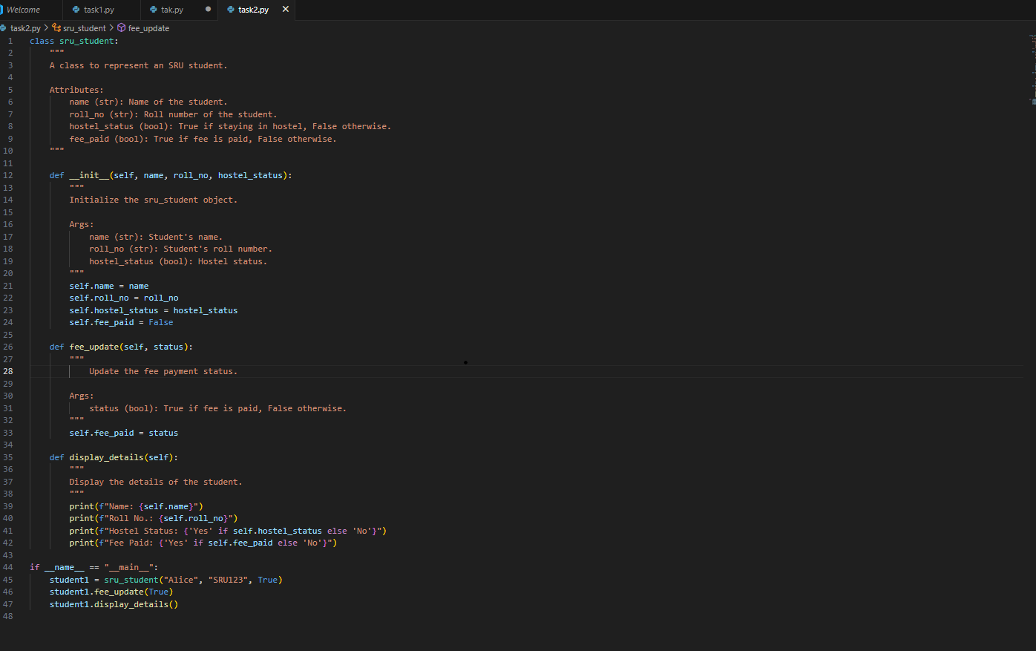  COMPARISION:  # First Implementation:  """  A class to represent an SRU student.  Attributes:  name (str): Name of the student.  roll_no (str): Roll number of the student.  hostel_status (bool): True if staying in hostel, False otherwise.  fee_paid (bool): True if fee is paid, False otherwise.  """  # Second Implementation:  # No class-level docstring is present.  # __init__ method docstrings:  # First Implementation:  """  Initialize the sru_student object.  Args:  name (str): Student's name.  roll_no (str): Student's roll number.  hostel_status (bool): Hostel status.  """  # Second Implementation:  # No docstring for __init__ method.  # fee_update method docstrings:  # First Implementation:  """  Update the fee payment status.  Args:  status (bool): True if fee is paid, False otherwise.  """  # Second Implementation:  """  Updates the fee payment status.  Args:  status (bool): True if fee is paid, False otherwise.  """  # display_details method docstrings:  # First Implementation:  """  Display the details of the student.  """  # Second Implementation:  """  Displays the student's details.  """  # CONCLUSION:  # - The first implementation provides a class-level docstring and docstrings for __init__, fee_update, and display_details methods.  # - The second implementation only provides docstrings for fee_update and display_details methods, and omits the class-level and __init__ docstrings.  # - The first implementation's docstrings are more descriptive and follow a structured format.  Task Description#3  - Write a Python script with 3–4 functions (e.g., calculator: add, subtract, multiply, divide).  - Incorporate manual docstring in code with NumPy Style  - Use AI assistance to generate a module-level docstring + individual function docstrings.  - Compare the AI-generated docstring with your manually written one.  Expected Output#3: Students learn structured documentation for multi-function scripts  CODE & OUTPUT:  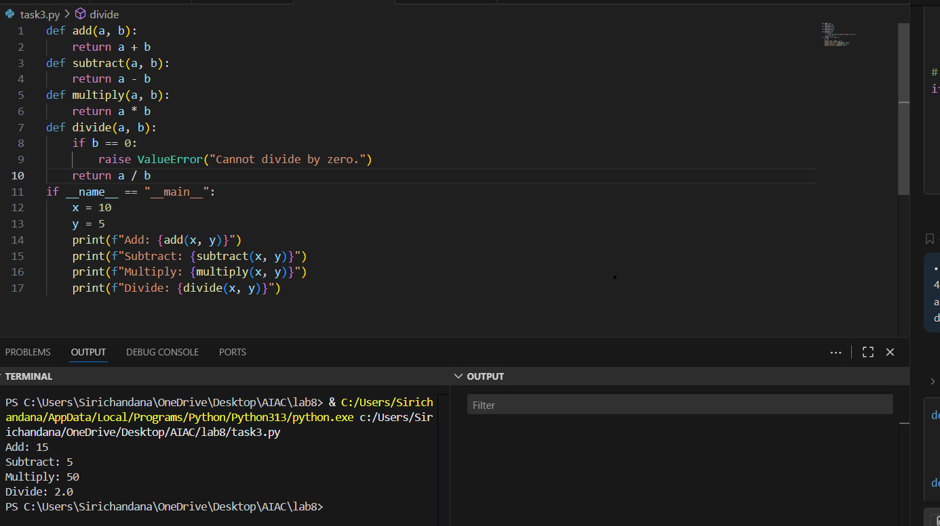  DOC STRING:  """  This script provides basic calculator functions: add, subtract, multiply, and divide.  Functions:  add(a, b): Returns the sum of a and b.  subtract(a, b): Returns the difference of a and b.  multiply(a, b): Returns the product of a and b.  divide(a, b): Returns the division of a by b. Raises ValueError if b is zero.  """  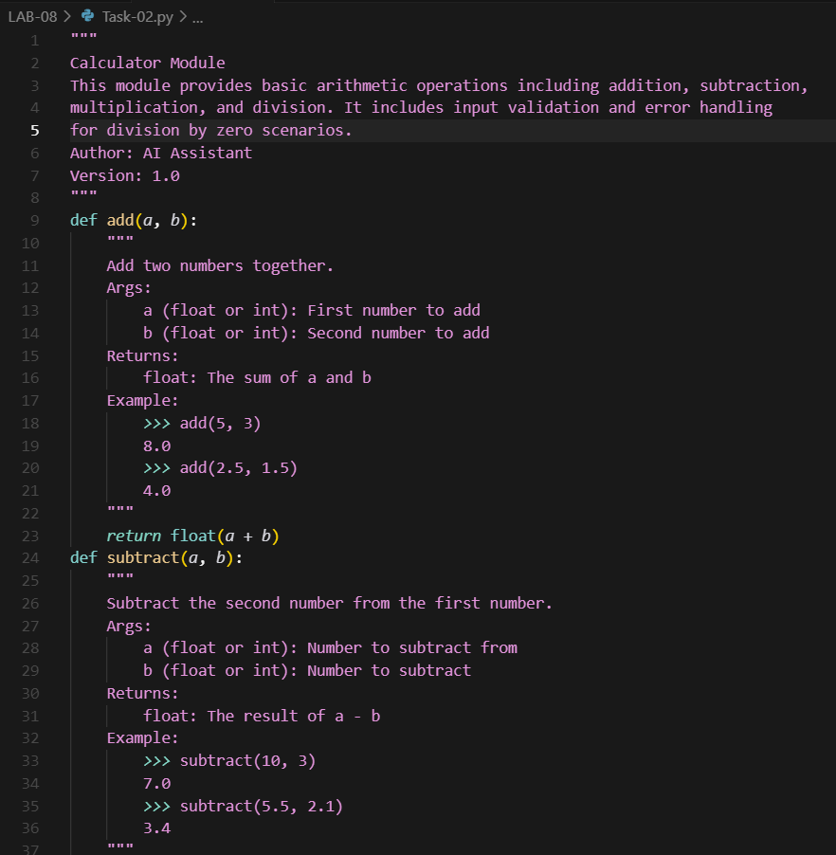  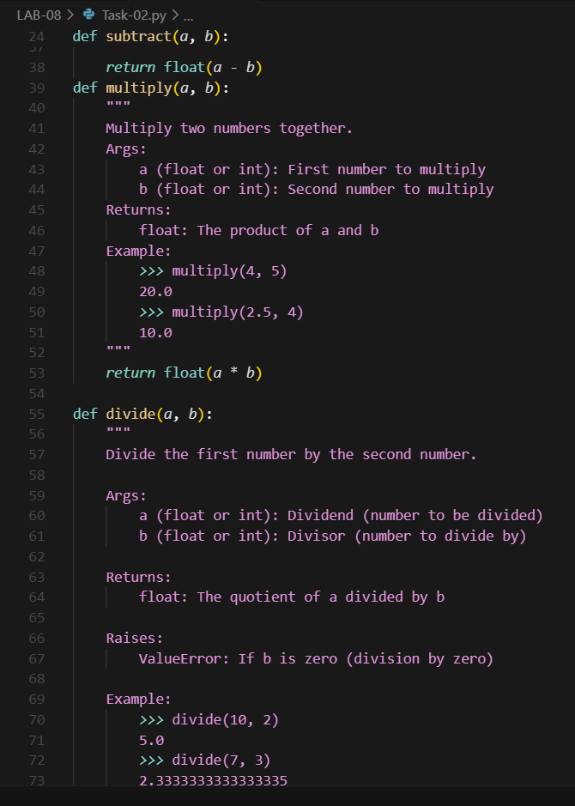  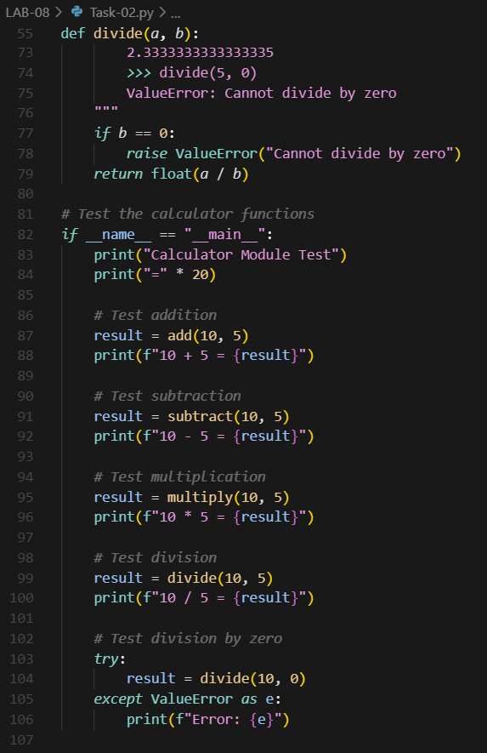  COMPARISION:  """  This script provides basic calculator functions: add, subtract, multiply, and divide.  Functions:  add(a, b): Returns the sum of a and b.  subtract(a, b): Returns the difference of a and b.  multiply(a, b): Returns the product of a and b.  divide(a, b): Returns the division of a by b. Raises ValueError if b is zero.  """  Push documentation whole workspace as .md file in GitHub Repository  Note: Report should be submitted a word document for all tasks in a single document with prompts, comments & code explanation, and output and if required, screenshots |  |  |  |  |  | Week4 - Wednesday

