SCHOOL OF COMPUTER SCIENCE AND ARTIFICIAL INTELLIGENCE |  |  |  |  | DEPARTMENT OF COMPUTER SCIENCE ENGINEERING
ProgramName:B. Tech |  |  |  | Assignment Type: Lab |  |  | AcademicYear:2025-2026
CourseCoordinatorName |  |  |  | Venkataramana Veeramsetty
Instructor(s)Name |  |  |  | 1. Dr. Mohammed Ali Shaik  2. Dr. T Sampath Kumar  3. Mr. S Naresh Kumar  4. Dr. V. Rajesh  5. Dr. Brij Kishore  6. Dr Pramoda Patro  7. Dr. Venkataramana  8. Dr. Ravi Chander  9. Dr. Jagjeeth Singh
CourseCode |  |  | 24CS002PC215 | CourseTitle |  | AI Assisted Coding
Year/Sem |  |  | II/I | Regulation |  | R24
Date and Day  of Assignment |  |  |  | Time(s)
Duration |  |  | 2 Hours | Applicableto  Batches
AssignmentNumber:3.3(Present assignment number)/24(Total number of assignments)
 | Q.No. | Question |  |  |  |  |  | ExpectedTime  to complete
 | 1 | Lab 3: Prompt Engineering – Improving Prompts and Context Management  Lab Objectives:  - To understand how prompt structure and wording influence AI-generated code.  - To explore how context (like comments and function names) helps AI generate relevant output.  - To evaluate the quality and accuracy of code based on prompt clarity.  - To develop effective prompting strategies for AI-assisted programming.  Lab Outcomes (LOs):  After completing this lab, students will be able to:  - Generate Python code using Google Gemini in Google Colab.  - Analyze the effectiveness of code explanations and suggestions by Gemini.  - Set up and use Cursor AI for AI-powered coding assistance.  - Evaluate and refactor code using Cursor AI features.  - Compare AI tool behavior and code quality across different platforms.  Task Description#1  - Try 3 different prompts to generate a factorial function.  Expected Output#1  - Comparison of AI-generated code styles  Prompt 1 : # develop a python function to print factorial 5  CODE:  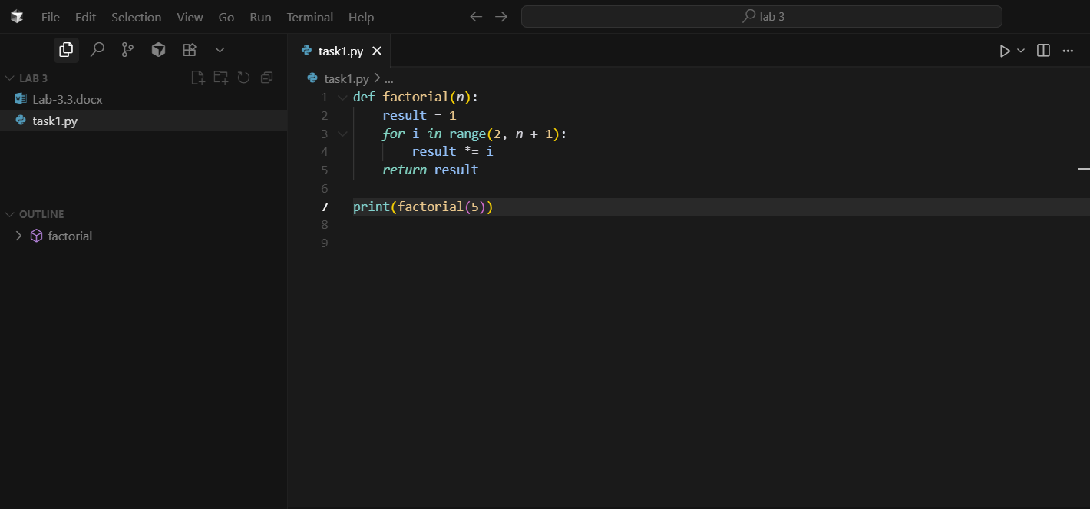  OUTPUT:  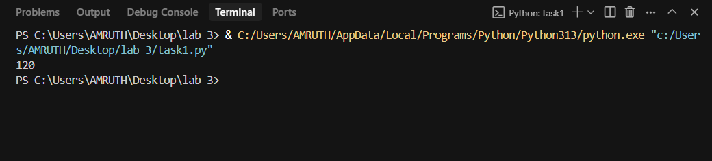  Prompt 2: # develop a python program which prints the factorial numbers which entered by the user  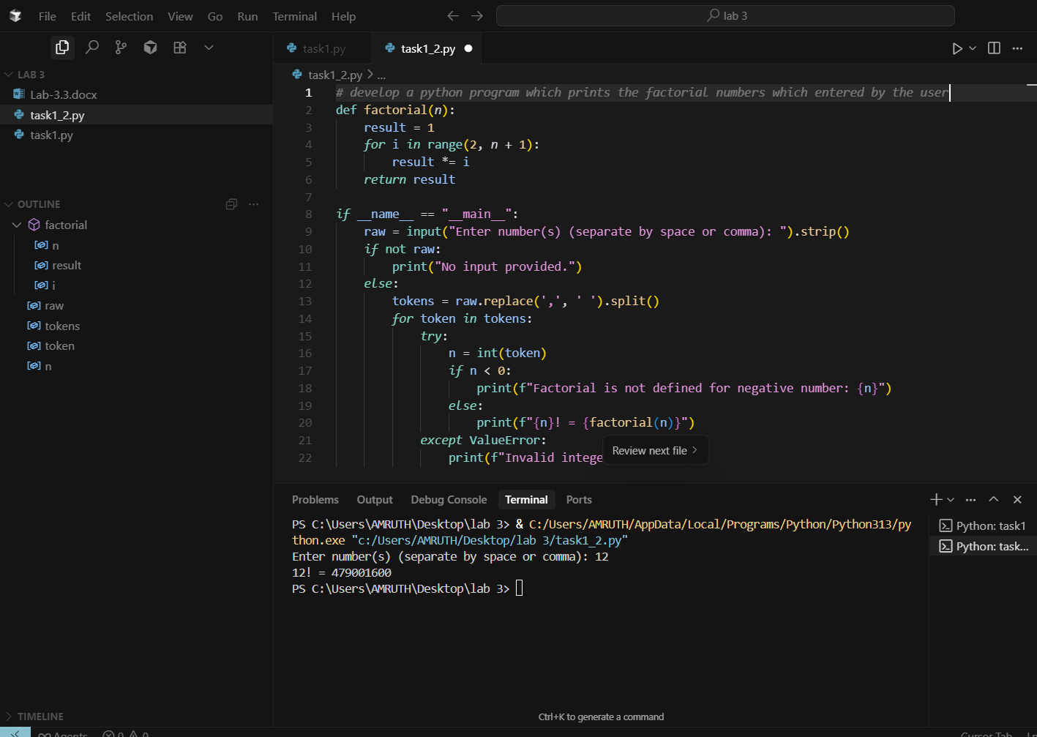  Prompt 3: #develop a python program which prints 1 to 20 factorials  CODE:  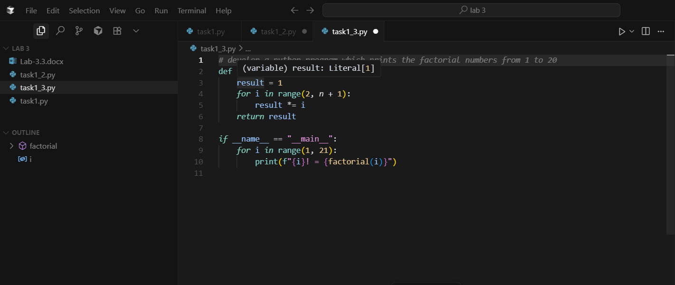  OUTPUT:  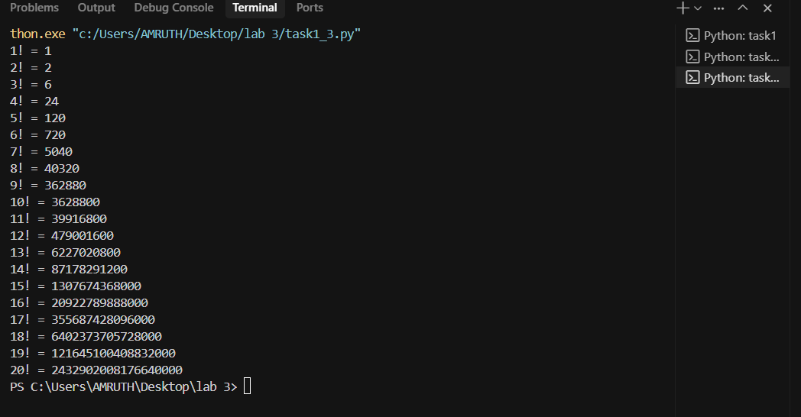  Report:  --------  case 1: in case 1 I have given a prompt to print only factorial of 5  Case 2: in case 2 I have made a prompt that to develop the python program to enter the factorial number by user manually  Case 3: I have made prompt which make and prints 1 to 20 factorials  Task Description#2  - Provide a clear example input-output prompt to generate a sorting function.  Expected Output#2  - Functional sorting code from AI  Prompt : # make a python program which sorts the numbers in descending order and then it sorts into ascending order  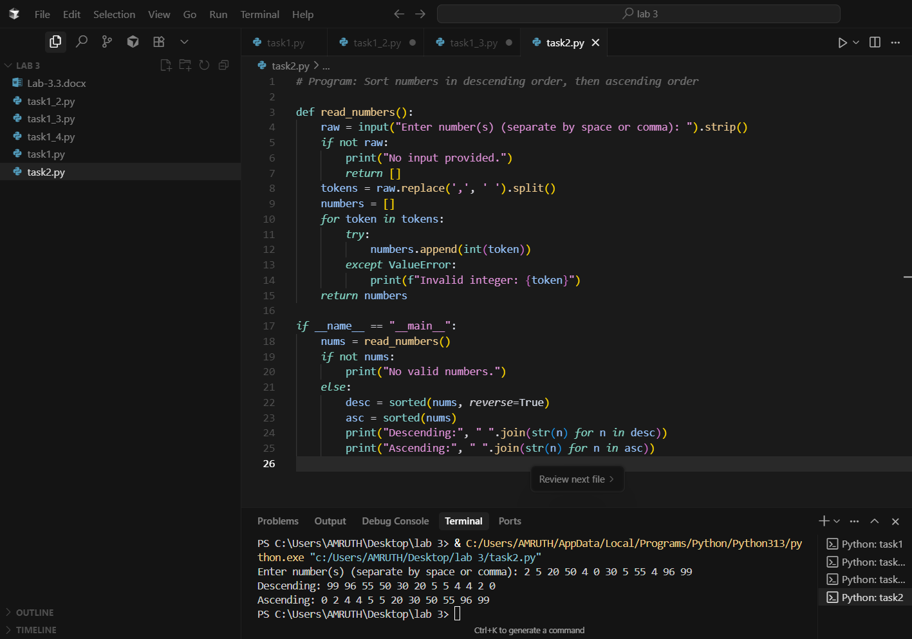  Task Description#3  - Start with the vague prompt “Generate python code to calculate power bill” and improve it step-by-step  Expected Output#3  - Enhanced AI output with clearer prompts  Prompt 1: # develop a python program which calculates power bill  CODE:  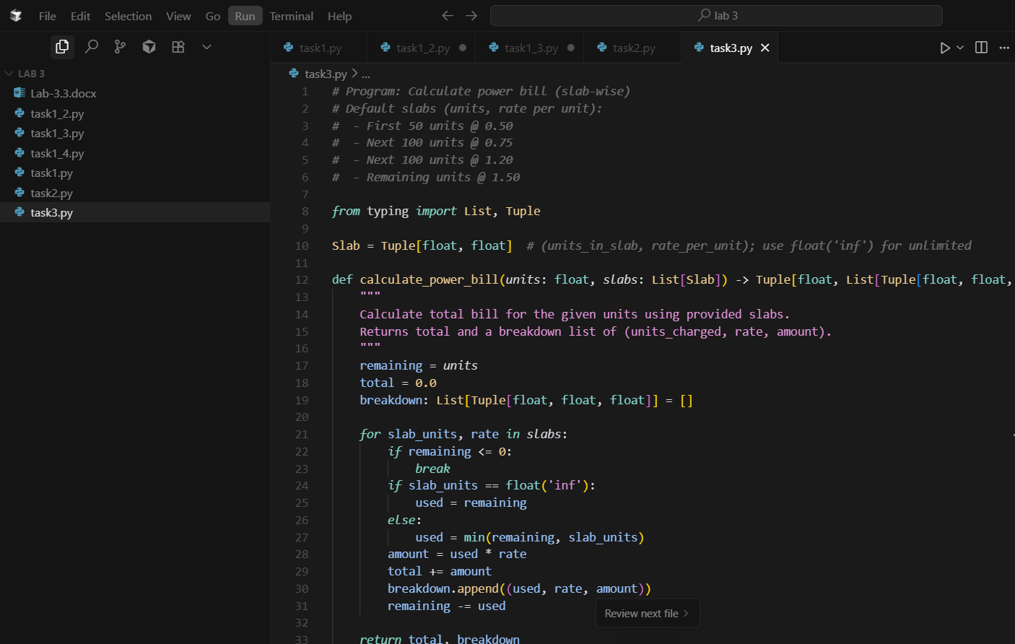  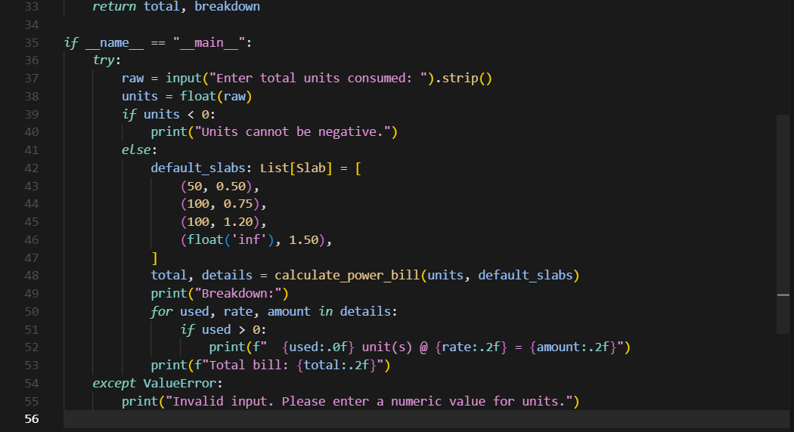  OUTPUT:  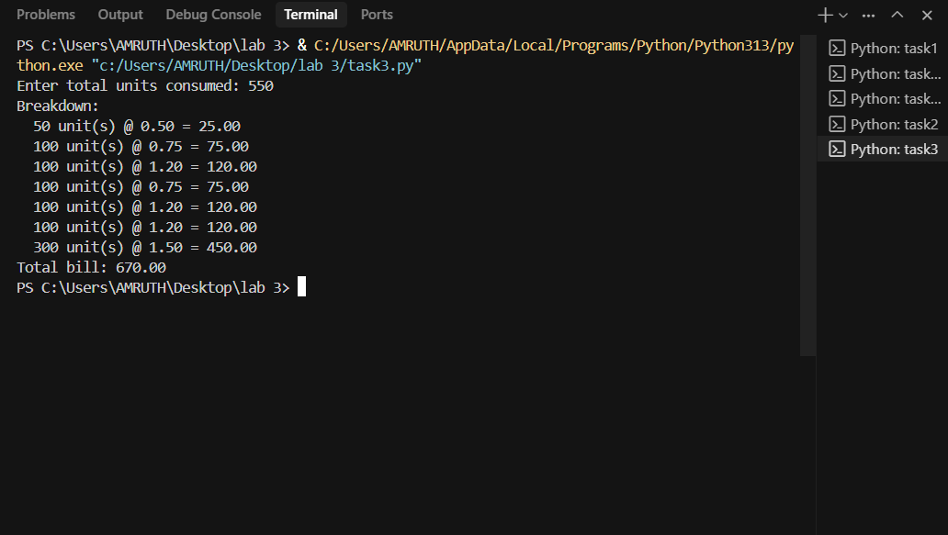  Prompt 2 : # develop a python program which calculates power bill and it asks whether it is commercial , residential or industrial then it prints the cost  CODE:  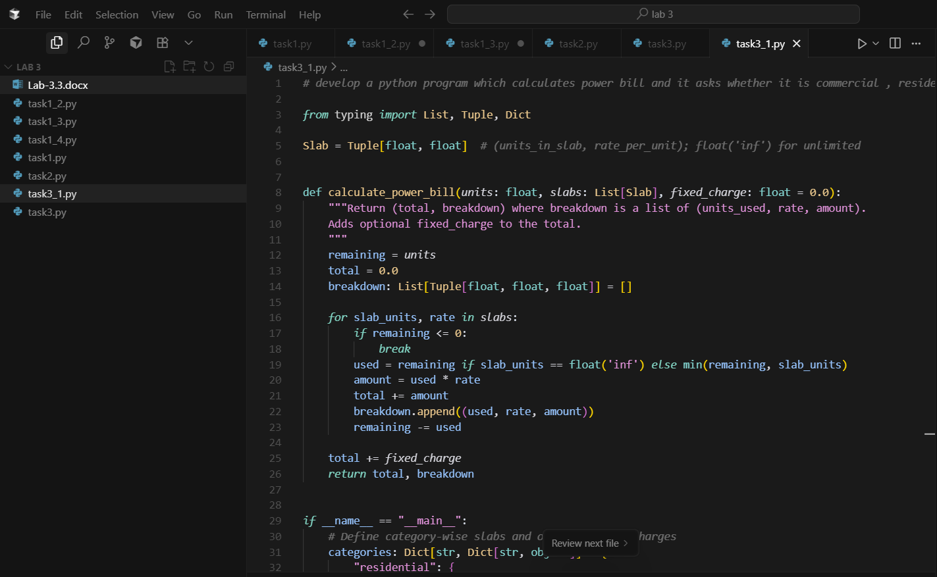  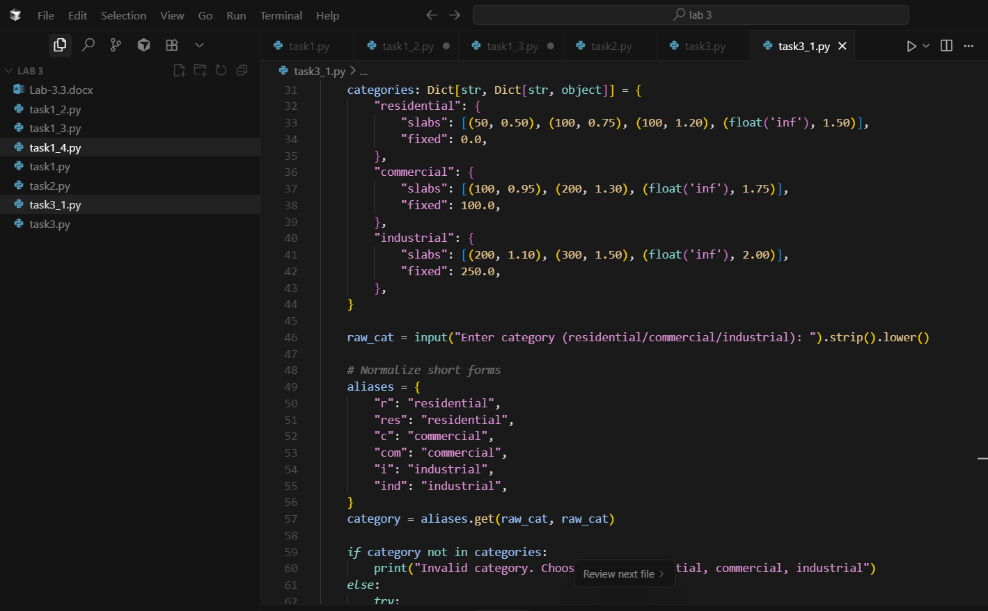  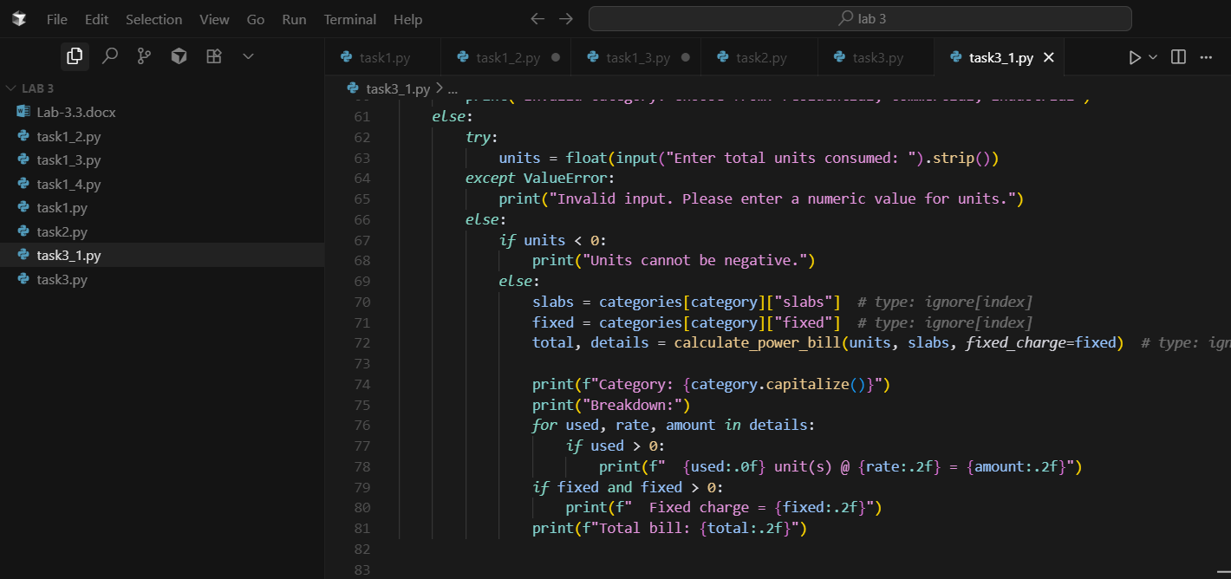  OUTPUT:  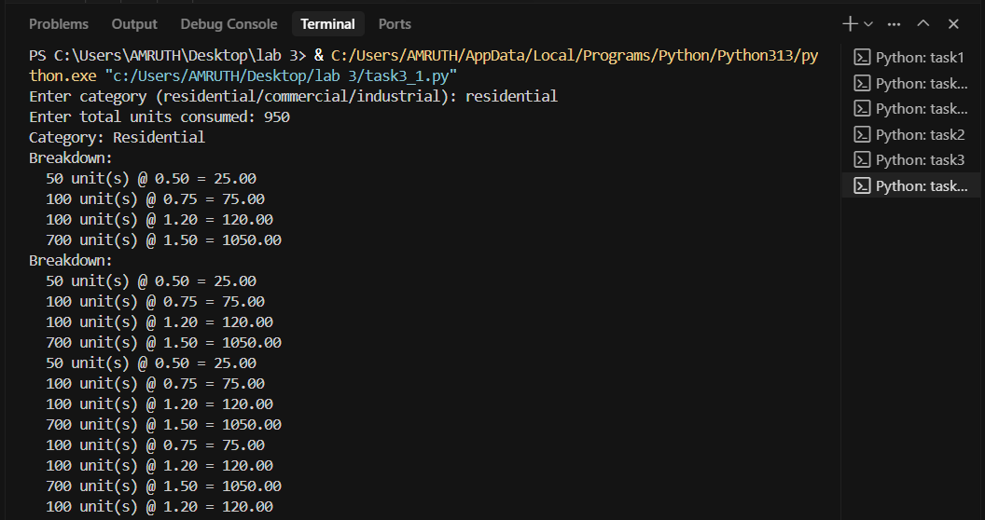  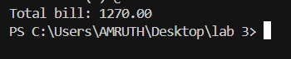  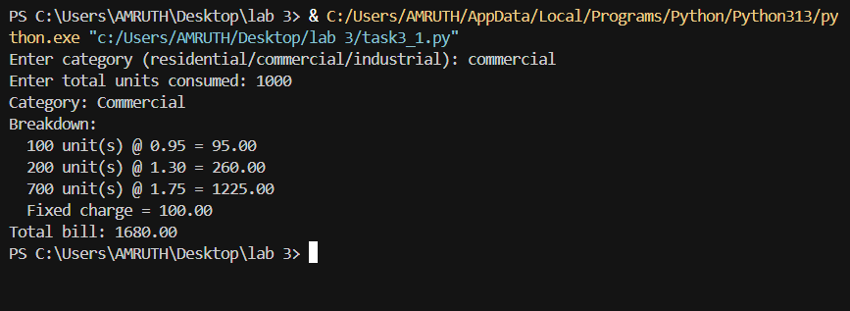  Report : in task 3 I have made a power bill calculator which calculates the power bill after entering the units but we don’t know that either residential or commercial or anything else so I have added category option in task3_1.py this makes easier to identify.  Task Description#4  - Write structured comments to help AI generate two linked functions (e.g., login_user() and register_user()).  Expected Output#4  - Consistent functions with shared logic  Prompt : #Write Python code that creates two linked functions: register_user() and login_user().  CODE:  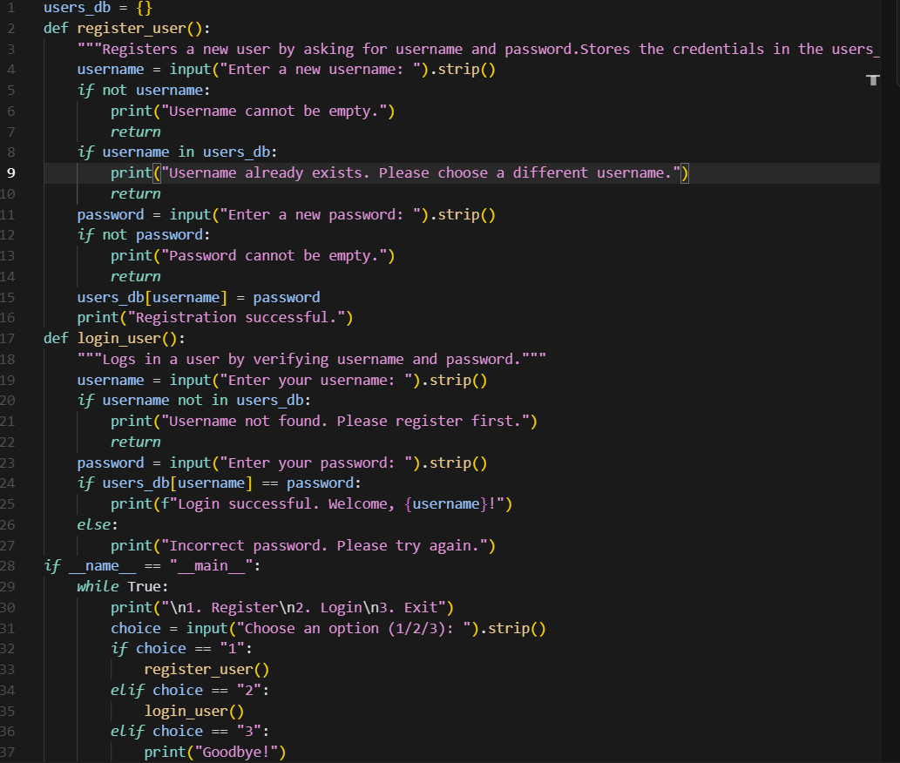  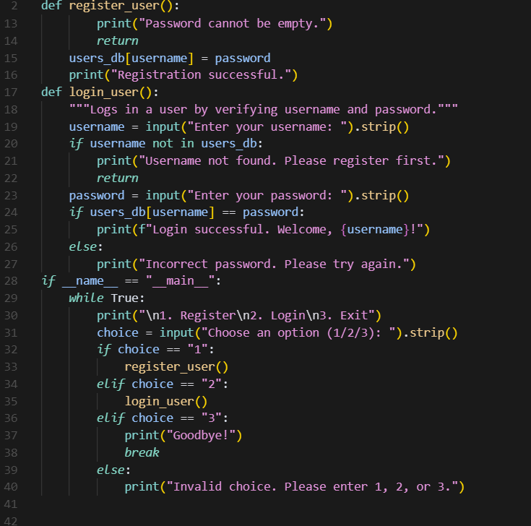  OUTPUT:  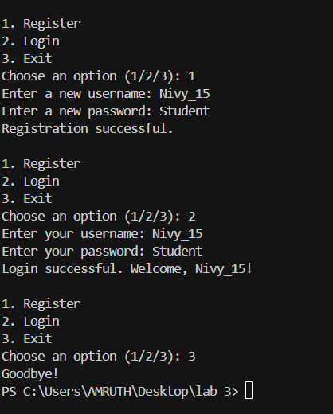  Task Description#5  - Analyzing Prompt Specificity: Improving Temperature Conversion Function with Clear Instructions  Expected Output#5  - Code quality difference analysis for various prompts  PROMPT:  - Write a code for Improving Temperature Conversion Function with Clear Instructions  CODE: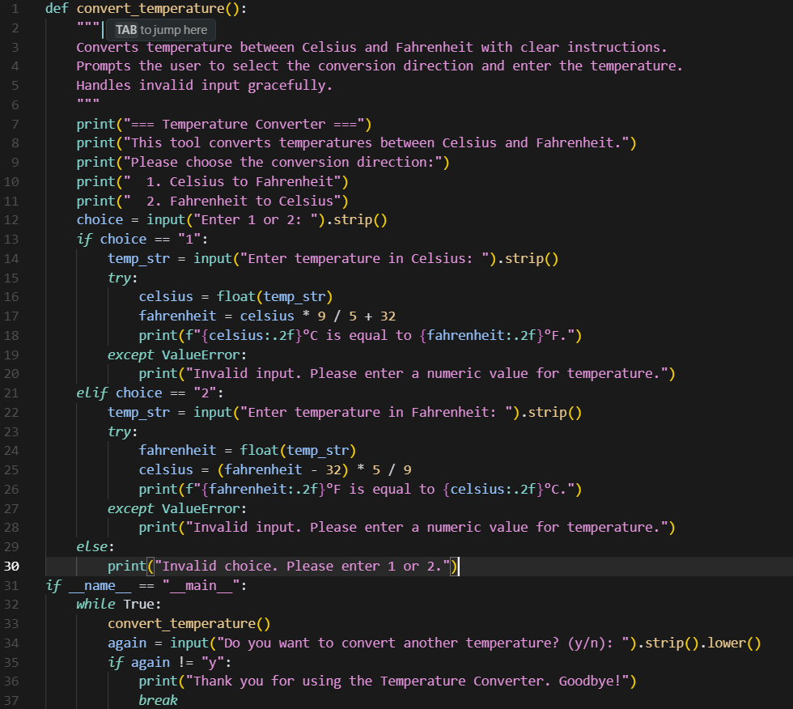  OUTPUT:  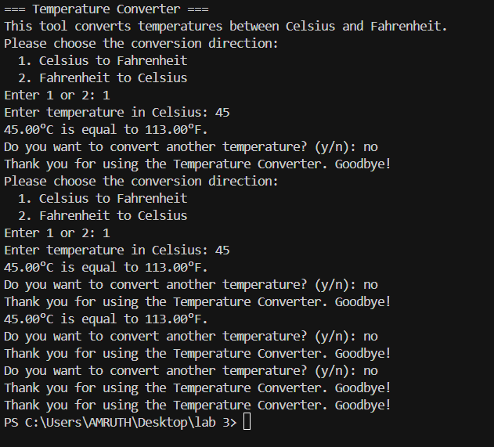  Note: Report should be submitted a word document for all tasks in a single document with prompts, comments & code explanation, and output and if required, screenshots  Evaluation Criteria:  Criteria Max Marks  Factorial Function (Task#1) 0.5  Sorting Function (Task#2) 0.5  Vogue Vs. Specific Prompting (Task #3) 0.5  Linked Functions (Task #4) 0.5  Temperature Conversion Function (Task #5) 0.5  Total 2.5 Marks |  |  |  |  |  | 03.08.2025 EOD

