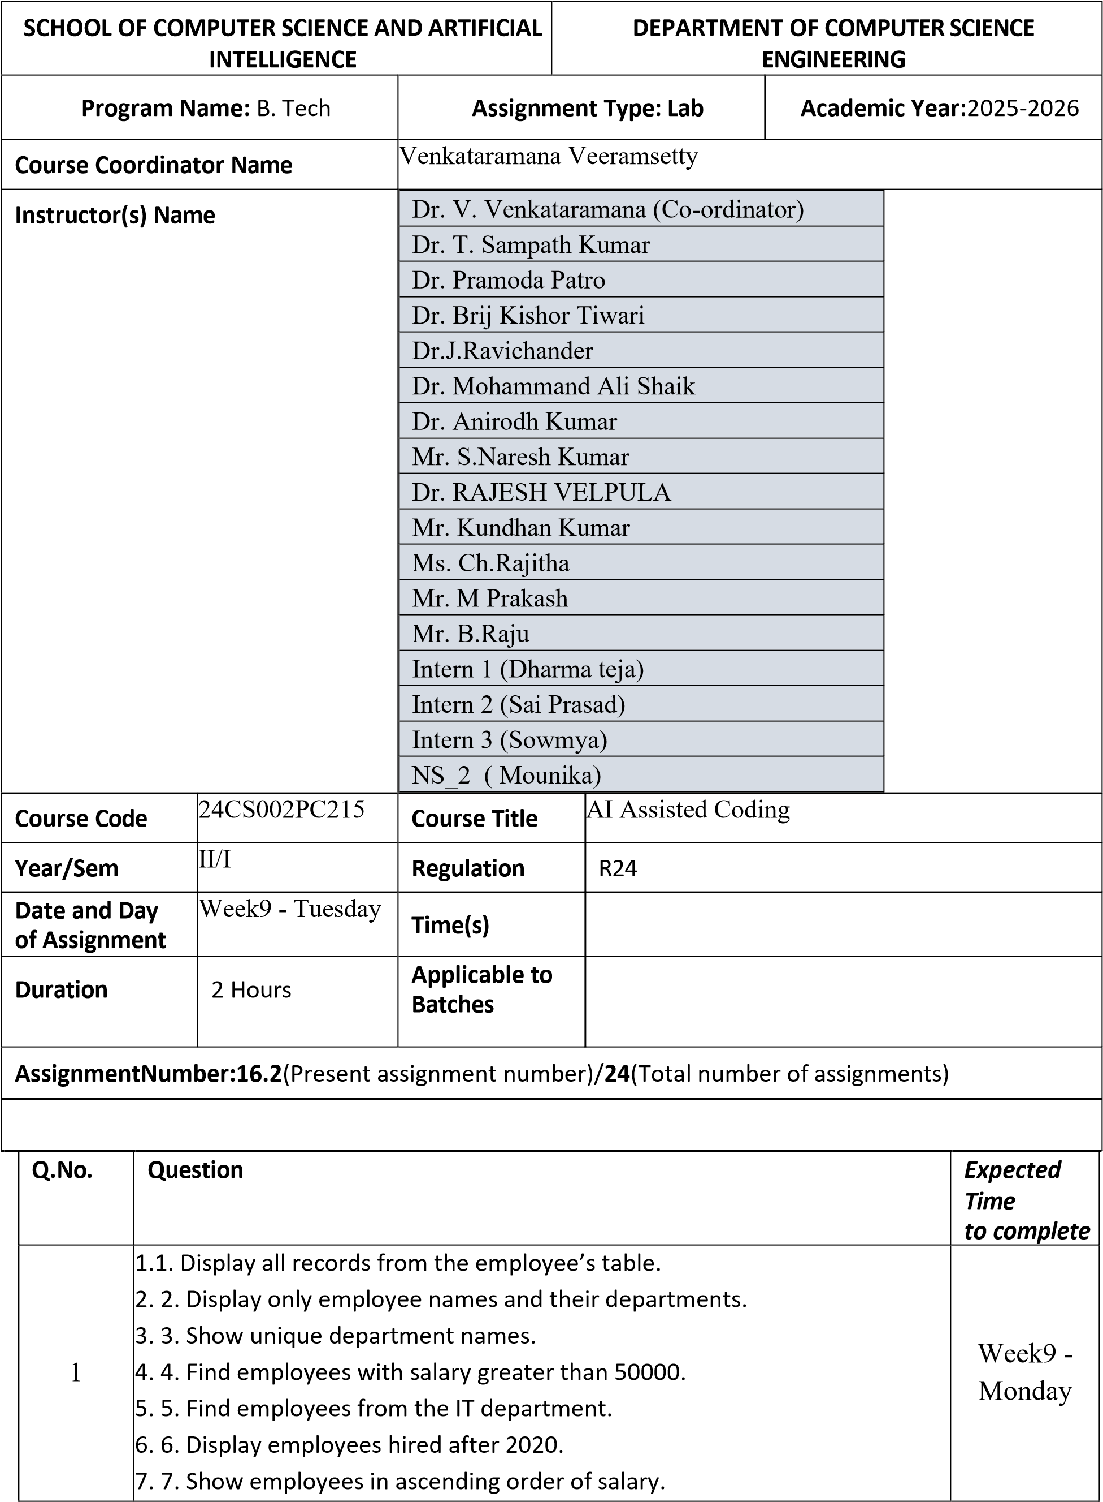

- 8. Show top 3 highest-paid employees.
- 9. Count total employees in the company.
- 10. Find the average salary of employees.
- 11. Find the highest and lowest salary.
- 12. Find total salary expenditure per department.
- 13. Display departments having more than one employee. 14. 14. Show average salary by department.;
- 15. Count employees hired each year.
- 16. List employees with their department locations.
- 17. Find employees working in Bangalore.
- 18. Display all employees even if they don’t belong to a department.
- 19. Find departments with no employees.
- 20. Count employees in each department.
- 21. Find employees earning above average salary.
- 22. Find the department with the highest average salary.
- 23. Find employees hired most recently.
- 24. Find employees earning the second highest salary.
- 25. Find all employees in the same department as 'Amit Sharma'.
- 26. Increase salary by 10% for IT employees.
- 27. Change department of employee 'Ravi' to Marketing.
- 28. Delete employees with salary below 40000.
- 29. Add a new column 'email' to employees.
- 30. Update email IDs for all employees.
- 31. Find top 2 departments by average salary.
- 32. Find how many employees work in each city.
- 33. Show employee count and total salary together.
- 34. Display employees with names starting with 'A'.
- 35. Display employees whose last name ends with 'a'.
- 36. Find employees hired in 2020.
- 37. Show number of days since each employee was hired.
- 38. Display employee names in uppercase.
- 39. Concatenate first and last names.
- 40. Find employees whose salary is between 45000 and 60000.
- 41. Create a view for high salary employees (>55000).
- 42. Display all records from the view.
- 43. Add NOT NULL constraint to department name.
- 44. Drop the view.
- 45. Rename the employees table to staff.
- 46. Create a backup copy of the employees table.
- 47. Delete all data but keep the structure.
- 48. Drop the employees backup table.
- 49. Create an index on employee last name.
- 50. Drop the index.

Employee Table
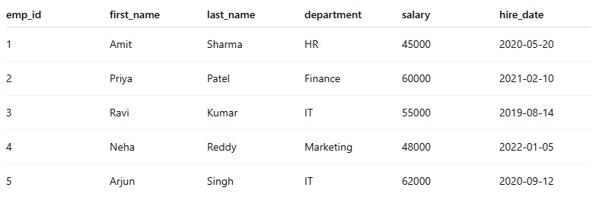

Department Table

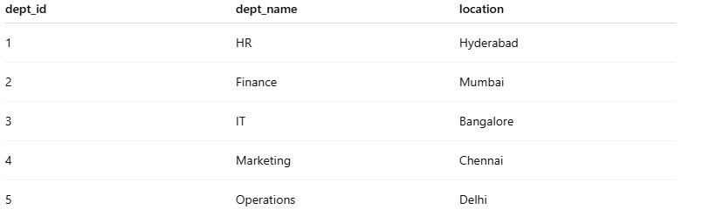

CODE:
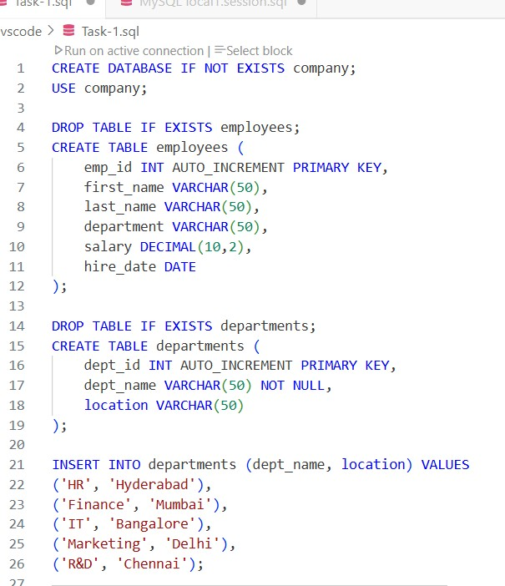
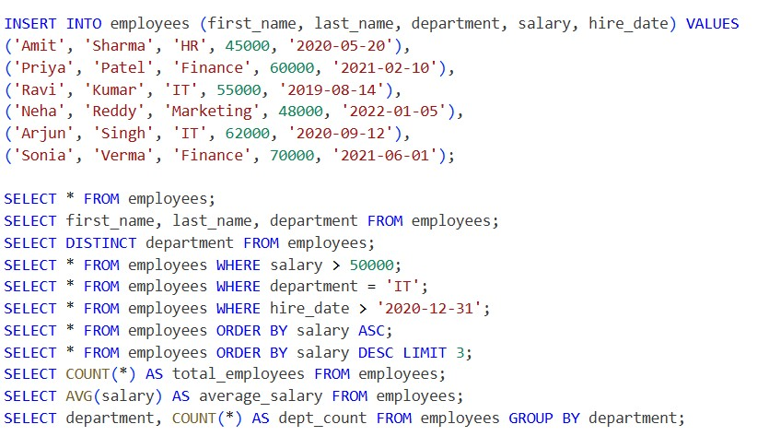
OUTPUT:
