ASSIGNMENT-1.1
TASK 1: : Factorial without Functions
- Description:
Use GitHub Copilot to generate a Python program that calculates the factorial of a number without defining any functions (using loops directly in the main code).
- CODE:
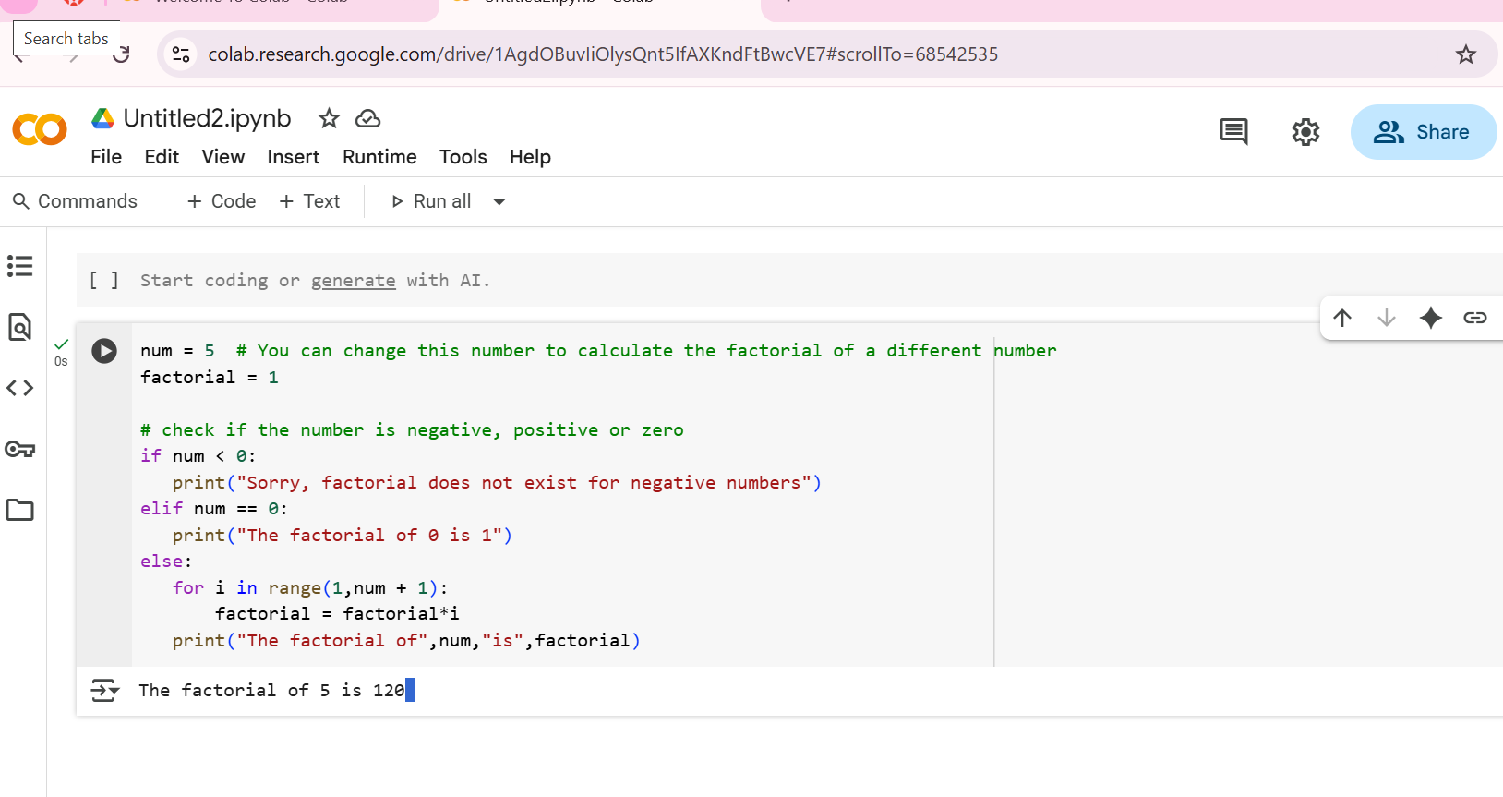
- Explain:
- num = 5: This line initializes a variable called num with the value 5. This is the number for which the factorial will be calculated. You can change this value to find the factorial of a different number.
- factorial = 1: This line initializes a variable called factorial to 1. This variable will store the calculated factorial value. The factorial of any non-negative integer is 1 if the integer is 0, and for positive integers, it is the product of all positive integers up to that number. We start with 1 because multiplying by 1 doesn't change the result.
- if num < 0:: This is a conditional statement that checks if the value of num is less than 0. Factorials are not defined for negative numbers.
- print("Sorry, factorial does not exist for negative numbers"): If num is negative, this line will be executed, printing a message indicating that the factorial does not exist for negative numbers.
- elif num == 0:: This is another conditional statement that is checked if the first condition (num < 0) is false. It checks if the value of num is equal to 0.
- print("The factorial of 0 is 1"): If num is 0, this line will be executed, printing that the factorial of 0 is 1 (which is the mathematical definition of the factorial of 0).
- else:: This block is executed if neither of the previous conditions (num < 0 or num == 0) is true. This means num must be a positive integer.
- for i in range(1,num + 1):: This is a for loop that iterates from 1 up to and including the value of num. The variable i will take on each of these values in turn.
- factorial = factorial*i: Inside the loop, this line multiplies the current value of factorial by the current value of i and updates the factorial variable with the result. This repeatedly multiplies factorial by 1, then 2, then 3, and so on, up to num.
- print("The factorial of",num,"is",factorial): After the loop finishes (meaning all numbers from 1 to num have been multiplied), this line prints the final result, showing the original number and its calculated factorial.
Task 2:

Code:
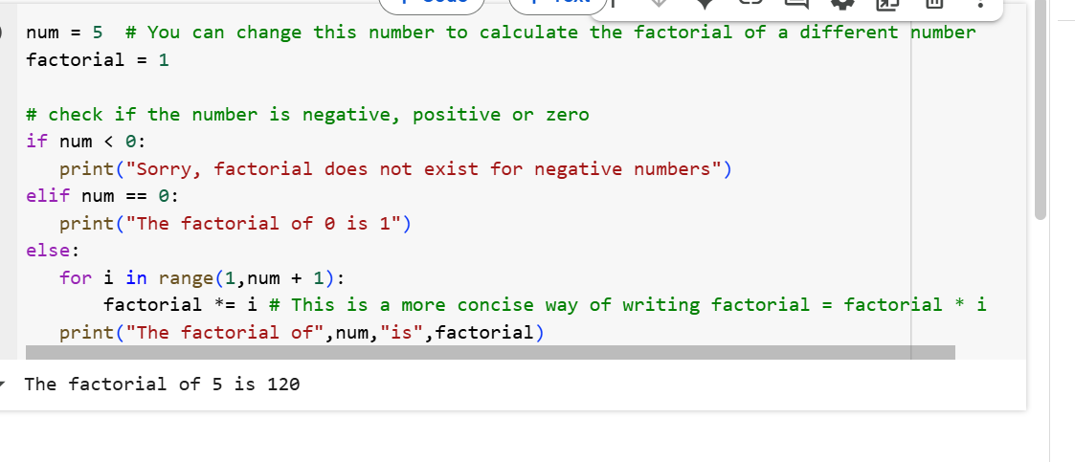

Explain:
The core logic of the code remains the same: it calculates the factorial of a given number. The primary change for conciseness is in this line:
factorial *= i
This is a shorthand operator in Python. It's equivalent to writing:
factorial = factorial * i
Both lines perform the same operation: they multiply the current value of factorial by the value of i (the current number in the loop) and then store the result back into the factorial variable. Using *= is just a more compact way to express this.
The rest of the code functions as explained before:
- It initializes num to the number for which the factorial is to be calculated and factorial to 1.
- It checks for negative numbers and zero as special cases.
- For positive numbers, it iterates from 1 up to num, multiplying factorial by each number in the range.
- Finally, it prints the calculated factorial.

Task 3:
Code:
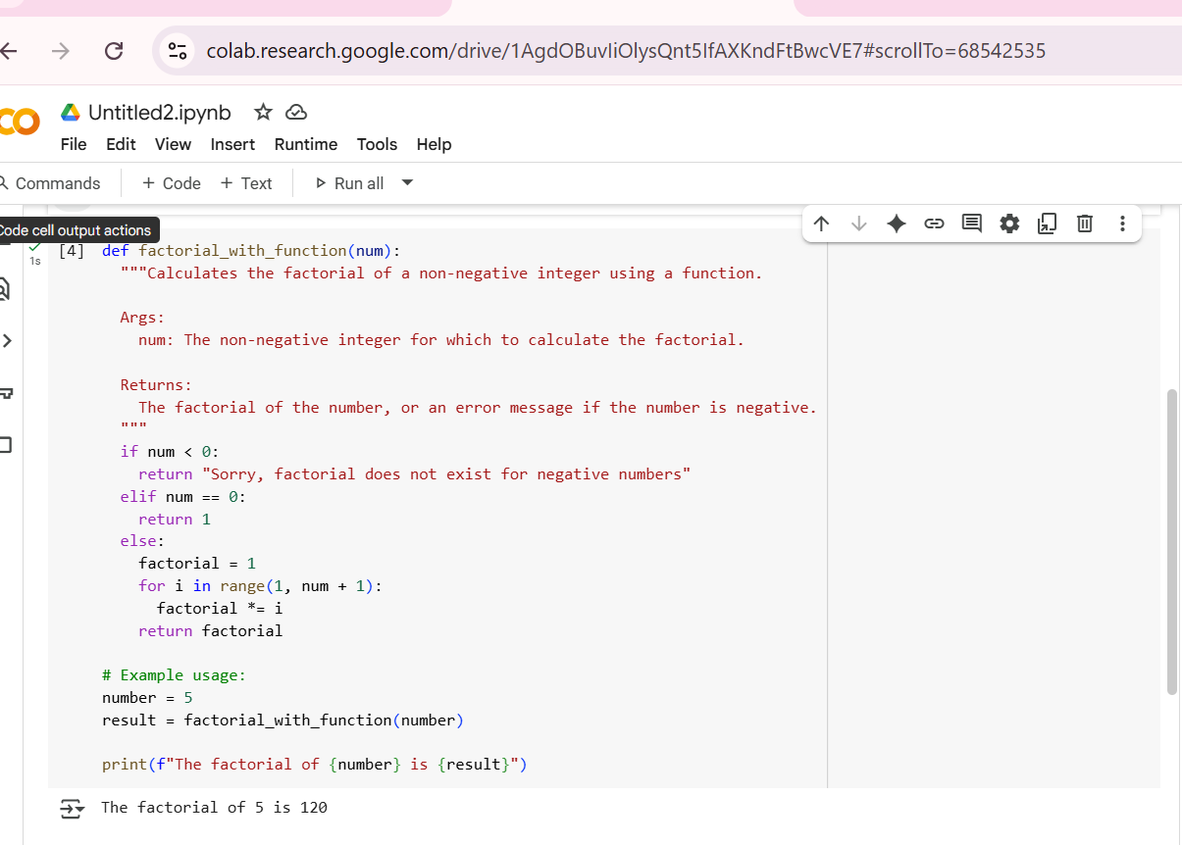
Explain:
1.def factorial_with_function(num):: This line defines a function named factorial_with_function that takes one argument, num. The code inside this function will be executed whenever the function is called. Using a function allows you to reuse the factorial calculation logic without having to rewrite it every time.
- """Calculates the factorial of a non-negative integer using a function....""": This is a docstring, which is a multiline string used to explain what the function does. It's a good practice to include docstrings to make your code more understandable.
- if num < 0:: This checks if the input number num is negative.
- return "Sorry, factorial does not exist for negative numbers": If num is negative, the function immediately returns this string message. The return statement exits the function.
- elif num == 0:: If num is not negative, this checks if it's zero.
- return 1: If num is zero, the function returns the value 1, as the factorial of 0 is defined as 1.
- else:: This block is executed if num is a positive integer.
- factorial = 1: Initializes a local variable factorial within the function to 1. This variable will store the calculated factorial.
- for i in range(1, num + 1):: This loop iterates from 1 up to and including num.
- factorial *= i: In each iteration, the current value of factorial is multiplied by the loop variable i, and the result is stored back in factorial. This is the core calculation of the factorial.
- return factorial: After the loop finishes, the function returns the final calculated factorial value.
- # Example usage:: This is a comment indicating the code below demonstrates how to use the function.
- number = 5: A variable number is assigned the value 5.
- result = factorial_with_function(number): This line calls the factorial_with_function with number (which is 5) as the input. The value returned by the function (which will be the factorial of 5) is stored in the result variable.
- print(f"The factorial of {number} is {result}"): This line prints the final output using an f-string, which allows you to easily embed variable values within a string.
Task 4: 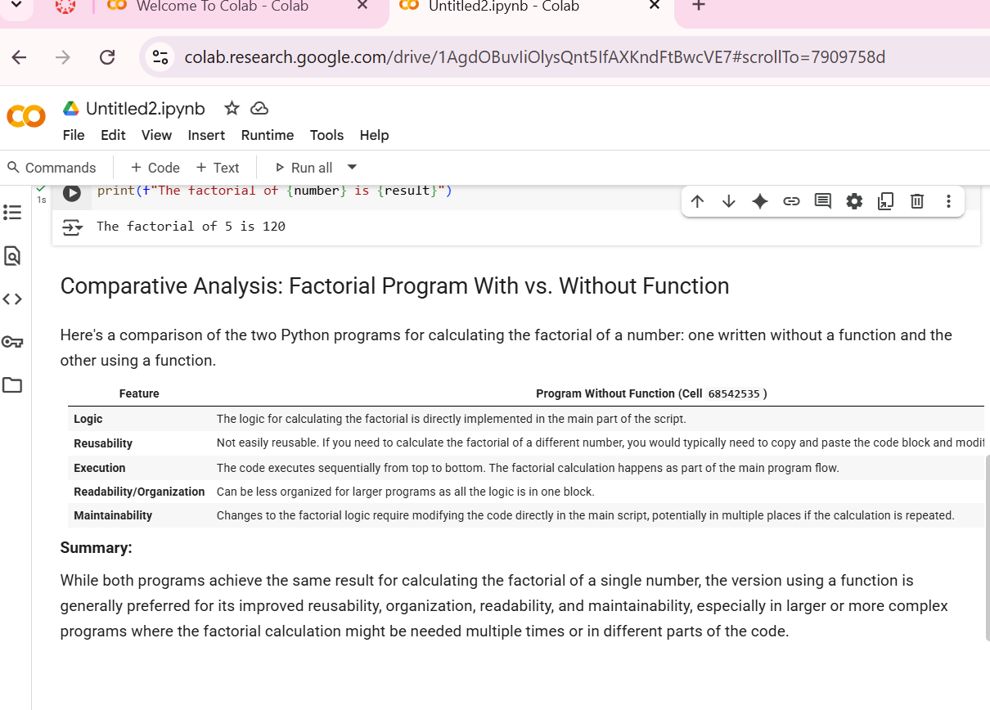
Explain:
- Logic: Where the core calculation logic resides.
- Reusability: How easy it is to use the code to calculate the factorial of different numbers.
- Execution: How the code runs when executed.
- Readability/Organization: How easy the code is to read and understand, especially in larger programs.
- Maintainability: How easy it is to make changes to the factorial calculation logic.

Task5:
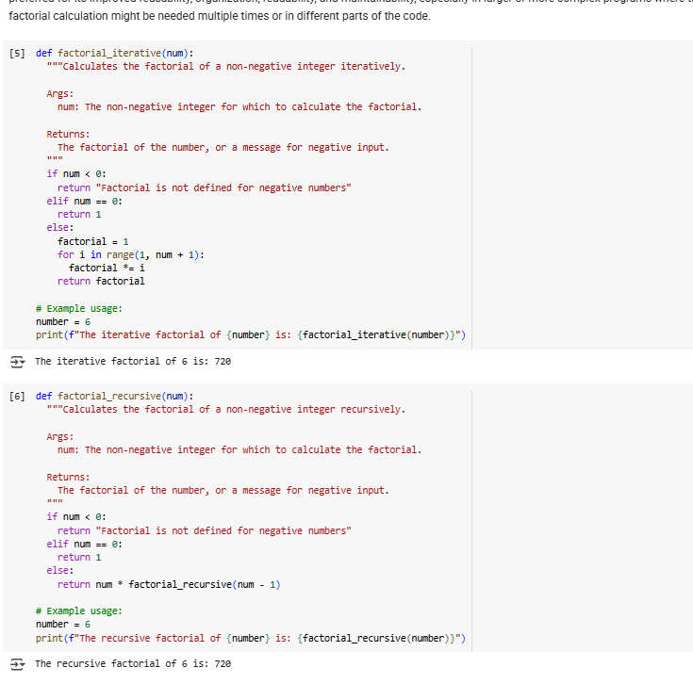
Explain:
This function calculates the factorial using a loop.
- It first handles the base cases: returning a message for negative numbers and returning 1 for 0.
- For positive numbers, it initializes a factorial variable to 1.
- It then uses a for loop to iterate through numbers from 1 up to the input num.
- In each iteration, it multiplies the current factorial value by the loop counter i.
- Finally, after the loop completes, it returns the accumulated factorial value.
This approach builds the factorial step-by-step by repeatedly multiplying within the loop.
Now, let's look at the Recursive Factorial Function
This function calculates the factorial by calling itself within its definition. This is the core concept of recursion.
- It also handles the base cases for negative numbers and 0, similar to the iterative version. The case for num == 0 is crucial; it's the "base case" that stops the recursion.
- For positive numbers, the function returns the result of multiplying num by the factorial of num - 1.
- The function keeps calling itself with a smaller and smaller number (num - 1) until it reaches the base case of num == 0.
- Once the base case is reached, it returns 1, and the results of the multiplications from each recursive call are combined back up the chain of calls until the initial call returns the final factorial value.

