ASSIGNMENT-4.1

TASK 1: Task #1 – Zero-Shot Prompting with Conditional Validation
Objective
Use zero-shot prompting to instruct an AI tool to generate a function that validates an
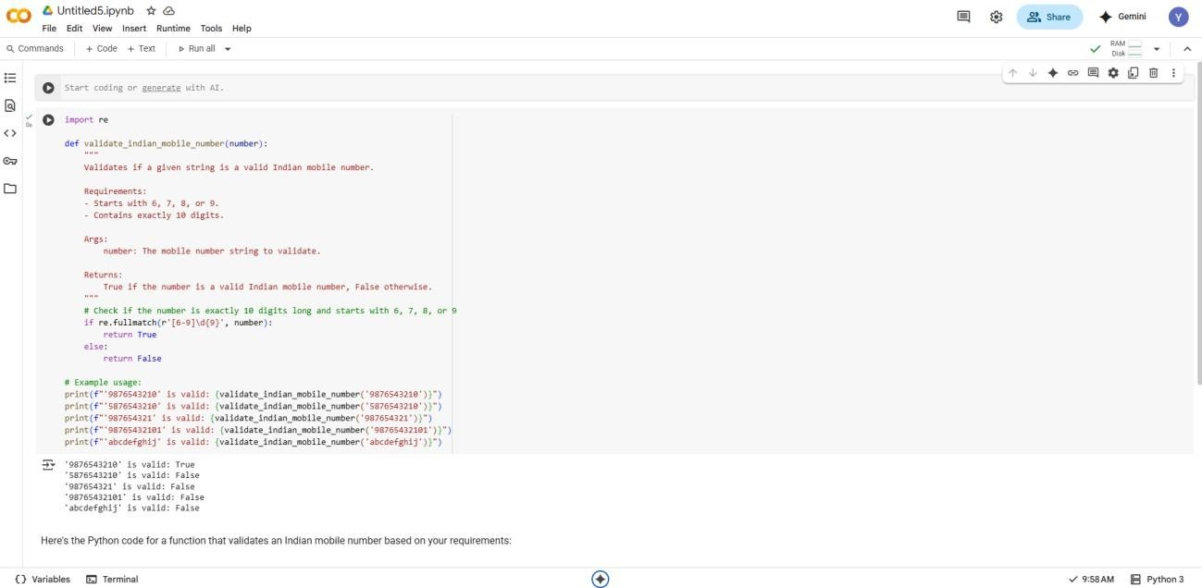
an Indian mobile number

EXPLANATION:
The provided Python code defines a function validate_indian_mobile_number that uses the re mod ule (for regular expressions) to validate if a given string is a valid Indian mobile number. The function checks if the input string is exactly 10 digits long and starts with a digit from 6 to 9 by using the regular expression pattern [6-9]\d{9} with re.fullmatch(). If the string matches this pattern, the function returns True, indicating a valid number; otherwise, it returns False. The code also includes example usage demonstrating how to call the function with various inputs and printing the validation result for each.

TASK 2:
Use one-shot prompting to generate a Python function that calculates the factorial of a number

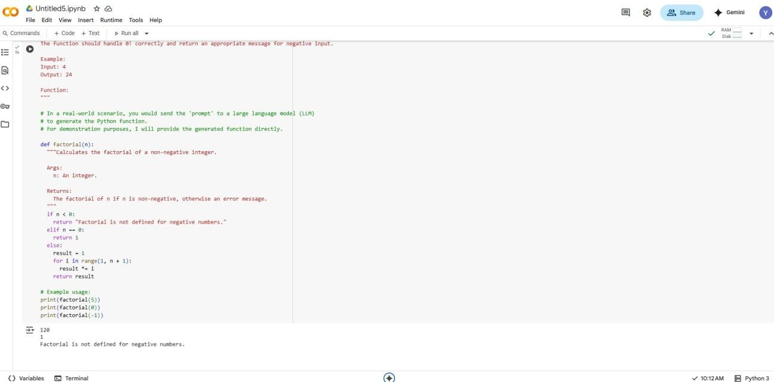
EXPLANATION :
Certainly! This Python code defines a function called
factorial

given non-negative integer n. It first checks if the input n is negative; if so, it returns a message indicating that factorial is not defined for negative numbers. If n is 0, it returns 1, as the factorial of 0 is
1. For any positive integer n, the function calculates the factorial by iterating from 1 up to n and multiplying the numbers together, storing the result in the result variable. Finally, it returns the calculated factorial. The example usage demonstrates calling the function with different inputs (5, 0, and -1) and printing their respective outputs.

Task 3: create a function that parses a nested dictionary representing student information.

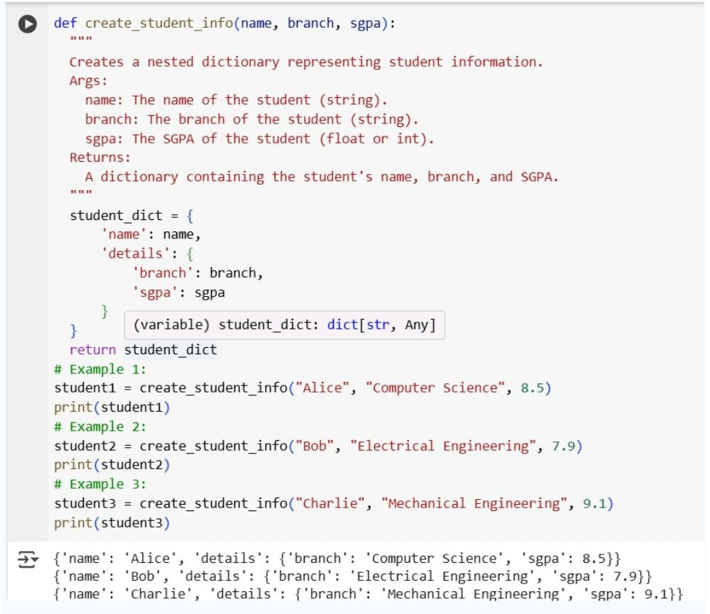
EXPLANATION:
called extract_student_info that takes a nested dictionary representing student data as input. This function is designed to safely extract specific pieces of information: the student's full name, their academic branch (major), and their SGPA (grade point average). It uses the .get() method with

The provided Python code defines a function
default empty dictionaries ({}) at each level of nesting to avoid errors if a key is missing. If a key is not found at any level, it defaults to 'N/A' for that specific piece of information. Finally, the function returns

the d
a new dictionary containing the extracted 'Full Name', 'Branch', and 'SGPA'. The code also includes several example dictionaries (example_data_1 through example_data_4) to demonstrate how
function handles different scenarios, including cases where some information might be missing, an
prints the results of applying the function to these examples.

TASK 5: Python function that processes text and analyzes word frequency

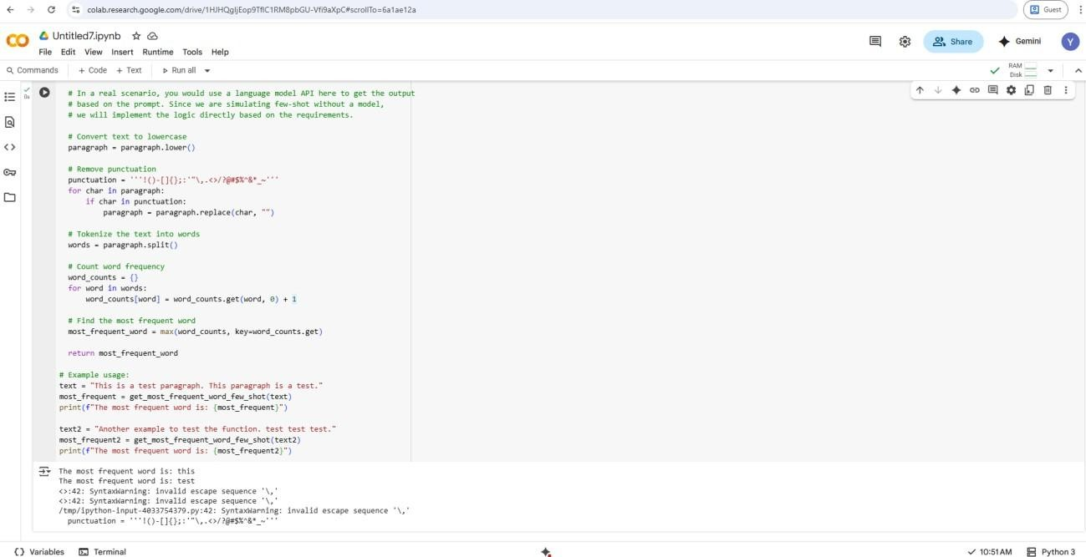

EXPLANATION:

This Python function,
get_most_frequent_word_few_shot , takes a paragraph of text as input

and identifies the most frequently used word. Although the function's name suggests few-shot prompting, in this implementation, the few-shot examples are only used to construct a prompt string, and the core logic for finding the most frequent word is handled directly within the
function. The function first converts the input paragraph to lowercase to ensure case-insensitive counting and then removes common punctuation marks. After cleaning the text, it splits the
paragraph into individual words. It then counts the occurrences of each word and finally returns the word that appears most often in the cleaned text.

TASK 4 :
generate functions for CSV file analysis
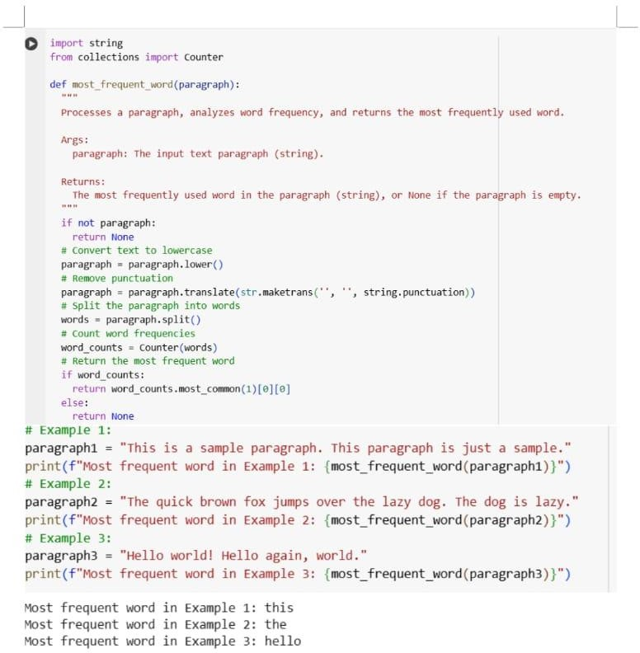
EXPLANATION : This code defines a Python function
called most_frequent_word. This
function is designed to find the most

frequently used word within a given text paragraph. It first converts the entire input paragraph to lowercase to ensure case-insensitivity in word counting. Next, it removes all
punctuation marks from the text. The cleaned text is then split into individual words. The code uses the Counter object from
the collections module to efficiently count the occurrences of each
word. Finally, it identifies and
returns the word with the highest frequency count. The included examples demonstrate the
function's usage with different sample paragraphs

