AssignmentNumber:3.2
2403a54071
Task Description#1: Tuesday, 12 August 2025

- Ask AI to write a function to calculate compound interest, starting with only the function name. Then add a docstring, then input-output example.
Code:
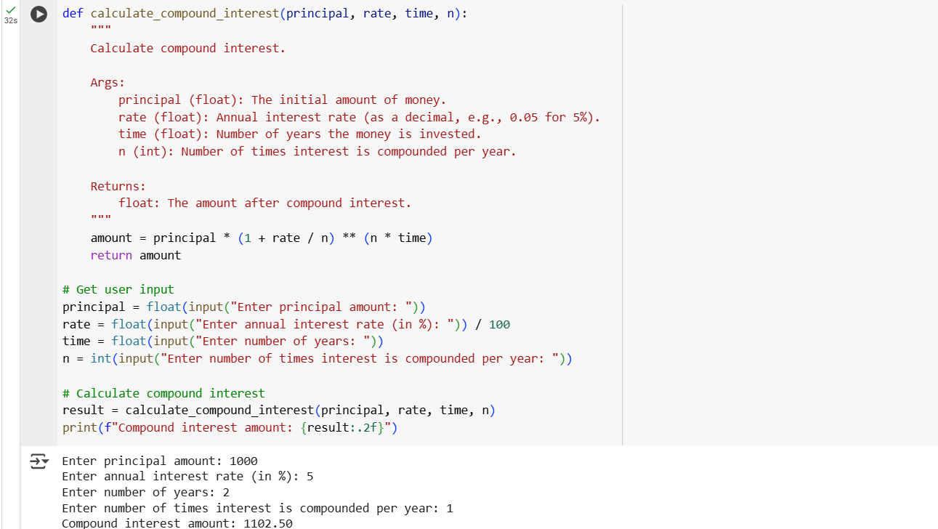
Explanation:
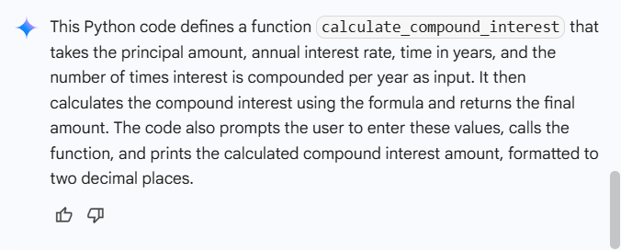
Task Description#2:
- Do math stuff, then refine it to: # Write a function to calculate average, median, and mode of a list of numbers.
Code:
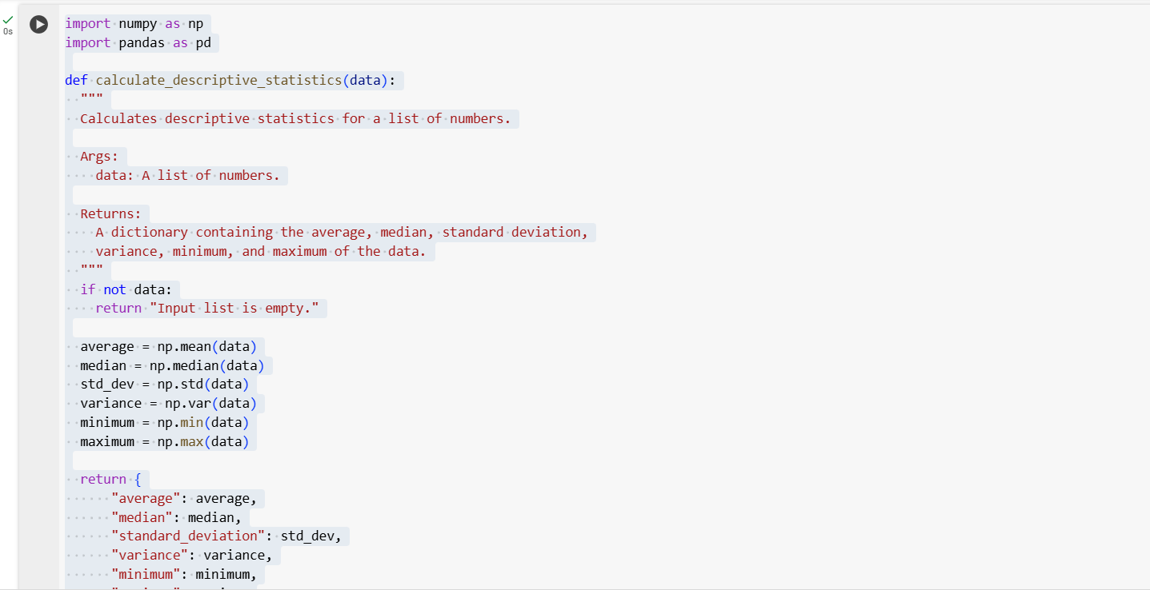
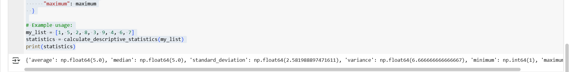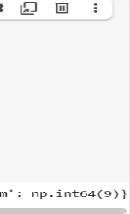
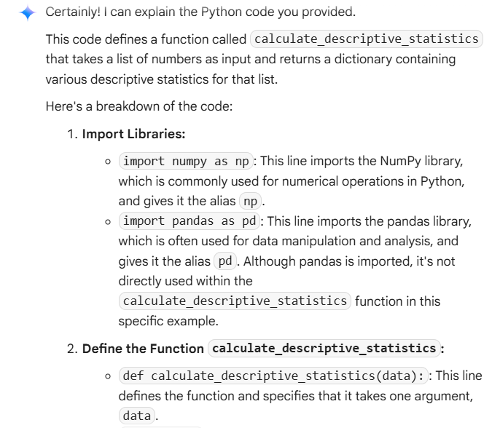
Explanation:
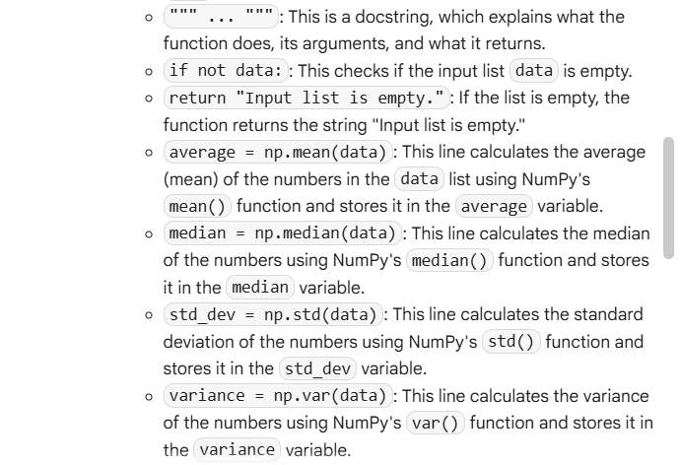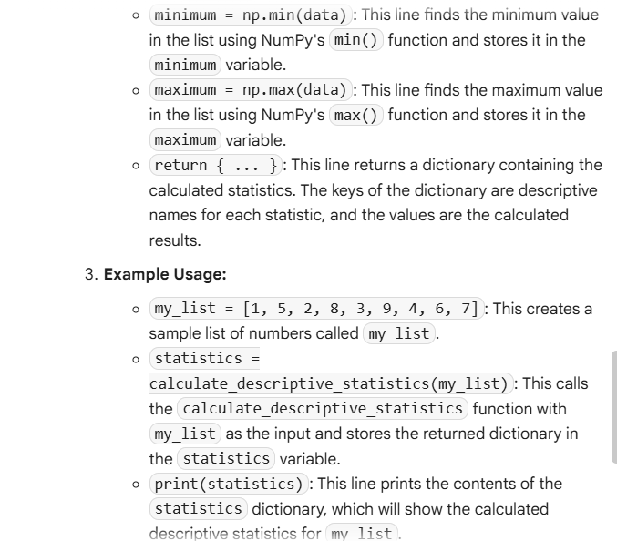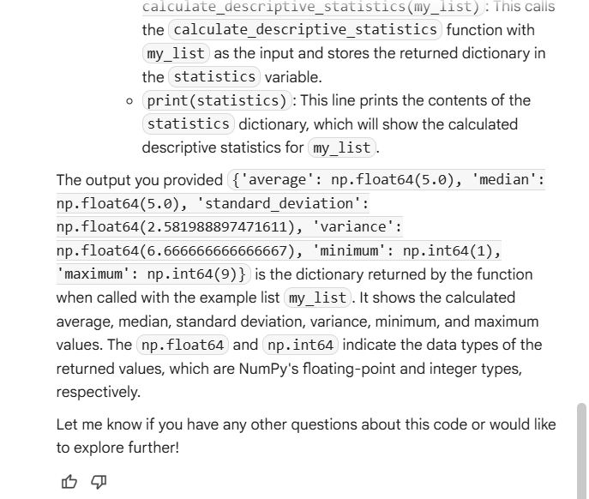
Task Description#3:
- Provide multiple examples of input-output to the AI for convert_to_binary(num) function. Observe how AI uses few-shot prompting to generalize.
Code:
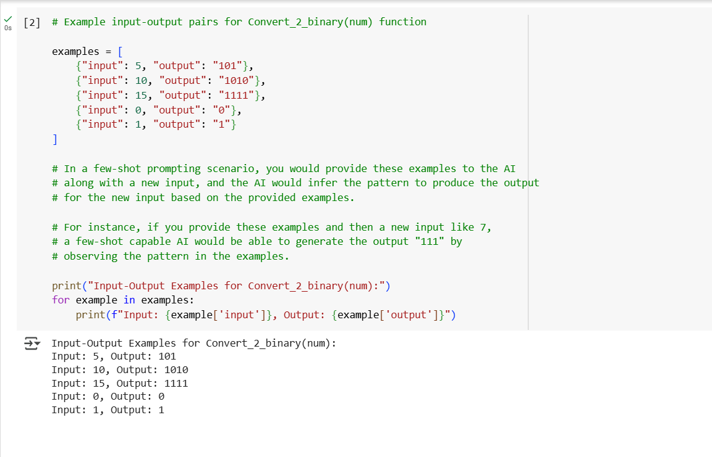
Explanation:
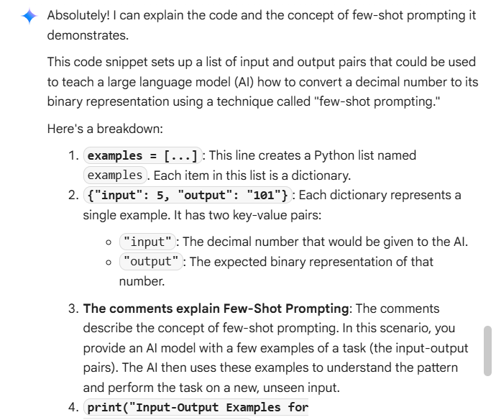
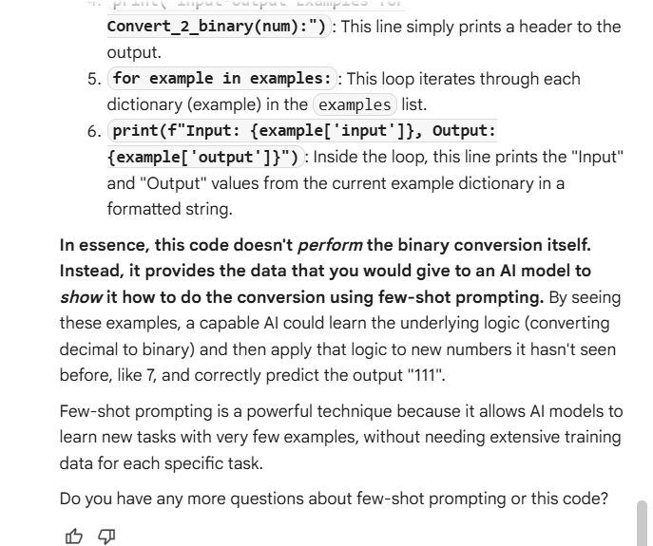
Task Description#4:
- Create an user interface for an hotel to generate bill based on customer requirements.
Code:
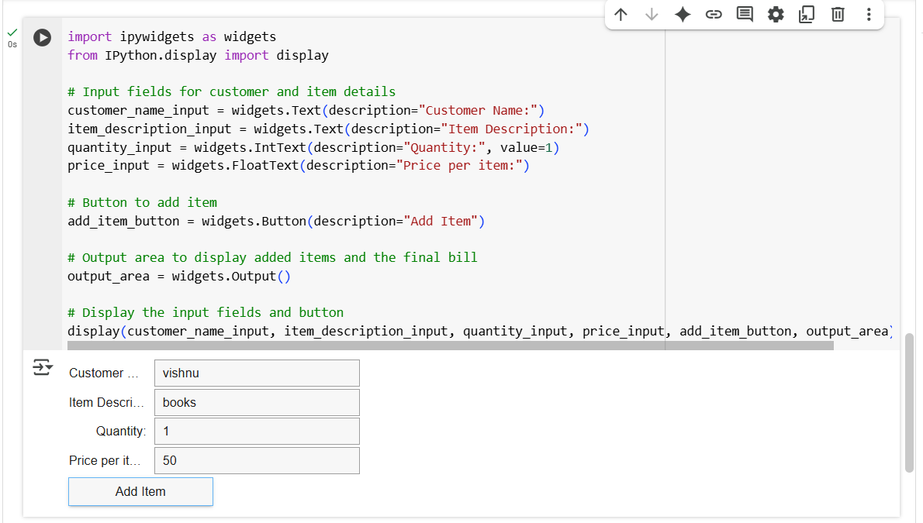

Explanation:
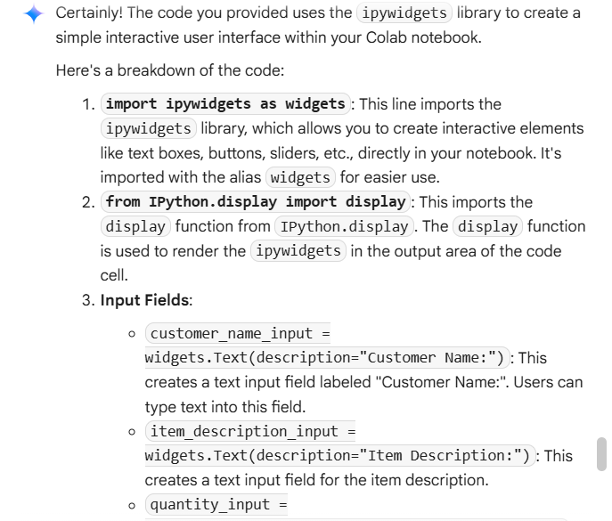
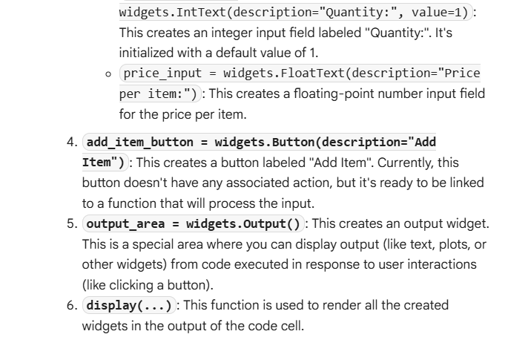
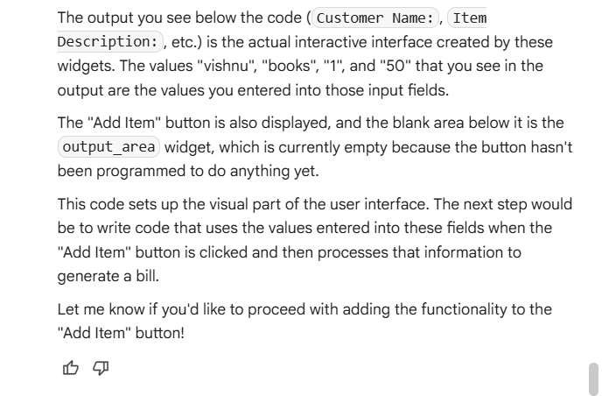
Task Description#5:
- Analyzing Prompt Specificity: Improving Temperature Conversion Function with Clear Instructions.
Code:
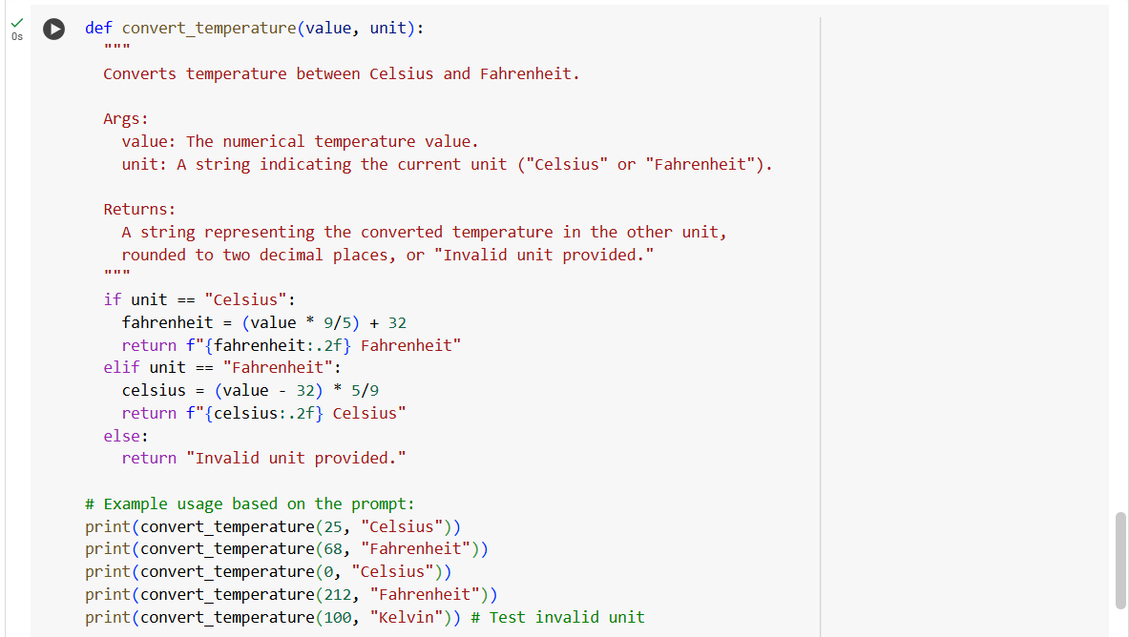
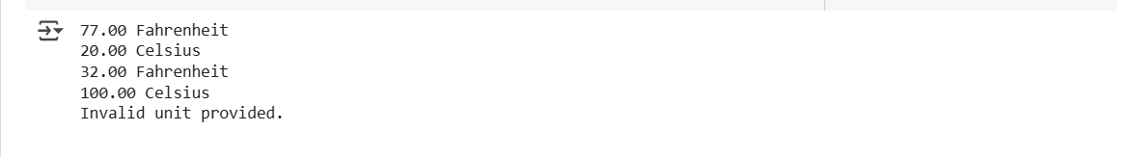
Explanation:
