Assignment-4.3
2403a54071
Task Description#1:
● Zero-shot: Prompt AI to write a function that checks whether a given year is a leap
year.
Code:
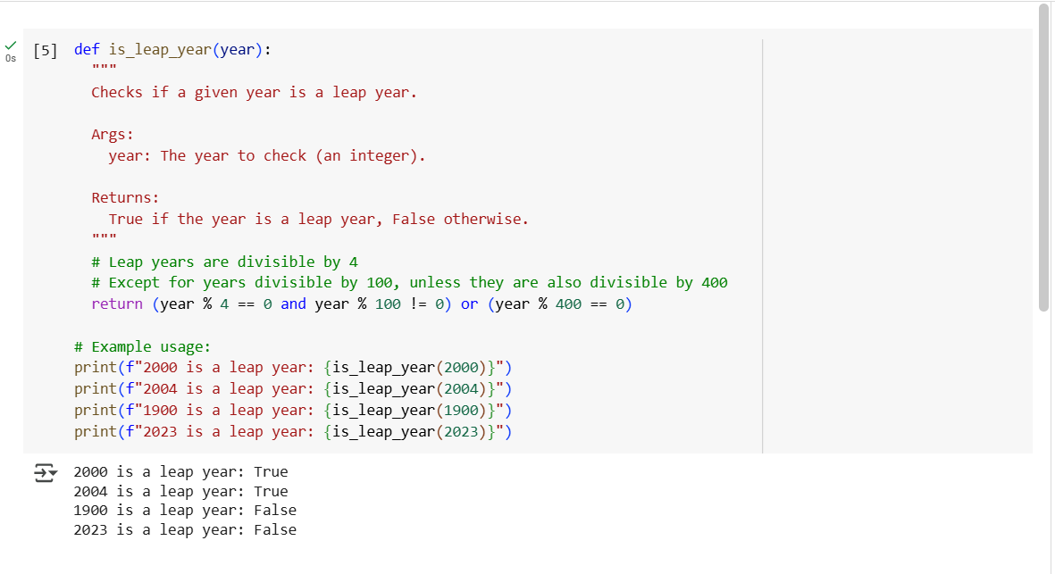
Explanation:
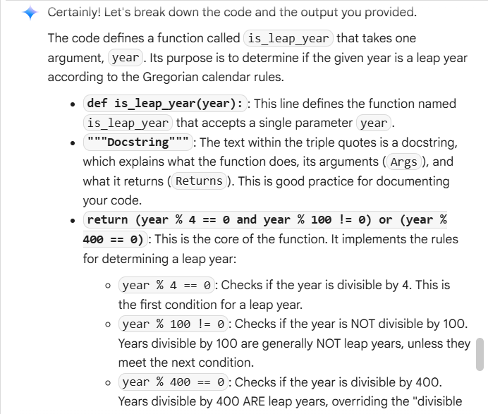
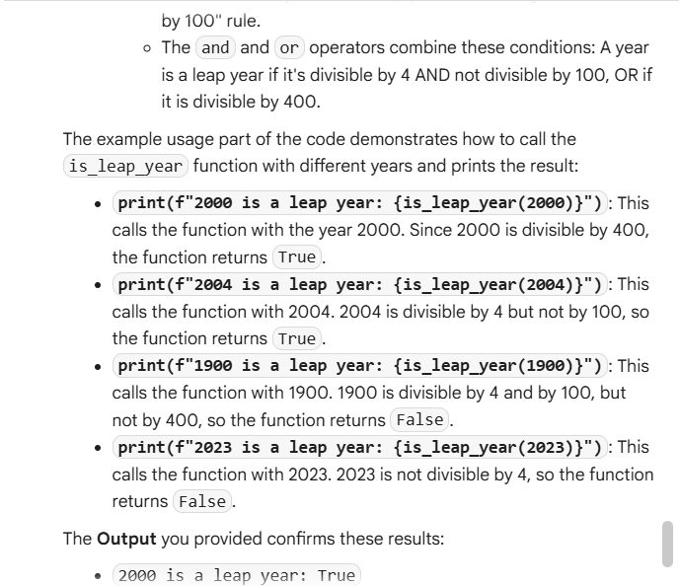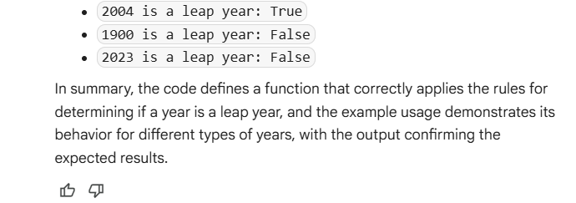
Task Description#2
● One-shot: Give one input-output example to guide AI in writing a function that
converts centimeters to inches.
Code:
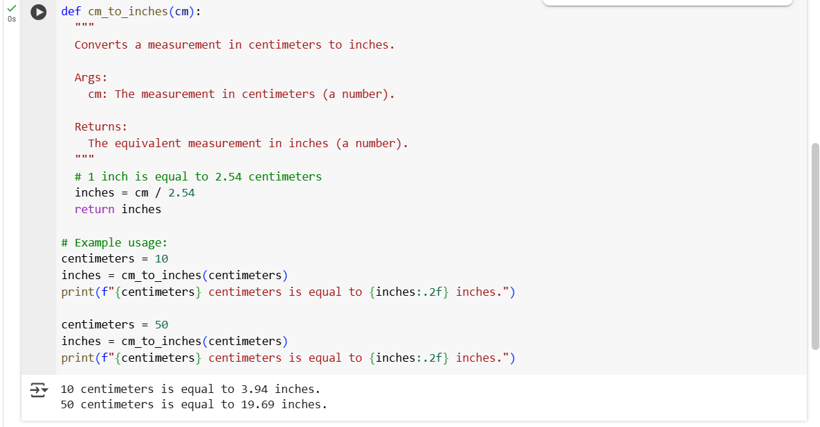
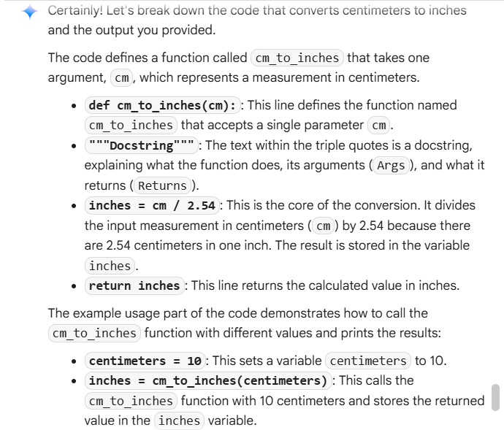
Explanation:

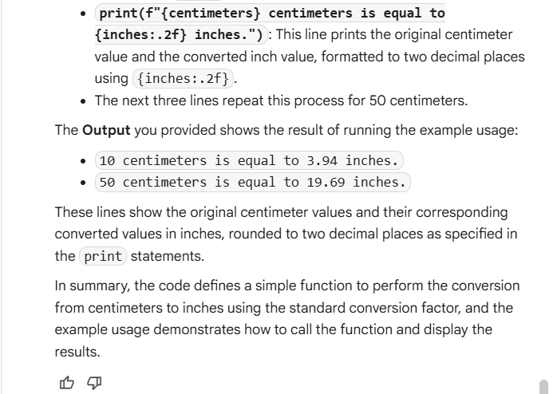
Task Description#3:
● Few-shot: Provide 2–3 examples to generate a function that formats full names as “Last, First”.
Code:
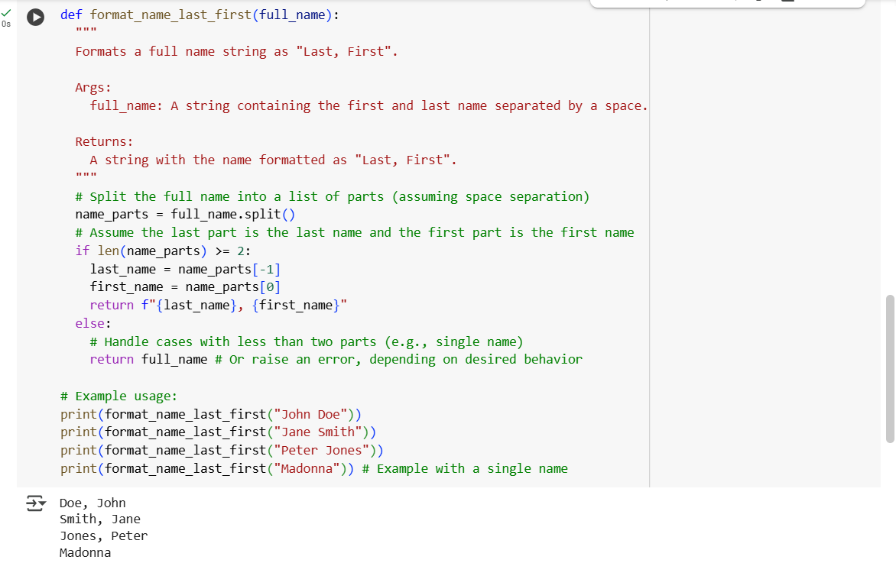
Explanation:
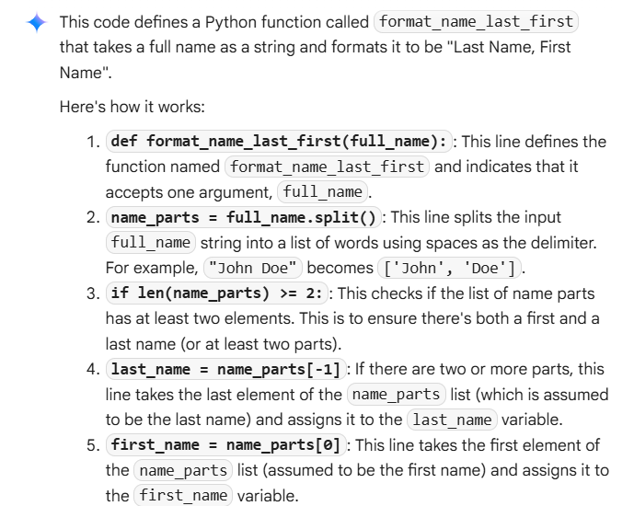
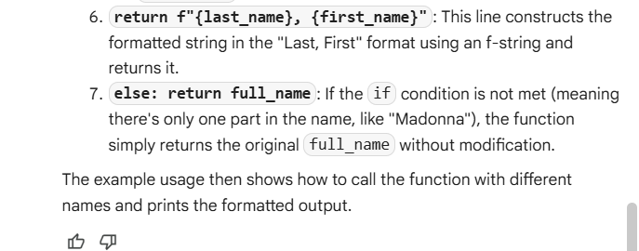
Task Description#4:
● Compare zero-shot and few-shot prompts for writing a function that counts the
number of vowels in a string.
Code:
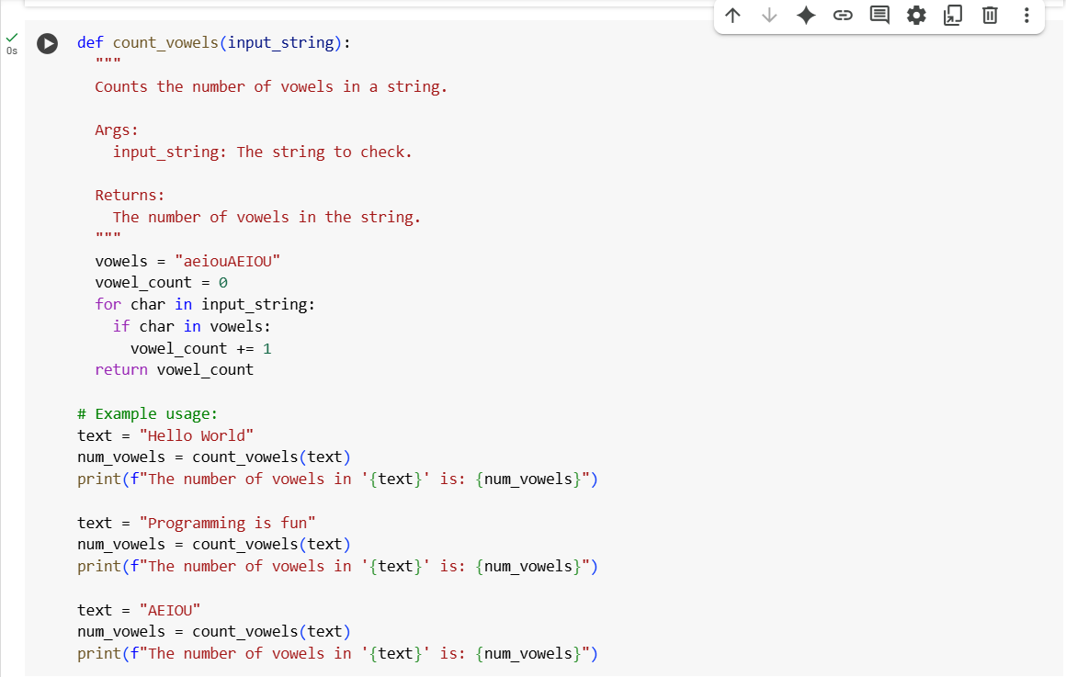
Explanation:
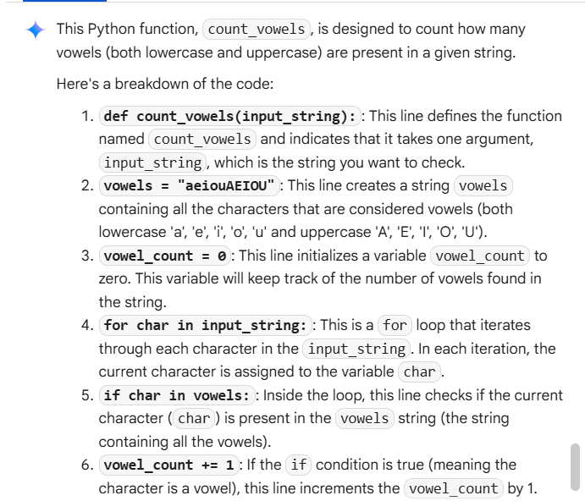
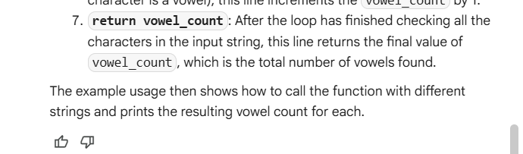
Task Description#5:
● Use few-shot prompting to generate a function that reads a .txt file and returns the
number of lines.
Code:
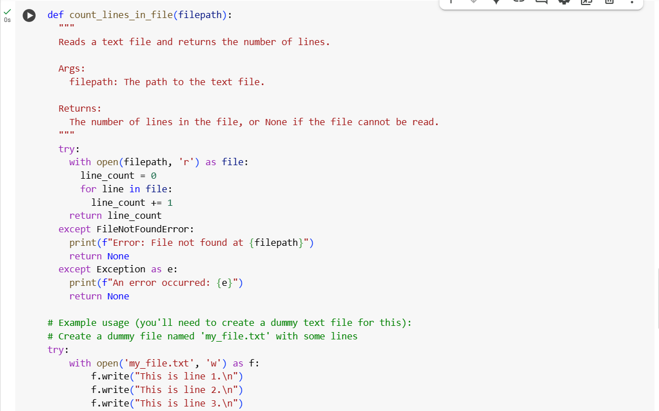
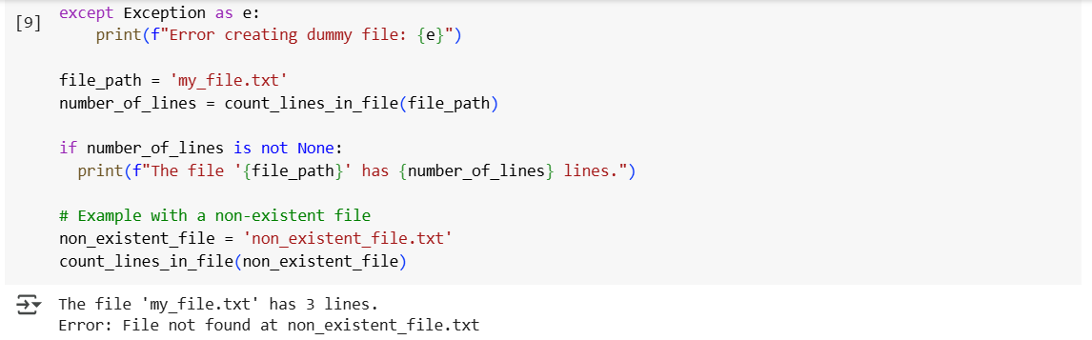
Explanation:
