**Name : Alle Sai Charan**

Enroll no : 2403A54072

Batch : (DS)Batch-3

Task -0

* Install and configure GitHub Copilot in VS Code. Take screenshots of each step.

Expected Output

* Install and configure GitHub Copilot in VS Code. Take screenshots of each step.

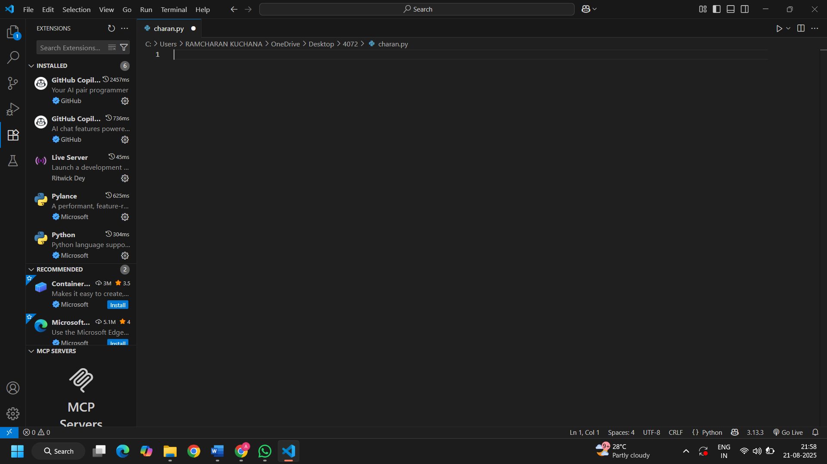

Task 1: Factorial without Functions

* Description:  
  Use GitHub Copilot to generate a Python program that calculates the factorial of a number without defining any functions (using loops directly in the main code).
* Expected Output:
  + A working program that correctly calculates the factorial for user-provided input.
  + Screenshots of the code generation process.

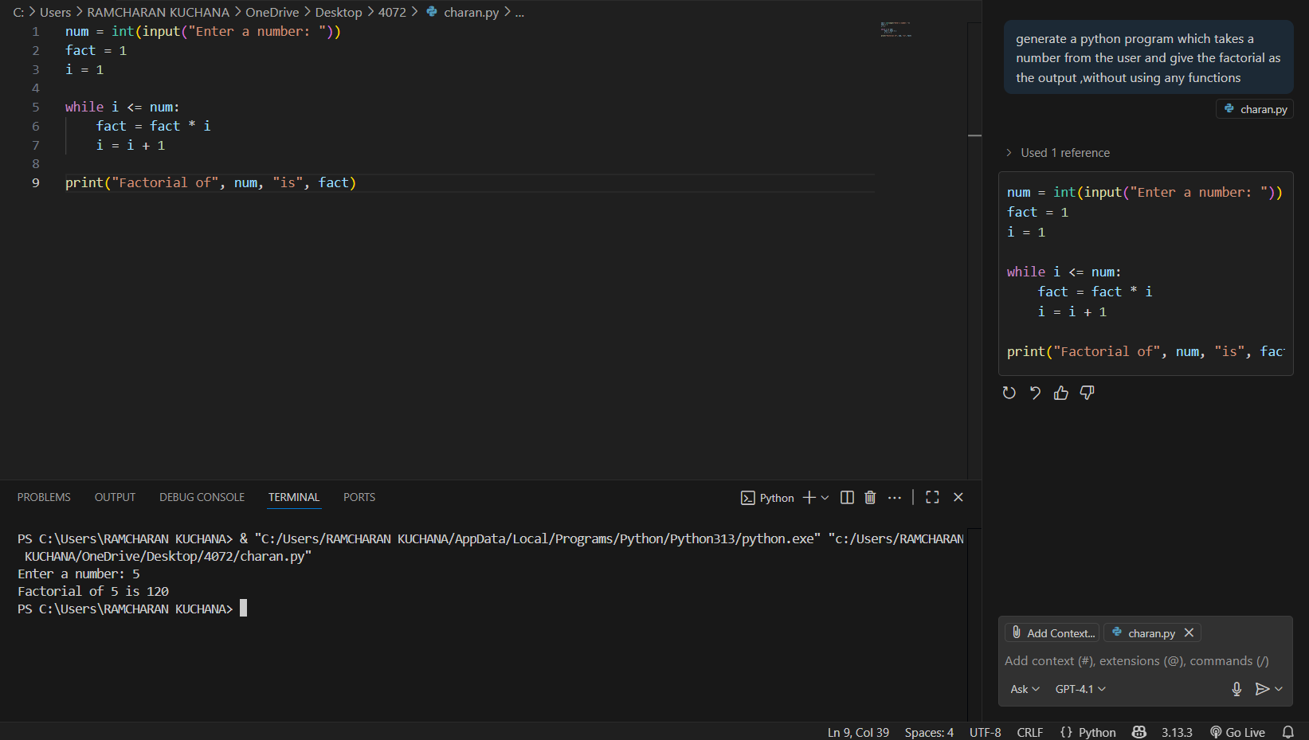prompt : generate a python program which takes a number from the user and give the factorial as the output ,without using any functions

Task 2: Improving Efficiency

* Description:  
  Examine the Copilot-generated code from Task 1 and demonstrate how its efficiency can be improved (e.g., removing unnecessary variables, optimizing loops).
* Expected Output:
  + Original and improved versions of the code.
  + Explanation of how the improvements enhance performance.

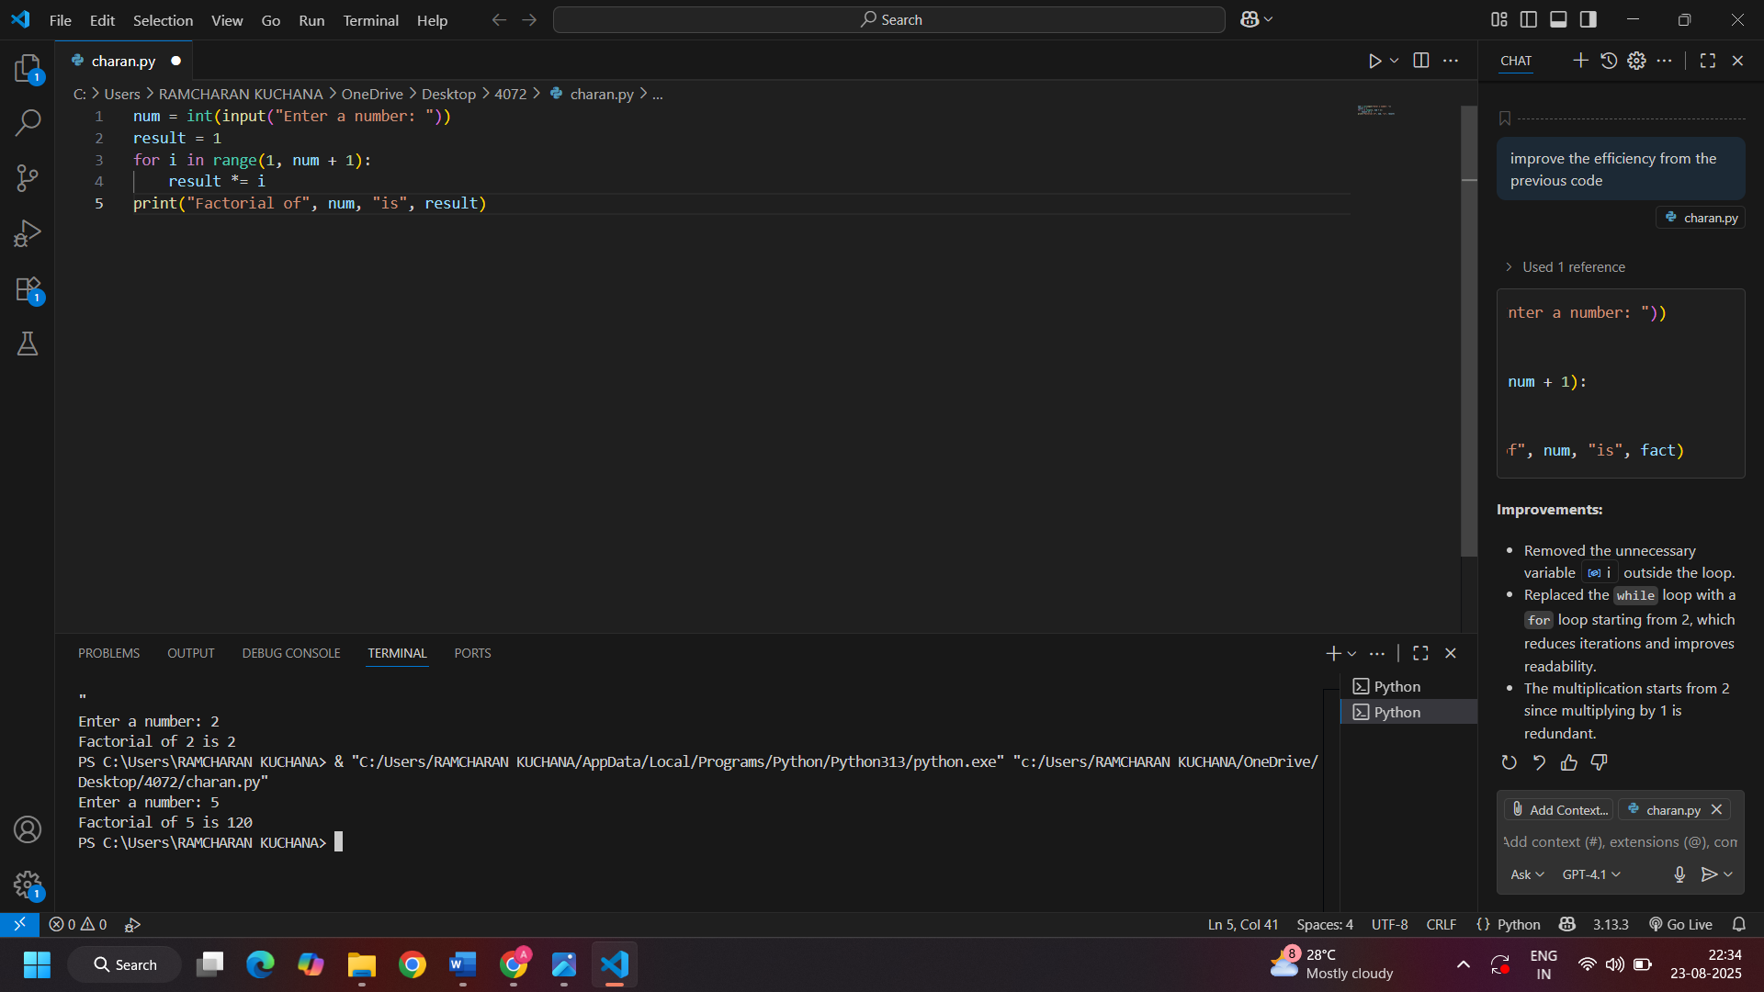 prompt : improve the efficiency from the previous code by removing unnecessary variables,optimizing loops etc…

Task 3:Factorial with Functions

* Description:  
  Use GitHub Copilot to generate a Python program that calculates the factorial of a number using a user-defined function.
* Expected Output:
  + Correctly working factorial function with sample outputs.
  + Documentation of the steps Copilot followed to generate the function.

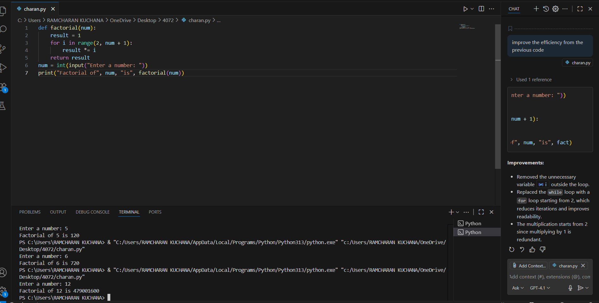Prompt :generate a python program which take the input from the user and give factorial of it by taking an user defined function

Task 4: Comparative Analysis – With vs Without Functions

* Description:  
  Differentiate between the Copilot-generated factorial program with functions and without functions in terms of logic, reusability, and execution.
* Expected Output:

A comparison table or short report explaining the differences

Prompt:

* Differentiate between program with functions and without functions in terms of logic, reusability, and execution.

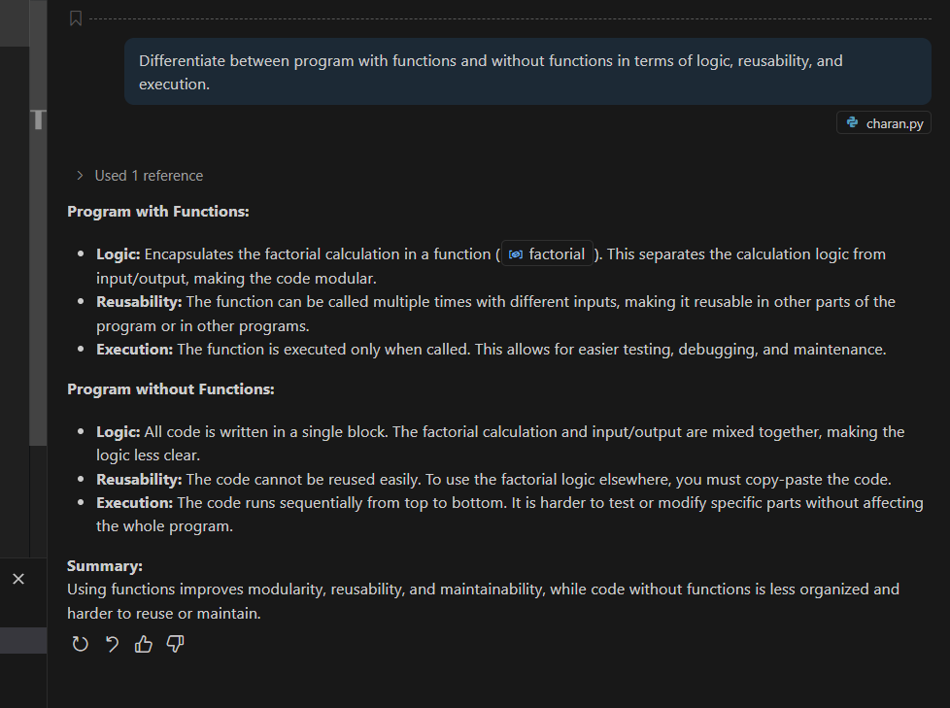

Task 5: Iterative vs Recursive Factorial

* Description:  
  Prompt GitHub Copilot to generate both iterative and recursive versions of the factorial function.
* Expected Output:
  + Two correct implementations.
  + A documented comparison of logic, performance, and execution flow between iterative and recursive approaches.
* 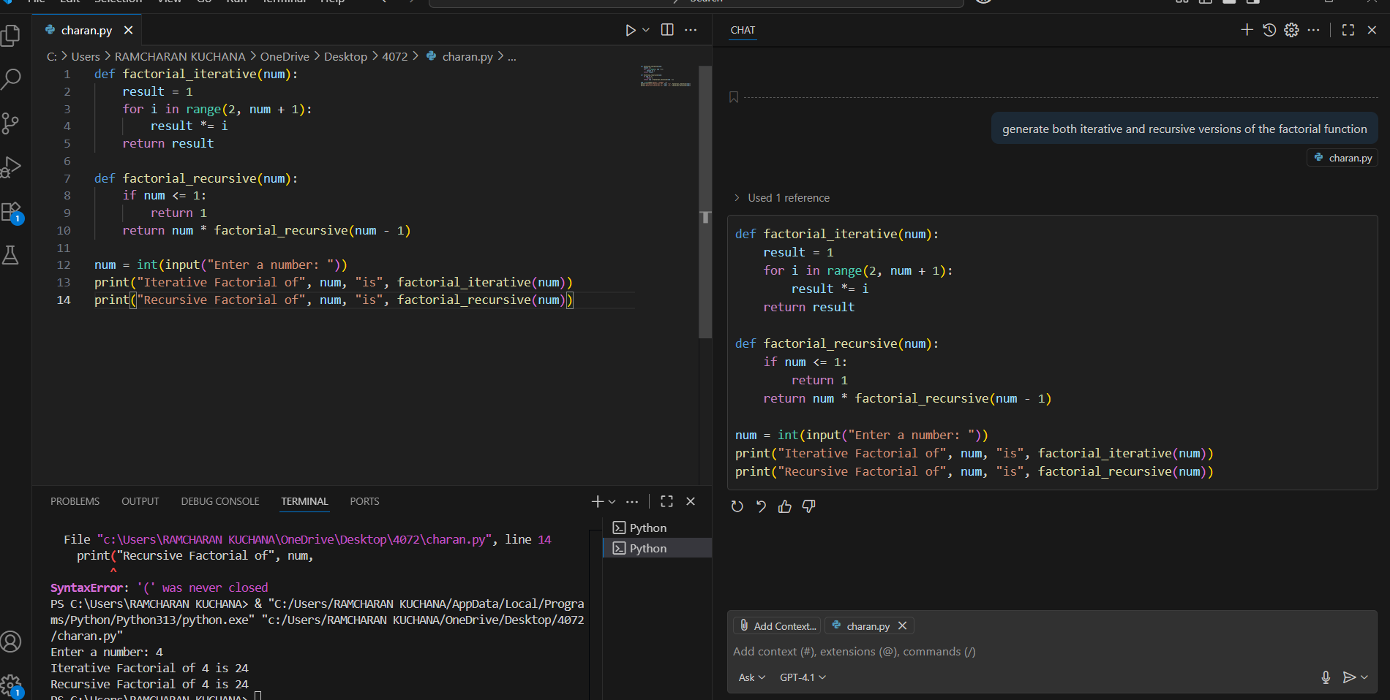Prompt : generate both iterative and recursive versions of the factorial function