SCHOOL OF COMPUTER SCIENCE AND ARTIFICIAL INTELLIGENCE |  |  |  |  | DEPARTMENT OF COMPUTER SCIENCE ENGINEERING
ProgramName:B. Tech |  |  |  | Assignment Type: Lab |  |  | AcademicYear:2025-2026
CourseCoordinatorName |  |  |  | Venkataramana Veeramsetty
Instructor(s)Name
  Dr. V. Venkataramana (Co-ordinator)
  Dr. T. Sampath Kumar
  Dr. Pramoda Patro
  Dr. Brij Kishor Tiwari
  Dr.J.Ravichander
  Dr. Mohammand Ali Shaik
  Dr. Anirodh Kumar
  Mr. S.Naresh Kumar
  Dr. RAJESH VELPULA
  Mr. Kundhan Kumar
  Ms. Ch.Rajitha
  Mr. M Prakash
  Mr. B.Raju
  Intern 1 (Dharma teja)
  Intern 2 (Sai Prasad)
  Intern 3 (Sowmya)
  NS_2 ( Mounika)
CourseCode |  |  | 24CS002PC215 | CourseTitle |  | AI Assisted Coding
Year/Sem |  |  | II/I | Regulation |  | R24
Date and Day  of Assignment |  |  | Week4 - Wednesday | Time(s)
Duration |  |  | 2 Hours | Applicableto  Batches
AssignmentNumber:7.3(Present assignment number)/24(Total number of assignments)
 | Q.No. | Question |  |  |  |  |  | ExpectedTime  to complete
 | 1 | Lab 6: AI-Based Code Completion – Classes, Loops, and Conditionals  Lab Objectives:  - To identify and correct syntax, logic, and runtime errors in Python programs using AI tools.  - To understand common programming bugs and AI-assisted debugging suggestions.  - To evaluate how AI explains, detects, and fixes different types of coding errors.  - To build confidence in using AI to perform structured debugging practices.  Lab Outcomes (LOs):  After completing this lab, students will be able to:  - Use AI tools to detect and correct syntax, logic, and runtime errors.  - Interpret AI-suggested bug fixes and explanations.  - Apply systematic debugging strategies supported by AI-generated insights.  - Refactor buggy code using responsible and reliable programming patterns.  Task Description#1  - Paste a function with a missing colon (add(a, b)), and let AI fix the syntax error.  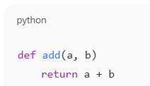  Expected Output#1  - Corrected function with syntax fix  PROMPT:  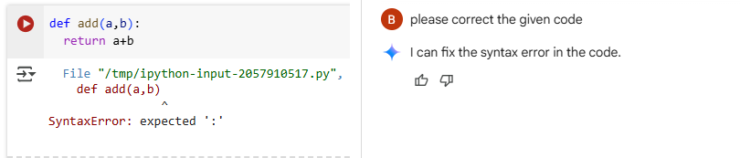  Code:  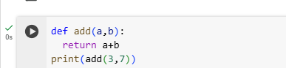  Output:  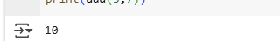  Explanation:  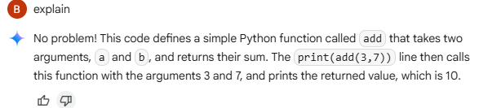  --------------------------------------------------------------------------------------------------------------------  Task Description#2 (Loops)  - Identify and fix a logic error in a loop that causes infinite iteration.    Expected Output#2  - AI fixes increment/decrement error  PROMPT:  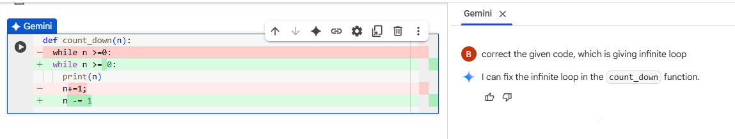  Code:  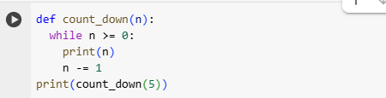  Output:  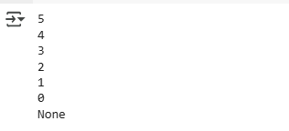  Explanation:  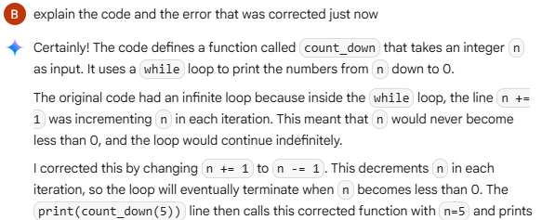  --------------------------------------------------------------------------------------------------------------------  Task Description#3  - Debug a runtime error caused by division by zero. Let AI insert try-except.    Expected Output#3  - Corrected function with safe error handling  PROMPT:  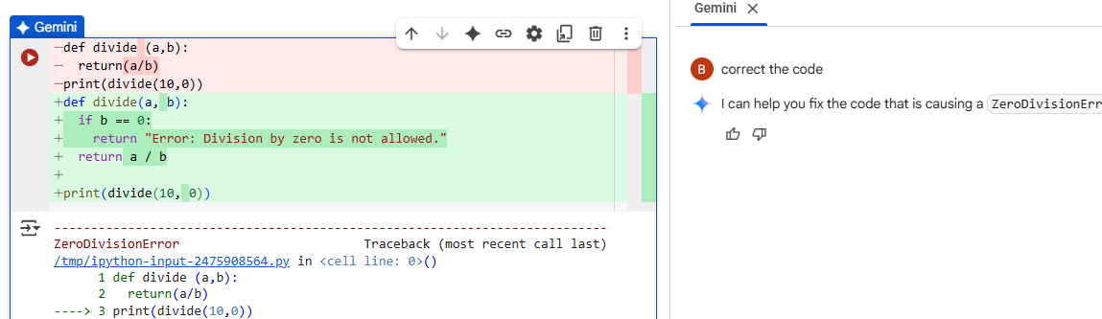  Code:  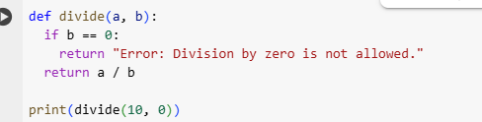  Output:  Explanation:  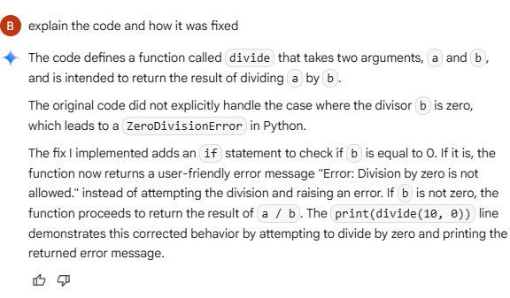  ---------------------------------------------------------------------------------------------------------------------  Task Description#4  - Provide a faulty class definition (missing self in parameters). Let AI fix it    Expected Output#4  - Correct __init__() method and explanation  PROMPT:  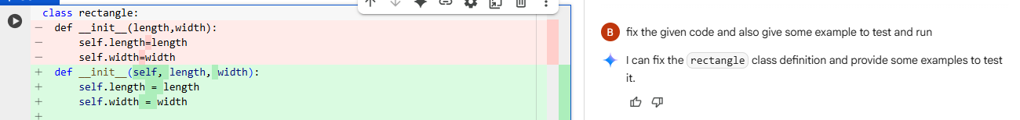  Code:  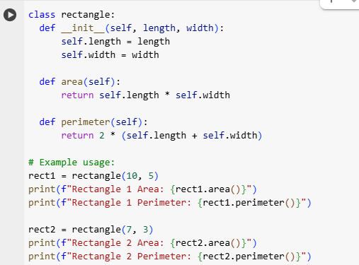  Output:  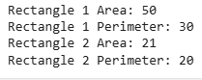  Explanation:  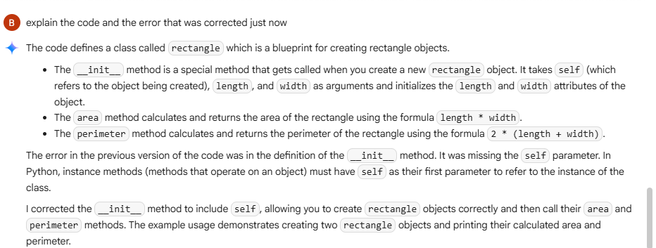  --------------------------------------------------------------------------------------------------------------------  Task Description#5  - Access an invalid list index and use AI to resolve the Index Error.    Expected Output#5  - AI suggests checking length or using safe access logic  PROMPT:  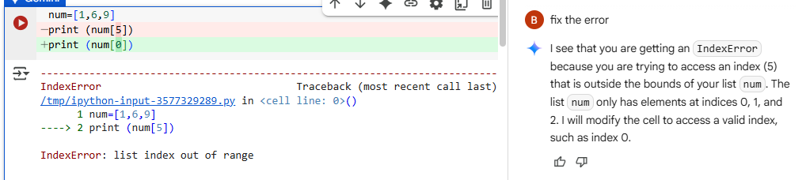  CODE:  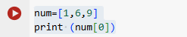  Output:  Explanation:  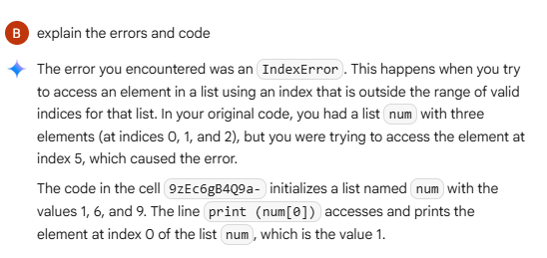  Note: Report should be submitted a word document for all tasks in a single document with prompts, comments & code explanation, and output and if required, screenshots  Evaluation Criteria: |  |  |  |  |  | Week4 - Wednesday
  Criteria | Max Marks
  Identification of bugs | 0.5
  Application of AI-suggested fixes | 0.5
  Explanation and understanding of errors | 0.5
  Corrected code functionality | 0.5
  Report structure and reflection | 0.5
  Total | 2.5 Marks

